**CURRENT TOPIC HUMAN COMPUTER INTERACTION**

**CS-630-740**

**SMART HEALTH TRACKING SYSTEM**

**(TRACKING EMOTIONS)**

**PROJECT PHASE 3**

**By,**

**NEERAJA KARETI**

**(S01995530)**

**SNO CONTENTS PAGE NO**

1 Project Goal 3

2 Explore the questions 3

3 Practical issues 3

4 Ethical related issues 3

5 Evaluate Data 4

6 Analyze Data 4

7 Interpret Data 4

8 Present Data 4

9 Collected Data 5

10 Conclusion 15

1. **GOAL OF THE PROJECT**

The goal of the project is to design the smart health tracking system which will allow the member to track the emotion for the activity. The system interface should be user friendly while member interact with the system. The designed interface system will allow the user to add an activity, to view the list of scheduled activity, view the history of activity and will capture the emotion of the member for specific activity.

1. **EXPLORE THE QUESTIONS**

The following are the questions I framed for evaluating my designed interface system with my friends to provide the feedback on the designed system.

1. Did the interface is user friendly?
2. Will the user able to interact with the system easily?
3. Did the system respond faster when user performs the action?
4. Did the user able to register in the system without any error?
5. Does the user able to sign into the smart health tracking system without any error?
6. Will the user can add the activity without facing any issues?
7. Do the user able to view the history of activity based on the activity type?
8. Does the designed system capture the user emotion for that activity?
9. Does the designed interface is attractive to user?
10. Is there anything needed to improve in further design of the product? Overall your experience with using the smart health tracking system.
11. **PRACTICAL ISSUES**

The practical issues related to the designed interface system are listed below:

* When member logins to system if they give wrong username and password then the system will not allow the member to access the designed system. There is no option for using the forgot password. So, the member must remember their password to access the system.
* While doing the archive activity, the member must again enter the emotion for that activity. After that only member will be able to archive that activity.
* There might be a problem while viewing the history of activity.
* The member emotion options are limited. The member can’t give their own emotion for the activity.
* The option for choosing the activity is also too limited, the member will not be able to add the new activity of their own.

1. **ETHICAL ISSUE**

The ethical issues involved in the designed interface will be listed below:

* The code should not be complex, and it’s should be very easy to understand. Moreover, the code file should be safeguard.
* Should not give the unauthorized access to log file.
* When there is any fault in the code, it should be handled and corrected immediately.
* The designed interface should be protected. Though it will be based on the project budget how strong the security protection for the system. If budget is low, the security might be compromised.

1. **EVALUATE THE DATA**

The collected data has been evaluated by using usability testing. In which 10 people participated in the survey and gave their evaluation report for the designed interface.

1. **ANALYZE THE DATA**

When collected data has been analyzed I found that most of the people who done evaluation to the designed interface system needs further improvement in the designed system. Firstly, the user interface should be designed in more attractive way by including more funny images which is related to the project. The other one is user must be able to add the activity based on their own. Because the user only knows the activity which relief them from the stress. The interface should provide the forgot password option to the member and last one will be it should have some online support or help when the member not able to use the designed system or else not able to perform the specific action in the designed system. I think these are the improvements that the user wishes to do changes in the system.

1. **INTERPT THE DATA**

While doing the evaluation, the member want to add their activity which they wish to undertake for the stress relief. This will not be a good way to include in further design because the activity offered for the will be decided by the department and it’s not possible for the department to provide the activity for which the member want to enroll.

1. **PRESENT THE DATA**

The further design of the interface will present all the data that is given in the designed interface evaluation. Will do the changes in the system by including the forgot password option for the member. Will include more funny images in the interface such that interface design will be attractive. And will lastly include the online support facility for the member who are not able to perform the required action in the designed system.

1. **COPY OF COLLECTED DATA**

These are the collected data for evaluating the interface system which is done from different sets of persons.

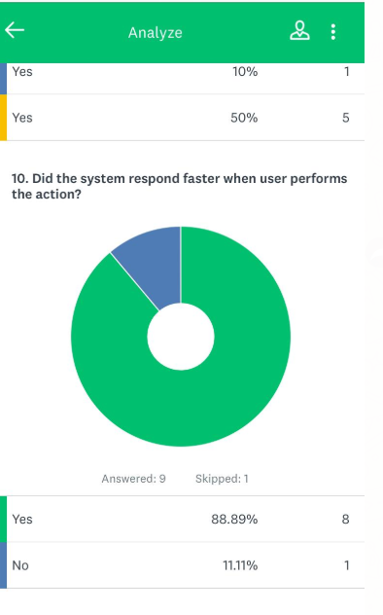

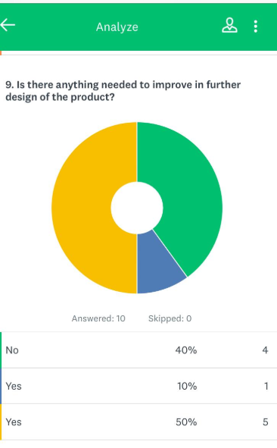

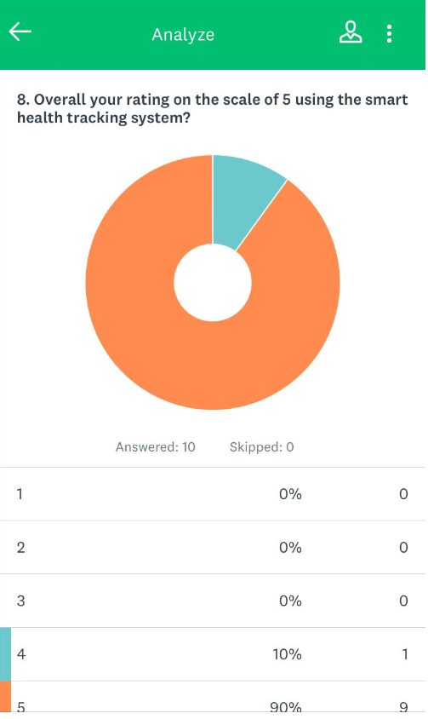

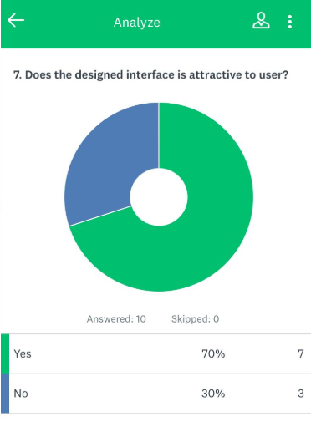

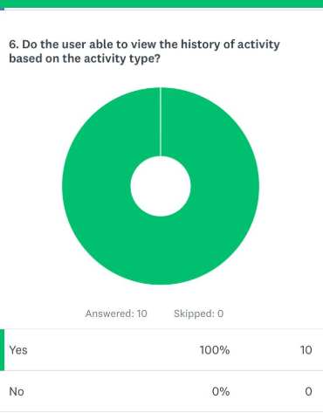

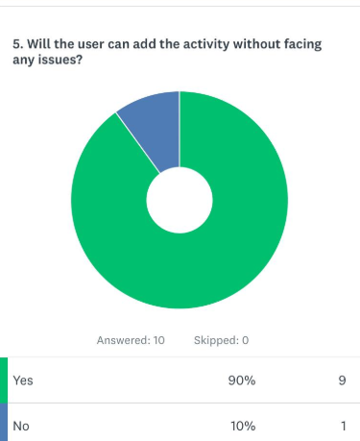

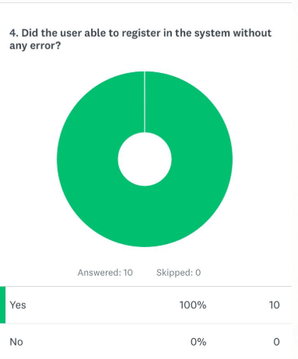

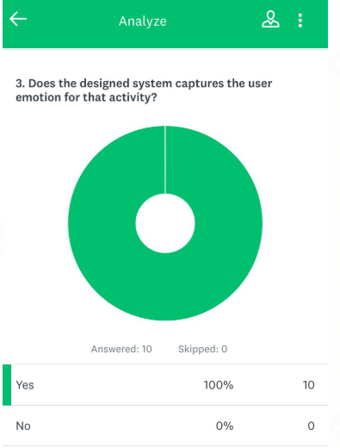

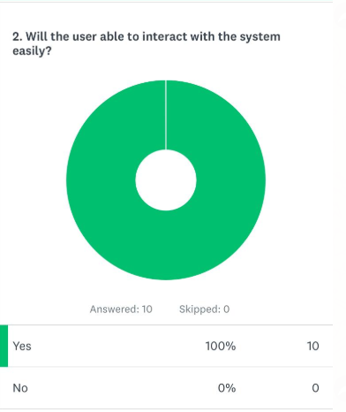

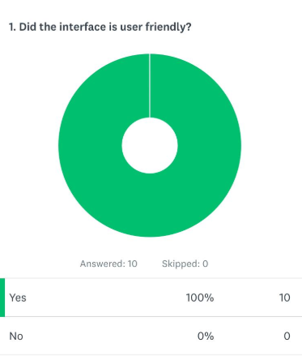

*Graphical representation of overall rating of the interface system*

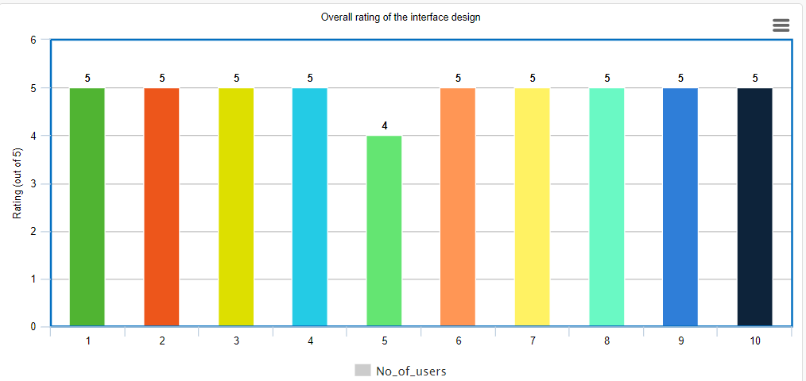

1. **CONCLUSION**

Based on the collected data for evaluating the interface design of the system, will further implement all those changes in the designed interface system and will make the interface system more attractive to the members who going to use the smart health tracking system. The report gave me 4.5 out of 5 for the overall rating of my product which was evaluated by 10 different people.