Article
What the Black Box Reveals: Geometry Leakage and Over-Redaction in Template-Controlled Image Redaction
Neer Vasa
Independent Researcher, Melbourne, Australia; Neervasa00000@gmail.com
Correspondence: Neervasa00000@gmail.com
Abstract: Solid black boxes hide the pixels of redacted text, but their size and position remain visible. Using 3.76 million synthetic redactions in a template-controlled, known-layout setting, this paper measures on the same boxes how much box geometry reveals and how much area each masking policy blacks out. An attacker who knew the font, text start and surname list placed the hidden surname in its top ten guesses 50.2% of the time for an exact box, against 5.932% with no box. Square grids, which need no knowledge of the text, reduced this slowly at a high area cost, and differently aligned copies added leakage. Padding needs more knowledge. Given the text start, baseline, line bounds and a class width, it is exactly a start-anchored width-only grid, and with a known list a fixed field box covering the widest entry is never larger than a zero-leakage class; both facts follow from the definitions. What we measure is the gap: on 1,000 surnames, the field box leaked 0 bits at about 0.78 times the area of the smallest zero-leakage class. Bits are averages over people, so a class narrower than the widest name can expose the few long names beyond it. On mock forms, padding’s hit rates were consistent with the no-box rate, but padding lost protection when releases were jittered or re-rendered. All values are the best case for a geometry-only, matched-renderer attacker under the stated prior and candidate list; a context attacker can learn more.
Keywords: redaction; image privacy; information leakage; side channel; verifiable redaction; document security; privacy–utility trade-off; padding

1. Introduction
Court rules require personal identifiers to be removed before filing [1], and the DICOM standard requires burned-in text to be removed from the pixels [2]. Blurred and mosaicked text can be recovered [3] and blurred faces re-identified [4,5], so practice has settled on the solid black box.
A solid box hides its pixels, but not its geometry: its position, width and height. This leak is old. Lopresti and Spitz showed in 2004 that the width of a redacted word narrows the candidates, and in 2005 proposed constant-size boxes against it [6,7]. Bland et al. broke PDF redactions through glyph positions and estimated raster widths [8]; JPEG residue near a box is another channel [9].
Many systems do not draw exact boxes. Tools that let a third party verify a redacted image sign it in square blocks of pixels, called tiles, and black out only whole tiles [10–14]. Rounding each box outward to the grid is snapping. Snapping hides fine geometry but blacks out more than was asked for (over-redaction). They prove that hidden pixels stay hidden but treat the box itself as public [15].
Our intended setting is template-controlled, known-layout redaction: born-digital documents, generated images and forms whose template gives each field’s position. We ask: RQ1, how much does a box’s geometry reveal, to attackers with more or less knowledge? RQ2, how do grids and padding trade that leak against area, and how does it add up over releases? RQ3, what do real redaction boxes look like?
This paper does not claim a new width attack, constant-size-box defence or cryptographic construction [7,8], and its conceptual advance is modest. Its contribution is a controlled, paired measurement of the leakage–area trade-off in a template-controlled, known-layout setting (scope: Box 1): on the same targets and positions, it measures both the information leaked by a published box and the additional area blacked out by each policy. It covers exact boxes, square grids, full-line width-only grids and repeated releases, which need no knowledge of the text, then padding, which does, and mock forms. Two padding results are analytic, not empirical (Propositions 1 and 2, Section 3.3); what we measure are the gaps and the trade-off curves. The central question is how much privacy a policy buys for the area it removes from the page.
We modelled snapping on TileSeal, an open tool for signed, redactable images [16–18].

Box 1. Scope and non-goals
This study measures leakage from the geometry of a published redaction box: its width, height and position. It does not measure residual information in surrounding pixels, compression artefacts, metadata or document context.
The main experiments use single-line Latin text in six fonts at three primary sizes, against matched-renderer attackers that know the rendering software, font, size, candidate list and prior.
Not evaluated: automatic detection of these coordinates in scanned documents, recovery of hidden text from real documents, incomplete candidate lists, multi-line text, non-Latin scripts and the cryptographic properties of verifiable-redaction systems. Results are the best case for a geometry-only, matched-renderer attacker under the stated prior and list, given ideal template knowledge; a context attacker can learn more (Section 4.5). No font, renderer build or text list was held out.

2. Related Work

2.1. Attacks and Defences
Lopresti and Spitz computed string widths from font metrics: for country names and members of Congress, one width matched only 1.3 to 2.9 strings on average [6,7], and their follow-up listed constant-size boxes as a countermeasure without measuring it [7]. Bland et al. attacked PDF files, where glyph positions survive redaction [8]; in a raster estimate on 10 names in one font they found about 11 bits from the exact width and about 8 bits at 300 DPI (a lower bound); their defences are glyph-shift discretisation, layout obfuscation, redacting adjacent words or the whole line, adversarial redactions and rasterisation, and “quantization” appears only in their raster-DPI experiment, so we credit constant-size boxes to Lopresti and Spitz alone. Ho and Chang set box size aside [9].
Table 1. Setting, threat model and measurements of the closest studies, as reported in each cited paper.
Study | Setting | Threat model | What was measured
Lopresti and Spitz [6,7] | Scans; font metrics | Width vs word list | Strings per width; boxes proposed
Ho and Chang [9] | JPEG; wavelet | Residue near the box | Residue; box size set aside
Bland et al. [8] | PDF; raster estimate | PDF glyph positions | PDF attack; raster bits
Verifiable redaction [14,15,19,20] | Signed or ZK images | Box treated as public | Hidden-pixel security
Context attacks [21–23] | Text | Language model, context | Span recovery
This study | Raster lines; forms | Geometry; matched renderer | Bits, top-10, area; releases

Table 1 positions this study: we quantify what earlier work proposed but did not measure [6–8], the joint effect of box height, origin, policy, area cost and repeated releases on geometry leakage.
Other attacks use context. RedactBuster predicts a redacted entity’s type from its sentence [21]. Charpentier and Lison recovered up to 80% of de-identified spans with a language model and background knowledge [22], and later strengthened such attacks through reasoning and aggregation [23]. Public tools automate the width attack [24,25], a PDF checker flags size leaks [26], rasterised bars in the Epstein PDFs revealed character counts [27], and LeakageBench measures redaction misses [28]. Length-hiding encryption [29] and region size in photo redaction [30] are related trade-offs.

2.2. Verifiable Redaction and Provenance
Redactable signatures let anyone remove parts of a signed message and keep the rest verifiable [16,17,31]; for images, this appears as signed tile hashes [10,11] and croppable JPEG signatures on 8-pixel blocks [12]. Zero-knowledge (ZK) proofs show that an image was edited correctly without revealing the original [15,19,32]. Ko et al. noted a trade-off between block size and the precision of the erasable area [14]; VIMz has a 32-pixel block-redaction circuit [13] and Trustless Provenance uses 10–80 px blocks [20]. ZK-IMG places output leakage outside its scope [15], and C2PA “redaction” removes metadata assertions [33]. None of these security definitions covers box geometry.

3. Materials and Methods

3.1. Threat Model and Attackers
A custodian releases an image in which a solid box covers some text. The requested box is the layout engine’s text box (Pillow’s getbbox) plus 1 px on each side; we call it the layout box. Its left edge is usually the text start (the pen position). The ink box hugs the inked pixels plus 1 px. Every attacker knows the font, the size, the kind of text and its prior, and keeps the candidate set: the entries whose box would match the published box. These best-case attackers render candidates with the redactor’s software (matched renderer). Section 4.5 relaxes this. For padding, the redactor is given the text start and baseline (Section 1). Table 2 summarises the attackers.
Table 2. What each attacker knows besides the box. ✓ known; ✗ not known; – not used.
Attacker | Font, size, list and prior | Baseline | Text start | Copy offsets | Sentence
A1, start-known | ✓ | ✓ | ✓ | – | ✗
A2, width-only | ✓ | ✓ | ✗ | – | ✗
A3, several copies | ✓ | ✓ | ✗ | ✓ | ✗
A4, language model | ✓ | ✓ | ✓ | – | ✓

A1 knows the text start and baseline, so a candidate must reproduce all four box edges; A2 knows only the baseline and keeps a candidate if any start reproduces the box. A3 holds k ∈ {1, 2, 3, 5} copies, each shifted by a random, known 0–63 px so that each snaps differently (k = 1 equals A2), with 8-, 16-, 32- and 64-px grids, on surnames and words in DejaVu Sans and Liberation Serif at 16 px (n = 4,000 per point). A4 ranks A1’s candidates with Qwen2.5-0.5B, with no retrieval or background knowledge, on 400 words from eight public-domain books; as a control, the model ranked the whole list with no box (“sentence alone”).

3.2. Text and Rendering
There were five kinds of hidden text, each with a prior. Surnames (12.88 bits): the 50,000 most common US surnames in the 2010 Census, weighted by count [34]; the tie at the 50,000th place (count 419) is broken by Census file order. Words (10.10 bits): wordfreq 3.1.1 [35], top_n_list("en", 60000), keeping alphabetic ASCII entries, first 20,000, weighted by word_frequency. E-mail addresses (15.61 bits): local parts built from the first 1,000 alphabetic Census surnames, bare or as “initial.surname” for 26 initials, with five weighted domains, giving 135,000 distinct strings. Digit strings of 4–10 digits (26.06 bits) and dates from 1940–2025 in two formats (15.94 bits).
Text was rendered black on white, on a single line, with Pillow in six fonts (DejaVu Sans and Serif; Liberation Sans, Serif and Mono; Noto Sans) at 12, 16 and 24 px. Surnames, words and e-mails were also rendered at 42 px, about 10-point text at 300 DPI, in three fonts, giving 99 text–font–size units. Start and baseline were drawn uniformly over the page. Images were clean, JPEG quality 75 or scan-like (small rotation, blur, noise and JPEG); degradation happens before redaction. The main sweep had 19 policy–condition cells (Table A1): 3,762,000 redactions and 7,652,000 result rows. A later sweep on the same targets added padding, width-only grids and the 128-px grid.

3.3. Redaction Policies
Grid snapping with grid size G rounds the requested box [x₀, x₁) × [y₀, y₁) outward to the grid:
[⌊x₀/G⌋G, ⌈x₁/G⌉G) × [⌊y₀/G⌋G, ⌈y₁/G⌉G) (1)
G = 1 is exact; G ∈ {8, 16, 32, 64, 128} covers tile schemes and 32-px ZK blocks. A width-only grid snaps only the side edges, at full line height. Jitter extends each side by a random 0–16 px before snapping.
Fixed-width padding rounds the width up to a multiple of a class width C and blacks out the full text line, from the font’s ascent to its descent plus 1 px. It is the constant-size idea of Lopresti and Spitz [7]. Edge-aligned padding keeps the requested box’s left edge. Start-aligned padding puts the left edge at a fixed offset from the text start, shared by every entry v in the field’s list D. With ℓ, r, t and b the edges of an entry’s requested box relative to the pen position p and baseline y_{b}, the published box for hidden text w is [x_{L}, x_{R}) × [y_{T}, y_{B}), with
x_{L} = p + min_{v∈D} ℓ(v) − 1, x_{R} = x_{L} + C⌈(p + r(w) − x_{L})/C⌉ (2)
y_{T} = y_{b} + min(−a_{f}, min_{v∈D} t(v)) − 1, y_{B} = y_{b} + max(d_{f}, max_{v∈D} b(v)) + 1 (3)
where a_{f} and d_{f} are the font’s ascent and descent. Every defence acts on the requested box, so no change to the signing tool is needed. Start-aligned padding is a form of length bucketing: for a fixed text start, baseline, full-line bounds and class width C, the published box is determined by the class index k(w) = ⌈(p + r(w) − x_{L})/C⌉ of the hidden entry, so its leakage to A1 is the entropy of that class index, H(k(W)), rather than a measure of variation within a class. Proposition 1. A start-anchored width-only grid (left edge x_{L} as in Equation (2), full-line height as in Equation (3), right edge rounded up to a multiple of G from x_{L}) with G = C publishes the same box as start-aligned padding for every w. Proof: both right edges are x_{L} + C⌈(p + r(w) − x_{L})/C⌉ = x_{L} + C·k(w), and the other edges are identical. Proposition 2. With a known list D, the fixed field box [x_{L}, p + max_{v∈D} r(v)) × [y_{T}, y_{B}) is the narrowest box with this left edge and height that covers every entry and is the same for all, so it leaks nothing; no zero-leak class box is smaller. Proof: a class leaks nothing only if k(v) is equal for all v ∈ D, so C·k ≥ p + max_{v} r(v) − x_{L}; rounding the field box’s right edge up to a multiple of C gives that class box. Section 4.8 checks Proposition 1 in software and measures the gap in Proposition 2.

Box 2. What the redactor must know
Grids need no knowledge of the text. Start-aligned padding assumes:
(a) the text start (pen position) and baseline of the field are known;
(b) the box covers the full line, from the font’s ascent to its descent;
(c) the field’s candidate list is bounded, because Equations (2) and (3) use its extreme edges;
(d) one class width per field; about eight times the text size kept each font’s average below 0.005 bits up to 24 px, but not each person: at every size one surname kept at most two candidates (Table 6). Only a class covering the widest entry protects everyone.
Every release must reuse the same mask, without jitter.

3.4. Measuring Leakage
Top-10 is how often the truth is among the attacker’s ten best guesses. Score ties are counted in expectation: a target tied with others of equal prior scores (k − number strictly ahead)/number tied, clipped to [0, 1], with k = 10. Area is the blacked-out area divided by the requested area, summarised by its median. The no-box rate is what the prior alone gives; for surnames it is exactly 5.932% (the sampled targets gave 5.95%). Bits leaked: each bit halves the number of equally likely candidates. The surname prior’s 12.88 bits are like choosing among about 7,500 equally likely names; a leak of 6.66 bits leaves about 75. These counts are for intuition only.
Formally, W is drawn from a prior p over D. After seeing box b, the attacker uses p(w | b) ∝ p(w) P(b | w), where P(b | w) is the share of uniform starts and jitter draws that turn w into b. For A1 without jitter, p(w | b) is the prior renormalised over the candidate set S(b). The uncertainty left is
H(W | b) = − Σ_{w∈S(b)} p(w | b) log₂ p(w | b) (4)
and over n targets drawn from the prior we report
bits leaked = H(W) − (1/n) Σ_{i=1}^{n} H(W | b_{i}) (5)
which estimates the mutual information I(W; B | K_{A}) under attacker A’s knowledge K_{A}. This is an average over people; a target in a rare wider class can be strongly disclosed even when the average is near zero (Section 4.9). On degraded images and for digit strings, attackers keep candidates within an edge tolerance calibrated on 400 separate strings per cell (the truth stayed in the set in at least 99.3% of cases); these are reported as top-10 or length accuracy, not bits.

3.5. Statistics
Each cell has 2,000 targets drawn from the prior with replacement; the same targets and positions are reused across policies and attackers, so comparisons are paired. Main results pool six fonts and three sizes (n = 36,000 per cell). The study plan was written on 29 October 2026, before the main run, but not publicly registered, so it is not relied on as preregistration. Paired sign-flip permutation tests (100,000 flips) give one-sided p-values, target bootstraps (10,000 resamples) give 95% confidence intervals (CIs), and Holm’s correction covers the 18 font–size cells (Appendix Table A5). Per-font values are in Table A6; A3, A4 and the forms use Wilson or item-paired bootstrap intervals.

3.6. Mock Forms and Real Boxes
Pillow forms: 100 one-page mock case records with invented content (case number, given name, surname, date of birth, e-mail and a Notes sentence repeating the surname), in DejaVu Sans and Liberation Serif at 16 px, with a random left margin. LibreOffice forms: 100 new forms converted to PDF by LibreOffice 25.2 and rasterised at 96 DPI, at 16 and 24 px, clean and after a simulated scan, attacked by A1 matched to LibreOffice or using our Pillow model. For start-aligned padding, the template gives the pen column (it matched the rounded surname start in 100 of 100 LibreOffice forms at each size; on scan-like forms it was mapped through the known rotation), and the padded box contained all inked pixels in all 400 LibreOffice observations.
Real boxes (RQ3): only the box annotations of the van Heusden et al. dataset, 11,351 redactions on 932 Dutch freedom-of-information pages at about 300 DPI [36,37], as a geometric calibration only.

3.7. Software and the Tool
Rendering used Pillow 12.3.0 with RAQM 0.10.5, HarfBuzz 14.2.1 and FreeType 2.14.3; the padding sweep used FriBidi 1.0.8 and reproduced all 432 published layout-box cells it repeated. Forms used LibreOffice 25.2.3.2 and Poppler 25.03.0. TileSeal [18] signs salted SHA-256 hashes of 64 × 64 tiles (or 8-, 16- or 32-px sub-tiles) with one Ed25519 signature; anyone can redact without a key, and box geometry is public. In all 392 test redactions, our snapping model predicted exactly which tiles TileSeal blacked out. Runs used TileSeal commit f8f2558, which has no padding option. TileSeal’s released pad_box performs a centred grow with a 32-px minimum height; it does not implement the start- or edge-aligned policies evaluated here.

4. Results
Unless stated otherwise, results are for surnames, attacker A1, layout boxes and clean images.

4.1. How Much Does an Exact Box Reveal? (RQ1)
What we found. A lot. With an exact box, A1 put the hidden surname in its top ten 50.2% of the time, against 5.932% with no box (Figure 1); for common words, 79.7% against 23.8%. In bits, exact boxes leaked 6.66 of 12.88 for surnames. Even digit strings, never guessed, leaked their length: the most likely length was right for 68.4% of 16-px boxes, against 14.3% with no box.
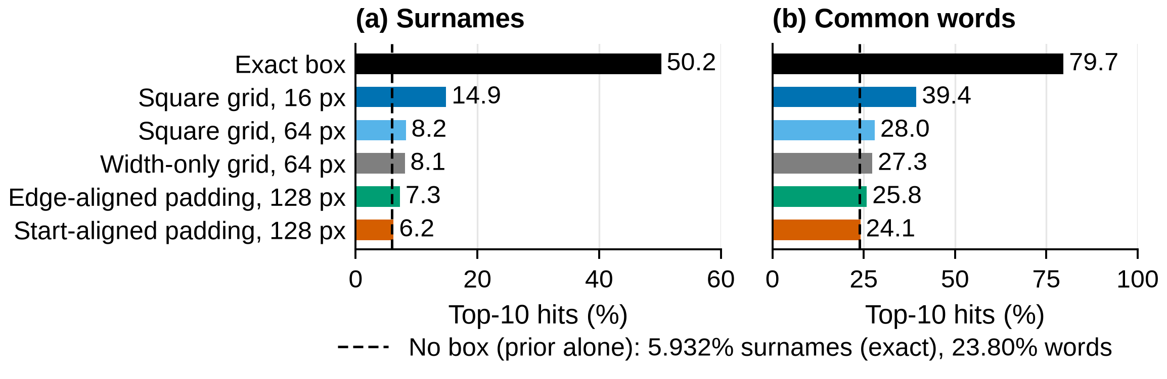
Figure 1. An exact box makes the hidden text far easier to guess. Top-10 hits under attacker A1 for (a) surnames and (b) common words, with frequency priors, clean synthetic lines, layout boxes (n = 36,000 per bar; six fonts, three sizes). Dashed line: the prior alone (no box). Lower is better.
What it means. The font matters (exact-box hits ranged from 30.2% in monospaced Liberation Mono to 61.1% in DejaVu Serif), and larger text leaks more (66.9% at 42 px). Scan-like images cut exact-box hits to 27.9% and 16-px hits from 14.9% to 12.9%, so image quality is not a defence.

4.2. Grids or Padding: Which Buys More Privacy per Area? (RQ2)
What we found. Grids reduce the leak slowly and at a high area cost: a 16-px grid still leaked 2.19 bits at 2.45× the area, and a 64-px grid 0.67 bits at 10.04× (Figure 2), because a tile is large compared with a line of text. Start-aligned 128-px padding leaked 0.08 bits on average at 3.36×, for either box model and for A1 and A2; by Proposition 1 this is class-width bucketing, and it matches the class entropy H(k(W)) (Table 3 note). Padding uses more field knowledge (text start, baseline, full-line bounds, class width), so this gap shows what that knowledge buys, not which mechanism leaks less (Table A5); Section 4.8 gives knowledge-matched baselines. The average hides a tail: surnames beyond the first class share a wider class with few others (Section 3.4); in some cells one surname is fully identified (Section 4.9).
What it means. The class must cover the field: most of the pooled 0.08 bits comes from 24-px text. Classes of about eight times the text size left at most 0.005 bits on average: the exact per-font means were at most 0.0041 bits (two 2,000-target samples gave 0.0124 and 0.0088). That average still hides people: at each size one surname kept at most two candidates (Section 4.9). Longer fields are harder: e-mails kept 0.73 bits even with a 256-px class at 24 px. Without the start, edge-aligned full-line padding on layout boxes or a width-only full-line grid with ink boxes is the measured fallback (Table 3).
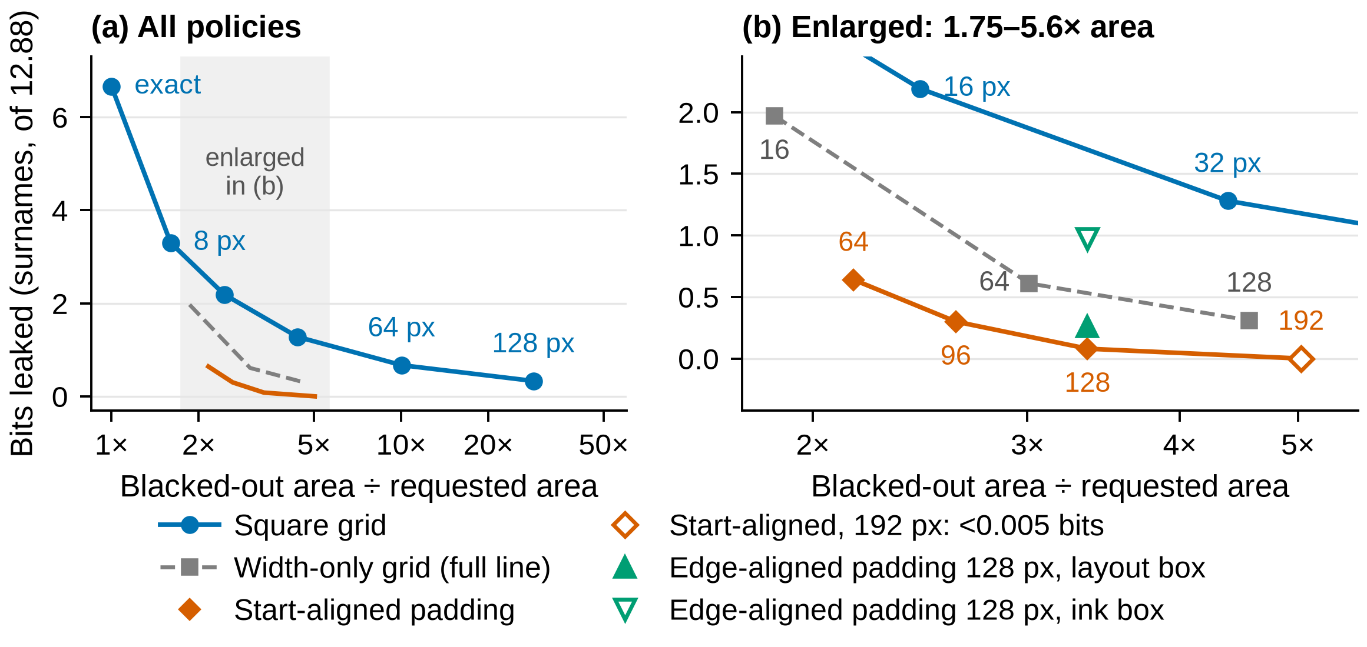
Figure 2. Geometry leakage against median over-redaction for surnames under A1, clean synthetic lines, layout boxes unless marked (n = 36,000 per policy; six fonts, three sizes); lower left is better. (a) All policies; (b) the shaded region enlarged, labelled by grid or class width in px. The 192-px class leaked below the 0.005-bit reporting threshold; its hollow marker at 0 marks position only. Padding uses more field knowledge: a knowledge trade-off, not a ranking (matched: Table 5).
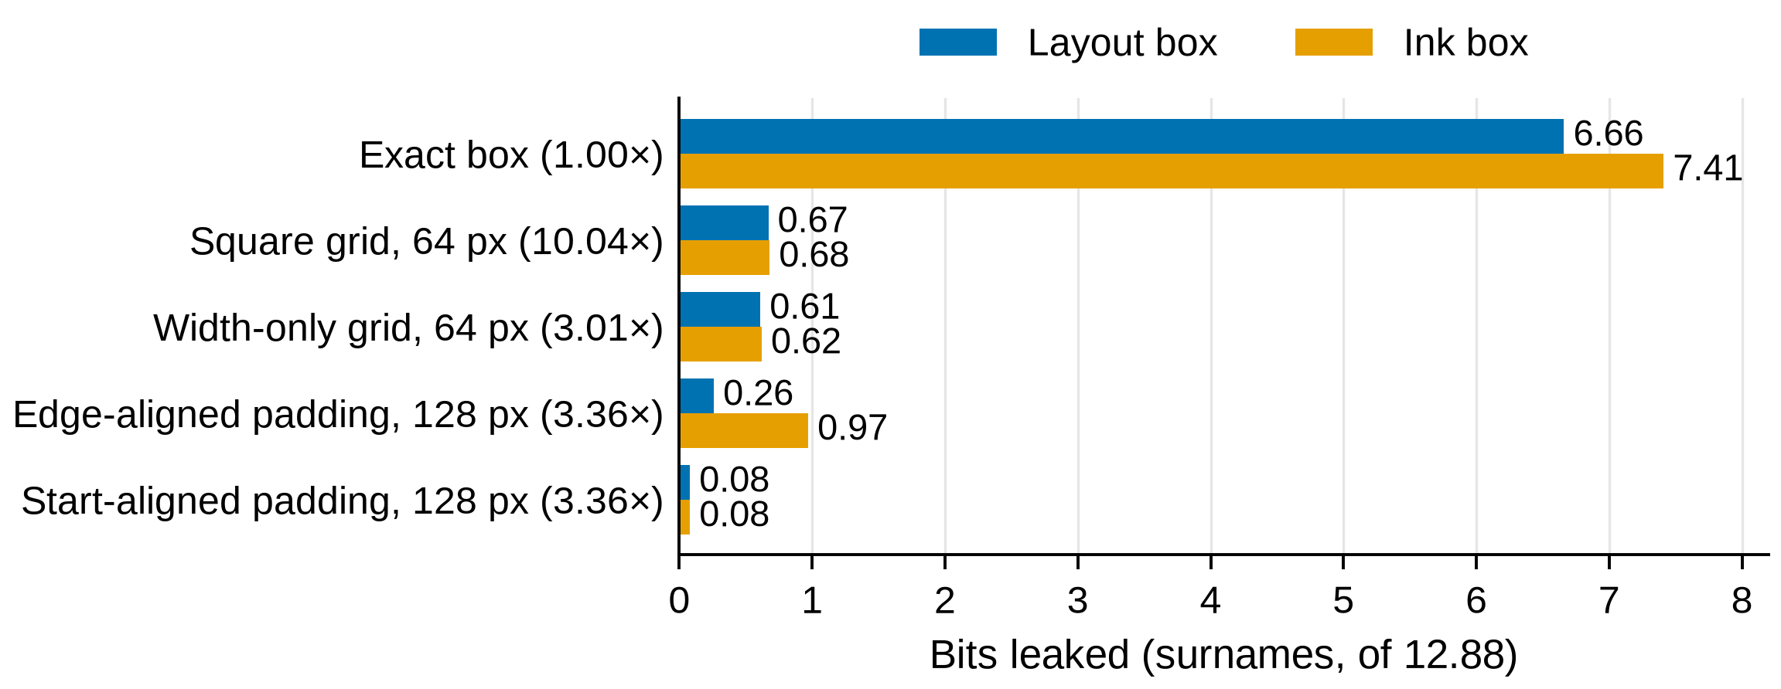
Figure 3. Covering the full line lowers the area cost, and a start-aligned edge removes the dependence on the box model. Surname bits leaked to A1, clean lines, layout and ink boxes (n = 36,000 per bar); area in parentheses.
Table 3. Summary of policies: what the redactor must know, bits leaked to A1 and area cost (clean synthetic lines, pooled over six fonts and three sizes; n = 36,000 per cell). Bits are for layout / ink boxes; area is the median over-redaction with layout boxes. Knowledge-matched comparisons: Table 5.
 | Surnames (12.88 bits) |  | Words (10.10 bits)
Policy, grouped by what the redactor must know | Bits, layout / ink | Area | Bits, layout | Area
Requested box only
Exact box | 6.66 / 7.41 | 1.00× | 6.91 | 1.00×
Square grid, 16 px | 2.19 / – | 2.45× | 2.63 | 2.84×
Square grid, 64 px | 0.67 / 0.68 | 10.04× | 0.92 | 13.93×
Square grid, 128 px | 0.33 / 0.34 | 28.64× | 0.48 | 43.34×
Full-line bounds (edge-aligned padding also a field-wide class width)
Width-only grid, 64 px | 0.61 / 0.62 | 3.01× | 0.83 | 4.13×
Width-only grid, 128 px | 0.31 / 0.31 | 4.56× | 0.44 | 6.97×
Edge-aligned padding, 128 px | 0.26 / 0.97 | 3.36× | 0.24 | 5.69×
Edge-aligned padding, 192 px | 0.19 / 0.90 | 5.03× | 0.18 | 8.53×
Text start, baseline, full-line bounds and a field-wide class width
Start-aligned padding, 96 px | 0.30 / 0.29 | 2.62× | 0.20 | 4.27×
Start-aligned padding, 128 px | 0.08 / 0.08 | 3.36× | 0.06 | 5.69×
Start-aligned padding, 192 px | <0.005 / <0.005 | 5.03× | <0.005 | 8.53×
–: not reported for ink boxes. <0.005: printed as 0.00 at two decimals in the source; a rounded value on these lists, not a guarantee of zero leakage. Start-aligned 128 px by size: 0.000, 0.003 and 0.23 bits at 12, 16 and 24 px (exact, every surname weighted by its prior: 0, 0.0015 and 0.227; pooled 0.076 against 0.079 sampled, both 0.08); averages over targets (tail: Table 6). The 16-px grid’s 2.45× is the median over pooled targets; the median of the 18 per-cell medians is 2.65×, and it is 3.22× at 12 px against 1.99× at 24 px.

4.3. Which Parts of Padding Matter?
What we found. Two choices mattered (Figure 3). Covering the full line: the width-only 64-px grid leaked 0.61 bits at 3.01× the area, against 0.67 bits at 10.04× for the square 64-px grid. Aligning to the text start: with full-line 128-px padding, edge-aligned boxes leaked 0.26 bits with layout boxes but 0.97 with ink boxes, because an ink-hugging left edge reveals a coarse side-bearing class of the first letter (1–5 values per font and size), not the letter itself; start-aligned boxes leaked 0.08 bits with either box model.
What it means. Blacking out the full line gave similar leakage to square tiles of the same size at under a third of the area, and starting the box at the text start removed the ink-edge leak.

4.4. What Happens over Several Releases?
What we found. Grid copies add up; a fixed padded mask does not (Figure 4a). With a 16-px grid, A3’s surname hits rose from 11.5% with one copy to 22.0% with five (two fonts, 16 px). In bits, five 16-px copies gave A3 about as much as one 8-px copy gave A1 on this subset (3.30 against 3.09; not Table A2’s pooled 3.30): differently aligned releases add leakage, though grid and attacker differ. These A3 values come from a likelihood rescoring; its restored scorer reproduces all 128,000 archived A3 rows (Data Availability). Shifted padding copies (a sanity check) stayed at the no-box level; releases that change the box did leak (Figure 4b). For 24-px DejaVu Sans surnames under start-aligned padding, five copies of the canonical unjittered mask added nothing to its 0.285 bits, while five jittered releases reached 0.64 bits. Re-rendering in another font changed the 128-px class for 188 of 2,000 surnames (exploratory; raw file not archived) and raised a mixed-font 24-px sample from 0.22 bits after one release to 0.69 after five; edge-aligned padding rose from 0.38 to 1.30 bits (exploratory; raw file not archived). A 192-px class removed both effects (at most 0.01 bits).
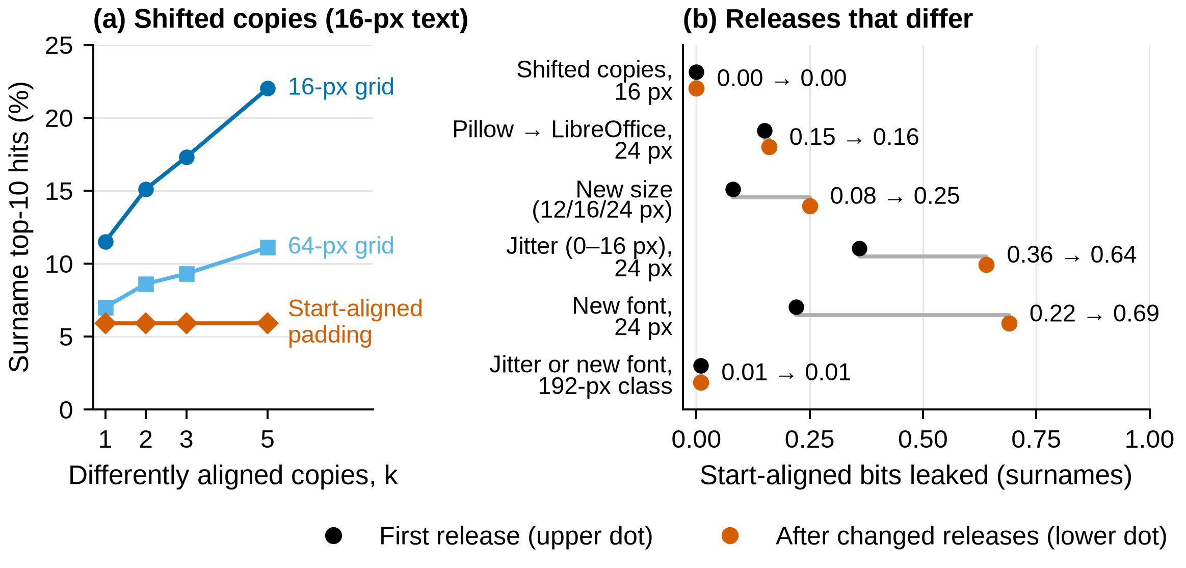
Figure 4. Grid copies add up; padding gained nothing from copies only while every release showed the same box. (a) A3 top-10 against the number of differently aligned copies (16-px text, DejaVu Sans and Liberation Serif; n = 4,000 per point); edge-aligned padding gave the same flat line as start-aligned. (b) Start-aligned surname bits after the first release (black; k = 1, jittered in the jitter row) and after the changed releases (orange; k = 5 for jitter and font). A1 and layout boxes, except the renderer row (A2, ink boxes) and new-size row (A2); n = 2,000 per row; 128-px class unless marked.
What it means. Reusing one canonical mask without jitter avoided the increase seen with differently aligned grid copies; a re-rendered release needs a class covering its widest rendering.

4.5. How Much Does the Attacker Need to Know?
What we found. Each piece of knowledge was removed in turn (Figure 5; six fonts at 16 px, clean, 500 targets per font). Not knowing the font cut exact-box hits only from 48.6% to 38.2%. A uniform prior cut them to 5.7%. An independently sourced prior (each surname’s frequency as an English word) cut exact-box hits on the published 16-px targets from 48.3% to 21.2% (exploratory; prior file not archived). On LibreOffice forms a Pillow-model attacker found 0 of the 63 surnames that the matched attacker b_lo_table found among 100, as the renderers’ ink boxes differ by up to 3 px per edge; recalibrating its tolerance restored 31 of 100 (exploratory; raw file not archived). With this calibrated attacker, padding stayed below the 16-px grid in every LibreOffice cell, so the form conclusions do not change.
The language model (A4) found 97.0% of words with exact boxes and 49.8% at 64 px, but the sentence alone gave 44.8% (exploratory), so the 64-px box added only 5.0 points; edge-aligned 128-px padding added at most 0.25 points to its own sentence-alone baseline (exploratory; Table A4).
What it means. Top-10 describes the box and the prior together; bits describe what the geometry gives up (under the true prior, exact-box leakage remained 6.48 bits in the 16-px setting, a six-font mean on published targets; exploratory). A wrong renderer is not reliable protection: recalibration restored part of the attack (exploratory).
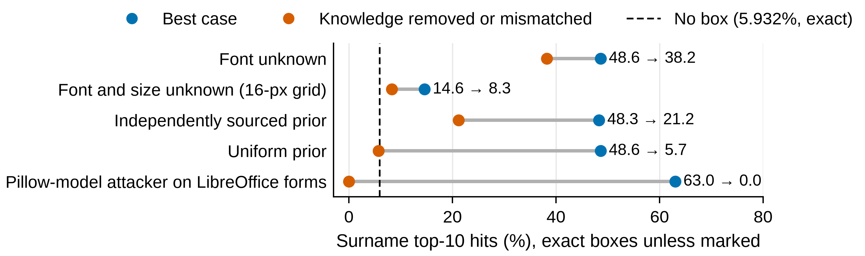
Figure 5. A weaker attacker finds less, but the box still leaks unless the attacker’s prior or renderer is wrong. Surname top-10 for A1 (blue; full knowledge) and with one piece of knowledge removed or mismatched (orange); clean lines (six fonts at 16 px, 500 targets each) or LibreOffice forms (100); exact boxes unless marked. Dashed line: no box (5.932% synthetic, exact; 6% LibreOffice). Independently sourced prior: exploratory.

4.6. Validation on Template-Controlled Mock Forms
What we found. When the form template supplies each field’s text start and baseline, start-aligned padding’s hit rates were consistent with the no-box rate (Figure 6; Table A3; 100 forms per condition). On Pillow forms, exact boxes found 52.0% of surnames and padding 7.0%, the no-box rate. On LibreOffice forms, start-aligned padding stayed at 6–8% in every cell, against a no-box rate of 6%. It was numerically below the 16-px grid in every reported cell (by 4 to 13 points on LibreOffice forms), but the differences rest on 3–13 discordant forms of 100 and the Pillow A2 interval includes zero (Table A3). On clean forms the 64-px grid matched it within 1 point but blacked out 4.4–5.6 times as much area.
What it means. The forms are consistent with the synthetic result on whole pages, but cannot show protection for each person. Coarse boxes also hide visible text: on Pillow forms, 16-px boxes cut into a neighbouring word on 94% of forms and 64-px boxes hid 14.7% of visible words (not measured for start-aligned padding).
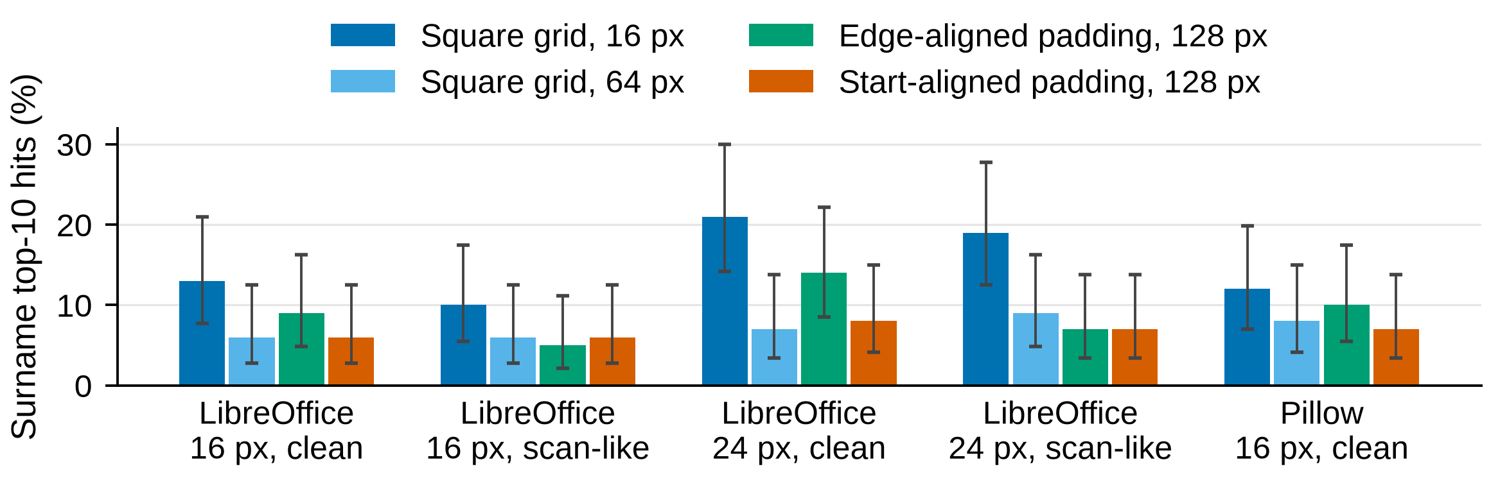
Figure 6. On template-controlled mock forms (coordinates supplied by the template), start-aligned padding’s hit rates are consistent with the no-box rate on both renderers, clean or scanned. Surname top-10 (100 forms per bar; Wilson 95% intervals; template layout boxes); LibreOffice: matched attacker b_lo_table; Pillow: A1. No box: 6% (LibreOffice), 7% (Pillow).

4.7. What Do Real Boxes Look Like? (RQ3)
What we found. Real boxes are larger than our test text (Table 4). Their median width was 228 px and median height 49 px, and their widths had 9.35 bits of entropy over 1,433 values. Snapping to 64 px cut this to 3.67 bits at a median over-redaction of 2.95×. No recovery was attempted.
Table 4. Geometry of 11,351 real redactions on 932 freedom-of-information pages. H: entropy of box geometry, in bits (not leakage about hidden text). Area: median over-redaction (90th percentile). Grids in annotation-image pixels at about 300 DPI (8–64 px = 0.68–5.42 mm), not comparable with the grids of Tables 3 and A2 (text at 12–24 px).
Grid | Distinct widths | H(width) | H(width, height) | Area
Exact | 1,433 | 9.35 | 12.76 | –
8 px | 279 | 6.58 | 9.18 | 1.18× (1.33×)
16 px | 149 | 5.60 | 7.53 | 1.40× (1.72×)
32 px | 79 | 4.62 | 6.04 | 1.87× (2.62×)
64 px | 40 | 3.67 | 4.79 | 2.95× (4.98×)
Annotations: 3,914 solid black, 3,242 grey, 2,535 bordered, 1,660 coloured; all are included because the table measures box geometry, not pixel recovery.

4.8. Knowledge-Matched Baselines (Follow-Up Sweep)
Design. A follow-up sweep re-rendered and re-attacked a 1,000-surname list in the six fonts at 12, 16 and 24 px (Table 5; same draws for every policy): square grids, start-aligned padding, the start-anchored grid with G = C (C = 32–256 px) and the fixed field box of Proposition 2, from x_{L} to the widest right edge of any entry’s layout box (which includes its 1-px margin), not rounded to a multiple of C.
What we found. As a software consistency check of Proposition 1, padding and the start-anchored grid gave identical boxes (0 differences over 288,000 target and 144,000 candidate boxes; one row in Table 5), and their leakage matched the analytic H(k(W)). Leakage fell to 0 bits at C ≥ 96, 128 and 192 px for 12, 16 and 24 px text (Figure 7a). The measured result is the size of the gap in Proposition 2: the field box needed 0.78, 0.79 and 0.78 times the median area of the smallest zero-leak class at 12, 16 and 24 px (Table 5; Figure 7b). Smaller classes cost less area but leak (C = 96: 0.266 bits at 2.67× pooled), and square grids leaked 0.44–2.65 bits at every size.
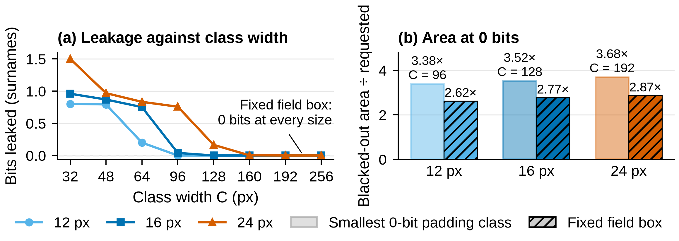
Figure 7. With the same template knowledge, the fixed field box reaches 0 bits at about 0.78 times the area of the smallest 0-bit padding class (direction: Proposition 2; Table 5; n = 12,000 per size). (a) Bits leaked by padding (= start-anchored grid, G = C) by class width; lines coincide at 0. (b) Median area of the smallest 0-bit padding class (light) and of the field box (hatched).
Table 5. Knowledge-matched baselines: bits leaked to A1 / median area on the first 1,000 alphabetic Census surname rows (file order, Census-count prior; clean, layout boxes; 2,000 targets per font–size cell, n = 12,000 per size, 36,000 pooled). Padding and the field box use the same template knowledge. Identical padding and start-anchored grid values check Proposition 1.
Policy | 12 px | 16 px | 24 px | Pooled | Top-10 (%)
Square grid, 16 px | 1.66 / 3.26× | 2.00 / 2.69× | 2.65 / 2.00× | 2.10 / 2.47× | 29.7
Square grid, 64 px | 0.44 / 14.63× | 0.58 / 10.45× | 0.86 / 6.43× | 0.63 / 10.24× | 16.8
Padding = start-anchored grid, C = 64 | 0.200 / 2.29× | 0.752 / 2.09× | 0.834 / 2.19× | 0.595 / 2.19× | 16.3
Padding = start-anchored grid, C = 128 | 0 / 4.50× | 0 / 3.52× | 0.165 / 2.50× | 0.055 / 3.44× | 12.5
Padding = start-anchored grid, C = 192 | 0 / 6.76× | 0 / 5.27× | 0 / 3.68× | 0 / 5.16× | 12.0
Fixed field box | 0 / 2.62× | 0 / 2.77× | 0 / 2.87× | 0 / 2.75× | 12.0
0 is exact, not rounded. Analytic H(k(W)) at C = 128: 0, 0 and 0.176 (pooled 0.059; measured 95% CI [0.051, 0.059]). Square-grid values differ from Table 3 because the list differs. Field box ÷ smallest 0-bit class (C = 96, 128, 192), median area: 0.78, 0.79 and 0.78 at 12, 16 and 24 px. Per-person (tail) leakage on the 50,000-name list: Table 6.
What it means. Padding adds nothing beyond anchoring at the text start, full-line height and class-width bucketing (Proposition 1). With that knowledge and a known list, the field box is never larger than a zero-leak class (Proposition 2); here it saved about a fifth of the area. The field box grows with the widest entry, so with longer lists; it was not measured on the 50,000-name list, and these areas should not be extrapolated. The pooled 0.055 bits at C = 128 differs from the main 0.08 because the list differs (1,000 against 50,000 names); on the main list the same code reproduced 0.08 bits at 3.36× and the per-size values.

4.9. Per-Person (Tail) Leakage
What we found. Table 6 scores every surname of the 50,000-name list in every font–size cell, weighted by its prior (retained layout geometry; no new renders). At C ≥ 128 the averages are tiny: 0.076 bits at 128 px (0.079 sampled, Table 3; both 0.08). The worst case is not: in some cells one surname sits alone in the wider class and is fully identified, a pointwise leak of 18.60 bits (more than the 12.88-bit prior because the name is rare). This happened at every class width up to 192 px except 160 px, where the worst class still held 10 names; only C = 256 and the field box gave zero leakage for every person on this list. Such people are rare: at C = 128, surnames left with fewer than 100 candidates carry 0.0037% of the prior mass. Exact boxes left 7.575% of an archived 16-px subset with fewer than 100 candidates (Table 6 note).
Table 6. Per-person leakage of padding on the 50,000-surname list (A1, layout boxes, every surname weighted by its prior). Mean and min-entropy leakage (bits) and prior mass left with fewer than 100 / 10 candidates, averaged over 18 font–size cells; largest pointwise leak in any font, with the names in that class.
Policy | Mean bits | Min-entropy | Mass <100 / <10 (%) | Largest pointwise leak, bits (names in class)
 |  |  |  | 12 px | 16 px | 24 px
Start-aligned, C = 64 | 0.645 | 0.639 | 0.0072 / 0.0004 | 8.04 (546) | 18.60 (1) | 18.60 (1)
Start-aligned, C = 96 | 0.296 | 0.307 | 0.0077 / 0.0002 | 17.77 (2) | 11.23 (100) | 18.60 (1)
Start-aligned, C = 128 | 0.076 | 0.116 | 0.0037 / 0.0002 | 0 | 18.60 (1) | 8.76 (458)
Start-aligned, C = 160 | 0.0058 | 0.0070 | 0.0023 / 0 | 0 | 0 | 14.56 (10)
Start-aligned, C = 192 | 0.0005 | 0.0005 | 0.0036 / 0.0002 | 0 | 0 | 18.60 (1)
Start-aligned, C = 256 | 0 | 0 | 0 / 0 | 0 | 0 | 0
Fixed field box | 0 | 0 | 0 / 0 | 0 | 0 | 0
18.60: one surname alone in its class, fully identified (Liberation Sans). Min-entropy: gain in the chance that one best guess is right. Archived 16-px subset (4,000 sampled targets), share with < 100 / < 10 candidates: exact 7.575% / 1.000%, 16-px grid 0.175% / 0.025%, 64-px grid 0.025% / 0%.
Coordinate errors. Table 6 was rescored with wrong coordinates (run_perturb.py; layout bounds re-measured on the study renderer, no renders; zero-error cells matched Table 6): a start error drawn per instance, uniform on −4…+4 or −2…+2 px; baseline or line bounds off by ±2 px; or a class width off by ±8 px; the attacker knew the true template start x_{L} and the error distribution. At C = 128 the pooled mean moved from 0.076 to 0.073–0.076 bits; at C = 192 it stayed below 0.001. Baseline and line-bound errors changed nothing, because every surname’s box has the same height. The tail stayed: at C = 128 and 192 one surname was still fully identified under start errors (18.60 bits; 15.22 and 15.77 with the width error); at 24 px, C = 128, the worst class rose from 8.76 to 9.31 bits (start ±4) and 9.88 (width ±8). C = 256 and the field box stayed at 0 under every error.

5. Discussion

5.1. What This Means for Redaction Tools
Scope. Verifiable-redaction schemes that publish a snapped box inherit the grid trade-off [12–14,20]. Given template knowledge and a known list, we recommend a class covering the widest entry, or the fixed field box, which is never larger (Proposition 2; about 0.78 times the area here). A narrower class protects the average, not each person: up to C = 192, one surname could still be fully identified (Table 6; what the results support: Table 7).
Table 7. What the results support, and what they do not (setting of Box 1).
Redactor knowledge | What the tested results support | What this paper does not show
Nothing beyond the requested box | Grids reduced leakage slowly, at a high area cost; leakage stayed nonzero | That a grid meets a target leakage level in general
Full-line bounds only | Full-line coverage cut area at similar leakage | Robustness to scans, changed releases or context
Text start, baseline, line bounds, class width | Padding = start-anchored grid (Prop. 1); field box ≤ any zero-leak class (Prop. 2; 0.78× here); narrower classes can expose one name, even with small coordinate errors (§4.9) | That the gap holds on longer lists, or that coordinates can be recovered
Several releases will be published | One reused canonical mask avoided the increase seen with grid copies | That mask reuse removes every channel

5.2. Comparison with Earlier Work
As Lopresti and Spitz found for Courier [6], the monospaced font leaked least; their constant-size boxes [7] are the idea behind our padding, which we compare with grids on the same boxes. Bland et al. estimated about 8 bits from widths at 300 DPI (ten names, one font) [8]; our exact-box surname estimate is 6.66 bits (six fonts, 12–24 px). As Orekondy et al. found for photos [30], region size trades privacy against utility.

5.3. Scope, Limitations, and What Was Not Tested
Limitations. Padding was tested only up to 24-px text, not at 42 px or at the 49-px median height of real boxes (about 300 DPI). The mock forms are synthetic (100 per condition, FreeType in both renderers); repeated releases were tested only on clean surnames and words at 16 and 24 px; the knowledge-matched sweep used one 1,000-surname list, clean images and A1. Results describe the six evaluated font builds (single-line Latin text, three sizes, matched renderers): other builds of the same fonts moved 2 of 36 cells by 4–9 points, and no held-out font was tested. Area is a proxy for utility: equal areas can hide very different amounts of readable text. An own-height variant is not reported, and nine secondary values are exploratory (Table A7); no headline result depends on them. Not tested: coordinate recovery from arbitrary scans; coordinate errors larger than those of Section 4.9; a third renderer; multi-line or non-Latin text; JPEG or scan-like single lines; incomplete lists; A4, or a model stronger than the 0.5B model on 400 words, against padding; and padding’s cost to neighbouring text (measured only for grids and edge-aligned padding). Each could weaken the padding result; small coordinate errors barely did (Section 4.9).

6. Conclusions
A black box hides the letters, but its geometry can still narrow the hidden text. Tile snapping reduced this leakage only gradually at a substantial area cost, full-line coverage lowered that cost at similar leakage, and differently aligned grid copies added leakage.
In the template-controlled, known-layout setting tested here, start-aligned full-line padding is by construction a start-anchored width-only grid: its low average leakage comes from knowing the text start, baseline, line bounds and class width. Averages hide the tail: up to a 192-px class one surname could be fully identified, also under small coordinate errors, so with a known list a redactor should use a class covering the widest entry, or the fixed field box, which is never larger (about 0.78 times the area on 1,000 surnames). On mock forms, padding’s hit rates were consistent with the no-box rate, but jittered or re-rendered releases leaked. All values are the best case for a geometry-only, matched-renderer attacker under the stated prior and candidate list (Box 1, Table 7).

Author Contributions: N.V. carried out the conceptualization, methodology, software, validation, analysis, data curation, writing and visualization. The author has read and agreed to the published version of the manuscript.
Funding: This research received no external funding.
Institutional Review Board Statement: Not applicable. The study involved no human participants; it uses synthetic text and public CC BY 4.0 box annotations only.
Informed Consent Statement: Not applicable.
Data Availability Statement: Code, archived CSVs, evidence inventory, number checks: https://github.com/neervasa00000000/Guard, tag v1.1-artifact (commit 51747fc). ./reproduce.sh and make all re-aggregate archived result CSVs into Figures 1–6 and Tables 3, 4 and A1–A6 (no re-rendering, candidate generation or re-attack); scripts/check_numbers.py checks them against expected_numbers.json, transcribed from manuscript version 8.5. Re-running e1_run.py needs the hash-checked fonts. Branch exp-v1.2 at commit deaef36 [AUTHOR TO PUSH] adds policies.py and run_v12.py (Section 4.8; Noto Sans geometry replayed from the retained layout run, as the pinned binary was unavailable, and verified against archived scores), run_tail.py (Table 6, from retained geometry; data in research/e1/data/v1_3) and the restored a3_exact.py, phase_exact.py, fetch_data.py and e1_validate_guard.py; commit bb9e483 on the same branch adds scripts/run_perturb.py (coordinate errors, Section 4.9; data in research/e1/data/v1_4). The restored A3 scorer reproduces all 128,000 archived A3 rows; make check reports 369 passed, 0 failed, 9 exploratory. Table A2’s A2 cells were not re-checked against phase_exact.py and remain exploratory. Not every raw observation of the 3.76-million-redaction sweep is included. Third-party data (Census surnames, Gutenberg texts, Qwen2.5-0.5B weights, redaction annotations) are fetched with SHA-256 checks; only derived box geometry from the CC BY 4.0 annotations is redistributed.
Conflicts of Interest: The author develops TileSeal, the open-source tool whose snapping is modelled and checked in this study. The author declares no other conflicts of interest.

Appendix A. Detailed Tables
Tables A1–A6 give the detailed values behind the main text; Table A7 is the evidence inventory.
Table A1. The 19 policy–condition cells of the main sweep (from e1_run.py). “Exact” is the 1-px grid.
Condition | Policy | Grid settings (px) | Cells
Clean | Exact and square grid | 1, 8, 16, 32, 64 | 5
JPEG quality 75 | Exact and square grid | 1, 8, 16, 32, 64 | 5
Scan-like | Exact and square grid | 1, 8, 16, 32, 64 | 5
Clean | Jitter 0–16 px per side, then snap | 1, 16 | 2
Clean | Edge-aligned 128-px class, full-line height, then snap | 1, 16 | 2
Units: 90 (five lists × six fonts × three sizes) + 9 at 42 px = 99; 99 × 19 × 2,000 = 3,762,000 redactions; A1, A2 and 128,000 A3 rows give 7,652,000 result rows (no-box baselines not counted).
Table A2. Leakage by grid, clean renders, six fonts × three sizes pooled (n = 36,000 per cell): top-10 (%), bits, and median over-redaction area on the same boxes.
 | Surnames (prior 12.88 bits) |  |  | Words (prior 10.10 bits)
Grid | Top-10 A1 / A2 | Bits A1 / A2 | Area | Top-10 A1 / A2 | Bits A1 / A2 | Area
Exact | 50.2 / 49.0 | 6.66 / 6.54 | 1.00× | 79.7 / 79.0 | 6.91 / 6.83 | 1.00×
8 px | 21.2 / 17.6 | 3.30 / 2.63 | 1.60× | 50.4 / 44.8 | 3.82 / 3.19 | 1.78×
16 px | 14.9 / 12.2 | 2.19 / 1.54 | 2.45× | 39.4 / 34.6 | 2.63 / 1.97 | 2.84×
32 px | 10.7 / 9.0 | 1.28 / 0.75 | 4.38× | 31.9 / 28.6 | 1.65 / 1.07 | 5.49×
64 px | 8.2 / 7.1 | 0.67 / 0.30 | 10.04× | 28.0 / 25.8 | 0.92 / 0.45 | 13.93×
No box | 5.932* | 0 | – | 23.80 | 0 | –
* Exact expected top-10 from the prior (sampled targets: 5.95%). A2: exact-likelihood rescoring over every sampled start (phase_exact.py, restored on exp-v1.2), not re-checked against the archive: exploratory.
Table A3. Start-aligned 128-px padding on mock forms: surname top-10 (%), 100 forms per row. Difference: 16-px grid minus padding (points; form-paired bootstrap 95% CI). Area: median over-redaction, start-aligned / 64-px grid.
Forms | Exact | 16-px grid | Start-aligned | Difference [CI] | Area, start / 64 px
LibreOffice, 16 px, clean | 63 | 13 | 6 | +7 [2, 12] | 3.36× / 17.64×
LibreOffice, 16 px, scan-like | 22 | 10 | 6 | +4 [1, 8] | 4.15× / 15.66×
LibreOffice, 24 px, clean | 73 | 21 | 8 | +13 [7, 20] | 2.47× / 10.78×
LibreOffice, 24 px, scan-like | 34 | 19 | 7 | +12 [6, 19] | 2.67× / 11.49×
LibreOffice, 16 px, clean, Pillow model | 0 | 12 | 6 | +6 [2, 11] | 3.36× / 17.64×
Pillow, 16 px, clean, A1 | 52 | 12 | 7 | +5 [1, 10] | 3.66× / 20.42×
Pillow, 16 px, clean, A2 | 51 | 10 | 7 | +3 [0, 7] | 3.66× / 20.42×
Top-10 only (calibrated edge tolerance, Section 3.4). LibreOffice rows: matched attacker b_lo_table unless marked; the calibrated b_lo_calibrated (exact 31 vs 63) is separate, not pooled. LibreOffice CIs cannot be re-bootstrapped from the archive. No box: 6% LibreOffice, 7% Pillow. Pillow scan-like forms not rescored.
Table A4. Sentence context: top-10 (%) on 400 words in real sentences (16 px, clean) with A1’s candidates ranked by the frequency prior or the language model (LM). Gain: LM with the box minus LM with no box (item-paired points, bootstrap 95% CI).
 | DejaVu Sans (main run) |  |  | Liberation Serif (follow-up run)
Grid | Prior | LM | Gain [CI] | Prior | LM | Gain [CI]
Exact | 58.5 | 97.0 | +52.3 [47.5, 57.3] | 51.3 | 96.0 | +51.3 [46.5, 56.3]
8 px | 7.5 | 80.3 | +35.5 [30.8, 40.3] | 6.0 | 75.8 | +31.0 [26.5, 35.5]
16 px | 3.5 | 70.8 | +26.0 [21.5, 30.3] | 1.6 | 66.3 | +21.5 [17.5, 25.8]
32 px | 0.8 | 58.8 | +14.0 [10.5, 17.5] | 0.5 | 56.5 | +11.8 [8.8, 15.0]
64 px | 0.0 | 49.8 | +5.0 [3.0, 7.3] | 0.0 | 50.0 | +5.3 [3.0, 7.5]
Edge-aligned pad 128 * | 0.25 | 45.25 | +0.25 [0.0, 0.75] | 0.0 | 45.0 | +0.0 [0.0, 0.0]
Sentence alone (LM, no box, same 400 items): top-10 44.8% [40.0, 49.6] (not recomputable: rank_lm_nobox missing for 300 of 400 items). * Later rerun, both fonts in one session (64-px cells: 49.5% in both). Edge-aligned rows use that rerun’s sentence-alone baseline, 180/400 (45.0%); other rows 179/400 (44.8%). Exploratory (raw file not archived): sentence-alone baselines, Liberation Serif (1.6% is not a multiple of 1/400), padding row.
Table A5. Paired tests (A1, layout boxes, clean). Holm: cells of 18 with p < 0.05 after Holm correction, earlier independent-proportion test → paired test. Δ: pooled difference in top-10 (first policy minus second, points) with target-bootstrap 95% CI. Padding rows: a knowledge trade-off, not a ranking (matched: Table 5).
 | Surnames |  |  | Words
Comparison | Holm, top-10 | Holm, bits | Δ top-10 [CI] | Holm, top-10 | Δ top-10 [CI]
Exact > 8 px | 18 → 18 | 18 | +29.0 [28.5, 29.4] | 18 → 18 | +29.3 [28.9, 29.8]
8 px > 16 px | 18 → 18 | 18 | +6.4 [6.1, 6.6] | 18 → 18 | +11.0 [10.6, 11.3]
16 px > 32 px | 18 → 18 | 18 | +4.2 [4.0, 4.4] | 18 → 18 | +7.5 [7.3, 7.8]
32 px > 64 px | 10 → 18 | 18 | +2.4 [2.3, 2.6] | 9 → 18 | +3.9 [3.7, 4.1]
64 px > edge-aligned 128 px | 2 → 9 | 17 | +1.0 [0.8, 1.1] | 3 → 12 | +2.2 [2.0, 2.4]
64 px > start-aligned 128 px | – → 18 | 18 | +2.0 [1.9, 2.2] | – → 18 | +3.9 [3.7, 4.1]
–: not tested before. Values before each arrow are exploratory (not archived). For words, bits held in 17 or 18 of 18 cells for every comparison, and every pooled p-value was at the smallest possible value, 1/100,001.
Table A6. Per-font results for surnames (A1, layout boxes, clean; three sizes pooled, n = 6,000 per font): top-10 (%) / bits leaked.
Font | Exact | 16-px grid | 64-px grid | Edge-aligned 128 | Start-aligned 128 | Width-only 64
DejaVu Sans | 56.7 / 7.32 | 15.8 / 2.29 | 9.2 / 0.73 | 9.3 / 0.48 | 7.0 / 0.10 | 9.0 / 0.67
DejaVu Serif | 61.1 / 7.70 | 15.2 / 2.32 | 7.7 / 0.72 | 8.4 / 0.64 | 6.1 / 0.13 | 7.5 / 0.66
Liberation Mono | 30.2 / 4.58 | 15.0 / 2.30 | 8.3 / 0.72 | 6.3 / 0.15 | 6.3 / 0.15 | 8.0 / 0.66
Liberation Sans | 47.5 / 6.44 | 13.9 / 2.02 | 8.0 / 0.60 | 5.7 / 0.03 | 5.7 / 0.03 | 7.8 / 0.57
Liberation Serif | 49.7 / 6.60 | 13.7 / 1.93 | 8.1 / 0.55 | 6.3 / 0.01 | 6.3 / 0.01 | 7.9 / 0.49
Noto Sans | 56.2 / 7.30 | 15.7 / 2.26 | 8.3 / 0.69 | 7.7 / 0.24 | 6.1 / 0.06 | 8.2 / 0.62
Pooled | 50.2 / 6.66 | 14.9 / 2.19 | 8.2 / 0.67 | 7.3 / 0.26 | 6.2 / 0.08 | 8.1 / 0.61
Area, pooled | 1.00× | 2.45× | 10.04× | 3.36× | 3.36× | 3.01×

Table A7. Evidence inventory, release tag v1.1-artifact (paths under research/e1/). Reproduced: re-aggregated from archived CSVs (no re-rendering) and checked by check_numbers.py. Re-run: re-rendered and re-attacked (run_v12.py). Re-scored: recomputed on exp-v1.2 from retained layout geometry, no renders. Exploratory: not archived or not re-checked; marked in the text.
Result | Archived input | Status
Table 3; Figures 2 and 3 | review4/pooled.csv | Reproduced
Tables 4 and A1 | data/foia_geometry_summary.csv; e1_run.py cell matrix | Reproduced
Table A2 A1 cells; Figure 1 | data/pooled_clean_dict_grid_attacker.csv; pooled.csv | Reproduced
Table A2 A2 cells | per_font.csv; phase_exact.py not re-checked | Exploratory
Table A3; Figure 6 | data/forms/start_policy_summary.csv; start_vs_grid16_paired.csv | Reproduced
Table A4, DejaVu exact and grids | cases/followup/e1_a4_cases.csv.gz | Reproduced
Table A4, Lib. Serif, 179/400, padding gain | a4_reproduction.csv not in repository | Exploratory
Table A5, Holm count and pooled Δ | data/paired_tests.csv | Reproduced
Table A5, value before Holm arrow | not a column in paired_tests.csv | Exploratory
Table A6 | data/per_font.csv; pooled.csv | Reproduced
Figure 4a, A3 11.5% to 22.0% | a3_cases.csv.gz; a3_exact.py (all 128,000 rows) | Re-scored
Figure 4b, jitter, unjittered mask, font change | data/results_summary.csv; per_font.csv | Reproduced
Figure 4b, edge-aligned 0.38 to 1.30 | no row in results_summary.csv | Exploratory
Figure 5, known, font unknown, uniform | cases/followup/test4_cases.csv.gz | Reproduced
Figure 5, word-frequency prior | s4_priors.csv not in repository | Exploratory
Figure 5, recalibrated 31/100 | not a row in the form summary | Exploratory
d2jit_pooled.csv; test4_fontcluster.csv | cases/followup/d2jit_cases.csv.gz; test4_cases.csv.gz | Reproduced
Re-render, 188/2,000 (s2_rerender.csv) | raw file absent; count in results_summary.csv | Exploratory
Own-height cells (w1_pooled.csv) | not implemented; not reported | Exploratory
Form pages | PDFs and scans not in repository | Exploratory
Table 5; Figure 7 | v1_2/summary.csv; run_v12.py (exp-v1.2) | Re-run
Table 6; Section 4.9, coordinate errors | data/v1_3/tail_summary.csv, run_tail.py; data/v1_4/summary.csv, run_perturb.py (exp-v1.2) | Re-scored

References
1. United States Courts. Federal Rules of Civil Procedure, Rule 5.2: Privacy Protection for Filings Made with the Court. Available online: https://www.law.cornell.edu/rules/frcp/rule_5.2 (accessed on 10 November 2026).
2. NEMA. DICOM PS3.15 Annex E.3: Basic Application Level Confidentiality Options (Clean Pixel Data Option). Available online: https://dicom.nema.org/medical/dicom/current/output/chtml/part15/sect_E.3.html (accessed on 10 November 2026).
3. Hill, S.; Zhou, Z.; Saul, L.; Shacham, H. On the (In)effectiveness of Mosaicing and Blurring as Tools for Document Redaction. Proc. Priv. Enhancing Technol. 2016, 2016, 403–417. https://doi.org/10.1515/popets-2016-0047.
4. Todt, J.; Hanisch, S.; Strufe, T. Fantômas: Understanding Face Anonymization Reversibility. Proc. Priv. Enhancing Technol. 2024, 2024, 24–43. https://doi.org/10.56553/popets-2024-0105.
5. Zhai, H.; Wang, S.; Naghavi, P.; Hao, Q.; Wang, G. Revelio: Blurred Images Can Still Disclose Your Identity. In Proceedings of the IEEE Symposium on Security and Privacy (SP), May 2026; pp. 3911–3929. https://doi.org/10.1109/SP63933.2026.00030.
6. Lopresti, D.; Spitz, A.L. Quantifying Information Leakage in Document Redaction. In Proceedings of the 1st ACM Workshop on Hardcopy Document Processing (HDP), November 2004; pp. 63–69. https://doi.org/10.1145/1031442.1031452.
7. Lopresti, D.; Spitz, A.L. Information Leakage Through Document Redaction: Attacks and Countermeasures. In Proceedings of SPIE 5676, Document Recognition and Retrieval XII, January 2005; pp. 183–190. https://doi.org/10.1117/12.589552.
8. Bland, M.; Iyer, A.; Levchenko, K. Story Beyond the Eye: Glyph Positions Break PDF Text Redaction. Proc. Priv. Enhancing Technol. 2023, 2023, 43–61. https://doi.org/10.56553/popets-2023-0069.
9. Ho, N.Z.-Y.; Chang, E.-C. Residual Information of Redacted Images Hidden in the Compression Artifacts. In Proceedings of Information Hiding (IH 2008); Lecture Notes in Computer Science; Springer: Berlin/Heidelberg, Germany, 2008; pp. 87–101. https://doi.org/10.1007/978-3-540-88961-8_7.
10. Hatano, Y.; Miyazaki, K.; Toyoshima, H. Digital Image Data Authenticity Assuring Method, and Digital Image Data Disclosure System. US Patent Application US 2006/0117183 A1, 2006.
11. Hughes, R.J. Review and Redaction-Tolerant Image Verification Using Cryptographic Methods. Sci. Glob. Secur. 2021, 29, 3–16. https://doi.org/10.1080/08929882.2021.1894810.
12. Perazzo, P.; Mattei, M.; Anastasi, G.; Avvenuti, M.; Dini, G.; Lettieri, G.; Vallati, C. JPEGs Just Got Snipped: Croppable Signatures Against Deepfake Images. In Proceedings of the International Joint Conference on Neural Networks (IJCNN), June 2025; pp. 1–6. https://doi.org/10.1109/IJCNN64981.2025.11227387.
13. zero-savvy. VIMz Source Code, Branch redact-block (Block-Redaction Circuit redact_step.circom, Commit 59e7669). GitHub Repository, 2025. Available online: https://github.com/zero-savvy/vimz/tree/redact-block (accessed on 10 November 2026).
14. Ko, H.; Lee, I.; Lee, S.; Kim, J.; Oh, H. Efficient Verifiable Image Redacting Based on zk-SNARKs. In Proceedings of the ACM Asia Conference on Computer and Communications Security (ASIA CCS), June 2021; pp. 213–226. https://doi.org/10.1145/3433210.3453110.
15. Kang, D.; Hashimoto, T.; Stoica, I.; Sun, Y. ZK-IMG: Attested Images via Zero-Knowledge Proofs to Fight Disinformation. arXiv 2022, arXiv:2211.04775. Available online: https://arxiv.org/abs/2211.04775 (accessed on 10 November 2026).
16. Steinfeld, R.; Bull, L.; Zheng, Y. Content Extraction Signatures. In Proceedings of Information Security and Cryptology (ICISC); Lecture Notes in Computer Science, Volume 2288; Springer, 2002; pp. 285–304. https://doi.org/10.1007/3-540-45861-1_22.
17. Johnson, R.; Molnar, D.; Song, D.; Wagner, D. Homomorphic Signature Schemes. In Proceedings of Topics in Cryptology (CT-RSA); Lecture Notes in Computer Science, Volume 2271; Springer, 2002; pp. 244–262. https://doi.org/10.1007/3-540-45760-7_17.
18. Vasa, N. TileSeal (Repository Name Guard): Offline-Verifiable Tile Redaction for Raster Images. GitHub Repository, 2026. Available online: https://github.com/neervasa00000000/Guard (accessed on 10 November 2026).
19. Dziembowski, S.; Ebrahimi, S.; Hassanizadeh, P. VIMz: Private Proofs of Image Manipulation Using Folding-Based zkSNARKs. Proc. Priv. Enhancing Technol. 2025, 2025, 344–362. https://doi.org/10.56553/popets-2025-0065.
20. Mikołajczyk, P.; Hassanizadeh, P.; Ebrahimi, S. Towards Trustless Provenance: A Privacy-Preserving Framework for On-Chain Media Verification. Cryptology ePrint Archive, Paper 2025/1024, 2025. Available online: https://eprint.iacr.org/2025/1024 (accessed on 10 November 2026).
21. Beltrame, M.; Conti, M.; Guglielmin, P.; Marchiori, F.; Orazi, G. RedactBuster: Entity Type Recognition from Redacted Documents. In Proceedings of the European Symposium on Research in Computer Security (ESORICS); Lecture Notes in Computer Science, Volume 14983; Springer, 2024; pp. 451–470. https://doi.org/10.1007/978-3-031-70890-9_23.
22. Charpentier, L.G.G.; Lison, P. Re-identification of De-identified Documents with Autoregressive Infilling. In Proceedings of the 63rd Annual Meeting of the Association for Computational Linguistics (Volume 1: Long Papers), July 2025; pp. 1192–1209. https://doi.org/10.18653/v1/2025.acl-long.60.
23. Charpentier, L.G.G.; Lison, P. Stronger Re-identification Attacks through Reasoning and Aggregation. arXiv 2025, arXiv:2510.09184. https://doi.org/10.48550/arXiv.2510.09184.
24. Gilbert, A. unredact: Recovering Redacted Text from Box Width, Font Metrics and Language-Model Ranking. Open-Source Software, GitHub, 2026. Available online: https://github.com/Alex-Gilbert/unredact (accessed on 10 November 2026).
25. KhoomeiK. deredact: Character-Count-Constrained LLM Decoding to Fill in Redacted Text. Open-Source Software, GitHub, 2024. Available online: https://github.com/KhoomeiK/deredact (accessed on 10 November 2026).
26. Phaselab. unredact: A PDF Redaction Checker. Open-Source Software, GitHub, 2026. Available online: https://github.com/phaselabinc/unredact (accessed on 10 November 2026).
27. Wyatt, P. A Case Study in PDF Forensics: The Epstein PDFs. PDF Association, December 2025. Available online: https://pdfa.org/a-case-study-in-pdf-forensics-the-epstein-pdfs (accessed on 10 November 2026).
28. Vijaya Kumar, V.P.; Venkatesh, S.; Yamshchikov, I.P. LeakageBench: Document-Level Leakage Risk for Redacting Personally Identifiable Information in Document Images. In Findings of the Association for Computational Linguistics: EMNLP 2026, October 2026; pp. 50519–50537. https://doi.org/10.18653/2026.findings-emnlp.2350.
29. Gellert, K.; Jager, T.; Lyu, L.; Neuschulten, T. On Fingerprinting Attacks and Length-Hiding Encryption. In Proceedings of Topics in Cryptology (CT-RSA 2022); Lecture Notes in Computer Science, Volume 13161; Springer, 2022; pp. 345–369. https://doi.org/10.1007/978-3-030-95312-6_15.
30. Orekondy, T.; Fritz, M.; Schiele, B. Connecting Pixels to Privacy and Utility: Automatic Redaction of Private Information in Images. In Proceedings of the IEEE Conference on Computer Vision and Pattern Recognition (CVPR), June 2018; pp. 8466–8475. https://doi.org/10.1109/CVPR.2018.00883.
31. Derler, D.; Pöhls, H.C.; Samelin, K.; Slamanig, D. A General Framework for Redactable Signatures and New Constructions. In Proceedings of Information Security and Cryptology (ICISC); Lecture Notes in Computer Science, Volume 9558; Springer, 2016; pp. 3–19. https://doi.org/10.1007/978-3-319-30840-1_1.
32. Datta, T.; Chen, B.; Boneh, D. VerITAS: Verifying Image Transformations at Scale. In Proceedings of the IEEE Symposium on Security and Privacy (SP), May 2025; pp. 4606–4623. https://doi.org/10.1109/SP61157.2025.00097.
33. Coalition for Content Provenance and Authenticity. C2PA Technical Specification, Version 2.4 (Section 6.8, Redaction of Assertions). April 2026. Available online: https://spec.c2pa.org/specifications/specifications/2.4/specs/C2PA_Specification.html (accessed on 10 November 2026).
34. U.S. Census Bureau. Frequently Occurring Surnames from the 2010 Census (names.zip). Available online: https://www2.census.gov/topics/genealogy/2010surnames/names.zip (accessed on 10 November 2026).
35. Speer, R. wordfreq: Access a Database of Word Frequencies, in Various Natural Languages. Python Package. Available online: https://github.com/rspeer/wordfreq (accessed on 10 November 2026).
36. van Heusden, R.; Meijer, K.; Marx, M. Redacted Text Detection Using Neural Image Segmentation Methods. Int. J. Doc. Anal. Recognit. 2025, 28, 597–607. https://doi.org/10.1007/s10032-025-00513-1.
37. van Heusden, R. Neural Image Segmentation for Redacted Text Detection Dataset. Zenodo (CC BY 4.0), March 2024. https://doi.org/10.5281/zenodo.10805206.

