Article
What the Black Box Reveals: Geometry Leakage and Over-Redaction in Template-Controlled Image Redaction
Neer Vasa
[Affiliation], Melbourne, Victoria, Australia; [Email]; ORCID [ORCID]
Correspondence: [Email]
Abstract: Solid black boxes hide the pixels of redacted text, but their size and position remain visible. Earlier work showed that box width can narrow the possible hidden text and proposed constant-size boxes. This paper measures, on the same boxes, how much raster box geometry reveals and how much area each masking policy blacks out, comparing exact boxes, square tile grids, width-only grids and padding in a template-controlled, known-layout setting. Across 3.76 million synthetic redactions in six fonts, a matched-renderer attacker who knew the font, the text start and the surname list placed the hidden surname among its top ten guesses 50.2% of the time for an exact box, against 5.95% with no box. A 16-pixel grid still left 2.19 bits at 2.45 times the requested area, and differently aligned grid copies increased leakage. Start-aligned full-line padding, a form of length bucketing that uses the text start, full-line bounds and a field-wide class width, gave the lowest measured leakage among the policies evaluated: 0.08 bits at 3.36 times the area, driven largely by 24-pixel text. This comparison is not information-matched. Padding stayed close to the no-box rate on template-controlled mock forms but lost protection when releases were jittered or re-rendered, and it was not tested on arbitrary scans or with perturbed coordinates. The study measures geometry leakage only.
Keywords: redaction; image privacy; information leakage; side channel; verifiable redaction; document security; privacy–utility trade-off; padding

1. Introduction
Court rules require personal identifiers to be removed before filing [1], and the DICOM standard requires burned-in text to be removed from the pixels [2]. Blurred and mosaicked text can be recovered [3] and blurred faces re-identified [4,5], so practice has settled on the solid black box.
A solid box hides its pixels, but not its geometry: its position, width and height. This leak is old. Lopresti and Spitz showed in 2004 that the width of a redacted word narrows the candidates, and in 2005 proposed constant-size boxes against it [6,7]. Bland et al. broke PDF redactions through glyph positions, gave a rough raster-width estimate and also proposed quantising widths [8]. JPEG residue near a box is a further raster channel [9].
Many systems do not draw exact boxes. Tools that let a third party verify a redacted image sign it in square blocks of pixels, called tiles, and black out only whole tiles [10–14]. They round each box outward to the tile grid, which we call snapping. Snapping hides fine geometry but blacks out more than was asked for (over-redaction). They prove that hidden pixels stay hidden but treat the box itself as public [15].
Our intended setting is template-controlled, known-layout redaction: born-digital documents, generated images and forms whose template gives each field’s position. Use on scanned documents, where the layout must first be found, is not evaluated. We ask: RQ1, how much does a box’s geometry reveal, to attackers with more or less knowledge? RQ2, how do grids and padding trade that leak against area, and how does it add up over releases? RQ3, what do real redaction boxes look like?
This paper does not claim a new width attack, a new constant-size-box defence or a new cryptographic construction [7,8]. Its contribution is a controlled, paired evaluation of redaction-box geometry: on the same targets and positions, it measures both the information leaked by a published box and the additional area blacked out by each policy. It covers exact boxes, square grids, width-only grids, two padding placements, which parts of padding matter, repeated releases and template-controlled mock forms. The central question is how much privacy a policy buys for the area it removes from the page.
We modelled snapping on TileSeal, an open tool for signed, redactable images built on a standard construction [16–18].

Box 1. Scope and non-goals
This study measures leakage from the geometry of a published redaction box: its width, height and position. It does not measure residual information in surrounding pixels, compression artefacts, metadata or document context.
The main experiments use single-line Latin text in six fonts at three primary sizes, against matched-renderer attackers that know the rendering software, font, size, candidate list and prior. Padding is evaluated only where the redactor knows the text start, baseline, full-line bounds and a field-wide class width.
Not evaluated: automatic detection of these coordinates in scanned documents, recovery of hidden text from real documents, incomplete candidate lists, multi-line text, non-Latin scripts and the cryptographic properties of verifiable-redaction systems. The results are a controlled measurement of geometry leakage and over-redaction, not a general-purpose redaction defence.

2. Related Work

2.1. Attacks and Defences
Lopresti and Spitz computed string widths from font metrics: for country names and members of Congress, one width matched only 1.3 to 2.9 strings on average [6,7], and their follow-up listed constant-size boxes as a countermeasure without measuring it [7]. Bland et al. attacked PDF files, where glyph positions survive redaction [8]; in a raster estimate on 10 names in one font they found about 11 bits from the exact width and about 8 bits at 300 DPI (a lower bound), and proposed quantising redactions to fixed widths. Ho and Chang set box size aside [9]; that channel is what we measure.
Table 1. What the closest studies measured about raster box geometry. ✓ measured; ✗ not measured; partly: measured in a limited setting. This table is the basis of the novelty claim.
Study | Medium | Width | Height, origin | Bits | Area cost | Releases | Pad vs grid | What it did not measure
Lopresti and Spitz [6,7] | Scans; font metrics | ✓ | ✗ | ✗ | ✗ | ✗ | ✗ | Bits; cost of proposed boxes
Ho and Chang [9] | JPEG, wavelet | ✗ | ✗ | ✗ | ✗ | ✗ | ✗ | Box geometry (set aside)
Bland et al. [8] | PDF; raster estimate | ✓ | ✗ | partly | ✗ | ✗ | ✗ | Raster height and origin; area; grids
Verifiable redaction [14,15,19,20] | Signed, ZK images | ✗ | ✗ | ✗ | ✗ | ✗ | ✗ | Geometry leak
Context attacks [21–23] | Text | ✗ | ✗ | ✗ | ✗ | ✗ | ✗ | Box geometry
This study | Raster images | ✓ | ✓ | ✓ | ✓ | ✓ | ✓ | Real-document recovery

Table 1 is the basis of our novelty claim. The contribution is not a new width attack or a new constant-size defence, and we do not claim fixed-width padding or the idea of hiding box geometry [6–8]. It is a controlled, paired evaluation of what earlier work proposed but did not quantify: the joint effect of box height, origin, policy, area cost and repeated releases on geometry leakage. This pairing changes the practical reading of the results: a policy that looks strong on leakage alone may black out a large part of the page, while a policy with a higher area cost may buy a much larger reduction in leakage. Every policy is scored on the same targets, positions and attackers.
Other attacks use context. RedactBuster predicts the type of a redacted entity from its sentence [21]. Charpentier and Lison recovered up to 80% of de-identified spans with a language model and background knowledge [22], and later strengthened such attacks through reasoning and aggregation [23]. Public tools automate the width attack [24,25]. A PDF checker flags size leaks [26], rasterised bars in the Epstein PDFs still revealed character counts [27], and LeakageBench measures what redaction tools miss [28]. Length-hiding padding for encrypted messages [29] and region size in photo redaction [30] are related trade-offs.

2.2. Verifiable Redaction and Provenance
Redactable signatures let anyone remove parts of a signed message and keep the rest verifiable [16,17,31]; for images, this appears as signed tile hashes [10,11] and croppable JPEG signatures on 8-pixel blocks [12]. Zero-knowledge (ZK) proofs show that an image was edited correctly without revealing the original [15,19,32]. Ko et al. noted a trade-off between block size and the precision of the erasable area [14]; VIMz has a 32-pixel block-redaction circuit [13] and Trustless Provenance uses 10–80 px blocks [20]. ZK-IMG places output leakage outside its scope [15], and C2PA “redaction” removes metadata assertions [33]. None of these security definitions covers box geometry.

3. Materials and Methods

3.1. Threat Model and Attackers
A custodian releases an image in which a solid box covers some text. The requested box is the layout engine’s text box (Pillow’s getbbox) plus 1 px on each side; we call it the layout box. Its left edge is usually the text start (the pen position). The ink box hugs the inked pixels plus 1 px. Every attacker knows the font, the size, the kind of text and its prior, and keeps the candidate set: the entries whose box would match the published box. These are best-case, matched-renderer attackers: they render candidates with the same software as the redactor. Section 4.5 relaxes this. The redactor works in the known-layout setting of Section 1: for padding, it is given the text start and baseline. The four attackers are summarised in Table 2.
Table 2. What each attacker knows besides the box. ✓ known; ✗ not known; – not used.
Attacker | Font, size, list and prior | Baseline | Text start | Copy offsets | Sentence
A1, start-known | ✓ | ✓ | ✓ | – | ✗
A2, width-only | ✓ | ✓ | ✗ | – | ✗
A3, several copies | ✓ | ✓ | ✗ | ✓ | ✗
A4, language model | ✓ | ✓ | ✓ | – | ✓

A1 knows the text start and baseline, so a candidate must reproduce all four box edges; A2 knows only the baseline and keeps a candidate if any start reproduces the box. A3 holds k ∈ {1, 2, 3, 5} copies, each shifted by a random, known 0–63 px so that each snaps differently (k = 1 equals A2), with 8-, 16-, 32- and 64-px grids (the four grid sizes of the 128,000 A3 rows), on surnames and words in DejaVu Sans and Liberation Serif at 16 px (n = 4,000 per point). A4 ranks A1’s candidates with Qwen2.5-0.5B, with no retrieval or background knowledge, on 400 words from eight public-domain books; as a control, the model ranked the whole list with no box (“sentence alone”).

3.2. Text and Rendering
There were five kinds of hidden text, each with a prior. Surnames (12.88 bits): the 50,000 most common US surnames in the 2010 Census, weighted by count [34]; the 50,000th place falls among names with count 419, and that tie is broken by Census file order. Words (10.10 bits): wordfreq 3.1.1 [35], top_n_list("en", 60000), keeping alphabetic ASCII entries, first 20,000, weighted by word_frequency. E-mail addresses (15.61 bits): local parts built from the first 1,000 alphabetic Census surnames, bare or as “initial.surname” for 26 initials, with five weighted domains, giving 135,000 distinct strings (construction in the release notes). Digit strings of 4–10 digits (26.06 bits) and dates from 1940–2025 in two formats (15.94 bits).
Text was rendered black on white, on a single line, with Pillow in six fonts (DejaVu Sans and Serif; Liberation Sans, Serif and Mono; Noto Sans) at 12, 16 and 24 px. Surnames, words and e-mails were also rendered at 42 px, about 10-point text at 300 DPI, in three fonts, giving 99 text–font–size units. Start and baseline were drawn uniformly over the page. Images were clean, JPEG quality 75 or scan-like (small rotation, blur, noise and JPEG); degradation happens before redaction. The main sweep had 19 policy–condition cells (Table A1): 3,762,000 redactions and 7,652,000 result rows. A later padding sweep on the same targets added start-aligned padding, width-only grids and the 128-px grid.

3.3. Redaction Policies
Grid snapping with grid size G rounds the requested box [x₀, x₁) × [y₀, y₁) outward to the grid:
[⌊x₀/G⌋G, ⌈x₁/G⌉G) × [⌊y₀/G⌋G, ⌈y₁/G⌉G) (1)
G = 1 is an exact tool; G ∈ {8, 16, 32, 64, 128} covers tile schemes, including 32-px ZK block circuits. A width-only grid snaps only the side edges and blacks out the full line height. Jitter extends each side by a random 0–16 px before snapping.
Fixed-width padding rounds the width up to a multiple of a class width C and blacks out the full text line, from the font’s ascent to its descent plus 1 px. It is the constant-size idea of earlier work [7,8]. Edge-aligned padding keeps the requested box’s left edge. Start-aligned padding puts the left edge at a fixed offset from the text start, shared by every entry v in the field’s list D. With ℓ, r, t and b the edges of an entry’s requested box relative to the pen position p and baseline y_{b}, the published box for hidden text w is [x_{L}, x_{R}) × [y_{T}, y_{B}), with
x_{L} = p + min_{v∈D} ℓ(v) − 1, x_{R} = x_{L} + C⌈(p + r(w) − x_{L})/C⌉ (2)
y_{T} = y_{b} + min(−a_{f}, min_{v∈D} t(v)) − 1, y_{B} = y_{b} + max(d_{f}, max_{v∈D} b(v)) + 1 (3)
where a_{f} and d_{f} are the font’s ascent and descent. Every defence acts on the requested box, so no change to the signing tool is needed. Start-aligned padding is a form of length bucketing: for a fixed text start, baseline, full-line bounds and class width C, the published box is determined by the class index k(w) = ⌈(p + r(w) − x_{L})/C⌉ of the hidden entry, so its leakage to A1 is the entropy of that class index, H(k(W)), rather than a measure of variation within a class.

Box 2. What the redactor must know
Grids need no knowledge of the text. Start-aligned padding assumes:
(a) the text start (pen position) and baseline of the field are known;
(b) the box covers the full line, from the font’s ascent to its descent;
(c) the field’s candidate list is bounded, because Equations (2) and (3) use its extreme edges;
(d) one class width per field, about eight times the text size (96, 128 and 192 px at 12, 16 and 24 px; tested up to 24 px).
Every release must reuse the same mask, without jitter. Finding the start in real scans was not tested.

3.4. Measuring Leakage
Top-10 is how often the truth is among the attacker’s ten best guesses. Score ties are counted in expectation: a target tied with others of equal prior scores (k − number strictly ahead)/number tied, clipped to [0, 1], with k = 10. Area is the blacked-out area divided by the requested area, summarised by its median. The no-box rate is what the prior alone gives. Bits leaked: each bit halves the number of equally likely candidates. The surname prior’s 12.88 bits are like choosing among about 7,500 equally likely names; a leak of 6.66 bits leaves the equivalent of about 75. These entropy-equivalent counts are for intuition only.
Formally, W is drawn from a prior p over D. After seeing box b, the attacker uses p(w | b) ∝ p(w) P(b | w), where P(b | w) is the share of uniform starts and jitter draws that turn w into b. For A1 without jitter, p(w | b) is the prior renormalised over the candidate set S(b). The uncertainty left is
H(W | b) = − Σ_{w∈S(b)} p(w | b) log₂ p(w | b) (4)
and over n targets drawn from the prior we report
bits leaked = H(W) − (1/n) Σ_{i=1}^{n} H(W | b_{i}) (5)
which estimates the mutual information I(W; B | K_{A}) under attacker A’s knowledge K_{A}. On degraded images and for digit strings, attackers keep candidates within an edge tolerance calibrated on 400 separate strings per cell (the truth stayed in the set in at least 99.3% of cases); these are reported only as top-10 or length accuracy, never as bits.

3.5. Statistics
Each cell has 2,000 targets drawn from the prior with replacement; the same targets and positions are reused across policies and attackers, so comparisons are paired. Main results pool six fonts and three sizes (n = 36,000 per cell). The study plan was written on 29 October 2026 before the main run. It was not registered in a public registry, and the manuscript does not rely on it as preregistered evidence. Paired sign-flip permutation tests (100,000 flips) give one-sided p-values, target bootstraps (10,000 resamples) give 95% confidence intervals (CIs), and Holm’s correction covers the 18 font–size cells (Appendix Table A5). Per-font values are in Table A6; A3, A4 and the forms use Wilson or item-paired bootstrap intervals. The 36,000 targets share six fonts and three sizes, so their intervals do not establish generalisation to new fonts.

3.6. Mock Forms and Real Boxes
Pillow forms: 100 one-page mock case records with invented content (case number, given name, surname, date of birth, e-mail and a Notes sentence repeating the surname), in DejaVu Sans and Liberation Serif at 16 px, with a random left margin. LibreOffice forms: 100 new forms converted to PDF by LibreOffice 25.2 and rasterised at 96 DPI, at 16 and 24 px, clean and after a simulated scan, attacked by A1 matched to LibreOffice or using our Pillow model. For start-aligned padding, the template gives the pen column (it matched the rounded surname start in 100 of 100 LibreOffice forms at each size; on scan-like forms it was mapped through the known rotation), and the padded box contained all inked pixels in all 400 LibreOffice observations.
Real boxes (RQ3): only the box annotations of the van Heusden et al. dataset, 11,351 redactions on 932 Dutch freedom-of-information pages at about 300 DPI [36,37]. This is a geometric calibration, not a recovery test.

3.7. Software and the Tool
Rendering used Pillow 12.3.0 with RAQM 0.10.5, HarfBuzz 14.2.1 and FreeType 2.14.3; the padding sweep used FriBidi 1.0.8 and reproduced all 432 published layout-box cells it repeated. Forms used LibreOffice 25.2.3.2 and Poppler 25.03.0. TileSeal [18] signs salted SHA-256 hashes of 64 × 64 tiles (or 8-, 16- or 32-px sub-tiles) with one Ed25519 signature; anyone can redact without a key, and box geometry is public. In all 392 test redactions, our snapping model predicted exactly which tiles TileSeal blacked out. Runs used TileSeal commit f8f2558, which has no padding option. TileSeal’s released pad_box performs a centred grow with a 32-px minimum height (e.g., (100, 200, 30, 12) → (64, 192, 128, 32)); it does not implement the start- or edge-aligned policies evaluated here. The snapping model was validated against TileSeal; the padding policies were applied separately by the study harness.

4. Results
Unless stated otherwise, results are for surnames, attacker A1, layout boxes and clean images.

4.1. How Much Does an Exact Box Reveal? (RQ1)
What we found. A lot. With an exact box, A1 put the hidden surname in its top ten 50.2% of the time, against 5.95% with no box (Figure 1); for common words, 79.7% against 23.8%. In bits, exact boxes leaked 6.66 of 12.88 for surnames. Even digit strings, never guessed, leaked their length: the most likely length was right for 68.4% of 16-px boxes, against 14.3% with no box.
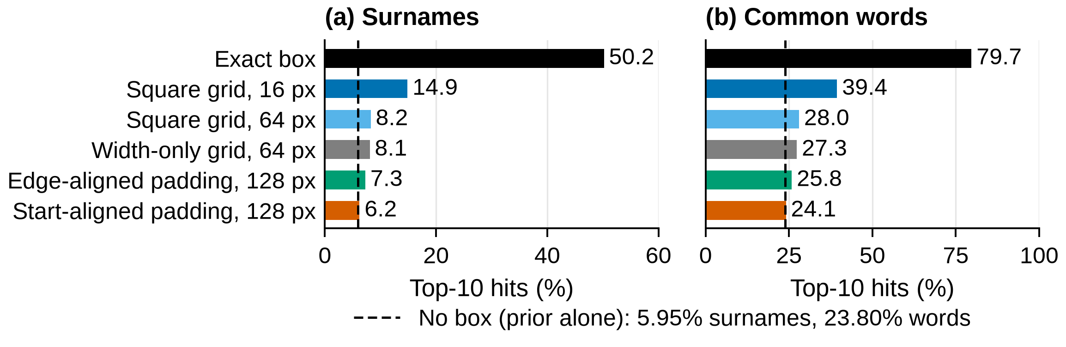
Figure 1. An exact box makes the hidden text far easier to guess. Top-10 hits under attacker A1 for (a) surnames and (b) common words, with their frequency priors, on clean synthetic lines with layout boxes (n = 36,000 targets per bar, six fonts and three sizes pooled). Padding bars assume the redactor knowledge of Box 2. Dashed line: the prior alone (no box). Lower is better; results are conditional on the matched-renderer attacker.
What it means. The box is a strong clue on its own. The font matters (exact-box hits ranged from 30.2% in monospaced Liberation Mono to 61.1% in DejaVu Serif), and larger text leaks more (66.9% at 42 px). Scan-like images cut exact-box hits to 27.9% and 16-px hits from 14.9% to 12.9%, so image quality is not a defence.

4.2. Grids or Padding: Which Buys More Privacy per Area? (RQ2)
What we found. Grids reduce the leak slowly and at a high area cost. A 16-px grid still leaked 2.19 bits at 2.45× the area, and a 64-px grid 0.67 bits at 10.04× (Figure 2), because a tile is large compared with a line of text. Start-aligned 128-px padding leaked 0.08 bits at 3.36× (top-10 6.2%), for either box model and for A1 and A2. For A1, no grid policy evaluated here achieved lower leakage than start-aligned padding at equal or lower area in any pooled cell (one cell per list, pooled over six fonts and three sizes) under the paper’s stated information assumptions. Because padding uses additional field knowledge, this is not a knowledge-matched dominance result. Against the 64-px grid it leaked 0.59 fewer bits (95% CI 0.58–0.60), in all 18 font–size cells after Holm correction.
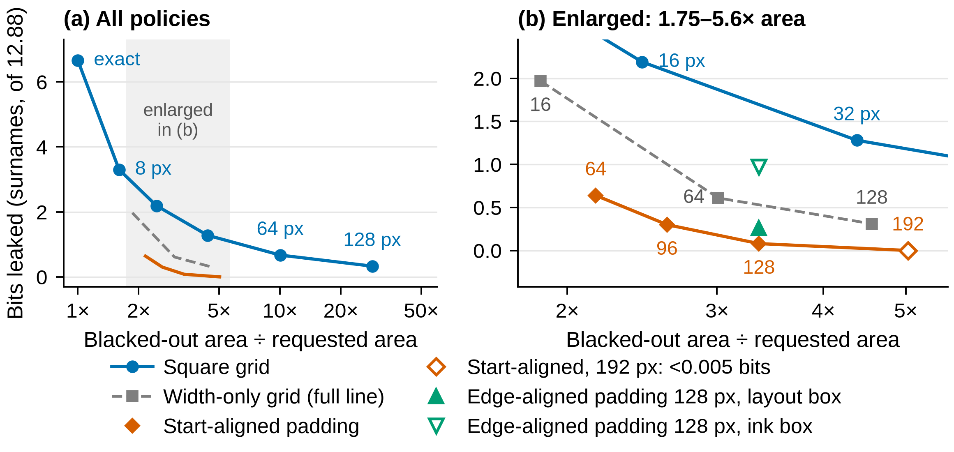
Figure 2. Measured geometry leakage against median over-redaction for surnames under attacker A1, clean synthetic lines and layout boxes (unless marked). Each point pools six fonts and three text sizes (n = 36,000 targets per policy); lower left is better. (a) All policies; (b) the shaded region of (a) enlarged, with points labelled by grid or class width in px. The 192-px class leaked below the 0.005-bit reporting threshold; its hollow marker is drawn at 0 for position only and does not mean zero leakage. Padding points assume the redactor knows the text start, full-line bounds and a field-wide class width (Box 2); the comparison is not information-matched, is conditional on these assumptions and does not establish a general defence.
The padding and grid results are not information-matched: grids use only the requested box, while start-aligned padding also uses the text start, baseline, full-line bounds and a field-wide class width. Under A1 its published box is determined by the class index k(w) (Section 3.3), so its leakage is the entropy of that class indicator rather than a general measure of box-geometry leakage. The comparison shows each policy under its stated information, not that padding beats grids given the same field knowledge.
Edge-aligned padding did well only with layout boxes: 0.26 bits with layout boxes but 0.97 with ink boxes, because an ink-hugging left edge shows where the first letter begins. Starting the box at the text start removes this leak. Table 3 summarises the policies and what each needs the redactor to know.
What it means. Start-aligned padding had the lowest measured leakage among the policies evaluated here, but it used more field knowledge than the grid policies, and its 0.08 bits is not a universal privacy guarantee. The class must cover the field: at 128 px, start-aligned padding leaked 0.000, 0.003 and 0.23 bits at 12, 16 and 24 px (n = 12,000 each), so the pooled 0.08 bits is driven largely by 24-px text and is not a uniform rate across sizes; classes of about eight times the text size left at most 0.005 bits. Longer fields are harder: e-mails kept 0.56 bits at 128 px and 0.73 bits even with a 256-px class at 24 px. Without the start, edge-aligned full-line padding on layout boxes (0.26 bits to A1, 0.07 to A2) or a width-only full-line grid with ink boxes (128 px: 0.31 bits at 4.56×) is the measured fallback.
Table 3. Summary of policies: what the redactor must know, bits leaked to A1 and area cost (clean synthetic lines, pooled over six fonts and three sizes; n = 36,000 per cell). Bits are for layout / ink boxes; area is the median over-redaction with layout boxes. Padding rows use more field knowledge than grid rows, so the rows are not information-matched.
 |  | Surnames (12.88 bits) |  | Words (10.10 bits)
Policy | Redactor must know | Bits, layout / ink | Area | Bits, layout | Area
Exact box | Nothing extra | 6.66 / 7.41 | 1.00× | 6.91 | 1.00×
Square grid, 16 px | Nothing extra | 2.19 / – | 2.45× | 2.63 | 2.84×
Square grid, 64 px | Nothing extra | 0.67 / 0.68 | 10.04× | 0.92 | 13.93×
Square grid, 128 px | Nothing extra | 0.33 / 0.34 | 28.64× | 0.48 | 43.34×
Width-only grid, 64 px | Full-line bounds | 0.61 / 0.62 | 3.01× | 0.83 | 4.13×
Width-only grid, 128 px | Full-line bounds | 0.31 / 0.31 | 4.56× | 0.44 | 6.97×
Edge-aligned padding, 128 px | Full line; field class | 0.26 / 0.97 | 3.36× | 0.24 | 5.69×
Edge-aligned padding, 192 px | Full line; field class | 0.19 / 0.90 | 5.03× | 0.18 | 8.53×
Start-aligned padding, 96 px | Text start; full line; field-wide class | 0.30 / 0.29 | 2.62× | 0.20 | 4.27×
Start-aligned padding, 128 px | Text start; full line; field-wide class | 0.08 / 0.08 | 3.36× | 0.06 | 5.69×
Start-aligned padding, 192 px | Text start; full line; field-wide class | <0.005 / <0.005 | 5.03× | <0.005 | 8.53×
–: not reported for ink boxes. <0.005: printed as 0.00 at two decimals in the source; a rounded value on these lists, not a guarantee of zero leakage. With ink boxes, width-only grids leaked fewer bits than edge-aligned padding at no greater area in five list–policy pairs: width-only 64 px against edge-aligned 128 and 192 px (surnames) and 128 px (words), and width-only 128 px against edge-aligned 192 px (surnames and words). No grid evaluated here leaked less than start-aligned padding at equal or lower area; because padding uses more field knowledge, this is not a knowledge-matched dominance result.

4.3. Which Parts of Padding Matter?
What we found. Two choices mattered in the archived comparisons (Figure 3). Covering the full line: the width-only 64-px grid, which snaps only the side edges and blacks out the full line, leaked 0.61 bits at 3.01× the area, against 0.67 bits at 10.04× for the square 64-px grid. Aligning to the text start: with full-line 128-px padding, edge-aligned boxes leaked 0.26 bits with layout boxes but 0.97 with ink boxes, while start-aligned boxes leaked 0.08 bits with either box model.
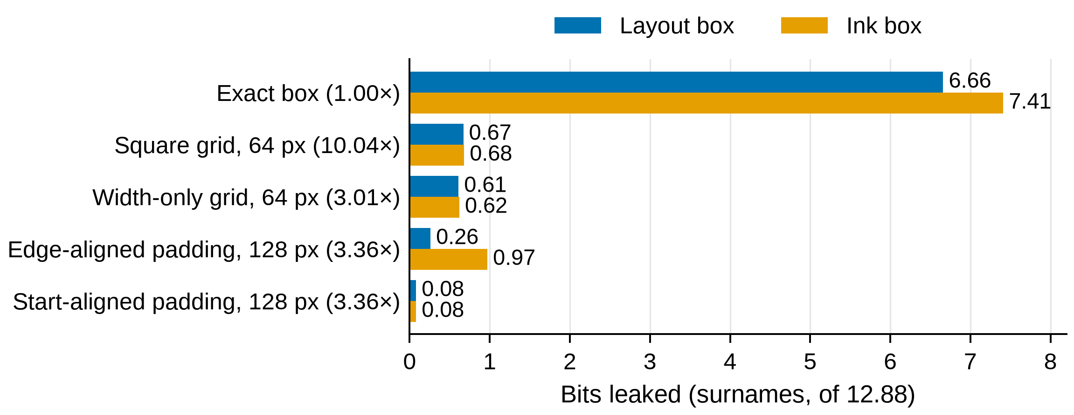
Figure 3. Covering the full line lowers the area cost, and a start-aligned edge removes the dependence on the box model. Bits leaked for surnames under attacker A1 on clean synthetic lines (six fonts and three sizes pooled, n = 36,000 per bar) for the exact box, the square and width-only 64-px grids and full-line 128-px padding, edge- or start-aligned, with layout and ink boxes; area in parentheses. Start-aligned bars assume the redactor knowledge of Box 2. Lower is better; results are conditional on the matched-renderer attacker.
What it means. In the tested settings, blacking out the full line gave similar leakage to square tiles of the same size at under a third of the area, and starting the box at the text start removed the leak from an ink-hugging left edge.

4.4. What Happens over Several Releases?
What we found. Grid copies add up; a fixed padded mask does not (Figure 4a). With a 16-px grid, A3’s surname hits rose from 11.5% with one copy to 22.0% with five (two fonts, 16 px). On this two-font, 16-px subset, five differently aligned 16-px grid copies leaked 3.30 bits to A3 (start unknown), and one 8-px copy leaked 3.09 bits to A1 (start known); the two differ in grid size and attacker, so this illustrates that repeated differently aligned releases can increase leakage, not a precise ranking of the two grids. Table A2’s pooled 8-px 3.30 bits (A1, six fonts, three sizes) is a different quantity. For padding, shifted copies (the same box moved by a known offset; a sanity check only) stayed at the no-box level. Releases that change the box did leak (Figure 4b). For 24-px DejaVu Sans surnames under start-aligned padding, the canonical unjittered mask leaked 0.285 bits, and five copies of it added nothing; one release jittered by 0–16 px leaked 0.36 bits, and five jittered releases 0.64 bits. Re-rendering in another font changed the 128-px class for 188 of 2,000 surnames; against a baseline of 0.22 bits for one release of a mixed-font sample (24 px, six fonts), five releases leaked 0.69 bits; edge-aligned padding rose from 0.38 to 1.30 bits. A 192-px class removed both effects (at most 0.01 bits).
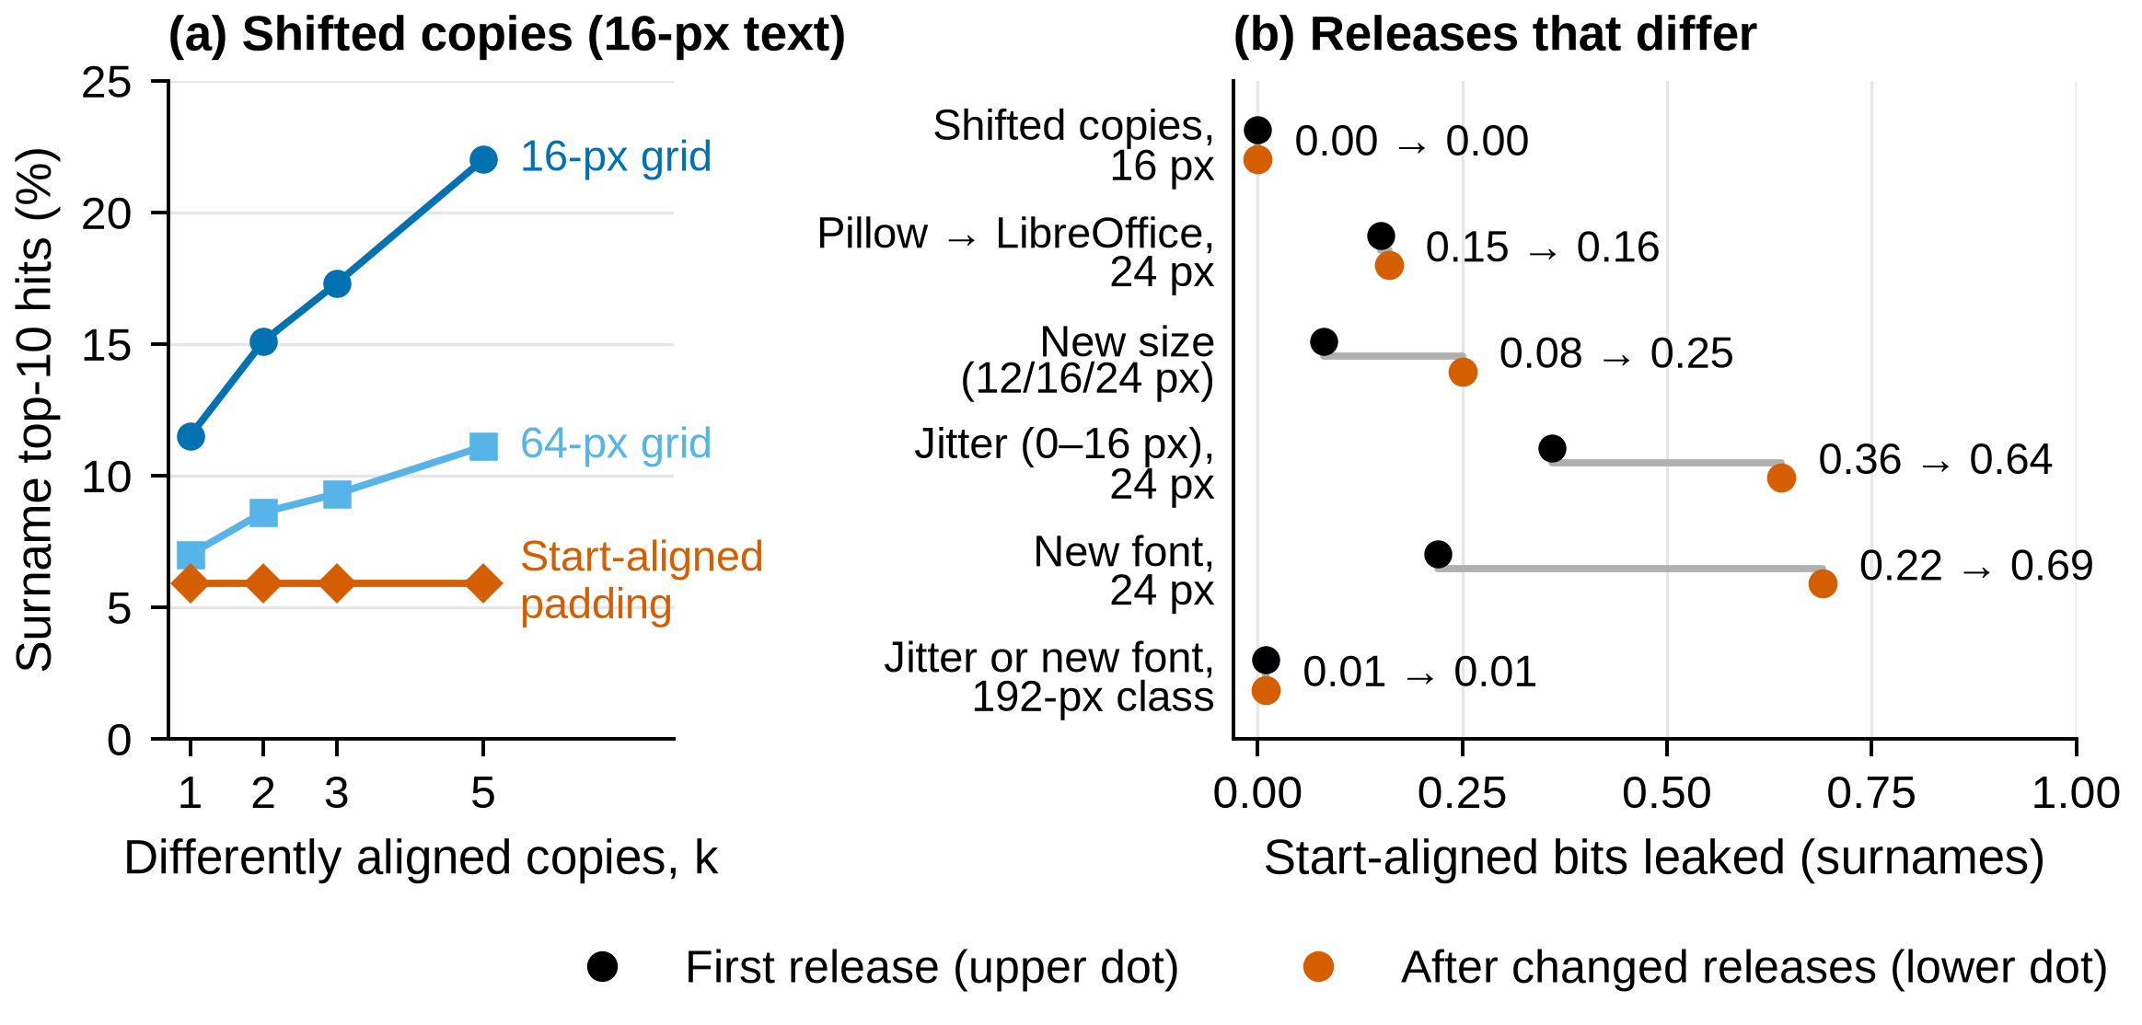
Figure 4. Grid copies add up; padding gained nothing from copies only while every release showed the same box. (a) A3 top-10 against the number of differently aligned copies (16-px text, DejaVu Sans and Liberation Serif; n = 4,000 per point); edge-aligned padding gave the same flat line as start-aligned. (b) Start-aligned bits for surnames after the first release (black, upper dot; k = 1, in the jitter row one jittered release) and after the changed releases (orange, lower dot; k = 5 for jitter and font). Attacker A1 and layout boxes, except the renderer row (A2, ink boxes) and the new-size row (A2); n = 2,000 per row; 128-px class unless marked; padding assumes the redactor knowledge of Box 2. Lower is better; results are conditional on these assumptions.
What it means. In the tested repeated-release setting, reusing one canonical mask, without jitter, avoided the leakage increase seen with differently aligned grid copies; a re-rendered release also needs a class wide enough for its widest rendering.

4.5. How Much Does the Attacker Need to Know?
What we found. The main numbers are a best case for the attacker (Figure 5). Each piece of knowledge was removed in turn (six fonts at 16 px, clean, 500 targets per font). Not knowing the font cut exact-box hits only from 48.6% to 38.2%. A uniform prior cut them to 5.7%. Ranking the same list by an independently sourced prior (same list, re-weighted by each surname’s frequency as an English word) cut exact-box hits on the published 16-px targets from 48.3% to 21.2%. A Pillow-model attacker found 0 of 100 surnames on LibreOffice forms that the matched attacker found 63 times, because the renderers’ ink boxes differ by up to 3 px per edge; recalibrating its tolerance restored 31 of 100.
The language model (A4) was strongest for words: it found 97.0% of words with exact boxes and 49.8% at 64 px, but the sentence alone gave 44.8%, so the 64-px box added only 5.0 points (Table A4). Edge-aligned 128-px padding added almost nothing to the sentence (at most 0.25 points against the padding rerun’s own sentence-alone baseline; Table A4).
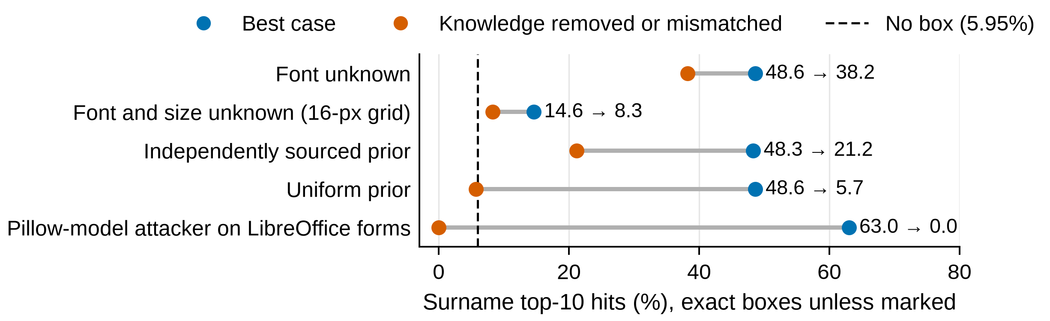
Figure 5. A weaker attacker finds less, but the box still leaks unless the attacker’s prior or renderer is wrong. Surname top-10 for the best-case attacker A1 (blue) and with one piece of knowledge removed or mismatched (orange), on clean synthetic lines (six fonts at 16 px, 500 targets per font) or LibreOffice mock forms (100 forms); exact boxes unless marked. No padding is shown. Dashed line: no box (5.95% on synthetic lines; 6% on LibreOffice forms).
What it means. Top-10 describes the box and the attacker’s prior together; bits describe what the geometry gives up (on the same targets, bits under the true prior stayed at 6.48). A wrong renderer is not protection, since calibration restores much of the attack.

4.6. Validation on Template-Controlled Mock Forms
What we found. When the form template supplies each field’s text start and baseline, start-aligned padding stayed near the no-box rate (Figure 6; Table A3). This tests the policy, not an end-to-end system: the coordinates came from the form generator. On Pillow forms, exact boxes found 52.0% of surnames (no box: 7.0%), the 16-px grid 12.0% and start-aligned padding 7.0%. On LibreOffice forms, start-aligned padding stayed at 6–8% in every cell, against a no-box rate of 6%, and was below the 16-px grid in every cell, clean or scan-like, by 4 to 13 points. On clean forms the 64-px grid matched it within 1 point but blacked out 4.4–5.6 times as much area.
What it means. In the template-controlled setting, the synthetic result carries over to whole pages. Coarse boxes also hide visible text: on Pillow forms, 16-px boxes cut into a neighbouring word on 94% of forms, and 64-px boxes hid 14.7% of a page’s visible words. This damage was not measured for start-aligned padding.
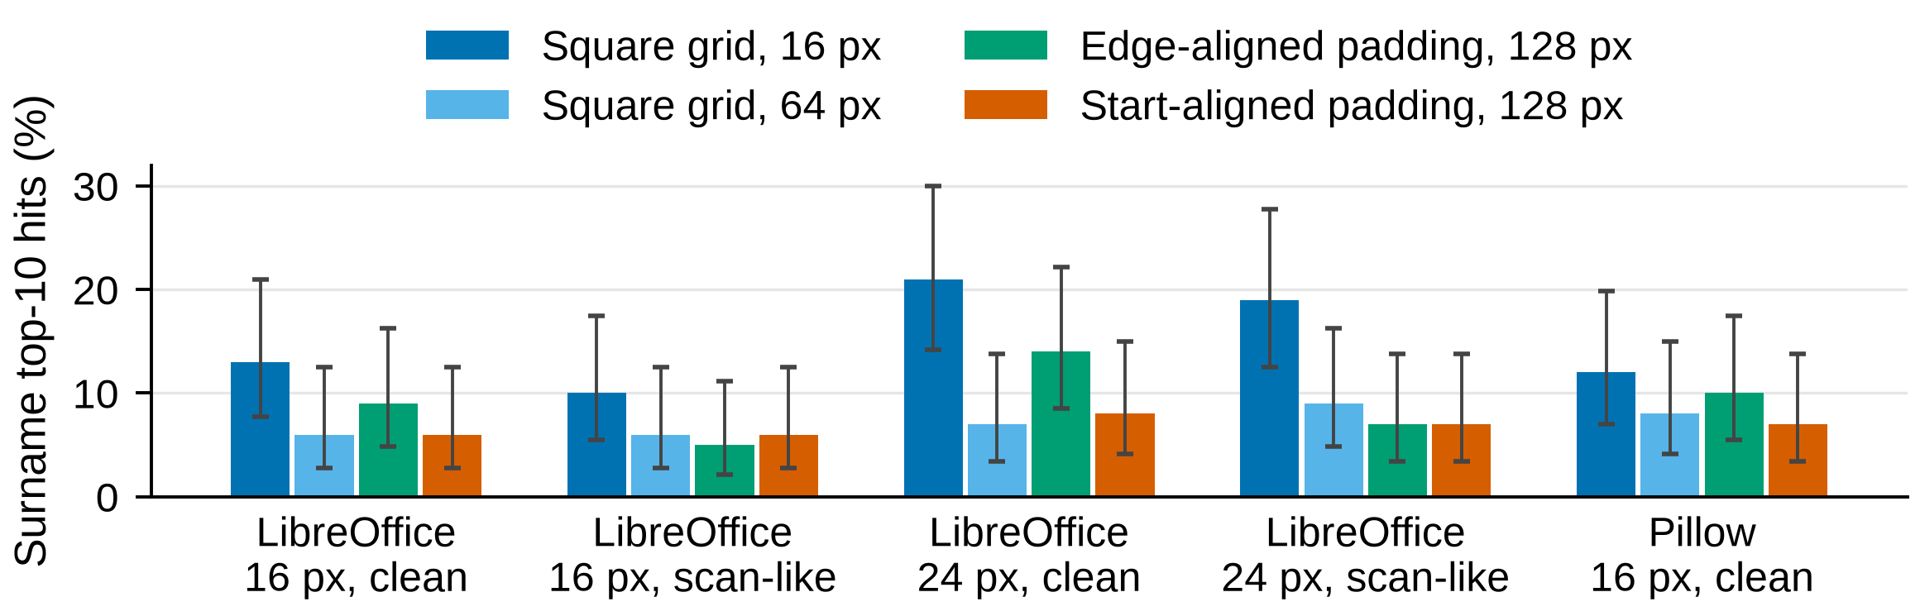
Figure 6. On template-controlled mock forms (coordinates supplied by the template), start-aligned padding stays near the no-box rate on both renderers, clean or scanned. Surname top-10 by policy on clean and scan-like forms (100 forms per bar; Wilson 95% intervals; layout boxes from the form template). LibreOffice bars use the matched attacker; Pillow bars use A1. No box: 6% (LibreOffice), 7% (Pillow).

4.7. What Do Real Boxes Look Like? (RQ3)
What we found. Real boxes are larger than our test text (Table 4). Their median width was 228 px and median height 49 px, and their widths had 9.35 bits of entropy over 1,433 values. Snapping to 64 px cut this to 3.67 bits at a median over-redaction of 2.95×. This is geometry only: width entropy bounds what a width could reveal, not what was leaked about hidden text, and no recovery was attempted on this corpus.
Table 4. Geometric characterisation of 11,351 real redactions on 932 freedom-of-information pages (about 300 DPI). H: entropy of box geometry over boxes, in bits; this is not leakage about hidden text, which was not available. Area: median over-redaction (90th percentile in parentheses).
Grid | Distinct widths | H(width) | H(width, height) | Area
Exact | 1,433 | 9.35 | 12.76 | –
8 px | 279 | 6.58 | 9.18 | 1.18× (1.33×)
16 px | 149 | 5.60 | 7.53 | 1.40× (1.72×)
32 px | 79 | 4.62 | 6.04 | 1.87× (2.62×)
64 px | 40 | 3.67 | 4.79 | 2.95× (4.98×)

5. Discussion

5.1. What This Means for Redaction Tools
Scope. In the tested template-controlled setting, start-aligned full-line padding had the lowest measured leakage among the policies evaluated. This result depends on knowing the text start, full-line bounds and a field-wide class width; it does not show that these coordinates can be recovered automatically or that the policy remains effective when they are wrong. Verifiable-redaction schemes that publish a snapped box inherit the grid trade-off [12–14,20]. Table 5 summarises what the results support.
Table 5. What the results support, and what they do not (template-controlled, known-layout setting; matched-renderer attackers).
Redactor knowledge | What the tested results support | What this paper does not show
Nothing beyond the requested box | Square grids reduced measured geometry leakage, but at substantial over-redaction cost; leakage remained nonzero | That a grid meets a target leakage level across fonts, documents, attackers or real scans
Full-line bounds only | Edge-aligned full-line padding and width-only full-line grids reduced leakage more efficiently than square grids in the tested settings | Robustness to real scans, changed releases or context-assisted attacks
Text start, baseline, full-line bounds and a field-wide class | Start-aligned full-line padding had the lowest measured leakage among the policies evaluated; it is a form of length bucketing | That padding dominates a knowledge-matched grid baseline, that the coordinates can be recovered automatically, or that the policy holds under coordinate error
Several releases will be published | Reusing one canonical mask avoided the leakage increase caused by differently aligned grid copies in the tested setting | That mask reuse removes every leakage channel, including compression artefacts or context leakage

The following observations are limited to the tested template-controlled, known-layout setting. They are not deployment rules for arbitrary scanned documents.
1. In the tested synthetic setting, snapping reduced but did not remove geometry leakage. A 16-px grid still left 2.19 bits of surname leakage under the matched-renderer attacker.
2. In the tested settings, a width-only grid that covers the full line leaked about as much as a square grid of the same size (0.61 against 0.67 bits at 64 px) at under a third of the area.
3. When the text start, baseline, full-line bounds and a field-wide class were known, start-aligned full-line padding had the lowest measured leakage among the policies evaluated. It is a form of length bucketing, uses more field knowledge than the grid policies, and should not be read as a knowledge-matched improvement over grids.
4. In the tested repeated-release setting, differently aligned grid copies increased leakage. Reusing one canonical mask avoided that particular increase.
5. Changed releases (jittered copies or re-rendered text) reduced the protection of the tested padding policy. The results support keeping the published mask unchanged when possible; they do not establish that this removes all leakage channels.

5.2. Comparison with Earlier Work
As Lopresti and Spitz found for Courier [6], the monospaced font leaked least. Their constant-size boxes [7] and Bland et al.’s width quantisation [8] are the idea behind our padding; we add its leakage and area against grids on the same boxes, and the role of full-line coverage and a start-aligned edge. Bland et al. estimated about 8 bits from widths at 300 DPI using ten names in one font [8]; our exact-box surname estimate is 6.66 bits pooled over six fonts at 12–24 px. The settings differ, so the numbers are not directly comparable, but both show that exact box geometry reveals substantial information. As Orekondy et al. found for photos [30], region size trades privacy against utility.

5.3. Scope, Limitations, and What Was Not Tested
• The main attacker is a best-case, matched-renderer attacker; it does not represent every realistic attacker.
• Start-aligned padding used template-supplied coordinates; recovering them from arbitrary scanned documents was not shown.
• Start-aligned padding was not evaluated under perturbed text-start or baseline estimates, with incomplete candidate lists, on JPEG or scan-like single lines, or against the language-model attacker A4.
• Start-aligned padding is a form of length bucketing: its leakage depends on the class width and the distribution of class indices, and the pooled 0.08-bit result is driven largely by 24-px text. The class-width rule was tested only up to 24-px text, while real boxes in the calibration corpus had a median height of 49 px, so it may not transfer to larger text.
• No recovery experiment was run on real documents; the real-box analysis is geometric only. The mock forms are synthetic, number 100 per condition and use FreeType in both renderers.
• The language-model test used 400 words and one small model, so it does not cover context attacks broadly.
• Repeated releases were tested only on clean surnames and words (e-mails for copies), 16 and 24 px.
• The main experiments use single-line Latin text in six fonts and three primary sizes; multi-line text, non-Latin scripts and mixed fonts were not tested, and no font or candidate list was held out.
• An exploratory own-height padding variant is not reported; its cells are not in the release.
• Collateral damage on mock forms was measured for grids and edge-aligned padding, not start-aligned padding, so the area advantage is not shown to be a readability advantage.

6. Conclusions
A solid black box hides the letters it covers, but its width, height and position can still narrow the possible hidden text. Measured together with the area it blacks out, tile snapping reduced geometry leakage only gradually and imposed a substantial over-redaction cost, and differently aligned copies of a grid-redacted image increased the leakage available to an attacker.
In the template-controlled, known-layout setting tested here, start-aligned full-line padding had the lowest measured leakage among the policies evaluated when the text start, full-line bounds and a field-wide class width were known, under a matched-renderer attacker. It also remained close to the no-box rate on mock forms whose template supplied those coordinates. This is a conditional result, not a general defence: it used more field knowledge than the grids, it lost protection when releases were jittered or re-rendered, and the paper did not evaluate automatic recovery of the required coordinates from arbitrary scanned documents.
These results are a controlled measurement of the leakage–area trade-off in redaction-box geometry. They are intended to inform the design of template-controlled redaction tools, not to be read as a universal privacy guarantee.

Author Contributions: N.V. carried out the conceptualization, methodology, software, validation, analysis, data curation, writing and visualization. The author has read and agreed to the published version of the manuscript.
Funding: [Funding]
Institutional Review Board Statement: Not applicable; no human participants or personal data (synthetic text, invented form values, CC BY 4.0 box annotations). [Ethics statement — confirm]
Informed Consent Statement: Not applicable.
Data Availability Statement: The analysis code, configuration files, target manifests, summary results and evidence inventory are available at https://github.com/neervasa00000000/Guard, release tag v1.0-manuscript, commit 9d3ebcf6a83283afd8f7075f71e9eced3d57dc82; the repository will be archived at Zenodo under DOI [DOI TO ADD]. The release includes the harness and tests (research/e1, with e1lib.py and e1_run.py), 25 .csv.gz case archives under research/e1/cases/ (3,408,000 records), the case files and summaries listed in Table A7, rerun_full.sh and an evidence file naming the source of each result. scripts/regenerate_tables.py rebuilds Table A2 (with its A2 column) from research/e1/review4/pooled.csv, and scripts/check_numbers.py audits this manuscript’s tables; other tables and figures are not regenerated by script. Some rebuilds need external review-kit scripts that are not in the repository. Results marked not independently reconstructable in Table A7 rely on files not in the release and should not be treated as independently verifiable until their archive status is confirmed. The release does not include every original raw observation from the 3.76-million-redaction sweep, and the full render was not rerun for this manuscript. Third-party data (Census surnames, Project Gutenberg texts, Qwen2.5-0.5B weights, redaction annotations) are fetched by a script that checks their SHA-256 hashes; only derived box geometry from the CC BY 4.0 annotations is redistributed.
Conflicts of Interest: The author develops TileSeal, the open-source tool whose snapping is modelled and checked in this study. The author declares no other conflicts of interest.

Appendix A. Detailed Tables
Tables A1–A6 give the detailed values behind the main text; Table A7 is the evidence inventory.
Table A1. The 19 policy–condition cells of the main sweep (from e1_run.py). “Exact” is the 1-px grid.
Condition | Policy | Grid settings (px) | Cells
Clean | Exact and square grid | 1, 8, 16, 32, 64 | 5
JPEG quality 75 | Exact and square grid | 1, 8, 16, 32, 64 | 5
Scan-like | Exact and square grid | 1, 8, 16, 32, 64 | 5
Clean | Jitter 0–16 px per side, then snap | 1, 16 | 2
Clean | Edge-aligned 128-px class, full-line height, then snap | 1, 16 | 2
Units: 90 (five lists × six fonts × three sizes) plus 9 at 42 px = 99; 99 × 19 × 2,000 = 3,762,000 redactions. Scoring A1 and A2 plus 128,000 A3 rows gives 7,652,000 result rows; no-box baselines are not counted.
Table A2. Leakage by grid on clean renders, pooled over six fonts and three sizes (n = 36,000 per cell). Top-10 in %; bits leaked; area is the median over-redaction on the same boxes.
 | Surnames (prior 12.88 bits) |  |  | Words (prior 10.10 bits)
Grid | Top-10 A1 / A2 | Bits A1 / A2 | Area | Top-10 A1 / A2 | Bits A1 / A2 | Area
Exact | 50.2 / 49.0 | 6.66 / 6.54 | 1.00× | 79.7 / 79.0 | 6.91 / 6.83 | 1.00×
8 px | 21.2 / 17.6 | 3.30 / 2.63 | 1.60× | 50.4 / 44.8 | 3.82 / 3.19 | 1.78×
16 px | 14.9 / 12.2 | 2.19 / 1.54 | 2.45× | 39.4 / 34.6 | 2.63 / 1.97 | 2.84×
32 px | 10.7 / 9.0 | 1.28 / 0.75 | 4.38× | 31.9 / 28.6 | 1.65 / 1.07 | 5.49×
64 px | 8.2 / 7.1 | 0.67 / 0.30 | 10.04× | 28.0 / 25.8 | 0.92 / 0.45 | 13.93×
No box | 5.95 | 0 | – | 23.80 | 0 | –
A2 values use the exact likelihood over every sampled start.
Table A3. Start-aligned 128-px padding on mock forms: surname top-10 (%), 100 forms per row. Difference: 16-px grid minus start-aligned padding, in points, with form-paired bootstrap 95% CI. Area: median over-redaction of start-aligned padding / 64-px grid.
Forms | Exact | 16-px grid | Start-aligned | Difference [CI] | Area, start / 64 px
LibreOffice, 16 px, clean | 63 | 13 | 6 | +7 [2, 12] | 3.36× / 17.64×
LibreOffice, 16 px, scan-like | 22 | 10 | 6 | +4 [1, 8] | 4.15× / 15.66×
LibreOffice, 24 px, clean | 73 | 21 | 8 | +13 [7, 20] | 2.47× / 10.78×
LibreOffice, 24 px, scan-like | 34 | 19 | 7 | +12 [6, 19] | 2.67× / 11.49×
LibreOffice, 16 px, clean, Pillow model | 0 | 12 | 6 | +6 [2, 11] | 3.36× / 17.64×
Pillow, 16 px, clean, A1 | 52 | 12 | 7 | +5 [1, 10] | 3.66× / 20.42×
Pillow, 16 px, clean, A2 | 51 | 10 | 7 | +3 [0, 7] | 3.66× / 20.42×
Top-10 only: LibreOffice attackers use a calibrated edge tolerance (Section 3.4), so no bits are given. LibreOffice rows use the matched attacker unless marked. No box: 6% on LibreOffice forms, 7% on Pillow forms. Pillow scan-like forms were not rescored.
Table A4. Sentence context: top-10 (%) on 400 words in real sentences (16 px, clean) when A1’s candidates are ranked by the frequency prior or by the language model (LM). Gain: item-paired gain of the LM with the box over the LM with no box, in points, with bootstrap 95% CI.
 | DejaVu Sans (main run) |  |  | Liberation Serif (follow-up run)
Grid | Prior | LM | Gain [CI] | Prior | LM | Gain [CI]
Exact | 58.5 | 97.0 | +52.3 [47.5, 57.3] | 51.3 | 96.0 | +51.3 [46.5, 56.3]
8 px | 7.5 | 80.3 | +35.5 [30.8, 40.3] | 6.0 | 75.8 | +31.0 [26.5, 35.5]
16 px | 3.5 | 70.8 | +26.0 [21.5, 30.3] | 1.6 | 66.3 | +21.5 [17.5, 25.8]
32 px | 0.8 | 58.8 | +14.0 [10.5, 17.5] | 0.5 | 56.5 | +11.8 [8.8, 15.0]
64 px | 0.0 | 49.8 | +5.0 [3.0, 7.3] | 0.0 | 50.0 | +5.3 [3.0, 7.5]
Edge-aligned pad 128 * | 0.25 | 45.25 | +0.25 [0.0, 0.75] | 0.0 | 45.0 | +0.0 [0.0, 0.0]
Sentence alone (LM, no box, same 400 items): top-10 44.8% [40.0, 49.7]. The prior column is low because the 400 words exclude very common and very short words. * Later rerun with both fonts in one session; its 64-px cells were 49.5% in both fonts. Edge-aligned rows use the padding rerun’s own sentence-alone baseline of 180/400 (45.0%); other rows use 179/400 (44.8%). Gains are against the stated baseline.
Table A5. Paired tests (A1, layout boxes, clean). Holm: number of the 18 font–size cells with p < 0.05 after Holm correction, for the earlier independent-proportion test → the paired test. Δ: pooled difference in top-10 (first policy minus second, points) with target-bootstrap 95% CI.
 | Surnames |  |  | Words
Comparison | Holm, top-10 | Holm, bits | Δ top-10 [CI] | Holm, top-10 | Δ top-10 [CI]
Exact > 8 px | 18 → 18 | 18 | +29.0 [28.5, 29.4] | 18 → 18 | +29.3 [28.9, 29.8]
8 px > 16 px | 18 → 18 | 18 | +6.4 [6.1, 6.6] | 18 → 18 | +11.0 [10.6, 11.3]
16 px > 32 px | 18 → 18 | 18 | +4.2 [4.0, 4.4] | 18 → 18 | +7.5 [7.3, 7.8]
32 px > 64 px | 10 → 18 | 18 | +2.4 [2.3, 2.6] | 9 → 18 | +3.9 [3.7, 4.1]
64 px > edge-aligned 128 px | 2 → 9 | 17 | +1.0 [0.8, 1.1] | 3 → 12 | +2.2 [2.0, 2.4]
64 px > start-aligned 128 px | – → 18 | 18 | +2.0 [1.9, 2.2] | – → 18 | +3.9 [3.7, 4.1]
–: not tested before. For words, bits held in 17 or 18 of 18 cells for every comparison, and every pooled p-value was at the smallest possible value, 1/100,001.
Table A6. Per-font results for surnames (A1, layout boxes, clean; three sizes pooled, n = 6,000 per font): top-10 (%) / bits leaked.
Font | Exact | 16-px grid | 64-px grid | Edge-aligned 128 | Start-aligned 128 | Width-only 64
DejaVu Sans | 56.7 / 7.32 | 15.8 / 2.29 | 9.2 / 0.73 | 9.3 / 0.48 | 7.0 / 0.10 | 9.0 / 0.67
DejaVu Serif | 61.1 / 7.70 | 15.2 / 2.32 | 7.7 / 0.72 | 8.4 / 0.64 | 6.1 / 0.13 | 7.5 / 0.66
Liberation Mono | 30.2 / 4.58 | 15.0 / 2.30 | 8.3 / 0.72 | 6.3 / 0.15 | 6.3 / 0.15 | 8.0 / 0.66
Liberation Sans | 47.5 / 6.44 | 13.9 / 2.02 | 8.0 / 0.60 | 5.7 / 0.03 | 5.7 / 0.03 | 7.8 / 0.57
Liberation Serif | 49.7 / 6.60 | 13.7 / 1.93 | 8.1 / 0.55 | 6.3 / 0.01 | 6.3 / 0.01 | 7.9 / 0.49
Noto Sans | 56.2 / 7.30 | 15.7 / 2.26 | 8.3 / 0.69 | 7.7 / 0.24 | 6.1 / 0.06 | 8.2 / 0.62
Pooled | 50.2 / 6.66 | 14.9 / 2.19 | 8.2 / 0.67 | 7.3 / 0.26 | 6.2 / 0.08 | 8.1 / 0.61
Area, pooled | 1.00× | 2.45× | 10.04× | 3.36× | 3.36× | 3.01×

Table A7. Evidence inventory for release tag v1.0-manuscript (commit 9d3ebcf), per the release’s evidence notes. Archived per-target: case-level rows in the release. Archived summary: pooled cells in the release, without per-target rows. Kit: rebuilding needs external review-kit scripts that are not in the repository. Not independently reconstructable: rests on files not in the release (author to confirm).
Item | Result | Files in the release | Status
Table 1 | Published studies | – | Not applicable
Tables 2, A1 | Attacker and cell definitions | Harness (e1lib.py, e1_run.py) | Archived (code)
Table A2; grid curve in Figure 2; Figure 1 (exact, grids) | Main clean sweep | 25 case archives; corrected clean summary | Archived summary; A2 column rebuilt by regenerate_tables.py; raw A1 rows for four units
Figures 1–3 (padding, width-only); Tables 3, A6 | Padding sweep, 12–24 px | review4/pooled.csv, per_font.csv | Archived summary (per-target units not archived); kit
Figure 4a | Grid copies (A3) | a3_cases.csv.gz (128,000 rows) | Archived per-target; kit
Figure 4b; Section 4.4 | Padding copies, jitter, new font or size, renderer | a3_start/results_cases.csv.gz, results_summary.csv | Archived per-target; kit
Figure 5 | Attacker-knowledge tests | test4_cases.csv.gz; fig3_baseline.csv | Archived per-target; kit. Independently sourced prior: not independently reconstructable
Figure 6; Table A3 | Mock forms | review4/forms case scores and tables | Archived per-target (pages not archived); kit
Table 4 | Real-box geometry | foia_boxes.csv, foia_geometry_summary.csv | Archived summary (no rebuild from images)
Table A4 | Language model | e1_a4_cases.csv.gz (DejaVu Sans, exact and grids) | Exact and grid rows: archived per-target. 179/400, 180/400, padding and Liberation Serif rows: summary only, not independently reconstructable
Table A5 | Paired tests | Test outputs (mdpi_checks) | Summary only (author to confirm)
Not in the release: d2jit_pooled.csv, test4_fontcluster.csv, s4_priors.csv, a4_reproduction.csv, s2_rerender.csv, the padding-sweep per-target units and the rendered form pages. The 3,408,000 archived records are file rows, not the 3,762,000 redactions of the original sweep.

References
1. United States Courts. Federal Rules of Civil Procedure, Rule 5.2: Privacy Protection for Filings Made with the Court. Available online: https://www.law.cornell.edu/rules/frcp/rule_5.2 (accessed on 10 November 2026).
2. NEMA. DICOM PS3.15 Annex E.3: Basic Application Level Confidentiality Options (Clean Pixel Data Option). Available online: https://dicom.nema.org/medical/dicom/current/output/chtml/part15/sect_E.3.html (accessed on 10 November 2026).
3. Hill, S.; Zhou, Z.; Saul, L.; Shacham, H. On the (In)effectiveness of Mosaicing and Blurring as Tools for Document Redaction. Proc. Priv. Enhancing Technol. 2016, 2016, 403–417. https://doi.org/10.1515/popets-2016-0047.
4. Todt, J.; Hanisch, S.; Strufe, T. Fantômas: Understanding Face Anonymization Reversibility. Proc. Priv. Enhancing Technol. 2024, 2024, 24–43. https://doi.org/10.56553/popets-2024-0105.
5. Zhai, H.; Wang, S.; Naghavi, P.; Hao, Q.; Wang, G. Revelio: Blurred Images Can Still Disclose Your Identity. In Proceedings of the IEEE Symposium on Security and Privacy (SP), May 2026; pp. 3911–3929. https://doi.org/10.1109/SP63933.2026.00030.
6. Lopresti, D.; Spitz, A.L. Quantifying Information Leakage in Document Redaction. In Proceedings of the 1st ACM Workshop on Hardcopy Document Processing (HDP), November 2004; pp. 63–69. https://doi.org/10.1145/1031442.1031452.
7. Lopresti, D.; Spitz, A.L. Information Leakage Through Document Redaction: Attacks and Countermeasures. In Proceedings of SPIE 5676, Document Recognition and Retrieval XII, January 2005; pp. 183–190. https://doi.org/10.1117/12.589552.
8. Bland, M.; Iyer, A.; Levchenko, K. Story Beyond the Eye: Glyph Positions Break PDF Text Redaction. Proc. Priv. Enhancing Technol. 2023, 2023, 43–61. https://doi.org/10.56553/popets-2023-0069.
9. Ho, N.Z.-Y.; Chang, E.-C. Residual Information of Redacted Images Hidden in the Compression Artifacts. In Proceedings of Information Hiding (IH 2008); Lecture Notes in Computer Science; Springer: Berlin/Heidelberg, Germany, 2008; pp. 87–101. https://doi.org/10.1007/978-3-540-88961-8_7.
10. Hatano, Y.; Miyazaki, K.; Toyoshima, H. Digital Image Data Authenticity Assuring Method, and Digital Image Data Disclosure System. US Patent Application US 2006/0117183 A1, 2006.
11. Hughes, R.J. Review and Redaction-Tolerant Image Verification Using Cryptographic Methods. Sci. Glob. Secur. 2021, 29, 3–16. https://doi.org/10.1080/08929882.2021.1894810.
12. Perazzo, P.; Mattei, M.; Anastasi, G.; Avvenuti, M.; Dini, G.; Lettieri, G.; Vallati, C. JPEGs Just Got Snipped: Croppable Signatures Against Deepfake Images. In Proceedings of the International Joint Conference on Neural Networks (IJCNN), June 2025; pp. 1–6. https://doi.org/10.1109/IJCNN64981.2025.11227387.
13. zero-savvy. VIMz Source Code, Branch redact-block (Block-Redaction Circuit redact_step.circom, Commit 59e7669). GitHub Repository, 2025. Available online: https://github.com/zero-savvy/vimz/tree/redact-block (accessed on 10 November 2026).
14. Ko, H.; Lee, I.; Lee, S.; Kim, J.; Oh, H. Efficient Verifiable Image Redacting Based on zk-SNARKs. In Proceedings of the ACM Asia Conference on Computer and Communications Security (ASIA CCS), June 2021; pp. 213–226. https://doi.org/10.1145/3433210.3453110.
15. Kang, D.; Hashimoto, T.; Stoica, I.; Sun, Y. ZK-IMG: Attested Images via Zero-Knowledge Proofs to Fight Disinformation. arXiv 2022, arXiv:2211.04775. Available online: https://arxiv.org/abs/2211.04775 (accessed on 10 November 2026).
16. Steinfeld, R.; Bull, L.; Zheng, Y. Content Extraction Signatures. In Proceedings of Information Security and Cryptology (ICISC); Lecture Notes in Computer Science, Volume 2288; Springer, 2002; pp. 285–304. https://doi.org/10.1007/3-540-45861-1_22.
17. Johnson, R.; Molnar, D.; Song, D.; Wagner, D. Homomorphic Signature Schemes. In Proceedings of Topics in Cryptology (CT-RSA); Lecture Notes in Computer Science, Volume 2271; Springer, 2002; pp. 244–262. https://doi.org/10.1007/3-540-45760-7_17.
18. Vasa, N. TileSeal (Repository Name Guard): Offline-Verifiable Tile Redaction for Raster Images. GitHub Repository, 2026. Available online: https://github.com/neervasa00000000/Guard (accessed on 10 November 2026).
19. Dziembowski, S.; Ebrahimi, S.; Hassanizadeh, P. VIMz: Private Proofs of Image Manipulation Using Folding-Based zkSNARKs. Proc. Priv. Enhancing Technol. 2025, 2025, 344–362. https://doi.org/10.56553/popets-2025-0065.
20. Mikołajczyk, P.; Hassanizadeh, P.; Ebrahimi, S. Towards Trustless Provenance: A Privacy-Preserving Framework for On-Chain Media Verification. Cryptology ePrint Archive, Paper 2025/1024, 2025. Available online: https://eprint.iacr.org/2025/1024 (accessed on 10 November 2026).
21. Beltrame, M.; Conti, M.; Guglielmin, P.; Marchiori, F.; Orazi, G. RedactBuster: Entity Type Recognition from Redacted Documents. In Proceedings of the European Symposium on Research in Computer Security (ESORICS); Lecture Notes in Computer Science, Volume 14983; Springer, 2024; pp. 451–470. https://doi.org/10.1007/978-3-031-70890-9_23.
22. Charpentier, L.G.G.; Lison, P. Re-identification of De-identified Documents with Autoregressive Infilling. In Proceedings of the 63rd Annual Meeting of the Association for Computational Linguistics (Volume 1: Long Papers), July 2025; pp. 1192–1209. https://doi.org/10.18653/v1/2025.acl-long.60.
23. Charpentier, L.G.G.; Lison, P. Stronger Re-identification Attacks through Reasoning and Aggregation. arXiv 2025, arXiv:2510.09184. https://doi.org/10.48550/arXiv.2510.09184.
24. Gilbert, A. unredact: Recovering Redacted Text from Box Width, Font Metrics and Language-Model Ranking. Open-Source Software, GitHub, 2026. Available online: https://github.com/Alex-Gilbert/unredact (accessed on 10 November 2026).
25. KhoomeiK. deredact: Character-Count-Constrained LLM Decoding to Fill in Redacted Text. Open-Source Software, GitHub, 2024. Available online: https://github.com/KhoomeiK/deredact (accessed on 10 November 2026).
26. Phaselab. unredact: A PDF Redaction Checker. Open-Source Software, GitHub, 2026. Available online: https://github.com/phaselabinc/unredact (accessed on 10 November 2026).
27. Wyatt, P. A Case Study in PDF Forensics: The Epstein PDFs. PDF Association, December 2025. Available online: https://pdfa.org/a-case-study-in-pdf-forensics-the-epstein-pdfs (accessed on 10 November 2026).
28. Vijaya Kumar, V.P.; Venkatesh, S.; Yamshchikov, I.P. LeakageBench: Document-Level Leakage Risk for Redacting Personally Identifiable Information in Document Images. In Findings of the Association for Computational Linguistics: EMNLP 2026, October 2026; pp. 50519–50537. https://doi.org/10.18653/2026.findings-emnlp.2350.
29. Gellert, K.; Jager, T.; Lyu, L.; Neuschulten, T. On Fingerprinting Attacks and Length-Hiding Encryption. In Proceedings of Topics in Cryptology (CT-RSA 2022); Lecture Notes in Computer Science, Volume 13161; Springer, 2022; pp. 345–369. https://doi.org/10.1007/978-3-030-95312-6_15.
30. Orekondy, T.; Fritz, M.; Schiele, B. Connecting Pixels to Privacy and Utility: Automatic Redaction of Private Information in Images. In Proceedings of the IEEE Conference on Computer Vision and Pattern Recognition (CVPR), June 2018; pp. 8466–8475. https://doi.org/10.1109/CVPR.2018.00883.
31. Derler, D.; Pöhls, H.C.; Samelin, K.; Slamanig, D. A General Framework for Redactable Signatures and New Constructions. In Proceedings of Information Security and Cryptology (ICISC); Lecture Notes in Computer Science, Volume 9558; Springer, 2016; pp. 3–19. https://doi.org/10.1007/978-3-319-30840-1_1.
32. Datta, T.; Chen, B.; Boneh, D. VerITAS: Verifying Image Transformations at Scale. In Proceedings of the IEEE Symposium on Security and Privacy (SP), May 2025; pp. 4606–4623. https://doi.org/10.1109/SP61157.2025.00097.
33. Coalition for Content Provenance and Authenticity. C2PA Technical Specification, Version 2.4 (Section 6.8, Redaction of Assertions). April 2026. Available online: https://spec.c2pa.org/specifications/specifications/2.4/specs/C2PA_Specification.html (accessed on 10 November 2026).
34. U.S. Census Bureau. Frequently Occurring Surnames from the 2010 Census (names.zip). Available online: https://www2.census.gov/topics/genealogy/2010surnames/names.zip (accessed on 10 November 2026).
35. Speer, R. wordfreq: Access a Database of Word Frequencies, in Various Natural Languages. Python Package. Available online: https://github.com/rspeer/wordfreq (accessed on 10 November 2026).
36. van Heusden, R.; Meijer, K.; Marx, M. Redacted Text Detection Using Neural Image Segmentation Methods. Int. J. Doc. Anal. Recognit. 2025, 28, 597–607. https://doi.org/10.1007/s10032-025-00513-1.
37. van Heusden, R. Neural Image Segmentation for Redacted Text Detection Dataset. Zenodo (CC BY 4.0), March 2024. https://doi.org/10.5281/zenodo.10805206.

