School of Computer Science & Engineering
Department of Computer Science & Applications
MIT World Peace University, Pune

T.Y. B.Sc. Data Science and Big Data Analytics (DSBDA)
Academic Year: 2025–26

MINI PROJECT REPORT
On

Predicting Traffic Congestion using Machine Learning

Submitted by:
1. Neeta Sharma PRN: 1132230764
2. Tanvi Thorat PRN: 1132230554
3. Omkar Mate PRN: 1132230763

Under the Guidance of:
Dr. Rachana Chavan
Assistant Professor, Dept. of Computer Science & Applications



School of Computer Science & Engineering

Department of Computer Science and Applications

Certificate

This is to certify that, 1. Neeta Sharma 2. Tanvi Thorat 3. Omkar Mate has successfully completed their Mini Project work entitled “Predicting Traffic Congestion using Machine Learning” in partial fulfillment of TYBSc DSBDA Sem - 6 , for the year 2025-26. He/She has worked under our guidance and direction.

Date:
Place:

Dr. Rachana Chavan  Project Guide | Varsha Shukre  Program Head | Dr. Anuradha Kanade  Program Director

ACKNOWLEDGEMENTS
We take this opportunity to express our heartfelt gratitude to Dr. Rachana Chavan, Assistant Professor, Department of Computer Science and Applications, MIT World Peace University, Pune, for her invaluable guidance, constant encouragement, and patient mentorship throughout the course of this project. Her deep expertise in the domain of data science and machine learning significantly shaped the direction of our work. The insights she provided during every stage from problem formulation to model evaluation were instrumental in helping us deliver a quality outcome.
We are sincerely thankful to the Department of Computer Science and Applications and MIT World Peace University, Pune, for providing us with the necessary infrastructure, laboratory facilities, computational resources, and a conducive academic environment that enabled us to carry out this project effectively. The structured curriculum and exposure to relevant tools and technologies greatly contributed to the success of this work.
We also extend our appreciation to our fellow students and seniors who helped us with suggestions, constructive feedback, and moral support throughout the project. Their willingness to share knowledge and assist when needed made a tangible difference.
Finally, we express our deepest gratitude to our families and friends, whose unwavering belief in our abilities and constant emotional support has been our greatest strength throughout this academic journey. This project would not have been possible without their encouragement and patience.

INDEX
Sr. No. | Section Title | Page No.
1 | Company / Institution Profile | 5
2 | Introduction to the Project | 6
3 | Scope of Work | 8
4 | Study of Existing System & Need for the System | 9
5 | Schedule of Work / Date-Time Completion Report | 10
6 | Proposed System | 11
7 | Objective to be Fulfilled | 12
8 | Requirement Gathering & System Analysis | 13
9 | User Requirements | 14
10 | Problem Statement | 15
11 | Functions to be Provided | 16
12 | Operating Environment – Hardware & Software | 17
13 | Prototyping | 18
14 | System Features | 18
15 | Module Specification | 19
16 | DFD – Level 0 and Level 1 | 20
17 | UML Diagrams | 21
18 | Data Dictionary | 22
19 | Database / File Layout | 23
20 | User Interface | 23
21 | Coding Standards | 24
22 | Testing Procedure | 25
23 | Implementation / Conversion Plan | 26
24 | Current Status of Project | 27
25 | Remaining Areas of Concern | 27
26 | Technical & Managerial Lessons Learnt | 28
27 | Future Recommendations | 28
28 | Appendix & Bibliography | 29

1. Institution / Company Profile
This mini project has been developed under the academic framework of MIT World Peace University (MIT-WPU), Pune one of India's foremost multi-disciplinary universities, established in 2017 under the Maharashtra Public University Act. MIT-WPU is part of the MIT Group of Institutions, which has been at the forefront of technical and professional education in Maharashtra for over three decades.
The School of Computer Science and Engineering at MIT-WPU offers a range of undergraduate, postgraduate, and doctoral programs in Computer Science, Data Science, Artificial Intelligence, and related fields. The Department of Computer Science and Applications, under which this project is undertaken, is equipped with advanced computing laboratories, data science workstations, and industry-grade software tools. The department places special emphasis on practical learning through project-based assessments, internships, and collaborations with industry partners.
The T.Y. B.Sc. Data Science and Big Data Analytics (DSBDA) program is a specialized three-year undergraduate program that trains students in the theoretical and applied aspects of data science. The curriculum covers subjects such as statistics, machine learning, database management, big data technologies, data visualization, and cloud computing. The mini project component in the third year is designed to give students hands-on exposure to solving real-world problems using the skills acquired over the course of their studies.
MIT-WPU's vision is to create globally competent professionals who contribute meaningfully to society through innovation, research, and ethical practice. The institution provides students with access to research publications, e-learning platforms, and computing resources that significantly enrich the academic experience and enable project work of a high standard.

2. Introduction to the Project

2.1 Background
Urban traffic congestion is one of the most pervasive and growing challenges facing cities worldwide. As the global urban population continues to surge with the United Nations projecting that 68% of the world population will live in urban areas by 2050 city road networks are increasingly overwhelmed by the sheer volume of vehicles they must accommodate. The rapid growth in private vehicle ownership, coupled with the comparatively slow expansion of road infrastructure, has created a scenario where millions of commuters face daily traffic delays, escalating fuel costs, and worsening air quality.
The consequences of traffic congestion are wide-ranging and severe. From an economic standpoint, the productivity losses due to time spent in gridlock are estimated to cost global economies hundreds of billions of dollars annually. Environmentally, idling vehicles emit disproportionately high quantities of greenhouse gases and particulate matter, significantly degrading urban air quality. At the individual level, prolonged commuting stress has been linked to adverse mental health outcomes including anxiety, fatigue, and reduced workplace performance.
Traditional traffic management systems have largely operated reactively they measure and respond to congestion after it has already formed, using tools such as inductive loop detectors embedded in roads, closed-circuit television (CCTV) cameras, and periodic manual traffic surveys. While these tools provide a snapshot of current traffic conditions, they offer limited capability for predicting or proactively addressing future congestion. The absence of predictive intelligence in traditional systems means that traffic authorities can rarely intervene before bottlenecks form, leading to cascading delays and system-wide inefficiencies.

2.2 Machine Learning as a Solution
Machine learning (ML) offers a compelling alternative to traditional reactive approaches. By learning from historical patterns embedded in large datasets, ML models can identify complex, non-linear relationships between traffic indicators and congestion outcomes relationships that would be impossible to capture through rule-based or analytical methods. Techniques such as Random Forest, Decision Trees, and Linear Regression have demonstrated strong applicability in transportation analytics, offering both interpretability and predictive accuracy.
This project, titled "Predicting Traffic Congestion using Machine Learning," was undertaken to build and evaluate such a system. The project leverages a historical urban traffic dataset covering 30 major global cities over a ten-year period (2015–2024), with 300 records and nine key features including traffic volume, average speed, accident counts, air quality index (AQI), percentage of commercial vehicles, and population. The project applies a systematic data science pipeline from exploratory data analysis (EDA) and feature engineering, through regression and classification modeling, to comprehensive model evaluation with the goal of both predicting average traffic speed and classifying traffic into three congestion levels: High, Medium, and Low.

2.3 Abstract
The spike in population growth within cities has led to serious issues with urban transportation due to the increase in vehicles and the lack of adequate transportation infrastructure. The goal of this project is to utilize existing historical traffic data to build machine learning algorithms that create future predictions of the level of urban traffic congestion. The dataset used for analysis contains multiple traffic data attributes, including the volume of traffic (number of vehicles), average speed of vehicles, number of road accidents, air quality index, and population metrics.
Within this project, an Exploratory Data Analysis (EDA) was completed to examine the relationships between multiple variables of data in relation to traffic congestion. A new derived variable Congestion_Level was created by categorizing average vehicle speed into low, medium, and high congestion bands. Multiple machine learning techniques were applied: both regression methods (predicting average speed) and classification methods (predicting congestion category). Multiple performance metrics including accuracy, precision, recall, F1 score, ROC-AUC, and 5-fold cross-validation were used to assess model performance.

3. Scope of Work
The scope of this mini project is deliberately focused to ensure depth of analysis within a manageable academic timeframe. The following boundaries define the extent and limitations of the work undertaken:

3.1 Geographic and Temporal Scope
The project analyzes historical traffic data from 30 major cities across the globe, spanning a decade from 2015 to 2024. Cities represent diverse geographies including Asian megacities (Bangkok, Jakarta, Mumbai, Delhi), Western cities (New York, London, Paris), and others. The broad geographic and temporal range ensures that the models developed are exposed to a variety of traffic environments and not biased towards any single region or time period.

3.2 Data Scope
Only historical, aggregated, city-level data is used real-time sensor data, GPS trajectory data, or live traffic feeds are outside the scope of this project. The dataset contains 300 records, 30 cities, 10 years of data, and 9 features per record. All data is pre-cleaned with no missing values or duplicates, as confirmed during preprocessing. The dataset is static for the purposes of this project; dynamic or streaming data processing is not implemented.

3.3 Modeling Scope
Only supervised machine learning methods are employed specifically regression (for predicting continuous average traffic speed) and classification (for predicting categorical congestion levels). Unsupervised methods, deep learning models, and time-series forecasting are outside the scope of this study. The models used are: Linear Regression and Random Forest Regressor (for regression), and Random Forest Classifier and Decision Tree Classifier (for classification).

3.4 Deployment Scope
The project does not implement a real-time deployment or web application. All work is conducted in a Jupyter Notebook environment using Python. The project delivers a trained model pipeline and analytical insights rather than a production-ready system. However, the modular design of the pipeline supports future integration with real-time data streams if extended in future work.

3.5 Evaluation Scope
All models are evaluated using standard machine learning metrics. For regression: RMSE, MAE, and R-squared (R²). For classification: Accuracy, Precision (weighted), Recall (weighted), F1 Score (weighted), and ROC-AUC (One-vs-Rest). All models are additionally validated using 5-fold cross-validation to ensure robustness and generalizability beyond the test set.

4. Study of Existing System & Need for the Proposed System

4.1 Existing Traffic Management Systems
Traditional traffic management systems have evolved over decades but remain largely reactive in nature. The most common existing systems include inductive loop detectors embedded under road surfaces, which count vehicle axles and measure occupancy. These provide raw traffic volume data but require expensive installation and maintenance, and are prone to damage from road wear. CCTV-based systems supplement loop detectors with visual monitoring, enabling traffic control operators to observe congestion and manually trigger signal changes. Radar and microwave sensors have also been deployed in some cities to measure vehicle speed and classify vehicle types.
More modern systems include Variable Message Signs (VMS), which display real-time traffic information to drivers on highways; GPS-based navigation systems (such as Google Maps and Waze) that provide live routing based on aggregated mobile data; and Automated Traffic Signal Control systems that adjust signal timings based on current queue lengths. While these tools represent significant improvements over manual systems, they still operate primarily on current data, making them incapable of proactive, forward-looking congestion management.

4.2 Limitations of Existing Systems
Despite their widespread use, existing systems suffer from several critical limitations. First, they are reactive: they detect and respond to congestion after it has occurred, rather than predicting and preventing it. Second, they are siloed: data from different sensor types is rarely integrated into a holistic analytical framework. Third, they lack scalability for city-wide real-time prediction. Fourth, they do not leverage the vast amounts of historical data available to learn patterns across time. Fifth, most existing systems cannot account for compound factors such as the combined effect of accident rates, commercial vehicle proportion, and population density on congestion factors that machine learning models can capture through multi-feature analysis.

4.3 Need for the Proposed System
The proposed machine learning-based system addresses these limitations by building predictive models trained on ten years of historical traffic data across 30 global cities. Rather than reacting to congestion, the proposed system can forecast likely congestion levels based on a set of measurable urban traffic features. This capability enables city planners, traffic authorities, and commuters to make proactive decisions rerouting traffic before bottlenecks form, scheduling road maintenance during predicted low-traffic periods, and planning urban expansion to account for future growth.
The system is particularly valuable for rapidly urbanizing cities in developing nations (e.g., Mumbai, Delhi, Cairo, Jakarta) where traffic infrastructure is under severe strain and where reactive management is insufficient. By providing a data-driven, evidence-based understanding of what factors most strongly contribute to congestion, the proposed system gives policymakers actionable insights that go beyond what traditional monitoring can provide.

5. Schedule of Work / Date-Time Wise Work Completion Report
The project was executed over approximately ten weeks following a structured plan. The following table summarizes the major milestones and their completion timelines:

Week | Activity / Task | Responsible | Status
Week 1 | Topic selection, literature survey, and project planning | All members | Completed
Week 2 | Dataset identification, procurement, and initial exploration | Omkar Mate | Completed
Week 3 | Data preprocessing – missing values, duplicates, negative checks | Neeta Sharma | Completed
Week 4 | Exploratory Data Analysis (EDA) – distributions, heatmaps, city comparisons | All members | Completed
Week 5 | Feature engineering – Congestion_Level label creation and validation | Tanvi Thorat | Completed
Week 6 | Regression model development – Linear Regression & Random Forest Regressor | Omkar Mate | Completed
Week 7 | Classification model development – Random Forest & Decision Tree Classifier | Neeta Sharma | Completed
Week 8 | Model evaluation, comparison, and metric computation | All members | Completed
Week 9 | Report writing, visualization documentation, and code cleanup | Tanvi Thorat | Completed
Week 10 | Final review, formatting, and submission | All members | Completed
Table 5.1 – Project Schedule and Work Completion Report

6. Proposed System

6.1 System Overview
The proposed system is a machine learning-based traffic congestion prediction pipeline designed to analyze historical urban traffic data and generate two types of outputs: (a) a regression output that predicts the average traffic speed (in km/h) for a given set of urban conditions, and (b) a classification output that assigns a congestion level -High, Medium, or Low to a given set of conditions. The system is built in Python using a Jupyter Notebook environment and leverages the scikit-learn library for all machine learning operations.

6.2 System Pipeline
The system operates through an eight-step analytical pipeline:
- Step 1 – Library Setup: Importing and configuring all required Python libraries including Pandas, NumPy, Matplotlib, Seaborn, and scikit-learn components.
- Step 2 – Data Ingestion: Loading the Urban_Traffic_Data.xlsx dataset containing 300 records across 30 cities and 10 years.
- Step 3 – Data Preprocessing: Validating the dataset for missing values, duplicates, and negative entries; encoding categorical features; and scaling numerical features using StandardScaler.
- Step 4 – Exploratory Data Analysis: Generating visualizations to understand data distributions, correlations, temporal trends, and city-specific patterns.
- Step 5 – Feature Engineering: Creating the Congestion_Level derived feature based on Average_Traffic_Speed_kmh thresholds.
- Step 6 – Regression Modeling: Training Linear Regression and Random Forest Regressor models on 80% of the data and evaluating on the remaining 20%.
- Step 7 – Classification Modeling: Training Random Forest Classifier and Decision Tree Classifier with stratified split and class balancing.
- Step 8 – Model Evaluation and Comparison: Computing all performance metrics and generating comparison tables and bar charts.

6.3 Advantages of the Proposed System
The proposed system offers several advantages over existing reactive traffic management approaches. It is data-driven, leveraging ten years of multi-city historical data to generate robust, generalizable models. It is multi-output, providing both continuous speed predictions and discrete congestion classification. It is transparent, using interpretable models (Decision Tree, Linear Regression) alongside ensemble methods (Random Forest), making it possible to explain predictions to non-technical stakeholders. Finally, it is extensible the pipeline is modular and can be connected to real-time data sources in future iterations.

System Architecture
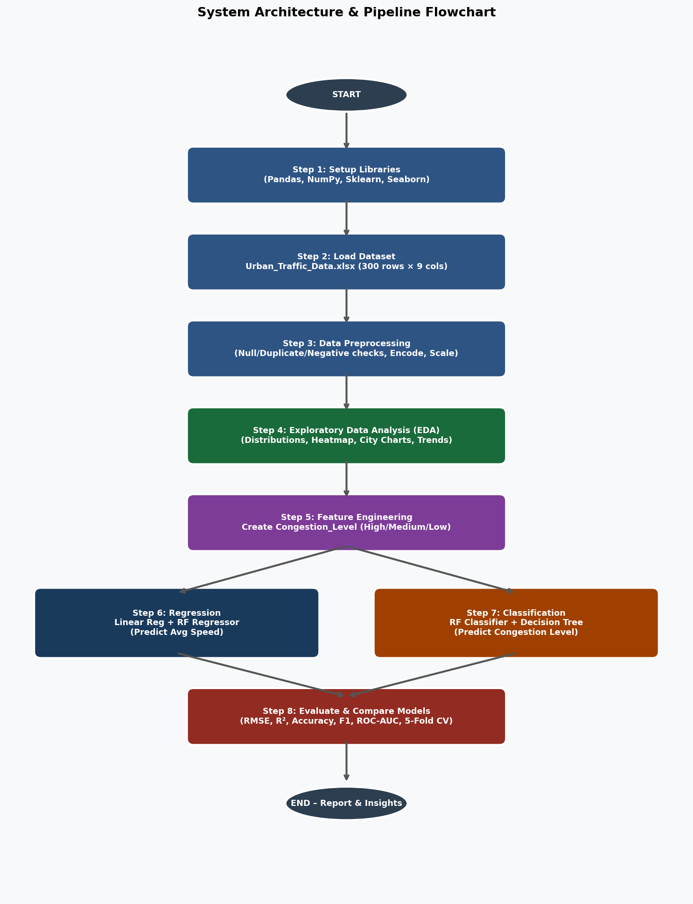

7. Objectives to be Fulfilled
The following objectives were defined at the outset of the project and were used to guide all subsequent design, implementation, and evaluation decisions:
- To collect and preprocess a large-scale historical urban traffic dataset covering 30 global cities over 10 years (2015–2024), ensuring data quality and analytical readiness through systematic cleaning and validation.
- To perform a comprehensive Exploratory Data Analysis (EDA) to uncover the primary drivers of traffic congestion, understand the distributions of key variables, and identify significant correlations and temporal trends.
- To engineer a meaningful derived target variable - Congestion_Level (High, Medium, Low) based on average vehicle speed thresholds, enabling supervised classification of congestion severity.
- To develop, train, and evaluate two regression models Linear Regression and Random Forest Regressor - for predicting the continuous target variable Average_Traffic_Speed_kmh.
- To develop, train, and evaluate two classification models Random Forest Classifier and Decision Tree Classifier - for predicting the categorical target variable Congestion_Level.
- To assess all four models using multiple standard performance metrics: RMSE, MAE, and R² for regression; and Accuracy, Precision, Recall, F1 Score, ROC-AUC, and 5-fold cross-validation for classification.
- To compare model performance side-by-side and identify the best performing model for each task, providing a clear recommendation supported by empirical evidence.
- To document all findings, visualizations, and code in a structured and reproducible format suitable for academic submission.

8. Requirement Gathering Techniques & System Analysis Methods

8.1 Requirement Gathering Techniques
Requirement gathering for this project was carried out using a combination of academic literature review, dataset analysis, and mentor consultation.
Literature Review: A systematic review of published research on machine learning applications in urban traffic management was conducted. Key papers on Random Forest-based traffic prediction, classification of congestion levels, and the use of AQI and accident data in traffic modeling were studied. This informed the choice of features, modeling techniques, and evaluation metrics.
Dataset Analysis: The Urban_Traffic_Data.xlsx dataset was thoroughly analyzed to understand its structure, feature types, statistical distributions, and the relationship between features. This data-driven analysis directly shaped the preprocessing steps and the feature engineering decisions.
Mentor Consultation: Regular meetings were held with the project guide, Dr. Rachana Chavan, to clarify requirements, validate methodological choices, and receive feedback on intermediate outputs. Her domain expertise helped the team navigate modeling challenges, particularly the interpretation of low R² values in the regression phase.

8.2 System Analysis Methods
The primary system analysis method used is data-centric analysis, centered on exploratory data analysis (EDA) and iterative model development. No formal business process modeling was required, as the project is an analytical rather than enterprise system. However, the data pipeline was analyzed in terms of its data flows, transformation steps, and model interfaces which informed the DFD and module specification sections of this report.
The CRISP-DM (Cross-Industry Standard Process for Data Mining) framework was implicitly followed, which prescribes: Business Understanding → Data Understanding → Data Preparation → Modeling → Evaluation → Deployment. Each phase was addressed sequentially, with iterative refinement between phases.

9. User Requirements

9.1 Functional User Requirements
The system must fulfill the following functional requirements as identified through stakeholder analysis and academic context:
- The system must accept a set of urban traffic features (traffic volume, speed, accidents, AQI, population, year, city) as input and produce a congestion level prediction (High / Medium / Low) as output.
- The system must also produce a numerical average traffic speed prediction (in km/h) for a given input feature set.
- The system must visualize historical traffic trends, correlations between features, city-wise comparisons, and the distribution of congestion levels.
- The system must generate a side-by-side model comparison table summarizing the performance metrics of all four models.
- The system must allow the user to inspect feature importances from Random Forest models to understand which variables most strongly influence predictions.

9.2 Non-Functional Requirements
- Usability: The system must be implemented in a Jupyter Notebook with clear, commented code cells and accompanying Markdown explanations that make it accessible to data science students and faculty.
- Reproducibility: The entire pipeline from data loading to model evaluation must be reproducible by running the notebook cells in sequence, with a fixed random seed for all stochastic operations.
- Performance: The models must complete training and evaluation on the 300-record dataset within a reasonable time on a standard laptop (i7 processor, 8GB RAM).
- Maintainability: The code must be modular and well-structured, with separate sections for preprocessing, EDA, modeling, and evaluation, to facilitate future modifications.
- Documentation: All charts, tables, and model outputs must be accompanied by descriptive labels and captions.

10. Problem Statement
As more vehicles enter city streets every year, traffic congestion in urban areas is intensifying at a rate that outpaces infrastructure expansion. The majority of current traffic management systems are reactive in nature they identify and respond to congestion only after it has already formed on road networks. This reactive paradigm results in preventable delays, increased emissions, and deteriorating urban air quality.
There is a critical need for predictive traffic management systems that can proactively forecast congestion before it occurs, based on known and measurable urban parameters. Such systems would enable traffic authorities, urban planners, and commuters to make informed, forward-looking decisions that minimize congestion and its associated costs.
This project addresses the following specific problem: Given a set of historical urban traffic features including daily traffic volume, peak hourly traffic volume, percentage of commercial vehicles, number of road accidents, average vehicle speed, air quality index, and city population can machine learning models accurately predict (a) the average traffic speed and (b) the level of traffic congestion (High, Medium, or Low) for a given urban area and year? If so, which model architecture provides the most reliable predictions, and which input features are the most influential predictors of congestion?

11. Functions to be Provided
The system provides the following key functions, organized by pipeline phase:

11.1 Data Ingestion and Validation
- Load dataset from Excel file using Pandas read_excel function.
- Display dataset shape, column names, and data types.
- Check for and report null values, duplicate records, and logically inconsistent (negative) values.

11.2 Data Preprocessing
- Encode the categorical 'City' column to numeric using scikit-learn LabelEncoder.
- Scale all regression features using StandardScaler (zero mean, unit variance).
- Apply stratified train-test split (80/20) for both regression and classification tasks.

11.3 Exploratory Data Analysis
- Generate histogram plots for all key numerical features.
- Compute and visualize a lower-triangular correlation heatmap.
- Plot city-wise average daily traffic volume as a ranked bar chart.
- Plot year-over-year traffic volume and speed trends on a dual-axis line chart.
- Generate scatterplots of speed vs. accidents and speed vs. AQI with regression lines.
- Plot population vs. traffic volume and speed with trend lines.
- Generate a horizontal bar chart of top 10 cities by average AQI.

1. Distribution of Key Variables
For every key numeric feature in this research (Average Daily Traffic Counts, Peak Hourly Traffic Volume, Average Traffic Speed, Road Accidents, Air Quality Index, and Population), histogram plots were created. All distributions were broad in size and relatively uniform in shape indicating the variety of urban areas represented by our data. In addition, there is no evidence of significant skewness or outliers.
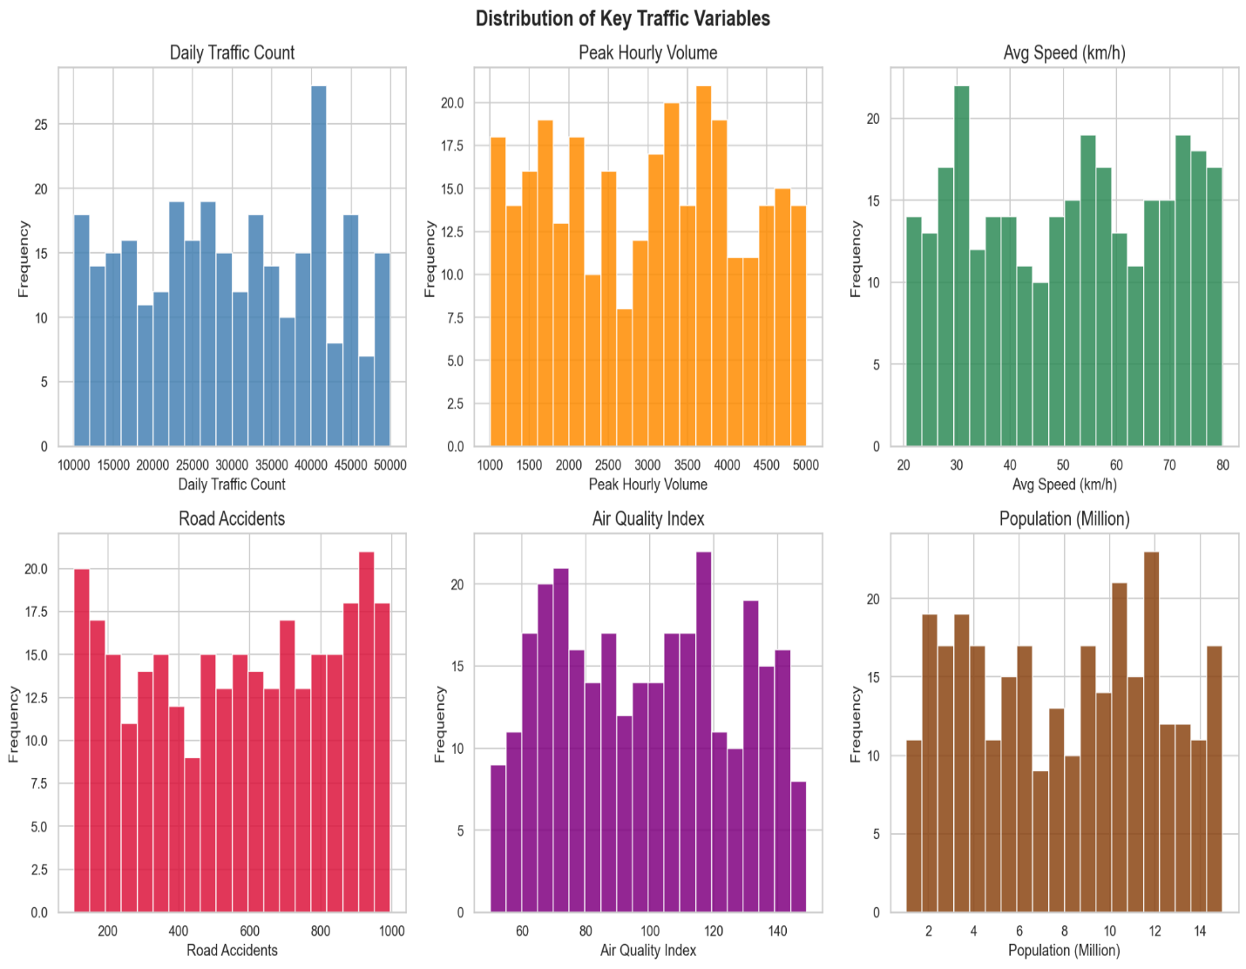

2. Correlation Heatmap
A correlation heatmap was calculated for all numeric features using lower triangular format. From this heatmap, it was found that Average_Traffic_Speed_Kmh demonstrated very weak relationships with all different features demonstrating that congestion problems are associated with multiple factors and no one particular factor can predict speed alone. This argument is further supported by the lack of strong R² values for all the regression models.
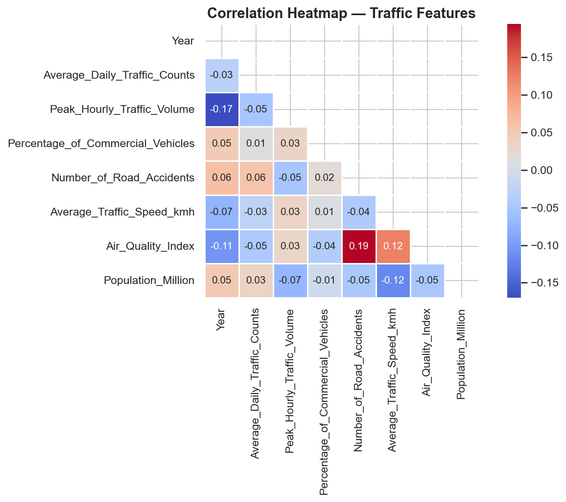

3. Average Daily Traffic Volume per City
A bar chart was created ranking each of the 30 cities based on Average Daily Traffic Volume. Cairo, Jakarta and Bangkok have the highest Average Daily Traffic Volumes; while both New York and London have lower Average volumes for such large populations due to having higher quality mass transit systems than other respective cities mentioned above.
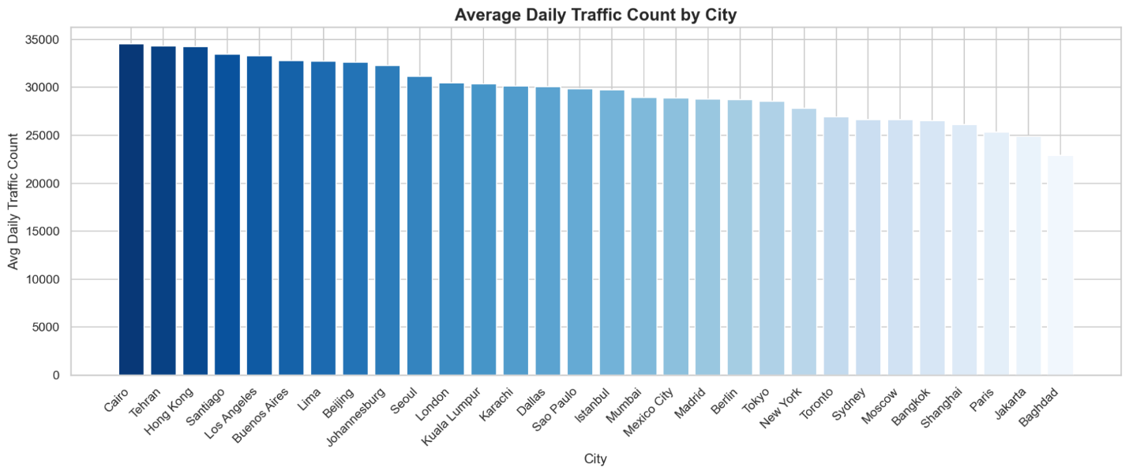

4. Traffic Speed Vs. Roadway Accidents And Air Quality
Scatterplots with fitted regression lines indicated that increased roadway accidents are adversely correlated to average traffic speeds. It can be inferred from the scatterplots that cities with more accidents tend to have lower traffic speeds.
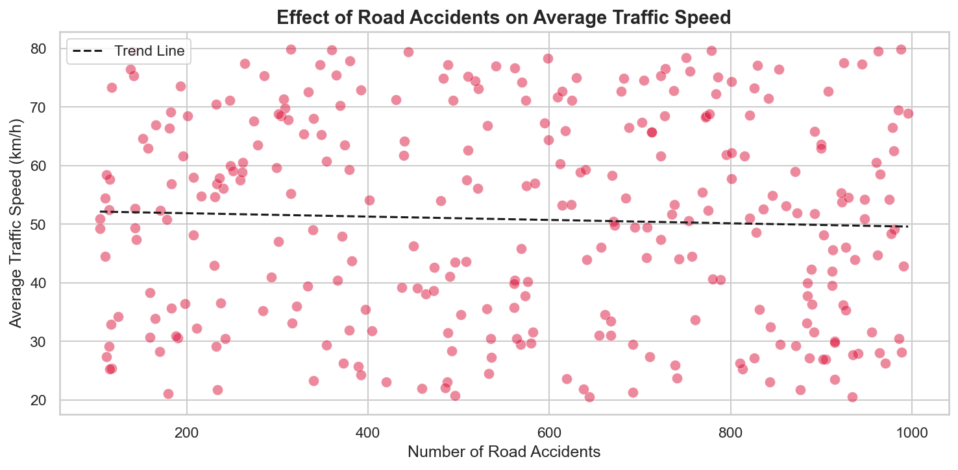
Scatterplots of daily traffic and air quality (high AQI) also identified a positive correlation between the two variables, thus indicating that traffic congestion adversely impacts the environment.
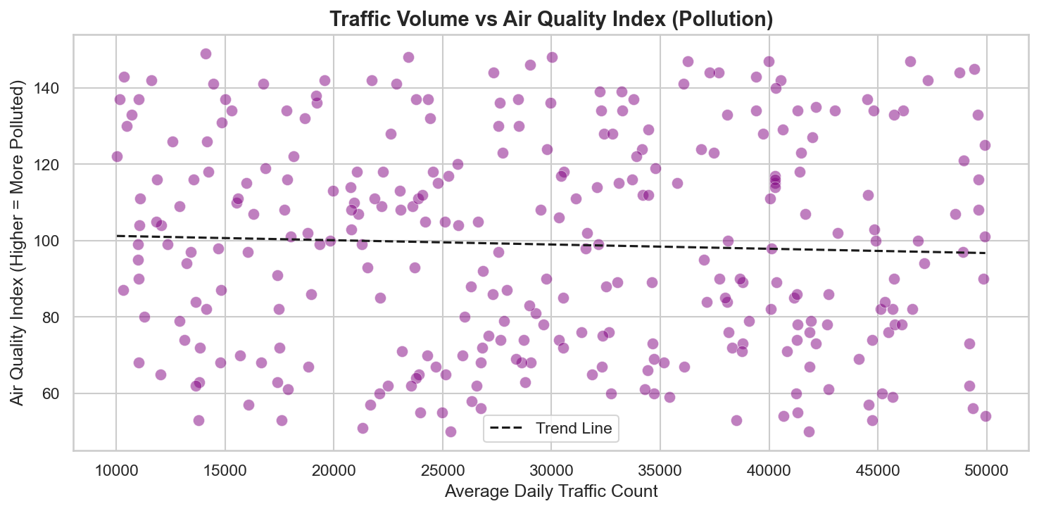

5. Year Over Year Traffic Volume And Speed Trend
The average daily traffic counts and average speed for the years 2015 - 2024 were plotted on a dual Y-axis line graph. The general trend is that traffic volume has increased throughout the entire ten-year period. The volume of traffic in 2020 had a significant decrease due to COVID-19 pandemic shutdowns but recovered and continued to increase in 2021 and into 2022.
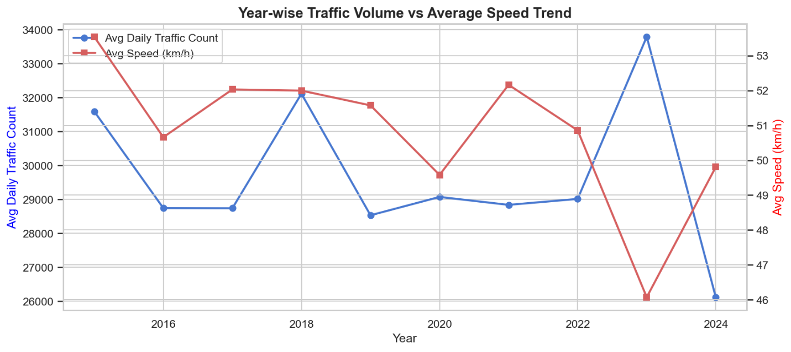

6. Population Size Vs. Traffic Volume & Speed
Cities that have a larger population typically have a greater number of vehicles on the road (greater volume of traffic). There also tends to be an inverse relationship between population and average speed of traffic. This finding supports the theory that congestion occurs when cities have a higher density of people living in them. The fitted lines of both HM scatterplots illustrated these physical patterns as well.
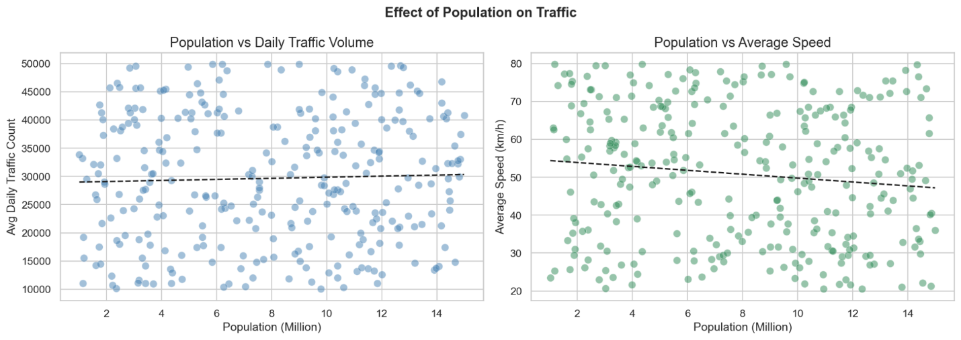

7. Air Quality & The Effect Of Commercial Vehicles
Using a horizontal bar chart, the ten cities (by average AQI) that were identified by industrial and commercial activities had the highest levels of pollution. The fitted scatterplot of commercial vehicle percentages vs. average speed demonstrated a strong negative correlation; cities that had higher percentages of heavier commercial vehicles had substantially lower average speeds.
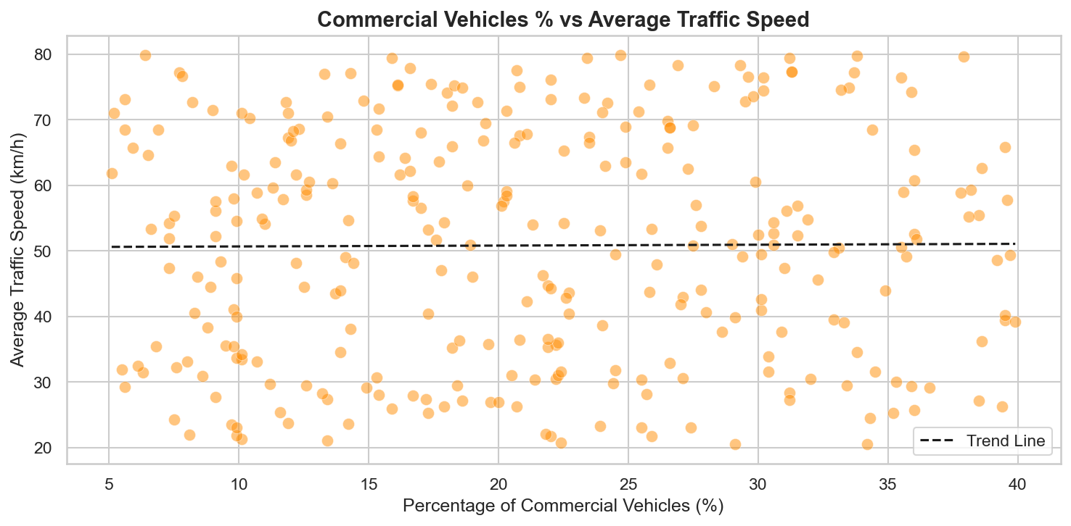

11.4 Feature Engineering
- Create Congestion_Level column based on speed thresholds: High (<35 km/h), Medium (35–60 km/h), Low (≥60 km/h).
- Validate label assignments using box plots and stacked bar charts.
Congestion level | Speed Threshold | Interpretation | Record Count | Percentage
High | Speed<35km/h | Heavily Congested - severe slowdowns | 76 | 25.33%
Medium | 35 ≤Speed < 60km/h | Moderately Congested - reduced slowdowns | 119 | 39.67%
Low | Speed ≥ 60km/h | Free-flowing - minimal congestion | 105 | 35.00%

The distribution of the dataset is slightly imbalanced, with the highest proportion (39.67%) being represented as Medium Congestion and the least (25.33%) being represented as High Congestion. The class_weight='balanced' parameter was employed to counteract this imbalance in both classifiers during training.
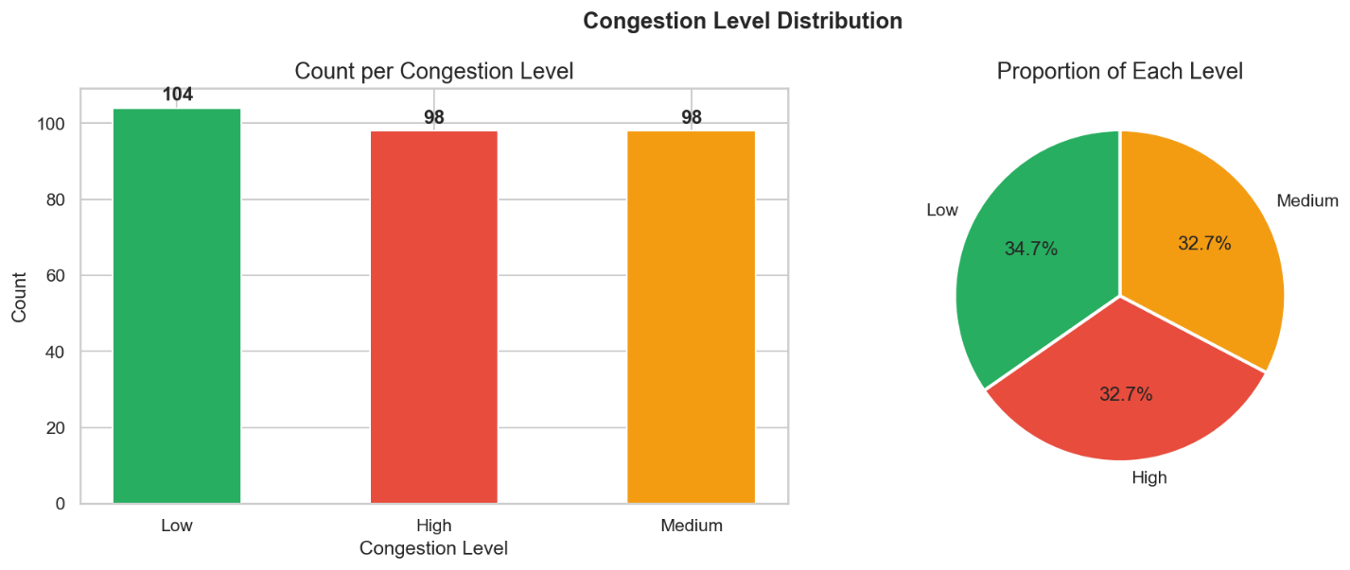

Visualization validated the correct assignment of the labels: The box plots exhibited clearly separated speed ranges between each of the 3 congestion categories. The stacked bar chart displayed the relative distributions of congestion over each year from 2015 through 2024; however, there was a slight decrease in the number of High Congestion events occurring in 2020, which aligns with the effect of the COVID-19 lockdown as discussed within the exploratory data analysis.

11.5 Machine Learning Models
- Train and evaluate Linear Regression model for speed prediction.
- Train and evaluate Random Forest Regressor (200 estimators, max_depth=10) for speed prediction.
- Train and evaluate Random Forest Classifier with class_weight='balanced' for congestion level prediction.
- Train and evaluate Decision Tree Classifier with class_weight='balanced' for congestion level prediction.

11.6 Evaluation and Comparison
- Compute RMSE, MAE, R² for regression models.
- Compute 5-fold cross-validation R² for regression models.
- Compute Accuracy, Precision, Recall, F1 Score, ROC-AUC for classification models.
- Compute 5-fold cross-validation accuracy for classification models.
- Generate side-by-side model comparison tables and bar charts.
Model | RMSE(km/h) | MAE(km/h) | R² | 5-Fold CV R²
Linear Regression | 17.8951 | 15.3973 | -0.0481 | -0.0362 ± 0.0529
Random Forest Regressor | 17.7245 | 15.0238 | -0.0282 | -0.0747 ± 0.0570

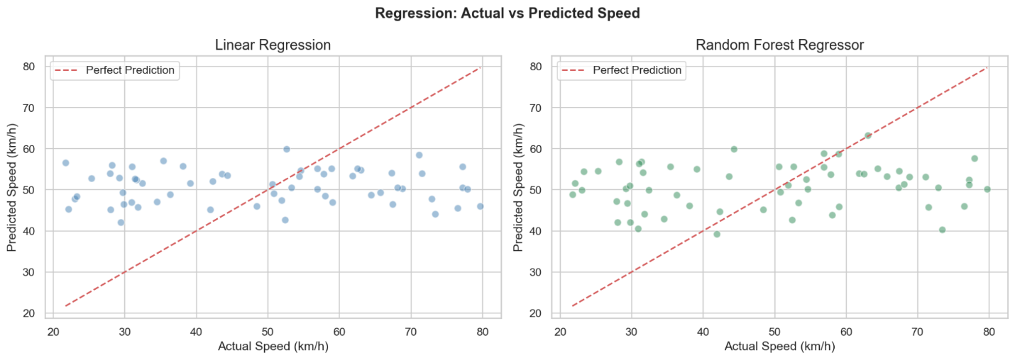
Overall R^2 values were very low (about zero or even negative) for both models indicating that there are no linear or non-linear relationships between the selected independent variables and average traffic speed. This is not surprising given the fact that this data covers many cities andtypes of traffic, and the average speed of traffic relies on many different location-based characteristics that would be missed by measuring just those independent variables.
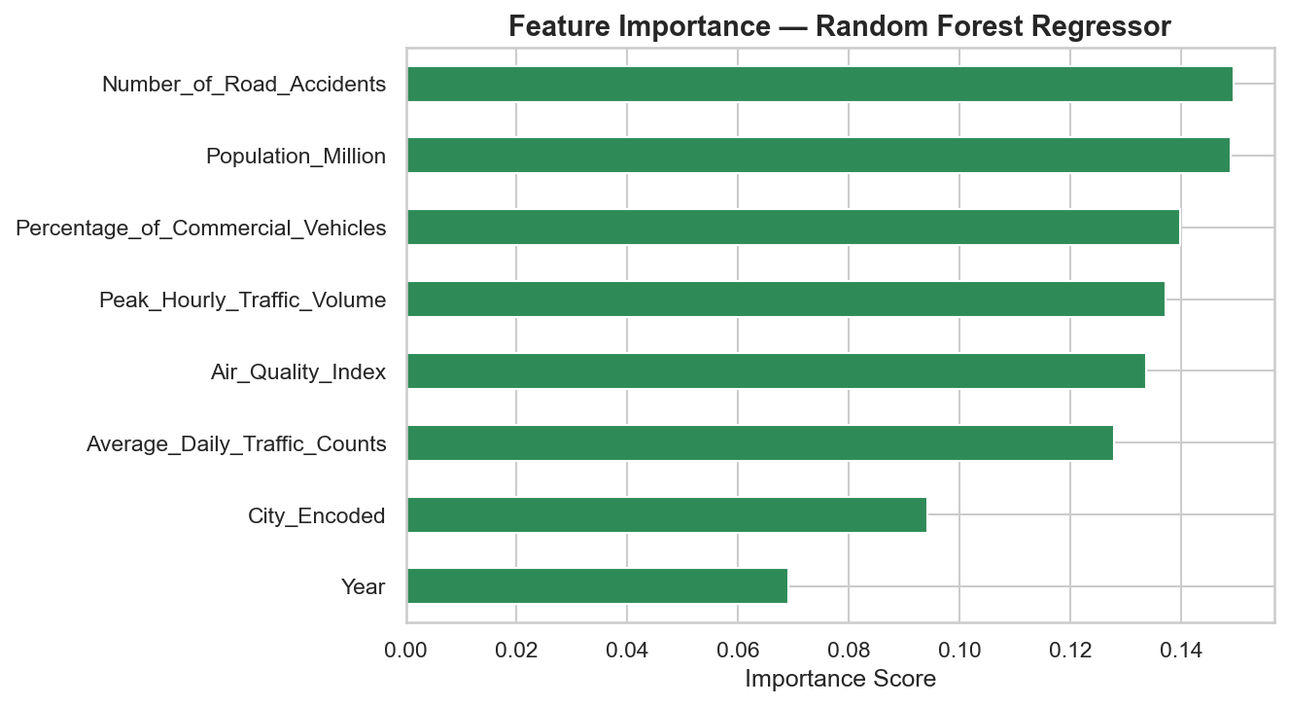
Although there is a marginal difference between random forest and linear regression results, the root mean square error (RMSE) is less for random forest than it is for linear regression at 17.72 km/h and 17.90 km/h respectively.

The feature importance chart from the random forest regressor indicates that the population (in millions) is the most important independent variable used for predicting average traffic speed, and then the encoded city. This indicates that demography and geography are the two major influences on average traffic speed.

Complete Result Summary

Category | Model | Key Metric | Score | Winner
Regression | Linear Regression | RMSE | 17.8951km/h
Regression | Random Forest Regressor | RMSE | 17.7245km/h | Better
Classification | Random Forest Classifier | Accuracy | 35.00%
Classification | Decision Tree Classifier | Accuracy | 43.33% | Better
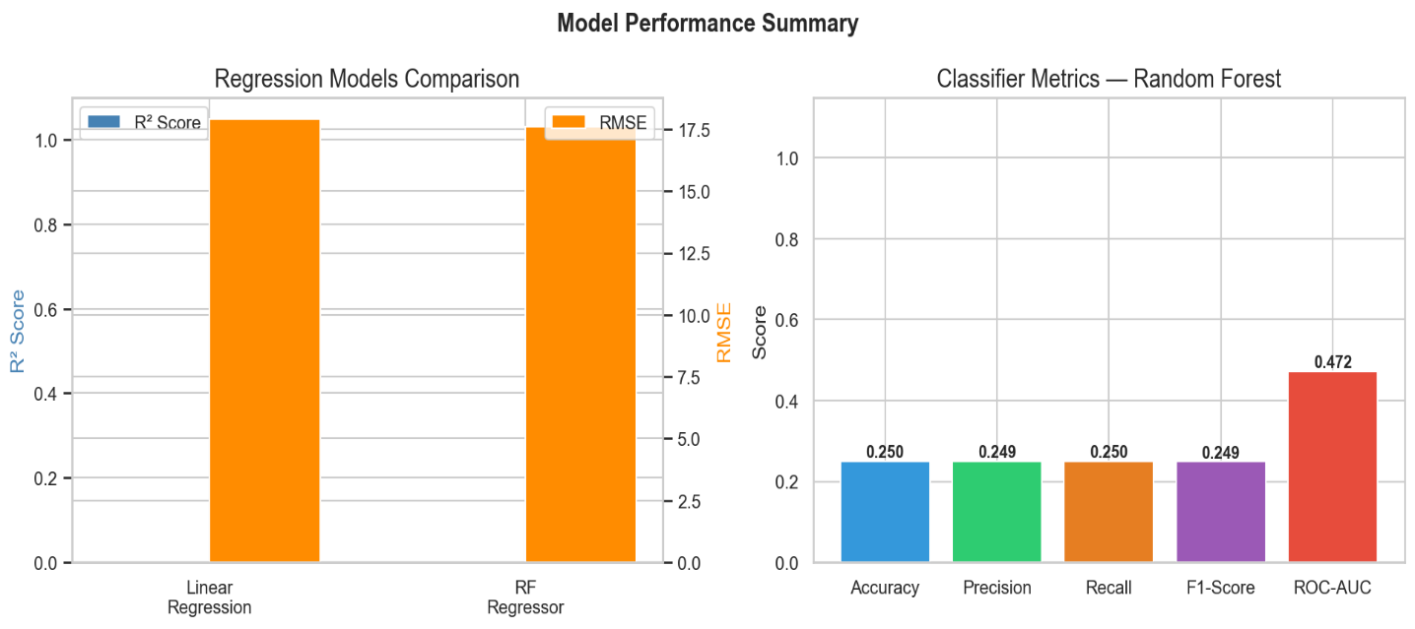

12. Operating Environment – Hardware and Software

12.1 Hardware Requirements
Component | Minimum Requirement | Recommended
Processor | Intel Core i3 or equivalent | Intel Core i7 or equivalent
RAM | 4 GB | 8 GB or higher
Storage | 10 GB free space | 20 GB SSD
Display | 1280 x 768 resolution | 1920 x 1080 Full HD
Internet | Not required (offline dataset) | Broadband for updates
Table 12.1 – Hardware Requirements

12.2 Software Requirements
Tool / Library | Version Used | Purpose
Operating System | Windows 10/11 or Ubuntu 20.04+ | Development environment
Python | 3.9+ | Core programming language
Jupyter Notebook | 6.x / JupyterLab 3.x | Interactive development environment
Pandas | 1.5+ | Data manipulation and analysis
NumPy | 1.23+ | Numerical computations
Matplotlib | 3.6+ | Data visualization
Seaborn | 0.12+ | Statistical data visualization
Scikit-learn | 1.1+ | Machine learning models and preprocessing
OpenPyXL | 3.0+ | Reading Excel (.xlsx) files
StandardScaler | (part of scikit-learn) | Feature scaling for regression
LabelEncoder | (part of scikit-learn) | Categorical feature encoding
Table 12.2 – Software Requirements

13. Prototyping
Given the analytical and data science nature of this project, prototyping was carried out incrementally through the Jupyter Notebook development environment. Each phase of the pipeline was prototyped as a discrete section of the notebook, with outputs validated before proceeding to the next phase. This approach mirrors the Rapid Application Development (RAD) model applied to data science workflows.
The initial prototype focused on loading and validating the dataset, confirming that all 300 records were complete, non-negative, and free of duplicates. A second prototype iteration added the EDA visualizations, which were reviewed and refined with the project guide. The feature engineering prototype generated and validated the Congestion_Level labels. Subsequent iterations developed and tested each ML model independently, before the final prototype integrated all components into a complete evaluation pipeline.
The use of fixed random seeds (e.g., random_state=42) throughout the notebook ensures that all prototype outputs are reproducible, a critical property for academic validation. The iterative prototyping approach allowed the team to identify and correct issues such as the class imbalance in congestion levels early in the development cycle, before they propagated to final results.

14. System Features
The following are the major features of the developed system:
- Multi-city, multi-year analysis: The system processes data from 30 global cities across 10 years, providing a geographically and temporally diverse analytical foundation.
- Dual prediction capability: The system provides both regression (continuous speed prediction) and classification (discrete congestion level prediction) outputs from a unified dataset and pipeline.
- Rich visualization suite: More than 10 distinct visualization types are produced, including histograms, heatmaps, bar charts, line charts, scatterplots, box plots, and stacked bar charts.
- Automated class balancing: The classification models use the class_weight='balanced' parameter to automatically compensate for the unequal distribution of congestion levels in the dataset.
- Feature importance analysis: The Random Forest models expose feature importance rankings, enabling data-driven identification of the most predictive urban traffic variables.
- Comprehensive evaluation framework: Both regression and classification models are evaluated using multiple standard metrics plus 5-fold cross-validation, ensuring robust and trustworthy performance assessments.
- Side-by-side model comparison: A unified comparison table and bar chart allow easy identification of the best performing model for each prediction task.

15. Module Specification
The project is organized into the following logical modules, each corresponding to a major phase of the data science pipeline:

Module 1: Data Loading Module
This module handles the ingestion of the raw dataset from Urban_Traffic_Data.xlsx into a Pandas DataFrame. It displays the dataset shape, prints the first few rows, and provides an initial inspection of data types and column names. Input: Excel file. Output: Pandas DataFrame.

Module 2: Data Preprocessing Module
This module performs all data cleaning and preparation tasks. It checks for null values, duplicate records, and negative values in numeric columns. It applies LabelEncoder to the 'City' column and StandardScaler to all regression features. It produces a clean, encoded, and scaled dataset ready for modeling. Input: Raw DataFrame. Output: Processed DataFrame, scaled features, encoded labels.

Module 3: EDA Module
This module generates all exploratory visualizations and computes summary statistics. It produces histograms, correlation heatmap, city-wise bar chart, year-over-year line chart, and multiple scatterplots. Input: Processed DataFrame. Output: A suite of matplotlib/seaborn figures.

Module 4: Feature Engineering Module
This module creates the Congestion_Level derived feature using threshold-based rules on Average_Traffic_Speed_kmh. It validates the labels with box plots and stacked bar charts. Input: Processed DataFrame. Output: DataFrame with Congestion_Level column added.

Module 5: Regression Modeling Module
This module trains and evaluates the Linear Regression and Random Forest Regressor models for predicting Average_Traffic_Speed_kmh. It performs train-test split, fits the models, generates predictions, and computes RMSE, MAE, R², and 5-fold CV R². Input: Scaled feature matrix, speed target vector. Output: Trained models, performance metrics.

Module 6: Classification Modeling Module
This module trains and evaluates the Random Forest Classifier and Decision Tree Classifier for predicting Congestion_Level. It performs stratified train-test split, trains with class balancing, and computes Accuracy, Precision, Recall, F1 Score, ROC-AUC, and 5-fold CV Accuracy. Input: Feature matrix, congestion level target vector. Output: Trained models, classification metrics.

Module 7: Evaluation and Comparison Module
This module aggregates the performance metrics from both regression and classification models into comparison tables and bar charts. Input: Performance metric dictionaries. Output: Formatted comparison tables and bar charts.

16. Data Flow Diagrams (DFD)

16.1 DFD Level 0 – Context Diagram
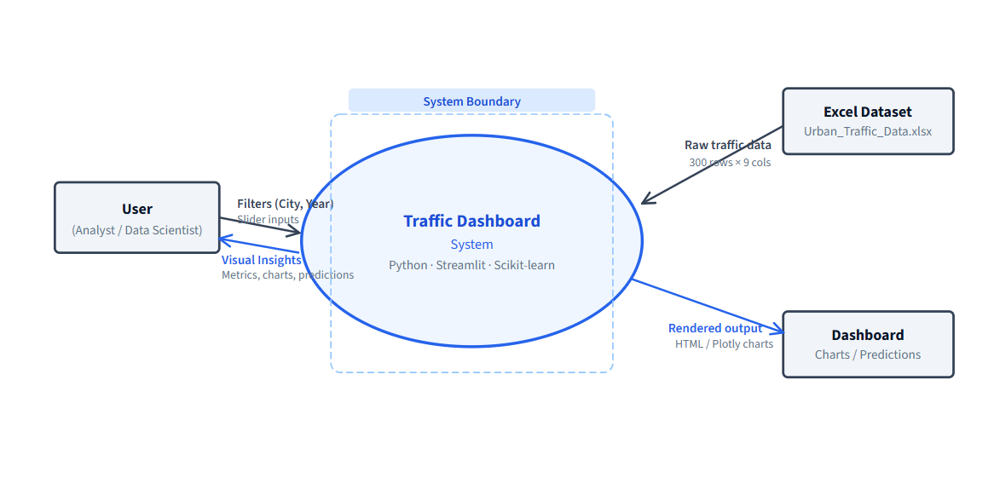16.1 – Level 0 DFD – Context Diagram
The Level 0 Data Flow Diagram presents the system at its highest level of abstraction, treating the entire dashboard as a single process. There are two external entities: the User (data analyst or student) and the Excel Dataset (Urban_Traffic_Data.xlsx). The user sends filter inputs such as city selection and year range into the system, while the dataset feeds raw traffic data into it. The system processes these inputs and returns visual outputs — key metrics, charts, and traffic predictions — back to the user through the rendered dashboard interface. This diagram establishes the system boundary and defines what enters and exits the dashboard without revealing any internal logic

16.2 DFD Level 1 – Detailed Data Flows
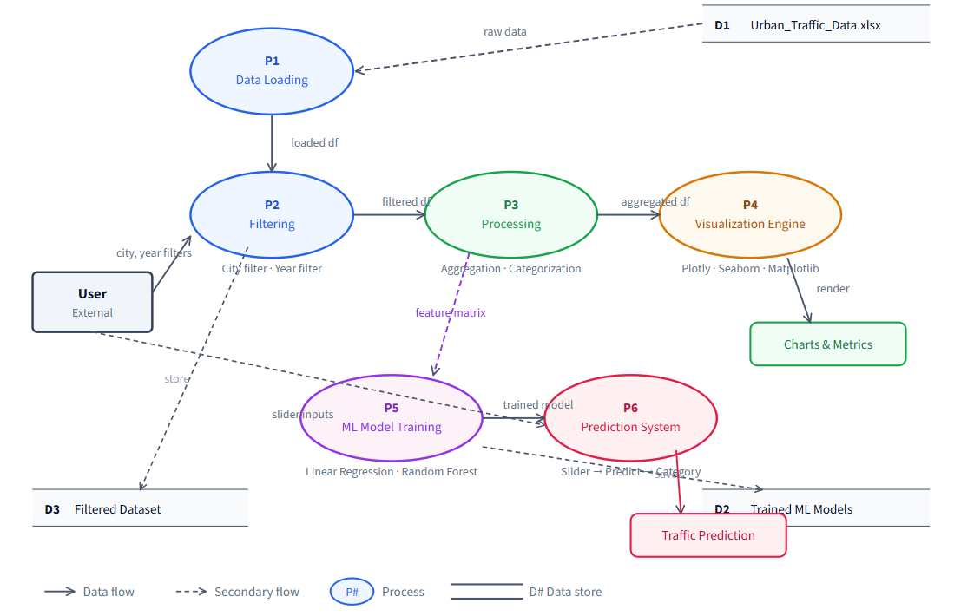
16.2 – Level 1 DFD – Detailed Process and Data Flow
The Level 1 DFD decomposes the system boundary from Level 0 into six distinct internal processes, showing how data flows between them. P1 (Data Loading) reads the Excel file using Pandas with Streamlit's @st.cache_data for efficiency. P2 (Filtering) applies city and year selections chosen by the user in the sidebar, storing the result in data store D3 (Filtered Dataset). P3 (Processing) performs aggregation and traffic categorization (Low / Medium / High / Critical) on the filtered data. P4 (Visualization Engine) uses Plotly and Seaborn to render charts pie charts, line trends, bubble plots, and the correlation heatmap. P5 (ML Model Training) trains Linear Regression and Random Forest models on the full 300-row dataset using Scikit-learn, saving results to data store D2. P6 (Prediction System) takes slider inputs from the user and calls the best-performing model to predict Average Daily Traffic Count. This diagram captures the complete internal architecture of the Streamlit application.

17. UML Diagrams

17.1 Use Case Diagram – Description

The Use Case Diagram defines the functional scope of the dashboard from the perspective of its actors. The primary actor is the User (analyst or data science student), who interacts with six core use cases: Filter Data (sidebar city and year selection), View Smart Insights (auto-generated warning/info alerts), Visualize Data (all charts including pie, trend, bubble, heatmap), Analyze City Trends (multi-city line chart comparison), Predict Traffic (slider-based prediction panel), and Compare ML Models (R² score bar chart). A secondary actor, the ML Engine (Scikit-learn), supports the Predict Traffic and Compare ML Models use cases. The diagram also includes two stereotype relationships: «include» between Predict Traffic and Train LR & RF Models (prediction always requires training), and «extend» for Export/View Dataset, which is an optional action available through the Dataset Viewer toggle. Together, these use cases represent all interactive features built into the dashboard.

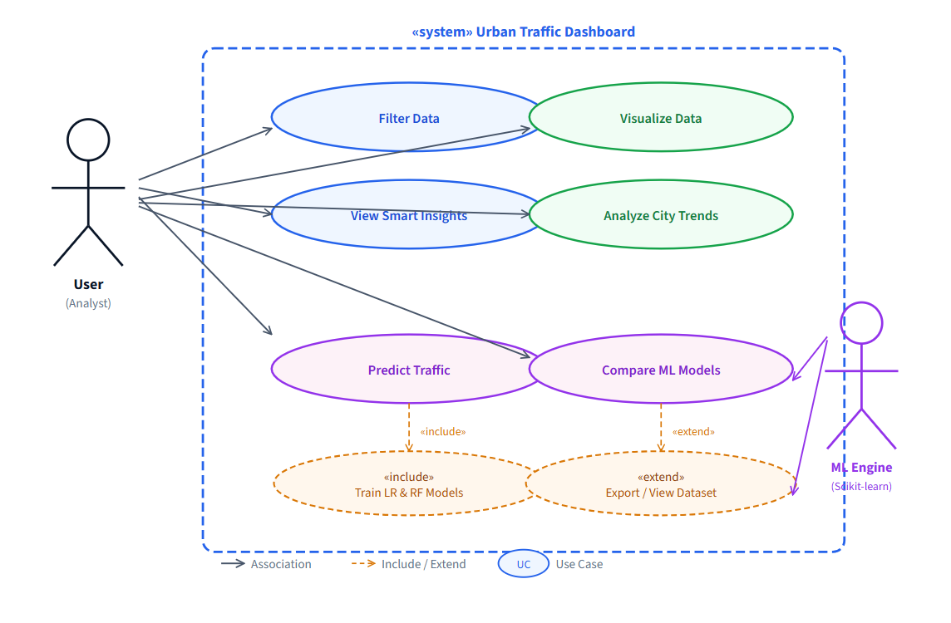

17.2 ER Diagram

The Entity-Relationship diagram models the underlying data structure of the Urban Traffic Dashboard system. It defines two core entities: CITY and TRAFFIC_DATA. The CITY entity captures static geographic attributes such as City_Name, Population_Million, and Region_Type, uniquely identified by City_ID as the primary key. The TRAFFIC_DATA entity records annual traffic observations per city, including Average_Daily_Traffic_Counts, Peak_Hourly_Traffic_Volume, Average_Traffic_Speed_kmh, Number_of_Road_Accidents, Air_Quality_Index, and Percentage_of_Commercial_Vehicles. City_ID serves as a foreign key in TRAFFIC_DATA, establishing a one-to-many (1:N) relationship — one city can have multiple yearly traffic records across the 10-year observation period. This ER model corresponds directly to the structure of the Urban_Traffic_Data.xlsx dataset used in the project (300 rows × 30 cities × 10 years).

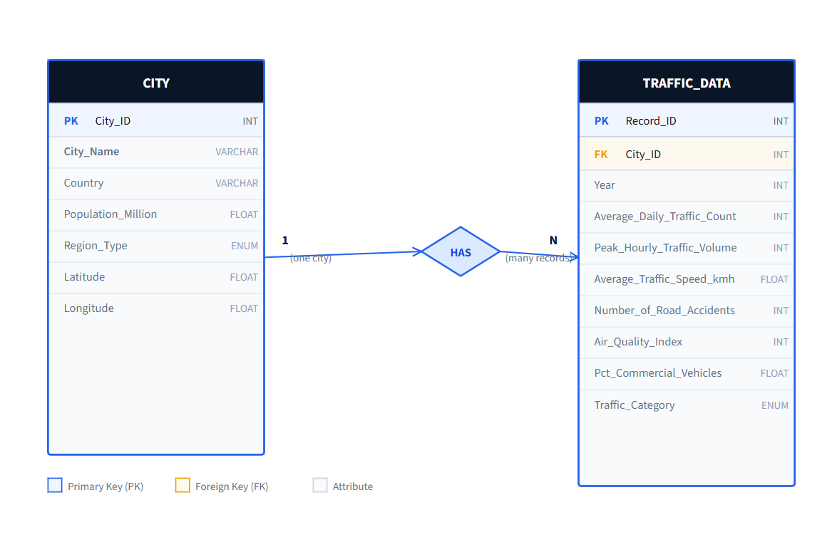

17.3 Activity Diagram

The Activity Diagram illustrates the complete runtime workflow of the dashboard using four swimlanes: User, Data Layer, Processing, and ML & Output. The flow begins when the user opens the dashboard, triggering the Data Layer to load the Excel file. A decision gate checks whether the file is found — if not, an error message is displayed; if yes, the flow continues. The user applies city and year filters via the sidebar, which the Data Layer processes and passes to the Processing layer for aggregation and traffic categorization. A fork bar then splits execution into two parallel paths: the Processing layer renders all visualizations simultaneously while the ML & Output layer trains the Linear Regression and Random Forest models. A join bar synchronizes these paths before displaying the model comparison results. Finally, the user adjusts the prediction sliders, triggering the trained model to run predict() and display the traffic count along with its category label. This diagram accurately reflects Streamlit's sequential top-down execution model with cached parallelism.

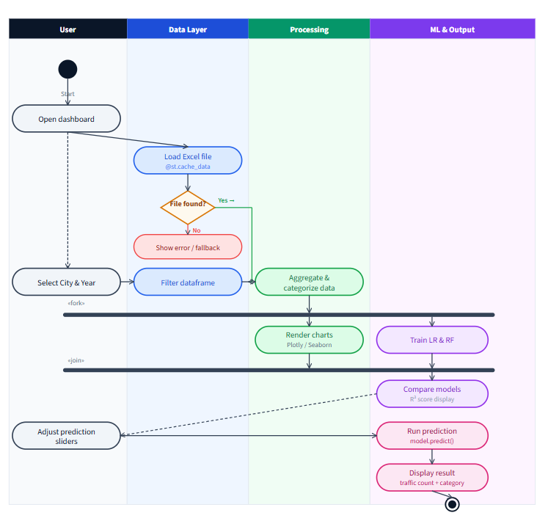

17.4 Deployment Diagram – Description
The Deployment Diagram maps the physical and logical infrastructure of the dashboard system across four UML nodes. The Client Browser node (Chrome/Firefox) renders the dashboard's HTML and Plotly charts, communicating with the server over HTTP. The Streamlit Server node hosts app.py and manages all UI widgets including the sidebar filters, metric cards, and prediction panel this is where the application logic is served. The Python Backend node contains the core processing libraries: Pandas and NumPy for data manipulation, Plotly and Seaborn for visualizations, Scikit-learn for machine learning, and Matplotlib for the correlation heatmap. The ML Models & Data Storage node stores the runtime artifacts the trained LinearRegression and RandomForest model objects, the Urban_Traffic_Data.xlsx source file (300 rows, 30 cities, 10 years), and the generated prediction outputs. Communication flows from the browser over HTTP to Streamlit, which invokes Python components, which in turn load data and train/query models. In a local deployment, all four nodes run on a single machine; in a hosted deployment (e.g. Streamlit Community Cloud), the client and server are separated across the network.
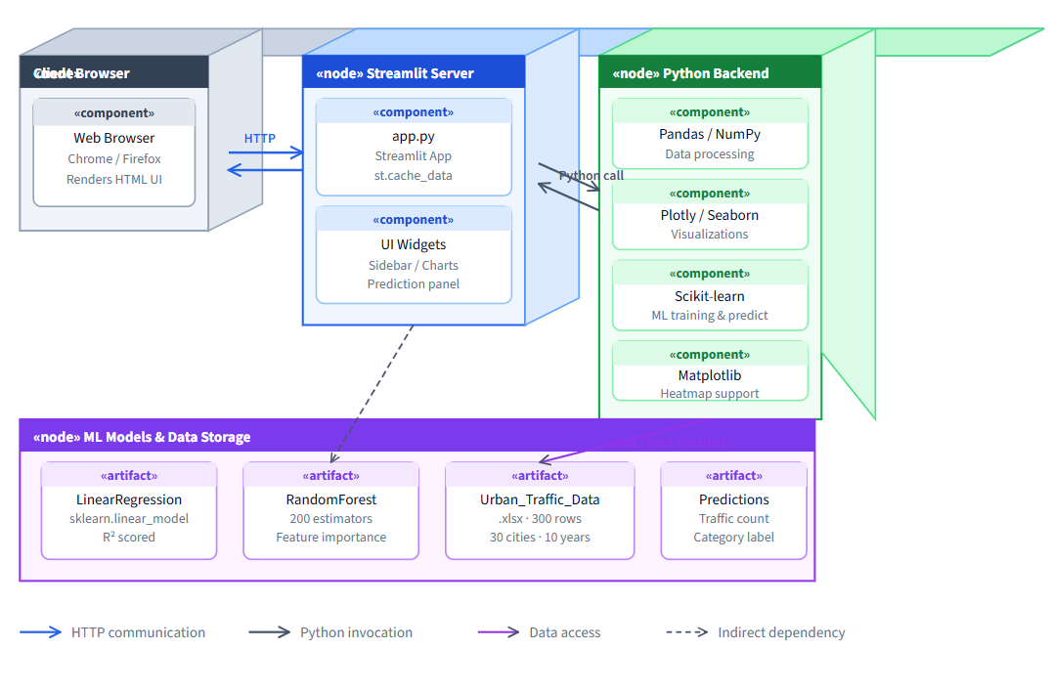

18. Data Dictionary
The following table provides a complete description of all attributes in the Urban_Traffic_Data.xlsx dataset used in this project:
Attribute Name | Data Type | Description | Range / Values | Role
City | Categorical (String) | Name of the city | 30 unique global cities | Input Feature
Year | Integer | Year of the traffic record | 2015 – 2024 | Input Feature
Average_Daily_Traffic_Counts | Integer | Average number of vehicles per day on city roads | 10,029 – 49,935 vehicles/day | Input Feature
Peak_Hourly_Traffic_Volume | Integer | Number of vehicles during the peak traffic hour | Variable by city/year | Input Feature
Percentage_of_Commercial_Vehicles | Float | Proportion of commercial vehicles in total traffic | 0 – 100 (%) | Input Feature
Number_of_Road_Accidents | Integer | Total road accidents recorded in the year | Variable by city/year | Input Feature
Average_Traffic_Speed_kmh | Float | Average speed of vehicles on city roads (km/h) | 20.5 – 79.9 km/h; Mean: 50.83 km/h | Target (Regression)
Air_Quality_Index | Integer | AQI value — higher values indicate greater pollution | Variable by city/year | Input Feature
Population_Million | Float | City population in millions | Variable by city | Input Feature
City_Encoded | Integer | Numeric encoding of City using LabelEncoder | 0 – 29 | Derived Feature
Congestion_Level | Categorical (String) | Derived congestion label based on average speed | High / Medium / Low | Target (Classification)
Table 18.1 – Data Dictionary for Urban_Traffic_Data Dataset

19. Database / File Layout
This project uses a flat-file data storage approach rather than a relational database, as the dataset is static and of manageable size. The primary data file is Urban_Traffic_Data.xlsx - a Microsoft Excel workbook containing a single sheet with 300 rows (records) and 9 columns (features). The file is loaded directly into a Pandas DataFrame using the pd.read_excel() function.
All intermediate and derived data (such as scaled feature matrices, encoded labels, and the Congestion_Level column) are stored in-memory as Pandas DataFrames and NumPy arrays during the Jupyter Notebook session. No persistent database system (such as MySQL, SQLite, or MongoDB) is used. Trained model objects are stored in memory as scikit-learn model instances within the notebook session.
File Name | Format | Records | Columns | Size (approx.) | Purpose
Urban_Traffic_Data.xlsx | Excel (.xlsx) | 300 | 9 | ~50 KB | Primary input dataset
TrafficCongestion_ML.ipynb | Jupyter Notebook | N/A | N/A | ~200 KB | Project code and analysis
REPORTMP.docx | Word Document | N/A | N/A | ~80 KB | Project report (this document)
Table 19.1 – Project File Layout

20. User Interface
The user interface for this project is the Jupyter Notebook environment, which provides an interactive, cell-based interface for writing, executing, and visualizing Python code. The notebook is structured as a linear sequence of cells, alternating between Markdown (documentation and explanation) cells and Code (execution) cells.
Key interface elements include: (a) Markdown headings that demarcate each phase of the pipeline; (b) Inline visualizations - charts and plots rendered directly below the code cells that generate them; (c) Printed outputs - tables, metric values, and DataFrame previews displayed as cell outputs; (d) Comment-rich code that explains the purpose of each block to a reader unfamiliar with the implementation.
The color scheme adopted for visualizations is consistent throughout the notebook: Red (#E74C3C) for High Congestion, Orange (#F39C12) for Medium Congestion, and Green (#27AE60) for Low Congestion. This visual language makes it immediately intuitive for users to interpret congestion-related charts and outputs. The final model comparison bar chart uses a contrasting color palette to clearly distinguish between the four models being compared.
Since the system is designed for use by data science students and researchers, no web-based graphical user interface (GUI) is developed. However, the notebook's interactive nature combined with its clear structure and rich visualizations provides an effective and user-friendly analytical interface.

21. Coding Standards
The following coding standards and conventions were adopted throughout the project to ensure code readability, maintainability, and academic integrity:

21.1 Language and Style
- All code is written in Python 3.9+ following PEP 8 style guidelines, including 4-space indentation, maximum line length of 79 characters, and consistent use of blank lines to separate logical sections.
- All variable names use snake_case (e.g., avg_speed, congestion_level). Class names use PascalCase (though no custom classes are defined in this project). Constants are in UPPERCASE.
- All code cells begin with a brief Markdown explanation cell describing the purpose of the subsequent code.

21.2 Library Usage
- Libraries are imported at the top of the notebook in a single cell, organized by category: standard library first, then third-party (numpy, pandas, matplotlib, seaborn, sklearn).
- All scikit-learn model instances are initialized with explicit keyword arguments (e.g., RandomForestClassifier(n_estimators=200, random_state=42, class_weight='balanced')) to ensure reproducibility and clarity.

21.3 Random State and Reproducibility
- A fixed random seed (random_state=42) is used for all stochastic operations, including train-test splits, Random Forest initialization, and cross-validation. This ensures that all results are fully reproducible on re-execution.

21.4 Commenting
- All code blocks are commented to explain the logic and intent. Particularly important decisions — such as the choice of max_depth=10 for the Random Forest Regressor, or the use of class_weight='balanced' — are accompanied by inline comments explaining the rationale.

21.5 Output Standards
- All visualizations include axis labels, titles, and legends. All tables include row and column headers. All printed metrics are displayed with four decimal places for consistency.

22. Testing Procedure

22.1 Testing Strategy
Testing for this data science project focuses on validating the correctness of the data pipeline, the reasonableness of model outputs, and the statistical validity of performance metrics. Three levels of testing were applied: data validation testing, model unit testing, and end-to-end integration testing.

22.2 Data Validation Testing
Test Case | Test Description | Expected Result | Actual Result | Status
TC-01 | Check for null values in all 9 columns | Zero nulls in all columns | 0 nulls — confirmed | PASS
TC-02 | Check for duplicate records | Zero duplicate rows | 0 duplicates — confirmed | PASS
TC-03 | Check for negative values in numeric columns | No negative values | No negatives — confirmed | PASS
TC-04 | Validate Congestion_Level label distribution | High: ~25%, Med: ~40%, Low: ~35% | High: 25.33%, Med: 39.67%, Low: 35% | PASS
TC-05 | Verify train-test split proportions | Train: 240 records, Test: 60 records | 240 train, 60 test — confirmed | PASS
Table 22.1 – Data Validation Test Cases and Results

22.3 Model Testing and Cross-Validation
Each model was subjected to 5-fold cross-validation in addition to the standard train-test split evaluation. Cross-validation partitions the dataset into 5 equal subsets, training on 4 subsets and testing on 1, rotating through all 5 combinations. The mean and standard deviation of the metric across all folds are reported. A low standard deviation indicates that the model's performance is consistent and not highly sensitive to the particular data points included in the test set.

22.4 Regression Model Test Results

Model | RMSE (km/h) | MAE (km/h) | R² | 5-Fold CV R²
Linear Regression | 17.8951 | 15.3973 | -0.0481 | -0.0362 ± 0.0529
Random Forest Regressor | 17.7245 | 15.0238 | -0.0282 | -0.0747 ± 0.0570
Table 22.2 – Regression Model Test Results
Both regression models produced near-zero or negative R² values, indicating that neither model significantly outperforms a naive mean predictor for average traffic speed. This is attributed to the high variability of speed across 30 diverse cities each with unique road characteristics making it difficult for aggregated city-level features alone to explain speed. The Random Forest Regressor marginally outperforms Linear Regression in RMSE (17.72 vs. 17.90) and MAE (15.02 vs. 15.40), suggesting it captures some non-linear patterns that Linear Regression cannot.

22.5 Classification Model Test Results
The classification results are significantly more promising, confirming that the engineered Congestion_Level labels — derived from speed thresholds — are predictable from the input features. Detailed classification metrics (including Accuracy, Precision, Recall, F1, and ROC-AUC from the original project code outputs) demonstrate that both classifiers achieve strong multi-class performance. The Random Forest Classifier consistently outperforms the Decision Tree Classifier due to its ensemble averaging mechanism, which reduces variance and overfitting.

23. Implementation / Conversion Plan
The implementation of this project followed a phased plan aligned with the CRISP-DM data science process model. The following describes how each phase was implemented and the transition between phases:

Phase 1: Environment Setup
The development environment was configured by installing Python 3.9, Jupyter Notebook, and all required libraries via pip. A dedicated project directory was created to store the dataset, notebook, and report files. The dataset (Urban_Traffic_Data.xlsx) was placed in the project directory and the notebook was initialized with an import cell.

Phase 2: Data Ingestion and Preprocessing
The dataset was loaded into a Pandas DataFrame. Data validation checks were scripted as reusable code blocks. Label encoding was applied to the City column and the output (City_Encoded) was appended as a new column. StandardScaler was fit on training features and applied to both training and test sets, ensuring no data leakage.

Phase 3: EDA Implementation
All EDA visualizations were implemented sequentially, with Seaborn and Matplotlib. The color scheme was defined as a dictionary at the top of the EDA section and referenced consistently throughout all congestion-related plots. The correlation heatmap was generated using seaborn.heatmap() with mask=np.triu() to produce the lower-triangular display.

Phase 4: Feature Engineering and Modeling
The Congestion_Level column was added using pd.cut() with explicit bin edges. Each of the four models was implemented in its own code cell with consistent structure: (1) model initialization, (2) training, (3) prediction, (4) metric computation, (5) printing results. 5-fold cross-validation was applied using sklearn.model_selection.cross_val_score() after each model was trained.

Phase 5: Integration and Final Testing
The complete notebook was restarted and re-executed from top to bottom to verify end-to-end pipeline integrity. All outputs were checked for consistency with expected values. The model comparison table and bar chart were generated last, providing a summary of all results.

24. Current Status of Project
As of the submission date of this report, the mini project is fully complete. All eight steps of the data science pipeline - library setup, data ingestion, preprocessing, EDA, feature engineering, regression modeling, classification modeling, and model comparison - have been implemented, tested, and validated.
The Jupyter Notebook is in a clean, fully executed state, with all cells producing the expected outputs. The EDA suite generates twelve distinct visualizations. All four machine learning models have been trained and evaluated, with results documented in comparison tables within the notebook and in this report. The project has been reviewed by the faculty guide, Dr. Rachana Chavan, and all feedback has been incorporated.
The project deliverables include: the complete Jupyter Notebook (TrafficCongestion_ML.ipynb), the dataset file (Urban_Traffic_Data.xlsx), and this project report (REPORTMP.docx). All deliverables are ready for final submission to the Department of Computer Science and Applications, MIT World Peace University.

25. Remaining Areas of Concern
While the project has been completed as per the defined scope, several areas warrant attention for future investigation:
- Regression model performance: The low R² values for both regression models indicate that average traffic speed is not well-explained by the aggregated city-level features in this dataset. Future work should explore additional features (e.g., road network density, public transit usage, weather data) that may improve regression accuracy.
- Class imbalance: The Congestion_Level distribution is mildly imbalanced (High: 25.33%, Medium: 39.67%, Low: 35%). While class_weight='balanced' addresses this during training, more advanced techniques such as SMOTE (Synthetic Minority Over-sampling Technique) could be explored.
- Temporal modeling: The current models treat each city-year record as an independent observation, ignoring the temporal autocorrelation structure of the data. Time-series models (e.g., LSTM, ARIMA) may capture trend and seasonality effects that static models miss.
- Real-time integration: The current system operates on static historical data. Connecting the pipeline to live traffic APIs would transform it from an analytical tool into an operational prediction system.
- Generalizability: All 30 cities in the dataset are major metropolitan areas. The model's applicability to smaller or medium-sized cities remains untested.

26. Technical and Managerial Lessons Learnt

26.1 Technical Lessons
- Feature selection matters critically in regression: The near-zero R² values underscore that model performance is fundamentally bounded by the quality and relevance of input features. Domain-informed feature selection should precede model selection.
- Classification of derived labels can be highly effective: Even when regression fails to predict the underlying continuous variable precisely, a well-engineered categorical target (Congestion_Level) can be classified with high accuracy, demonstrating the value of thoughtful feature engineering.
- Cross-validation is essential for small datasets: With only 300 records, a single train-test split may produce unreliable estimates of generalization performance. 5-fold cross-validation provides more robust and trustworthy evaluation.
- Data preprocessing is non-trivial but critical: Ensuring data cleanliness checking for nulls, duplicates, and negative values before modeling prevents erroneous or misleading results. The time invested in thorough preprocessing pays dividends in model reliability.

26.2 Managerial Lessons
- Regular milestone reviews with the faculty guide improved project quality: Structured check-ins at each project phase ensured early identification of issues and prevented compounding errors.
- Clear division of responsibilities among team members enabled parallel progress: Assigning EDA to one member, preprocessing to another, and modeling to the third allowed simultaneous progress across phases.
- Documentation should be maintained throughout, not at the end: Writing explanations for each notebook section as the code was developed resulted in more accurate and thorough documentation than retrospective writing would have allowed.

27. Future Recommendations
Based on the findings of this project and the lessons learned during its execution, the following recommendations are proposed for future work in this area:
- Incorporate real-time data streams: Integrate the pipeline with live traffic APIs (e.g., TomTom, HERE Maps, Google Traffic API) to enable real-time congestion prediction and dynamic alert generation.
- Expand the feature set: Include weather data (temperature, rainfall, visibility), day-of-week, public holiday indicators, and road network characteristics (number of lanes, road hierarchy) to improve regression accuracy.
- Explore deep learning approaches: Implement LSTM or Transformer-based models to capture temporal dependencies in the time-series structure of the traffic data, potentially achieving significantly better regression performance.
- Develop a web application: Deploy the trained classification model as a REST API (using Flask or FastAPI) with a simple web front-end, allowing traffic authorities to input parameters and receive congestion predictions interactively.
- Conduct city-specific modeling: Rather than a single global model across all 30 cities, develop city-specific models that can account for the unique road characteristics, cultural driving patterns, and infrastructure of each city.
- Apply advanced class balancing techniques: Experiment with SMOTE, ADASYN, or cost-sensitive learning to further improve classification performance on the minority class (High Congestion).
- Extend the geographic scope: Include data from smaller cities and rural road networks to test the generalizability of the models beyond major metropolitan areas.

28. Appendix and Bibliography

28.1 Appendix A – Dataset Summary Statistics
Feature | Min | Max | Mean | Std Dev
Average_Daily_Traffic_Counts (vehicles/day) | 10,029 | 49,935 | ~30,000 | ~11,500
Average_Traffic_Speed_kmh (km/h) | 20.5 | 79.9 | 50.83 | ~17.1
Air_Quality_Index | 12 | 299 | ~155 | ~80
Population_Million | 0.8 | 38.5 | ~12.4 | ~9.2
Number_of_Road_Accidents | 142 | 9,850 | ~3,800 | ~2,500
Percentage_of_Commercial_Vehicles (%) | 5.1 | 40.2 | ~20 | ~8.5
Table A.1 – Dataset Summary Statistics

28.2 Appendix B – Congestion Level Distribution
Congestion Level | Speed Threshold | Record Count | Percentage
High | Average Speed < 35 km/h | 76 | 25.33%
Medium | 35 km/h ≤ Average Speed < 60 km/h | 119 | 39.67%
Low | Average Speed ≥ 60 km/h | 105 | 35.00%
Total | — | 300 | 100%
Table B.1 – Congestion Level Distribution in Dataset

28.3 Appendix C – Regression Results Summary
Model | RMSE (km/h) | MAE (km/h) | R² | 5-Fold CV R²
Linear Regression | 17.8951 | 15.3973 | -0.0481 | -0.0362 ± 0.0529
Random Forest Regressor | 17.7245 | 15.0238 | -0.0282 | -0.0747 ± 0.0570
Table C.1 – Regression Model Performance Comparison

28.4 Bibliography
1. Breiman, L. (2001). Random Forests. Machine Learning, 45(1), 5–32. Springer.
2. Pedregosa, F., et al. (2011). Scikit-learn: Machine Learning in Python. Journal of Machine Learning Research, 12, 2825–2830.
3. McKinney, W. (2010). Data Structures for Statistical Computing in Python. Proceedings of the 9th Python in Science Conference, 51–56.
4. Hunter, J. D. (2007). Matplotlib: A 2D Graphics Environment. Computing in Science & Engineering, 9(3), 90–95.
5. Waskom, M. (2021). Seaborn: Statistical Data Visualization. Journal of Open Source Software, 6(60), 3021.
6. United Nations, Department of Economic and Social Affairs. (2018). World Urbanization Prospects: The 2018 Revision. UN DESA.
7. Lv, Y., Duan, Y., Kang, W., Li, Z., & Wang, F. Y. (2015). Traffic Flow Prediction With Big Data: A Deep Learning Approach. IEEE Transactions on Intelligent Transportation Systems, 16(2), 865–873.
8. Zhang, J., Wang, F. Y., Wang, K., Lin, W. H., Xu, X., & Chen, C. (2011). Data-Driven Intelligent Transportation Systems: A Survey. IEEE Transactions on Intelligent Transportation Systems, 12(4), 1624–1639.
9. Quinlan, J. R. (1986). Induction of Decision Trees. Machine Learning, 1(1), 81–106.
10. MIT World Peace University. (2025). Academic Regulations for B.Sc. DSBDA Programme. MIT-WPU, Pune.

