Please press **S** for continue.

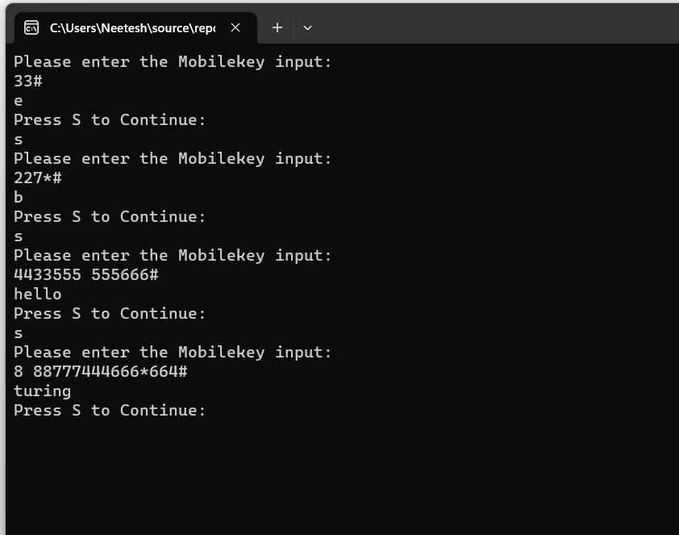

**Input 33#**

**Output e**

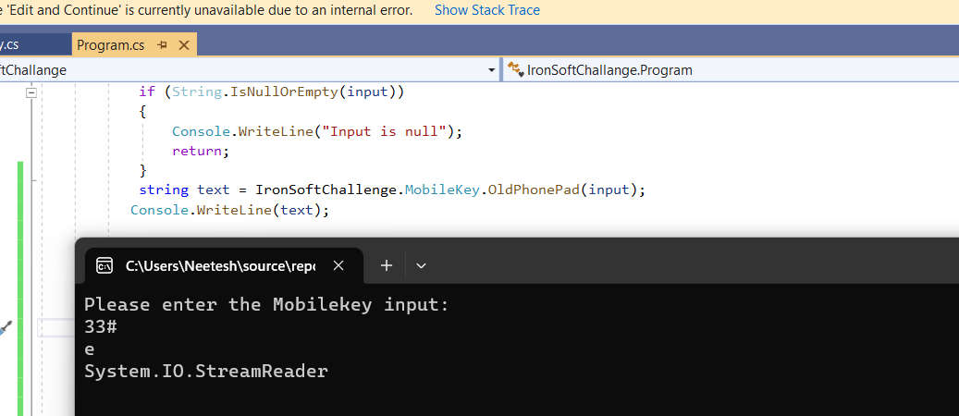

**Input 227*#**

**Output b**

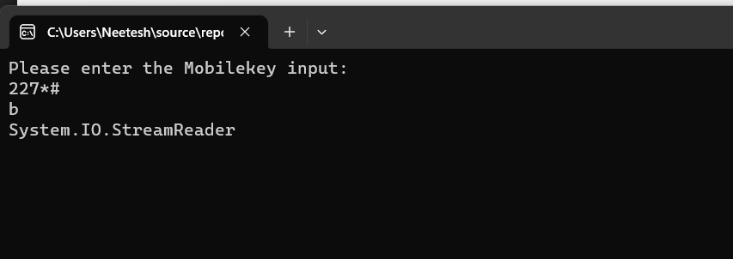

Input: 4433555 555666#

Output: hello

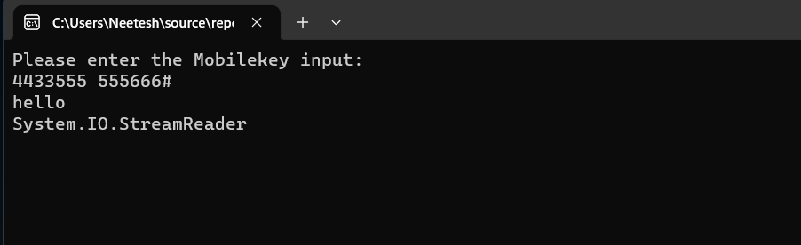

Input : 8 88777444666*664#

