STOCK MARKET PREDICTIONS USING MACHINE LEARNING
Table of Contents
Introduction 3
Aim and Objectives 3
Aim 3
Objectives 3
Research Questions 3
Project Description 4
Methodology 5
Data Collection 5
Data analysis techniques 6
Research Plan 7
Conclusion 7
References 8

Introduction
As a result of the quick and complex nature of market fluctuations, it has always been difficult to make precise forecasts about the stock market. When economic indicators, historical data, and technological advancement are all in sync with one another, machine learning emerges as a tool that is very beneficial for the job at hand. In order to conduct an in-depth analysis of the intricate market patterns, the strategy calls for the use of machine learning techniques. This will result in a change to the methodology that is used to estimate the stock market. The purpose of the project is to improve the accuracy of predictions by using cutting-edge computer algorithms and a broad variety of different data sources. The objective of the platform is to provide purchasers with useful information that will assist them in navigating the intricate and constantly shifting financial environment.

Aim and Objectives

Aim
This research explores and utilises machine learning approaches to better estimate and make choices within the financial markets, for stock market investigation.

Objectives
- To analyse stock markets, machine learning methods are employed.
- To determine the effectiveness of different regression methods, including the ARIMA model, for this it has been aimed to assess their performance.
- To enhance the reliability of financial market predictions and decision-making tools.
- To compile the study efficiently, it is important to utilise a range of prior research articles.

Research Questions
- Is it possible for computer programmes that make use of machine learning to properly forecast the movement of the stock market?
- Which kind of machine learning models are the most effective for forecasting the stock market?
- How does the inclusion of different financial measurements and global elements affect the accuracy of estimates?
- How accurate are the predictions made by machine learning models in comparison to more conventional methods of prediction?

Project Description
The stock data from Amazon that is currently accessible on Kaggle will be used for the project. Throughout the course of the last several years, the data shown below illustrates the daily pricing of Amazon stock (AMZN) expressed in American dollars. A number of significant characteristics, including beginning and ending costs, transaction volume, and high and low values, are included in the data, which makes it a good source for research since it covers these characteristics. Complex time series forecasting techniques, such as “Autoregressive Integrated Moving Average (ARIMA) and Seasonal ARIMA (SARIMA)”, will be employed in order to get relevant data for the project. These techniques will be utilised in order to gain value (Oroojlooy and Hajinezhad, 2023). However, these models are powerful in portraying the changes that manifest in the financial time series data when the feature of time and the direction is modified. The quaternary step in the project means the use of EDA—exploratory data analysis will be applied as part of the project measures to study Amazon-based pricing evaluation to try and find out which patterns, trends, and any deviations are present in the analysed data (Ozbayoglu et al. 2023). By adopting the concept of exploratory data analysis, it is possible to gain a better understanding of the features associated with the set of datasets used.
The time series analysis will use stock data as they help to have a good measure of the natural variations in time. This is one method that may be attempted, given that it is a possibility, to disaggregate the time series into trend and variance because of (Pang et al. 2020). When this happens, it means it is so much easier to identify the broader patterns. Apart from stringent experimental and time-series analysis, in order to realise the goal of attaining the high and genuine knowledge related to the swings that can be made on Amazon’s stock prices, a blend of ARIMA and SARIMA models will be used. In appliance to this project, users are capable of demonstrating how difficult statistical models can be applied in real-world financial data to generate informed predictions on the stock market.

Methodology

Data Collection
The utilisation of the secondary data, which is used for the current research also includes the Amazon stock data sets that are purchased from Kaggle, a very reliable platform that has been renowned for its good track record of making data sets sharing possible. With such details, it is not complicated to identify the historical daily opening and closing values of Amazon stock. Finally, the application incorporates a range of important financial statistics and trade figures.
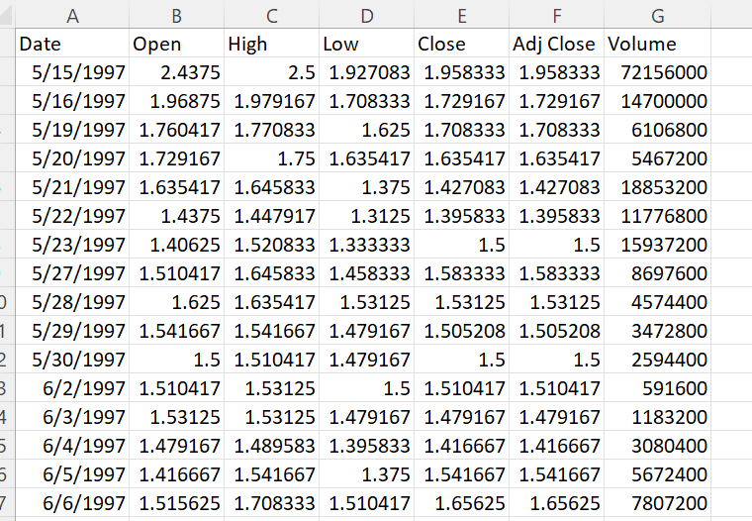
Figure 1: Dataset of Amazon
(Source: Self-Obtained)
The utilisation of the secondary data, which is used for the current research, also includes the Amazon stock data sets that are purchased from Kaggle, a very reliable platform that has been renowned for its good track record of making data set sharing possible. With such details, it is not complicated to identify the historical daily opening and closing values of Amazon stock. Finally, the application incorporates a range of important financial statistics and trade figures. The link to the dataset is “https://www.kaggle.com/datasets/varpit94/amazon-stock-data” which can be accessed from the Kaggle. It has seven columns which are date and price-related variables which are open, high, low, close, adjacent close and last one is volume

Data analysis techniques
The most economical approach for this investigation is to utilise the readily available data because this approach takes the least amount of time compared to developing new information and it allows resources to be concentrated on other areas that require finances and attention. Finding more relatable actual facts and conducting the complex machine learning models in action is problematic for the first objective (Ray, 2019). Exploratory data analysis and time series analysis are two types of analysis that are most commonly employed in order to use the secondary data to which one obtains access through Kaggle. By using ARIMA and SARIMA models, it is possible to acquire a clearer understanding of the emerging patterns that could prove to be more precise regarding the possible trends in the stock market in the future.
In the course of this study, a method was formulated and implemented in sequential order with a view of unveiling the key trends and features in the pricing data from Amazon. Therefore, they improved the time series forecast models that they had previously already built. (Sengupta et al. 2020). However, one of the fundamental things to consider in the data entry process is how the data is prepared before its entry. In order to evaluate the Amazon stock data rates, this data is imported from Kaggle and given a complete analysis to ensure the accuracy of the data. In future, if date-based labelling is used, then the process of performing a time series investigation might prove to be simpler because such labelling is easy to apply and understand (Qiu et al. 2020). The consequent organisation will incorporate the utilisation of exploratory data analysis (EDA), information visualisations, outline measurements, and affiliation investigation to find designs and likely exceptions.
Learning more about EDA permits one to induce bits of knowledge into picking worthy highlights and set up a full get handle on the course of action of the dataset. It is in circumstances like these that time arrangement examination truly sparkles. To discover designs, cycles, and residuals, the information is considered to begin with being broken down into an assortment of distinctive ways. For this reason, to create accurate models, it is essential to assess the consistency of factual characteristics throughout the course of this time period (Shah et al. 2020). During the subsequent stage, which is known as feature engineering, the user chooses characteristics that are very important based on the findings of the exploratory data analysis. Additionally, latency characteristics may be introduced in order to better illustrate changes in time progression. Following the completion of the requisite stages, tried-and-true models such as the “Autoregressive Integrated Moving Average (ARIMA) and the Seasonal ARIMA” have been employed for the purpose of producing forecasts. It can generate accurate forecasts about the future price of Amazon stock if they have access to a considerable quantity of data.

Research Plan
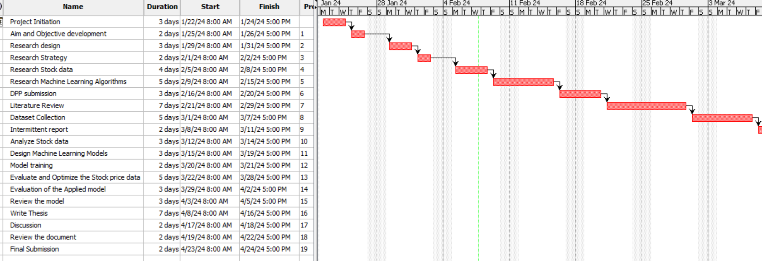
Figure 2: Project plan for analysis of stock data using various ML models
(Source: Self-Generated)

Conclusion
Following the conclusion of the study, a complete overview of the use of machine learning in stock market research is presented. For the sole purpose of doing this, the Amazon stock dataset that was obtained from Kaggle is employed. During the course of the research, the group will make use of cutting-edge techniques in order to improve the precision of their predicted outcomes. The time-series analysis, experimental data analysis, ARIMA and SARIMA models are examples of such investigations. The focus of this research is to assess the prediction abilities of machine learning models of stocks in understanding historical data and a large number of financial characteristics.
A process involving a long and tedious process of preparing the data, aggregating preliminary analysis, and applying more variables in the model, is being used to improve the results associated with the calculation. Consumers are offered a sort of step-by-step procedure to understand the patterns, certain trends, and outliers embedded in the Amazon pricing data completely. To conclude, this study contributes to the area of financial forecasting whereby complex statistical models enable real-world data on the fluctuations of the market to demonstrate adaptability to changes in the stock market as a dynamic and evolving ecosystem.

References
Orooj Looy, A. and Hajinezhad, D., 2023. A review of cooperative multi-agent deep reinforcement learning. Applied Intelligence, 53(11), pp.13677-13722.
Ozbayoglu, A.M., Gudelek, M.U. and Sezer, O.B., 2020. Deep learning for financial applications: A survey. Applied Soft Computing, 93, p.106384.
Pang, X., Zhou, Y., Wang, P., Lin, W. and Chang, V., 2020. An innovative neural network approach for stock market prediction. The Journal of Supercomputing, 76, pp.2098-2118.
Qiu, J., Wang, B. and Zhou, C., 2020. Forecasting stock prices with long-short term memory neural networks based on attention mechanisms. PloS one, 15(1), p.e0227222.
Ray, S., 2019, February. A quick review of machine learning algorithms. In 2019 International conference on machine learning, big data, cloud and parallel computing (COMITCon) (pp. 35-39). IEEE.
Sengupta, S., Basak, S., Saikia, P., Paul, S., Tsalavoutas, V., Atiah, F., Ravi, V. and Peters, A., 2020. A review of deep learning with special emphasis on architectures, applications and recent trends. Knowledge-Based Systems, 194, p.105596.
Shah, D., Isah, H. and Zulkernine, F., 2019. Stock market analysis: A review and taxonomy of prediction techniques. International Journal of Financial Studies, 7(2), p.26.

