
UNIVERSITY OF HERTFORDSHIRE
School of Physics, Engineering and Computer Science
MSc Advance Data Science and Analytic
DATA SCIENCE AND ANALYTICS MASTER PROJECT 7COM1075
Date: 11-03-2024
STOCK MARKET PREDICTIONS USING MACHINE LEARNING

Name: Neetha Hosaholalu Chandrashekar
Student ID: 22009275
Supervisor: Julia Goncharenko
Table of Contents
Introduction and Overview 3
Aim 3
Objectives 3
Research Question 3
Background 3
Progress to Date 5
Completion of Data Collection 5
Implementation of Software 6
Data Cleaning 7
EDA 8
Planned work 8
Model Development 8
Evaluation 9
Optimization 9
Documentation 9
References 11

Introduction and Overview
As a result of the quick and complex nature of market fluctuations, it has always been difficult to make precise forecasts about the stock market. When economic indicators, historical data, and technological advancement are all in sync with one another, machine learning emerges as a tool that is very beneficial for the job at hand. In order to conduct an in-depth analysis of the intricate market patterns, the strategy calls for the use of machine learning techniques. This will result in a change to the methodology that is used to estimate the stock market. The purpose of the project is to improve the accuracy of predictions by using cutting-edge computer algorithms and a broad variety of different data sources. The objective of the platform is to provide purchasers with useful information that will assist them in navigating the intricate and constantly shifting financial environment.

Aim
This research explores and utilises machine learning approaches to better estimate and make choices within the financial markets, for stock market investigation.

Objectives
- To analyse stock markets, machine learning methods are employed.
- To determine the effectiveness of different regression methods, including the ARIMA model, for this it has been aimed to assess their performance.
- To enhance the reliability of financial market predictions and decision-making tools.
- To compile the study efficiently, it is important to utilise a range of prior research articles.

Research Question
Which kind of machine learning models are the most effective for forecasting the stock market and how they will be evaluated?

Background
The stock market is characterised by a dynamic and complex panorama of highly fluctuating prices and details. As per the view of Azaz et al. (2023), investment analysts, traders and financial experts alike are in constant pursuit of developing ways that can predict trends with both accuracy and precision. As illustrated by Balasubramanian et al. (2024), with the introduction of such changes, more people will make the transition to other sectors of the economy and hence generate revenues. Till the other day game, fundamental, and technical analysis remained the most popular methods of examination or research. While the handling of big data and the ignoring of non-linear interactions remains an unresolved issue, the scientific research community is inclined to search for alternative methods.
The last decade has seen the widespread application of machine learning to predict commodity prices. As cited by Bhati et al. (2022), potential grounds come about from not only technological advances but also the possibility of having historical data at the disposal and incorporation of economic factors into scientific research. Machine learning, a part of AI which allows computers to learn from data and automatically identify similar patterns, is a tool that is used in many programs. As per the view of Dehankar et al. (2021), a new technology may be able to give detailed analytics about how markets work, and this, quite possibly, can give more accurate and real-time predictions than the existing ones.
The reasoning for starting the project lay in the fact that the markets evolve quickly and new trends often emerge without prior warning, making necessary the production of a device which would be quicker and smarter in comparing past and future outcomes. Machine learning provides an ability to dig out data from the masses, identify even complex patterns, and adapt to market changes, which all lead to better decisions. The technique intends to do this by applying the best machine learning techniques that are available out there, so to speak, so that the stock market predictions will be revolutionised and in the end, the financial decision-making will be improved. In the past, forecasts about the stock market would be based on price motion, earnings reports, and economic variables. As stated by Htun et al. (2022), while search volume, keyword targeting and the like still play a big role in the success of campaigns, more data including different types of available now necessitates a more nuanced kind of analysis. ML effectively deals with the data under the complex perception, by searching for detail patterns which can go unnoticed with other methods.
The stock market is impacted by various factors such as world economic happenings, geopolitical changes and views of financial sector stakeholders. With machine learning models that do natural language processing and mood analysis, complex considerations may be envisaged. It’s important to have a better idea of how the market operates. The purpose of this project is to conduct research in finance using machine learning to predict future stock trends. In future, it is recommended that purchasers and decision-makers employ state-of-the-art technology, and different databases and always stick to truthfulness while trying to understand and manage stock markets. This project represents a major step forward in leveraging machine learning within the finance sector. It shows how data-driven decisions will shape the future of stock trading in an ever-changing world.

Progress to Date
The successful launch of the project marks a turning point in applying machine learning to predict the stock market. Having all the needed software tools installed and implemented, the broad range of literature reviewed and data collected make the developmental process complete.

Completion of Data Collection
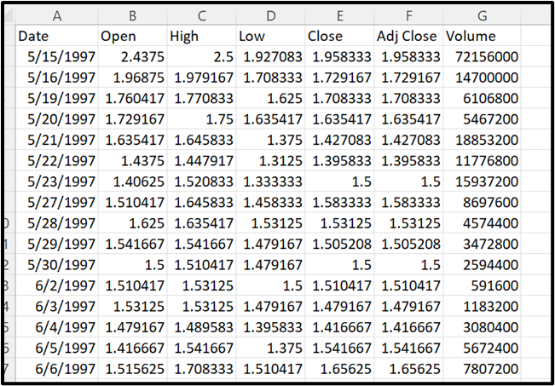
Figure 1: Amazon stock Data for the project
(Source: Self-Acquired)
Prioritising research data collecting was crucial. This research used Amazon pricing data from Kaggle, a popular dataset supplier. The file "AMZN.csv" has the Date, Open, High, Low, Close, Adj Close, and Volume columns. Historical Amazon stock opening and closing prices are shown here. The dataset has 6257 rows and 7 columns. Amazon's stock performance may be assessed yearly by exploring this comprehensive collection's time series. This dataset includes Open, High, Low, Close, Adj Close, and Volume. The dataset's Date column was changed from object to datetime for analysis. Statistics affect stock prices. Stock market activity is shown by means and standard deviations. According to Koukaras et al. (2022), the data can train and test machine-learning algorithms on over 6,000 products.

Implementation of Software
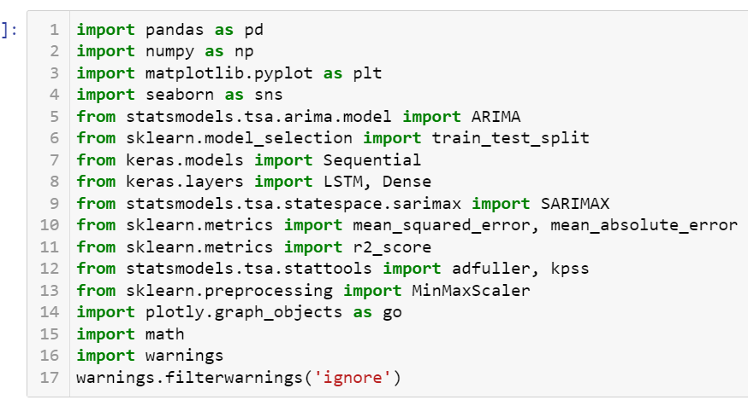
Figure 2: Libraries used
(Source: Self-Generated)
The software architecture provides sophisticated libraries and tools for extensive research and predictive modelling. This method needs Python. Python is suitable for complex stock market data due to its data science adaptability. Pandas and Numpy are necessities for data analysis. This software preprocesses datasets and extracts insights. Trend analysis and pattern finding are straightforward using Matplotlib and Seaborn. Stat models, especially ARIMA, are utilised for time series analysis. Scikit-learn readily integrates machine learning algorithms with model assessment and performance monitoring tools for accurate prediction models. Keras creates and trains LSTM networks to extract complex temporal correlations. Plotly creates appealing analytical charts. This entire toolkit quickly analyses data, builds models, and evaluates performance to deliver reliable stock market forecasting insights.
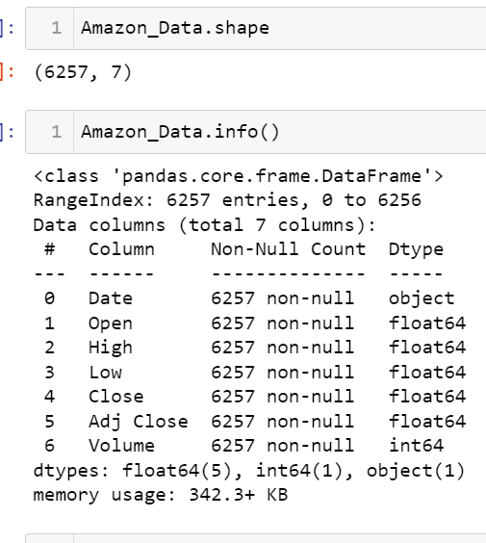
Figure 3: Data Exploration
The data exploration has been done with the help of pandas as visualised in the above figure. The shape and information of the dataset have been retrieved with the shape and info function.

Data Cleaning
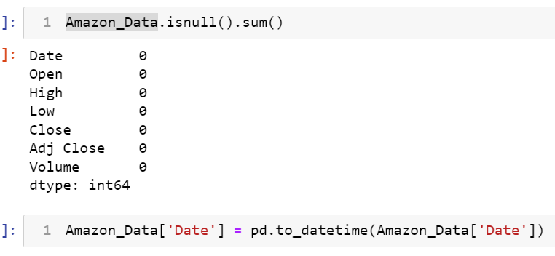
Figure 4: Data cleaning of the Amazon data
The data cleaning has been done where the data has been checked with null values and no null values have been found in the data.

EDA
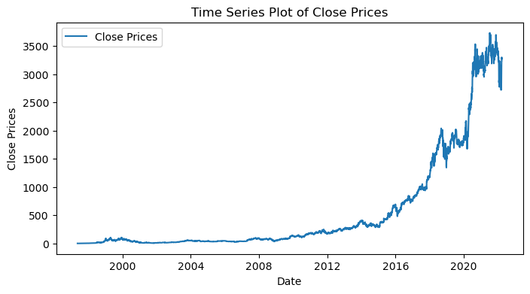
Figure 5: Time series analysis of close price
The close price which will be used further for forecasting and evaluation has been used to retrieve the time series analysis. The other EDA part has also been done where a histogram of volume has been done to acquire the frequency, and a chart of stock price has been visualised with a candle stick graph, and scatter plot of close and open price.

Planned work

Model Development
This conversation focuses heavily on the implementation of machine learning strategies, specifically on constructing prediction models. In the not-too-distant future, three key models will be created. The models mentioned are the Long Short-Term Memory (LSTM) model, the Seasonal Autoregressive Integrated Moving Average (SARIMA) model, and the Autoregressive Integrated Moving Average (ARIMA) model. Every type has its own unique set of capabilities and advantages that are exclusive to individuals. Utilising this method allows for generating accurate forecasts and conducting in-depth analysis of data that follows a time series. You can achieve both of these outcomes. As cited by Nikumbh and Vijaykumar (2023), patterns and transient correlations in authentic stock market information are viably captured by ARIMA due to its moving normal and autoregressive components. ARIMA can successfully capture time-related designs. With this data, the demonstration can precisely speak to the designs and associations in address.
Recurrent neural networks (RNNs), and more particularly Long Short-Term Memory networks, exceed expectations of perceiving distant associations inside successive information. RNNs can learn through involvement. By consolidating Long Short-Term Memory (LSTM) into the method of foreseeing developments within the stock advertise, the show picks up the capacity to perceive complicated designs and linkages that have existed for long periods. Working with datasets that show repetitive designs or patterns, the Seasonal Autoregressive Integrated Moving Average (SARIMA) show may be an accommodating device to have at its transfer. The SARIMA demonstrate joins regularity components, upgrading the exactness of the ARIMA show for a particular reason. Concerning the potential of SARIMA to portray the patterned nature of stock showcase practices, a certain degree of adequacy can be credited to the demonstration.

Evaluation
A thorough process will assess model efficacy. Historical data is used to test stock market prediction systems. Benchmark models guarantee that selected models meet or surpass industry requirements. As per the view of Rouf et al. (2021), model accuracy and precision are measured by MSE, MAE, and R-squared. Compare all models against metrics to determine strengths and weaknesses.

Optimization
Improve prediction models' accuracy and dependability. Improved feature engineering and hyperparameters can remedy overfitting and underfitting. Adjust autoregressive/moving average terms and differencing order to enhance ARIMA/SARIMA models. Improve LSTM network design, learning rate, and batch size. Altering the model ensures stock market forecasts match. Models need frequent optimisation to predict and react to financial market developments.

Documentation
Comprehensive, flexible project documentation is needed. Preserving development and assessment insights helps project teams learn. Second, repeatability and openness let other researchers and professionals check and replicate findings. Methodology, data preparation, model architecture, hyperparameter selections, and optimisation rationale will be explained. Triumphs and difficulties will be examined. Clarity, performance measurements, and model visualisations will be supplied. Data will help machine learning stock market trend forecasts. Sharing methods, mistakes, and insights helps finance researchers improve predictive models via collaboration and iteration.

References
Azaz, H.K., Shah, A., Abbas, A., Shahid, R., Zahid, Z.U., Sharif, M.U., Jan, T. and Zafar, M.H. 2023, "A performance comparison of machine learning models for stock market prediction with novel investment strategy", PLoS One, vol. 18, no. 9.
Balasubramanian, P., Chinthan, P., Badarudeen, S. and Sriraman, H. 2024, "A systematic literature survey on recent trends in stock market prediction", PeerJ Computer Science, .
Bhati, K., Bamne, K., Kamineni, S. and Kumar, P. 2022, "Visualizing and Forecasting Stock Price", International Research Journal of Innovations in Engineering and Technology, vol. 6, no. 4, pp. 44-48.
Dehankar, A., Itankar, A., Meshram, A., Bhople, N. and Patle, B. 2021, "Review on Stock Market Prediction", International Research Journal of Innovations in Engineering and Technology, vol. 5, no. 6, pp. 13-15.
Htun, H.H., Biehl, M. and Petkov, N. 2023, "Survey of feature selection and extraction techniques for stock market prediction", Financial Innovation, vol. 9, no. 1, pp. 26.
Koukaras, P., Nousi, C. and Tjortjis, C. 2022, "Stock Market Prediction Using Microblogging Sentiment Analysis and Machine Learning", Telecom, vol. 3, no. 2, pp. 358.
Nikumbh, A. and Vijaykumar, S. 2023, "Stock Price Prediction an Intelligent Approach", BVIMSR’s Journal of Management Research, vol. 15, no. 1, pp. 23-28.
Rouf, N., Majid, B.M., Arif, T., Sharma, S., Singh, S., Aich, S. and Hee-Cheol, K. 2021, "Stock Market Prediction Using Machine Learning Techniques: A Decade Survey on Methodologies, Recent Developments, and Future Directions", Electronics, vol. 10, no. 21, pp. 2717.

