
UNIVERSITY OF HERTFORDSHIRE
School of Physics, Engineering and Computer Science
MSc Advance Data Science and Analytics
Advanced Computer Science Master Project 7COM1039-0206-2023
Date: 04-29-2024
STOCK MARKET PREDICTIONS USING MACHINE LEARNING
Name: Neetha Hosaholalu Chandrashekar
Student ID: 22009275
Supervisor: Julia Goncharenko
Abstract
This research focuses on utilizing ML algorithms for forecasting path of the financial world, which can aid in the making of decisions by investors, financial analysts, and organizations alike. Data analysis includes data preprocessing, Exploratory Data Analysis (EDA), and feature selection and such statistical methods to examine stock prices and trading volumes and volatility trends over time. Three key models are employed: The LSTM, SARIMA, and ARIMA approaches, which are innovative in their ability to fully capture the cyclical behaviours and the trend series within stock market samples. Analysing these models leads to a conclusion that LSTM has higher predictive capabilities, thus indicating that it can process intricate data patterns more accurately than other networks. In the process the model assessment metrics like Mean Absolute Error (MAE) and Root Mean Square Error (RMSE) lay out the prediction accuracy of LSTM in stock return forecasting. The paper puts the focus on using special models means to address the non-stationary nature of the stock market and thus emphasizes the possibility of ML to be used to achieve high predictive accuracy. The LSTM model showed the ability to interpret the complex data patterns as well as the relationships among data by consequently improving the predictive performance. Furthermore, this research gave an insight into the high dependence on complex models dealing with the non-stationarity problems of the stock market data to shed light on the role of modern machine learning methods, for instance LSTM, in achieving better predicting accuracy and thus informing the investors of effective decisions in the dynamic investment arena.
Keywords: Machine Learning, Stock Market Prediction, LSTM, SARIMA, ARIMA, Data Analysis, Model Assessment, Forecasting Accuracy, Non-Stationarity.
Acknowledgement
I wish to convey my heartfelt gratitude to the scholars and the researcher who shared their powerful insights and perspectives, which constitute of this research. Moreover, I thanks to my mentor has given me a significant amount of support and has helped me to navigate the process at the same time. I would much like to express my gratefulness to organizations who allowed me for acquaintance with data and resources that I used in the course of this study. Collectively, their contribution and joint efforts have made it possible for this research mission to achieve its global goal.

MSc Final Project Declaration
This report is submitted in partial fulfilment of the requirement for the degree of Master of Science in Advance Data Science and Analytic at the University of Hertfordshire (UH).
It is my own work except where indicated in the report.
I did not use human participants in my MSc Project.
I hereby give permission for the report to be made available on the university website provided the source is acknowledged.

Table of Contents
CHAPTER 1: INTRODUCTION 8
1.1 Introduction 8
1.2 Aim and Objectives 9
Aim 9
Objectives 9
1.3 Research Questions 9
1.4 Background 9
1.5 Problem statement 10
1.6 Scope of the Study 11
1.7 Legal, Ethical, Social, and Professional Issues 12
1.8 Dissertation structure 12
1.9 Summary 13
CHAPTER 2: LITERATURE REVIEW 14
2.1 Introduction 14
2.2 Development of Machine Learning in Finance 14
2.3 Overview of Stock Market Prediction Models 16
2.4 Arima Model for Stocks Data 17
2.5 Time Series Analysis with Machine Learning 19
2.6 Challenges and Limitations 20
2.7 Literature Gap 21
2.8 Summary 22
CHAPTER 3: METHODOLOGY 24
3.1 Introduction 24
3.2 Research Strategy 24
3.3 Research Approach 24
3.4 Research design 25
3.5 Data Collection Method 25
3.6 Data analysis 27
3.7 Data preparation and cleaning 28
3.8 Exploratory data analysis 31
3.9 ADF and KPSS testing 34
3.10 Summary 36
CHAPTER 4: RESULTS AND ANALYSIS 38
4.1 Model Applied on stocks 38
4.2 Discussion 43
4.3 Linking with Objectives 44
CHAPTER 5: CONCLUSION AND RECOMMENDATIONS 45
5.1 Conclusion 45
5.2 Recommendation 46
5.3 Achieving the aim of the study 47
5.4 Research Questions analysis 47
5.5 Future Scope 47
References 49
Appendies 54

List of Figures
Figure 1.8.1: Structure of the final report 12
Figure 2.3.1: Stock market-based application of ML techniques 17
Figure 2.4.1: Elements of ARIMA model 18
Figure 3.5.1: Amazon stock Data for the project 26
Figure 3.7.1: Importing of libraries 28
Figure 3.7.2: Data Shape and information 29
Figure 3.7.3: Statistics of Amazon data 30
Figure 3.7.4: Data Preprocessing 30
Figure 3.8.1: Time Series plot 31
Figure 3.8.2: Stock price candle stick chart 32
Figure 3.8.3: Histogram of volume 33
Figure 3.8.4: Scatter plot for high and low prices 34
Figure 3.9.1: Testing and analysis with ADF test 34
Figure 3.9.2: Testing and analysis with KPSS test 35
Figure 4.1.1: Analysis based on the Arima model 38
Figure 4.1.2: Analysis and evaluation based on the Sarima model 39
Figure 4.1.3: LSTM model architecture and fitting on train data 40
Figure 4.1.4: Analysis based on the LSTM model 41
Figure 4.1.5: Comparison of all tha algorithms based on their RMSE 42

CHAPTER 1: INTRODUCTION

1.1 Introduction
The stock market has never ceased being unpredictable and predicting its price fluctuations in such an environment have always been a challenging endeavour. Being in a position to predict an unexpected change in the trading, investing, and the whole financial industry the individuals are unceasingly curious to try and find ways of analysis by which the trends has been explained and a good decision has been made. Traditional methods of analysis, centred on the technical and fundamental point of view, do not always capture the whole complexity of the performance of the trading market. The Stakeholders get in a position wherein they stand or walk in the presence of factors and uncertainties.
Machine learning methods at the same time provide a real basis for bettering the decision-making capabilities of financial markets and for helping to see the future more clearly in terms of the probabilities. By learning from past data, machine learning can change the face of the stock market forecasts. By possessing the capacity to analyse data in large amounts, determine minuscule patterns and change the algorithm itself to adapt to the fast-paced nature of financial markets, ML can foster innovations.
The research aims to investigate the connection between the machine learning method and the financial markets. The validity of ML methods in forecasting stock prices and directing investments is the topic of this part. The research plan is about building an intelligent tool based on computer technology that allows the stakeholders to get the needed information regarding market performances and tendencies.
Machine learning in stock market forecasting is a real departure from the previous academic finance, which was mainly based on theories and models, and gives decision-makers a data-driven and flexible way to take decisions. ML can significantly boost forecasting accuracy as the algorithm can process huge amounts of data without delay and point out concealed associations and patterns.
Following this introductory section, a detailed investigation of machine learning algorithms has been done that better predict stock market trends. Computational instruments which come equipped with highly advanced techniques are presented as a critical factor in the steering direction of financial markets in the passage. Along have this investigation, the complexity of market behaviour has been revealed and fresh perspectives on the goal of reaching the right decision in the ever-changing market as well as financial environment have unfolded.

1.2 Aim and Objectives

Aim
The purpose of this project is to examine and apply machine learning techniques to improve stock market analysis by estimating and making decisions in the financial markets.

Objectives
- To analyse stock markets, machine learning methods are employed.
- To determine the effectiveness of different regression methods, including the ARIMA model, for this it has been aimed to assess their performance.
- To enhance the reliability of financial market predictions and decision-making tools.
- To compile the study efficiently, it is important to utilise a range of prior research articles.

1.3 Research Questions
Which kind of machine learning models are the most effective for forecasting the stock market and how they are evaluated?

1.4 Background
The stock market functions in a dynamic and complex setting moulded by ever-changing values, intricate patterns, and the interaction of many economic and geopolitical factors. Contradicted by the complexity that market analysts obtain in their field, traditional tools like fundamental and technical analysis have proved to be most crucial for a specific period. Despite these techniques not being able to depict the intimate details of market behaviour, they are useful tools for financial analysts as well as investors to be knowledgeable enough to gain insight into varying degrees of uncertainty in the markets and help them in making their decisions.
Due to ML technology that has been popular recently, forecasting stock market trends is common now. According to Srivastava and Eachempati (2023), the attraction to big data has been triggered by the increase in data, the rise of powerful computers, and the successful development of elaborated algorithms capable of dealing with gigantic data sets. Machine learning, a kind of artificial intelligence, uses algorithms to analyse past data and to pick out complex patterns. It starts with these patterns and then ponders how to respond and eventually deal with changing markets and offers a data-driven approach to appraisal of market trends.
The wide-ranging strength of machine learning is its capacity to uncover unconventional interconnections as well as non-linear relationships in the set of available data; for this reason, machine learning has become the most promising field for stock market predictions. As cited by Tsai et al. (2023), ML models are capable of independently finding patterns and insights that are beyond the ability of human analysts, which means they can perform tasks that are based on pre-established rules and assumptions, unlike human analysts. The fact that ML (machine learning) models are highly suitable for the dynamic and volatile financial market is because they can change their predictions very fast, and more precise than before.
The significance of data increases with its amount, making the use of machine learning for stock market prediction a greater possibility. The use of digital technology has, however, resulted in the increased generation of massive amounts of market data every day. Formulation of the data includes real-time trading, historical price data, business financials, macroeconomic indicators, and news sentiment. As per the view of Venkateswara Rao and Reddy (2023), with the advent of machine learning which is endowed with the capacity to accurately analyse and process large datasets, stakeholders are privy to valuable insights and foresight that could underpin their investment decisions.
Furthermore, machine learning techniques make it easy for predictive models to get as many variables and data sources as possible. This feature includes a variety of data- from informal write-ups to user postings or more structured data like open value and economic indicators. ML incorporates data from multiple sources and gives a total context of market movements that helps models improve their predictive accuracy.

1.5 Problem statement
The current issue revolving around this study is how to effectively navigate through the highly dynamic and complicated market structure in the endeavour of leading the accurate prediction of stock market trends. Traditional market research methods usually fail to provide detailed reports on the markets, consequently, they work with insufficient facts useful for financial analysts and investors. The fact that this is happening despite and even with Classic movies is often studied and debated, both by film scholars and enthusiasts.
The utmost concern here is the use of skilled tools and techniques to tap what is already known since the insights must provide forecasts and indications that can be depended on. According to Zeng et al. (2023), machine Learning technological innovations seem to have an opportunity to provide solutions. However, they still require being proven practically when predicting stock market behaviour in a real environment. Furthermore, attention must be paid to challenges, like stationarity of data, the need to implement certain criteria for model evaluation and the taking of diverse data sources.
The problem statement focuses on creating reliable and flexible intelligent machine-learning methods for predicting a trend in the share market. The approaches should contain precise tools to aid investors in evaluating financial markets, predicting changes, and boosting the general confidence in making economic decisions in an unstable environment.

1.6 Scope of the Study
The project aims to enhance the accuracy of forecasting and make the decision-making process of financial analysts and investors better through an investigation of the use of machine learning methods in stock market forecasting. The main task is to assess the predictive power of distinct machine learning algorithms: from traditional models such as regressions to advanced time-series analysis, which involves algorithms like ARIMA, SARIMA, and LSTM networks, with forecasting stock market movements. At this stage of the research, it has been examined how well forecasting algorithms are running by way of looking at assessment metrics which consist of Mean Absolute Error (MAE) and Root Mean Square Error (RMSE).
Also, in stationarity analysis of stock market data, the project will be carried out i.e. to determine its influence on the model of market dynamics. This insight has enabled me to appreciate the many possibilities and difficulties which data fluctuations have brought along in this domain. This research aims to make the models more accurate and improve the understanding of financial market behaviour. The study will explore the role of different data sources, including unstructured like social network analysis and news sentiment, as well as structured financial data in the modelling. Thus, the main focus would be the development of super-powered stock prediction models powered by the latest machine learning algorithms, according to a study by the famous Orooj Looy and Hajinezhad (2023). These models shall endeavour to uncritically deal with financial economic characteristics which are in return helpful to stakeholders according to their interests.

1.7 Legal, Ethical, Social, and Professional Issues
Ethics should be considered throughout machine learning for stock market analysis investigations. All method specifics must be revealed for reliable and effective outcomes. Researchers must respect people and organisations' privacy while gathering, creating, and analysing data. These issues need ethics. Maintain neutrality throughout to minimise biases and manipulation and assure the dataset's trustworthy analyses and interpretations. Follow financial data and research ethics, techniques, and procedures. Researchers must evaluate misinterpretations and ambiguities to clarify them. Survey accuracy and impartiality need ethical experts. Their collaboration enhances stock forecasting model knowledge.
To protect financial information when using an Amazon dataset for research, one must abide with data privacy rules. Ensuring that the research is conducted ethically and with integrity requires adhering to professional standards of correctness, responsibility, and reliability. We can ensure that by focusing on legal compliance and professional ethics, this type of study benefits people and society while maintaining their privacy and confidence.

1.8 Dissertation structure


Figure 1.8.1: Structure of the final report

1.9 Summary
The entire task has been concluded with the goal of this study is to improve the level of precision of machine learning and to help the financial industry to make the right decision because of it. The goal of this project is to deal with the longstanding problems of forecasting and assessing the impact of changes in the market by comparing a variety of machine-learning predictive techniques, using appropriate model performance measures, and considering the possibility of inputting various types of data sources. These efforts point to a positive impact on the progression of techniques utilized to anticipate stock market behaviour. This will give partners valuable information to explore the complexities of financial markets and capitalise on speculation prospects while limiting threats.

CHAPTER 2: LITERATURE REVIEW

2.1 Introduction
Financial market forecasting is fast becoming a must in stock market analysis and investment strategies. The complexity and constantly evolving nature of financial markets and the fact that there is a lot of data provide the ML technologies with the required capabilities to make predictions more accurate. The next part of the article defines the aim of the study review and helps readers understand the machine learning-driven stock market's predictability. Technology has changed the face of the financial industry; it has converted historical and modern market data into a treasure trove. One of how machine learning is applied to finance is by enabling traders, investors and financial organisations to make decisions based on information they extract from data. As the algorithms can share data, and see patterns, correlations and trends, the machine learning algorithms are tested to predict stock price and market movements.
The statement the author made will be analysed. The analysis will start with the development and usage of machine learning in stock market prediction. Market fluctuations need rapid and precise modelling evaluations, which is a pivotal point for a machine learning model. The financial history of machine learning is useful in understating its current condition and tomorrow’s benefits. Efficient risk management, rational financial decision-making, and better portfolio optimization primarily depend on stock market predictions. The first paragraph which indicates the challenges of balancing between accuracy and resilience in stock price forecasting along with the need for better analytic tools, fostered machine learning research. This literature review outlines why ML can be used in stock market forecasts and gives the general situation to cover an existing gap between different viewpoints and theories.

2.2 Development of Machine Learning in Finance
The confluence of finance and machine learning is transforming financial organisations' operations, decision-making, and risk management. In the late 20th century, statistical models in banking led to machine learning. According to Azaz et al. (2023), as processing capacity and data quantity increased, banks used more powerful machine-learning approaches. Financial modelling started with time series analysis and linear regression. Although useful, these models cannot capture financial data's numerous non-linear connections. ML was a turning point as it involved a break from the previous methods, with the development of algorithms that could recognize patterns and adapt to market dynamics.
For ensemble approaches and decision trees, machine learning achieved success in the banking sector. Decision trees are intended to represent decision-making processes in a visual model. Diversified groups like Random Forests and Gradient Boosting improve prediction accuracy by linking multiple weak learners. As cited by Balasubramanian et al. (2024), it also led to more sophisticated modelling such as in trading signal recognition and stock price forecasting. The growing complexity and the load of the financial data signalled the requirement for more innovative methods. While the progress is remarkable in deep learning, mainly with the use of Convolutional Neural Networks (CNNs) and Recurrent Neural Networks (RNNs), in financial aspects such as time series prediction and risk assessment, it has seen some advanced improvements in these fields. ANNs emerged among other machine learning algorithms due to their ability to handle non-linear interactions.
The field of reinforcement learning has been precedence in machine learning for finance lately. The reinforcement learning algorithms adjust their strategies dynamically according to the environmental feedback through the trial and error process. Algorithmic trading, risk management, and portfolio optimisation are some areas where machine learning has been implemented. It has been a critical factor that led to the development of tailor-made solutions that are flexible enough to accommodate the somewhat fluctuating financial changes. In compliance with the statement by Bhati and colleagues (2022), the emergence of challenges has been witnessed by the evolution of machine learning within the field of funds. The subject-specific regularization methods and assessment criteria have been studied and refined to cope with the issues of data quality, demonstrate interpretability, and the risk of overfitting. Discussions about using AI moderately in funds have been started since the centres of morals exist, whether it be algorithmic exchange or control.
The application of machine learning to funds has emerged as a response to the transfer from complicated reinforcement learning algorithms to traditional factual models. The rapidly advancing adoption of artificial intelligence (AI) in various financial settings represents a crucial sign that the regulation frameworks are lagging. Understanding this structure provides us with a machine for examining the precision of ML models in heralding budgetary market movements as it is move towards stock market prediction.

2.3 Overview of Stock Market Prediction Models
Numerous distinctive models have been made and put to utilize in stock advertise expectations as individuals attempt to progress in this field. In this portion, a comprehensive see of the models utilized in foreseeing stock costs is given appearing their qualities, impediments and the changing confront of prescient analytics in the fund.
Regression Models: These were a few of the most punctual relapse instruments utilized in stock advertisement forecasts. They build up connections between distinctive components and stock costs accepting them to be straightly related. As stated by Bhati et al. (2022), they may be basic and simple to get it but is difficult for these models to memorize more complicated non-linear highlights from monetary information.
Time Series Analysis: Autoregressive Integrated Moving Average (ARIMA) stands among the foremost commonly utilized time arrangement models as they can capture reliance structures inside stock values. ARIMA models are good for short-term estimating but they may fall flat at capturing unexpected changes within the advertisement or other nonlinear patterns.
TECHNICAL ANALYSIS
Moving Averages: Specialized investigation alludes to the consideration of chronicled cost and volume designs. Moving midpoints like SMA and EMA are broadly utilized to follow patterns as well as conceivable passage or exit focuses. Be that as it may, they depend exceedingly on chronicled information and may be moderate in anticipating sudden advertising changes.
Relative Strength Index (RSI): RSI, which stands for the Relative Strength Index, is a momentum oscillator that may be used to determine whether or not a market is overbought or oversold. According to Dahal et al. (2023), it helps in forecasting potential reversals but, just like other technical indicators, its application is limited by its inability to capture the intricacies of market dynamics.
MACHINE LEARNING MODELS
Because decision trees, Random Forests, and Gradient Boosting can handle non-linear relationships and identify complex patterns, they have been employed. In particular, ensembles combine multiple models leading to improved predictive accuracy. They have successfully worked on feature selection and model robustness improvement.
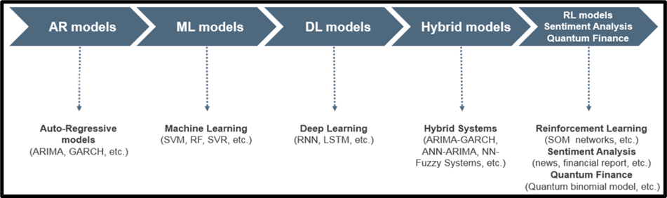

Figure 2.3.1: Stock market-based application of ML techniques
(Source: Albahli et al. 2022)
While each model has its strengths, the combination of these approaches has become very popular. Hybrid models seek to leverage statistical, and technical aspects with machine learning components so as to maximize the benefits of many types of methodologies making stock market prediction more robust and accurate. As mentioned by Dehankar et al. (2021), in exploring the scene of stock advertising forecast models, analysts and specialists proceed to investigate inventive ways to use the qualities of each approach and address their particular restrictions. The journey for moving forward with exactness and unwavering quality in estimating stock costs remains an energetic and advancing field inside the broader setting of budgetary analytics.

2.4 Arima Model for Stocks Data
The ARIMA model is a frequently applied model in series analysis and can be used for the prediction of stock prices. ARIMA components AR (Autoregressive) and MA (Moving average), differencing and stationarity are used to model trends and patterns. ARIMA function has been useful in the identification of the autocorrelation patterns of past stock prices in order to perform the stock market prediction. According to Htun et al. (2023), the model's performance becomes evident by its simple, interpretable nature, besides this linear relationship with the given data.
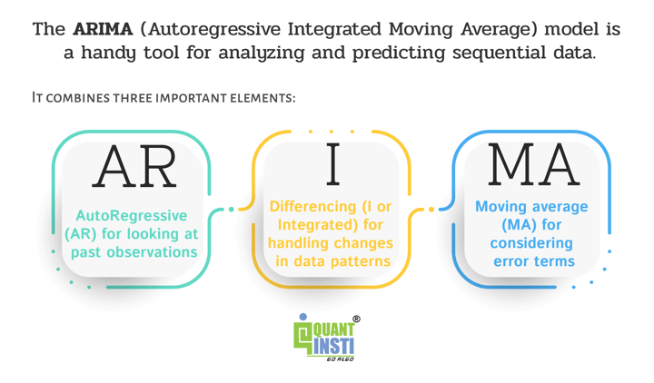

Figure 2.4.1: Elements of ARIMA model
(Source: Albahli et al. 2022)
ARIMA is characterised by three parameters: d (the degree of differencing), q (the order of the moving average), and p (the order of the autoregression). The parameter 'p' is the amount of lag data the model uses; this is the time series property of the model. The parameter "d" means the operations of differencing that are required to get stationarity of the crude information. Hence, 'q' stands for the number of moving normal windows taken after the number of slack expectation mistakes taken by the demonstrate. According to Koukaras et al. (2022), the ARIMA must be outlined for fitting the stock cost time arrangement with devoted parameters for the particular characteristics of the particular time arrangement being dissected.
One of the strengths of ARIMA is its effectiveness at short-term market price prediction. ARIMA can forecast the price movements of the future using the recognition of patterns and the use of past data. ARIMA has shortcomings, which include the fact that it can't detect non-linearity patterns and long-term trends. As per the view of Ku et al. (2023), the volatility of markets might result in the inaccuracy of the model's predictions. An assortment of techniques is utilized by businesses to obtain and hold clients, extending from conventional strategies like advertising competitive costs and prevalent client benefit to more advanced approaches such as showcasing computerization and data-driven bits of knowledge. To bargain with such circumstances, hybrid models that combine ARIMA and machine learning algorithms have been evaluated.
ARIMA might be a productive instrument for budgetary agents, in show disdain toward its limitations. Due to its straightforwardness, ease of utilization, and basically interpretability comes approximately, it is broadly utilized. As cited by Kurani et al. (2023), ARIMA is as often as possible utilized as a benchmark shown by scholastics and industry pros to evaluate the execution of advanced decoding approaches. The ARIMA appear to make strides in the cluster of prescient analytics techniques utilized to stock exhibit data by giving a framework for understanding and assessing short-term designs in stock costs among progressing money-related markets.

2.5 Time Series Analysis with Machine Learning
Time series analysis and ML have transformed stock price forecasting. This integration helps identify financial data trends and connections. Machine learning algorithms can adapt and learn from records, making time series stock market forecast more dynamic than statistical methods.
For non-linear data correlations, time series analysis increasingly incorporates machine learning, particularly neural networks. Nikumbh and Vijaykumar (2023) say LSTM RNNs can capture sequence data's long-term dependencies. LSTMs can detect complex patterns over time, making them excellent for stock market projections.
Ensemble methods like Random Forests improve model prediction. The random forest resists data noise. Pattern recognition and prediction are their strengths. Rouf et al. (2021) think money-related temporal arrangements help random Forests upgrade and anticipate stock market patterns reliably and powerfully.
Feature engineering is vital for improving the execution of machine learning models in time arrangement investigation. As per the view of Sahu et al. (2023), the model's capacity to distinguish significant designs depends essentially on pinpointing crucial highlights and changing crude information into important inputs. Machine learning models utilized for estimating stock showcase patterns frequently utilize assumption inquiries about, specialized pointers, and advertise news to supply settings and improve prescient accuracy.
Using machine learning for time arrangement examination is challenging due to the requirement for huge and differing datasets, the chance of overfitting, and the potential for drawing wrong conclusions. According to Saini and Sharma (2022), preprocessing and high-quality information are vital for guaranteeing the unwavering quality of machine learning models. Evaluating the interpretability of machine learning models remains challenging due to the got to get it the complex calculations behind their forecasts.
Stock market expectations have accomplished unparalleled levels of multifaceted nature and accuracy due to the integration of machine learning and time series analysis. As stated by Sanju et al. (2023), machine learning models give profitable bits of knowledge into the ever-changing nature of money-related markets, counting outfit strategies that upgrade vigour and neural networks competent of capturing persevering associations. Interpretability and information quality challenges must be addressed to utilize machine learning in time arrangement investigation for stock legitimately advertise forecasts.

2.6 Challenges and Limitations
Such tools as forecasting the stock market have their limitations. With an understanding of these challenges and addressing them, accurate predictive models can be created for the complex world of financial markets. Poor quality data is one major obstacle to predicting stock market movements. In finance data, irregularities such as noise, missing data, or anomalies may greatly affect the predictive accuracy of any model constructed. As cited by Sathyabama et al. (2021), data integrity is hard to maintain on a continuous basis in terms of consistency, accuracy and comprehensiveness. Such tasks as cleaning up data or putting it into standard form are necessary to enhance the robustness of forecasting models.
Overfitting refers to when a model has high accuracy on training but low generalization power to new cases especially with increasing complexity of the model; this is more prevalent in machine learning where sometimes models may collect irrelevant details from training while ignoring underlying patterns. According to Singh et al. (2021), balancing between generalisation and model complexity is crucial for a relevant model that mirrors real-life situations without overfitting it too much.
Financial markets are capricious and sporadic. Financial time series data can show non-stationary behaviour because of changing market dynamics, whereas forecasting methods often assume stationarity. The model, which is based on a fixed core structure, may be altered, in case of emergencies, such as sudden changes in the market mood, geopolitical events or progressive economic development. Saurav Sonkavde et al. (2023) showed that adjusting models to the changing market situations is one of the main challenges when it comes to accurate prediction.
Algorithmic trading has been debated for the ethical concerns and challenges that predictive algorithms have raised. The highly automated, prediction trading, occurring fast worsens market changes, and increases market volatility levels. Therefore, it is crucial to critically examine if such situations can be used for biasing as well as consider the ethics associated with computer-assisted processes. It is unclear how predictive algorithmic trading in finance is ethically used.
The more complicated models the less comprehensible they become. This kind of model is also called a “black-box” in the sense that the inner workings of how they come up with predictions are almost incomprehensible to humans due to complex algorithms such as neural networks. Like Strader et al. (2019) contend, interpretability is incisive for building up confidence, particularly in the financial sector which is known for accountability and transparency. The current research lines include the topic of identifiability, which is a difficult task to design inner interpretability while expressing complexity.
Machine learning calculations are frequently made for short-term expectations utilizing numerous models. Anticipating the future comes about over an expanded period is troublesome due to the eccentric changes in monetary markets. Projections may end up questionable owing to exogenous factors such as geopolitical occasions or unexpected showcase disturbances past a certain edge. Compelling decision-making requires perceiving and tending to the vulnerability connected to estimates.

2.7 Literature Gap
Despite Stock Market prediction has been carried out by different models, the literature offers a lot of space for further research and development. Gaps have to be identified and removed to further the field and enhance the dependability and change of predictive models in financial markets. The literature is weak on the issue of the market conditions that must be considered when studying the current market dynamics. Financial markets are characterized by ever-moving forces altered by factors, including economic activities, investor mood and political developments. As per the view of Usmani and Shamsi (2023), many of the models in current use, especially those which are data-dependent, may find it hard to adapt efficiently when there are rapidly changing market conditions. Further studies are required to develop models that are built to be adaptive to dynamics and data integration to make them more precise.
History price and volume data are usually used in financial analysis but an issue with these is that no study has been done on alternative data sources. Considering non-conventional data sources like social media sentiment, news analytics, or macroeconomic indicators can give a high level of understanding of market trends. According to Alamir et al. (2023), by combining different data sources it is also possible to develop much more complex and inclusive predictive models. Model explain ability and trust are becoming a serious concern because complex models run by machines are seen as not transparent. One must grasp the logic behind model forecasts, especially in the financial industry as openness is the main value. Learning how to make non-trivial models simpler will allow us to increase the implementation of predictive models in the financial decision-making process.
There are few investigations on long-term forecasts since most studies focus on short-term stock market projections. The difficulty of forecasting market trends over longer durations is influenced by heightened uncertainty and macroeconomic factors. This scarcity of literature has limited the sharing of knowledge on creating models intended for making long-term predictions that could be useful in strategic investment planning and portfolio management. Most times, these projections are made without considering connections between different assets across markets. Financial markets are interconnected and a shift in one asset class or market may affect others. It may be more insightful into global financial dynamics to scrutinize models that evaluate interrelationships among different classes of assets and markets which would result in better-informed predictions.
The performance parameters for various prediction models have not been standardized as they should be. The use of different measurements by researchers complicates such direct comparisons currently done in research. By providing a standardized set of parameters, it would be possible to compare and enhance research results in this area about stock exchange predictions.

2.8 Summary
The research on the literature allowed stock market forecasts to be analysed using modern machine learning and statistical methodologies. Predictive analytics has entered a new age thanks to banking machine learning. ARIMA models simplify and understand short-term stock price projections, improving time series analysis. Stock market prediction models showed the pros and cons of different strategies, highlighting the need for hybrid models with the best of each. Ensemble techniques, neural networks, and feature engineering enabled time series analysis to uncover complex financial data patterns. Data quality, model interpretability, and ethics remain challenges. The literature study recommended flexible models for changing market situations, exploring multiple data sources, prioritising model explain ability, expanding to long-term projections, including cross-asset viewpoints, and establishing uniform assessment standards.

CHAPTER 3: METHODOLOGY

3.1 Introduction
The ability to forecast the stock market continuously has amazed and continued interest of analysts, economists, and investors. Among the most prolific features is forecasting profit and losses with great accuracy, which might lead to more profitable portfolios and reduce the risk of loss. As financial market participants seek to optimise their forecasting abilities by utilising the financial data that is now available instead of confining themselves to limited resources, the popularity of machine learning techniques is also on the rise. The present chapter reviews the method of performing data analysis using machine learning for predicting the stock market performance. In this chapter, the underlying research design, methodology, approach, and data collection procedures will be laid down which will be the fundamentals of the upcoming analytic and model-building portions.

3.2 Research Strategy
The analysis used in a descriptive technique, in which the stated research questions were answered by gathering necessary information. In-depth research is a research methodology used to go into detail about a particular region or phenomenon about which the research is done. The descriptive technique is extremely helpful in the field of machine learning concerning the prediction of stock movement in stock markets. According to Amin Suhail et al. (2022), it does this by enabling investigation and studying of the spotting, arrangement and trends of historical stock market data. Researchers have synthetically analysed the past market activity and they will find the series of factors, dynamics and indicators that might affect markets in the future. This is the info used in the making of the predictive model that can predict trends with more accuracy. Additionally, the knowledge of the descriptive research method substantiates not only the organisation of complicated market data but also the synthesis of them resulting in meaningful information. The research has analysed vast chunks of data by applying statistical tools, summarising the details, and presenting data using visualisation methods.

3.3 Research Approach
The research is quantitative, which implies that it uses numerical data that involves collecting and analysing them. The purpose is to apply machine-learning procedures to learn about and interpret market phenomena related to stock prediction. This research involves the application of a quantitative approach that is aimed at the creation of predictive models based on the analysis of historical data markets and their subsequent application in the evaluation of real-time market movements. As stated by Bazrkar and Hossein (2023), doing this involves approaches like statistical modelling on historical data that researchers could design to truly reflect how market variables have an inherent relationship with stock prices, hence bringing about more reliable predictions.
The quantitative research strategy facilitates the analysis of the prediction of the stock market systematically and efficiently. It empowers learning to scrutinise historical market data, build predicting models, and question their utility. This method brings about precision and uniformity in the research outcomes by using quantitative approaches involving the tools and techniques. This causes an investor’s comprehension of stocks and stock market volatility to be improved and he/she can make more logically sound judgments.

3.4 Research design
In this study, cross-sectional research design was the methodology utilised. Cross-sectional research involves gathering data from many individuals or variables for one time period. Cross-section methods in machine learning applications to stock market trend forecasting allow investigation of various market factors and their relationship with stock prices at a particular point, thus yielding important insights into how the markets function. One of the major advantages of utilising the cross-sectional research approach is that it provides an image of the market at a particular moment in time and enables examination of how different factors work together to alter share value. According to Cheng et al (2023), patterns can be identified by collecting identical sets of data on many stocks, economic indicators and market indices at the same time, which can be attributed as causes behind fluctuations in markets.

3.5 Data Collection Method
Automatic systems that learn and track market movements have relied on the price collection of products from Amazon carried out by Kaggle's price data. The dataset structure presents the full picture of Amazon's past stock performance, so traders can study a wide range of factors of its market behaviour and build various forecasting models. The dataset also undergoes preprocessing techniques to ensure its efficiency for analysis. One action taken was the conversion from an object datatype to the datetime format of the Date column. After that, the data would be sorted via the chronological order for the stock price analysis. These translations are instrumental in precisely identifying the temporal relationships and even the trends within the analysed set of data.
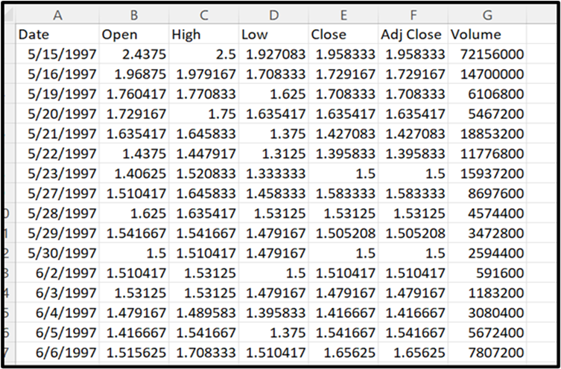

Figure 3.5.1: Amazon stock Data for the project
(Source: Self-Created)
This approach involved exploring the issue of the variability in stocks and stock distribution of the data. Mean and standard deviation were computed for each of the fair factors including opening and closing prices and this was done to have a more complete picture of Amazon's stock market behaviour. Understanding the distributional properties of the data after going through different modelling techniques provides valuable knowledge for effectively selecting a modelling technique.
Comprehensive and sufficient data resulted in creating and testing the model accurately. The model's performance can be gauged by the researchers in the following areas, market conditions and time frame, on an extensive data set comprising 6000 data points over the years. The inclusion of some variables like trading volume and average opening, high, low, and closing price values makes the data set a more complicated gathering process.
The tons of historical data that will be accessible to researchers and historiographers will enable the building of complex machine-learning models to capture the intricate market interconnections and the impact of the same on stock prices. The objective of this study is to improve the accuracy and reliability of market estimates through the sophisticated applications of statistical methods and the large amount of historical data. Through it, financial experts and investors can get useful reports from which they can make informed decisions.

3.6 Data analysis
Data analysis was undertaken in a Jupyter Notebook ecosystem that provided an interactive sphere studded with data exploration, model building, and visualisation. With the notebook as the major tool implemented, the research has been able to accomplish a smooth way of working that made them implement and conquer possibilities of improving their methodologies regarding stock market prediction by applying machine learning techniques.
Data analysis starts with thorough preparation for model construction and data quality. Missing data processing, numerical feature scaling, and categorical variable encoding are possible. Exploratory data analysis (EDA) follows preprocessing to determine data distribution and links. Different statistical methods are used to assess beginning and end prices, trading volume, and price volatility over time. Scatter plots, histograms, and time series graphs reveal trends and outliers. During feature selection, the most essential model variables are determined to minimise dimensionality and improve performance. As illustrated by Eslamieh et al. (2023), characteristic relevance is determined via feature ranking, correlation analysis, and model-based selection.
The data analysis step will forecast and assess time series stock market data using three key models. Long Short-Term Memory (LSTM) can detect complex patterns and long-term relationships. Those models can forecast changes in the stock exchange market by considering time-varying nonlinear interactions. The Seasonal Autoregressive Integrated Moving Average (SARIMA) model can correctly capture cyclical fluctuations in time series data such as stock price patterns because it contains seasonal components. In non-stationary time series data, Autoregressive Integrated Moving Average (ARIMA) models capture short-term volatility and long-term trends. According to Vithanage et al., (2023), the autoregressive, differencing, and moving averages as model components have been defined for suitable analysis. It predicts future prices and market movements based on this analysis. Extracting complex stock market behaviour from real-world data requires strong algorithms for discovering hidden time-series patterns and interrelationships between them. With such insight, an investor would be well-guided.

3.7 Data preparation and cleaning
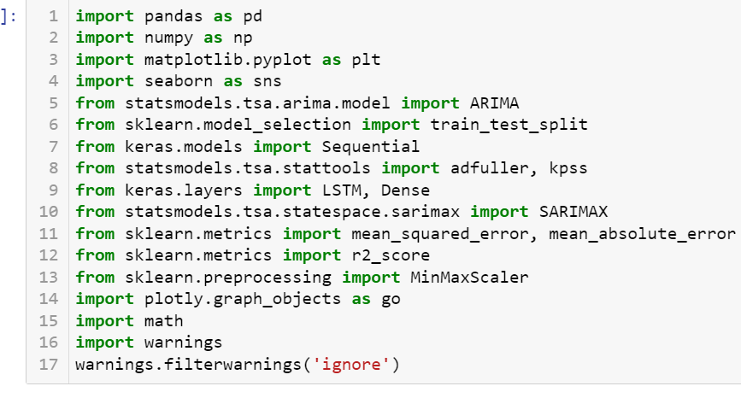

Figure 3.7.1: Importing of libraries
(The libraries which performs the stock market prediction)
The data analysis, modelling and assessment procedures in stock market prediction research were conducted employing an exhaustive list of libraries. The major libraries implicated were pandas for data manipulation, NumPy for numerical processing, and matplotlib and seaborn to visualise data, and time series analysis the models were supported by stats models and sci-kit-learn while Keras deep learning networks built the models. A comprehensive functionality of the specialised libraries such as statistical tests, feature scaling, and metric tests are done using the feature modules. The combination of these powerful instruments was important in the construction of a rigorous and systematic model for detecting stock market trends using machine learning algorithms.
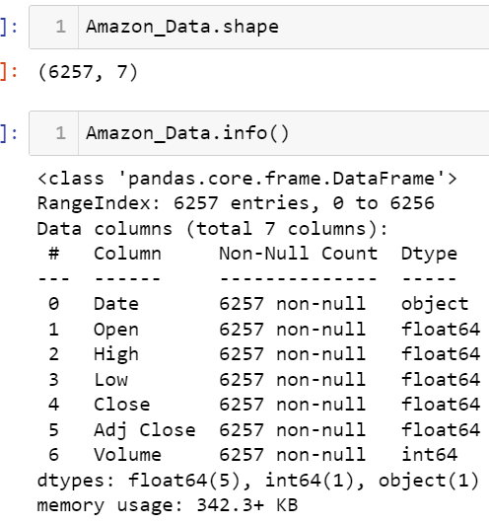\

Figure 3.7.2: Data Shape and information
(Dataset consist of 6257 rows and 7 column, it doesn’t have any null variable)
The data thoroughly captures Amazon Inc.'s historic stock exchange performance. The dataset has 7 columns and 6257 rows of data reflecting different pillars of Amazon’s stock trading. The 'Date' column which has a chronological reference follows the order in which days are presented in the recorded time. The columns which are marked "Open," "High," "Low," and "Close" are full of essential data, where the brokers see the stocks opening, their highest, lowest and closing values during each trading day. They give a player the ability to make split-second decisions which determine if the price of Amazon shares can go up or down on a certain day and how sentiment about other shares in the market is changing. On the contrary, there is an 'Adjusted Close' column which is adjusted for another effect of operations like dividends and stock splits, making the company performance visible. The 'activity' section specifies the share numbers traded which reflects the level of trading activity and demand of Amazon stock on a given day.
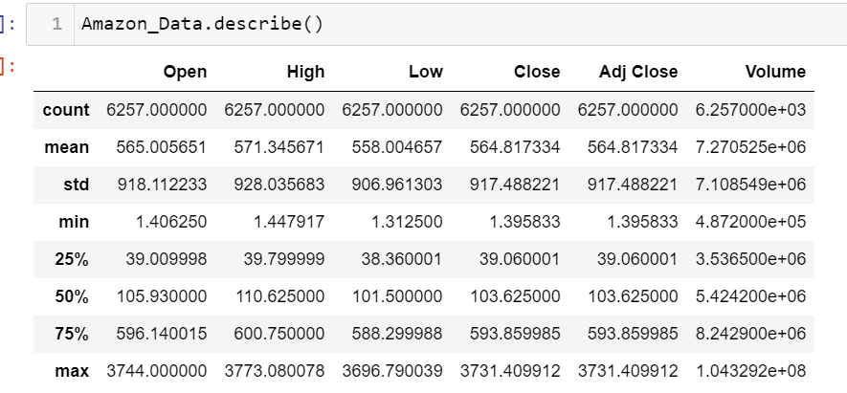

Figure 3.7.3: Statistics of Amazon data
(This figure gives the statistics of the whole dataset)
The variance in terms of not just trading volumes but also price per stock of Amazon's dataset as the main explanation is reflected in its summarized statistics. The distribution on the half price is the same as the one on the median and this implies that the price moves of the stock should be rather consistent with no major shakes. The minimum and maximum values point to the discrepancy of the census values, which in turn indicate the appreciable swings of Amazon share prices during the corresponding period. The statistics of Amazon Stock, typically traded in the Quarter-Burton area i.e. the megacity, suggests such a heavy market activity that it almost depletes the daily trading volume. This volume flows attracts a heap of both types of professionals who use the stock for both short-term trading and long-term investing.
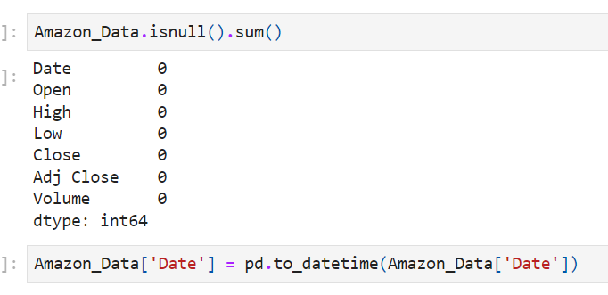

Figure 3.7.4: Data Preprocessing
(Checking null values and converting data type of date)
The missing value analysis on the Amazon Data Frame reveals no null values exist in any of its columns. The fact indicates that this dataset is exhaustive, meaning it covers the whole sampling area. Moreover, the ‘Date’ column was made into Date Time format by employing the datetime function acquired from pandas to make the data more useful. This change makes all dates similar and improves a chronological study of stock market quotations. In general, this dataset is more dependable and simpler to appraise as it avoids blank cells and has different formats for dates.

3.8 Exploratory data analysis
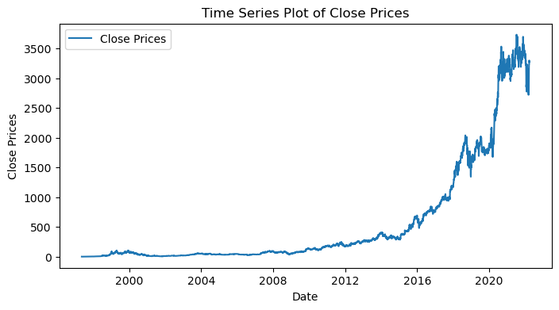

Figure 3.8.1: Time Series plot
(The closing price analysis based on date variable)
The figure shows the ongoing movement of Amazon's closing prices during the study time frame. A visualization of the data reveals peaks, fluctuations, and patterns corresponding to the stock price as it moves over time. The data reveals several trends, some of which are subtle while others are more drastic changes in the price of Amazon's shares. Risk-averse investors may have the chance to monitor the ups and downs map to analyse them as a basis for the decision to buy or sell. This goes on occasionally up to down to spike, but the statistics provide an overall positive upward tendency for Amazon stock values.
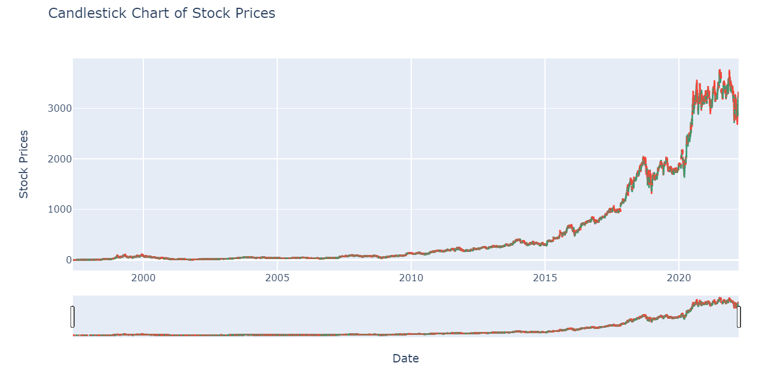

Figure 3.8.2: Stock price candle stick chart
(This figure shows financial instruments over 5 years, green indicates price appreciation red indicates price depreciation)
The Candlestick Chart gives a graphic presentation where it shows the daily swings in the Amazon shares value. Each candle shows the price only for the day: opening & closing and the highest and the lowest. Ideally, learning candlestick patterns would allow not only to make an assessment of current mood but also to predict forthcoming price variations. The chart shows that the market’s instability may be explained by the combination of the bearish trends (the ones that are downward) and the bullish trends (the ones that are pointing upward). Traders effectively will have a chance to upgrade their trading styles by closely examining price movements.
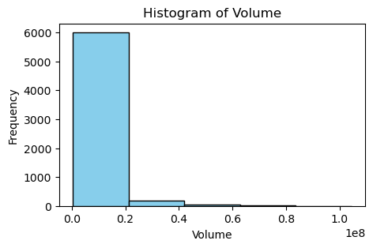

Figure 3.8.3: Histogram of volume
(Figure illustrates Distribution of Trading Volumes for Amazon Stock)
The chart shows a distribution of trading volumes for Amazon's stock. The stock's volume patterns represent a particular distribution. It isolates the usage of many different amounts of shares and the volume of activity around Amazon stocks' price fluctuations. The distribution of data shows the positive skew that was perceived from the histogram which had the majority of the range of transaction volumes concentrated at a lower level of it. Nevertheless, in the light of the vicissitudes and fluctuations in market turnover in this case periods of high volatility or interest are becoming visible. Investors can exploit this knowledge to assess various factors including market sentiment and liquidity. This knowledge will be useful to traders in making their decisions.
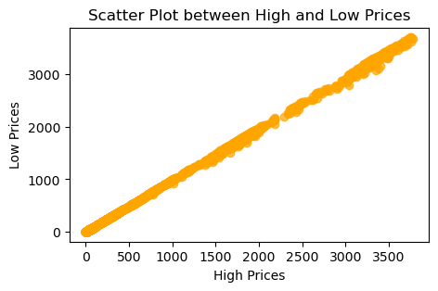

Figure 3.8.4: Scatter plot for high and low prices
(This figure shows a strong linear correlation between stock's most and least traded prices)
The scatter plot forms a graphical picture of the degree of relationship between the stock's most and least traded prices for each given day. It enables the discernment of the loosely defined relationship between two variables via a plot of spot distribution on the graph. In this figure, the scatter diagram shows a strong linear correlation between high and low prices implying that as the highest price goes up, so does the lowest price. This may be advantageous in both fields of comprehension of pricing dynamics and probably predicting future price variations based on historical trends.

3.9 ADF and KPSS testing
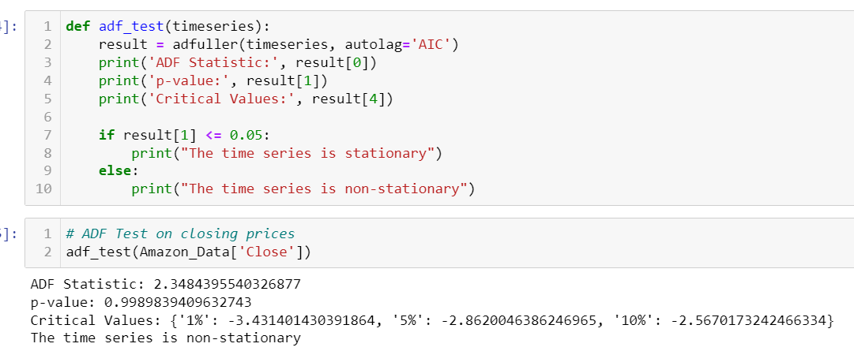

Figure 3.9.1: Testing and analysis with ADF test
(ADF test shows the dataset is not stationary, based on close price)
The Augmented Dickey-Fuller (ADF) test is a statistical technique that is employed to determine whether a dataset in a time series is stationary or not. The constant mean, constant variance, and autocorrelation are the three envelopes of a stationary time series that do not get altered from time to time. The closest period up to 22.04 to sixty months with an ADF stat of 2.3484 and the computation p-value of 2.3484 results in a p-value of around 0.999 about the closing prices of Amazon. Consequently, the alternative hypothesis is not ruled out in the light of these numbers, that is, the time series data cannot be described by the stationary method, as stated by the null hypothesis. P value is above the significance level typically accepted - 0.05 - so the data is under the presence stationarity impossible. In addition to that, the aforementioned dependency has disclosed the fact that the time series is non-stationary as it does not have an equivalent in the critical values of the ADF test.
The closing prices of the ADF test against Amazon climate realized the constantly moving nature of the stock market data. Concerning this, non-stationarity takes the role of a concept that as time passes, the sample mean and variance of the closing prices of Amazon are changing and not constant. There are other methods for time series analysis relying on stationarity assumptions which are possibly unable to mimic the behaviour of Amazon's stock price. Moreover, the existing set of non-stationary data becomes another obstacle in the path of precise forecasting of future price changes using techniques of simply historic data trending stations. In conclusion, both time-series modelling techniques should be used while analysing the high-frequency data of Amazon stocks because such data is highly non-stationary. As such, it enables risk reduction through more intricate and yet informed forecasting in the financial markets.
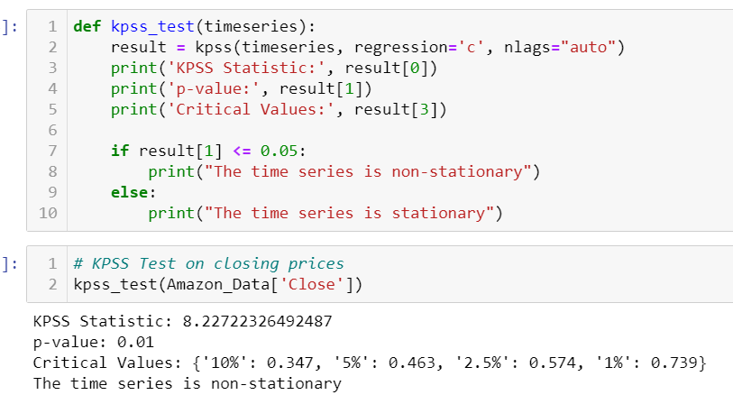

Figure 3.9.2: Testing and analysis with KPSS test
(KPSS test shows the dataset is not stationary, based on close price)
The Kwiacowsk-Phillips-Schmidt-Shin test is a statistical method that is used to determine the stationarity property of the time series data. The KPSS test provides evidence that the absence of a trend and no random movement between observations is predicated on the null hypothesis while the existence of a trend is termed as the alternative hypothesis. Conversely, the ADF test, as opposed to it, is used to quantify nonstationary variables (a time series has to display a unit root). Given the KPSS test result, the computation is as follows: KPSS spatial-temporal statistic equals 8.2272, p-value concerning the closing price series of Amazon equals 0.01. As the remaining p-value is less than the 0.05- percentage criterion for significance, it is decided to support the alternative hypothesis, which indicates non-stationarity and to reject the null hypothesis. In addition, this result is unambiguous, as confirmed when the estimated value of the KPSS statistic is compared to the important values provided by the test, as the statistic is found to be greater than the important values.
By conducting a KPSS test on Amazon closing prices, it is evident that the data does not follow a flat-line pattern in the long run. It can be interpreted as well that over the recorded period the closing prices are severely characterized by the statistical variations in their normal properties adjusted with the value and variability. Accordingly, projecting the future through a traditional time series analysis method that considers the changes in a planned period to be stationary would likely mislead investment and planning decisions. In short, the substantial changes in Amazon's closing prices over specific years require a close examination so that adequate modelling models can be applied to interpret the variability of the market. Financial analysts and investors can develop better decision-making skills for executing transactions within the Amazon stock markets by relying on the more developed forecasting approaches as well as the tailored strategies for managing risks which correspond to the evolving nature of Amazon stocks. This has to do with taking into account the character of the data which is not stationary, that is, parameters like mean and variance change over time.

3.10 Summary
This chapter is focused on the methodology that was employed in the research for the prediction of movements in the stock market using machine learning. Although a quantitative method reduces difficulties in the setup of mathematical models, descriptive research is oriented toward detecting past patterns in information about the market. Conducting cross-sectional marketing research helps to broaden the area of research by investigating the multiple aspects of the market using secondary data collection methods. Machine learning is a major turning point when it comes to data analysis because its model features every method of data preparation and preparation. The paper does not just deal with ethics in data usage, but rather it carries out a thorough assessment of transparency, honesty, and ethics in data utilisation. Researchers attempt to achieve two major tasks by applying advanced methods like LSTM, SARIMA and ARIMA. First, they focus on achieving in-depth comprehension of the stock market dynamics. Secondly, they sometimes conduct reliable forecasts. Sticking to codes of conduct is the only thing that makes sure that the research results are accurate and reliable, thus investors get solid information about their strategies.

CHAPTER 4: RESULTS AND ANALYSIS

4.1 Model Applied on stocks

This ARIMA model is a five-one-zero autoregressive integrated moving average for Amazon stock market data. Autoregressive coefficients of the model summary exhibit a decreasing trend meaning that recent past values have less impact on future ones. Log probability which gives a good measure of fit and at the same time, low AIC and BIC are indicators of a strong fit of the model to the data. The estimated variance (sigma^2) shows residual volatility. Residuals from this model still maintain normality, and absence of seasonality and employ white noise assumptions as shown by diagnostic tests. ARIMA models enable Amazon Company to predict stock prices.
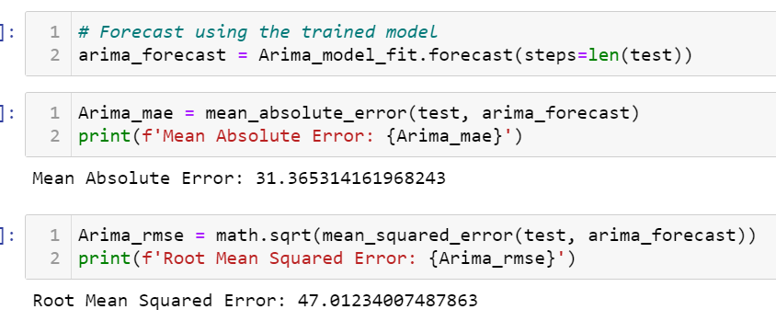

Figure 4.1.1: Analysis based on the Arima model
(Figure illustrate the ARIMA model prediction for MAE and RMSE)
The MAE for this ARIMA prediction model was 31.37, while RMSE was 47.01 for Amazon stock forecasts. These figures illustrate how far off actual values can be when compared with trading errors, including their distribution and average magnitude of these deviations. Model accuracy is given by Root Mean Square Error (RMSE), which measures prediction error standard deviation across all predictions while Mean Absolute Error (MAE) denotes that expected values miss 31.37 units out of their predictions. To do away with the ambiguity in what allows stakeholders to assess the validity of the ARIMA model in forecasting stock prices.
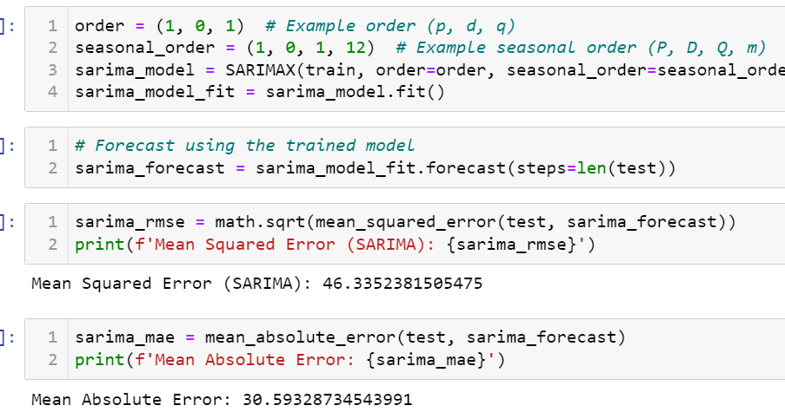

Figure 4.1.2: Analysis and evaluation based on the Sarima model
(Figure illustrate the SARIMA model prediction for MAE and RMSE)
The SARIMA model was trained on the dataset with an order of (1, 0, 1) and a seasonal order of (1, 0, 1,12). Herein, when predicting, SARIMA has an MAE of 30.59 and an RMSE of 46.34. The assessment measures for forecasting Amazon Inc.'s stock market performance by the SARIMA model were also discussed. Since stock market data is unpredictable, the model’s average prediction error (RMSE) stands at a very good figure of 46.34. Moreover, its mean absolute error (MAE) which is equal to 30.59 points out that it can predict stock markets correctly. This implies that moreover than ARIMA model will not be as accurate as the SARIMA model in future predictions on the stock market based on these findings. These criteria measure how useful stakeholders find the SARIMA model for financial decision-making as well as accuracy in Amazon Inc.’s stock market forecasts.
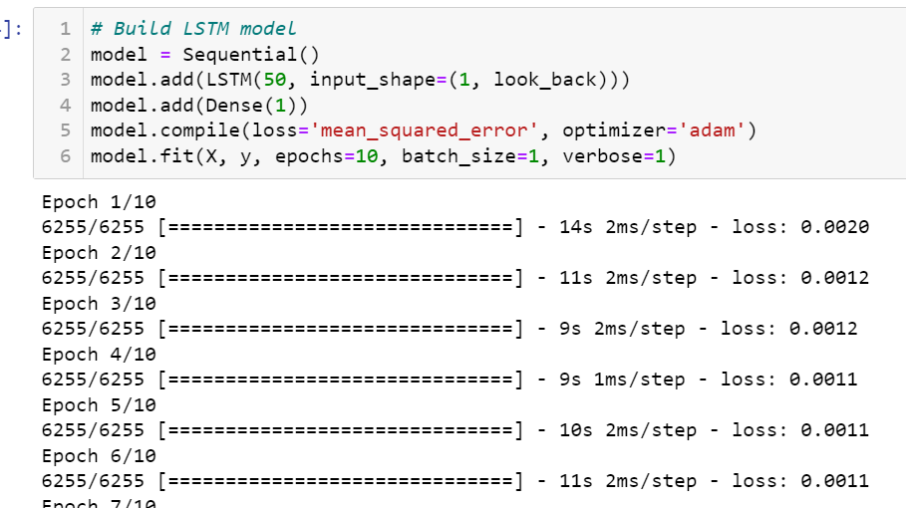

Figure 4.1.3: LSTM model architecture and fitting on train data
(Figure represents the loss (error) of the LSTM model during training)
Supervised normalized returns data was used to train LSTM. The model design features a 50-unit LSTM layer and a thick regression layer. Adam optimizer optimized the model after its creation using mean squared error loss. The model was trained in one batch for 10 epochs. Model loss values kept dropping during training suggesting better recognition of data patterns.
The Adam optimizer was chosen for the model optimisation procedure to tackle the challenges of noisy inputs and sparse gradients that are instrumental in creating the time series data for financial time series which are common. Adam optimizer yields improvements in convergence speed and performance better than standard gradient descent by adjusting the step size of each parameter, as the SGD, RMSProp and Adadelta optimizer does.
The LSTM model is constructed of one LSTM layer, and a dense layer (a fully connected layer). The abbreviation LSTM can be resolved into several units, which in this case is equal to the number of neurons or memory cells in the network. The very same point is the neuronal network itself, which is attributed to recognising and integrating the temporal collectively from the incoming input. The prediction will be generated by the output layer, which is a dense layer, that produces the result via the collective learned force from the LSTM layer. Among the four models, the model trained with the Adam optimizer seems to have done the best, as evidenced by its lowest Mean Absolute Error and Root Mean Squared Error. Adaptive learning rates and momentum are features of the Adam optimizer that can be useful in a variety of situations.
The LSTM model, which is designed for the context of RNN, is argued to be particularly suitable for predicting stock market trends such as forecasting the time series data. This is because of its powerful feature to decently understand sequence data even in its long-term form. The LSTM model was trained for 10 epochs, the test results were considered and the objective of finding the optimum trade-off between the training length and the model performance was served. There is the potential that a model may underfit due to the inability to pick up important trends with this number of epochs. Conversely overfitting can be caused by an excessive number of epochs when it turns out that the model memorises training data instead of detecting general patterns among them. To cleverly steer a model through overfitting and at the same time have it properly trained, decided that the epochs per training is 10.
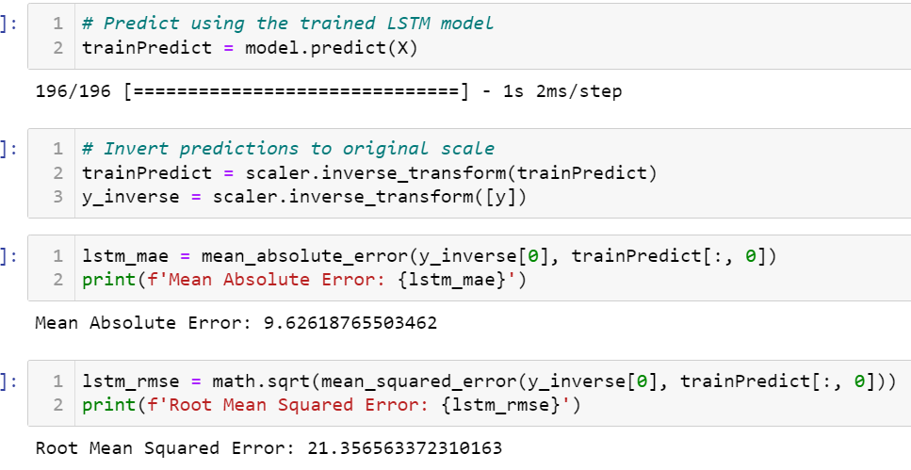

Figure 4.1.4: Analysis based on the LSTM model
(Figure illustrate the LSTM model prediction for MAE and RMSE)
The training dataset was predicted by the model after training. Subsequently, MinMaxScaler converted back the translated predicted values to their original scale. The performance of the model was assessed by mean absolute error (MAE) and root mean squared error (RMSE). With an MAE of 9.63 and an RMSE of 21.36, Amazon Inc.’s stock market returns were minimally mis predicted by the LSTM model. This reveals that it is possible for the LSTM model to accurately predict stock market returns. In addition, there is a need to test this model's resistance to new information and its ability to adapt under various conditions through tweaking its parameters on uncharted data.
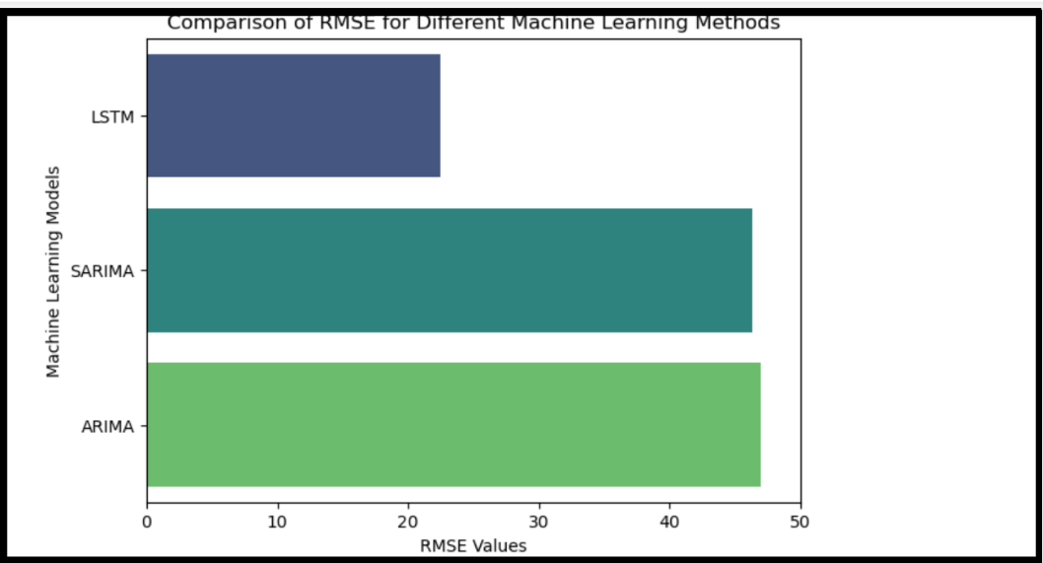
Figure 4.1.5: Comparison of all the algorithms based on their RMSE
(Figure shows LSTM model is twice better than other two models)
The above figure shows the comparison in the bar chart based on outcomes generated by all the algorithms which are LSTM, Arima and Sarima. The model shows that Arima has more RMSE than the other two algorithms and LSTM has less than all other. The analysis shows that the LSTM model has less RMSE with compare to the other model which are ARIMA and SARIMA model as visualised in the figure. Performance increases with decreased RMSE. The best model was LSTM which has 21.36 RMSE. ARIMA has 47.01 RMSE and SARIMA which has 46.34. LSTM can anticipate and describe complicated temporal relationships in financial time series data. Due to its reduced RMSE, LSTM is better for employment estimates and maybe Amazon Inc. stock returns. LSTM excels in financial analysis and decision-making.
When calculate the ratio of the RMSE of ARIMA and SARIMA to that of LSTM, both ARIMA and SARIMA have ratios greater than 2 when compared to LSTM. This means that both ARIMA and SARIMA have roughly double the RMSE compared to LSTM. Therefore, based on the given results, both ARIMA and SARIMA models are approximately "twice as bad" as the LSTM model in terms of RMSE.

4.2 Discussion
The given figures illustrate the stock market performance of Amazon and its implications for stakeholders. Exploring the data revealed the trends in Amazon stock prices, which are of interest to traders and investors. The time series data indicates an upward trend in Amazon's stock price, which reflects a positive sentiment in the market. These market insights are valuable for investors looking to buy or sell Amazon stocks. ARIMA and SARIMA models were used to predict Amazon stock returns.
The accuracy of these models was good, but LSTM performed even better. The LSTM model demonstrated superior predictive capabilities by effectively interpreting complex data patterns and linkages. Advanced machine learning approaches may outperform classic financial prediction models, leading to significant implications for academics and financial specialists. Regarding stationarity in time series research. As per the view of Jafar et al. (2023), the stock prices of Amazon exhibit stationarity in both KPSS and ADF testing. Sophisticated models are required in the active stock market due to the non-stationarity of data. Accurate market dynamics modelling is essential for investors and financial specialists.
Model and Metrics | Result | Research paper | Result of previous paper
Arima RMSE | 47.01234007487863 | Ho et al. 2021 | 90.3542
LSTM RMSE | 21.68341205095527 | Ho et al. 2021 | 93.8031
Sarima MAE | 30.59328734543991 | Wijesinghe and Rathnayaka, 2020 | 29.6975
Table 1: Comparison the results with various other papers
The consequences of model assessment using RMSE and MAE are also a subject of debate. The parameters evaluate the accuracy of the forecasting algorithm. The low MAE and RMSE of LSTM suggest its potential in forecasting stock returns. Investors rely on trusted sources to make informed investment decisions. As cited by Jariyapan et al. (2022), the programme covers financial forecasting using advanced machine learning and time series analysis. This information can assist financial analysts and investors in predicting stock returns and gaining insight into market dynamics. Stock market volatility can potentially enhance investment opportunities and mitigate risk.
The study emphasizes how crucial it is to use cutting-edge machine learning techniques, such long short-term memory (LSTM) models, to increase the accuracy of financial forecasting, especially when it comes to predicting stock market returns. Financial analysts and investors can become more adept at managing market volatility by enrolling in academic programs that teach financial forecasting utilizing time series analysis and advanced machine learning techniques. Deeper insights into market dynamics can be gained by further study on improving forecasting accuracy, investigating new features, and fine-tuning model architectures. This will ultimately lead to better investment choices and risk management techniques.

4.3 Linking with Objectives
The project objective is to make the algorithm compatible with the broader strategy of using machine learning techniques to upgrade financial market forecasting and tracking of any sort of stock. A practitioner applying machine learning techniques to stock market research seeks to improve the method's performance giving rise to tools that are more conducive for traders and investors to use in their decision-making process. A major task among them is to judge how the ARIMA model predicts the changes in stocks. Investors camp aims to define the most competent forecasting techniques which are considered to be the core of their purpose and principal occupation.
Furthermore, the research approaches better ideas and methods to improve the preciseness of financial market prediction. Through sophisticated machine-learning algorithms and data-driven tools, science may take up to the next level of analytics allowing understanding of market dynamics and being able to develop more potent forecasting models. This objective is directed towards financial professionals and investors who need new decision-making tools. The aim is to create resources that can be used on real-time and dependable information to help people make decisions based on accurate and timely data.
To reach all these objectives it is crucial to rely not only on previous scientific research and current literature but also on the analysis of various examples available in the digital world. For the sake of providing a complete and knowledgeable investigation, the option of using and merging the current material is achievable. Thus, that could be achieved as they possibly use the methods of the previous researchers and hence, create more detailed and consequential research on their findings.

CHAPTER 5: CONCLUSION AND RECOMMENDATIONS

5.1 Conclusion
To conclude the investigation of machine learning techniques for the prediction of the stock markets shows that not only does the efficiency of financial systems come into the spotlight but also gives an idea about the performance of Amazon's stock. The research has contributed to the acquisition of a fresh perspective on the core determinants affecting stock price variations and the veracity of forecasting approaches utilizing a comprehensive data analysis of historical public stock data as well as different predictive models such as classical time series models, i.e. ARIMA and SARIMA and modern LSTM machine learning models.
The exploratory data process by traders and investors produced useful data insights to help them make better decisions based on visual trends and patterns in the stock price of Amazon. Besides this, the task's modelling showed that the intensity of the LSTM models was outstanding in predicting stock returns, providing evidence of the high effectiveness of the advanced machine learning methods in the field of financial forecasting.
The analysis talked about the necessity of dealing with non-stationarity and model assessment metrics like RMSE and MAE. Besides the data's non-stationarity, the evolution of stock market activity, conditioned by multiple factors, made it necessary to resort to the formulation of elaborate models capable of accurately reflecting the market's dynamics.
The study not only deals with forecast functionality in finance but offers helpful ideas for analysts as well as investors. In the acquisition of a novel comprehension of the market dynamics and the possibility of reasonably precise forecasts of future returns in stock, both traditional time series analysis techniques and the newest machine learning approaches could be employed by all stakeholders. As per the view of Li and Xue (2024), it helps to develop the stock finding and buying strategy and to reduce risks of volatile stock market conditions.

5.2 Recommendation
Several suggestions may be made to improve the efficiency and precision of financial forecasting based on the knowledge and conclusions gained from the study on machine learning-based stock market predictions:
Hybrid Model Integration: In contrast to ARIMA and SARIMA the LSTM model demonstrates better performance, therefore we consider investigating mixed models that consist of both statistical methods and machine learning algorithms. The combination of selected models' benefits can boost prediction robustness and accuracy, especially when the model aims to identify the invisible and complex patterns of financial data.
Enhancing Data Quality: Polishing the data and its level of granularity that is used to train machine learning models is one of the most important aspects in the fight to make financial market predictions reliable. According to Pagliaro (2023), the incorporation of other data sources, such as sentiment analysis of social media or integration of alternative data sets, could be required to pursue a more holistic view of market models and market tendencies.
Interpretability of the Model: While machine learning models that include LSTM make a great prediction, their interpretation is stubborn which may be discouraging for the regulator to try to understand the process underneath influence forecasts of the machine learning models. To get spectacular information about the major predicting forces of the model, it is thus a fact that, an owner, should invest in methods and tools for increasing model interpretability, like feature significance analysis or model visualization techniques.
Constant observation and assessment: The dynamic financial markets are rather over-sensitive to outside influences. As per the view of Qazi et al. (2022), those conditions may create roller-coaster market patterns and behaviours. So, it is necessary to keep a close eye on the market environment and forecasting models to ensure continuous sensitivity to changing market conditions. In this case, there may even be a requirement to set up feedback and include the use of real-time data streams.
Using the recommendations given financial sector entities could boost the quality as well as the effectiveness of stock market forecasts and make the processes more reliable and the investment results more desirable.

5.3 Achieving the aim of the study
This project aims to explore the efficacy of machine learning methodologies in enhancing stock market prediction and analysis. After employing three distinct models on the dataset, the findings underscore the utility of machine learning in forecasting stock prices and market movements. Particularly, the Long Short-Term Memory (LSTM) model stands out with an RMSE value of 21.35 when applied to Amazon stock data, showcasing its remarkable effectiveness in assessing and predicting stock prices. With LSTM demonstrating superior accuracy compared to the other models utilized, the project achieves its objective of leveraging machine learning methods to improve stock market forecasting. However, to further enhance predictive capabilities, future research endeavours may focus on utilizing live datasets to identify and refine the most optimal predictive model.

5.4 Research Questions analysis
The research is going to focus on the answers to some of the crucial questions like does the use of machine learning for financial markets analysis is justified or not. As per the research results, the LSTM (Long Short-Term Memory) model emerged as the most effective for forecasting the stock market compared to ARIMA and SARIMA models. The LSTM model's superior performance suggests that deep learning architectures, specifically designed to capture temporal dependencies and nonlinear relationships, are better suited for stock market forecasting tasks.
So, the research rejects the null hypothesis, indicating that the performance of different machine learning models applied to stock market forecasting is indeed significantly different. The acceptance of the alternative hypothesis supports the notion that certain machine learning models, particularly deep learning architectures like LSTM, exhibit better performance in stock market prediction compared to traditional time series models like ARIMA and SARIMA.

5.5 Future Scope
When accounting for the likely different routes to take, many questions are left regarding hypotheses and concepts for further research. Through the implementation of sophisticated machine learning tools, the precision, and complement of market forecasts, can be improved even further. A prospective model may achieve a higher accuracy employment if it is armed with advanced techniques such as deep learning, reinforcement learning and ensemble techniques enabling it to extract nuanced patterns and interactions in financial data.
Additionally, it would be of interest to pursue research in the area of incorporating various sources of data. Market movements can also significantly be influenced by news articles, macroeconomic indicators and the sentiment on social media, apart from conventional financial data. As per the view of Saini and Sharma (2019), by integrating these varied information sources into predictive models’ researchers may improve forecast accuracy and have a broader understanding of markets.
Recently, transparency and interpretability have become important aspects of machine learning algorithms, especially in the financial sector. Additionally, future research may centre on creating understandable machine learning models that reveal what goes on behind the predictions but at the same time yield accurate forecasts. Such a strategy will lead to improved decision-making as stakeholders will comprehend and trust the outcomes of predictive models.
Moreover, predictive analytics is also used in risk management, portfolio optimization, and algorithmic trading techniques among others besides forecasting. Further investigations could examine these areas more closely to establish how machine learning methods can be applied to creating robust risk management systems as well as better investment portfolios.

References
Alamir, L.A., Saleh, M.E. and Mohammed, W.F. 2023, "Stock Market Prediction Using Deep Reinforcement Learning", Applied System Innovation, vol. 6, no. 6, pp. 106.
Albahli, S., Awan, A., Nazir, T., Irtaza, A., Alkhalifah, A. and Albattah, W. 2022, "A deep learning method DCWR with HANet for stock market prediction using news articles", Complex & Intelligent Systems, vol. 8, no. 3, pp. 2471-2487.
Albahli, S., Irtaza, A., Nazir, T., Mehmood, A., Alkhalifah, A. and Albattah, W. 2022, "A Machine Learning Method for Prediction of Stock Market Using Real-Time Twitter Data", Electronics, vol. 11, no. 20, pp. 3414.
Ameen Suhail, ,K.M., Sankar, S., Kumar, A.S., Nestor, T., Soliman, N.F., Algarni, A.D., El-Shafai, W. and Abd El-Samie, F.,E. 2022, "Stock Market Trading Based on Market Sentiments and Reinforcement Learning", Computers, Materials, & Continua, vol. 70, no. 1, pp. 935-950.
Azaz, H.K., Shah, A., Abbas, A., Shahid, R., Zahid, Z.U., Sharif, M.U., Jan, T. and Zafar, M.H. 2023, "A performance comparison of machine learning models for stock market prediction with novel investment strategy", PLoS One, vol. 18, no. 9.
Balasubramanian, P., Chinthan, P., Badarudeen, S. and Sriraman, H. 2024, "A systematic literature survey on recent trends in stock market prediction", PeerJ Computer Science, .
Bathla, G., Rani, R. and Aggarwal, H. 2023, "Stocks of year 2020: prediction of high variations in stock prices using LSTM", Multimedia Tools and Applications, vol. 82, no. 7, pp. 9727-9743.
Bazrkar, M.J. and Hosseini, S. 2023, "Predict Stock Prices Using Supervised Learning Algorithms and Particle Swarm Optimization Algorithm", Computational Economics, vol. 62, no. 1, pp. 165-186.
Bhati, K., Bamne, K., Kamineni, S. and Kumar, P. 2022, "Visualizing and Forecasting Stock Price", International Research Journal of Innovations in Engineering and Technology, vol. 6, no. 4, pp. 44-48.
Bhati, K., Bamne, K., Kamineni, S., Kumar, P. and Das, A. 2022, "Visualizing and Forecasting Stock", International Research Journal of Innovations in Engineering and Technology, vol. 6, no. 5, pp. 162-164.
Cheng, L., Lu, W. and Yeo, B. 2023, "Predicting abnormal trading behavior from internet rumor propagation: a machine learning approach", Financial Innovation, vol. 9, no. 1, pp. 3.
Dahal, K.R., Nawa, R.P., Gaire, S., Mahatara, S., Joshi, R.P., Gupta, A., Banjade, H.R. and Joshi, J. 2023, "A comparative study on effect of news sentiment on stock price prediction with deep learning architecture", PLoS One, vol. 18, no. 4.
Dehankar, A., Itankar, A., Meshram, A., Bhople, N. and Patle, B. 2021, "Review on Stock Market Prediction", International Research Journal of Innovations in Engineering and Technology, vol. 5, no. 6, pp. 13-15.
Eslamieh, P., Shajari, M. and Nickabadi, A. 2023, "User2Vec: A Novel Representation for the Information of the Social Networks for Stock Market Prediction Using Convolutional and Recurrent Neural Networks", Mathematics, vol. 11, no. 13, pp. 2950.
Htun, H.H., Biehl, M. and Petkov, N. 2023, "Survey of feature selection and extraction techniques for stock market prediction", Financial Innovation, vol. 9, no. 1, pp. 26.
J.H.P Vithanage, Salwathura, S.R., De Silva D.K.T.J.S, Wickramasinghe D.K.G.T.I, Kumari, S. and Samarakoon, U. 2023, "SMART TEA: Churn, Trend, Inventory and Sales Prediction System Using Machine Learning", International Research Journal of Innovations in Engineering and Technology, vol. 7, no. 11, pp. 453-460.
Jafar, S.H., Akhtar, S., El-Chaarani, H., Parvez, A.K. and Binsaddig, R. 2023, "Forecasting of NIFTY 50 Index Price by Using Backward Elimination with an LSTM Model", Journal of Risk and Financial Management, vol. 16, no. 10, pp. 423.
Jariyapan, P., Singvejsakul, J. and Chaiboonsri, C. 2022, "A Machine Learning Model for Healthcare Stocks Forecasting in the US Stock Market during COVID-19 Period", Journal of Physics: Conference Series, vol. 2287, no. 1, pp. 012018.
Koukaras, P., Nousi, C. and Tjortjis, C. 2022, "Stock Market Prediction Using Microblogging Sentiment Analysis and Machine Learning", Telecom, vol. 3, no. 2, pp. 358.
Ku, C.S., Xiong, J., Yen-Lin, C., Cheah, S.D., Hoong, C.S. and Lip, Y.P. 2023, "Improving Stock Market Predictions: An Equity Forecasting Scanner Using Long Short-Term Memory Method with Dynamic Indicators for Malaysia Stock Market", Mathematics, vol. 11, no. 11, pp. 2470.
Kurani, A., Doshi, P., Vakharia, A. and Shah, M. 2023, "A Comprehensive Comparative Study of Artificial Neural Network (ANN) and Support Vector Machines (SVM) on Stock Forecasting", Annals of Data Science, vol. 10, no. 1, pp. 183-208.
Li, S. and Xue, L. 2024, "The application of the propensity score matching method in stock prediction among stocks within the same industry", PeerJ Computer Science, .
Nikumbh, A. and Vijaykumar, S. 2023, "Stock Price Prediction an Intelligent Approach", BVIMSR’s Journal of Management Research, vol. 15, no. 1, pp. 23-28.
Orooj Looy, A. and Hajinezhad, D., 2023. A review of cooperative multi-agent deep reinforcement learning. Applied Intelligence, 53(11), pp.13677-13722.
Pagliaro, A. 2023, "Forecasting Significant Stock Market Price Changes Using Machine Learning: Extra Trees Classifier Leads", Electronics, vol. 12, no. 21, pp. 4551.
Qazi, M.I., Iqbal, K., Ijaz, S., Mehmood, A. and Bhatia, S. 2022, "A Hybrid Model to Predict Stock Closing Price Using Novel Features and a Fully Modified Hodrick–Prescott Filter", Electronics, vol. 11, no. 21, pp. 3588.
Rouf, N., Majid, B.M., Arif, T., Sharma, S., Singh, S., Aich, S. and Hee-Cheol, K. 2021, "Stock Market Prediction Using Machine Learning Techniques: A Decade Survey on Methodologies, Recent Developments, and Future Directions", Electronics, vol. 10, no. 21, pp. 2717.
Sahu, S.K., Mokhade, A. and Bokde, N.D. 2023, "An Overview of Machine Learning, Deep Learning, and Reinforcement Learning-Based Techniques in Quantitative Finance: Recent Progress and Challenges", Applied Sciences, vol. 13, no. 3, pp. 1956.
Saini, A. and Sharma, A. 2019, "Predicting the Unpredictable: An Application of Machine Learning Algorithms in Indian Stock Market", Annals of Data Science, , pp. 1-9.
Saini, A. and Sharma, A. 2022, "Predicting the Unpredictable: An Application of Machine Learning Algorithms in Indian Stock Market", Annals of Data Science, vol. 9, no. 4, pp. 791-799.
Sanju, T., Liyanage, H., Bandara, K., Kandakkulama, D., Silva, D.D. and Perera, J. 2023, "Stock-Crypto-App – Recommendation System for Stock and Cryptocurrency Market Using Cutting Edge Machine Learning Technology", International Research Journal of Innovations in Engineering and Technology, vol. 7, no. 9, pp. 110-117.
Sathyabama, S., Stemina, S.C., SumithraDevi, T. and Yasini, N. 2021, "Intelligent Monitoring and Forecasting Using Machine Learning Techniques", Journal of Physics: Conference Series, vol. 1916, no. 1.
Singh, A., Gupta, P. and Thakur, N. 2021, "An Empirical Research and Comprehensive Analysis of Stock Market Prediction using Machine Learning and Deep Learning techniques", IOP Conference Series.Materials Science and Engineering, vol. 1022, no. 1.
Sonkavde, G., Deepak, S.D., Bongale, A.M., Deokate, S.T., Doreswamy, D. and Bhat, S.K. 2023, "Forecasting Stock Market Prices Using Machine Learning and Deep Learning Models: A Systematic Review, Performance Analysis and Discussion of Implications", International Journal of Financial Studies, vol. 11, no. 3, pp. 94.
Srivastava, P. and Eachempati, P. 2023, "Prediction of the Stock Market From Linguistic Phrases: A Deep Neural Network Approach", Journal of Database Management, vol. 34, no. 1, pp. 1-22.
Strader, T.J., Rozycki, J.J., Root, T.H. and Huang, Y.(. 2019, "Machine Learning Stock Market Prediction Studies: Review and Research Directions", Journal of International Technology and Information Management, vol. 28, no. 4, pp. 63-83.
Tsai, P., Cheng-Han, G. and Yuan, S. 2023, "Stock Selection Using Machine Learning Based on Financial Ratios", Mathematics, vol. 11, no. 23, pp. 4758.
Usmani, S. and Shamsi, J.A. 2023, "LSTM based stock prediction using weighted and categorized financial news", PLoS One, vol. 18, no. 3.
Venkateswararao, K. and Reddy, B.V. 2023, "LT-SMF: long term stock market price trend prediction using optimal hybrid machine learning technique", The Artificial Intelligence Review, vol. 56, no. 6, pp. 5365-5402.
Zeng, X., Cai, J., Liang, C. and Yuan, C. 2023, "Prediction of stock price movement using an improved NSGA-II-RF algorithm with a three-stage feature engineering process", PLoS One, vol. 18, no. 6.
Ho, M.K., Darman, H. and Musa, S., 2021, July. Stock price prediction using ARIMA, neural network and LSTM models. In Journal of Physics: Conference Series (Vol. 1988, No. 1, p. 012041). IOP Publishing.
Wijesinghe, G.W.R.I. and Rathnayaka, R.M.K.T., 2020, December. Stock Market Price Forecasting using ARIMA vs ANN; A Case study from CSE. In 2020 2nd International Conference on Advancements in Computing (ICAC) (Vol. 1, pp. 269-274). IEEE.

Appendices
Tasks | Start Date | End Date | Days | Status
Project Initiation | 01-22-2024 | 01-25-2024 | 4 | Completed
Aim and Objective Development | 01-26-2024 | 01-29-2024 | 4 | Completed
Research Proposal | 01-30-2024 | 02-02-2024 | 3 | Completed
Literature Review | 02-03-2024 | 02-08-2024 | 6 | Completed
Research stock data | 02-09-2024 | 02-11-2024 | 3 | Completed
Dataset Collection | 02-12-2024 | 02-14-2021 | 3 | Completed
DPP | 02-15-2024 | 02-18-2024 | 7 | Completed
Research Machine Learning Algorithms | 02-19-2024 | 02-28-2024 | 10 | Completed
Data Preprocessing | 02-29-2024 | 03-07-2024 | 8 | Completed
IPR | 03-08-2024 | 03-10-2024 | 3 | Completed
Analyse Stock Data | 03-11-2024 | 03-15-2024 | 5 | Completed
Design Machine Learning Models | 03-16-2024 | 03-24-2024 | 9 | Completed
Model training | 03-25-2024 | 03-29-2024 | 5 | Completed
Evaluating and optimize the stock price data | 03-30-2024 | 04-08-2024 | 8 | Completed
Evaluation of the Applied model | 04-09-2024 | 04-12-2024 | 4 | Completed
Review the model | 04-13-2024 | 04-14-2024 | 3 | Completed
Write Thesis | 04-15-2024 | 04-22-2024 | 8 | Completed
Review the document and final submission | 04-23-2024 | 04-28-2024 | 8 | Completed
Project Plan

Management of Project
As an individually doing project, effective time management and planning are crucial for the successful execution of any project. This involves setting clear goals, establishing a timeline, and monitoring progress to ensure tasks are completed efficiently and on schedule.

Initial Time Allocation Plan
At the outset of the project, I meticulously planned out each stage, setting specific milestones and deadlines for completion. For instance, I allocated the first month for research and planning, followed by two months for implementation, testing and refinement.
Adjustments and Adaptations
Despite careful planning, unforeseen obstacles inevitably arose during the project. For example, I encountered delays in obtaining necessary resources, which required me to adjust the timeline and reprioritize tasks to stay on track. Additionally, unexpected technical challenges required me to allocate extra time for troubleshooting and problem-solving.
Challenges and Solutions
To address resource constraints, I leveraged my network to secure additional support and resources where needed. I also implemented strategies to streamline processes and optimize efficiency, such as breaking down tasks into smaller, more manageable components and establishing clear priorities.
Evaluation of Time Allocation
Reflecting on the project, I found that while the initial time allocation plan provided a solid framework, there were areas where adjustments were necessary. For example, I underestimated the time required for testing and debugging, leading to a more compressed timeline in the final stages of the project. In the future, I will allocate more time for these critical tasks to ensure smoother execution.
Lessons Learned
This project management experience taught me valuable lessons about the importance of adaptability and resilience in the face of challenges. I learned the significance of building flexibility into the initial time allocation plan and being prepared to adjust course as needed. Moving forward, I will apply these insights to refine my project management approach and achieve even better outcomes in future projects.

Code
#importing labraries
import pandas as pd
import numpy as np
import matplotlib.pyplot as plt
import seaborn as sns
from statsmodels.tsa.arima.model import ARIMA
from sklearn.model_selection import train_test_split
from keras.models import Sequential
from statsmodels.tsa.stattools import adfuller, kpss
from keras.layers import LSTM, Dense
from statsmodels.tsa.statespace.sarimax import SARIMAX
from sklearn.metrics import mean_squared_error, mean_absolute_error
from sklearn.metrics import r2_score
from sklearn.preprocessing import MinMaxScaler
import plotly.graph_objects as go
import math
import warnings
warnings.filterwarnings('ignore')
Amazon_Data=pd.read_csv('AMZN.csv')
Amazon_Data.head()
Amazon_Data.shape
Amazon_Data.info()
Amazon_Data.describe()
Amazon_Data.isnull().sum()
Amazon_Data['Date'] = pd.to_datetime(Amazon_Data['Date'])
#EDF
#time Series plot
plt.figure(figsize=(8, 4))
plt.plot(Amazon_Data['Date'], Amazon_Data['Close'], label='Close Prices')
plt.title('Time Series Plot of Close Prices')
plt.xlabel('Date')
plt.ylabel('Close Prices')
plt.legend()
plt.show()
#Candlestick Chart of Stock Prices
fig = go.Figure(data=[go.Candlestick(x=Amazon_Data['Date'],
open=Amazon_Data['Open'],
high=Amazon_Data['High'],
low=Amazon_Data['Low'],
close=Amazon_Data['Close'])])
fig.update_layout(title='Candlestick Chart of Stock Prices',
xaxis_title='Date',
yaxis_title='Stock Prices')
fig.show()
#Histogram
plt.figure(figsize=(7,4))
plt.hist(Amazon_Data['Volume'], bins=10, color='skyblue', edgecolor='black')
plt.title('Histogram of Volume')
plt.xlabel('Volume')
plt.ylabel('Frequency')
plt.show()
#scatter plot for high and low price
plt.figure(figsize=(7,5))
plt.scatter(Amazon_Data['High'], Amazon_Data['Low'], color='orange', alpha=0.7)
plt.title('Scatter Plot between High and Low Prices')
plt.xlabel('High Prices')
plt.ylabel('Low Prices')
plt.show()
Amazon_Data.set_index('Date', inplace=True)
def adf_test(timeseries):
result = adfuller(timeseries, autolag='AIC')
print('ADF Statistic:', result[0])
print('p-value:', result[1])
print('Critical Values:', result[4])
if result[1] <= 0.05:
print("The time series is stationary")
else:
print("The time series is non-stationary")
# ADF Test on closing prices
adf_test(Amazon_Data['Close'])
def kpss_test(timeseries):
result = kpss(timeseries, regression='c', nlags="auto")
print('KPSS Statistic:', result[0])
print('p-value:', result[1])
print('Critical Values:', result[3])
if result[1] <= 0.05:
print("The time series is non-stationary")
else:
print("The time series is stationary")
# KPSS Test on closing prices
kpss_test(Amazon_Data['Close'])
mazonClose=Amazon_Data['Close']
returns = np.diff(AmazonClose)
# Split the data into training and testing sets
train_size = int(len(returns) * 0.8)
train, test = returns[:train_size], returns[train_size:]
# Fit ARIMA model
order = (5, 1, 0) # Example order (p, d, q)
Arima_model = ARIMA(train, order=order)
Arima_model_fit = Arima_model.fit()
# Forecast using the trained model
arima_forecast = Arima_model_fit.forecast(steps=len(test))
Arima_mae = mean_absolute_error(test, arima_forecast)
print(f'Mean Absolute Error: {Arima_mae}')
Arima_rmse = math.sqrt(mean_squared_error(test, arima_forecast))
print(f'Root Mean Squared Error: {Arima_rmse}')
order = (1, 0, 1) # Example order (p, d, q)
seasonal_order = (1, 0, 1, 12) # Example seasonal order (P, D, Q, m)
sarima_model = SARIMAX(train, order=order, seasonal_order=seasonal_order)
sarima_model_fit = sarima_model.fit()
# Forecast using the trained model
sarima_forecast = sarima_model_fit.forecast(steps=len(test))
sarima_rmse = math.sqrt(mean_squared_error(test, sarima_forecast))
print(f'Mean Squared Error (SARIMA): {sarima_rmse}')
sarima_mae = mean_absolute_error(test, sarima_forecast)
print(f'Mean Absolute Error: {sarima_mae}')
# Function to create supervised dataset for LSTM
def create_dataset(dataset, look_back):
dataX, dataY = [], []
for i in range(len(dataset)-look_back):
a = dataset[i:(i+look_back), 0]
dataX.append(a)
dataY.append(dataset[i + look_back, 0])
return np.array(dataX), np.array(dataY)
# Normalize the differenced series
scaler = MinMaxScaler(feature_range=(0, 1))
scaled_series = scaler.fit_transform(returns.reshape(-1, 1))
# Create supervised dataset for LSTM
look_back = 1
X, y = create_dataset(scaled_series, look_back)
# Reshape input data to be [samples, time steps, features]
X = np.reshape(X, (X.shape[0], X.shape[1],1))
# Build LSTM model
model = Sequential()
model.add(LSTM(50, input_shape=(1, look_back)))#timestep=1
model.add(Dense(1))
model.compile(loss='mean_squared_error', optimizer='adam')
model.fit(X, y, epochs=10, batch_size=1, verbose=1)
# Predict using the trained LSTM model
trainPredict = model.predict(X)
# Invert predictions to original scale
trainPredict = scaler.inverse_transform(trainPredict)
y_inverse = scaler.inverse_transform([y])
lstm_mae = mean_absolute_error(y_inverse[0], trainPredict[:, 0])
print(f'Mean Absolute Error: {lstm_mae}')
lstm_rmse = math.sqrt(mean_squared_error(y_inverse[0], trainPredict[:, 0]))
print(f'Root Mean Squared Error: {lstm_rmse}')
data = [['LSTM', lstm_rmse], ['SARIMA', sarima_rmse], ['ARIMA', Arima_rmse]]
df = pd.DataFrame(data, columns=['Machine learning', 'RMSE'])
#comparison of RMSE with different model
plt.figure(figsize=(7, 5))
plt.xlim(0, 50)
sns.barplot(x='RMSE', y='Machine learning', data=df, palette='viridis')
plt.xlabel('RMSE Values')
plt.ylabel('Machine Learning Models')
plt.title('Comparison of RMSE for Different Machine Learning Methods')
plt.show()

