CHAPTER 4: RESULTS AND ANALYSIS

4.1 Data preparation and cleaning
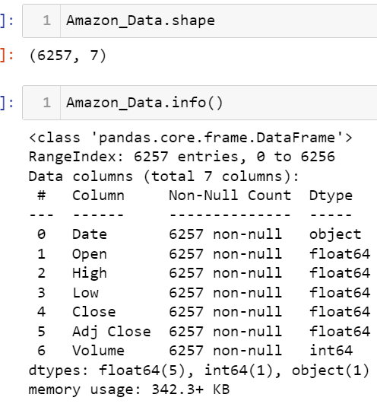\
Figure 4.1.1: Data Shape and information
(Source: Self-Generated)
The data thoroughly captures Amazon Inc.'s historic stock exchange performance. The dataset has 7 columns and 6257 rows of data reflecting different pillars of Amazon’s stock trading. The 'Date' column which has a chronological reference follows the order in which days are presented in the recorded time. The columns which are marked "Open," "High," "Low," and "Close" are full of essential data, where the brokers see the stocks opening, their highest, lowest and closing values during each trading day. They give a player the ability to make split-second decisions which determine if the price of Amazon shares can go up or down on a certain day and how sentiment about other shares in the market is changing. On the contrary, there is an 'Adjusted Close' column which is adjusted for another effect of operations like dividends and stock splits, making the company performance visible. The 'activity' section specifies the share numbers traded which reflects the level of trading activity and demand of Amazon stock on a given day.
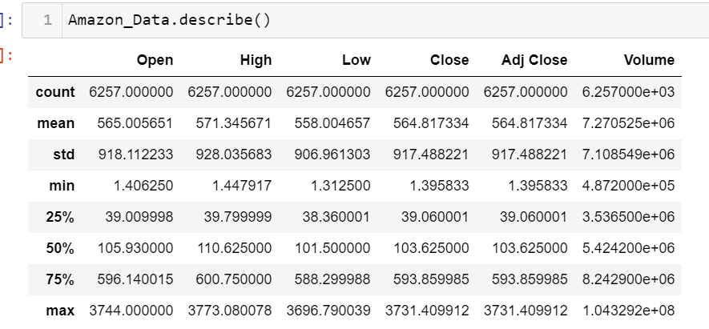
Figure 4.1.2: Statistics of Amazon data
(Source: Self-Created)
The variance in terms of not just trading volumes but also price per stock of Amazon's dataset as the main explanation is reflected in its summarized statistics. The distribution on the half price is the same as the one on the median and this implies that the price moves of the stock should be rather consistent with no major shakes. The minimum and maximum values point to the discrepancy of the census values, which in turn indicate the appreciable swings of Amazon share prices during the corresponding period. The statistics of Amazon Stock, typically traded in the Quarter-Burton area i.e. the megacity, suggests such a heavy market activity that it almost depletes the daily trading volume. This volume flows attracts a heap of both types of professionals who use the stock for both short-term trading and long-term investing.
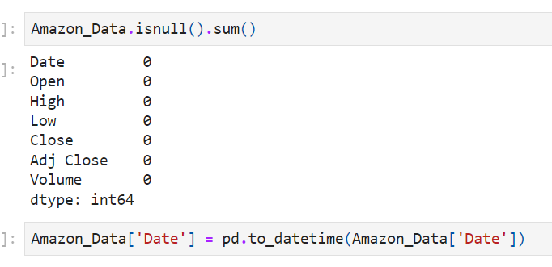
Figure 4.1.3: Checking null values and converting data type of date
(Source: Self-Created)
The missing value analysis on the Amazon Data Frame reveals no null values exist in any of its columns. The fact indicates that this dataset is exhaustive, meaning it covers the whole sampling area. Moreover, the ‘Date’ column was made into Date Time format by employing the datetime function acquired from pandas to make the data more useful. This change makes all dates similar and improves a chronological study of stock market quotations. In general, this dataset is more dependable and simpler to appraise as it avoids blank cells and has different formats for dates.

4.2: Exploratory data analysis
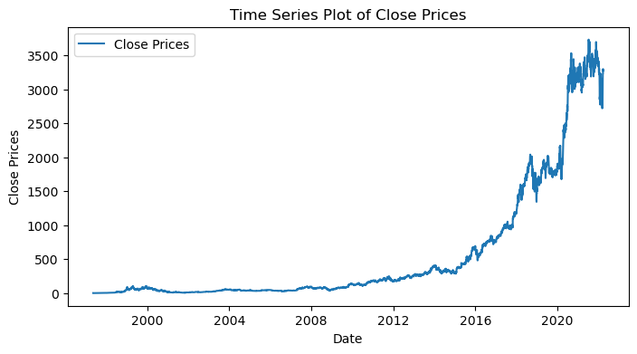
Figure 4.2.1: Time series analysis for the closing price
(Source: Self-Acquired)
The time series figure shows the ongoing movement of Amazon's closing prices during the study time frame. A visualization of the data reveals peaks, fluctuations, and patterns corresponding to the stock price as it moves over time. The data reveals several trends, some of which are subtle while others are more drastic changes in the price of Amazon's shares. Risk-averse investors may have the chance to monitor the ups and downs map to analyse them as a basis for the decision to buy or sell. This goes on occasionally up to down to spike, but the statistics provide an overall positive upward tendency for Amazon stock values.
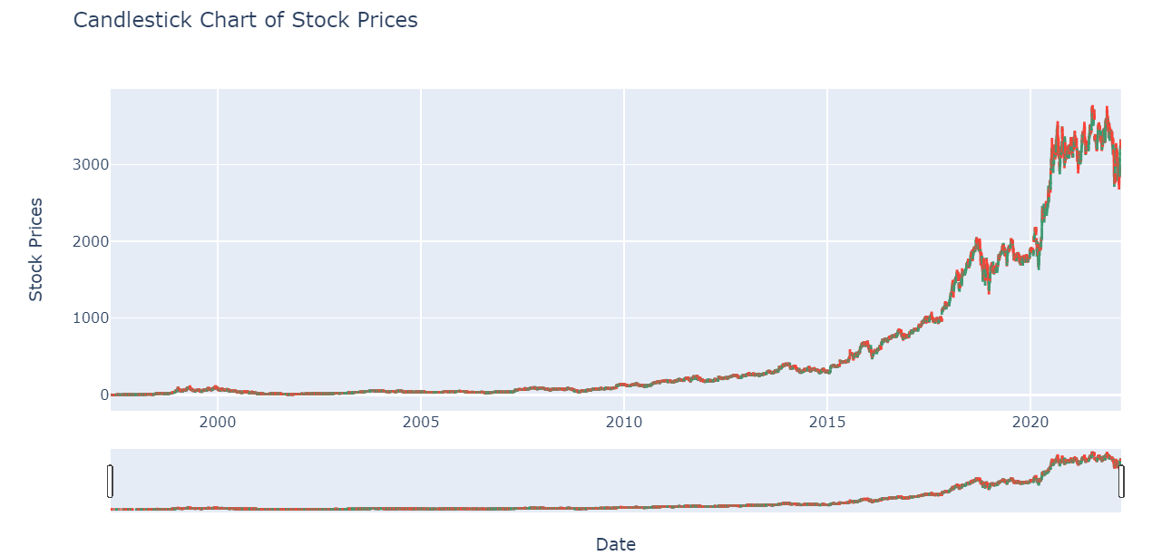
Figure 4.2.2: Stock price candle stick chart
(Source: Self-Generated)
The Candlestick Chart gives a graphic presentation where it shows the daily swings in the Amazon shares value. Each candle shows the price only for the day: opening & closing and the highest and the lowest. Ideally, learning candlestick patterns would allow not only to make an assessment of current mood but also to predict forthcoming price variations. The chart shows that the market’s instability may be explained by the combination of the bearish trends (the ones that are downward) and the bullish trends (the ones that are pointing upward). Traders effectively will have a chance to upgrade their trading styles by closely examining price movements.
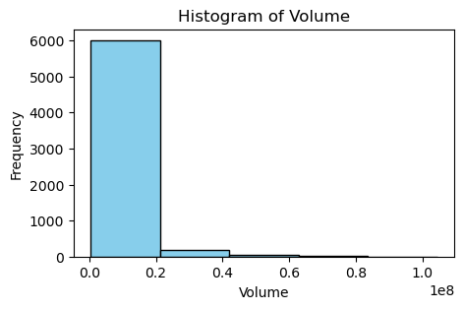
Figure 4.2.3: Frequency of volume
(Source: Self-Generated)
The chart shows a distribution of trading volumes for Amazon's stock. The stock's volume patterns represent a particular distribution. It isolates the usage of many different amounts of shares and the volume of activity around Amazon stocks' price fluctuations. The distribution of data shows the positive skew that was perceived from the histogram which had the majority of the range of transaction volumes concentrated at a lower level of it. Nevertheless, in the light of the vicissitudes and fluctuations in market turnover in this case periods of high volatility or interest are becoming visible. Investors can exploit this knowledge to assess various factors including market sentiment and liquidity. This knowledge will be useful to traders in making their decisions.
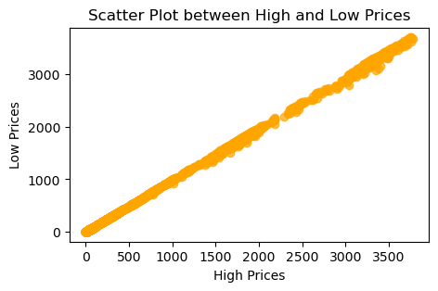
Figure 4.2.4: Scatter plot for high and low prices
(Source: Self-Acquired)
The scatter plot forms a graphical picture of the degree of relationship between the stock's most and least traded prices for each given day. It enables the discernment of the loosely defined relationship between two variables via a plot of spot distribution on the graph. In this figure, the scatter diagram shows a strong linear correlation between high and low prices implying that as the highest price goes up, so does the lowest price. This may be advantageous in both fields of comprehension of pricing dynamics and probably predicting future price variations based on historical trends.

4.3 Analysis with various models
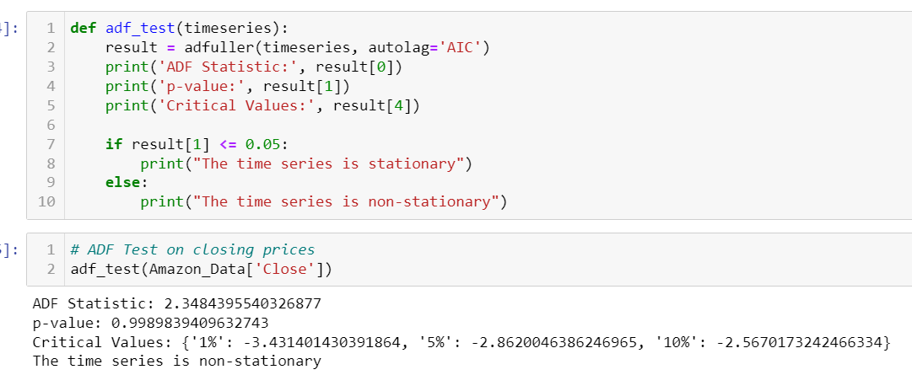
Figure 4.3.1: Testing and analysis with ADF test
(Source: Self-Developed)
The Augmented Dickey-Fuller (ADF) test is a statistical technique that is employed to determine whether a dataset in a time series is stationary or not. The constant mean, constant variance, and autocorrelation are the three envelopes of a stationary time series that do not get altered from time to time. The closest period up to 22.04 to sixty months with an ADF stat of 2.3484 and the computation p-value of 2.3484 results in a p-value of around 0.999 about the closing prices of Amazon. Consequently, the alternative hypothesis is not ruled out in the light of these numbers, that is, the time series data cannot be described by the stationary method, as stated by the null hypothesis. P value is above the significance level typically accepted - 0.05 - so the data is under the presence stationarity impossible. In addition to that, the aforementioned dependency has disclosed the fact that the time series is non-stationary as it does not have an equivalent in the critical values of the ADF test.
The closing prices of the ADF test against Amazon climate realized the constantly moving nature of the stock market data. Concerning this, non-stationarity takes the role of a concept that as time passes, the sample mean and variance of the closing prices of Amazon are changing and not constant. There are other methods for time series analysis relying on stationarity assumptions which are possibly unable to mimic the behaviour of Amazon's stock price. Moreover, the existing set of non-stationary data becomes another obstacle in the path of precise forecasting of future price changes using techniques of simply historic data trending stations. In conclusion, both time-series modelling techniques should be used while analysing the high-frequency data of Amazon stocks because such data is highly non-stationary. As such, it enables risk reduction through more intricate and yet informed forecasting in the financial markets.
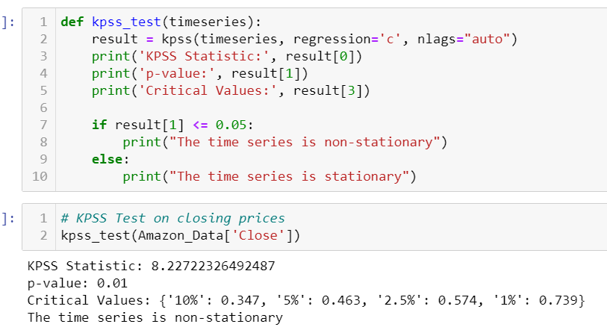
Figure 4.3.2: Testing and analysis with KPSS test
(Source: Self-Developed)
The Kwiacowsk-Phillips-Schmidt-Shin test is a statistical method that is used to determine the stationarity property of the time series data. The KPSS test provides evidence that the absence of a trend and no random movement between observations is predicated on the null hypothesis while the existence of a trend is termed as the alternative hypothesis. Conversely, the ADF test, as opposed to it, is used to quantify nonstationary variables (a time series has to display a unit root). Given the KPSS test result, the computation is as follows: KPSS spatial-temporal statistic equals 8.2272, p-value concerning the closing price series of Amazon equals 0.01. As the remaining p-value is less than the 0.05- percentage criterion for significance, it is decided to support the alternative hypothesis, which indicates non-stationarity and to reject the null hypothesis. In addition, this result is unambiguous, as confirmed when the estimated value of the KPSS statistic is compared to the important values provided by the test, as the statistic is found to be greater than the important values.
By conducting a KPSS test on Amazon closing prices, it is evident that the data does not follow a flat-line pattern in the long run. It can be interpreted as well that over the recorded period the closing prices are severely characterized by the statistical variations in their normal properties adjusted with the value and variability. Accordingly, projecting the future through a traditional time series analysis method that considers the changes in a planned period to be stationary would likely mislead investment and planning decisions. In short, the substantial changes in Amazon's closing prices over specific years require a close examination so that adequate modelling models can be applied to interpret the variability of the market. Financial analysts and investors can develop better decision-making skills for executing transactions within the Amazon stock markets by relying on the more developed forecasting approaches as well as the tailored strategies for managing risks which correspond to the evolving nature of Amazon stocks. This has to do with taking into account the character of the data which is not stationary, that is, parameters like mean and variance change over time.
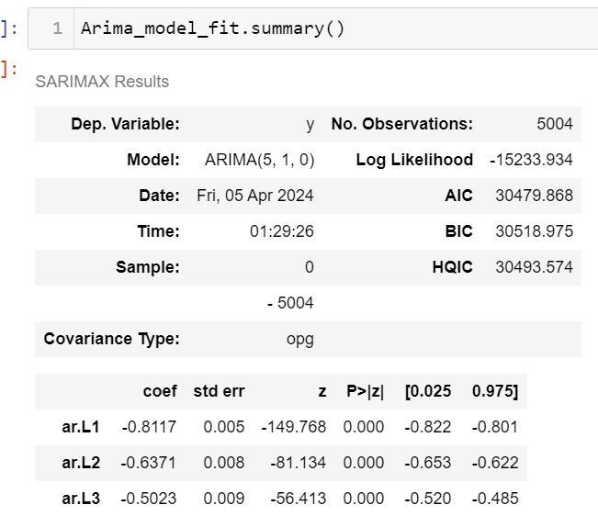
Figure 4.3.3: Summary of the Arima model
(Source: Self-Acquired)
This ARIMA model is a five-one-zero autoregressive integrated moving average for Amazon stock market data. Autoregressive coefficients of the model summary exhibit a decreasing trend meaning that recent past values have less impact on future ones. Log probability which gives a good measure of fit and at the same time, low AIC and BIC are indicators of a strong fit of the model to the data. The estimated variance (sigma^2) shows residual volatility. Residuals from this model still maintain normality, and absence of seasonality and employ white noise assumptions as shown by diagnostic tests like Jarque-Bera and Ljung-Box tests. ARIMA models enable Amazon Company to predict stock prices.
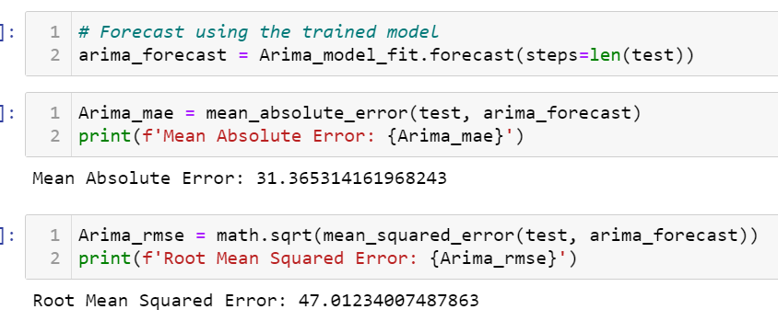
Figure 4.3.4: Analysis based on the Arima model
(Source: Self-Acquired)
The MAE for this ARIMA prediction model was 31.37, while RMSE was 47.01 for Amazon stock forecasts. These figures illustrate how far off actual values can be when compared with trading errors, including their distribution and average magnitude <of these deviations>. Model accuracy is given by Root Mean Square Error (RMSE), which measures prediction error standard deviation across all predictions while Mean Absolute Error (MAE) denotes that expected values miss 31.37 units out of their predictions. To do away with the ambiguity in what allows stakeholders to assess the validity of the ARIMA model in forecasting stock prices.
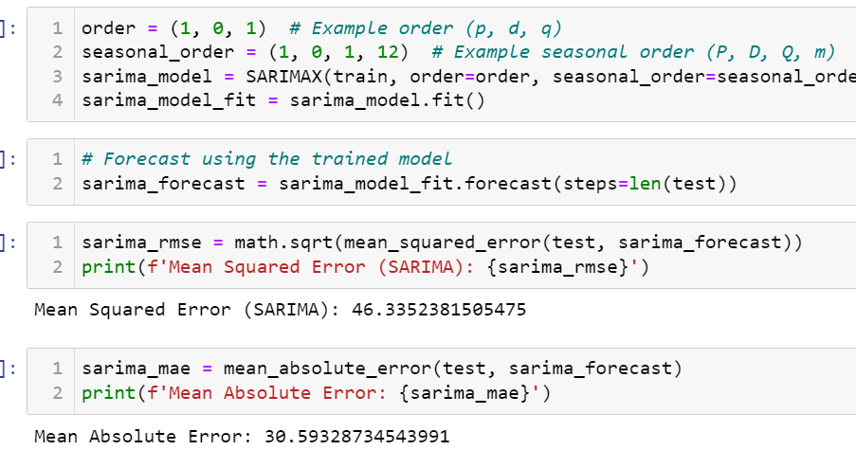
Figure 4.3.5: Analysis and evaluation based on the Sarima model
(Source: Self-Generated)
The SARIMA model was trained on the dataset with an order of (1, 0, 1) and a seasonal order of (1, 0, 1,12). Herein, when predicting, SARIMA has an MAE of 30.59 and an RMSE of 46.34. The assessment measures for forecasting Amazon Inc.'s stock market performance by the SARIMA model were also discussed. Since stock market data is unpredictable, the model’s average prediction error (RMSE) stands at a very good figure of 46.34. Moreover, its mean absolute error (MAE) which is equal to 30.59 points out that it can predict stock markets correctly. This implies that moreover than ARIMA model will not be as accurate as the SARIMA model in future predictions on the stock market based on these findings. These criteria measure how useful stakeholders find the SARIMA model for financial decision-making as well as accuracy in Amazon Inc.’s stock market forecasts.
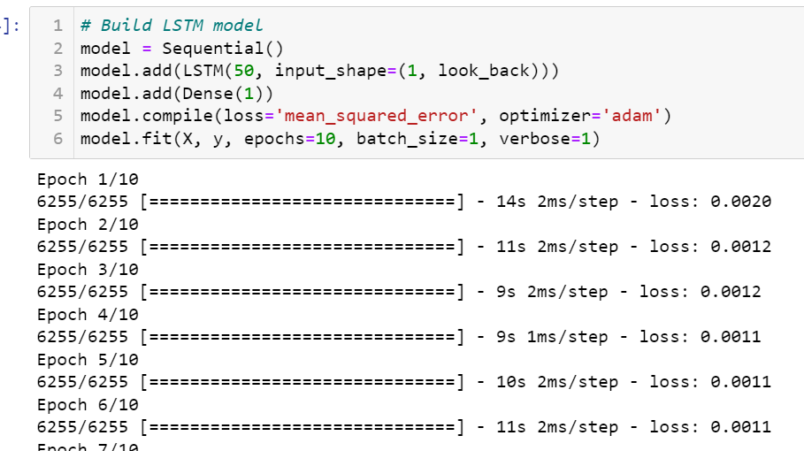
Figure 4.3.6: LSTM model architecture and fitting on train data
(Source: Self-Developed)
Supervised normalized returns data was used to train LSTM. The model design features a 50-unit LSTM layer and a thick regression layer. Adam optimizer optimized the model after its creation using mean squared error loss. The model was trained in one batch for 10 epochs. Model loss values kept dropping during training suggesting better recognition of data patterns.

