MAIN PROJECT

DOCUMENT FOR REVIEW

DREAMHOUSE

SUBMITTED BY,

NEETHU CHERIYAN

MCA S4 (D)

ROLL NO-44

SUBMITTED TO,

Ms.DHANYASUKUMARAN

Asst.PROFESSOR,CA

SNGCE

ABSTRACT

The project introduce a Ecommerce site for providing outstanding building materials with an extensive network of customer needs building materials suppliers can assess the needs which requires a lots of innate skills &experience .the admin handle the products like tile, sanitary items etc. with their brands. Each product contain the details .Customer can chooses the product by applying the filteration.Through the site manage the customer enquiries and bookings. Also display the previous projects & images to get the attraction from the customers automatic downloading documentation about the product is also possible through this site. Handling the small & bulk orders as user friendly provide more customer interaction & space of enquiry.

USE CASE DIAGRAM

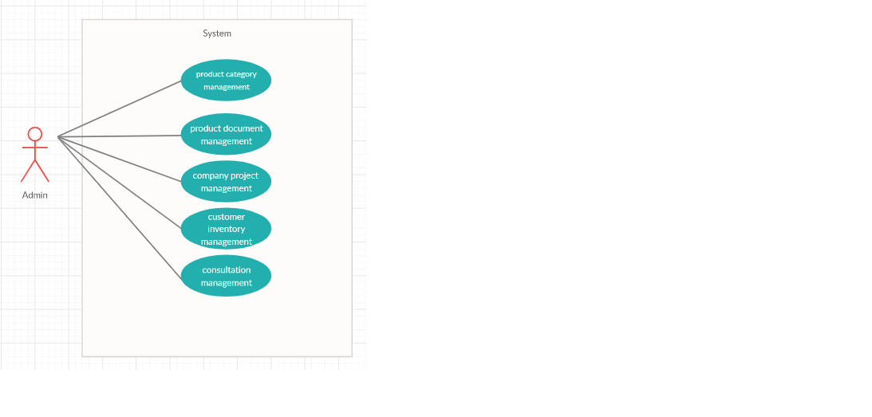

IDEAL BURNDOWN CHART

SPRINT PLANNER

|  |  |  |  |  |  |  |  |
| --- | --- | --- | --- | --- | --- | --- | --- |
| **Feature id** | **sprint** | **Start date** | **End date** | **Duration**  **(days)** | **Estimated work(hrs)** | **Sprint goal** | **Acceptance criteria** |
| **1** | 1.0 | 13/1/2020 | 16/1/2020 | 3 | 12 | Create add category form | Given I am an admin I want to add category |
|  | 1.0 | 20/1/2020 | 23/1/2020 | 3 | 12 | Create add sub category form | Given I am an admin I want to add sub category |
|  | 2.0 | 24/1/2020 | 28/1/2020 | 3 | 12 | Create add brand form | Given I am an admin I want to add brands |
|  | 2.0 | 03/2/2020 | 07/2/2020 | 5 | 20 | Create add filter form | Given I am an admin I want to add filters |
|  | 3.0 | 10/2/2020 | 14/2/2020 | 5 | 20 | Create add product  form | Given I am an admin I want to add product |
| **2** | 4.0 | 17/2/2020 | 19/2/2020 | 2 | 8 | Create add document  form | Given I am an admin I want to add document |
|  | 4.0 | 20/2/2020 | 26/2/2020 | 7 | 28 | Create add  project  form | Given I am an admin I want to add  project |
| **3** | 5.0 | 28/2/2020 | 09/3/2020 | 9 | 18 | Create  View of consultation | Given I am an admin I want to view conslttion details |
|  | 5.0 | 11/3/2020 | 18/3/2020 | 9 | 18 | Create  View of message from customer | Given I am an admin I want to view message |
|  | 6.0 | 19/3/2020 | 30/3/2020 | 10 | 10 | Create view of contact details | Given I am an admin I want to view contact details |
| **4** | 7.0 | 1/4/2020 | 9/4/2020 | 8 | 32 | Create view of bulk order | Given I am an admin I want to view order |
|  | 7.0 | 10/4/2020 | 16/4/2020 | 6 | 24 | Create view of small  order | Given I am an admin I want to view small order |

**Sprint Backlog-1**

|  |  |  |  |  |  |
| --- | --- | --- | --- | --- | --- |
| Feature id | sprint | User story | Tasks | Week1 | Week2 |
| 1 | 1.0 | Story 1.1  Create add category form | Design & placing user control |  |  |
|  |  |  | Development  Of components |  |  |
|  |  |  | Validation |  |  |
|  |  |  | Testing |  |  |
|  |  |  | Deployment |  |  |

|  |  |  |  |  |  |
| --- | --- | --- | --- | --- | --- |
| Feature id | sprint | User story | Tasks | Week1 | Week2 |
| 1 | 1.0 | Story 1.2  Create add sub category form | Design & placing user control |  |  |
|  |  |  | Development  Of components |  |  |
|  |  |  | Validation |  |  |
|  |  |  | Testing |  |  |
|  |  |  | Deployment |  |  |

**Sprint Backlog-2**

|  |  |  |  |  |  |
| --- | --- | --- | --- | --- | --- |
| Feature id | sprint | User story | Tasks | Week1 | Week2 |
| 1 | 2.0 | Story 1.3  Create add brand form | Design & placing user control |  |  |
|  |  |  | Development  Of components |  |  |
|  |  |  | Validation |  |  |
|  |  |  | Testing |  |  |
|  |  |  | Deployment |  |  |

|  |  |  |  |  |  |
| --- | --- | --- | --- | --- | --- |
| Feature id | sprint | User story | Tasks | Week1 | Week2 |
| 1 | 2.0 | Story 1.4  Create add filter form | Design & placing user control |  |  |
|  |  |  | Development  Of components |  |  |
|  |  |  | Validation |  |  |
|  |  |  | Testing |  |  |
|  |  |  | Deployment |  |  |

**Sprint Backlog-3**

|  |  |  |  |  |  |
| --- | --- | --- | --- | --- | --- |
| Feature id | sprint | User story | Tasks | Week1 | Week2 |
| 1 | 3.0 | Story 1.5  Create add product form | Design & placing user control |  |  |
|  |  |  | Development  Of components |  |  |
|  |  |  | Validation |  |  |
|  |  |  | Testing |  |  |
|  |  |  | Deployment |  |  |

**Sprint Backlog-4**

|  |  |  |  |  |  |
| --- | --- | --- | --- | --- | --- |
| Feature id | sprint | User story | Tasks | Week1 | Week2 |
| 2 | 4.0 | Story 2.1  Create add document form | Design & placing user control |  |  |
|  |  |  | Development  Of components |  |  |
|  |  |  | Validation |  |  |
|  |  |  | Testing |  |  |
|  |  |  | Deployment |  |  |

|  |  |  |  |  |  |
| --- | --- | --- | --- | --- | --- |
| Feature id | sprint | User story | Tasks | Week1 | Week2 |
| 2 | 4.0 | Story 2.2  Create add project form | Design & placing user control |  |  |
|  |  |  | Development  Of components |  |  |
|  |  |  | Validation |  |  |
|  |  |  | Testing |  |  |
|  |  |  | Deployment |  |  |

**Sprint Backlog-5**

|  |  |  |  |  |  |
| --- | --- | --- | --- | --- | --- |
| Feature id | sprint | User story | Tasks | Week1 | Week2 |
| 3 | 5.0 | Story 3.1  Create view consultation | Design & placing user control |  |  |
|  |  |  | Development  Of components |  |  |
|  |  |  | Validation |  |  |
|  |  |  | Testing |  |  |
|  |  |  | Deployment |  |  |

|  |  |  |  |  |  |
| --- | --- | --- | --- | --- | --- |
| Feature id | sprint | User story | Tasks | Week1 | Week2 |
| 3 | 5.0 | Story 3.2  Create view message from customer | Design & placing user control |  |  |
|  |  |  | Development  Of components |  |  |
|  |  |  | Validation |  |  |
|  |  |  | Testing |  |  |
|  |  |  | Deployment |  |  |

**SCREENSHOTS**

FIG1- CATEGORY

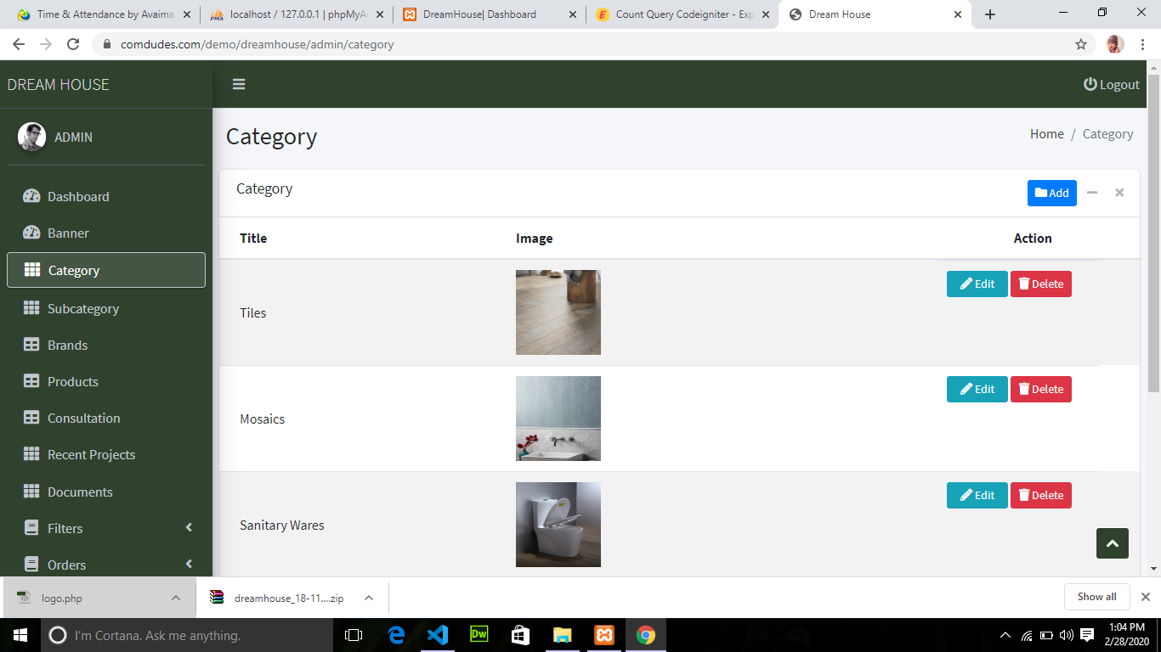

FIG2-BRAND

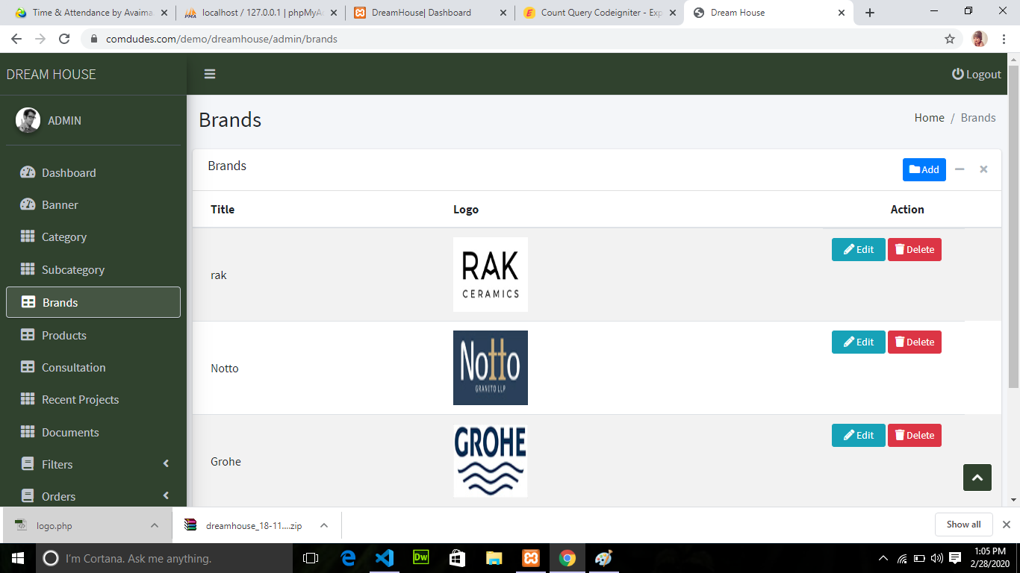

FIG3-BANNER

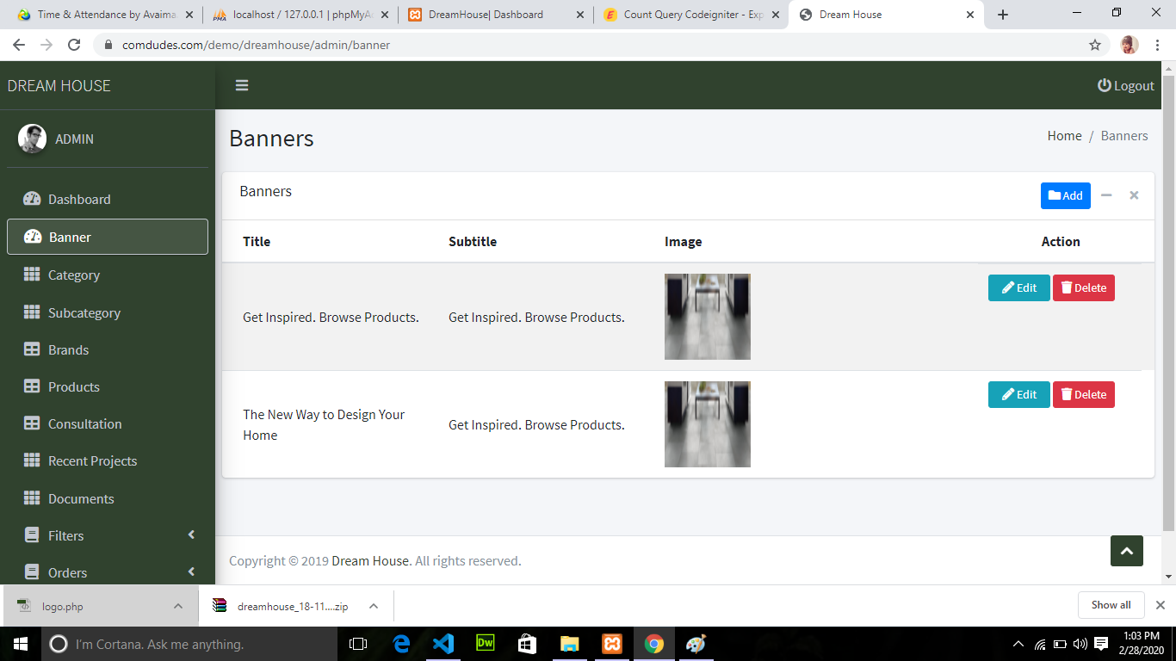

FIG4-PRODUCT

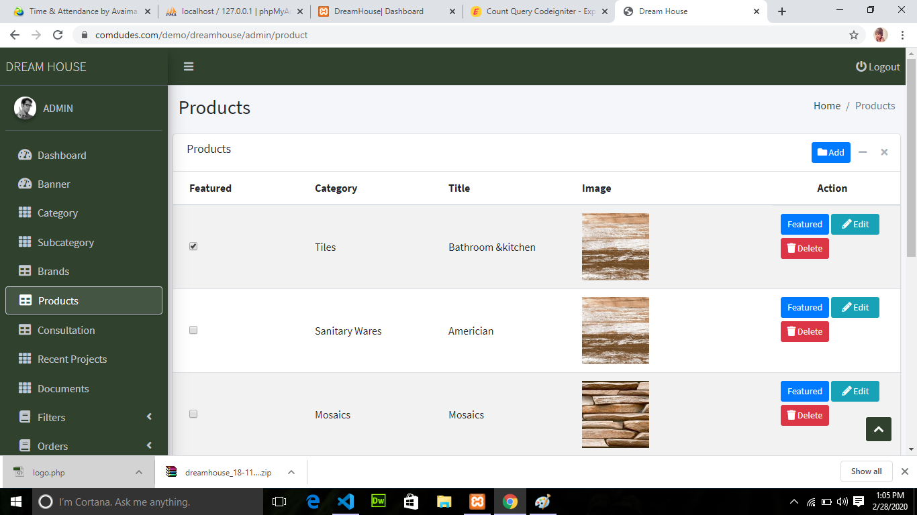

FIG6-PROJECT

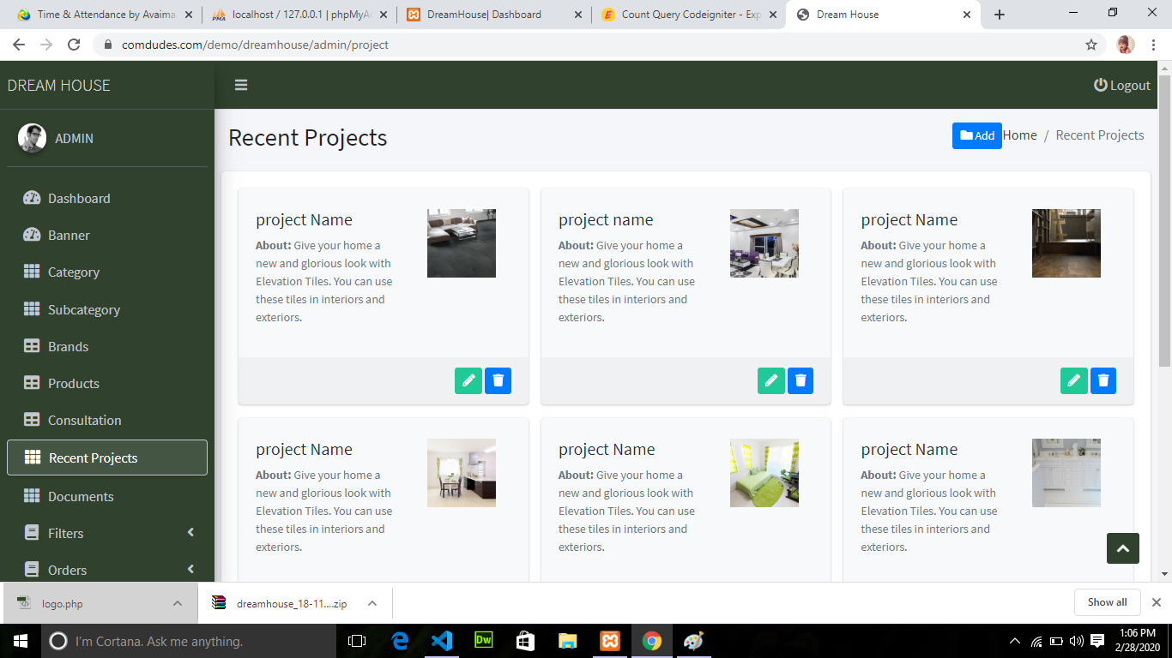

FIG7-DOCUMENTS

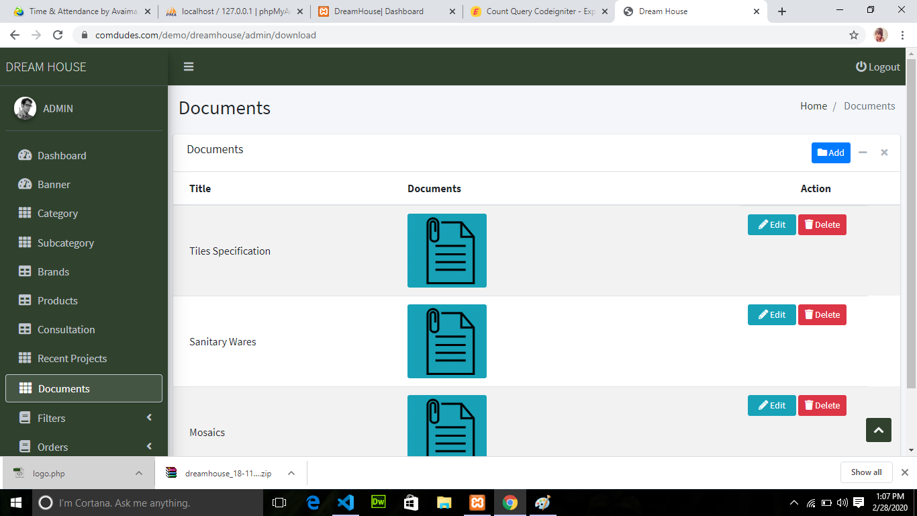

FIG8-TYPOLOGY

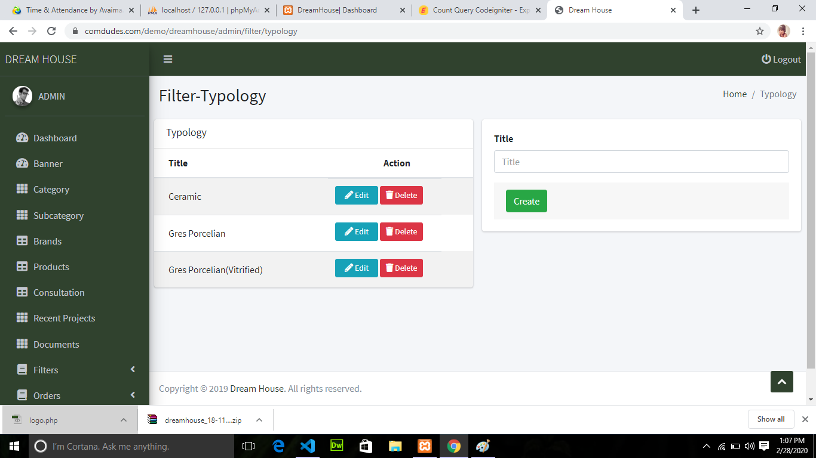

FIG-HOME

