BLC Consortium — Technical Design Document
Hyperledger Fabric · Ledger Model · Chaincode API · Backend API · Implementation Plan
Sprint v1.0 · July 2026 · Internal

1. Ledger Data Model
The ledger data model defines every object stored in the Fabric world state. All chaincode functions, backend endpoints, and frontend views depend on it. Assets are stored in CouchDB as JSON documents with keys following the pattern: asset-type~id.

1.1 Institution
Represents a consortium member — founding or approved through the voting process.

Field | Type | Required | Description
institutionId | string | Yes | Unique identifier — MSP ID of the organization
name | string | Yes | Display name of the institution
status | string | Yes | active | pending | rejected
type | string | Yes | founding | approved | partner
joinedAt | string | Yes | ISO 8601 timestamp of when the institution was admitted
approvedBy | string[] | No | List of institution IDs that voted to approve
docType | string | Yes | Fixed value: 'institution' — used for CouchDB queries

Key format: institution~{institutionId} Example: institution~org1msp

1.2 Certificate
Represents a certificate issued by a consortium institution. The sequential number is unique across the entire consortium.

Field | Type | Required | Description
certificateId | string | Yes | UUID — generated by chaincode on issuance
consortiumNumber | number | Yes | Sequential number across all institutions — auto-incremented
holderName | string | Yes | Name of the certified person
holderDetails | string | Yes | Description of what was certified
metadata | object | No | Flexible JSON — client-specific fields
certificateHash | string | Yes | SHA-256 hash of holderName + holderDetails + metadata (sorted keys)
issuerId | string | Yes | MSP ID of the issuing institution
issuedAt | string | Yes | ISO 8601 timestamp of issuance
status | string | Yes | active | revoked
docType | string | Yes | Fixed value: 'certificate'

Key format: certificate~{certificateId} Counter key: CERT_COUNTER

1.3 Membership Proposal
Represents a request by a new institution to join the consortium.

Field | Type | Required | Description
proposalId | string | Yes | UUID — generated on proposal creation
applicantId | string | Yes | MSP ID of the institution requesting to join
applicantName | string | Yes | Display name of the applicant
proposedBy | string | Yes | MSP ID of the institution that submitted the proposal
status | string | Yes | open | approved | rejected
votesFor | number | Yes | Current count of yes votes
votesAgainst | number | Yes | Current count of no votes
totalEligibleVoters | number | Yes | Number of active institutions at time of proposal creation
createdAt | string | Yes | ISO 8601 timestamp
resolvedAt | string | No | Timestamp when proposal was approved or rejected
docType | string | Yes | Fixed value: 'proposal'

Key format: proposal~{proposalId}

1.4 Vote
Represents a single vote cast by an institution on a membership proposal.

Field | Type | Required | Description
voteId | string | Yes | Composite: proposalId~institutionId
proposalId | string | Yes | Reference to the proposal being voted on
votedBy | string | Yes | MSP ID of the institution casting the vote
decision | string | Yes | yes | no
votedAt | string | Yes | ISO 8601 timestamp
docType | string | Yes | Fixed value: 'vote'

Key format: vote~{proposalId}~{votedBy} — composite key prevents double voting at the ledger level.

2. Chaincode API
All chaincode functions grouped by chaincode. Each function lists inputs, outputs, caller, and ledger writes.

2.1 institution-cc
Handles consortium governance: institution registration, membership proposals, and voting.

RegisterInstitution
Registers the calling organization as an active institution. Called once per organization during onboarding.

Item | Detail
Caller | Any organization admin
Input | name (string) — display name of the institution
Output | Institution object
Ledger writes | Creates Institution asset with status: active, type: founding (first) or approved
Validation | Institution must not already exist on the ledger

ProposeNewMember
Submits a proposal for a new institution to join. Any active institution can propose.

Item | Detail
Caller | Any active institution
Input | applicantId (string), applicantName (string)
Output | Proposal object with proposalId
Ledger writes | Creates Proposal asset with status: open, sets totalEligibleVoters to current active count
Validation | Caller must be active. Applicant must not be a member. No open proposal for applicant exists.

CastVote
Casts a vote on an open membership proposal. Automatically resolves if threshold is met.

Item | Detail
Caller | Any active institution (except the applicant)
Input | proposalId (string), decision (string: yes | no)
Output | Updated Proposal object
Ledger writes | Creates Vote asset. Updates Proposal vote counts. If majority reached: updates Proposal to approved, creates Institution for applicant.
Threshold logic | Default: majority (floor(totalEligibleVoters / 2) + 1). Configurable parameter for future 66% upgrade.
Validation | Proposal must be open. Caller must not have already voted. Caller must not be the applicant.

GetInstitution / GetAllInstitutions / GetProposal
Query functions — read only, no ledger writes. GetAllInstitutions uses CouchDB rich query on docType. Anyone can call these.

2.2 certificate-cc
Handles certificate issuance, verification, and sequential numbering.

IssueCertificate
Issues a new certificate and assigns the next consortium-wide sequential number.

Item | Detail
Caller | Any active institution
Input | holderName (string), holderDetails (string), metadata (object, optional)
Output | Certificate object including certificateId and consortiumNumber
Ledger writes | Creates Certificate asset. Increments CERT_COUNTER.
Hash logic | SHA-256 of JSON.stringify({ holderName, holderDetails, metadata }) with metadata keys sorted alphabetically.
Validation | Caller must be an active institution on the ledger.

VerifyCertificate
Verifies a certificate by recalculating its hash and comparing against the stored hash.

Item | Detail
Caller | Anyone
Input | certificateId (string)
Output | { status: VALID | TAMPERED, certificate: Certificate }
Ledger writes | None — read only
Logic | Recalculate hash from stored data. Compare against stored certificateHash. Match = VALID. Mismatch = TAMPERED.

GetCertificate / GetCertificatesByInstitution
Query functions — read only. GetCertificatesByInstitution uses CouchDB rich query on issuerId, sorted by consortiumNumber descending.

3. Backend API — REST Endpoints
Separate Node.js/Express service connecting the frontend to Fabric using the fabric-network SDK.

3.1 Institution Endpoints
Method | Endpoint | Auth | Description
POST | /institutions/register | JWT | Register calling org as an institution
GET | /institutions | None | Get all active institutions
GET | /institutions/:id | None | Get institution by ID
POST | /institutions/propose | JWT | Submit membership proposal for a new institution
POST | /institutions/vote | JWT | Cast a vote on an open membership proposal
GET | /proposals/:id | None | Get proposal details and current vote count

3.2 Certificate Endpoints
Method | Endpoint | Auth | Description
POST | /certificates | JWT | Issue a new certificate
GET | /certificates/:id | None | Get certificate by ID
GET | /certificates/:id/verify | None | Verify certificate — returns VALID or TAMPERED
GET | /certificates/institution/:id | JWT | Get all certificates issued by an institution

3.3 Auth Endpoints
Method | Endpoint | Auth | Description
POST | /auth/login | None | Institution login — returns JWT
GET | /health | None | Liveness check

4. Network Structure

4.1 Organizations
Organization | MSP ID | Role | Components
Institution 1 | Org1MSP | Founding member | 1 peer, 1 CA, 1 MSP
Institution 2 | Org2MSP | Founding member | 1 peer, 1 CA, 1 MSP
OrdererOrg | OrdererMSP | Ordering service | 1 Raft orderer, 1 CA

4.2 Channel Configuration
- Channel name: blc-channel
- Members: Org1MSP, Org2MSP
- Chaincodes deployed: institution-cc, certificate-cc
- State database: CouchDB
- Endorsement policy: Default majority — both orgs must endorse at the 2-org stage

4.3 Architecture Diagram
The following diagram shows the full system architecture — frontend, backend services, Fabric network topology, and the existing Polygon PoC running alongside:

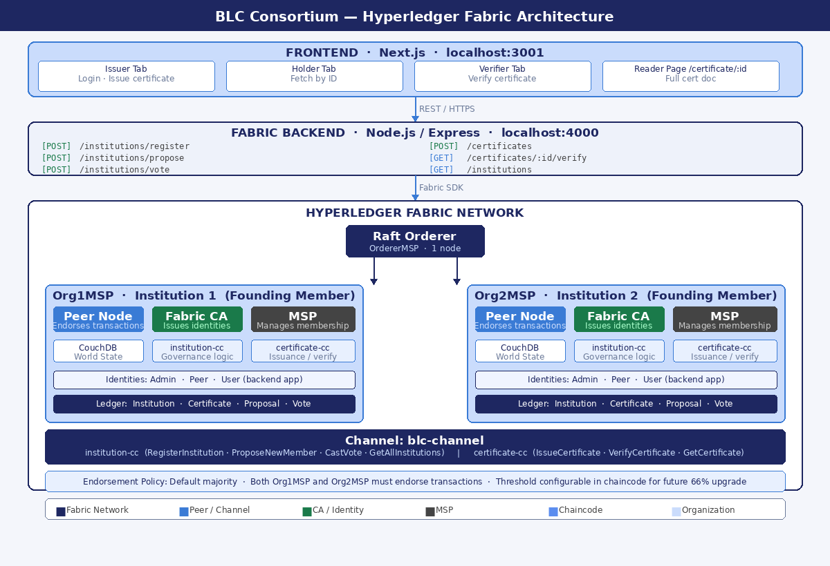

Full system architecture: Frontend → Fabric Backend → Hyperledger Fabric Network with Raft orderer, two founding organizations (Org1MSP and Org2MSP), blc-channel, institution-cc and certificate-cc chaincodes, CouchDB world state, and endorsement policy.

4.4 Crypto Material
Generated using Fabric CA. Each organization gets:
- Admin identity — channel operations and chaincode deployment
- Peer identity — peer node communication
- User identity — backend application submits transactions

5. Fabric Test Network — What Gets Reused
The fabric-samples test network provides a ready-made starting point. The following are reused or adapted:

- docker-compose files — Base structure for peers, orderer, CouchDB. Organization names and ports updated for BLC.
- configtx.yaml — Channel configuration template reused. Consortium name, channel name, MSP IDs updated.
- network.sh — Used or adapted to bring up the network, create the channel, and deploy chaincode.
- Fabric CA setup — CA configuration reused for generating crypto material for both organizations.
- Chaincode lifecycle — The package → install → approve → commit workflow is followed exactly.

What will NOT be reused:
- Sample chaincodes (asset-transfer-basic etc.) — replaced by institution-cc and certificate-cc.
- Application samples — replaced by the new Fabric backend service.

The test network uses 'Org1' and 'Org2' by default. These will be renamed to Institution1 and Institution2 for the BLC demo.

6. Implementation Tasks — BLC-31 Breakdown
BLC-31 covers consortium creation and onboarding. Subtasks broken into implementable units:

Phase 1 — Network Setup
Task | Estimated effort | Dependency
Adapt fabric-samples test network config for BLC (org names, ports, channel name) | 0.5 day | None
Generate crypto material for Org1 and Org2 using Fabric CA | 0.5 day | Network config
Start network — peers, orderer, CAs, CouchDB | 0.5 day | Crypto material
Create blc-channel and join both organizations | 0.5 day | Network running

Phase 2 — Chaincode
Task | Estimated effort | Dependency
Write institution-cc — RegisterInstitution, ProposeNewMember, CastVote, queries | 2 days | Ledger model finalized
Write certificate-cc — IssueCertificate, VerifyCertificate, GetCertificate, queries | 1.5 days | Ledger model finalized
Deploy both chaincodes to blc-channel (package, install, approve, commit) | 0.5 day | Channel created
Test chaincode functions using peer CLI | 0.5 day | Chaincode deployed

Phase 3 — Backend API
Task | Estimated effort | Dependency
Scaffold new Express/Node.js service with Fabric network SDK connection | 1 day | Network running
Implement institution endpoints (register, propose, vote, query) | 1 day | institution-cc deployed
Implement certificate endpoints (issue, verify, query) | 0.5 day | certificate-cc deployed
Implement JWT authentication for institution login | 0.5 day | Backend scaffolded

Phase 4 — Demo Preparation
Task | Estimated effort | Dependency
Extend Next.js frontend — institution dashboard, voting UI | 1.5 days | Backend API ready
End-to-end demo — Institution 1 and 2 founded, Institution 3 applies, vote, approval, certificate issuance | 0.5 day | All phases complete
Documentation updates — ARCHITECTURE.md, SETUP.md, README | 0.5 day | Demo working

Total Estimate
Phase | Estimate
Phase 1 — Network setup | 2 days
Phase 2 — Chaincode | 4.5 days
Phase 3 — Backend API | 3 days
Phase 4 — Demo preparation | 2.5 days
Total | ~12 days

Estimate is for one developer. Does not include unexpected blockers or scope changes.

