India Tender Website Navigation Guide

Steps to Navigate:
Step 1-: Enter the tender website URL (https://eprocure.gov.in/eprocure/app)
Step 2-: Go to Tender Status Tab
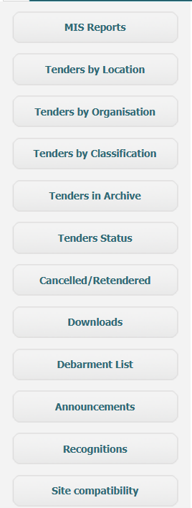
Step 3-: Applying Filters
- In Tender Status field need to select AOC for the awarded data
- Date should be between 01/01/2024 to recent
- In Product Category, select these filters-: Equipment (Hospital / Lab) ,Medical Equipments / Waste, Non Consumables (Hospital / Lab), Consumables (Hospital / Lab)
Step 4-: Enter the Captcha and click Search button

