
Birla Institute of Technology & Science,
Pilani, Rajasthan
Work Integrated Learning Program Division
An Assignment Report
ON
A2 Project Implementation
Title: London Housing Case Study
Submitted in partial fulfilment of the requirement for the award of
Master in Technology Degree in Software Engineering.


Subject Code: SEZG585
Course Title: Cross Platform Application Development

Submitted by
- Neetin Verma – 2020MT93012
- Amogh Bab K A – 2020MT93252
- Sanjib Bhadra – 2020MT93511

Course Author
Pravin Y Pawar
Birla Institute of Technology & Science,
Pilani, Rajasthan
Chapter 1
INTRODUCTION

A borough is just a fancy word for district. There are 32 London boroughs within Greater London, and each borough has its own governing council. As you can guess, some of them are more desirable to live in and will reflect that desirability in a greater rise in housing prices.
In this project, we present a progressive web application that can generate predictions for future housing prices in London. In order to select a prediction method, various regression methods were explored and compared. Gaussian Processes (GP) for regression was chosen as our model due to its flexible and probabilistic approach to learning and model selection. To handle the large dataset of past property transactions in London, we exploit the spatial structure of the dataset to distribute computations to smaller independent local models. Overall predictions are obtained by recombining predictions from local models. By training the model and generating predictions on the server-side of the application, we are able to offload computationally intensive tasks and focus on generating visualizations on the client-side. Our results demonstrate that our approach to the problem has been largely successful, and is able to produce predictions that are competitive to other housing price prediction models
  - Project Background
The project targets the analysis of housing prices trends based on the statistical data sets. Based on the key parameters obtained for a specific borough or district, the pricing of houses in the locality is analyzed. The buyers are often in a need to identify or capture relevant data points pertaining to a borough and determine the desirability of residing. This initiative leverages the process by enabling the advisories and visualizing the pricing trends. To describe broadly, the proposed system performs below major functions:
- EDA – Exploratory Data Analysis
- Prediction Analysis
The working principle is stated below:
- The system will connect to a data source, preferably a CSV data set populated by a different analytical process.
- System will perform cleaning of raw data according to some predefined logic and transform into a readable format.
- Standard web user interface to visualize the output in form of charts and graphs. The front end client will consume the API exposing the data.
  - Aims & Objectives
Aim of this project is to identify change in property price across different London Boroughs also understanding the factors influencing the changes which borough of London has seen the greatest average increase in housing prices over the (approximately) two decades covered by the dataset.
  - Relevance
As a data science enthusiast, the core for data science will always be the concepts of software Engineering. It also helps the codes by allowing them to reutilize their code easily and share it with the collaborators so that contribution on that particular concept will be increased and the duration of the project will be faster for deployment. It also helps in understanding the coding standards by writing the code and structuring it accordingly for execution.
  - Risk
- Quality of data used for analysis & predictions.
- Incompatible version of Libraries.
- Machine Performance depends while processing the huge quantity of dataset.

Chapter 2
LITERATURE SURVEY
A literature review is a body of text that aims to review the critical points of current knowledge and methodological approaches on a particular topic. For complete study of the system there is a need to go through each and every technical aspect of the related material in depth. Presented below is the survey of associated technologies and summary of related work done in the past.
As per the authors mentioned, The real estate market is one of the fields where machine learning can be applied to optimize and predict the price with high accuracy. Determining housing price is vital model for decision making for customers in which number of parameters can be considered to predict price of desired house. The participants that are involved in the process are not aware of the various analytical techniques available to guess the property price considering various features relating to surroundings, environment and other amenities etc. The design will help users to invest in a property without approaching an agent. It also decreases the risk involved in the transaction. Use of lasso regression is done as model because of its convertible and probability methodology on model selection. The result displays that the approach of the issue needs to be successful, and has the ability to operate predictions that would be comparative with other house price prediction models.

Chapter 3
SYSTEM ANALYSIS
Analysis is a detailed study of the various operations performed by a system and their relationships within and outside of the system. One aspect of analysis is defining the boundaries of the system and determining whether or not a candidate system should consider the related systems. During analysis data are collected on the available files decision points and transactions handled by the present system. This involves gathering information and using structured tools for analysis

Chapter 4
SOFTWARE REQUIREMENT SPECIFICATION
A Software Requirements Specification (SRS) is a complete description of the behavior of the system to be developed. It includes the functional and non-functional requirement for the software to be developed. The functional requirements include what the software should do and nonfunctional requirements include the constraint on the design or the implementation. Requirements must be measurable, testable, related to identified needs or opportunities, and defined to a level of detail sufficient for system design. Software requirement specification will contain states what the software will do. What the software as to do is directly perceived by its users- either human users or other software systems. The common understanding between and the user and developer is captured in requirements document. The writing of software requirement specification reduces development effort, as careful review of the documents can be reveal omissions, misunderstandings, and inconsistencies early in the development cycle when these problems are easier to correct. The SRS discusses the product but not the project that developed it. Hence the SRS serves as a basis for later enhancement of the finished product. The SRS may need to altered, but it does provide a foundation for continued production evaluation.
System requirement plays an important part in the analysis of the system. Only when the requirement specification is properly given, it is possible to design the appropriate system, which will fit into a pre-defined and required environment.
The requirement specification for any system can be broadly stated as given below:
- The system should be able to interface with existing system.
- The system should be better and accurate than existing system.
- The system should be interactive so that its user should easily understand the operation.
- The system should show the appropriate message when the user finishes the operations.
Also, when there is any error condition, suitable message should be displayed. The requirement analysis phase is for understanding the existing system, which is usually a simple activity. The goal of this activity is to understand the requirements of the good system to be the current mode of operation are basic requirements available for the analysis. The process of obtaining answers to questions that might arise in an analyst’s mind continues until the analyst feels that enough information has been obtained.
4.1 Purpose
The main purpose of the requirement document is to understand the requirements specification or document for the system engineers or the software developers to understand the system developed and for the system customer to specify the requirement and read them to check that they meet necessary needs.
4.2 Hardware and Software Requirements
The software requirement specification is produced at the culmination of the analysis task. The function and performance allocated to software as part of system engineering are refined by establishing a complete information description, a detailed function description, representation of system behavior, an indication of performance requirement and design constraints appropriate validation criteria, and other information pertinent to requirement. The introduction to software requirements specification states the goals and objectives of the software, describing it in the context of computer-based system. The Information Description provides a detailed description of the problem that the software must solve. Information content, flow and structure are documented. A description of each function required to solve the problem is presented in the Functional Description. Validation Criteria is probably the most important and ironically the most often neglected section of the software requirement specification. Software requirement specification can be used for different purpose.
4.2.1 Hardware Requirement
- CPU: 8 Core
- RAM: 30 GB RAM
- SSD: 80 GB
- Operating system: Debian GNU/Linux 9
- Dedicated Port: 8888 with public IP
- Framework: Jupyter Note Book (Anaconda) & Python IDE
4.2.2 Software Requirement
- Dataset: London boroughs
- Programming language: Python, Angular
- Libraries: Panda, NumPy, Matlib
- Operating system: Windows 10
Chapter 5
SYSTEM DESIGN
Design and Testing are the actual process of producing a solution according to the specification derived from the analysis stage. It is the process of defining the architecture, modules, interfaces, and data for a system to satisfy specified requirements. Systems design could be seen as the application of systems theory to product development. There is some overlap with the disciplines of systems analysis, systems architecture and systems engineering.
5.1 Logical Design
The logical design of a system pertains to an abstract representation of the data flows, inputs and outputs of the system. This is often conducted via modeling, using an over-abstract (and sometimes graphical) model of the actual system. In the context of systems, designs are included
5.2 Physical Design
The physical design relates to the actual input and output processes of the system. This is explained in terms of how data is input into a system. In physical design, the following requirements about the system are decided.
- Input requirement
- Output requirements
- Storage requirements
- Processing requirements
- System control and backup or recovery
Put another way, the physical portion of system design can generally be broken down into three sub-tasks: User Interface, Design Data and Design Process.
5.3 Architectural Design
The architectural design of a system emphasizes the design of the system architecture that describes the structure, behavior and more views of that system and analysis. Logical Architecture is an organization of sub system, software classes and the layers that makes the system completely logical. In this type of architecture, the components are placed randomly and mapped so that we can represent it in flow manner and try to bring up by identifying the functional elements of the system.
Fig 5.1: REPRESENTATION OF LOGICAL ARCHITECTURE.
5.4 ER Model
ER Model is a high-level Entity Relationship model used to define the data elements and relationship of the system. It is conceptual based design in the database which helps developers to understand the relationship between data and view the data present in the system.
Fig 5.2: REPRESENTATION OF ER MODEL
5.5 USE-CASE Model
Based on UML, the use case model helps us in understanding the behaviour of the system which in turn helps us in capturing the requirement specification of the system. This will be the high-level definition and scope of the system to understand the interactions between the system and its actors.

The proposed system essentially has a web UI which provides a rich interface for visiting users. The UI is powered by backend modules via API calls. The back-end component refers to few libraries which do the heavy lifting and computational tasks. The use case scenarios will have both users and backend systems as actors. Below are the use cases that are narrated in detail.

5.5.1 UC1: Citizens to get a list of available districts in the user interface
Fig 5.3: USE CASE DIAGRAM TO GET A LIST OF AVAILABLE DISTRICTS

Description | User to be rendered with an user interface landing page containing all districts, so that user can click on respective districts logo and view further details.
Actor | Normal Users (London Citizens)
Preconditions | User is authenticated and logged in.
Postconditions | User is able to view all districts in respective grids(clickable) in the web page
Flow | - User logs into the web application.  - User redirects to the landing page containing a list of districts in grid view.

5.5.2 UC2: Citizens can view the pricing trend for a given district
Fig 5.4: USE CASE DIAGRAM TO VIEW THE PRICING TREND BASED ON DISTRICTS

Description | User to be rendered with a web page indicating pricing trends in various areas belonging to a district. Users can also narrow down the search results by providing wanted areas they want to filter.
Actor | Normal Users (London Citizens)
Preconditions | User is authenticated and logged in.
Postconditions | Users are able to get a compact view of pricing trends of a district and its  respective areas.
Flow | 1. User logs into the web application.  2. User redirects to the landing page containing a list of districts in grid view.  3. User chooses a district from the list.  4. User gets a detailed view of pricing of the selected districts and the areas under that district.

5.5.3 UC3: user to get the graphical and tabular representation for comparison purposes
Fig 5.5: USE CASE DIAGRAM TO VIEW THE GRAPHICAL AND TABULAR REPRESENTATION

Description | User to be rendered with a web page that can help visualize vital parameters to assess a district
Actor | Normal Users (London Citizens)
Preconditions | User is authenticated and logged in.
Postconditions | Users are able to get a pictorial/graphical view of vital parameters  pertaining to a district.
Flow | 1. User logs into the web application.  2. User can expand the menu button for visualization  3. Users will get a convenient view depicting graphs and comparisons of 1 district against the other.

Chapter 6
SYSTEM IMPLEMENTATION
Implementation is the stage in the project where the theoretical design is turned into the working system and is giving confidence to the new system for the users i.e., will work efficiently and effectively. It involves careful planning, investigation of the current system and its constraints on implementation, design of method to achieve the changeover, an evaluation, of change over methods. A part from planning major task of preparing the implementation is education of users. The more complex system is implemented, the more involved will be the system analysis and design effort required just for implementation. An implementation coordinating committee based on policies of individual organization has been appointed.
The implementation process begins with preparing a plan for the implementation for the system. According to this plan, the activities are to be carried out; discussions may regarding the equipment has to be acquired to implement the new system. Implementation is the final and important phase. The most critical stage is in achieving a successful new system and in giving the users confidence that the new system will work and be effective. The system can be implemented only after thorough testing is done and if it found to working according to the specification. This method also offers the greatest security since the old system can take over if the errors are found or inability to handle certain types of transaction while using the new system.
The major elements of implementation plan are test plan, training plan, equipment installation plan, and a conversion plan. The implementation state involves the following tasks:
- Careful planning
- Investigation of system and constraints.
- Design of methods to achieve the changeover.
- Training of the staff in the changeover phase.
Successful implementation may not guarantee improvement in the organization using the new system, but improper installation will prevent it. It has been observed that even the best system cannot show good result if the analysts managing the implementation do not attend to every important detail. This is an area where the systems analysts need to work with utmost care.

6.1 Methodology
The Methodology of a system emphasizes the design of the system architecture that describes the structure, behavior and more views of that system and analysis.
The Project pipeline is as follows:
- Sourcing and loading
- Cleaning, transforming, and visualizing
- Modelling
- Evaluating and concluding
The Model used is the regression model, as the data available is linear and we have scaled the data accordingly as the target inputs.
Linear Regression
The simplest regression model is linear regression, which involves using a linear combination of independent variables to estimate a continuous dependent variable [11]. While the model is too simple to accurately model the complexity of London housing market, there are many fundamental concepts in linear regression that many other regression techniques build upon. If we consider a model where y is the dependent variable and x = (x0, . . . , xD) T is the vector of D independent variables, a linear regression model can be formulated as follows:
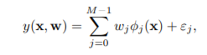
where φj (x) is a basis function with corresponding parameter wj , εj is the noise term, M is the number of basis functions and w = (w0, . . . , wM−1) T . Assume the noise terms εj are independent and identically distributed, where εj ∼ N (0, σ2 ). Basis functions can either be linear functions of the independent variables in the simplest case where φj (x) = xj , or extended to non-linear functions such as φj (x) = x 2 j , x3 j or √xj . In most cases, φo(x) is set as 1, such that w0 can act as a bias parameter to allow for fixed offset in the data [19]. Even though y(x, w) can be a non-linear function of input x through the use of non-linear basis functions, the model is still linear with respect to w. Alternatively, we can also express (3.1) as
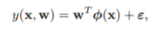
where φ = (φ0, . . . , φM−1) T and ε = (ε0, . . . , εM−1) T , which simplifies the expression and allow us to code in vectorized form, thereby avoiding the need for loops in computation.
6.2 Code Snippets
Linear Regression Model code
lin_reg = LinearRegression()
lin_reg.fit(x_train, y_train)
y_pred = lin_reg.predict(test_df)
result = pd.Series(np.exp(y_pred).astype(int))
submit_df = pd.concat([submit_id, result], axis=1, keys=['Id', 'SalePrice'])
Predicted CSV file
submit_csv = submit_df.to_csv('./house_price.csv', index=False)

Chapter 7
SYSTEM TESTING
Testing accomplishes a variety of things, but most importantly it measures the quality of the software we are developing. This view checks whether there are defects in the software under consideration and this view is rarely disproved or even disputed. Several factors contribute to the importance of making testing a high priority of any software development effort. These include reducing the cost of developing the program. Ensuring that the application behaves exactly as explained to the user for the vast majority of programs, unpredictability is the least desirable consequences of using an application. It also checks whether the software developed will satisfy the customer requirements and also to reduce the total cost of ownership. By providing software that looks and behaves as shown in the documentation, the customers require fewer hours of training and less support from product experts. Develop customer loyalty and word-of-mouth market share.
Fault occurs during all the phases in a software development cycle. Verification is hence performed on the output of each phase, but still some faults are likely to remain. This is actually removed in the final stage so that it will not be reflected in the code leading to malfunction.
System testing is execution of program to check logical changes made in it with the intention of finding error. Effective testing doesn’t guarantee reliability. Reliability is a design consideration.
Software testing is a critical element of software quality assurance and represents the ultimate review of specification, design and coding.
The general rules of coding could be:
- Testing is process of executing a program with the intention of finding the bugs.
- A good test case is one that uncovers undiscovered errors.
- Two classes of inputs are provided to the test process.
- A software configuration that would include SRS, SDS and source code.
- A test configuration with test plan and procedure.
- Tests are conducted and results are evaluated and interpreted with the expected results. When erroneous data is encountered, debugging commences.
7.2 Importance of Testing
The importance of software testing and its impact on software cannot be underestimated. Testing is the measurement of software quality. Hence, it is one of the most important stages in the software development process. It involves executing and implementation of the software and its operational behavior to check that is performing as required. One of the main goals is to have a minimum number of test cases that will find a majority of the implementing errors. Software testing is a fundamental component of software quality assurance and represents a review of specification, design and coding. The greater visibility of software systems and the cost associated with software failure are motivating factors for planning, through testing.
7.3 Test Information Flow
Information flow for testing follows the pattern shown in the figure below. Two types of input are given to the test process: (i) A Software Configuration. (ii) A Test Configuration
Tests are performed and all the outcomes are documented. Later, this documented test results will be compared with the expected results. When erroneous data is identified, debugging process is restarted with a different input parameter. The debugging procedure is the most unpredictable element of the testing procedure. An error that indicates a discrepancy of 0.01 percent between the expected and the actual results can take hours, days or months to identify and correct. It is the uncertainty in debugging that causes testing to be difficult to schedule reliability.
7.3 Types of Testing
Integration testing
This phase involves combining modules that can be combined and tested independently to reduce dependence on system testing. The combined set are tested to check how one how one module would affect the operation of other modules in the test. The most common problem may arise in large software system are the interface mismatches.
This units in our project are nothing but the modules provided by the interface. The integrated set of modules are tested. Each module in an integrated set is tested to check for the interface mistakes. The modules are implemented such that there are no interface mismatches between different modules and hence the test has succeeded.
System Level Testing
After performing unit tests and integration tests, the dependence on the system testing will be reduced. In system level testing, the sub-systems are all integrated together to make up the entire system and entire system as a whole is tested to check whether there are any problem with the integration of the components. It is concerned with validating that the system meets its functional and non-functional requirements.
After this test, it has been found that all functional requirements specified in the SRS are successfully achieved.
Real World User Level Testing
It is a unique type of testing, which is not designed to find defects. However it is designed to demonstrate the successful functioning of the program as we expect the end user to use it.
This test has been conducted on our software by giving different images. The test has been successful for all the values given.
Stress Testing
Stress test relies on stressing the system by going beyond its specified limits and hence testing how well the system can cope with overload situation.
Stress testing has two functions to perform: -
- Circumstances may arise through an unexpected combination of events where the load placed on the system exceeds the maximum anticipated load. In these circumstances, or unexpected loss of user services.
- It stresses the system and may cause defects to become known, that would not normally manifest themselves.
Performance Testing
Performance tests can also be considered as statical testing that is used to test program’s performance and reliability, rather than to discover software faults. The steps involved in statistical testing are:
- Generate a set of test data corresponding to operational profile.
- Applying these test cases to the program.
- After significant number of failures, software reliability is computed.
The statistical testing has been carried out by considering the probability of occurrence of the test data. Test cases are generated for all possible test data and execution performance of each are recorded. Depending on the significant number of failures required reliability metric could be computed.
Configuration Testing
In configuration testing phase, the different operating system, software applications, device driver etc are tested. Our module has been tested with windows 8.
Code coverage
Completeness
- The code is the complete and precise implementation of design as documented in the software design documentation.
- The code is integrated and debugged well to satisfy the design specified in SDD.
- The code has created all the appropriate initial data.
- The module is thoroughly checked for unreferenced and undefined variables, constants or data types.
Consistency
- One module is successfully texted to be logically consistent with the software design documentation.
- The complete module follows object-oriented model and hence is structurally consistent.
Correctness
The correctness of our model is identified by the DICE score and our model produced the average dice score of“0.9481 ”.The ideal Dice score should be” 1 ”which suggests that segmented images and ground truth are exactly the same.
Modifiability
New methods can be easily added to the class without affecting the existing method and hence code is easily modifiable.
Predictability
- Our project is successfully tested to be free of unintended infinite loops.
- No recursion is involved.
Traceability
Object-oriented programming paradigms are used for coding the package is subdivided in modules each named relatively. Hence the package is easily traceable.
Understandability
Consistent formatting techniques are used to enhance clarity such as indentation, Whitespaces, etc. This increases the understandability of code.
Fig 7.1: REPRESENTATION OF TESTING PROCESS LIFE CYCLE

Test Case Details
Once we have trained and fine-tuned our model, we can proceed to testing it Testing is done on a dataset that the algorithm has never seen Luckily we have prepared such a dataset Our test inputs are 'x_test', while the outputs: 'y_test’ We SHOULD NOT TRAIN THE MODEL ON THEM, we just feed them and find the predictions If the predictions are far off, we will know that our model overfitted. The below output will be obtained for the data collected.
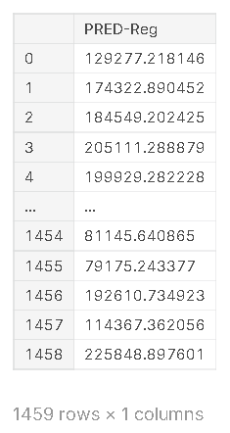
Fig 7.2: REPRESENTATION OF PREDICTION RESULT ON TESTING DATA.

Chapter 8
RELATED RESULTS & DISCUSSION
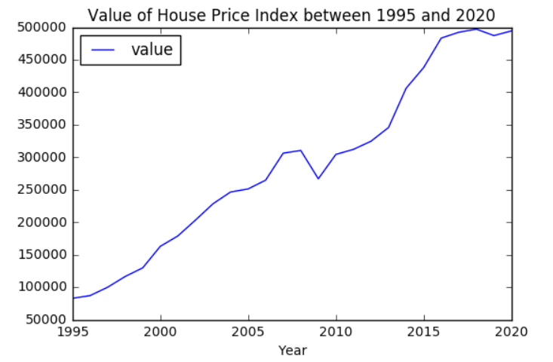
Fig 8.1: REPRESENTATION OF PRICE VARIATION BASED ON YEAR

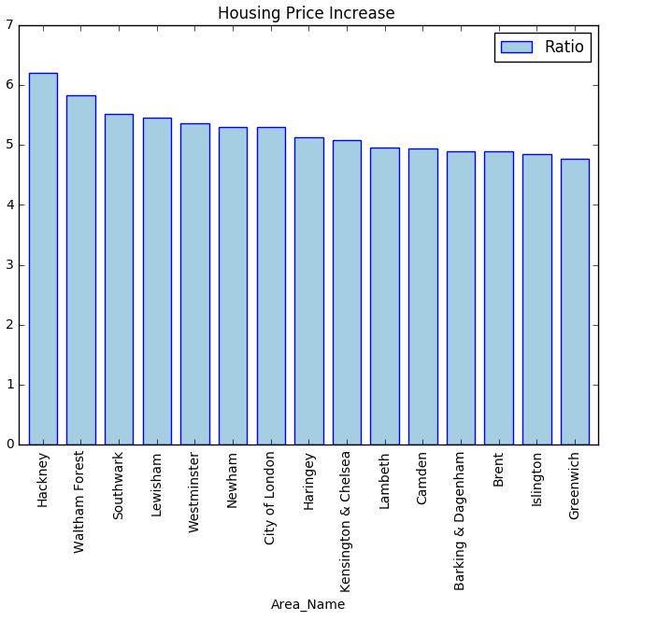
Fig 8.2: REPRESENTATION OF PRICE VARIATION BASED ON LOCALITY
REFERENCE
- Housing Price Prediction using Machine Learning by Yashraj Garud, Hemanshu Vispute , Nayan Bisai and Prof. Madhu Nashipudimath
- Rohan Bafna, Anirudh Dhole, Ankit Jagtap, Asif Kazi,Arbaz Kazi “Prediction of Residential Property Prices – A State of the Art”International Advanced Research Journal in Science, Engineering and Technology IARJSET
- Housing Price Prediction An Nguyen March 20, 2018
- Machine Learning for a London Housing Price Prediction Mobile Application, Aaron Ng, 2015
- https://www.researchgate.net/publication/283334152_Mapping_of_Real_Estate_Prices_Using_Data_Mining_Techniques

