Cookbook Draft:

Supply Chain Metrics That Matter: A Focus on Medical Device Company – Conmed

Le Yang

Ping Shi

Weijing Wang

Xiaoyun Zhao

Nikhilesh Rajeev

Neeti Panjwani

Northeastern University

Abstract

Research

Supply Chain Leaders are in the midst of delivering supply chain quality. The question is, "What defines excellence? “And what defines the value? “We’re here to answer these questions. To complete this analysis and understand the patterns, we analyze the performance and improvement of the supply chains of medical devices. We assume that the best supply chain outperforms their peers when driving change.

Performance is easier to calculate compared with improvement. In order to develop a tool for evaluating improvement, as a research team at Northeastern University, we have sought to develop the Supply Chain Index approach for assessing supply chain development. Information on the math used in this technique can be found in the cookbook. Through time, we've refined this

Evaluating Supply Chain Excellence:

Putting It All Together: Performance + Improvement

Every organization is judged by its own ability to make progress in the general review for the Supply Chains to Admire. Although the average values of a company's results might be higher, we are assessing company’s Supply Chain Index for their ability to drive year-over-year change and consistent progress on the indicators that we believe are relevant.

To score better on an average for performance indicators to meet the requirements for The Supply Chains, we are achieving a higher level of progress for this industry - Conmed

The method of estimation is as shown below:

Different Metrics in our cookbook are included. We will be evaluating the below and presenting the metrics as follows

1] Service level metric – We have measured percentage of carrier levels and service levels to determine service level percentage metric

2] Freight cost per unit metric - Calculated by dividing total freight costs by number of units shipped per period. Useful in businesses where units of measure are standard (e.g., pounds). Can also be calculated by mode (barge, rail,ocean, truckload, less-than-truckload, small package, air freight, intermodal, etc.).

3] Billed Weight, Approved Cost and Package metric – Used to determine all the three factors as per service level

4] Billed Weight by service level metric - used a heat map to determine the metric

5] Regional Sales - Quantity ordered by products numbers ordered

6] Billed weight average/freight metric – Metric used to determine the average of billed weight over freight charges

7] Inbound freight performance = This metric determines the inbound freight performance by diving inbound freight charge and sum of sales

8] Outbound freight performance = This metric determines the outbound performance by diving outbound freight charges and sum of sales

Tableau Cookbook

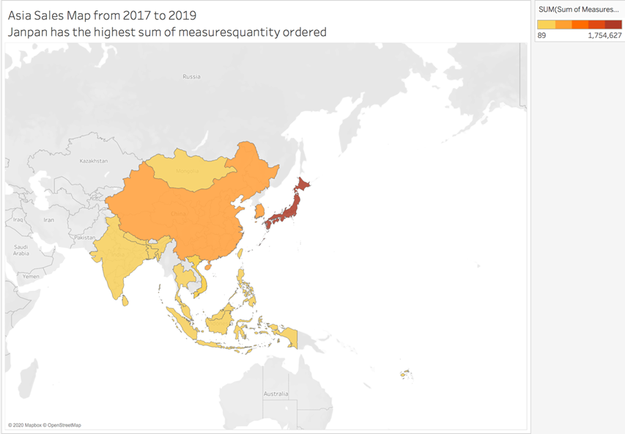

Figure 1

Figure 1 is the sum of MeasuresQuality Ordered by all the countries in Asia from 2017 to 2019. We use symbol maps to visualize it and set “ship to country” as dimension, sum of “MeasuresQuality Ordered” for color and mark “ship to country” as detail, so that we can get this Asia Sales Map from 2017 to 2019. If you click a country in the map, you can see the detailed figures of this country’s sum amount of MeasuresQuality Ordered. For instance, you can click Japan, then you can see the sum of MeasuresQuality Ordered is 1,754,627.

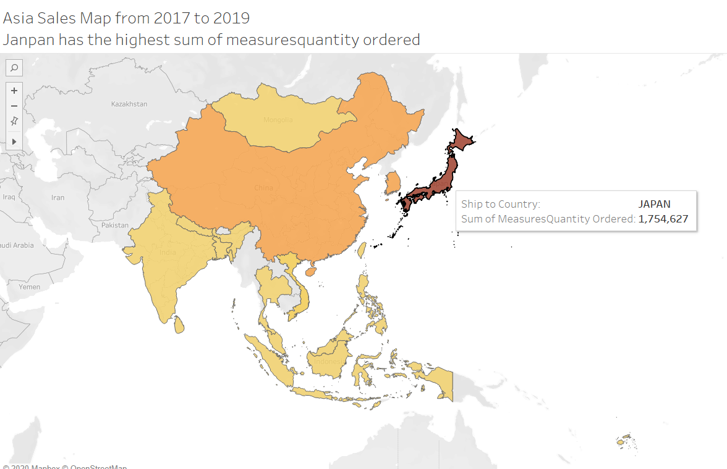

Figure 2

Figure 3

The second graph is Top 7 sum order of Asia. We set sum of measuresquantity ordered as columns and ship to country as rows and use horizontal bars to visualize it. Then, we filter ship to country by field of “Top” and chose Top 7 by sum of measuresquantity ordered, which is as shown in figure 4.

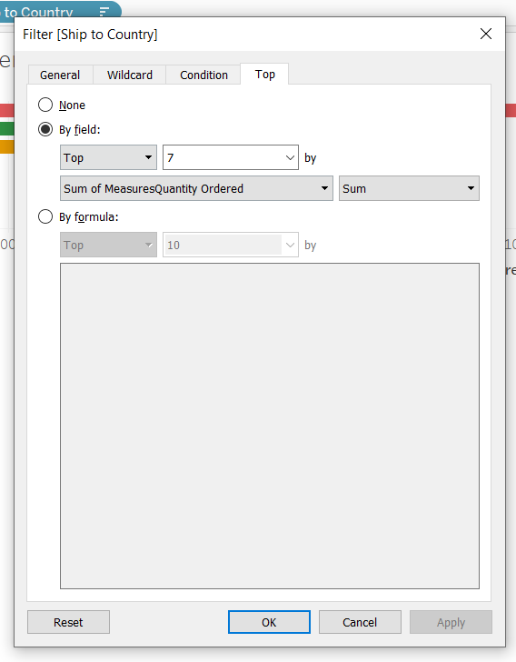

Figure 4

Also, make ship to country as color and modify the color of these counties for more readable.

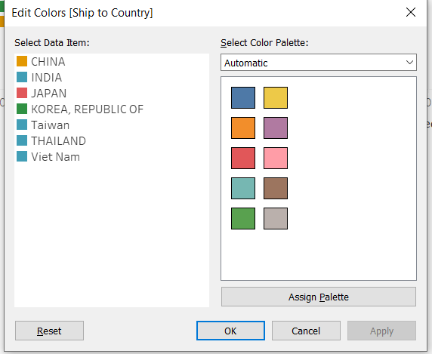

Figure 5

The third graph is sum of order of Japan, China and Korea in quarters, which as shown in figure 6. First, we set ship to country and date scheduled ShipDayDay as columns and sum of MeasuresQuantity Ordered as Rows. Then we choose lines to visualize it and filter the ship to country to choose Japan, China and Korea.

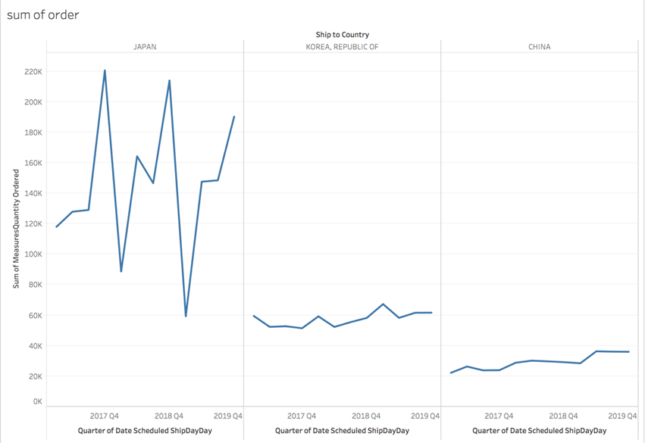

Figure 6

The fourth graph is Top high demand part of Japan, China and Korea, which is shown in figure 7. First, we set ship to country and Part as columns and sum of measuresquantity as rows. Then we utilize side-by-side bars to visualize it and make Part as color and label for more readable. Also, we filter ship to country just for China, Japan and Korea and filter Part with top 10 by sum of Measurequantity ordered, which is as shown in figure 8.

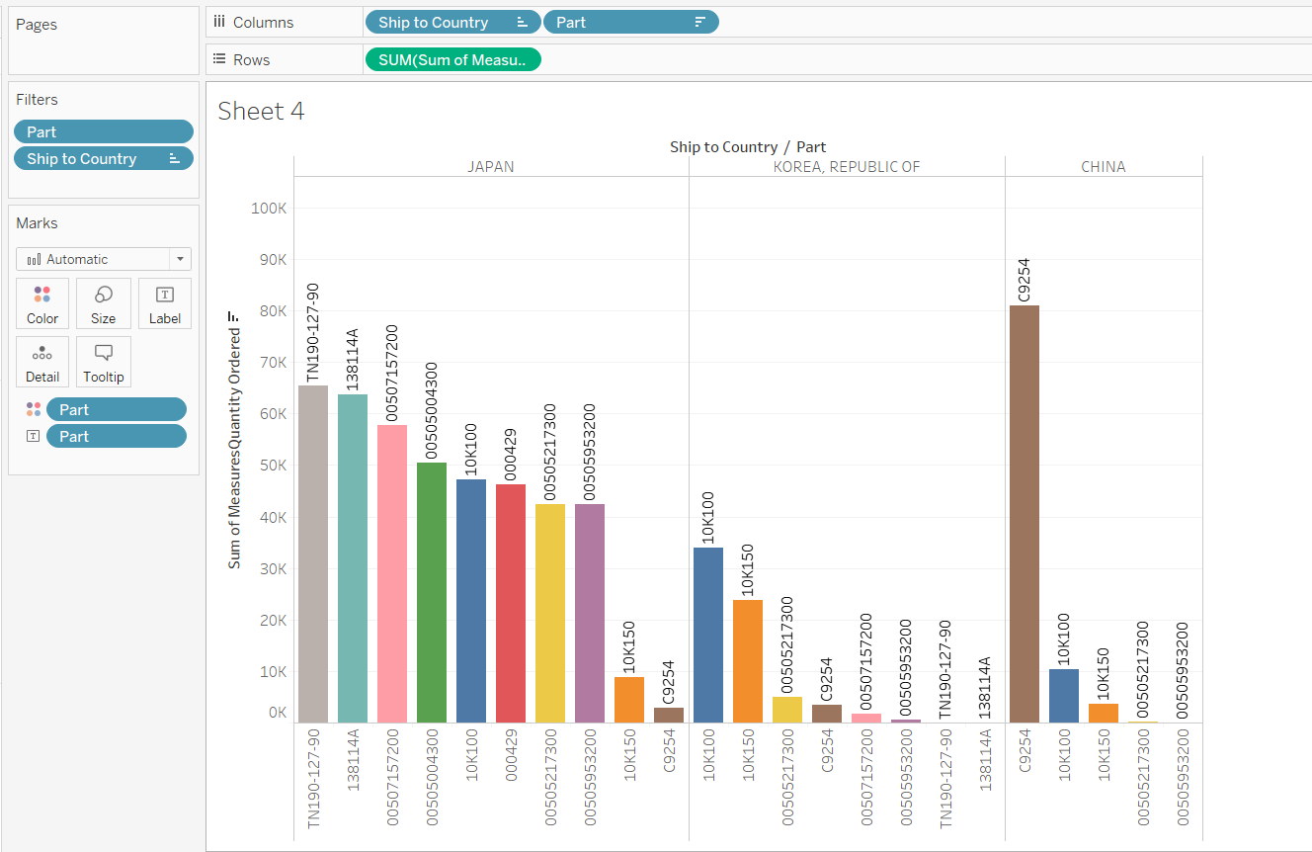

Figure 7

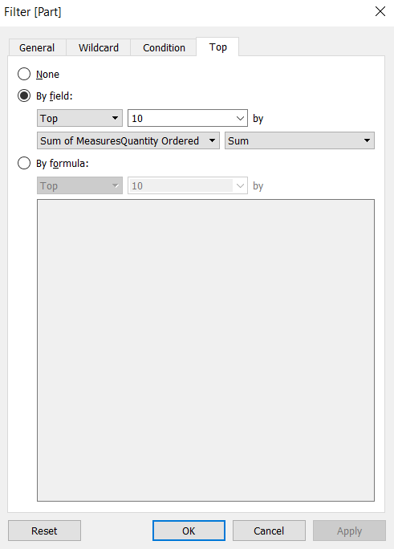

Figure 8

The fifth graph is the sum of orders of Asia based on scheduled ship day from 2017 to 2019, which is shown in figure 9. First, we set Quarter of date scheduled ShipDayday as columns and Sum of MeasuresQuantity as rows. Then we use continuous lines to visualize it, show it with forecast and make several important labels.

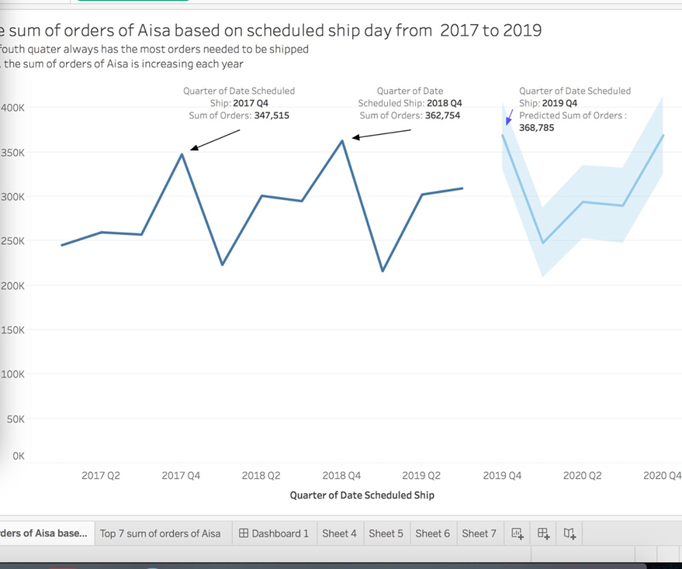

Figure 9

The sixth graph is average unit freight by Quarter of ship date of Japan, China and Korea, which is shown in figure 10. First we use Quarter of ship date as columns and Average unit freight as rows. Then we use continuous lines to visualize it and filter the receiver country for Japan, China and Korea.

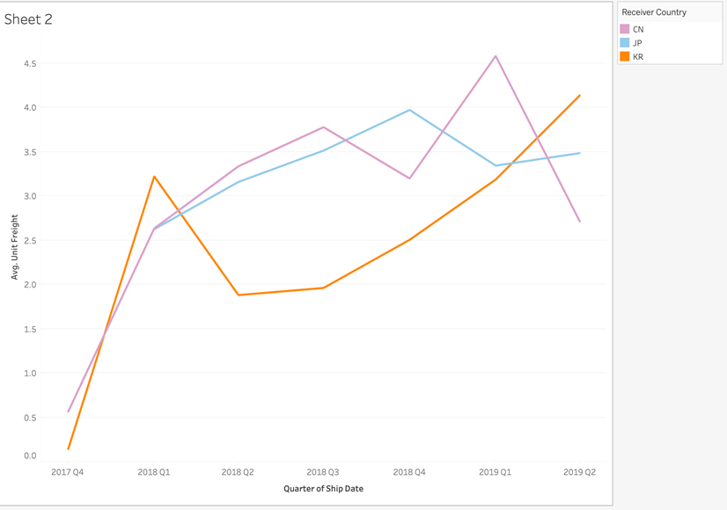

Figure 10

The seventh graph is unit freight by ship service type, which is shown in figure 11. First, we set average unit freight as columns and receiver country and service modified as rows. Then we use horizontal bars to visualize it and filter country for Japan, Korea and China. Also, we mark average unit freight as detail and color different countries.

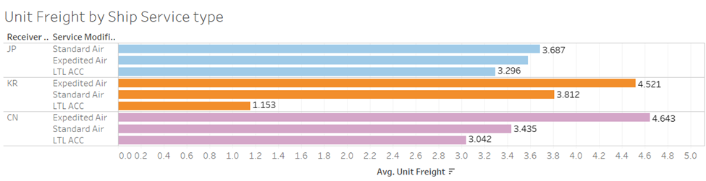

Figure 11

Also, we add quarter of ship date to get further analysis and the graph is shown in figure 12.

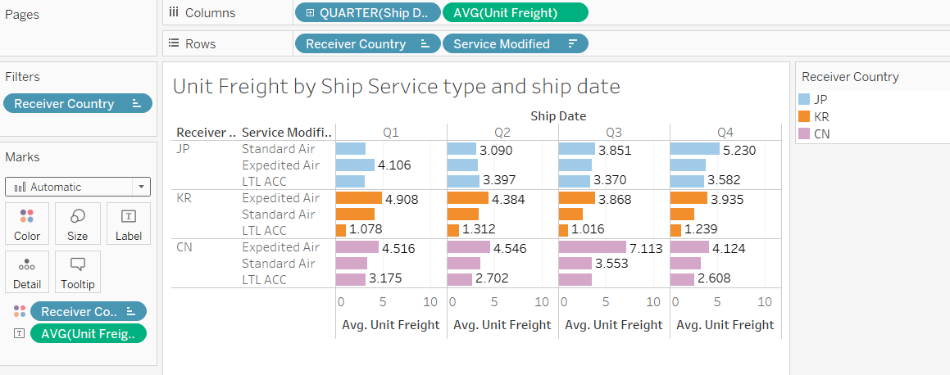

Figure 12

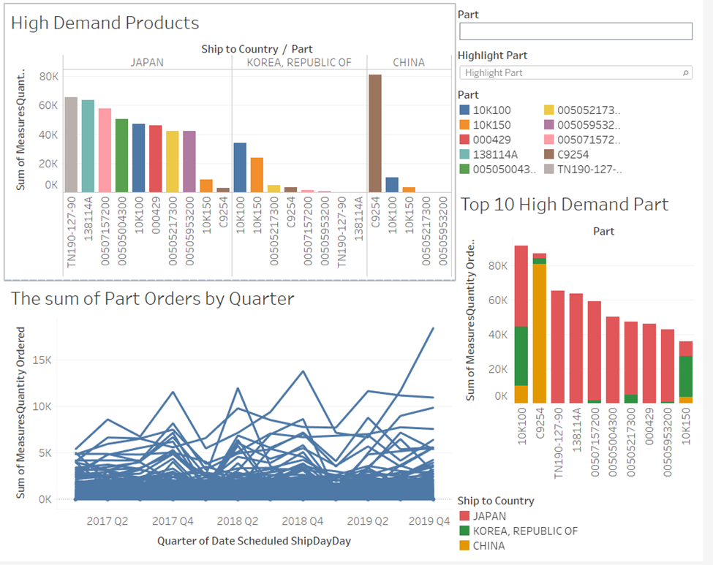

Figure 13

What’ more, we create a dashboard to give some instructions to ConMed to decide which product to ship to Japan warehouse and how far in advance to ship it. For instance, you can choose 10K100 which has the highest demand among Asia, then you can get its orders vary according to the season and the country in which need to ship.

Figure 14

References

Last Name, F. M. (Year). Article Title. *Journal Title*, Pages From - To.

Last Name, F. M. (Year). *Book Title.* City Name: Publisher Name.