STUDENT PERFORMANCE ANALYSIS
Using IBM SPSS Modeler

Dataset: Student Performance Dataset

Submitted By:
Name: Neetika Srivastava
Course: BCA (Data Science & Artificial Intelligence)
Semester: V

Software Used: IBM SPSS Modeler

Introduction:
This project aims to predict student academic performance using IBM SPSS Modeler. The student dataset is analyzed using data preparation, partitioning and a C&R Tree classification/modelling technique. The target field used in the project is Performance, which classifies students into Pass and Fail categories.
- Objective: To analyze student performance using IBM SPSS Modeler and classify students into Pass and Fail categories using a decision tree model.
- Dataset: Student Performance Dataset
Total Records: 395
Target Variable: Performance
Target Classes: Pass, Fail
- Tools Used
IBM SPSS Modeler, C&R Tree (Decision Tree), Student Performance Dataset
- Data Preparation
The student dataset was imported into IBM SPSS Modeler from a CSV file. G3 was selected as the target field for the C&R Tree model.

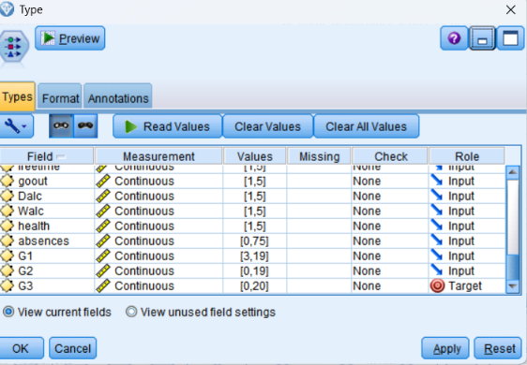
- Data Partitioning
The dataset was divided into training and testing data using the Partition node. 70% for training and 30% for testing.
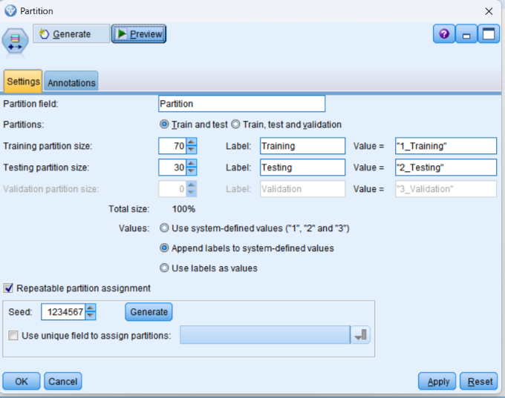

- C&R Tree Model
The C&R Tree model was used to build a prediction model for the target field G3. The model was trained using the training data and evaluated using the testing data.
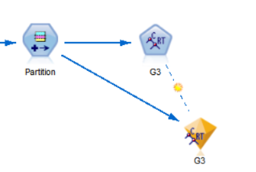

- Model Output- Diamond
After running the C&R Tree model, a model nugget (diamond) was generated. It contains the trained model and provides the model output for further analysis.
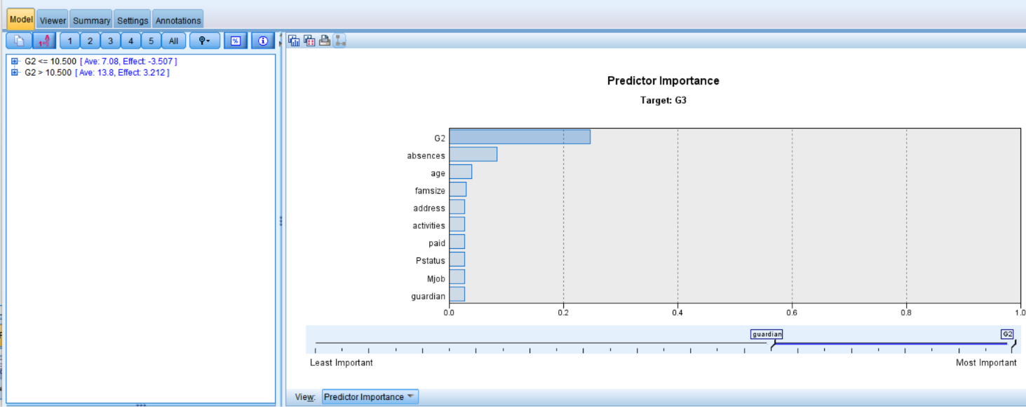
- Tree Structure / Viewer
The Viewer displays the tree structure generated by the C&R Tree model.

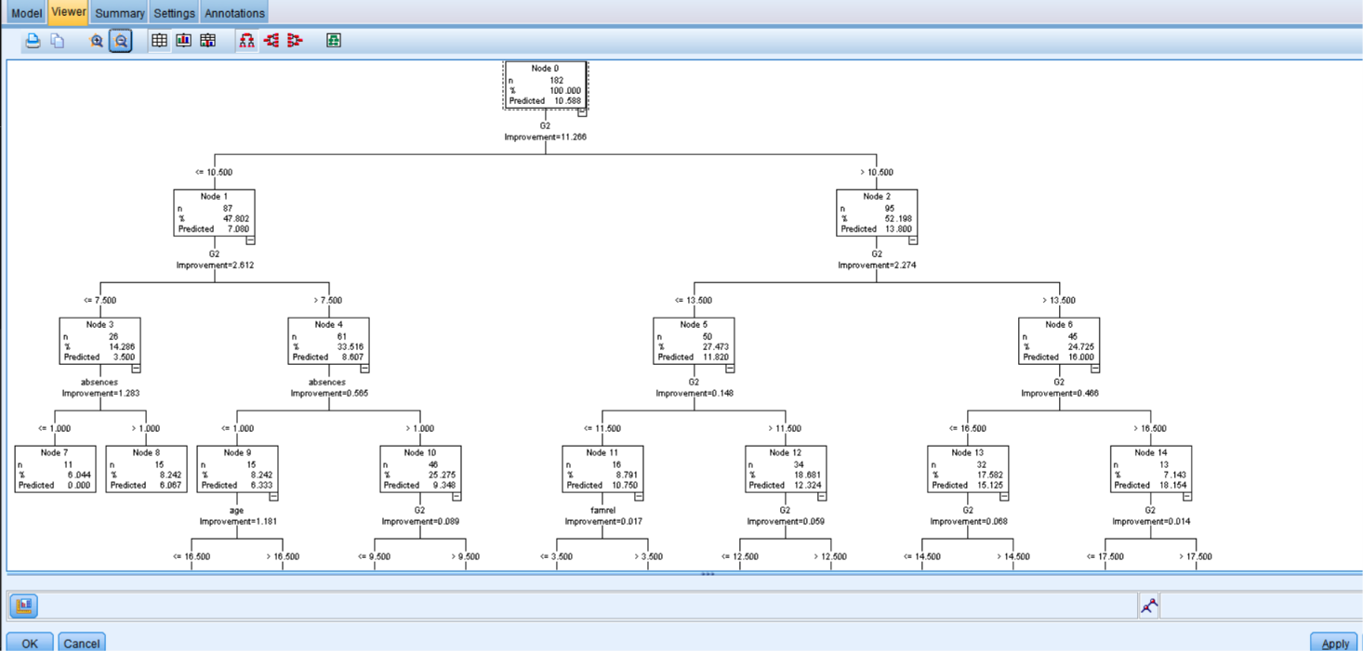
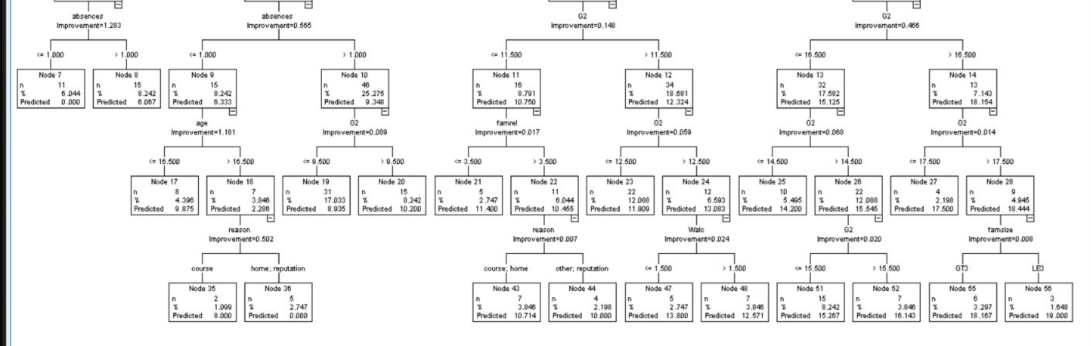

- G3 Analysis
The Analysis node was used to evaluate the predictions of the C&R Tree model for the target field G3.
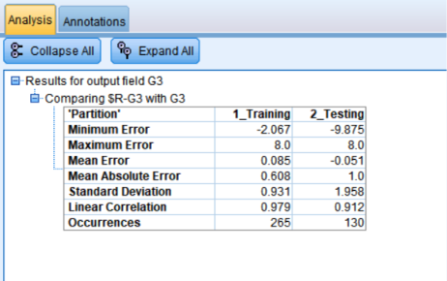
g

