 | FLUTTER & GAME DEVELOPMENT | ENGINEERING SPOTLIGHT  Building Games in Flutter Just Leveled Up  Introducing Ember Engine: The 2D + 3D Visual Editor & Engine Bridging the Gap for Flutter Game Developers
――――――――――――――――――――――――――――――――――――――――――――――――――――――――――
By the Ember Engine Core Team • Published for LinkedIn Engineering & GameDev Communities
1. The Dilemma: Why Making Games in Flutter Felt Incomplete
Over the last half-decade, Flutter has fundamentally transformed multiplatform UI engineering. With a single Dart codebase, developers deliver pixel-perfect, 120 FPS applications across iOS, Android, Windows, macOS, Linux, and the web. The developer experience is legendary: instant stateful hot reload, a rich widget ecosystem, intuitive package management, and near-native performance backed by Impeller and Skia.
“Why can’t we build great games in Flutter?”Naturally, thousands of passionate Flutter engineers asked the obvious question:
Up until now, taking that leap forced game developers into an uncomfortable compromise:
- The Code-Only Limit (Flame): Flame is an outstanding, battle-tested 2D framework, but it is strictly code-first. Designing levels means manually hardcoding Vector2 coordinates, guessing camera bounds in code, reloading, checking debug collision shapes, and repeating. For level design, physics tuning, and narrative pacing, code-only tooling becomes an exhausting bottleneck.
- The External Engine Exodus (Unity / Godot): Moving to Unity, Godot, or Unreal offers world-class visual scene editors, inspectors, and drag-and-drop gizmos. But the trade-off is painful: you abandon Dart, lose Flutter’s reactive UI ecosystem, learn C# or GDScript, fight complex FFI bridging layers, and battle bloated binary sizes on mobile.
“Game development is inherently visual, spatial, and iterative. Flutter engineers shouldn't have to leave the language and ecosystem they love just to get a visual scene editor, real-time inspector, and instant playtesting.”
— The Core Motivation Behind Ember Engine

What the Flutter ecosystem desperately needed was a true third path: a native game engine and visual desktop editor built entirely in Flutter, for Flutter developers. That missing piece has arrived: Ember Engine.
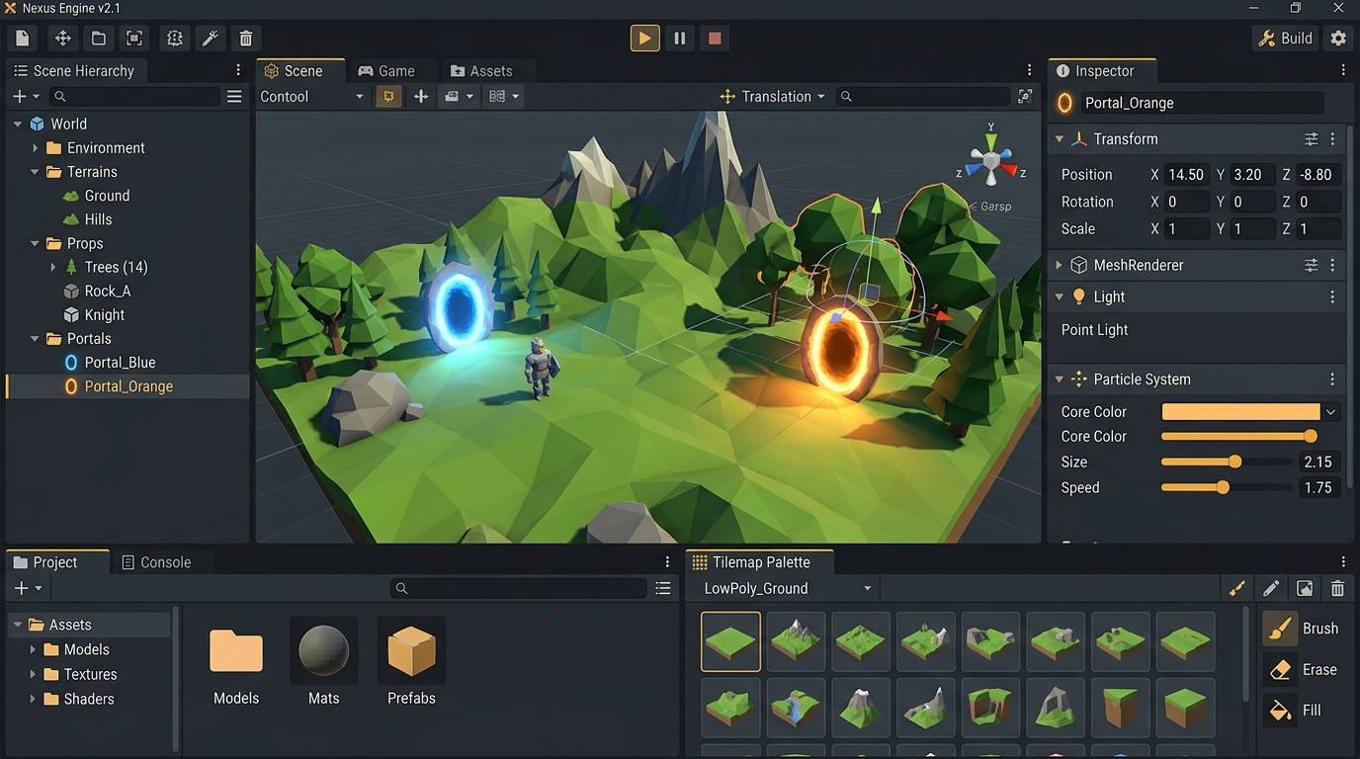
Figure 1: The Ember Engine Editor workspace featuring Scene Hierarchy, 3D/2D Viewport with interactive gizmos, Live Inspector, and integrated bottom drawer with Tilemap Palette.
2. Meet Ember Engine: Visual Power Meets Dart Simplicity
Ember Engine is a 2D + 3D game engine and professional desktop editor built from the ground up in Flutter and Dart. It provides the spatial, visual authoring experience of modern engines like Unity and Godot, while remaining deeply rooted in the lightweight agility of the Dart runtime.
Key Architectural Pillars at a Glance:
- Unity-Style Desktop Editor: Inspect entity hierarchies, scrub property numbers in real-time, toggle components, transform objects with 3D translation/rotation/scale gizmos, and trigger any editor action with the global Command Palette (Ctrl+K).
- Integrated 2D Pipeline & Tilemaps: Full Box2D rigid body physics powered by Forge2D (pure Dart, zero native compilation headaches). Includes mass, bounciness, friction, damping, joints (hinge, spring, weld), sensors, raycasting, and impulse explosions.
- Native 3D Viewport & Physics: A lightweight software perspective renderer executing directly on Flutter Canvas. Includes perspective projection, lighting, sky gradients, depth fog, glowing emissive materials, 3D first-person controllers with mouse capture, 3D raycasting, and autonomous enemy AI.
- Ember Script (Zero-Recompile Game Logic): Write entity logic in a clean, interpreted Dart-like language that compiles and binds to entities in memory. Edit running game code and see mechanics change instantaneously without triggering a Flutter rebuild.
- One-Click Multiplatform Publishing: Turn projects into standalone, click-and-play executables for Windows (.exe, Inno Setup installer, MSIX), Web (itch.io HTML5 ZIP), and Android (signed APK and Play Store-ready AAB).
3. The Secret Weapon: Ember Script & Instant Live Iteration
In traditional game programming, fine-tuning gameplay feel (such as jumping arc, weapon fire rates, or enemy chase speeds) requires frequent recompilation. Even with Flutter's fast UI hot reload, restarting game scenes or maintaining complex physics states can cause friction. To solve this, Ember Engine incorporates its own custom-engineered scripting architecture: lexer, parser, Abstract Syntax Tree (AST), and interpreter.
Why this changes everything for developers: Ember Script delivers Dart-syntax scripting that runs dynamically inside the engine runtime:
- Instant Inspector Binding: Top-level script variables (like 'var speed = 180;') automatically expose scrubbable, live fields in the editor’s Inspector panel without extra configuration code.
- Live State Retention: If you tweak an enemy's attack cooldown or adjust player momentum while the game is running, the logic updates live without resetting scores, player positions, or world state.
- Zero-Crash Sandboxing: A script with an error or infinite loop never crashes the editor or triggers a red error screen. The engine sandboxes execution, catches the issue, and flags it directly in the Problems tab with exact line references.
// Language: Ember Script (.ember)
var speed = 160;
var jumpForce = 420;
void onStart() {
self.tag = "Player";
}
void onUpdate(dt) {
// Smooth 8-way movement & jump controls
self.position = self.position + Input.move * speed * dt;
if (Input.pressed("Space") && self.grounded) {
self.applyImpulse(vec(0, -jumpForce));
playSound("jump");
}
}
void onTriggerEnter(other) {
if (other.hasTag("Coin")) {
destroy(other);
playSound("coin");
Game.data["score"] = (Game.data["score"] ?? 0) + 10;
find("HUD_Score").text.text = "Score: ${Game.data['score']}";
}
}

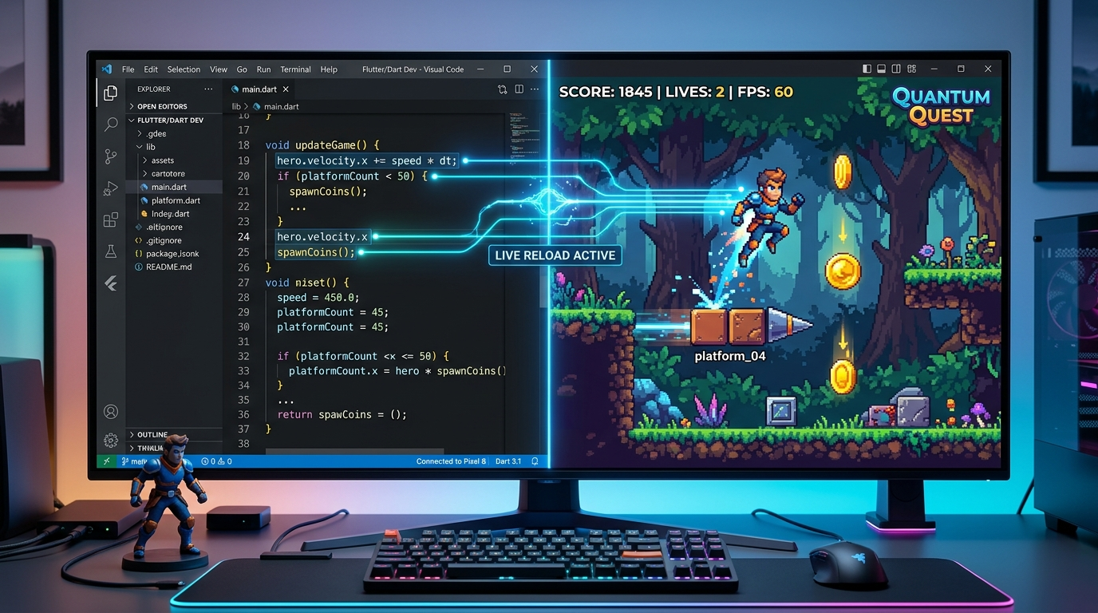
Figure 2: The split-screen Ember Script workflow: live coding on the left dynamically controls active game loops and entity components in real time without recompilation.
4. How Ember Engine Compares: Flame vs. Unity/Godot vs. Ember
To appreciate the unique positioning of Ember Engine, consider where it fits in the current game development landscape for Flutter engineers:
Feature / Dimension | Flame Framework | Unity / Godot | Ember Engine
Language & Runtime | Pure Dart | C# / C++ / GDScript | Pure Dart + Ember Script
Visual Scene Editor | None (Code-First) | Full Desktop Editor | Full Flutter Desktop Editor
Live In-Game Scripting | Flutter Hot Reload only | Reload requires assembly recompile | Instant AST Interpreter + Live Inspector
2D & 3D Integration | Primarily 2D | Heavy 2D/3D suite | Flame 2D + Built-in 3D Pipeline
Export & Deployment | Flutter CLI commands | Proprietary build systems | Integrated Export GUI (.exe, MSIX, Web, AAB)

5. Proven with Real Games: Five Complete Starter Templates
Many aspiring game engines fail because they launch as empty canvases with theoretical APIs. Ember Engine takes the opposite philosophy: it ships with complete, playable genre templates that demonstrate real-world architecture from start to finish.
- Ember Arena (3D FPS Shooter): A full 3D first-person wave shooter. Features portal spawners, exploding chaser drones, strafing gunners, charging brutes, projectile raycasts, weapon swapping (blaster & scattergun), health/ammo drops, dynamic fog, and high score tracking.
- Ember Siege (2D Physics Demolition): A physics-driven destruction game in the style of Angry Birds. Utilizes Box2D rigid bodies, realistic slingshot drag physics, material-based fracturing (wood, ice, stone), explosive powder kegs, multiple levels, and 3-star scoring.
- Ember Legends (Top-Down Action RPG): A classic top-down action RPG. Features multi-layered tilemaps, A* pathfinding monster AI (slimes, bats, skeleton archers), boss encounters with the Ember Golem, typewriter NPC dialogue, sword combat, inventory, and save crystals.
- Ember Quest (2D Platformer Adventure): A polished retro side-scroller. Implements platformer physics with coyote time, jump buffering, variable jump height, stompable enemies, breakable bricks, collectible power berries, and flagpoles.
- Flappy Arcade (One-Button Arcade): An arcade physics game demonstrating procedural pipe obstacle generation, collision events, audio triggers, and local high-score persistence.
6. The Final Mile: One-Click Multiplatform Publishing
For indie creators, the hardest part of game development isn't writing game loops—it’s getting the build into players' hands. Configuring installers, code-signing certificates, store packages, and cross-compilation usually requires days of frustrating DevOps work.
Built-in Store Readiness: Ember Engine integrates commercial export pipelines directly into the editor UI:
- Windows Desktop: Builds a release .exe with the Visual C++ runtime automatically bundled (runs cleanly on PCs without VC++ installed). Generates setup installers with Inno Setup, or builds unsigned/signed MSIX packages ready for the Microsoft Partner Center.
- Web (itch.io): Outputs pre-packaged ZIP archives with index.html at root, ready to drag-and-drop straight onto itch.io for browser play with HTML5 Canvas and WebAudio support.
- Android (Google Play): Produces release APKs and Google Play-compliant Android App Bundles (.aab). Includes an integrated keystore creator, secure password storage via Windows Credential Manager, and automatic build incrementing.
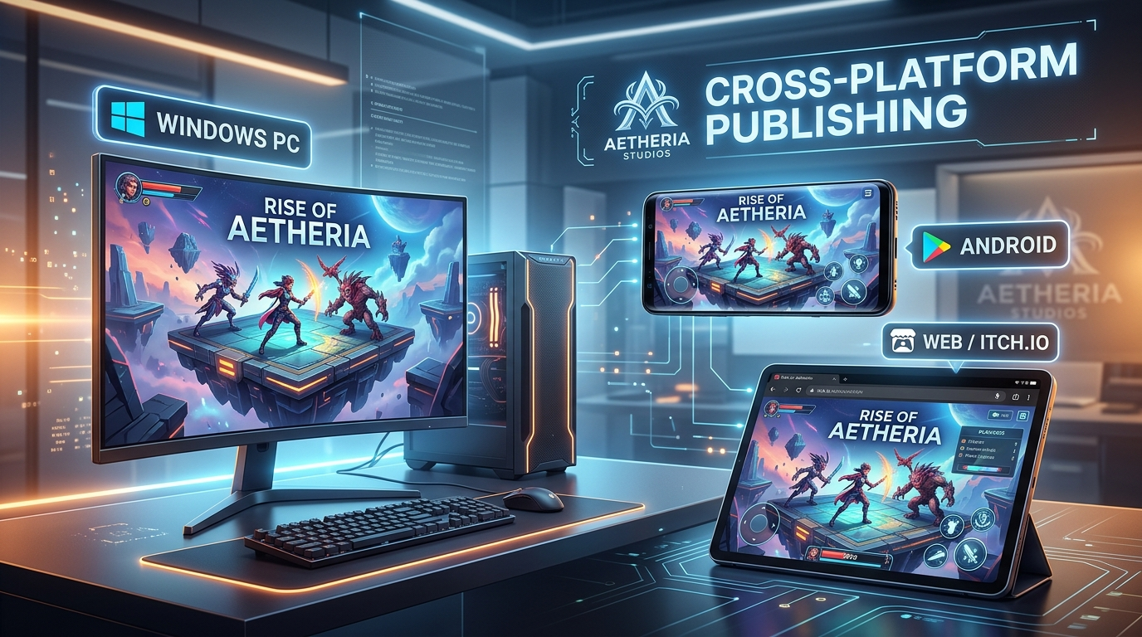
Figure 3: Multiplatform export in action: target Windows Desktop, Android mobile, and itch.io Web with one-click packaging directly from Ember Engine.
7. Engineered for Trust: Ember Doctor & Disaster Recovery
Nothing kills creative momentum faster than an editor crash that destroys two hours of level design. The Ember Engine team treated stability and data safety as top architectural priorities:
- Automatic Crash Recovery: Every 60 seconds (and automatically whenever you click Play), Ember Engine silently writes a snapshot recovery copy to your project’s `.recovery/` directory. If power fails or the process is interrupted, the next launch prompts you with one click: 'Restore unsaved changes?'.
- Ember Doctor: A dedicated diagnostic subsystem (the shield icon) performs comprehensive health audits on your game. It parses scripts for syntax problems, checks that all scene triggers point to valid levels, verifies that sprite/audio assets exist on disk, and confirms export toolchains are present.
- Isolated Error Boundaries: If a custom component or experimental script throws an unhandled exception, the editor catches it, preserves state, displays a non-intrusive alert, and writes full diagnostics to daily log files—never tearing down your editor session.
8. Why This Matters for Every Flutter Developer
Even if your day job isn't building AAA titles, the emergence of a native visual game engine in Flutter opens up tremendous opportunities:
- Gamification of Commercial Apps: Apps today increasingly leverage rich gamified mechanics (streaks, interactive challenges, celebratory reward animations, simulation mini-games). Ember Engine lets you build and embed rich game scenes directly without massive binary bloat.
- Rapid Spatial Prototyping: Instead of taking days to lay out physics mockups or interactive 2D/3D components, developers can visually design prototypes in minutes, test them in place, and share executables with stakeholders immediately.
- Expanding the Boundaries of Flutter: By proving that Flutter can power a desktop-class IDE with real-time 3D rendering, physics simulations, and embedded scripting, Ember Engine demonstrates the incredible maturity and versatility of the Flutter framework as a whole.
9. Conclusion & Getting Started
Flutter already conquered cross-platform application development. With Ember Engine, the ecosystem takes a giant leap forward into spatial creation and game design. Whether you're an indie developer looking to build your dream retro platformer, a mobile developer adding gamification to your product, or a Dart enthusiast curious about engine architecture, Ember Engine gives you the tools to create without compromise.
“Ready to build your first game? Clone the repository, run flutter run -d windows (or macOS/Linux), select a starter template from the Project Hub, and press Play!”
— Join the Ember Engine Community

Quick Start in 3 Commands:
// Language: Terminal / Bash
# 1. Clone & fetch dependencies
git clone https://github.com/neetoosan/EmberEngine.git
cd "EmberEngine"
flutter pub get
# 2. Launch the visual editor
flutter run -d windows # or: -d macos / -d linux
# 3. Press Play, explore the templates, and export your game!

#Flutter #Dart #GameDevelopment #EmberEngine #IndieDev #MobileDev #OpenSource #TechInnovation #SoftwareArchitecture

