QUESTION 242 : https://leetcode.com/problems/valid-anagram/description/
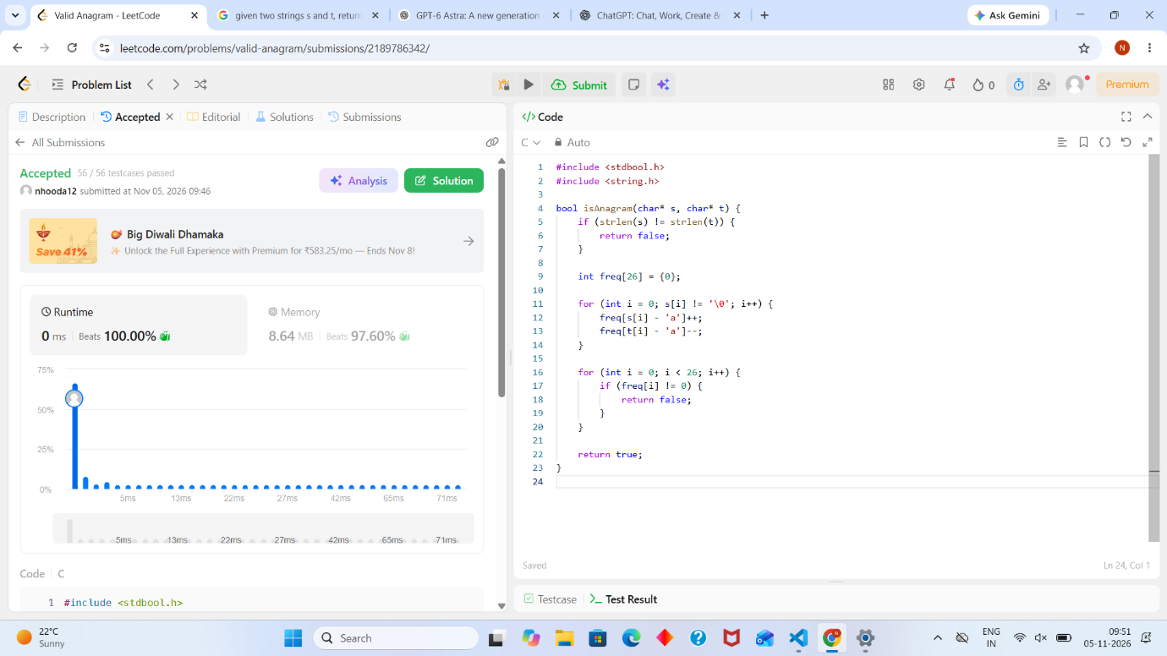
#include <stdbool.h>
#include <string.h>

bool isAnagram(char* s, char* t) {
if (strlen(s) != strlen(t)) {
return false;
}

int freq[26] = {0};

for (int i = 0; s[i] != '\0'; i++) {
freq[s[i] - 'a']++;
freq[t[i] - 'a']--;
}

for (int i = 0; i < 26; i++) {
if (freq[i] != 0) {
return false;
}
}

return true;
}

QUESTION 2235 : https://leetcode.com/problems/add-two-integers/description/
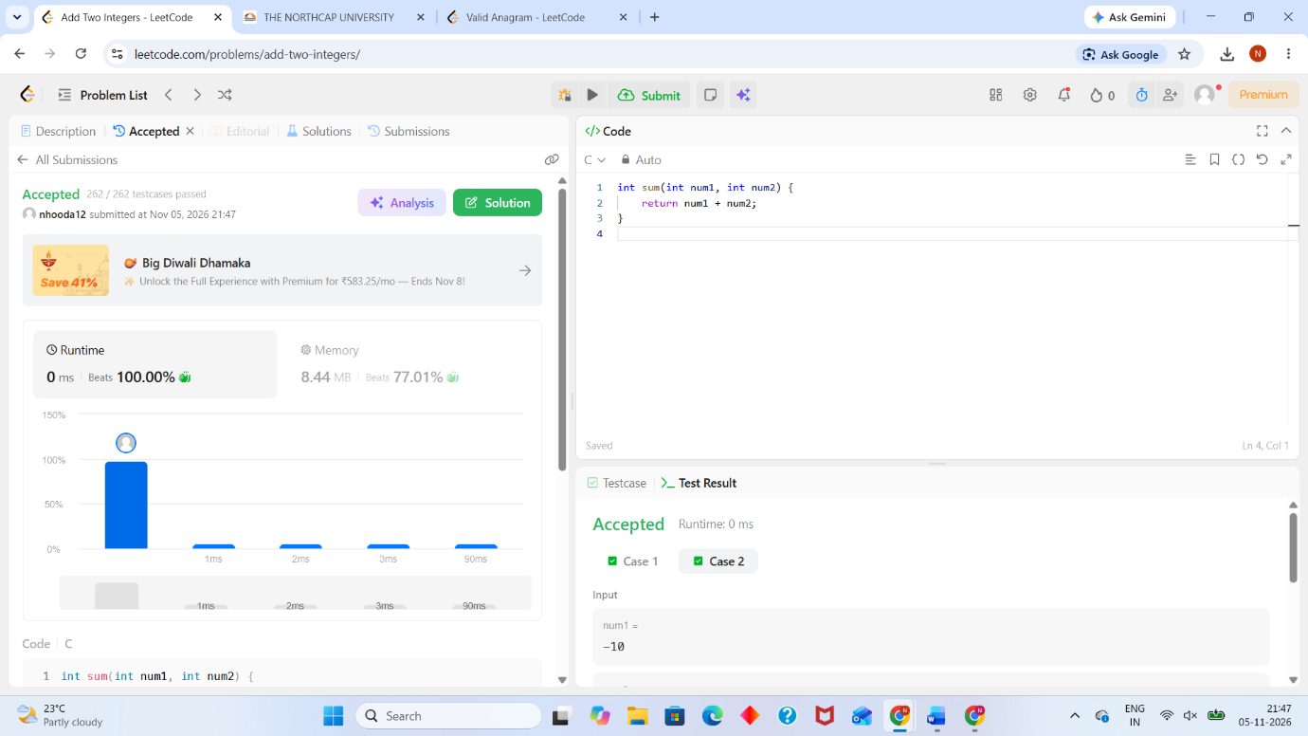
int sum(int num1, int num2) {
return num1 + num2;
}
QUESTION 2651 : https://leetcode.com/problems/calculate-delayed-arrival-time/description/ 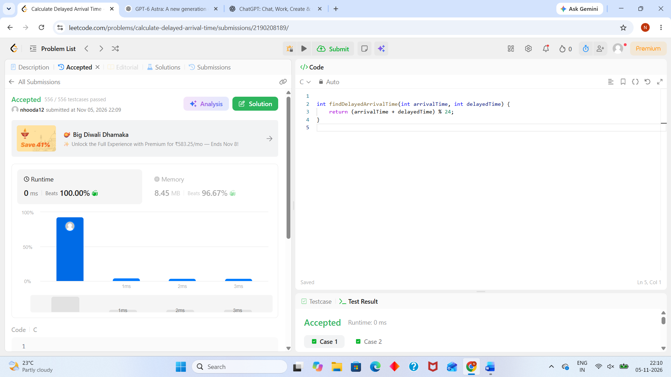

int findDelayedArrivalTime(int arrivalTime, int delayedTime) {
return (arrivalTime + delayedTime) % 24;
}
QUESTION 2739 : https://leetcode.com/problems/total-distance-traveled/description/
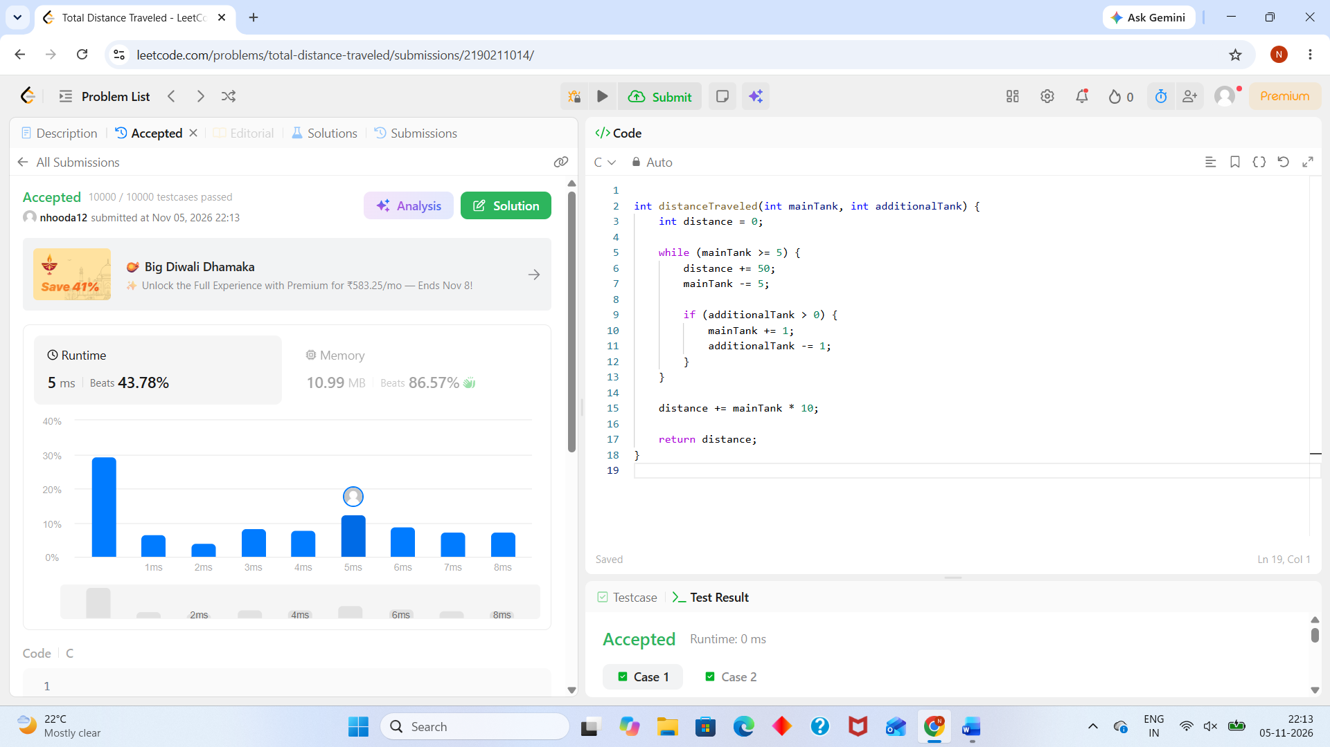
int distanceTraveled(int mainTank, int additionalTank) {
int distance = 0;

while (mainTank >= 5) {
distance += 50;
mainTank -= 5;

if (additionalTank > 0) {
mainTank += 1;
additionalTank -= 1;
}
}

distance += mainTank * 10;

return distance;
}

QUESTION 2413: https://leetcode.com/problems/smallest-even-multiple/submissions/2190214988/
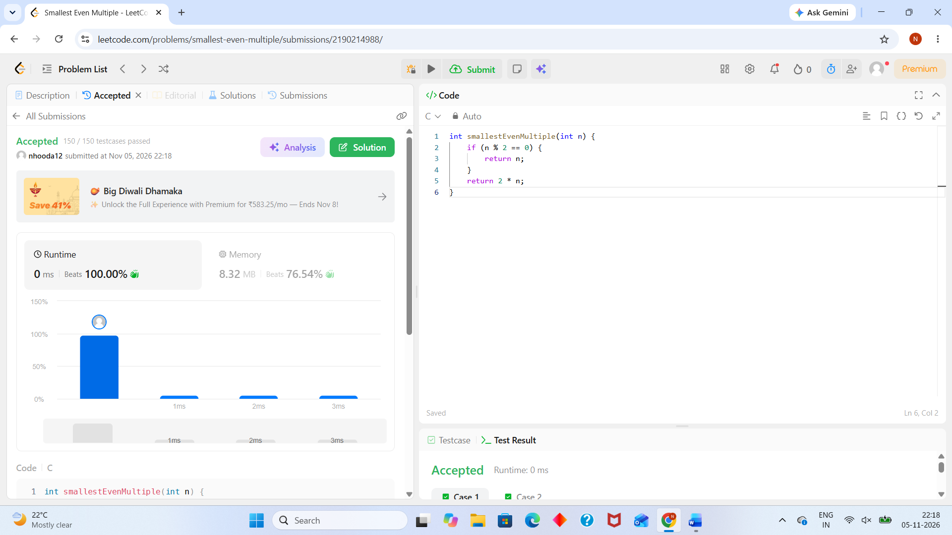
int smallestEvenMultiple(int n) {
if (n % 2 == 0) {
return n;
}
return 2 * n;
}

QUESTION 1342 : https://leetcode.com/problems/number-of-steps-to-reduce-a-number-to-zero/submissions/2190217117/
int numberOfSteps(int num) {
int steps = 0;

while (num != 0) {
if (num % 2 == 0) {
num = num / 2;
} else {
num = num - 1;
}

steps++;
}

return steps;
}

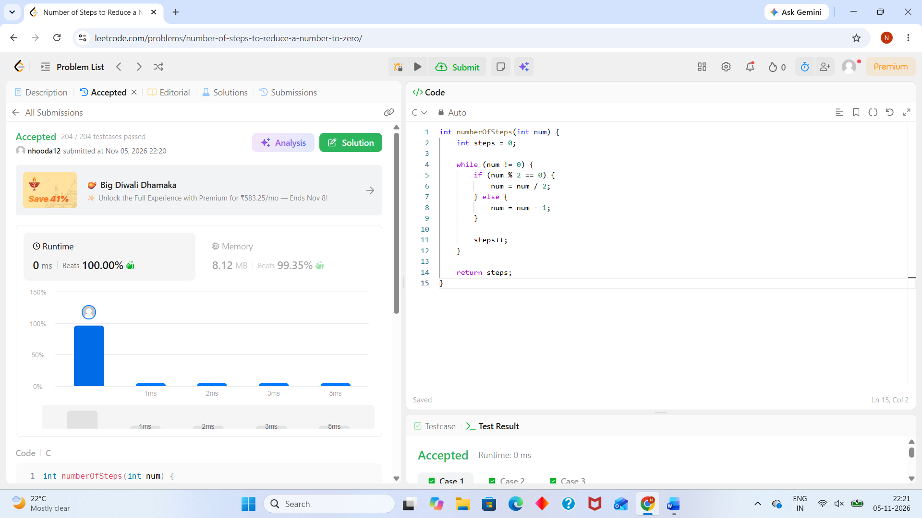

QUESTION 2169 : https://leetcode.com/problems/count-operations-to-obtain-zero/submissions/2190722833/
int countOperations(int num1, int num2) {
int operations = 0;

while (num1 > 0 && num2 > 0) {
if (num1 >= num2) {
num1 -= num2;
} else {
num2 -= num1;
}
operations++;
}

return operations;
}
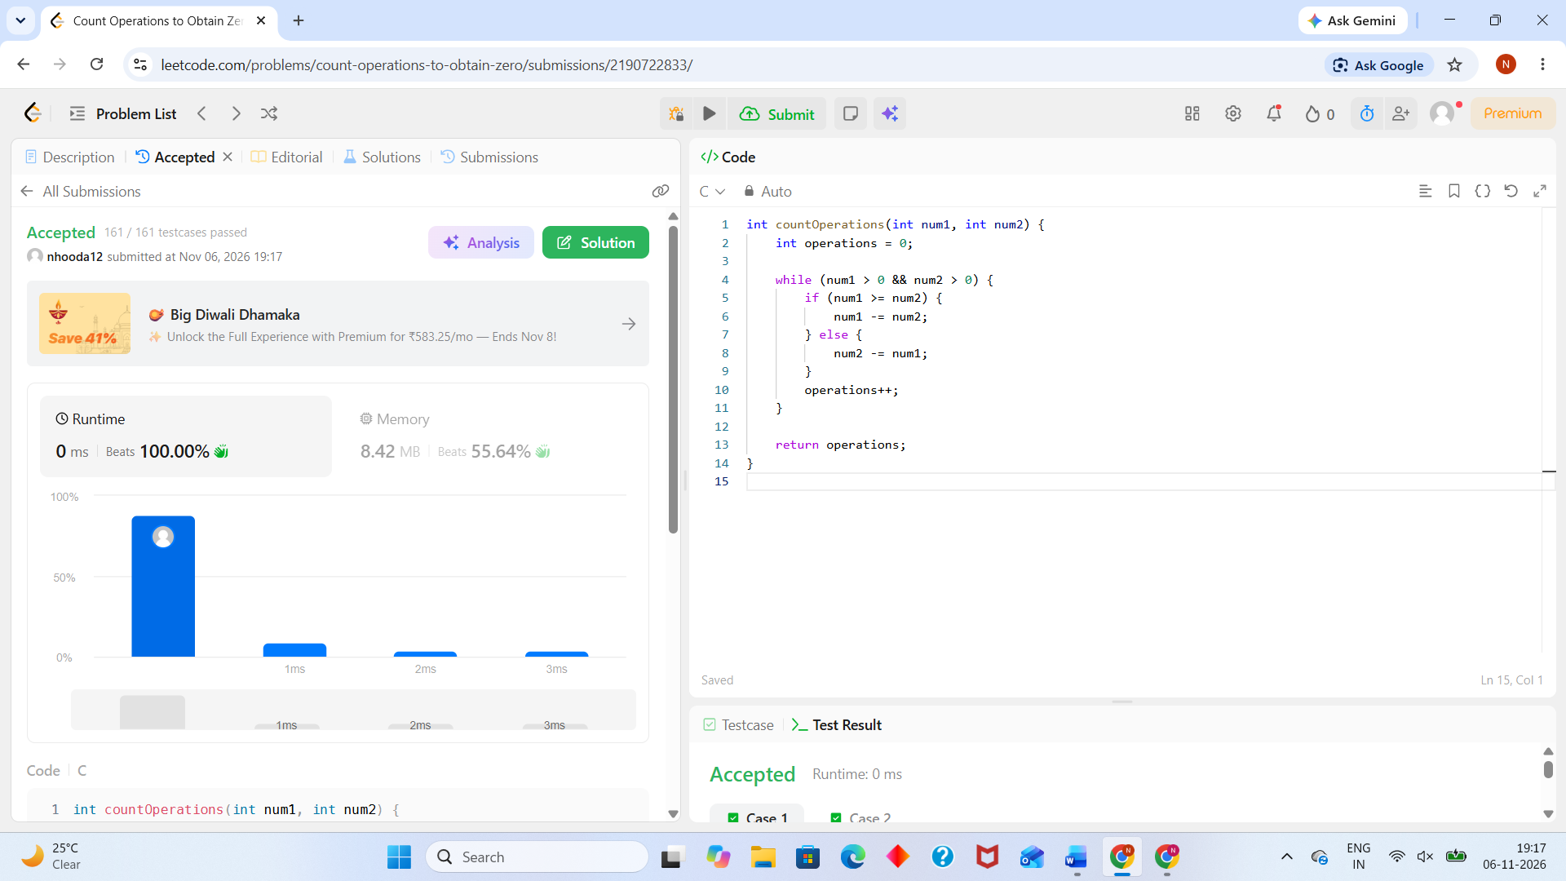

QUESTION 1523 : https://leetcode.com/problems/count-odd-numbers-in-an-interval-range/submissions/2190724469/

int countOdds(int low, int high) {
// If either low or high is odd, the count of odd numbers is (high - low) / 2 + 1
// If both are even, the count of odd numbers is (high - low) / 2
return (high - low) / 2 + (low % 2 || high % 2);
}
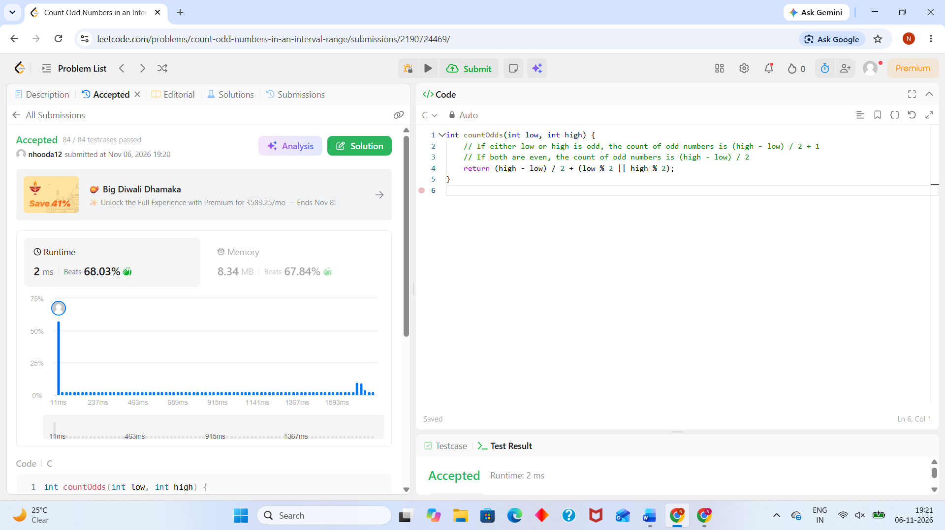

QUESTION 2652 : https://leetcode.com/problems/sum-multiples/submissions/2190726213/
int sumOfMultiples(int n) {
int sum = 0;
for (int i = 1; i <= n; i++) {
if (i % 3 == 0 || i % 5 == 0 || i % 7 == 0) {
sum += i;
}
}
return sum;
}

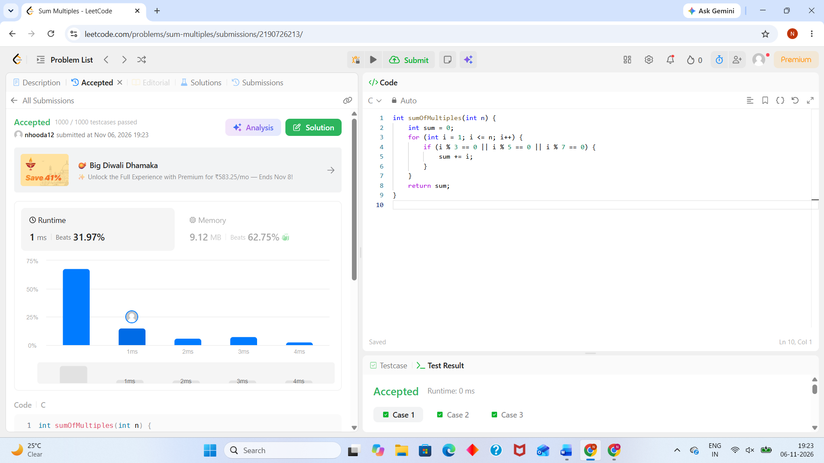

QUESTION 1281 : https://leetcode.com/problems/subtract-the-product-and-sum-of-digits-of-an-integer/submissions/2190727499/
int subtractProductAndSum(int n) {
int product = 1;
int sum = 0;

while (n > 0) {
int digit = n % 10;
product *= digit;
sum += digit;
n /= 10;
}

return product - sum;
}

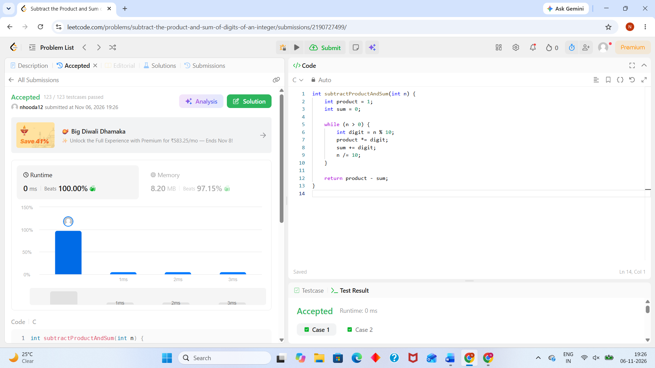

QUESTION 2520 : https://leetcode.com/problems/count-the-digits-that-divide-a-number/submissions/2190728535/
int countDigits(int num) {
int ans = 0;
int cur = num;
while (cur != 0) {
int digit = cur % 10;
if (digit != 0 && num % digit == 0) {
ans++;
}
cur /= 10;
}
return ans;
}

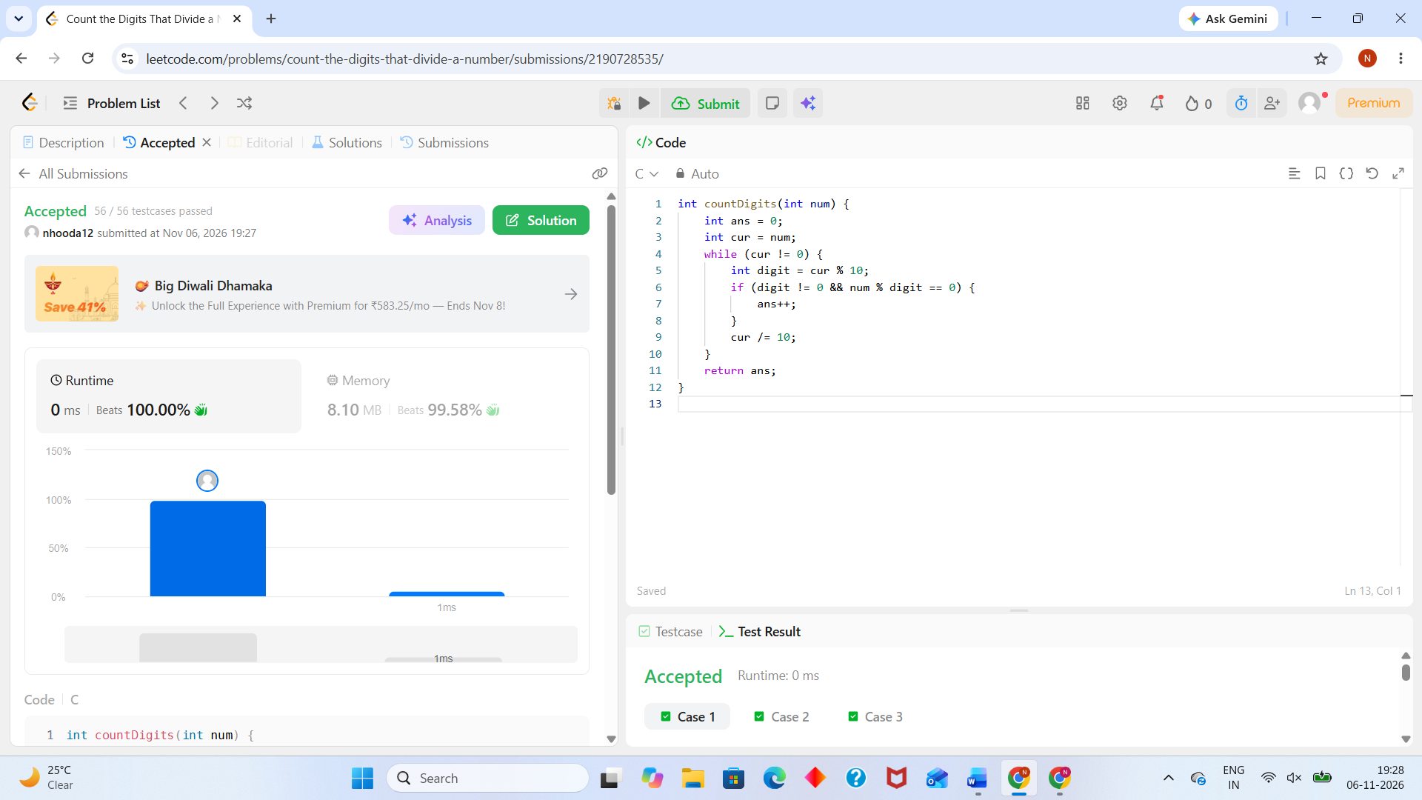

QUESTION 9 : https://leetcode.com/problems/palindrome-number/submissions/2190729483/
bool isPalindrome(int x) {
if (x < 0 || (x % 10 == 0 && x != 0)) {
return false;
}

long reversed = 0;
int original = x;

while (x > reversed) {
reversed = reversed * 10 + x % 10;
x /= 10;
}

return (x == reversed || x == reversed / 10);
}

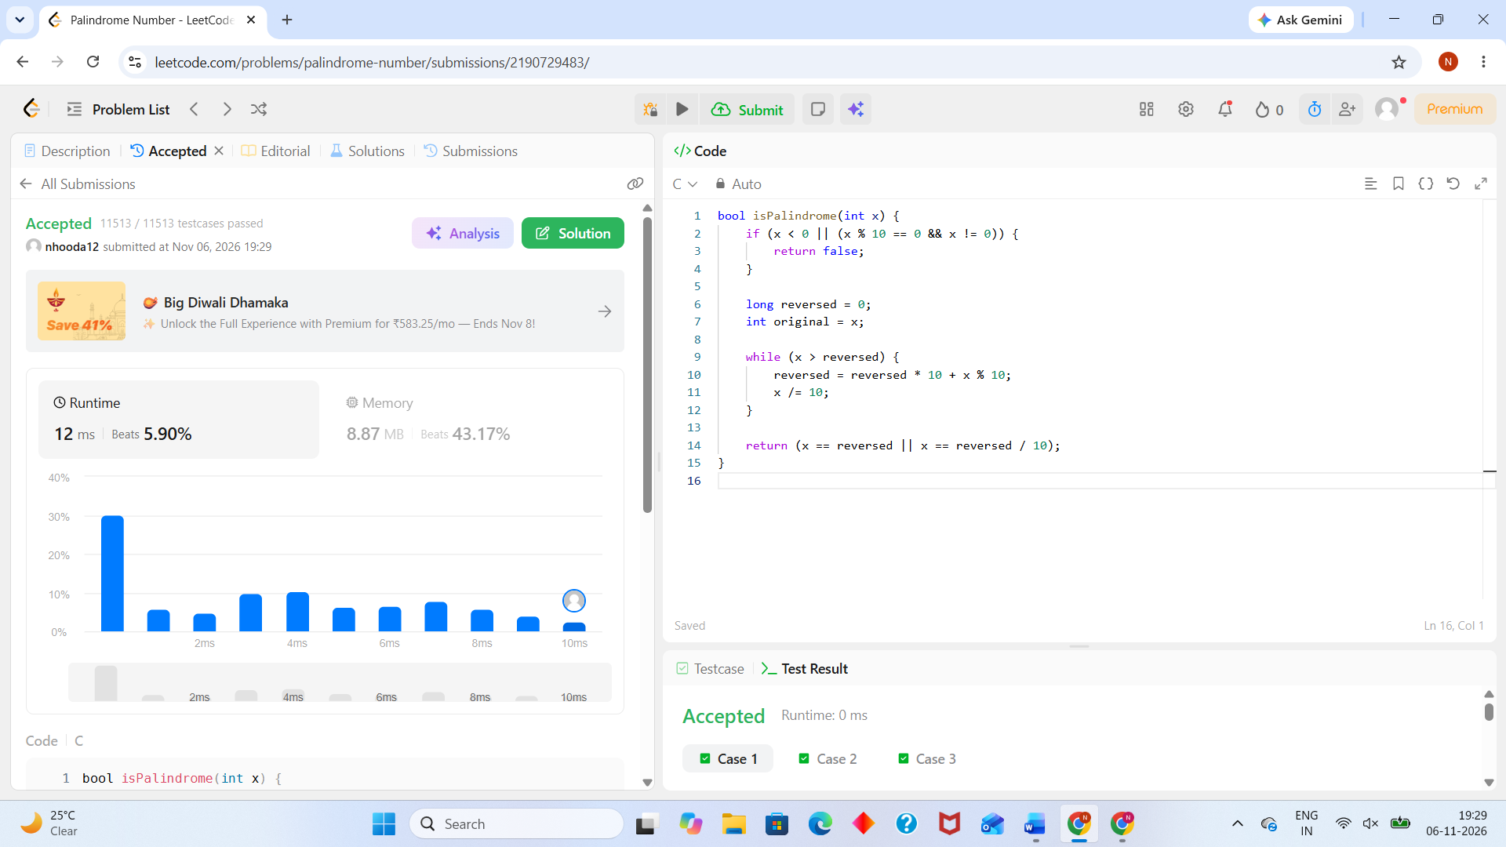

QUESTION 7 : https://leetcode.com/problems/reverse-integer/submissions/2190730557/
int reverse(int x) {
int rev = 0;
while (x != 0) {
int pop = x % 10;
x /= 10;

if (rev > INT_MAX / 10 || (rev == INT_MAX / 10 && pop > 7)) return 0;
if (rev < INT_MIN / 10 || (rev == INT_MIN / 10 && pop < -8)) return 0;

rev = rev * 10 + pop;
}
return rev;
}
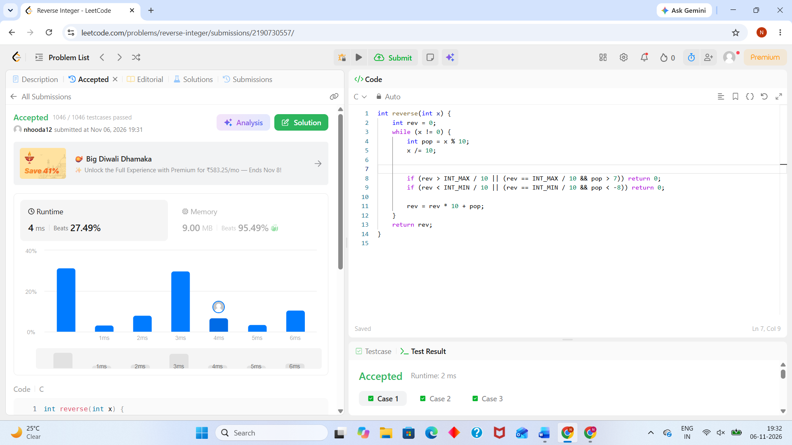
QUESTION 231 : https://leetcode.com/problems/power-of-two/description/
bool isPowerOfTwo(int n) {
return n > 0 && (n & (n - 1)) == 0;
}

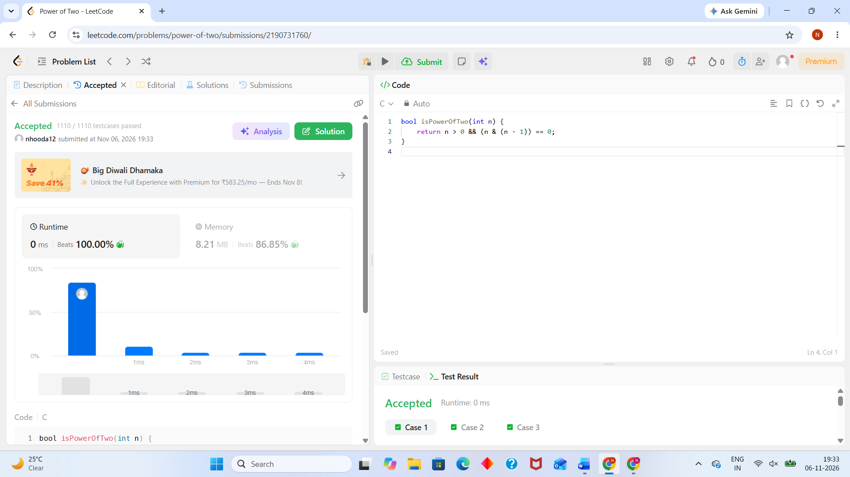

QUESTION 326 : https://leetcode.com/problems/power-of-three/submissions/2190732917/
bool isPowerOfThree(int n) {
if (n <= 0) {
return false;
}

while (n % 3 == 0) {
n /= 3;
}

return n == 1;
}

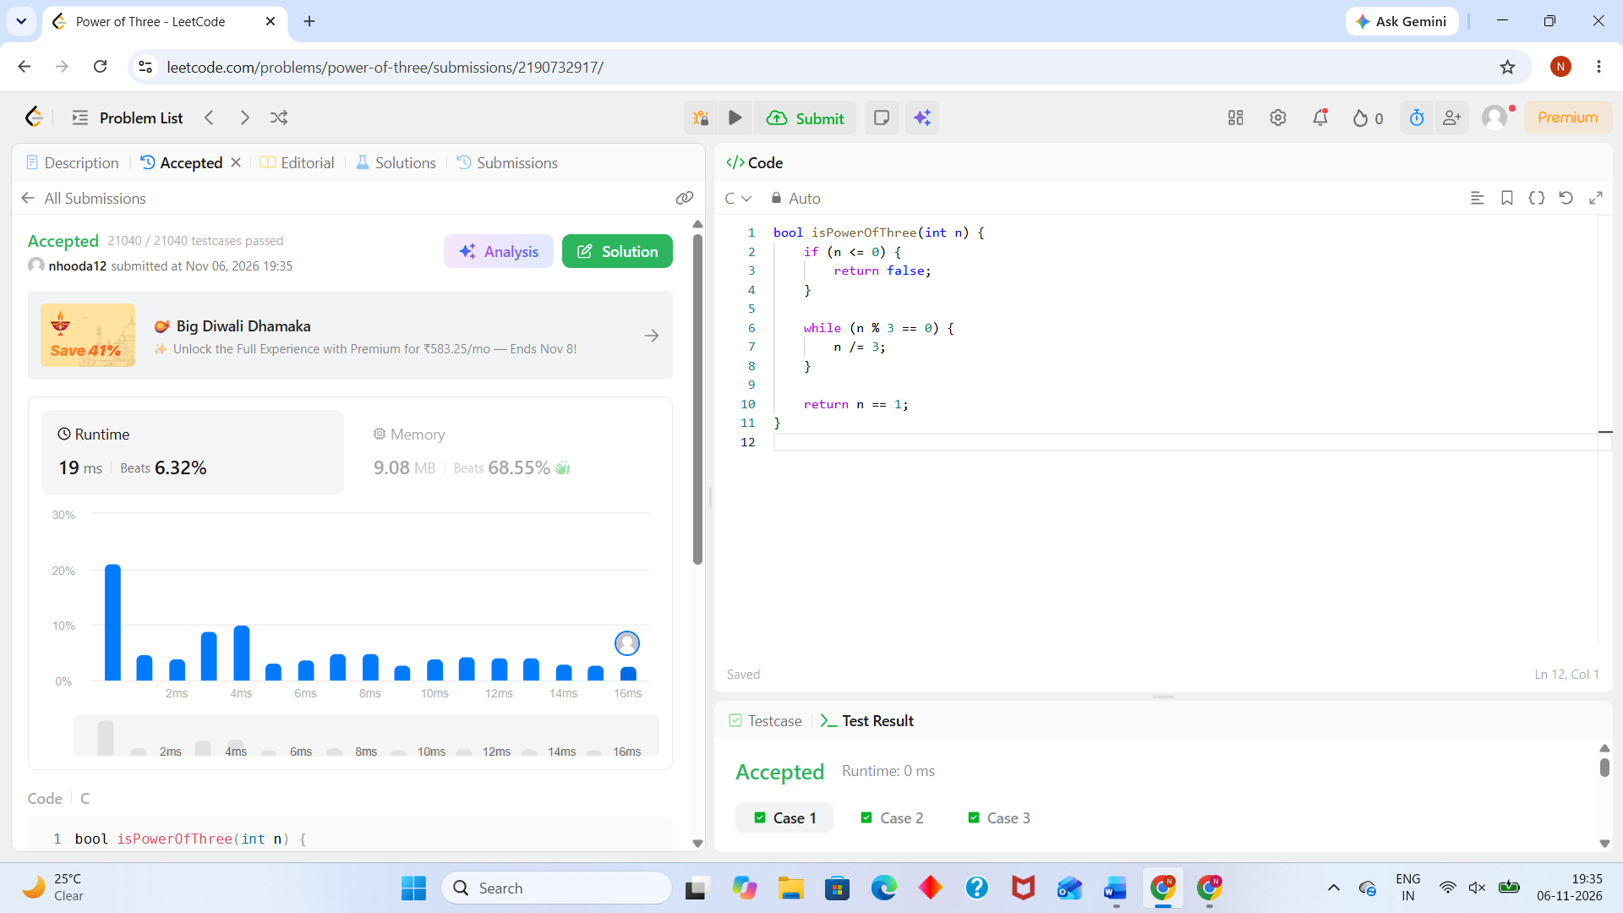

QUESTION 507 : https://leetcode.com/problems/perfect-number/submissions/2190735590/

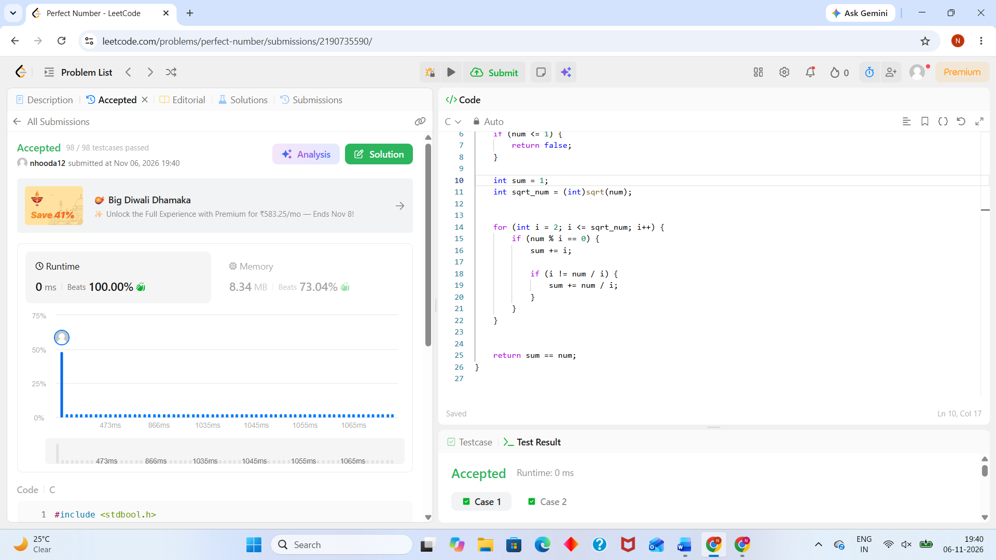
#include <stdbool.h>
#include <math.h>

bool checkPerfectNumber(int num) {
// Perfect numbers must be greater than 1
if (num <= 1) {
return false;
}

int sum = 1;
int sqrt_num = (int)sqrt(num);

for (int i = 2; i <= sqrt_num; i++) {
if (num % i == 0) {
sum += i;

if (i != num / i) {
sum += num / i;
}
}
}

return sum == num;
}

Read from STDIN, Write to STDOUT
#include <stdio.h>

int main() {
int N;
char S[105]; // Adjust array size based on max constraints of string S

// Read integer N from standard input
scanf("%d", &N);

// Read string S from standard input
scanf("%s", S);

// Print N * 2 on the first line
printf("%d\n", N * 2);
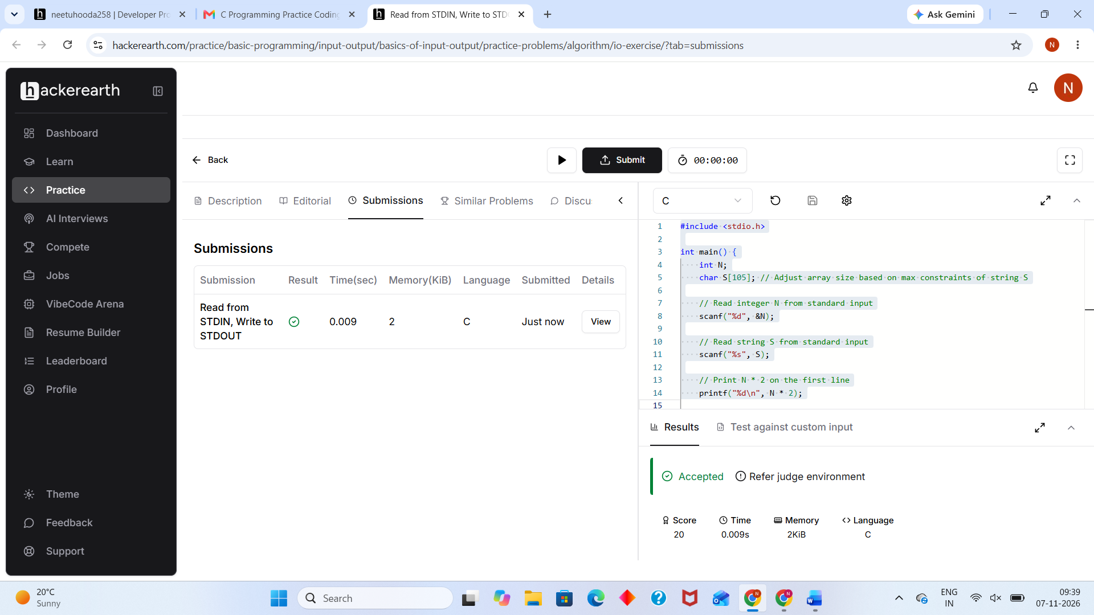
Roy and Profile Picture
https://www.hackerearth.com/practice/basic-programming/input-output/basics-of-input-output/practice-problems/algorithm/roy-and-profile-picture/
#include <stdio.h>

int main() {
int L, N, W, H;

// Read minimum dimension L
if (scanf("%d", &L) != 1) return 0;

// Read number of photos N
if (scanf("%d", &N) != 1) return 0;

// Process each photo
while (N--) {
scanf("%d %d", &W, &H);

if (W < L || H < L) {
printf("UPLOAD ANOTHER\n");
} else if (W == H) {
printf("ACCEPTED\n");
} else {
printf("CROP IT\n");
}
}

return 0;
}
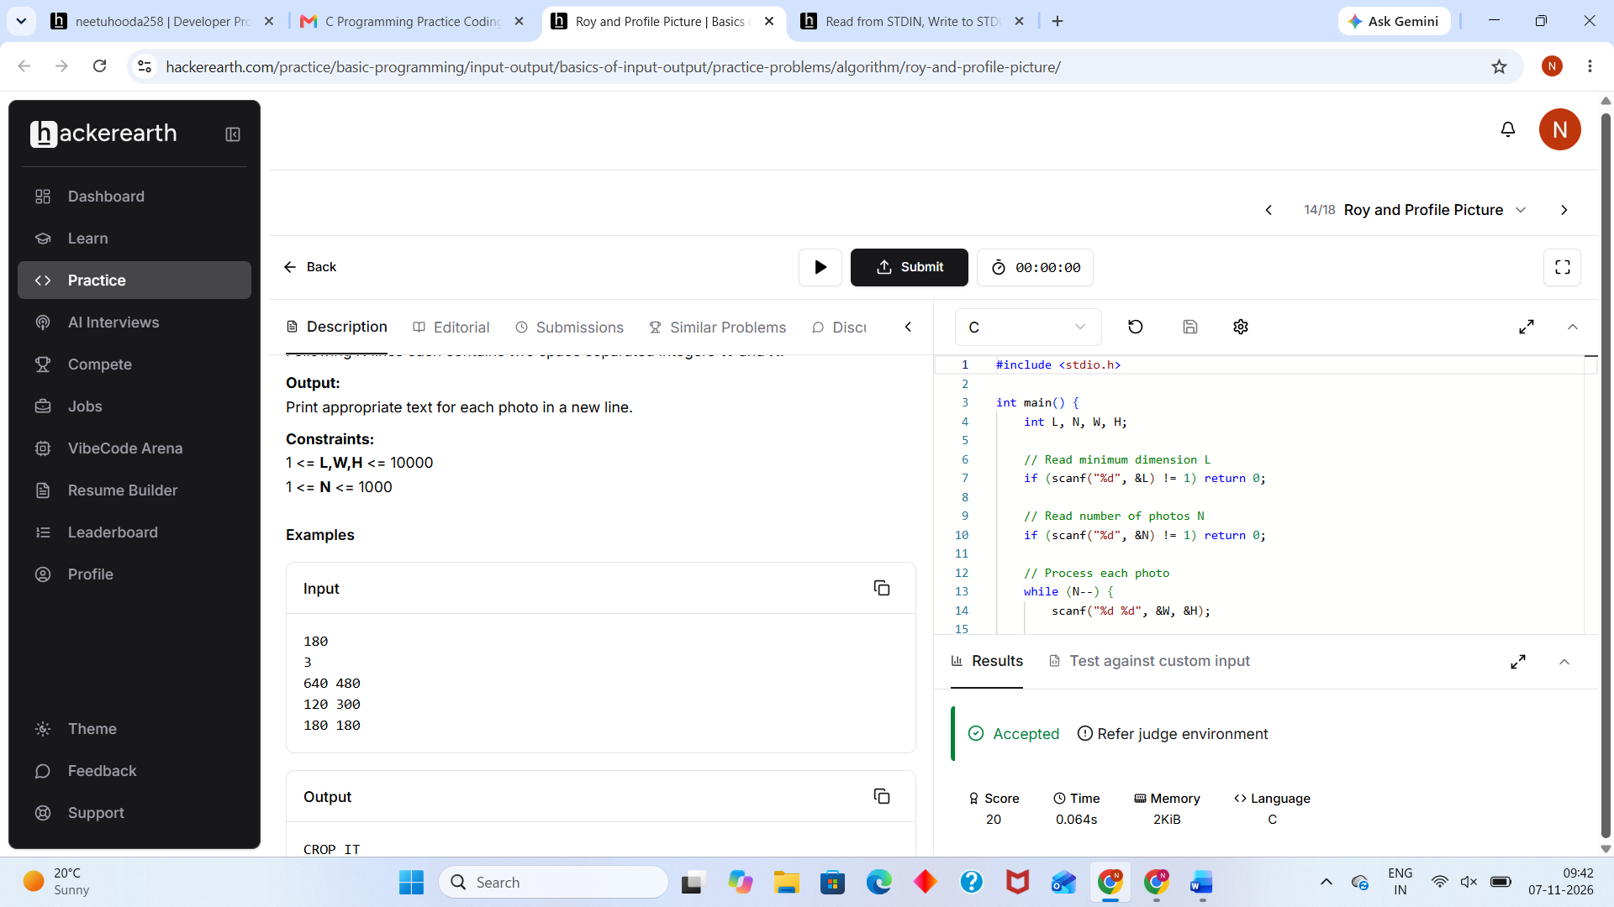

A.Digit Sum
https://www.hackerearth.com/problem/algorithm/digit-sum-4/
#include <stdio.h>

void solve() {
int n;
if (scanf("%d", &n) != 1) return;

// The last digit is easily found using the modulo operator
int last_digit = n % 10;

// Find the first digit by continuously dividing by 10 until n < 10
int first_digit = n;
while (first_digit >= 10) {
first_digit /= 10;
}

// Print the sum of the first and last digits
printf("%d\n", first_digit + last_digit);
}

int main() {
int t;
// Read the number of test cases
if (scanf("%d", &t) == 1) {
// Process each test case
while (t--) {
solve();
}
}
return 0;
}

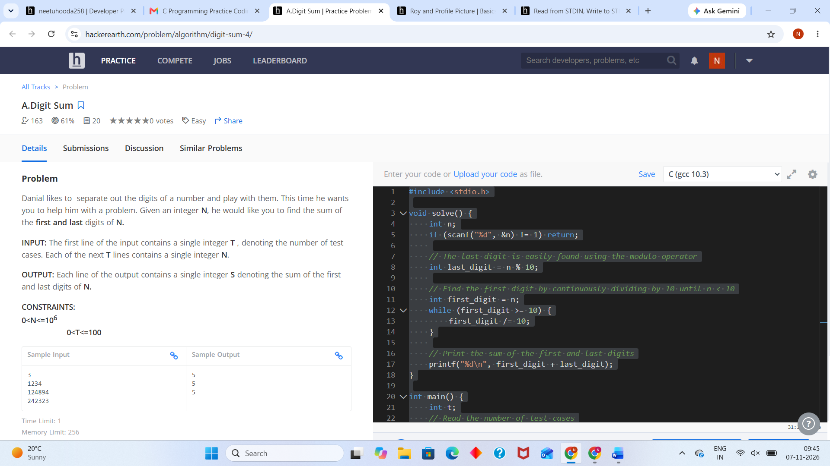
Factorial!
https://www.hackerearth.com/practice/basic-programming/input-output/basics-of-input-output/practice-problems/algorithm/find-factorial/
#include <stdio.h>

int main() {
int N;

// Read the single integer N from standard input
if (scanf("%d", &N) != 1) {
return 0;
}

long long factorial = 1;

// Calculate the factorial of N
for (int i = 1; i <= N; i++) {
factorial *= i;
}

// Print the final result followed by a newline character
printf("%lld\n", factorial);

return 0;
}

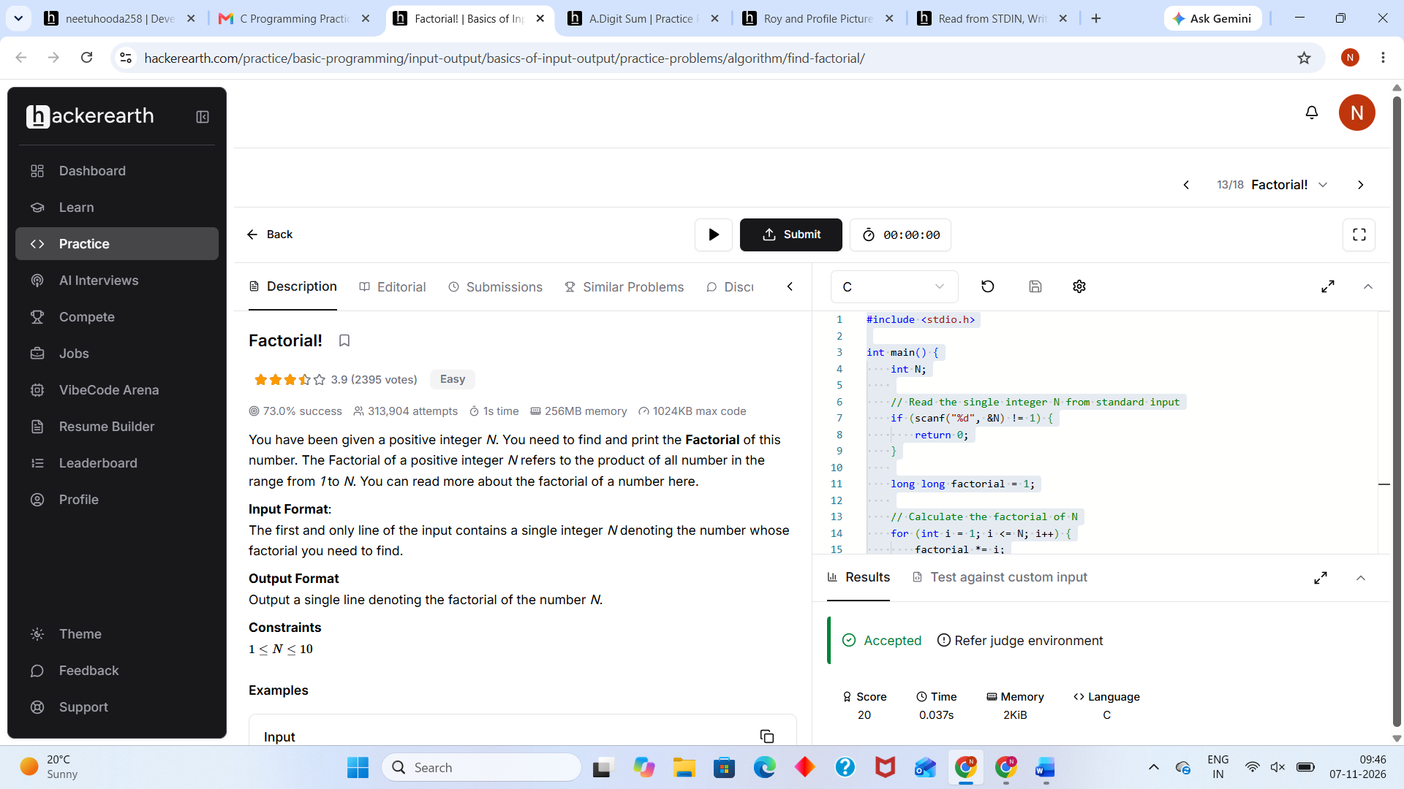

Prime Numbers
https://www.hackerearth.com/problem/algorithm/prime-numbers/
#include <stdio.h>

int main() {
int n;

// Read the input number
if (scanf("%d", &n) != 1) {
return 0;
}

int is_prime = 1; // Assume the number is prime initially

// Check for factors from 2 up to n/2
for (int i = 2; i <= n / 2; i++) {
if (n % i == 0) {
is_prime = 0; // Found a factor, so it is not prime
break;
}
}

// Print 1 if prime, 0 otherwise, followed by a newline
printf("%d\n", is_prime);

return 0;
}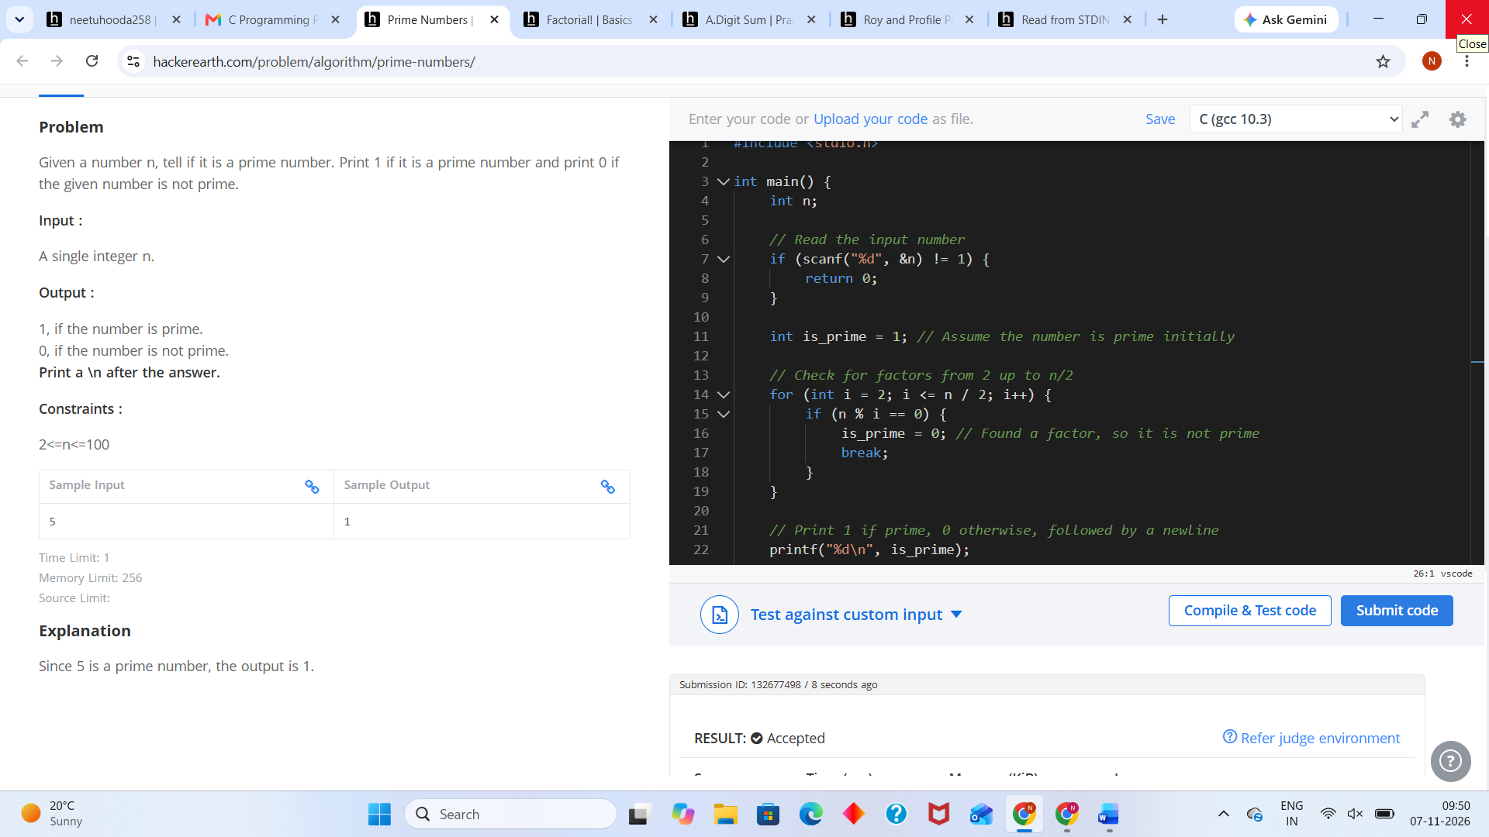

Solve Me First
https://www.hackerrank.com/challenges/solve-me-first/problem
#include <stdio.h>
#include <string.h>
#include <math.h>
#include <stdlib.h>

/*
* Complete the 'solveMeFirst' function below.
*/
int solveMeFirst(int a, int b) {
// Hint: Type return a+b; below
return a + b;
}

int main() {
int num1, num2;

// Read the two integers from standard input
if (scanf("%d %d", &num1, &num2) == 2) {
int sum;

// Call the function and store the result
sum = solveMeFirst(num1, num2);

// Print the result to standard output
printf("%d\n", sum);
}

return 0;
}



Conditional Statements in C
https://www.hackerrank.com/challenges/conditional-statements-in-c/problem
#include <stdio.h>
#include <stdlib.h>

int main() {
int n;
scanf("%d", &n);

if (n == 1) {
printf("one\n");
} else if (n == 2) {
printf("two\n");
} else if (n == 3) {
printf("three\n");
} else if (n == 4) {
printf("four\n");
} else if (n == 5) {
printf("five\n");
} else if (n == 6) {
printf("six\n");
} else if (n == 7) {
printf("seven\n");
} else if (n == 8) {
printf("eight\n");
} else if (n == 9) {
printf("nine\n");
} else {
printf("Greater than 9\n");
}

return 0;
}



Grading Students
https://www.hackerrank.com/challenges/grading/problem
#include <stdio.h>
#include <stdlib.h>

// Complete the gradingStudents function below.
// The function takes an array of grades and its size,
// and returns a dynamically allocated array of rounded grades.
int* gradingStudents(int grades_count, int* grades, int* result_count) {
*result_count = grades_count;
int* result = malloc(grades_count * sizeof(int));

for (int i = 0; i < grades_count; i++) {
int grade = grades[i];
if (grade >= 38) {
int remainder = grade % 5;
if (remainder >= 3) {
grade += (5 - remainder);
}
}
result[i] = grade;
}

return result;
}

int main() {
int n;
if (scanf("%d", &n) != 1) return 0;

int* grades = malloc(n * sizeof(int));
for (int i = 0; i < n; i++) {
scanf("%d", &grades[i]);
}

int result_count;
int* result = gradingStudents(n, grades, &result_count);

for (int i = 0; i < result_count; i++) {
printf("%d\n", result[i]);
}

free(grades);
free(result);
return 0;
}


FizzBuzz
https://www.hackerrank.com/challenges/fizzbuzz/problem
main(i){for(;i<101;puts(i++%5?"":"Buzz"))printf(i%3?i%5?"%d":"":"Fizz",i);}
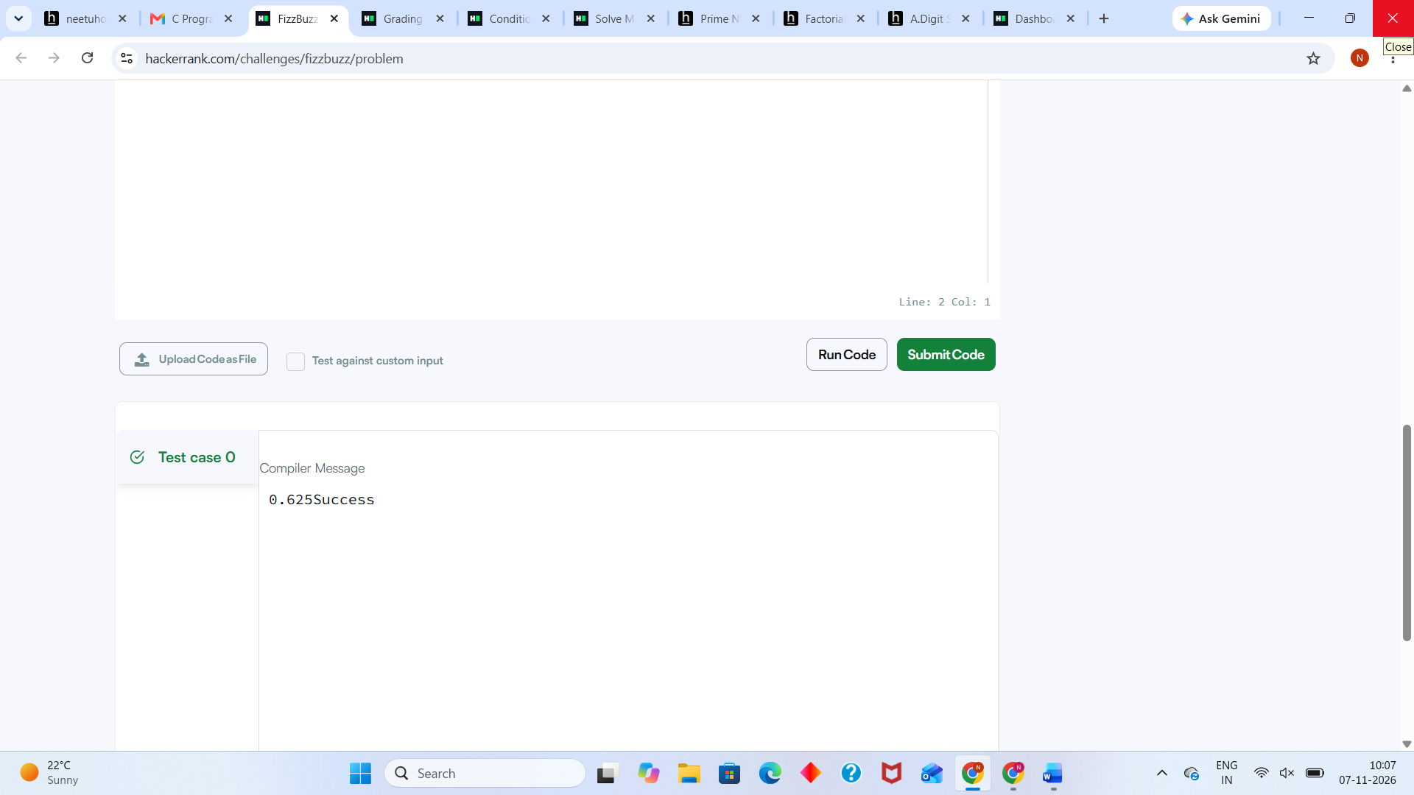

For Loop in C
https://www.hackerrank.com/challenges/for-loop-in-c/problem
#include <stdio.h>
#include <string.h>
#include <math.h>
#include <stdlib.h>

int main()
{
int a, b;
// Read the lower and upper bounds of the interval
if (scanf("%d\n%d", &a, &b) != 2) {
return 1;
}

// Array of string representations for numbers 1 to 9
// Index 0 is left empty so that the index matches the number itself
char *words[] = {"", "one", "two", "three", "four", "five", "six", "seven", "eight", "nine"};

// Loop through the interval [a, b] inclusive
for (int i = a; i <= b; i++) {
if (i >= 1 && i <= 9) {
printf("%s\n", words[i]);
}
else if (i > 9) {
if (i % 2 == 0) {
printf("even\n");
} else {
printf("odd\n");
}
}
}

return 0;
}

Number Line Jumps
https://www.hackerrank.com/challenges/kangaroo/problem
#include <stdio.h>
#include <stdlib.h>
#include <string.h>

/*
* Complete the 'kangaroo' function below.
* The function is expected to return a STRING.
*/
char* kangaroo(int x1, int v1, int x2, int v2) {
// If one is ahead and moving faster or at the same speed, they will never meet
if (v1 == v2) {
if (x1 == x2) {
return "YES";
} else {
return "NO";
}
}

// The number of jumps 'n' must be a positive integer.
// Equation: x1 + n*v1 = x2 + n*v2 => n*(v1 - v2) = x2 - x1 => n = (x2 - x1) / (v1 - v2)
// For n to be a valid number of jumps:
// 1. (x2 - x1) must be perfectly divisible by (v1 - v2) -> remainder is 0
// 2. The result 'n' must be greater than or equal to 0
if ((x2 - x1) % (v1 - v2) == 0 && (x2 - x1) / (v1 - v2) >= 0) {
return "YES";
}

return "NO";
}

int main() {
int x1, v1, x2, v2;

// Read the four space-separated integers from standard input
if (scanf("%d %d %d %d", &x1, &v1, &x2, &v2) == 4) {
// Get the result from the kangaroo function
char* result = kangaroo(x1, v1, x2, v2);

// Print the result followed by a newline
printf("%s\n", result);
}

return 0;
}


Find Digits
https://www.hackerrank.com/challenges/find-digits/problem
#include <stdio.h>
#include <string.h>
#include <math.h>
#include <stdlib.h>

/*
* Complete the 'findDigits' function below.
* The function is expected to return an INTEGER.
* The function accepts INTEGER n as parameter.
*/
int findDigits(int n) {
int count = 0;
int temp = n;

while (temp > 0) {
int digit = temp % 10;

// Check if the digit is not zero and divides the original number perfectly
if (digit != 0 && n % digit == 0) {
count++;
}

temp /= 10; // Move to the next digit
}

return count;
}

int main() {
int t;
// Read the number of test cases
if (scanf("%d", &t) != 1) return 0;

// Process each test case
while (t--) {
int n;
if (scanf("%d", &n) != 1) break;

int result = findDigits(n);
printf("%d\n", result);
}

return 0;
}


StairCase
https://www.hackerrank.com/challenges/staircase/problem
#include <stdio.h>
#include <string.h>
#include <math.h>
#include <stdlib.h>

// Complete the staircase function below.
void staircase(int n) {
for (int i = 1; i <= n; i++) {
// Print leading spaces (n - i)
for (int j = 0; j < n - i; j++) {
printf(" ");
}
// Print hash symbols (i)
for (int k = 0; k < i; k++) {
printf("#");
}
// Move to the next line
printf("\n");
}
}

int main() {
int n = 0;
if (scanf("%d", &n) != 1) return 1;

staircase(n);

return 0;
}


Printing Patttern Using Loops
https://www.hackerrank.com/challenges/printing-pattern-2/problem
#include <stdio.h>
#include <string.h>
#include <math.h>
#include <stdlib.h>

// Helper function to find the minimum of two integers
int min(int a, int b) {
return (a < b) ? a : b;
}

int main() {
int n;
// Read the single integer input
if (scanf("%d", &n) != 1) {
return 0;
}

int size = 2 * n - 1;

// Loop through each row and column of the grid
for (int i = 0; i < size; i++) {
for (int j = 0; j < size; j++) {
// Find the minimum distance to any of the 4 edges
int dist_to_top = i;
int dist_to_left = j;
int dist_to_bottom = size - 1 - i;
int dist_to_right = size - 1 - j;

int min_dist = min(min(dist_to_top, dist_to_left), min(dist_to_bottom, dist_to_right));

// The value decreases as we move inwards
printf("%d", n - min_dist);

// Print a space between numbers, but not after the last number in the row
if (j < size - 1) {
printf(" ");
}
}
// Move to the next line after completing a row
printf("\n");
}

return 0;
}


