QUESTION 242 : https://leetcode.com/problems/valid-anagram/description/
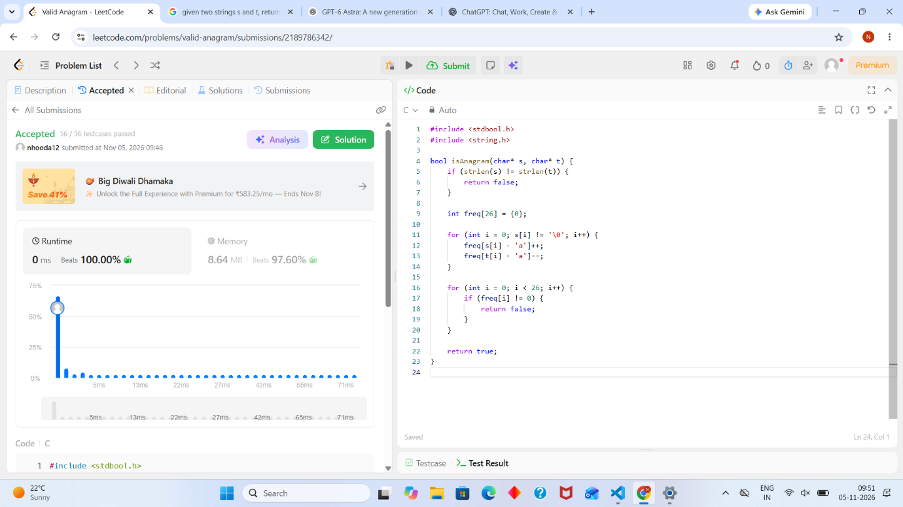
#include <stdbool.h>
#include <string.h>

bool isAnagram(char* s, char* t) {
if (strlen(s) != strlen(t)) {
return false;
}

int freq[26] = {0};

for (int i = 0; s[i] != '\0'; i++) {
freq[s[i] - 'a']++;
freq[t[i] - 'a']--;
}

for (int i = 0; i < 26; i++) {
if (freq[i] != 0) {
return false;
}
}

return true;
}

