QUESTION 2413: https://leetcode.com/problems/smallest-even-multiple/submissions/2190214988/
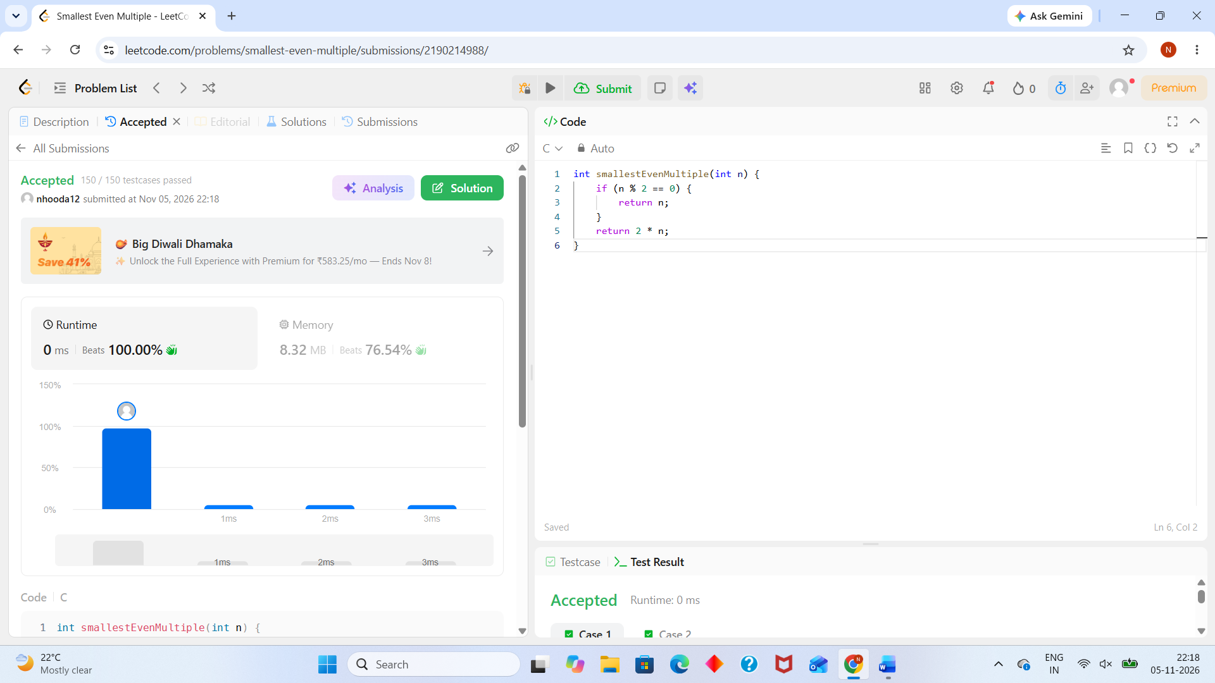
int smallestEvenMultiple(int n) {
if (n % 2 == 0) {
return n;
}
return 2 * n;
}

