**MongoDB**

* MongoDB is a NoSQL database.
* Used for web application ,real-time storage etc…
* Not an RDMS system.
* Can handle big data.
* It has good performance
* Easy cloud compatibility.

**DATA TYPES**

**String ,Integer, Boolean ,Double ,Arrays etc … are data types in MongoDB (like wrapper classes).**

**INSTALLATION**

1.Navigate to the MongoDB site.



2. Click enrol now.

3.Check specification and download.

4. Under the Software section, click on the Community server version.

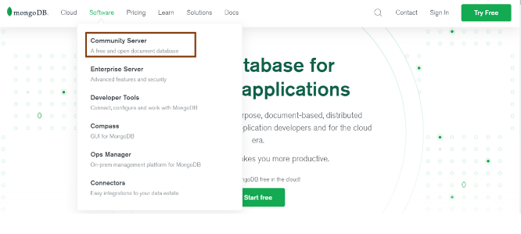

5. Ensure that the platform is Windows, and the package is MSI. Go ahead and click on download.

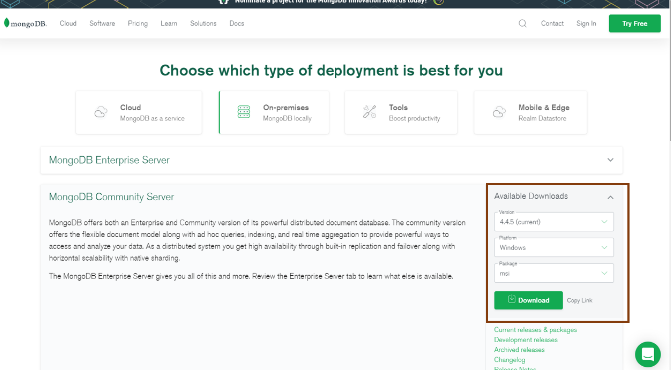

6.You can find the downloaded file in the downloads directory. You can follow the steps mentioned there and install the software.

. 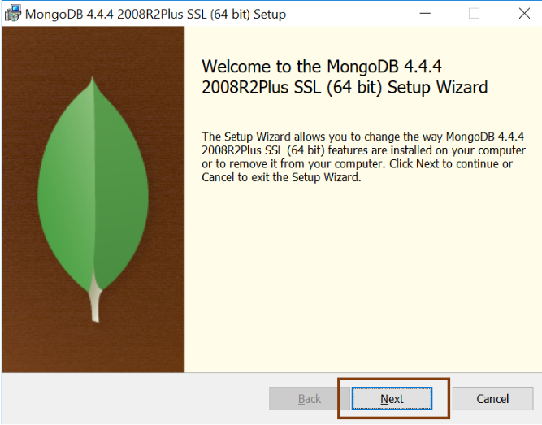

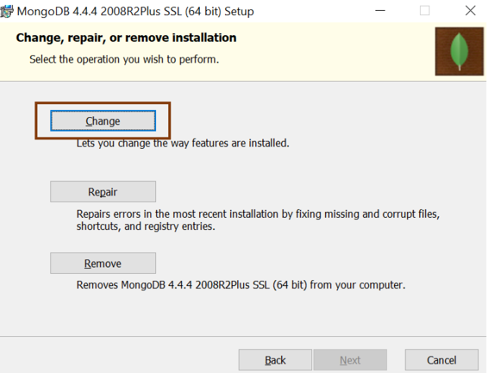

7.Installation completed.

**COLLECTION**

Collection is a group of documents. When a document is created collection is automatically created.

**CRUD OPERATIONS**

In MongoDB, the **db.collection.insert()** method is used to add or insert new documents into a collection in your database.

**Upsert**

There are also two methods "db.collection.update()" method and "db.collection.save()" method used for the same purpose. These methods add new documents through an operation called upsert.

Upsert is an operation that performs either an update of existing document or an insert of new document if the document to modify does not exist.

**Syntax:**



**Example:**

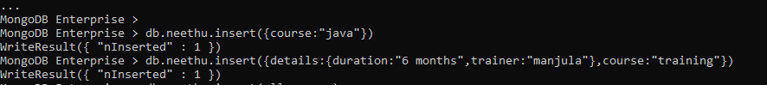

**.find()**

If the insertion is successful, we can view the inserted document by the following query.

**Example:**

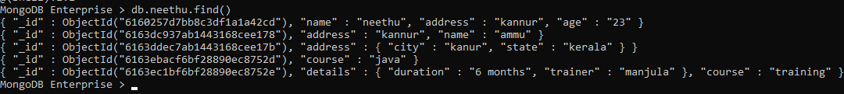

**MongoDB insert multiple documents**

If you want to insert multiple documents in a collection, you have to pass an array of documents to the db.collection.insert() method

## Create an array of documents

Define a variable named Allcourses that hold an array of documents to insert.

**Example:**

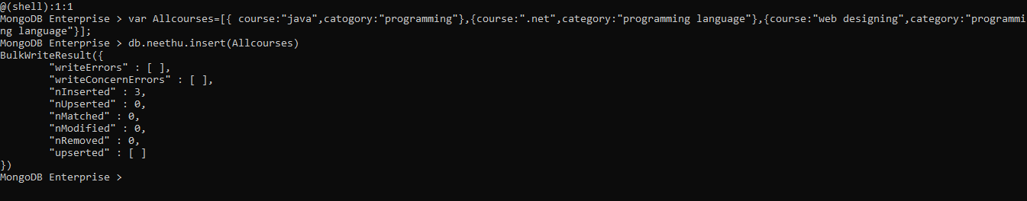

**AGGREGATION:**

Aggregate is a function in MongoDB.

**$group**

Group is used to grouping together items into required subsets on a particular criterion.  We can also use groups to perform operations across a common field in all documents, such as calculating the sum of a set of transactions and counting documents.

**Example:**

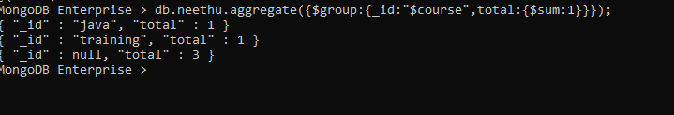

**$match**

Filters the documents to pass only the documents that match the specified condition(s) to the next pipeline stage.

**Example:**

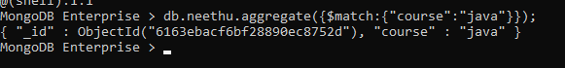

Created a collection with mark as follows:

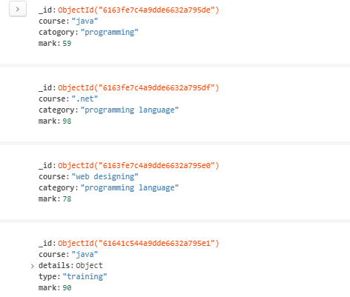

**$avg:**

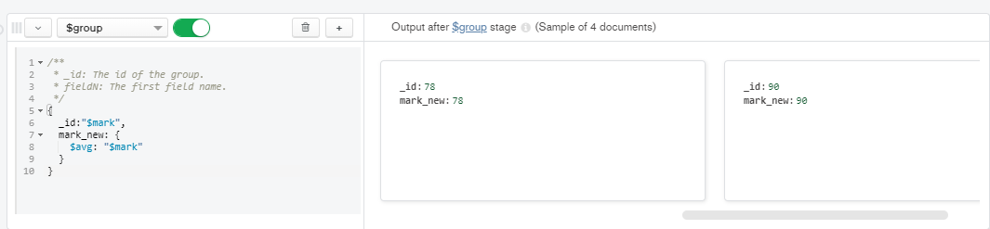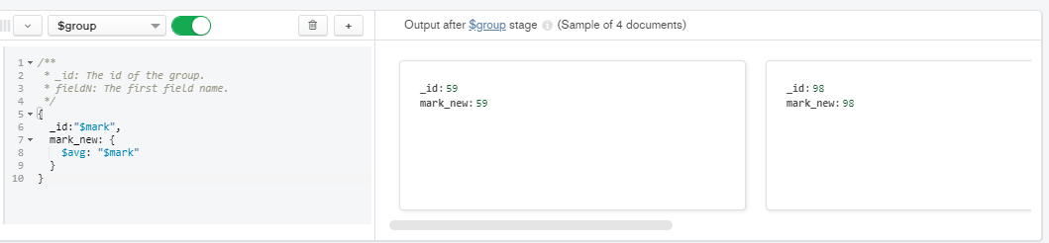

**$min:**

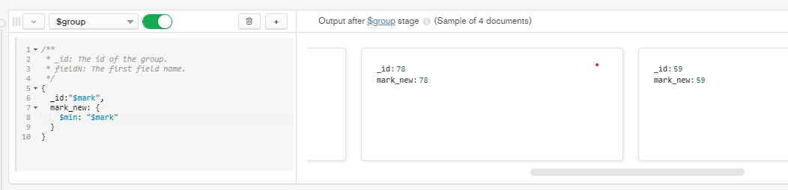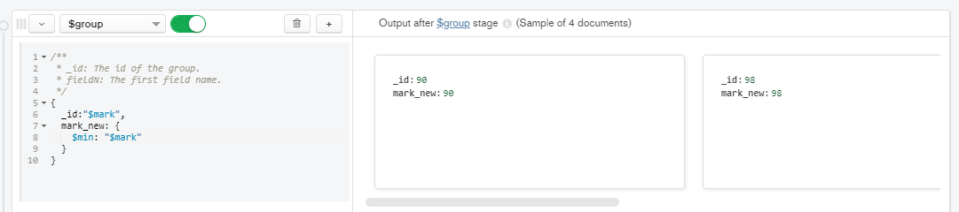

**$max:**

