Generative AI and ML
Capstone Project
GenAI Document Assistant
An Agentic RAG Application for Enterprise Document Q&A
Project Submission Documentation by Neetu V Pillai
August 2026

Contents
1. Introduction
2. Project Overview & Objectives
3. System Architecture
4. Technology Stack
5. Agent-Based Reasoning
6. Project Folder Structure
7. Setup & Installation
8. Running the Application
9. Demonstration & Sample Run
10. Setup Troubleshooting (Challenges Faced)
11. Limitations
12. Repository & Deployment
13. Conclusion

1. Introduction
Organizations increasingly hold critical knowledge across scattered, unstructured document formats — PDFs, spreadsheets, text files, and reports. Finding a specific answer buried in these documents is slow and manual. This project addresses that problem by building a Generative AI–powered application that lets users upload enterprise documents and ask natural-language questions, receiving accurate, source-grounded answers generated by autonomous AI agents.
The system combines three modern AI techniques: Large Language Models (LLMs) for natural language understanding and generation, Retrieval-Augmented Generation (RAG) to ground answers in real document content rather than the model's memorized training data, and Agentic AI, where multiple specialized agents plan, retrieve, reason, and validate collaboratively rather than relying on a single monolithic prompt.
This documentation covers the system's architecture, technology choices, setup instructions, a full demonstration with screenshots, and an honest account of the real technical challenges encountered and resolved during development.

2. Project Overview & Objectives
The goal of this capstone is to build an AI agent–based knowledge and decision support system. Users upload documents in multiple formats (PDF, TXT, CSV, Excel) and ask natural language questions; the system retrieves relevant content using a vector database and generates grounded responses using a locally-run LLM.

Objectives mapped to project tasks
- Set up the project foundation — repository, environment, and application structure.
- Design the user interaction layer — a FastAPI backend plus a Streamlit UI.
- Implement document ingestion for PDF, TXT, CSV, and Excel formats.
- Prepare data for semantic search via chunking with overlap.
- Build a vector-based knowledge store using ChromaDB with local embeddings.
- Implement intelligent document retrieval via similarity search.
- Develop a Retrieval-Augmented Generation (RAG) pipeline.
- Implement agent-based reasoning with Planner, Retriever, Reasoning, and Response agents.
- Add reliability and safety controls — input validation, error handling, guardrails.
- Deploy and document the solution, including limitations and challenges faced.

3. System Architecture
The application follows a layered architecture: a Streamlit front-end communicates over HTTP with a FastAPI backend, which orchestrates an agent pipeline built with LangGraph. The agent pipeline retrieves relevant context from a local Chroma vector database and generates answers using a locally-hosted LLM served by Ollama — keeping the entire stack free to run, with no external API keys or per-call costs.
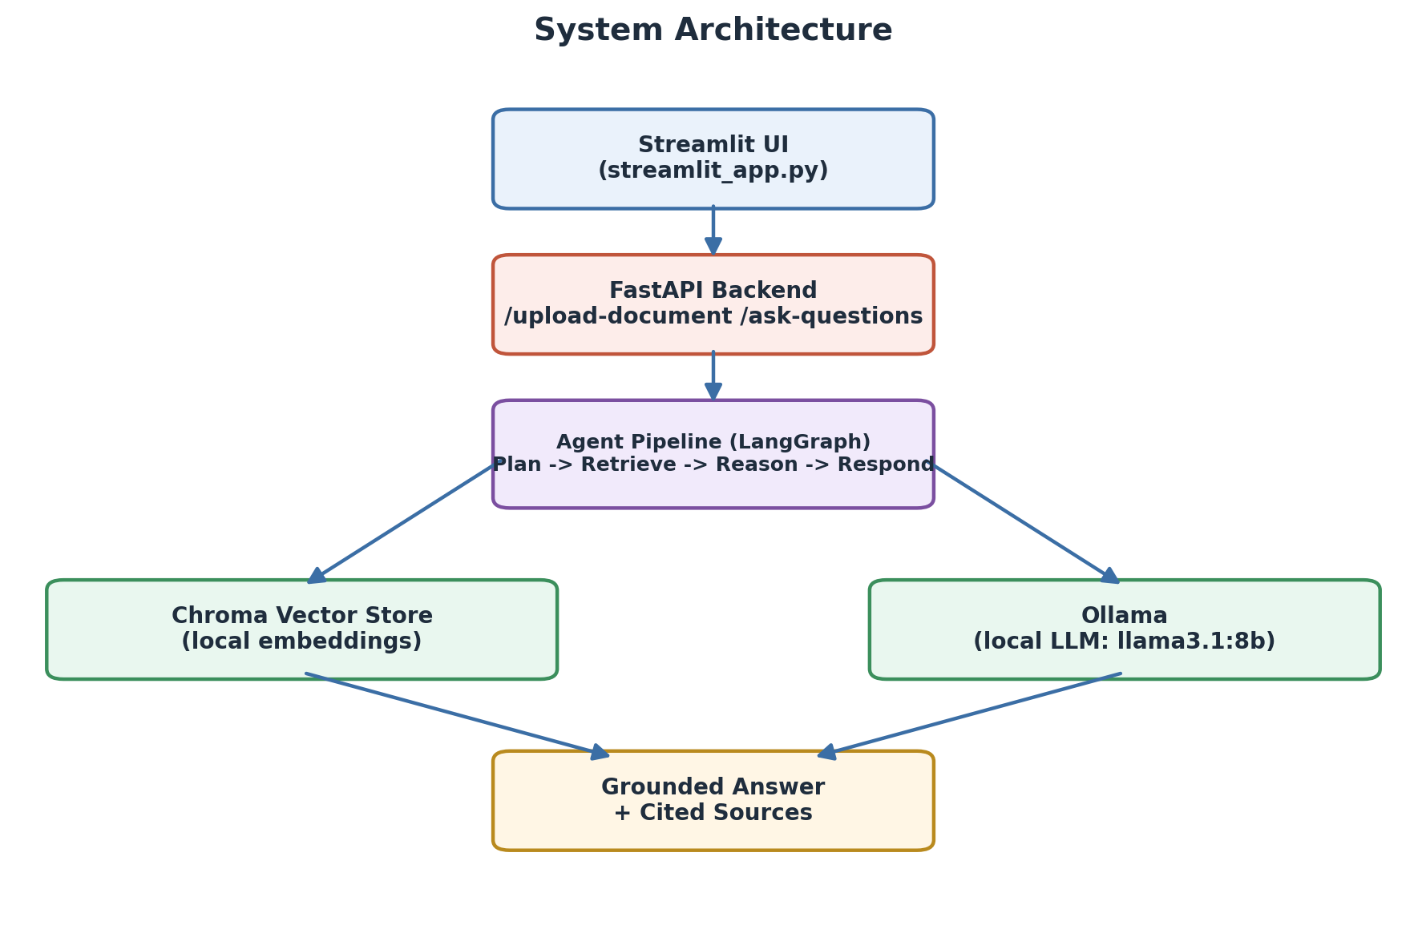
Figure 1: High-level system architecture

Component breakdown
Component | File / Module | Responsibility
UI layer | streamlit_app.py | Upload documents, ask questions, view answers and sources
API layer | app/api/main.py | Exposes /upload-document, /ask-questions, /health-check
Ingestion | app/services/ingestion.py | Extracts text from PDF, TXT, CSV, XLSX
Chunking | app/services/chunking.py | Splits text into overlapping chunks for embedding
Vector store | app/services/vector_store.py | Chroma DB with local sentence-transformers embeddings
RAG core | app/core/rag_pipeline.py | Standalone retrieve + generate function
Agents | app/agents/ | Planner, Retriever, Reasoning, Response, and orchestrator
Guardrails | app/core/guardrails.py | Input and output validation, reliability controls
Logging | app/utils/logging_config.py | Centralized logging for debugging

4. Technology Stack
Every component is free and runs locally — no API keys, no per-request billing, fully reproducible on any machine.
Layer | Tool | Notes
LLM | Ollama (llama3.1:8b) | Runs locally; no API key required
Embeddings | sentence-transformers (all-MiniLM-L6-v2) | Local embedding model
Vector database | ChromaDB | Embedded, persisted to local disk
Orchestration | LangChain + LangGraph | Agent graph and RAG chaining
API | FastAPI | REST endpoints for upload and Q&A
UI | Streamlit | Simple web interface
Deployment | Docker + docker-compose | Containerized API and UI services
Note: initial class guidance referenced langchain-openai. This project substitutes langchain-ollama to keep the entire stack free and local; the RAG and agent logic is otherwise unchanged from an OpenAI-backed implementation.

5. Agent-Based Reasoning
Rather than a single large prompt handling everything, the system uses four cooperating agents, each with one responsibility, wired together as a LangGraph state graph. State flows through the graph, making each step inspectable and independently testable.
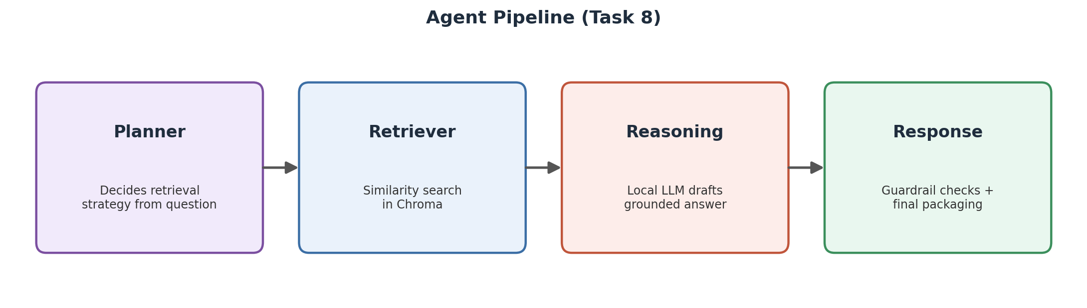
Figure 2: The four-agent pipeline
Agent | Responsibility
Planner | Decides retrieval strategy — a broad question (e.g. containing "compare" or "summarize") requests more chunks; a targeted question requests fewer.
Retriever | Embeds the question and runs cosine-similarity search against ChromaDB to fetch the most relevant chunks.
Reasoning | Sends retrieved context plus the question to the local LLM, instructed to answer only from the given context.
Response | Runs the draft answer through guardrail checks and packages the final answer with cited sources.

6. Project Folder Structure
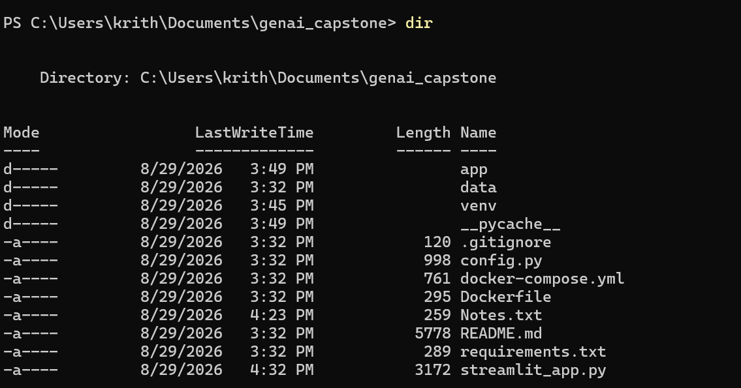
Figure 3: Project directory listing (VS Code terminal)
genai_capstone/ app/ api/main.py FastAPI endpoints services/ ingestion, chunking, vector store core/ RAG pipeline, guardrails agents/ Planner, Retriever, Reasoning, Response, orchestrator utils/ logging data/ uploads/ uploaded files chroma_db/ persisted vector store streamlit_app.py config.py requirements.txt Dockerfile docker-compose.yml README.md

7. Setup & Installation
- Install Ollama from ollama.com, then pull the model: ollama pull llama3.1:8b
- Clone or extract the project, and open it in VS Code.
- Create a virtual environment: python -m venv venv
- Activate it — Windows PowerShell: .\venv\Scripts\Activate.ps1
- Install dependencies: pip install -r requirements.txt
- Start the FastAPI backend: python -m uvicorn app.api.main:app --reload
- In a second terminal (venv activated), start the UI: streamlit run streamlit_app.py

8. Running the Application

8.1 Confirm the model is available
Verify Ollama has the required model pulled and ready:
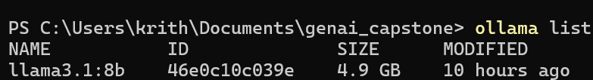
Figure 4: ollama list confirming llama3.1:8b is available locally

8.2 Start the FastAPI backend
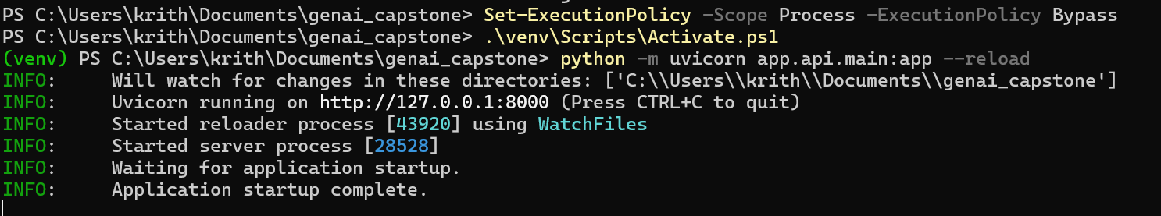
Figure 5: Uvicorn server startup log
A quick sanity check confirms the API is reachable:
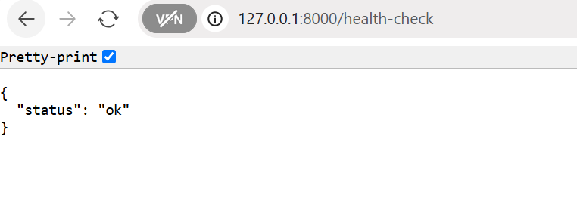
Figure 6: /health-check endpoint returning {"status": "ok"}

8.3 Start the Streamlit UI
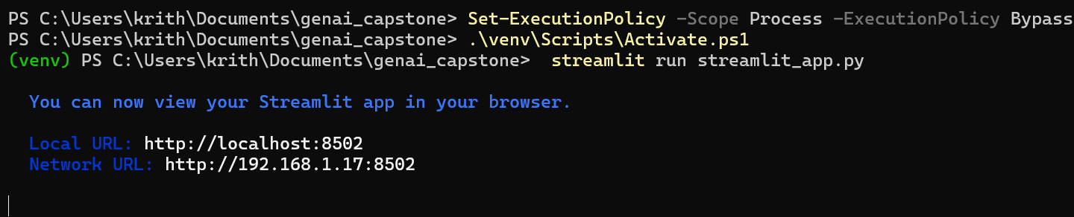
Figure 7: Streamlit server startup log
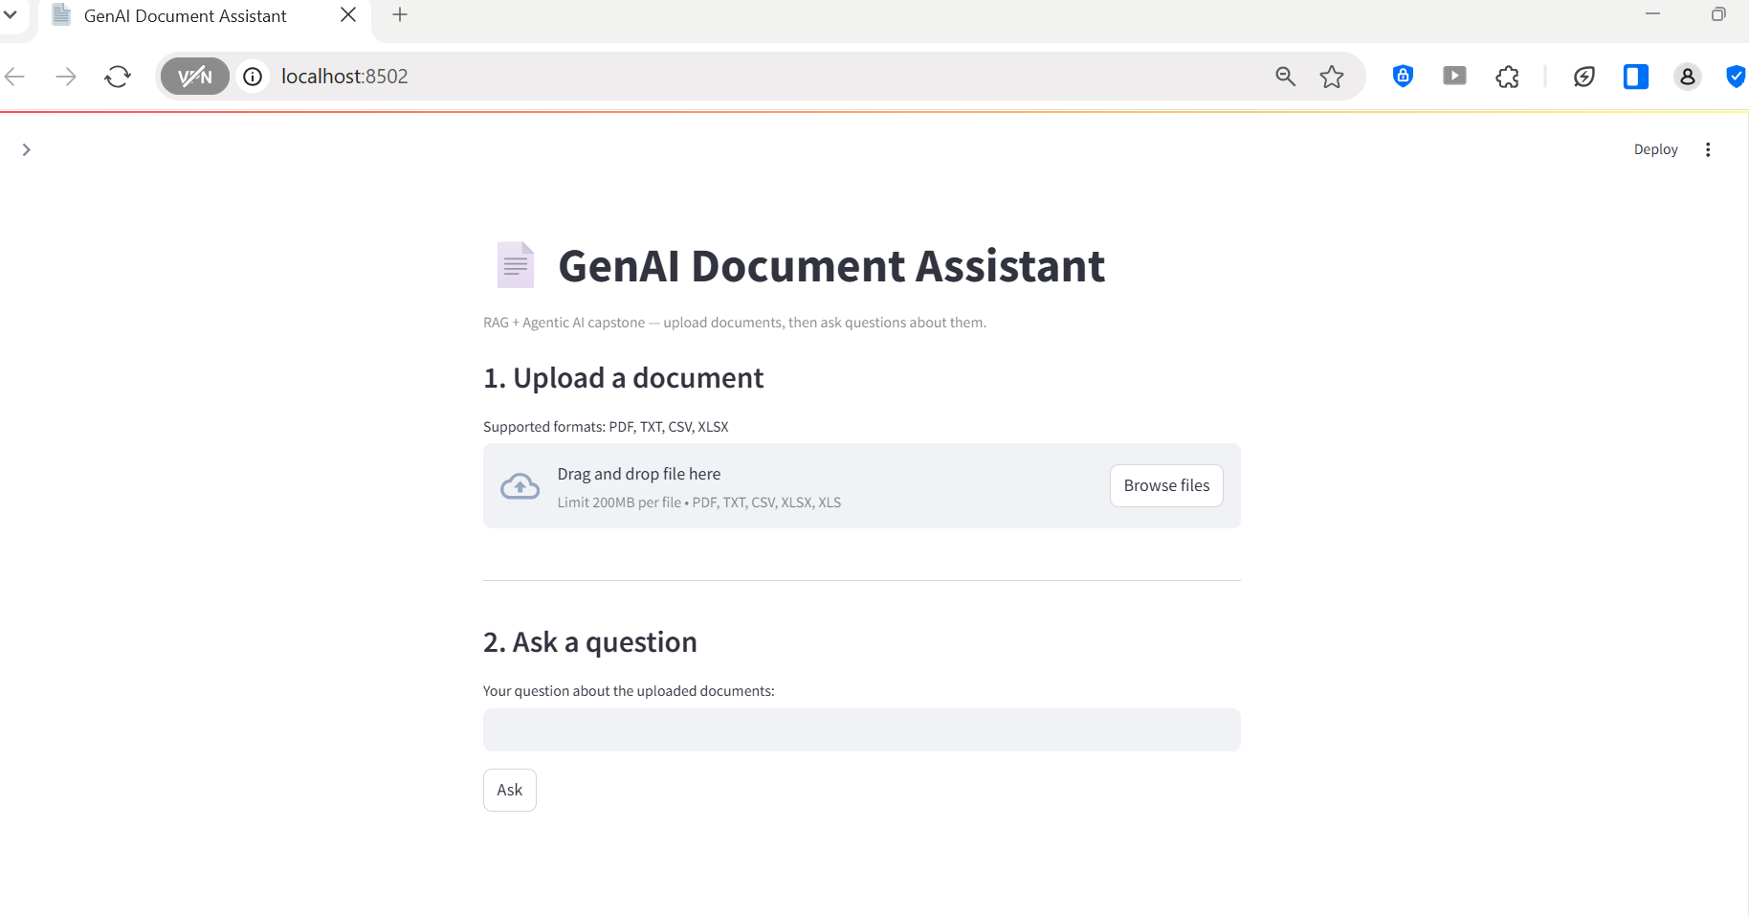
Figure 8: GenAI Document Assistant home page

9. Demonstration & Sample Run

9.1 Sample data file
A sample departments.csv file — containing department names and their categories — was used to demonstrate document ingestion and question answering.
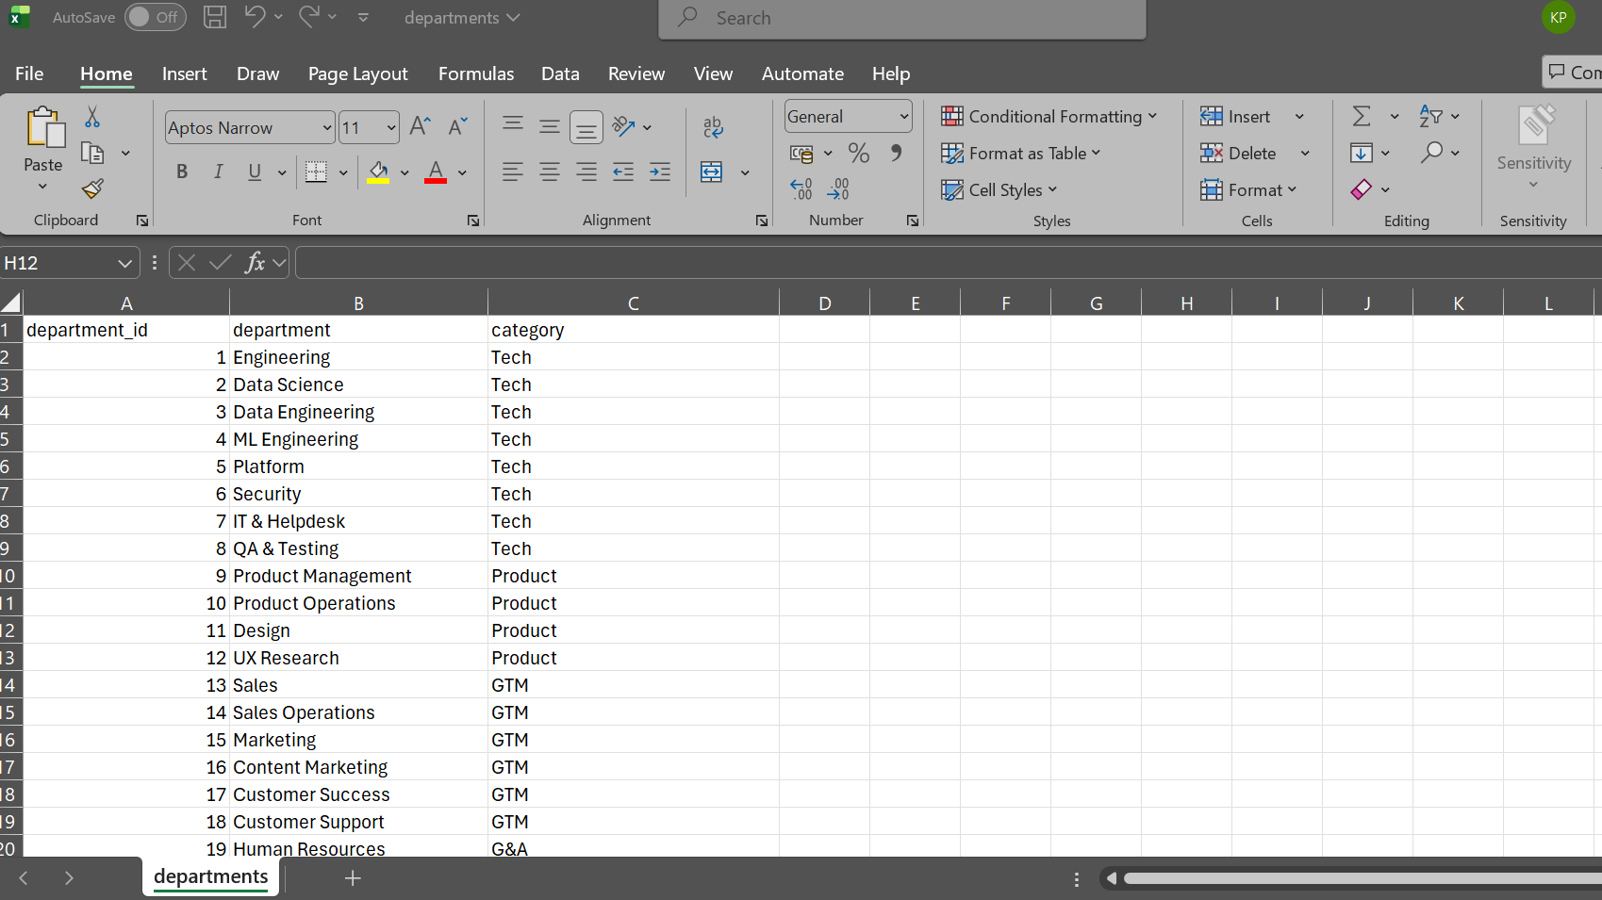
Figure 9: Sample departments.csv opened in Excel

9.2 Document ingestion
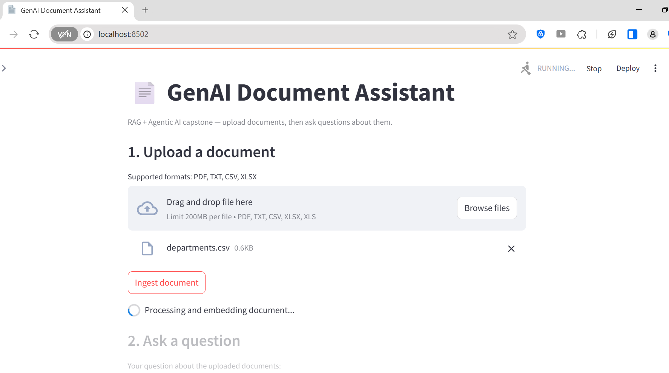
Figure 10: Uploading and ingesting departments.csv
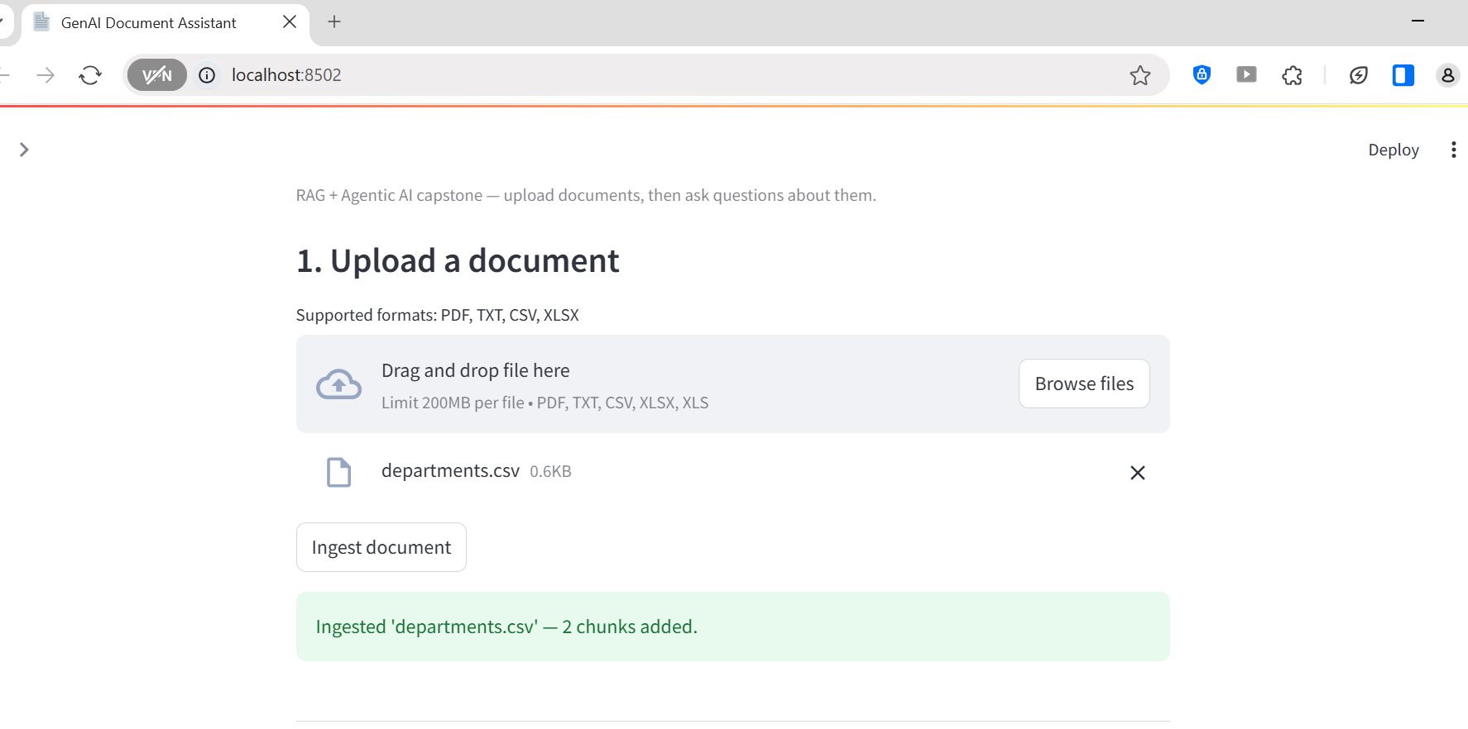
Figure 11: Successful ingestion — chunks added to the vector store

9.3 Asking a question — agent pipeline in progress
Clicking "Ask" triggers the full agent pipeline (Planner → Retriever → Reasoning → Response), shown live in the UI:
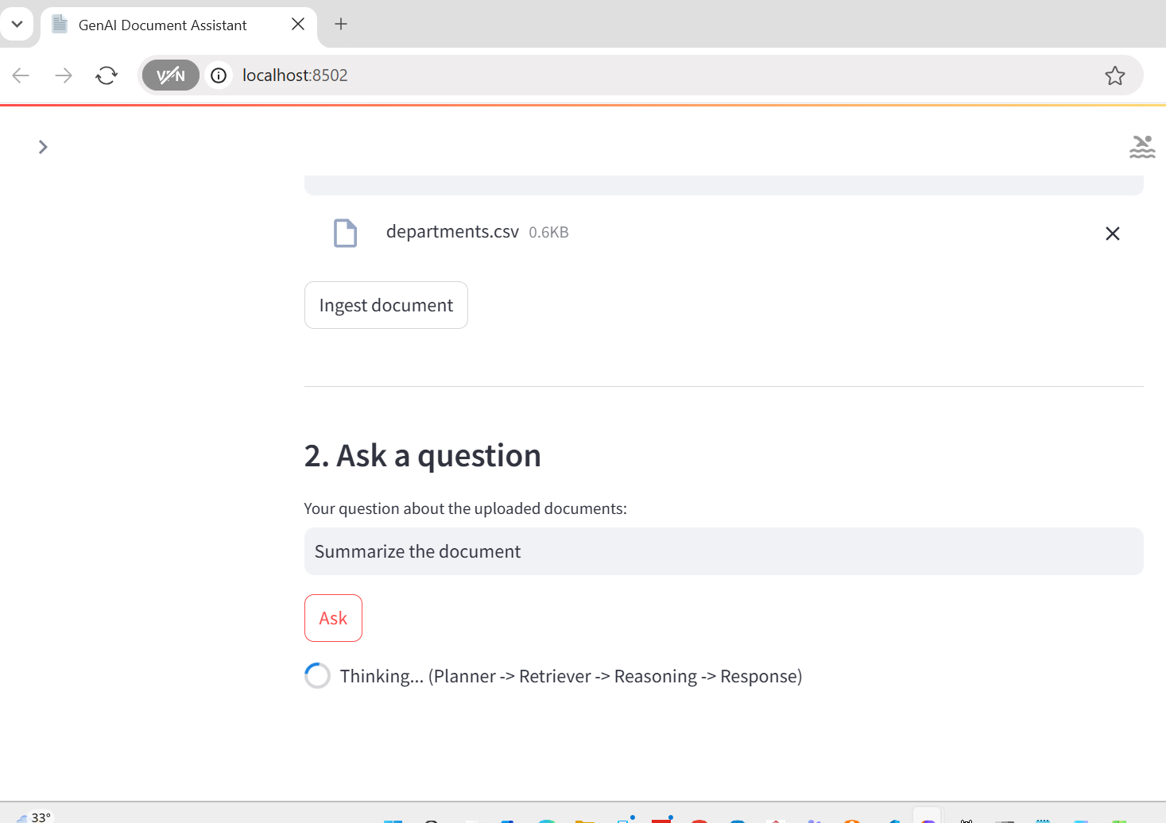
Figure 12: Agent pipeline running after a question is submitted

9.4 Grounded answers with cited sources
The system correctly answers questions using only the retrieved document context, and lists which source file(s) the answer was grounded in:
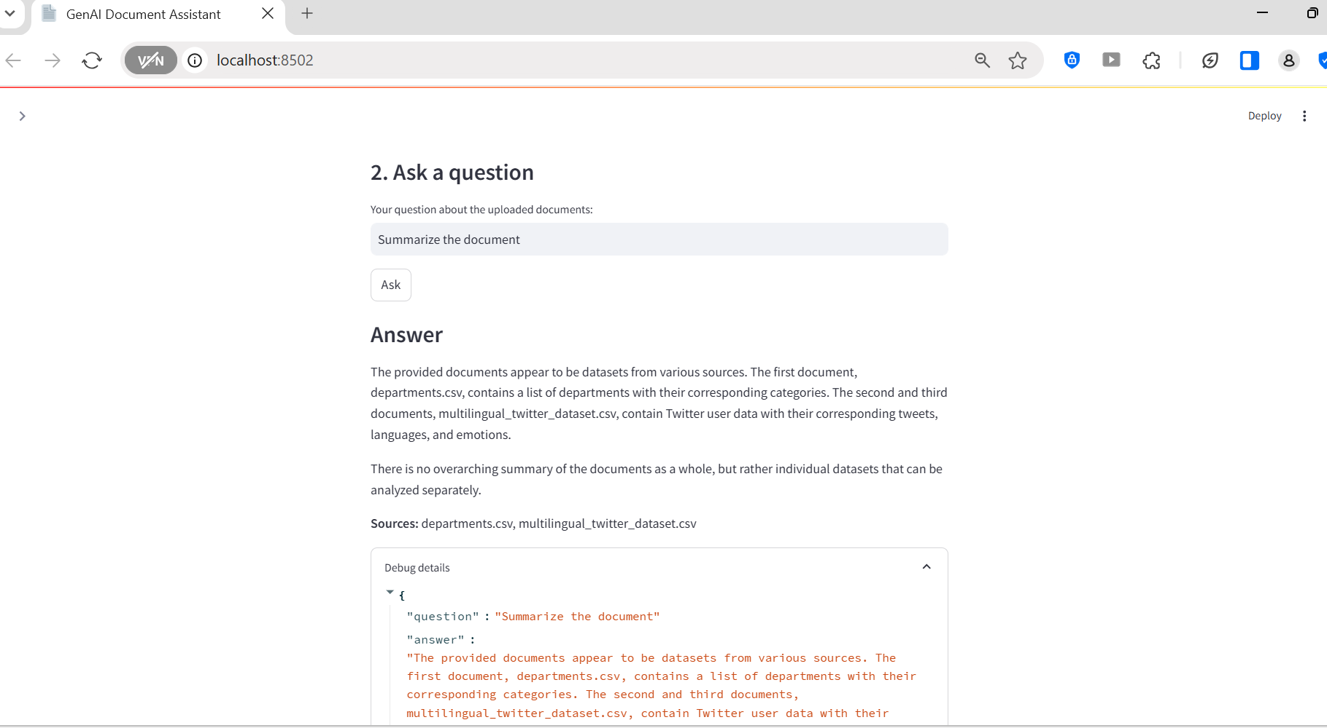
Figure 13: A broader "Summarize the document" query, correctly scoped across multiple uploaded files

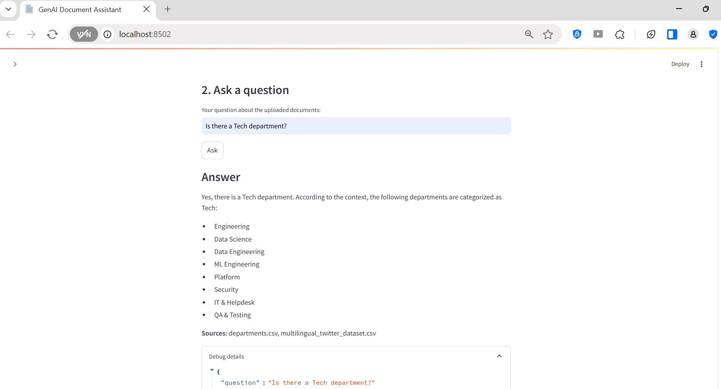
Figure 14: "Is there a Tech department?" answered with a grounded, itemized list

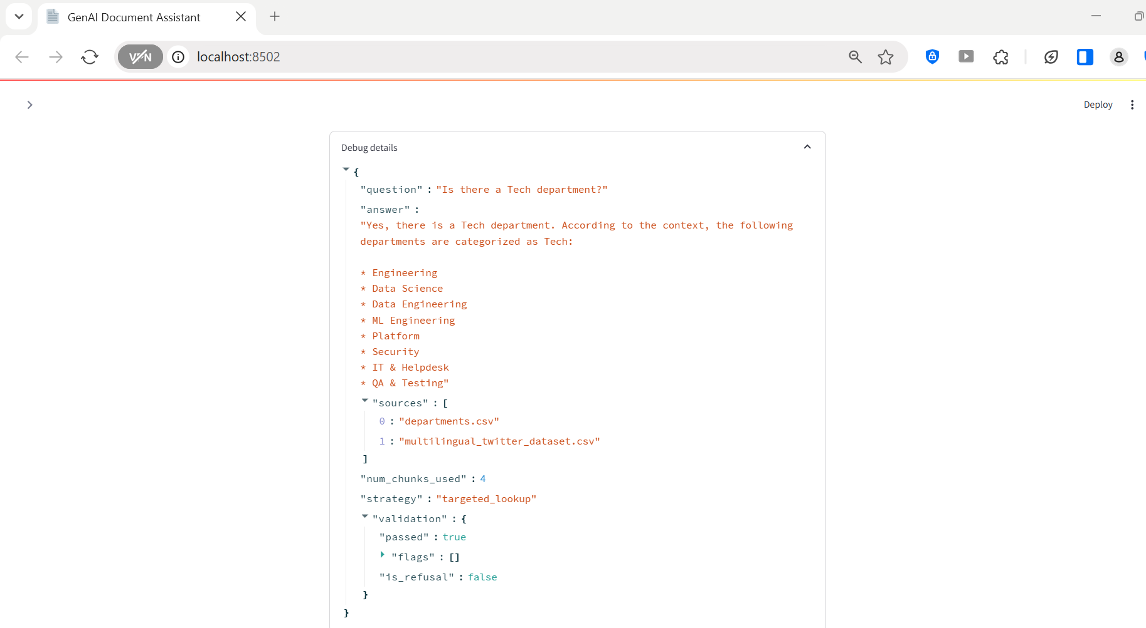
Figure 15: Debug detail view showing the full structured response object

9.5 Structured response payload
Every response returns a structured JSON object — question, answer, sources, chunk count, retrieval strategy, and guardrail validation results — useful for debugging and for integrating the API with other front-ends:
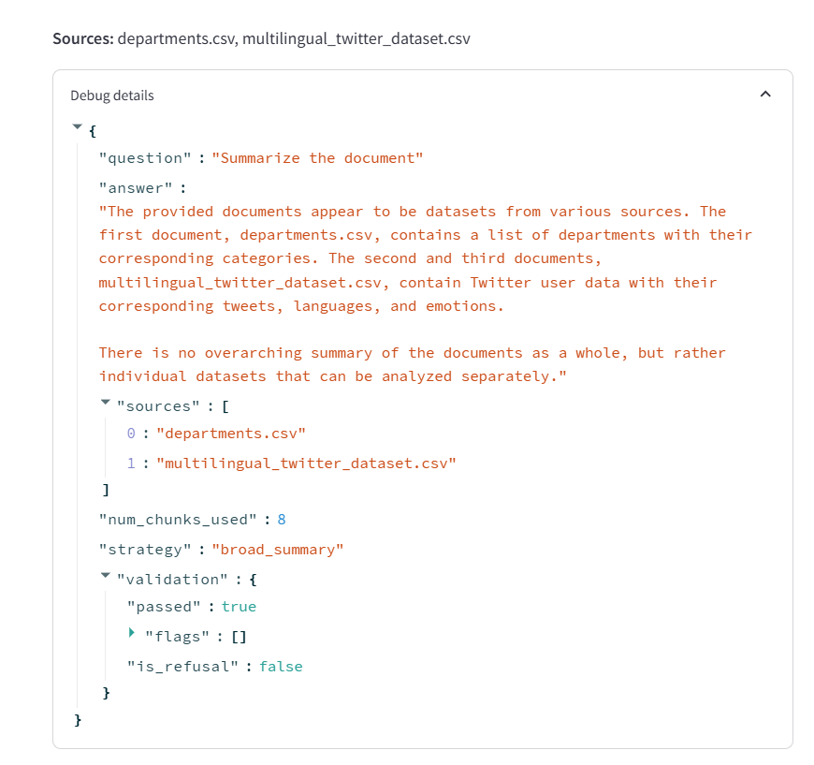
Figure 16: Full JSON response including guardrail validation fields

10. Setup Troubleshooting (Challenges Faced)
Real issues encountered while setting this project up on Windows, and how each was resolved. These are documented in detail since they are likely to recur for anyone else running this project on Windows.
1. python not recognized in terminal. Python was not installed, or not added to PATH. Resolved by reinstalling Python and checking “Add python.exe to PATH” during setup.
2. pandas failed to build from source (Meson/vswhere error). Caused by using a brand-new Python version (3.14) for which pandas, ChromaDB internals, and PyTorch do not yet publish pre-built wheels. Resolved by installing Python 3.12 and creating the virtual environment with that version instead.
3. chroma-hnswlib failed to build (needs Microsoft Visual C++ 14.0). Even on Python 3.12, this package has no pre-built Windows wheel — confirmed on PyPI that its Windows wheels only extend to Python 3.11. Resolved by creating the virtual environment with Python 3.11 instead, avoiding the need for a C++ compiler entirely.
4. venv\Scripts\activate not recognized in PowerShell. PowerShell requires the explicit script name and a relative-path prefix: .\venv\Scripts\Activate.ps1, rather than the Command-Prompt-style activate.
5. “Running scripts is disabled on this system” when activating. PowerShell's execution policy blocks script execution by default. Resolved for the current terminal session only with: Set-ExecutionPolicy -Scope Process -ExecutionPolicy Bypass.
6. No module named uvicorn despite installing requirements. The virtual environment was not actually activated in that terminal. Each new terminal tab requires the venv to be reactivated — activation does not persist across terminal windows.
7. Each new venv needs its own pip install. A venv is a fully isolated environment. Moving the project folder (e.g. out of OneDrive into a local-only path, to avoid background sync interference) required dependencies to be reinstalled in the new environment.
8. ollama._types.ResponseError: model not found. Ollama itself was running, but the model was never pulled. Resolved with ollama pull llama3.1:8b.
9. ReadTimeout on /ask-questions after Ollama was confirmed running. The first call to a newly-loaded model must load the full model into RAM from disk, which can exceed a short timeout — especially on CPU-only machines. Ollama also unloads idle models after a few minutes, so this can recur after a pause. Resolved by raising the Streamlit request timeout from 120s to 300s.
10. Zip extraction appeared to be missing files. An early, partial project archive (captured before all modules were written) was extracted instead of the final, complete one. Resolved by verifying file counts after extraction before debugging import errors.

11. Limitations
- Answer quality depends on the local LLM (llama3.1:8b by default); smaller local models are less capable than large hosted models.
- Guardrails are rule-based (keyword and heuristic checks), not a second LLM-based verification pass — they catch obvious failure patterns but not subtle hallucinations.
- No authentication or multi-user isolation; all uploaded documents share a single Chroma collection, so questions can retrieve context across every uploaded file rather than being scoped to one.
- Excel/CSV files are converted to flattened text tables, which works well for small-to-medium sheets but loses some structure on very large or complex spreadsheets, and can occasionally cause the model to conflate similarly-named columns.
- Ollama must be running locally for /ask-questions to work; the API returns a clear error if it cannot reach Ollama.
- The first query after starting Ollama or after an idle period is slow, since the model must load into memory from disk.

12. Repository & Deployment
GitHub repository: https://github.com/neetuvp/capstone_project_genai
The repository contains the complete source code, requirements.txt, Dockerfile, docker-compose.yml, and this documentation.

Docker deployment
docker-compose up --build
This starts the API on port 8000 and the UI on port 8501. Ollama runs on the host machine rather than inside a container, since it needs direct access to system resources for the LLM.

13. Conclusion
This project demonstrates a complete, working Generative AI and Agentic AI system: documents are ingested and chunked, embedded and stored in a local vector database, retrieved by semantic similarity, and answered by a coordinated pipeline of planning, retrieval, reasoning, and validation agents — all running on free, local infrastructure with no external API dependency. Beyond the working application, the development process itself surfaced and resolved a realistic set of environment and dependency challenges common to local LLM development on Windows, which are documented in full to support future setup and troubleshooting.

