Review of Objects and Classes

What is an Object?

- The object can be thought of as the fundamental building block in any OO system.

- Informally, an object represents an entity, either physical, conceptual, or software based. Typical examples of these include:-

- Physical entities: Car, Person, Student, Chair
- Conceptual entities: Chemical Process, Bank Account, Register
- Software entities: Linked List, Array, Sorted List

A more formal definition of an object could be:-

“An object is a concept, abstraction, or thing with sharp boundaries and meaning for an application”

- For example if we were designing a computer system to deal with flight bookings for an airline, typical objects selected for the system could include:-

Physical: Aircraft, Passenger, Airport
Conceptual: Booking, Reservation
Software Entity: Linked List (A typical data structure)

- An object is defined by its:-

- State
- Behaviour
- Identity

State

- The state of an object is one of the possible conditions in which an object may exist.
- The state of an object normally changes over time.
- The state of an object is usually implemented by a set of properties (called attributes), with the values of the properties, plus the links the object may have with other objects.

Behaviour

- Behaviour determines how an object acts and reacts
- Behaviour defines how an object reacts to requests from other objects.
- The visible behaviour of an object is modelled by the set of messages it can respond to (the operations the object can perform)
- These operations are visible in the class interface

Identity

- Each object has a unique identity, even if its state is identical to that of another object. (It may be an unique location in memory)

What is a Class?

- A class is a blueprint for all objects of that class type.

- Alternatively a class could be viewed as an object factory, which can create as many objects of that class as is required.
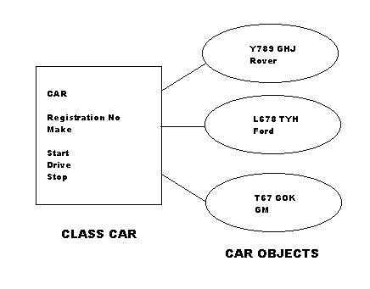

- A class makes instances of itself “objects”. Hence when a new object is created we say it is instantiated.

- A class defines:-

- the attributes of the class;
- the methods of the class;
- and has a unique name.

- The attributes of class allow objects to contain state data.

- The methods of a class determine the behaviour of the class.

Example Class/Object Instance
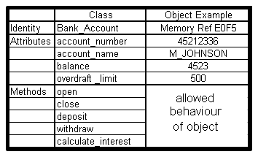

- The state data in an object can only be accessed or manipulated by the methods, defined by the class.

- This data hiding is called ENCAPSULATION. For each class there is a public interface saying what the data is and what can be done to it, but hidden, private implementation of the methods.

- 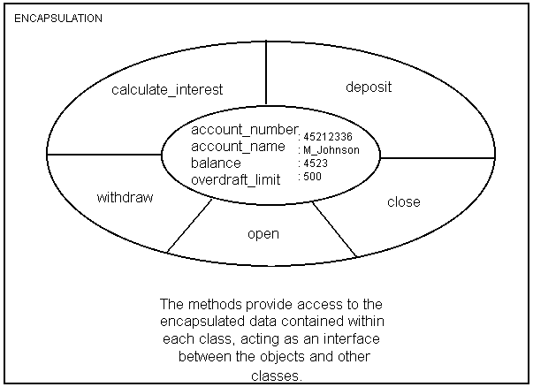The state of an object gives the status of the object at any one time. (E.g. the content and values of the attributes within the object.)

- A partial section of code for this example class is given at the end of these notes.

What’s the difference?

Key differences between classes and objects are :-

- Once created a class exists all the time the program is running. Objects may be created and destroyed during run time.
- For a single class there may be any number of objects existing at any one time.
- A class has a unique name, attributes and methods. An object has an identity, state and behaviour.
- A class provides no state values for the object attributes. These can only be given value when applied to objects.

“Example Class Syntax in Eiffel”

class ACCOUNT

creation
open

-- every class has a creation routine used to create objects

feature
balance: REAL
account_number: STRING
account_name: STRING
overdraft_limit: REAL

open is

-- gives values to all the attributes of the class. (state data)

do

io.putstring(“Enter the initial account balance: “)
io.readreal
balance := io.lastreal
io.putstring(“Enter the number of the new account: “)
io.readstring
account_number := io.laststring
io.putstring(“Enter the name of the account holder: “)
io.readstring
account_name := io.laststring
io.putstring(“Enter the overdraft limit: “)
io.readreal
overdraft_limit := io.lastreal

end -- open

deposit (amount: REAL) is

-- add amount to balance

do
balance := balance + amount

end -- deposit

-- Additional methods:- close, withdraw, calculate_interest should be included here.

end -- class ACCOUNT

