Assignment 1

Name | Rahil Kalathiya
Id | 24BCA056
Div | 1
Sub | PI

Q-1 | <!DOCTYPE html>  <html>  <head>  <title>index</title>  </head>  <body style="margin:0; font-family:Times New Roman;">  <div style="text-align:center; padding:15px;">  <h1 style="margin:0;" ><img src="logo.png"  style="width: 19px;; height: 20px;">CMPICA</h1>  </div>  <div style="text-align:center; padding-bottom:10px;">  <a href="#">Home</a> |  <a href="#">About Us</a> |  <a href="#">Program</a> |  <a href="#">Gallery</a> |  <a href="#">Contact Us</a>  </div>  <div>  <img src="cmpica1.jpg"  style="width:100%; height:300px; object-fit:cover;">  </div>  <table border="1" width="100%" cellpadding="15" cellspacing="0">  <tr>  <td width="75%" valign="top">  <h2 style="text-align:center;">Welcome To CMPICA</h2>  <p style="text-align:justify;">  Lorem ipsum dolor sit amet consectetur adipisicing elit. Delectus consectetur architecto doloremque quis magnam vitae nulla aperiam carum! Necessitatibus pariatur  cumque similique. quaerat quidem recusandae facilis aperiam explicabo repellendus? Laudantium, numquam voluptates velit officia eligendi blanditiis unde doloremque rem dolor.  Explicabo animi nostrum fugiat! Corporis perspiciatis dolore fugit dolorum expedita dolorem voluptas, natus error ea ipsam officia, sit voluptates. Possimus insto reiciendis  deleniti voluptatum quod error voluptatem recusandae porro maiores, corrupti exercitationem, accusamus consequuntur. At minus facilis quisquam accusamus minima modi repellat,  quasi temporibus iure repellendus magnam reprehenderit tenetur est dolor voluptatem velit iste perspiciatis tempore vitae quos nostrum? Ab.  </p>  </td>  <td width="25%" valign="top">  <h3 style="text-align:center;">User Login</h3>  <label>Email:</label><br>  <input type="text" style="width:90%;"><br><br>  <label>Password:</label><br>  <input type="password" style="width:90%;"><br><br>  <input type="button" value="Login">  <input type="button" value="Cancel"><br><br>  <a href="#">Forgot Password?</a> |  <a href="#">Register Now</a>  </td>  </tr>  </table>  <table border="1" width="100%" cellpadding="10" cellspacing="0">  <tr>  <td width="50%">  <video controls style="width:100%;">  <source src="" type="video/mp4">  </video>  </td>  <td width="50%">  <video controls style="width:100%;">  <source src="" type="video/mp4">  </video>  </td>  </tr>  </table>  <div style="text-align:center; padding:15px; border:1px solid black;">  copyright@CMPICA 2025.  </div>  </body>  </html>
Ans | 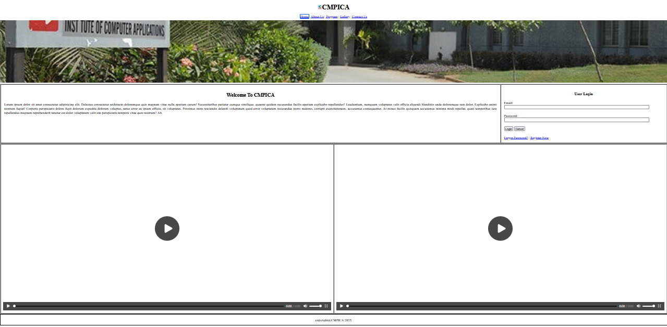
Q-2 | <!DOCTYPE html>  <html>  <head >  <title >index-1</title>  </head>  <body style="margin:0; font-family:Arial, sans-serif;">  <table border="1" width="100%">  <div img src="logo.png" style=" color:rgb(5, 1, 1); padding:15px; text-align:center; font-size:28px; font-weight:bold; background-color: #8e2de2 ; color: #dff5ff;"><img src="logo.png" style="height: 30px;"></img>  CMPICA  </div>  <div style="background:#f2f2f2; text-align:center; padding:10px;">  <a href="#" style="margin:0 10px; text-decoration:none; color:#8e2de2;">Home</a>  <a href="#" style="margin:0 10px; text-decoration:none; color:#8e2de2;">About Us</a>  <a href="#" style="margin:0 10px; text-decoration:none; color:#8e2de2;">Program</a>  <a href="#" style="margin:0 10px; text-decoration:none; color:#8e2de2;">Gallery</a>  <a href="#" style="margin:0 10px; text-decoration:none; color:#8e2de2;">Contact Us</a>  </div>  <div>  <img src="cmpica1.jpg"  style="width:100%; height:350px; object-fit:cover;">  </div>  </table>  <table border="1" width="100%">  <div style="display:flex; background:#dff5ff; padding:15px;">  <div style="width:70%; padding:15px;">  <h2 style="color:#8e2de2; text-align:center;">Welcome To CMPICA</h2>  <p style="text-align:justify;">  Lorem ipsum dolor sit amet consectetur adipisicing elit. Delectus consectetur architect doloremque quis magnam vitae nulla aperiam caro! Necessitatibus pariatur cumque similique.  querat quidem recusandae facilis aperiam explicabo repelendus? Laudantium, numquam voluptates velit officia eligendi blanditiis unde doloremque rem dolor.  Explicabo animi nostrum fugiat! Corporis perspiciatis dolore fugit dolorum expedita dolorem voluptas, natus error ea ipsam officia, be voluptates.  Possis insit reciciendis delenit voluptatum quod error voluptatem recusandae porro maiores, corrupti exercitationem, accusamus consequuntur.  At less facilis anyone accusamus minima modi repellat, quasi temporis iure repulsendus magnam reprehenderit tenetur est dolore voluptatem velit iste perspiciatis tempore  vitae quos nostrum? Ab.  </p>  </div>  <div style="width:30%; background:#eafaff; padding:15px; border-left:2px solid #ccc;">  <h3 style="color:#8e2de2; text-align:center;">User Login</h3>  <label>Email:</label><br>  <input type="text" style="width:95%; padding:5px;"><br><br>  <label>Password:</label><br>  <input type="password" style="width:95%; padding:5px;"><br><br>  <div style="text-align:center;">  <input type="button" value="Login">  <input type="button" value="Cancel">  </div>  <div style="text-align:center; margin-top:10px;">  <a href="#" style="color:#8e2de2;">Forgot Password?</a> |  <a href="#" style="color:#8e2de2;">Register Now</a>  </div>  </div>  </div>  </table>  <div style="display:flex; padding:15px;">  <div style="width:50%; padding:10px;">  <video controls style="width:100%;">  <source src="" type="video/mp4">  </video>  </div>  <div style="width:50%; padding:10px;">  <video controls style="width:100%;">  <source src="" type="video/mp4">  </video>  </div>  </div>  <div style="background:#8e2de2; color:white; text-align:center; padding:15px;">  copyright@CMPICA 2025  </div>  </body>  </html>
Ans | 