### 

**NAME:** Neev Shah

**USN:** 22BTRCL107

**CLASS:** AIML-C

**DATE:** 28th May 2024

# 

# **ETL**

**Please complete the following task, individually:**

**Step 1: Download the available dataset from this link:**

[**https://www.w3schools.com/python/pandas/data.csv**](https://www.w3schools.com/python/pandas/data.csv)

**My Code Link:**

[**https://colab.research.google.com/drive/18Gknet8CS6yrPnll2JFTB5DuuD4UQOme?usp=sharing**](https://colab.research.google.com/drive/18Gknet8CS6yrPnll2JFTB5DuuD4UQOme?usp=sharing)

**Step 2: Upload this dataset in Google Colab.**

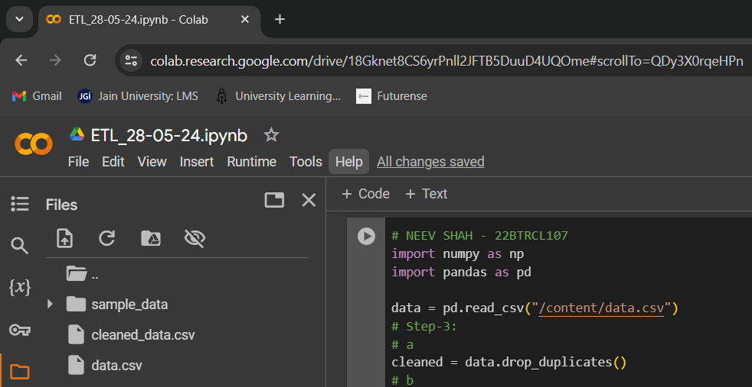

**Step 3: Perform ETL operations on this dataset. While transforming, include at least one condition to handle each of the following:**

**a - Duplicate Values**

**b - Missing Values**

**c - Wrong values**

**Step 4: Rename the columns as per your understanding.**

**Step 5: Load this dataset into another .CSV file.**

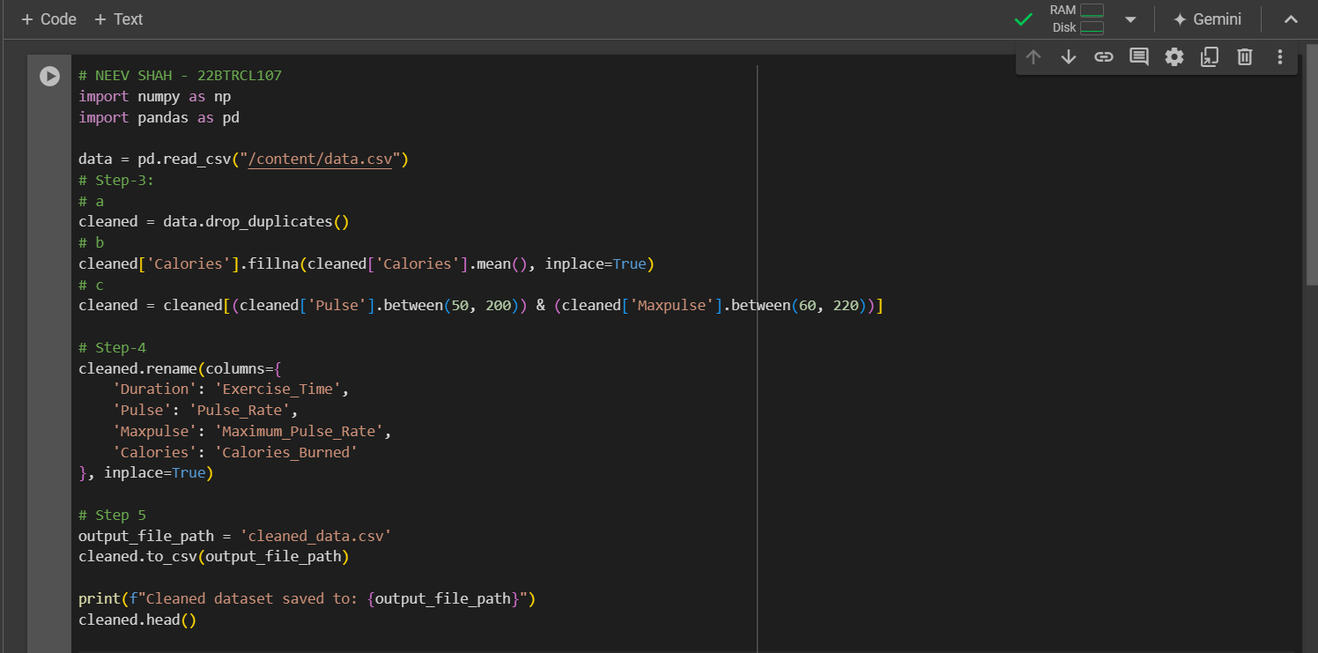

**OUTPUT:**

