ECE 445L Lab 9
Communication System: Encoding and Decoding
This laboratory assignment accompanies the book, Embedded Systems: Real-Time Interfacing to ARM Cortex M Microcontrollers, ISBN-13: 978-1463590154, by Jonathan W. Valvano, copyright © 2024.

Table of Contents
Table of Contents 1
Team Size 2
Goals 2
Review 2
Starter Files 2
Required Hardware 2
Abbreviated Requirements Document 3
Lab Overview 3
Preparation 6
Procedure 8
Deliverable 1 11
Deliverable 2 11
Deliverable 3 11
Deliverable 4 11
Deliverable 5 11
Deliverable 6 11
Deliverable 7 11
Lab Checkout 12
Lab Report 12
Hints 12

Team Size
The team size for this lab is 4.

Goals
- Interface a 2-D joystick
- Study ADC conversion and the Nyquist Theorem.
- Characterize the performance of the DAC and ADC.
- Encode information as sound output from the DAC to speaker.
- Decode information as sound input from the microphone to ADC.
- Develop a communication system based on sound.
- Use the communication channel to control the RSLK2 robot.

Review
- Data sheets for your microcontroller.
- Data sheets for your hardware components.
- Valvano Section 6.2 on periodic interrupts using the timer.
- Valvano Sections 7.5 and 8.4 on DAC interface and waveform generation
- Valvano Section 8.5.4 on hardware averaging and timer-triggered ADC
- Valvano Section 10.2.5, Example 10.4

Starter Files
- Starter projects:
  - Lab 9 transmitter template provided on GH classroom repo.
  - Lab 9 receiver template provided on GH classroom repo (runs on RSLK2).

- Example projects:
  - PeriodicTimer0AInts_4C123
  - ADCT0ATrigger_4C123
  - ST7735_4C123
  - FFT16.xlsx, presented in Lecture Lec47_FFT.pptx

Required Hardware
Parts | Datasheet | Price | Source (price source)
EK-TM4C123GXL | EK-TM4C123GXL datasheet | $16.99 | TI
8Ω or 32Ω speaker | N/A | N/A | EER Checkout Desk
Resistors and capacitors | N/A | N/A | EER Checkout Desk
Switches | N/A | N/A | EER Checkout Desk
TLV5616CP 12-bit DAC  or TLV5618 | TLV5616 datasheet | $9.61 | EER Checkout Desk  Or Mouser, Digikey
LM4041CILPR shunt diode  or LM4041C12 | LM4041C datasheet | $0.78 | EER Checkout Desk  Or Mouser, Digikey
LM4890M 1 Watt Audio Power Amplifier | LM4890M  LM4890M data sheet | $1.43 | From TA or Mouser
Electret Microphone with MAX4466 amplifier | https://www.amazon.com/dp/B08N4FNFTR  CMA-4544PF-W datasheet | $1.67 | In RSLK2 kit
RSLK2 Robot | RSLK2 Description
2-D joystick | https://www.amazon.com/dp/B0BX6FMC2H |  | In RSLK2 kit

Abbreviated Requirements Document
2. Function Description
2.1. Functionality: What will the system do precisely?
The user will control the system with a 2-D joystick and switches. You are free to define the exact specifications, but as a minimum the robot should be about to go forward, left, right, back and stop. The joystick, DAC, amp, and speaker exist on the transmitter system. The transmitter system is isolated from the receiver system by an air gap. The receiver system is the RSLK2 robot (from Lab 8) and includes a microphone with audio amplifier. The physical channel is sound from the speaker in the transmitter system to the microphone on the decoding system. The receiver system will interpret the sound and activate the RSLK robot, according to which symbol was sent. Each command should operate the robot for a finite amount of time and then stop. The robot should also stop if any bump switch is activated.
Because of the large audio noise created by the motors, communication should only occur when the robot is stopped.

Lab Overview
Lab 9 introduces the students to the field of audio signal processing. According to Wikipedia:
“Audio signal processing is a subfield of signal processing that is concerned with the electronic manipulation of audio signals. Audio signals are electronic representations of sound waves—longitudinal waves which travel through air, consisting of compressions and rarefactions. The energy contained in audio signals is typically measured in decibels. As audio signals may be represented in either digital or analog format, processing may occur in either domain. Analog processors operate directly on the electrical signal, while digital processors operate mathematically on its digital representation.”
Audio signals discernable to the human ear are in the range of 200 Hz to 16000 Hz: they include speech and musical instruments. In this lab, we will be processing the signals in the digital domain which means we need to convert them from the analog domain to the digital domain. In Lecture 39 we covered the Nyquist Theorem which specifies that to reproduce an analog signal from a digital signal we need to use greater than a 2X sampling frequency during the analog to digital conversion process.
Figure 9.1 shows the data-flow graph for the audio communication system that you will be building. The human operator provides input data to the system. The input information is first encoded as digital waveforms. The waveforms are output to the DAC/amp/speaker to create sounds. The sounds are transmitted across the air as pressure waves. The electret/amp/ADC converts the sounds into a sequence of data. The decoder converts the data back to the information (hopefully). Lastly, the output displays that information to the human operator. Feel free to change how the pieces fit together if the data streams and there are no wasted software delays.
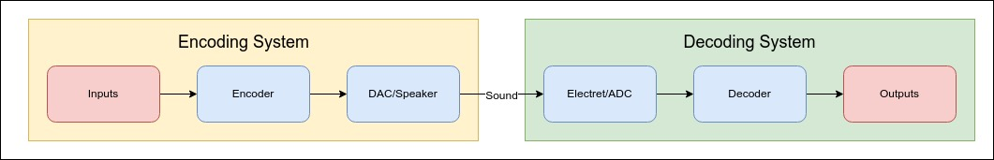
Figure 9.1. Data-Flow Graph of the Audio Communication System.
- Input: The input to the system arrives from the joystick and switches. The input task must run in the background using interrupts. Think about the appropriate priority level for this task.
- Input → Encoder: The linkage between these modules must include a data structure that supports streaming, such as a FIFO or double buffer. A level of abstraction must be created by designing a set (two or more) of public functions the input module can call to affect communication.
- Encoder: A frame is the smallest non-divisible communication packet. Each frame must include at least 8 data bits and an error checking method. There must be a mechanism that allows the receiver to synchronize to the transmitter. You are free to create whatever encoding mechanism you wish. However, the scheme in Figure 9.2 has a 1-bit symbol as specific frequencies, which are output for a fixed time. This is called frequency shift key (FSK). This FSK has a bit time of 81.92 ms, where 0 is encoded as 1.5625kHz (128 waves), and 1 is encoded as 0.78125kHz (64 waves). The start bit is always low. The added parity bit is a 1 or 0 to make the frame have an even number of ones. One of the challenges will be synchronizing the receiver to the transmitter. Even if the receiver knows you are sending a frame every 1 sec, how does the receiver know where this frame ends, and the next frame starts? You can use your Lab 5 system to create sounds from 300 Hz to 2000 Hz. You will use that capability to encode data using sine waves. There are no requirements to maximize bandwidth (information/sec), minimize latency (time from input to output), or eliminate errors (sound noise causing bits to flip). However, you will be asked to quantify each of these performance measures and discuss in your report how each could have been improved. The encoder task also runs in the background using interrupts. Think about the appropriate priority level for this task. Remember, there is a streaming data structure, so this interrupt task is different from the input task.
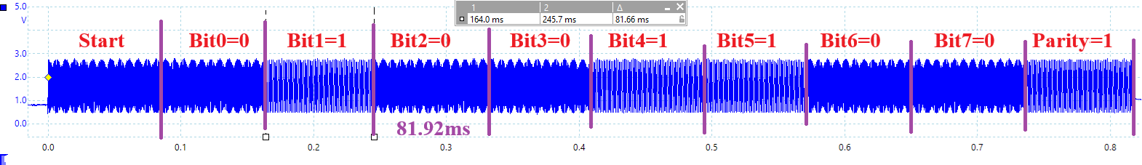
Figure 9.2. FSK frame that encodes of the ASCII character ‘2’ = 0x32. Parity is 1 in this case because 0x32 has an odd number of 1’s.
- Encoder → DAC: The encoded message is sent to the DAC module in an appropriate manner that you will design. The linkage between these modules also must include a data structure that supports streaming, such as a FIFO or double buffer.
- DAC: Please use as much of your Lab 5 as possible because the DAC does output to the speaker to send data across the communication channel. Since this interrupt will be high frequency, make sure it is very simple. Figure 9.3 shows the FSK output of the start bit (logic 0, frequency 1.5625kHz, duration 81.92 ms). Think about the appropriate priority level for this task.
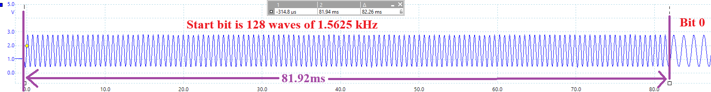
Figure 9.3. FSK encoding of the start bit

- DAC/Speaker → Microphone/ADC: Since there are two separate microcontrollers, the only linkage should be sound traveling as air pressure.
- ADC: The audio input is amplified, filtered, and then sampled by an ADC. The sampling rate is controlled by a periodic timer that triggers the ADC, and the ADC ISR executes when the conversion is complete. Because the timer starts the ADC, there is no sampling jitter. Think about the appropriate priority level for this task. How does the timer-triggered sampling affect the selection of priority for this ISR? Since this interrupt will also be high frequency, make sure it is very simple. However, you should implement digital filtering here to improve SNR. See the NoiseReject functions provided in the /inc/DSP.c file.
- ADC → Decoder: The linkage between these modules also must include a data structure that supports streaming, such as a FIFO or double buffer.
- Decoder: You can run the decoder in the while-loop of the main. The goal is to extract the data from the sampled sound. The system is considered real time if the software is fast enough to keep up (no data is lost). If the decoder cannot keep up, you can slow down the transmission rate or use a simpler decoding algorithm. Possibilities include but are not limited to cross correlation and FFT. There are three very fast integer FFT functions in the inc folder of the starter projects: cr4_fft_64_stm32.s, cr4_fft_256_stm32.s cr4_fft_1024_stm32.s. However, there is a set of simple (and more appropriate for this lab) DFT functions in the /inc/DSP.c file
- Decoder → Display: The linkage between these modules can be a simple function call.
- Display: This task is run from the main program. It outputs the data to the human operator. The output can use whatever device you wish, as long as the human operator obverse the values in some fashion. You could output characters on the LCD. During testing, when the input is created with data of known values, the output can check for lost or changed values.
- Decoder → RSLK: The linkage between these modules can be function calls. However, the RSLK software must include features such as stop on bump switch and the digital controllers from Lab 8. Feel free to specify exactly what the robot does with each command.

The max sampling rate on the TM4C123 is 125K samples/sec which is way above the Nyquist value (and the Valvano Postulate) for audio input signals. You should select sampling rates that allow all tasks to be completed in real time.
All I/O must be written in a style like the book, without calling any TivaWare driver code. It is necessary to use two microcontrollers, one for transmitting and the other for receiving.
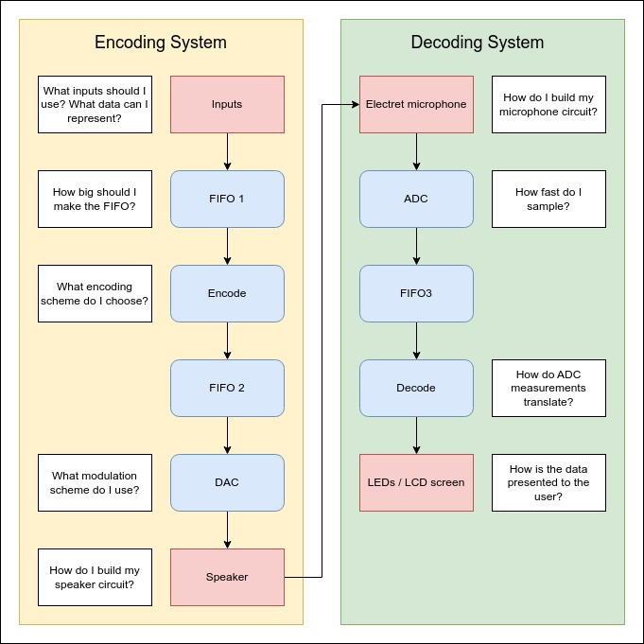
Figure 9.4. Possible Data-Flow Graph of the Communication System.
Figure 9.4 shows a possible expanded dataflow graph for the audio communication system that you will be building. Feel free to design your own implementation.

Preparation
- Choose an encoding/decoding scheme. Make some rough sketches of the sound waves you plan to use to transmit data. You are free to change this as you build it and see what works and what does not work.
- Choose a message format. Hint, how does the asynchronous UART protocol separate bits? How does it separate frames? What is the baud rate? Be able to provide an explanation of your message format.
- Distribute tasks. Provide a list of tasks of software to write, hardware to build, and tests to perform, equally distributed between team members. Ideally, everyone is working on something in parallel. Example distribution of tasks
  - Student 1 interfaces the joystick and switches, including debugging software to visualize activities in the transmitter.
  - Student 2 takes the Lab 5 audio output system and encodes the transmitted message as sounds.
  - Student 3 interfaces the microphone, collects data from the ADC, and decodes the message.
  - Student 4 processes the message and outputs commands to the robot, including debugging software to visualize activities in the receiver.
- Hardware Design. Collect all components you may use and provide a schematic of the encoding and decoding systems. The electret microphone with MAX4466 amplifier is shown in Figure 9.5. The circuit for this electret microphone is in Figure 9.6. You may use an alternative design if that works better for you. Please document the source.
- Software Design. Design header files for software modules and data structures. Write unit tests, potentially for each block in your call graph, demonstrating that each component works in isolation. You may then want to write integration tests to check that interactions between components work as well. The final main will likely be the combination of your integration tests.
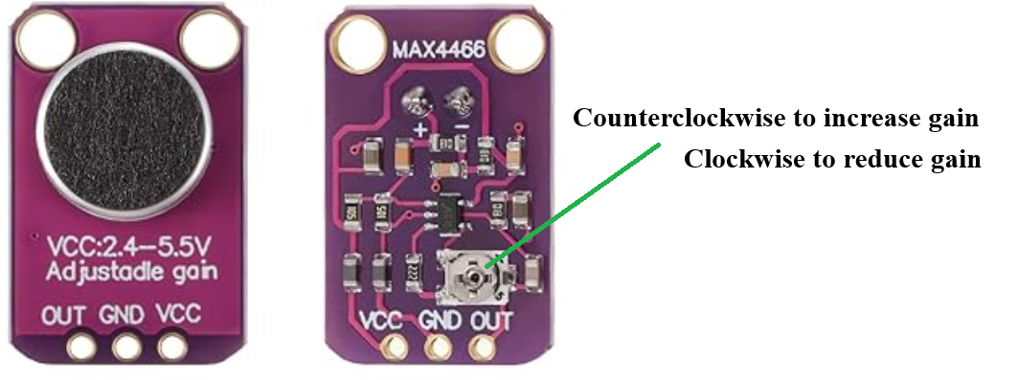
Figure 9.5. Electret microphone with MAX4466 amp. https://www.amazon.com/dp/B08N4FNFTR
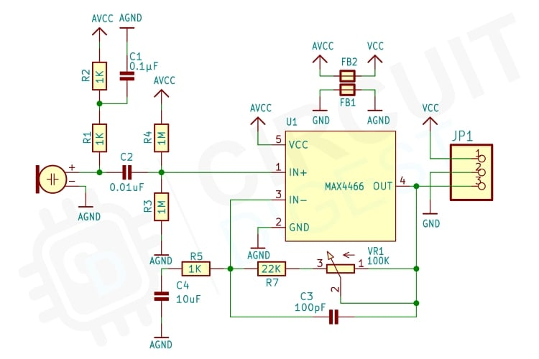
Figure 9.6. MAX4466 Electret Circuit.

Procedure
Note: Please implement and test each module separately.
For one transmitter output and one receiver input in a quiet room:
- Student 1: Input devices
  - Rebuild Lab 5 hardware and software so the speaker outputs a continuous tone at one frequency
  - Interface the joystick and switches and write interrupt-driven software that reads from input devices.
  - Add code to the encoder to measure CPU utilization in the transmitter.
- Student 2: Encoder
  - Tweak output parameters (sine wave table size, encoding scheme, symbol rate) of your encoder until the output waveform meets requirements of your designed message protocol.
  - Using a minimally intrusive dump (Lab 2 DumpCapture in dump.c), record the time and digital data as they are being output to the DAC for each wave shape you use (e.g., 1.5625kHz and 0.78125kHz). One or two cycles of sound will be sufficient to measure sampling jitter. (Deliverable 2).
  - With a scope on the DAC output, record a zoomed-in showing one or two bits (like Figure 9.3) and a zoomed-out view showing an entire frame (like Figure 9.2). Provide the necessary context needed to understand the signal:
    - What is the input message?
    - What is the encoding scheme including baud rate?
    - What is the DAC resolution (horizontal and vertical)? (Deliverable 3).
- Student 3: Decoder
  - Using the Lab 5 system that outputs one continuous tone, tweak the microphone circuit so the analog input is a clean sin wave as measured by a scope (like Figure 9.7). There is a turn pot on the microphone circuit you can use to adjust the amplifier gain.
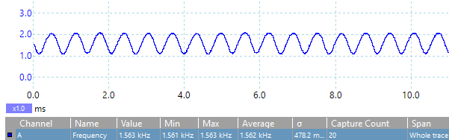
Figure 9.7. Continuous tone measured at ADC input.
  - Using the Lab 5 system that outputs one continuous tone, measure the SNR of your input signal using a spectrum analyzer (like Figure 9.8). (Deliverable 4).
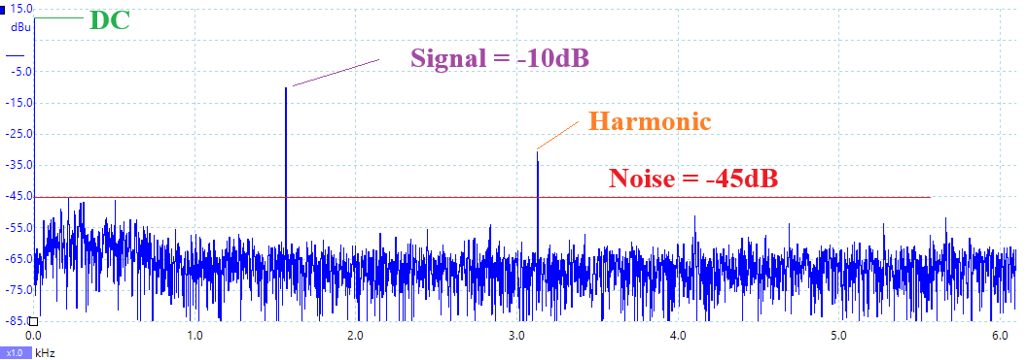
Figure 9.8. Continuous tone measured at ADC input. SNR = 30 dB is about 6 bits.
  - Using a minimally intrusive dump (Lab 2 DumpCapture in dump.c), record the digital data as they are being input from ADC. One or two cycles of sound will be sufficient to make sure the sampled digital data matches the analog input recorded in Procedure 3a).
  - With a two-channel scope on the DAC output and ADC input, record a zoomed-out view showing an entire frame (like Figure 9.9). Provide the necessary context needed to understand the signal:
    - What is the distance between microphone and speaker?
    - What is the gain and filtering of your microphone circuit? (Deliverable 5).
  - Verify that the decoder can correctly interpret the input stream.
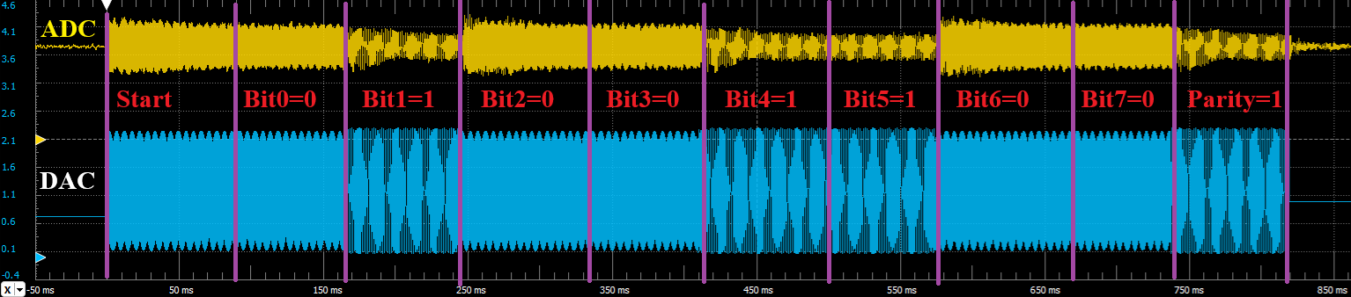
Figure 9.9. FSK frame that encodes of the ASCII character ‘2’ = 0x32. Parity is 1 in this case because 0x32 has an odd number of 1’s. 50 cm from speaker to microphone.
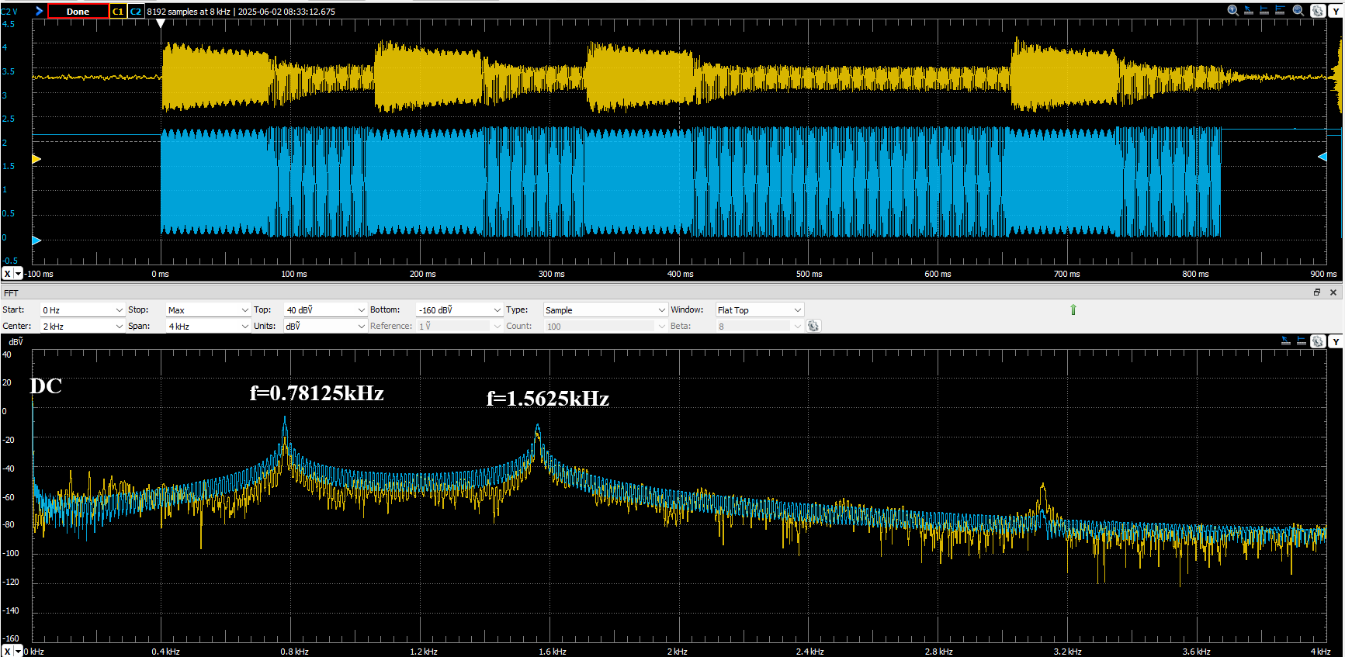
Figure 9.10. Spectrum of DAC output and ADC input during an FSK frame that encodes of the ASCII character ‘u’ = 0x75. 50 cm from speaker to microphone.
- Student 4: Process motor commands
  - Implement necessary robot commands
  - Add code to the decoder system to measure CPU utilization.
- Quantify the system performance:
  - Data bandwidth of the system – How many bits of data per second can your system transfer?
  - Single bandwidth of the system – What range of frequencies does your system utilize?
  - Latency of the system – How long does it take for a message to be sent and received from start to finish?
  - Reliability of the system – Sending the message N times, what is the rate of failure? N should be a statistically useful number.

Deliverable 1
Create a schematic or figure showing all external components connected to the two TM4C123 boards on KiCad. You do not need to show hardware components on the TM4C123 LaunchPad board or the RSLK robot, just circuits you added. Your schematic should show your encoder and decoder circuits. The encoder should be like the circuit created in Lab 5 with the joystick and switches. The decoder circuit should include the microphone and the amplification circuit. If you use the MAX4466 circuit, you do not need to show the details of Figure 9.6, just show the connections from the MAX4466 JP1 to the TM4C123.

Deliverable 2
Collect data on the TM4C and on the oscilloscope to show the performance of the encoder. Using some debugging technique, collect the quantized output the TM4C is attempting to output. Compare this output with the actual output of the TM4C. Did the DAC accurately create the signal? What errors exist? Include the array of values you recorded and the scope trace.

Deliverable 3
Record one scope trace showing a transmitted frame (like Figure 9.2). Annotate this recording showing the communication protocol.

Deliverable 4
Show the spectrum analyzer trace from a continuous tone and use it to measure SNR. Discuss why the received signal is much less than 12 bits.

Deliverable 5
Record a dual-channel scope trace showing both the transmitted and received frames (like Figure 9.9). Annotate this recording showing the communication protocol. Compare the two traces

Deliverable 6
Use debugging techniques to determine the CPU utilization of your encoder and decoder. Specifically, determine how much time the encoder spends per second to output the encoded waveform. Additionally, determine how much time is spent by the decoder TM4C in both sampling and decoding of the input data.
Show any traces or debugging output used to calculate these values.

Deliverable 7
Take measurements of your system performance to quantify its performance. Measure the total power consumption of the two TM4Cs. Measure the amount of time it takes to transmit one bit. Measure the distance at which the two TM4Cs can communicate. Play sound off your phone or computer while to see how noise tolerant your system is. You should record the following information in your report:

Maximum bits per second: (Data bits sent) / (Total message transmission time)
Energy per bit: (Supply voltage * Current) / (Maximum bits per second)
Range: (Distance between TM4Cs)
Noise tolerance: Approximate noise in DB that the system can tolerate while working.

Lab Checkout
The lab checkout is performed during the M/T lab session.
- Show that the system works with an arbitrary fixed input, with DAC scope output and ADC quantized input plot (see Procedure 3d).
- Demonstrate that the system works with any user input.
- Demonstrate that the system is robust (or best attempt robust) under noisy environments.
- Explain the encoding/decoding scheme.
- Explain any synchronization or robustness schemes implemented.

Lab Report
The lab report shall be submitted by the Friday after the second lab section.
You should complete the Lab09Report.docx file with your data and answers then submit the completed file to Canvas.

Hints
Let f_{s} be the receiver sampling rate (e.g., 12.5kHz). DFT length will be N (e.g., 128)
Let f₁ be a frequency at index k₁ (e.g., 8), f₁ = k₁ * f / N (e.g., 0.78125kHz)
Let f₂ be a frequency at index k₂ (e.g., 16), f₂ = k₂ * f / N (e.g., 1.5625kHz)
Calculate W = e^{-j2π/N} (e.g., e^{-j2π/128})
Calculate W^{k1} = e^{-j2πk1/N} (e.g., e^{-jπ/8} = cos(π/8)-jsin(π/8))
Calculate W^{k2} = e^{-j2πk2/N} (e.g., e^{-jπ/4} = cos(π/4)-jsin(π/4))
Place powers of W^{k1} in a ROM table with binary fixed-point format. For indices larger than 32, the values repeats. E.g., see file DFTcalculations.xlsx
const int32_t ReW[32] ={
1024, 946, 724, 392, 0, -392, -724, -946,
-1024, -946, -724, -392, 0, 392, 724, 946,
1024, 946, 724, 392, 0, -392, -724, -946,
-1024, -946, -724, -392, 0, 392, 724, 946
};
const int32_t ImW[32] ={
0, -392, -724, -946, -1024, -946, -724, -392,
0, 392, 724, 946, 1024, 946, 724, 392,
0, -392, -724, -946, -1024, -946, -724, -392,
0, 392, 724, 946, 1024, 946, 724, 392
};
Put these functions in dsp.c dsp.h in the inc folder
Usage for decoding FM modulation in receiver
- Call DFT_Init() once
- at f_{s} in real time using periodic interrupt
1) x=sample microphone using ADC, subtract off DC offset
2) call DFT(i,x) once per interrupt, with index i going from 0 to 127
void DFT(uint32_t i, int32_t x){
i = i&0x0F; // 0 to 15
rsum1 += x*ReW[i];
isum1 += x*ImW[i];
rsum2 += x*ReW[2*i];
isum2 += x*ImW[2*i];
}
3) after N=128 samples
a) call Mag1() for relative amplitude at f₁
b) call Mag2() for relative amplitude at f₂
int32_t Mag1(void){int32_t mag;
rsum1 /= 8192; // scale to prevent overflow
isum1 /= 8192;
mag = rsum1*rsum1+isum1*isum1;
rsum1=isum1=0;
return mag;
}
int32_t Mag2(void){int32_t mag;
rsum2 /= 8192; // scale to prevent overflow
isum2 /= 8192;
mag = rsum2*rsum2+isum2*isum2;
rsum2=isum2=0;
return mag;
}

