PORT | SIGNAL | NOTES
Port-A[2] | Right Motor direction, IN2, MR-
Port-A[3] | Left Motor Direction, IN4, ML-
Port-A[4] | GPIO
Port-A[5] | Left Bump 0
Port-A[6] | SCL I2C clock | SSD1306 I2C OLED
Port-A[7] | SDA I2C data

PORT | SIGNAL | NOTES
Port-B[0] | U1Rx MCU sensor TxD pin 3 | Luna TOF distance sensor
Port-B[1] | U1Tx MCU sensor RxD pin 2
Port-B[2] | ERA (insert J18) T3CCP0 Timer3 | Motor Tachometer
Port-B[3] | Center Right, Bump 2
Port-B[4] | 8266_GPIO_2 Status pin for MQTT | To the TM4C
Port-B[5] | ESP8266 Reset
Port-B[6] | GPIO
Port-B[7] | ELA (insert J17) T0CCP1 Timer0B | Motor Tachometer

PORT | SIGNAL | NOTES
Port-C[4] | Right, Bump 3
Port-C[5] | GPIO
Port-C[6] | GPIO | ST7735_DC
Port-C[7] | GPIO | ST7735_RST

PORT | SIGNAL | NOTES
Port-D[0] | GPIO or SSI1/3 for ST7735 or DAC | SSI1_SCK
Port-D[1] | GPIO or SSI1/3 for ST7735 or DAC | SSI1_FS
Port-D[2] | GPIO or SSI1/3 for ST7735 or DAC | SSI1_MISO
Port-D[3] | GPIO or SSI1/3 for ST7735 or DAC | SSI1_MOSI
Port-D[6] | U2Rx (J14), ESP8266=out,TM4C123=in | 115200 Baud
Port-D[7] | U2Tx (J10), TM4C123=out,ESP8266=in

PORT | SIGNAL | NOTES
Port-E[0] | GPIO or AIN
Port-E[1] | Left Ain2 | IR analog distance sensors
Port-E[2] | GPIO or AIN
Port-E[3] | GPIO or AIN
Port-E[4] | Right Ain9 | IR analog distance sensors
Port-E[5] | Center Ain8

PORT | SIGNAL NAME | NOTES
Port-F[0] | Center Left, Bump 1 | Also LAUNCHPAD_SW2
Port-F[1] | GPIO, PWM, T0CCP1 | Also RED_LED
Port-F[2] | Motor_PWML, ML+, IN3, PWM M1PWM6 | Also BLUE_LED
Port-F[3] | Motor_PWMR, MR+, IN1, PWM M1PWM7 | Also GREEN_LED
Port-F[4] | GPIO | Also LAUNCHPAD_SW1

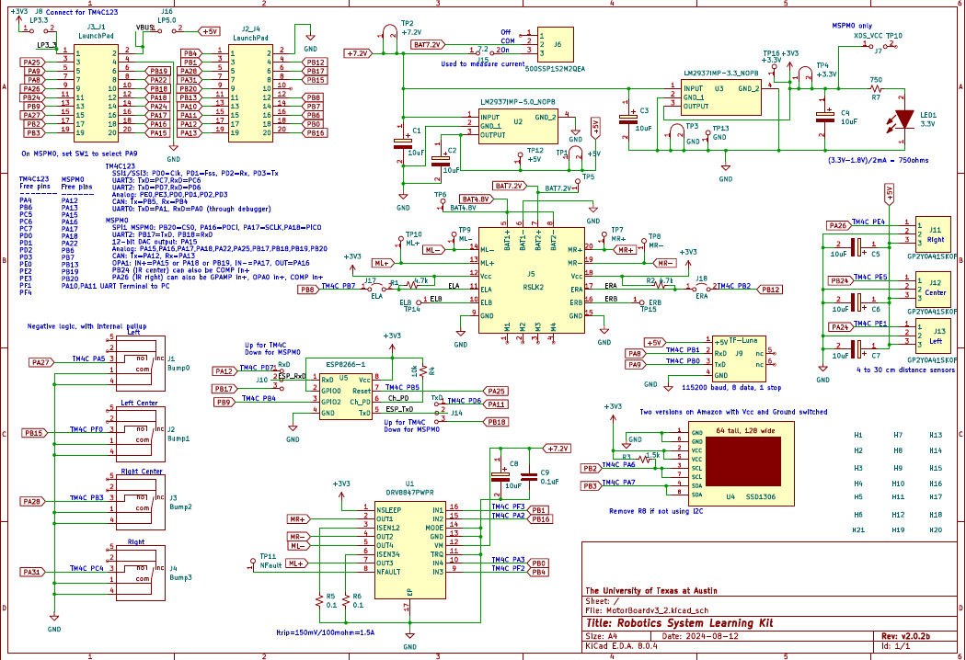

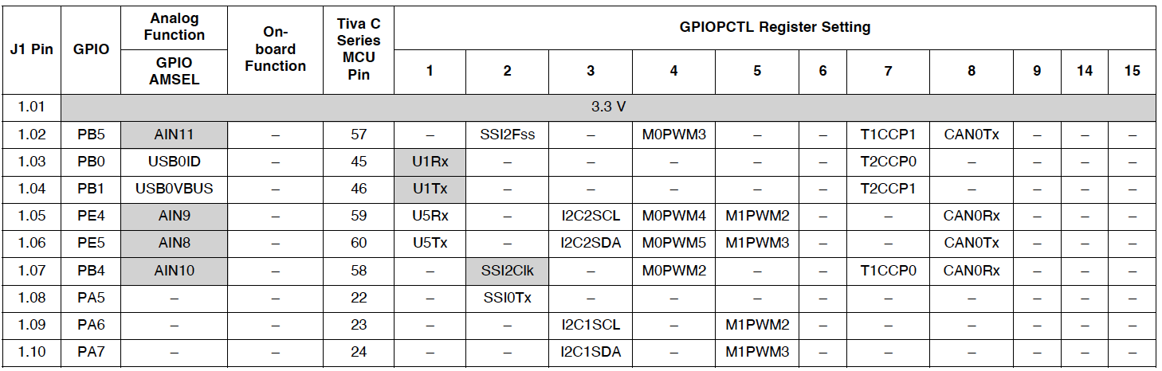

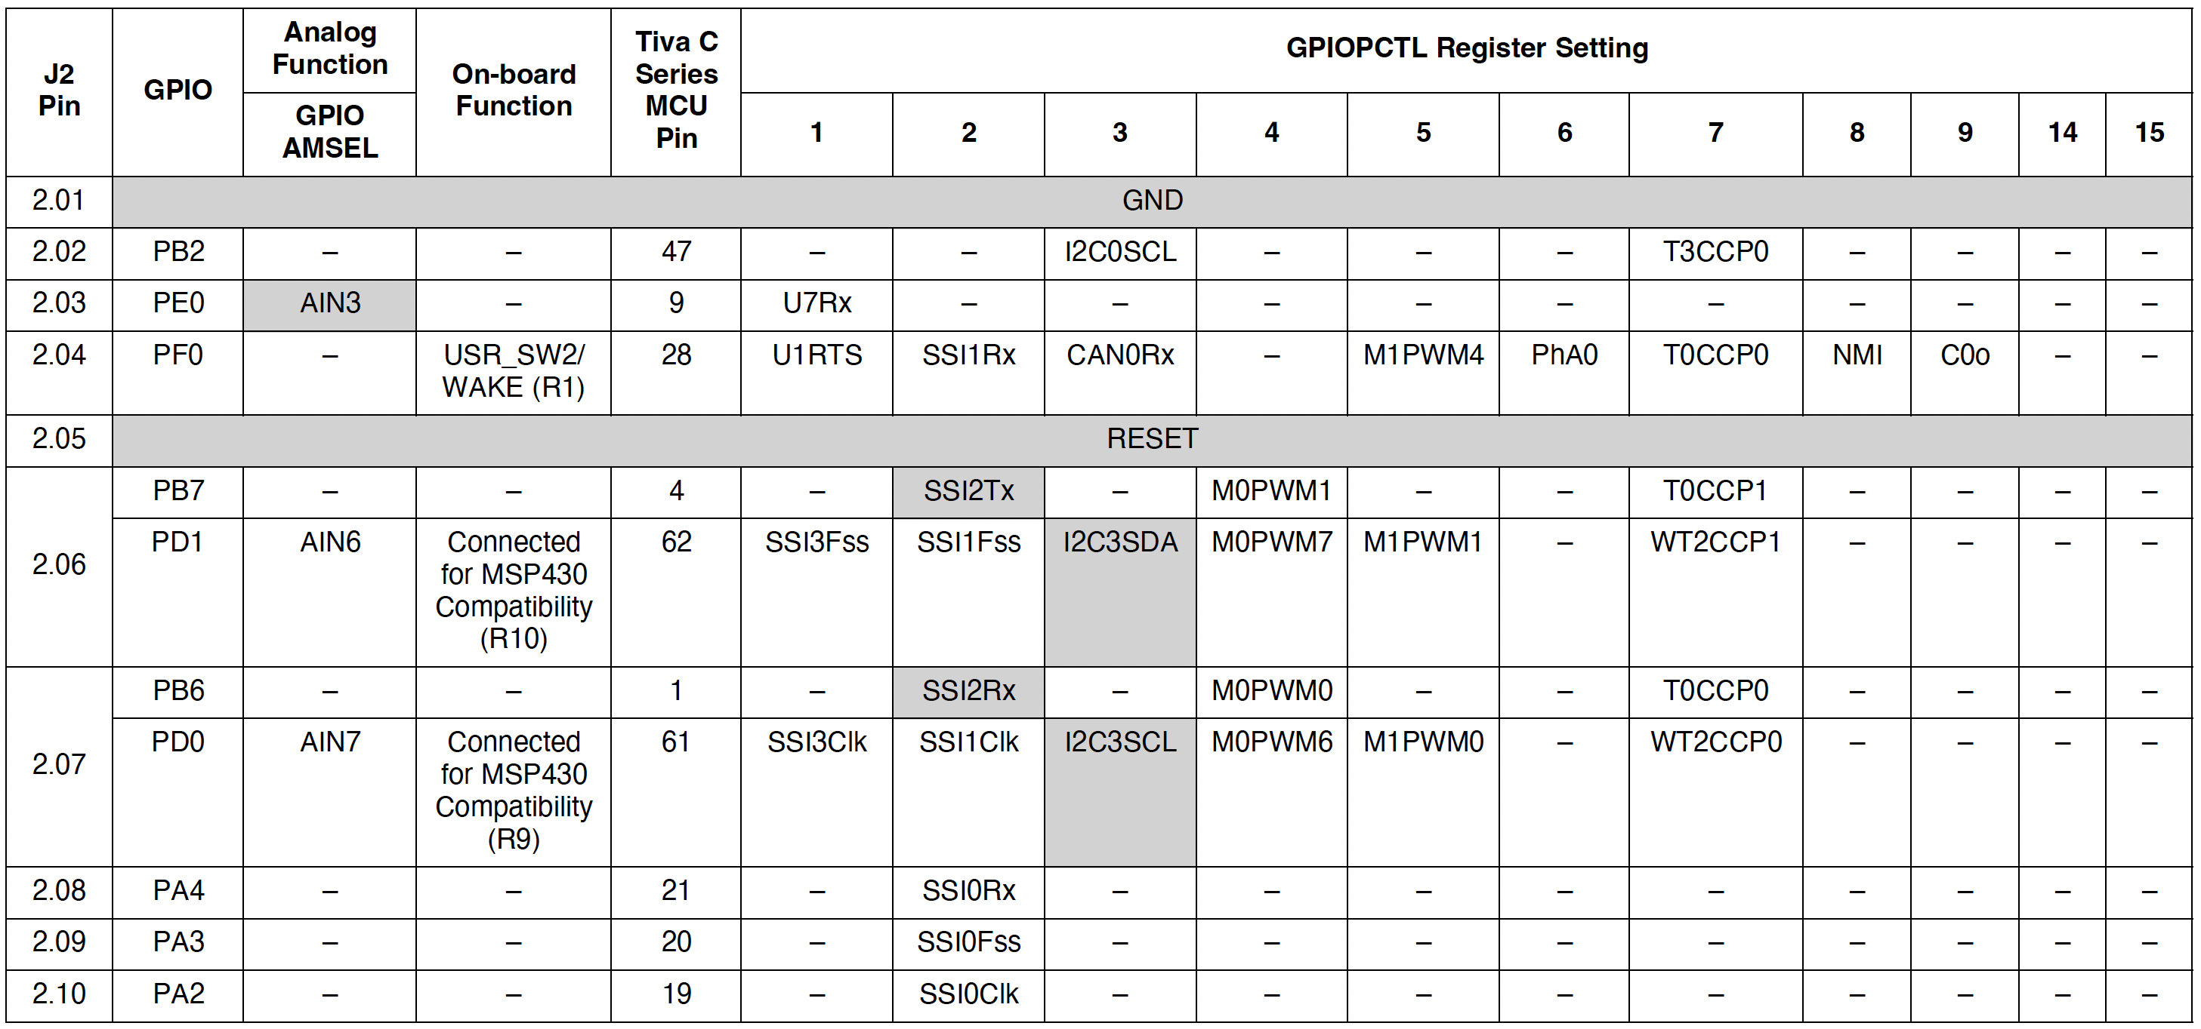

J3  Pin | GPIO | Analog Function | On-board Function | Tiva C Series MCU  Pin | GPIOPCTL Register Setting
 |  | GPIO AMSEL |  |  | 1 | 2 | 3 | 4 | 5 | 6 | 7 | 8 | 9 | 14 | 15
3.01 | 5.0 V
3.02 | GND
3.03 | PD0 | AIN7 | – | 61 | SSI3Clk | SSI1Clk | I2C3SCL | M0PWM6 | M1PWM0 | – | WT2CCP0 | – | – | – | –
 | PB6 | – | Connected for MSP430 Compatibilit y (R9) | 1 | – | SSI2Rx | – | M0PWM0 |  | – | T0CCP0 | – | – | – | –
3.04 | PD1 | AIN6 | – | 92 | SSI3Fss | SSI1Fss | I2C3SDA | M0PWM7 | M1PWM1 | – | WT2CCP1 | – | – | – | –
 | PB7 | – | Connected for MSP430 Compatibilit y (R10) | 4 | – | SSI2Tx | – | M0PWM1 | – | – | T0CCP1 | – | – | – | –
3.05 | PD2 | AIN5 |  | 63 | SSI3Rx | SSI1Rx | – | M0FAULT0 | – | – | WT3CCP0 | USB0EPE N
3.06 | PD3 | AIN4 | – | 64 | SSI3Tx | SSI1Tx | – | – | – | – | WT3CCP1 | USB0PFLT | – | – | –
3.07 | PE1 | AIN2 | – | 8 | U7Tx | – | – | – | – | – |  | – | – | – | –
3.08 | PE2 | AIN1 | – | 7 | – | – | – | – | – | – | – | – | – | – | –
3.09 | PE3 | AIN0 | – | 6 | – | – | – | – | – | – | – | – | – | – | –
3.10 | PF1 | – | – | 29 | U1CTS | SSI1Tx | – | – | M1PWM5 | – | T0CCP1 | – | C1o | TRD1 | –

J4  Pin | GPIO | Analog Function | On- board Function | Tiva C Series MCU  Pin | GPIOPCTL Register Setting
 |  | GPIO AMSEL |  |  | 1 | 2 | 3 | 4 | 5 | 6 | 7 | 8 | 9 | 14 | 15
4.01 | PF2 | – | Blue LED (R11) | 30 | – | SSI1Clk | – | M0FAULT0 | M1PWM6 | – | T1CCP0 | – | – | – | TRD0
4.02 | PF3 | – | Green LED (R12) | 31 | – | SSI1Fss | CAN0Tx | – | M1PWM7 | – | T1CCP1 | – | – | – | TRCLK
4.03 | PB3 | – | – | 48 | – | – | I2C0SDA | – | – | – | T3CCP1 | – | – | – | –
4.04 | PC4 | C1– | – | 16 | U4Rx | U1Rx | – | M0PWM6 | – | IDX1 | WT0CCP0 | U1RTS | – | – | –
4.05 | PC5 | C1+ | – | 15 | U4Tx | U1Tx | – | M0PWM7 | – | PhA1 | WT0CCP1 | U1CTS | – | – | –
4.06 | PC6 | C0+ | – | 14 | U3Rx | – | – | – | – | PhB1 | WT1CCP0 | USB0EPE N | – | – | –
4.07 | PC7 | C0– | – | 13 | U3Tx | – | – | – | – | – | WT1CCP1 | USB0PFLT | – | – | –
4.08 | PD6 | – | – | 53 | U2Rx | – | – | – | – | PhA0 | WT5CCP0 | – | – | – | –
4.09 | PD7 | – | – | 10 | U2Tx | – | – | – | – | PhB0 | WT5CCP1 | NMI | – | – | –
4.10 | PF4 | – | USR_SW 1 (R13) | 5 | – | – | – | – | M1FAULT0 | IDX0 | T2CCP0 | USB0EPE N | – | – | –

