**Koshi Saint James Residential Secondary School**

Itahari -9, Sunsari

Class :- 9 **First Terminal Examination – 2079** F.M.:-50

Subject:- Computer Time:- 1 : 30 hrs. P.M.:-20

**Group – A**

**1. Answer the following questions [6×2=12]**

a. Who is regarded as the father of computer? Why?

b. What is Open source software?

c. Difference between Interpreter and Compiler.

d. What is Primary memory? What are its types?

e. What is computer system?

f. What do you mean by General Purpose Computer and Special Purpose Computer?

**2. Match the following. [5×1=5]**

One Megabyte Operating System

Voltmeter 1024 KB

RAM Volatile Memory

Information Secondary Memory

Windows Processed Data

Analog Computer

**3. Choose the correct answer [5×1=5]**

a. A software is collection of ……...

i. Data b. Programs c. Both d. Instruction

b. ………… is a utility software.

a. Chrome b. Antivirus c. Windows 7 d. Music player

c. ……….. Tag is used to insert picture in HTML document.

a. <IMAGE> b. <IMG> c. <HREF> d. <A>

d. When input is wrong, then the output will also be wrong, it is termed as

a. IPM b. GIGO c. Bug d. Debug

e. Which of the following is known as flash drive?

a. DVD-ROM b. Floppy Disc c. Pen drive d. Cache Memory

**4. Give the correct technical terms. [5×1=5]**

a. The fastest and most expensive computer system.

b. The high speed memory between RAM and processing unit.

c. The device that displays the result of processing.

d. Error or mistakes in the program.

e. A computer that uses analog and digital signal.

**5. Write the Full form. [5×1=5]**

a. ALU b. LED c. GUI

d. PDA e. ATM

**6. Difference between: [Any two] [2.5 ×2=5]**

a. RAM and ROM .

b. Analog computer and Digital computer.

c. Impact printer and Non-impact printer.

**Group – B**

**7. Answer the following. [4×2=8]**

a. What is a Web Browser? Give two examples of it.

b. What is URL? Give some examples of URL.

c. What is Tag? How many types of tags are there in HTML?

d. What is a Homepage?

**8. Write HTML code for the following [5]**

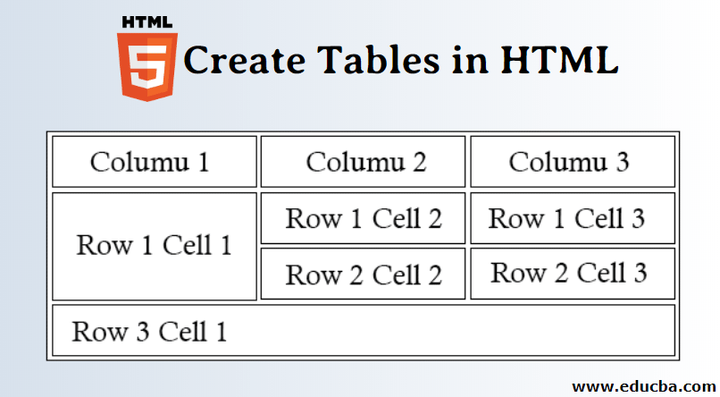

**The End**