CMP105 Coursework Report:

Definitely Not Mega Man

Justin Syfrig
1904770
Git Username: nefastes

Introduction
I thought of this project after launching some games on my NES, particularly Mega Man 1, my personal favourite. At first I wanted to make a Cuphead style boss fight, but quickly changed my mind and settled on to recreate similar mechanics and enemies to the original Mega Man game. Definitely Not Mega Man is a 2D platformer, in which you play Mega Man, a humanoid that need to defeat the evil Dr.Wily. The game aims to have six levels and one final boss to defeat. The current prototype contains one level and a tutorial level. Each level is divided in smaller sections, and the user progresses through those sections by climbing a ladder or opening a door. Definitely Not Mega Man is made using C++ and SFML (Simple and Fast Multimedia Library). SFML is very convenient to handle window events, such as the user inputs, and allows us to build on top of it to handle those events properly. In this way, it is easy to build logics to interact with the user, such as changing menus with correct button presses or mouse placements. SFML gives us a support to play audio sounds and musics, and also provides us with graphical libraries, which are very handy to display in game sprites, like the player, some items or enemies. However, animations, collision detections and responses, and other important elements are not supported by SFML. In this case, I used the provided frameworks by the CMP105 tutors and adjusted them where necessary. Definitely Not Mega Man’s major mechanics are ladder climbing, screen transitions and tile detections.

Controls
Mega Man can be moved left or right by pressing A or D accordingly. Hold SPACE to make Mega Man jump. You can do short jumps by briefly pressing it or higher jumps by holding the key for a certain amount of time. To make Mega Man use his blaster and shoot bullets, press either ENTER or LMB (left mouse button). Note that only three bullets can be fired at a time, like in the original game. Hold W to climb up of a ladder or S to climb it down. At any point on the ladder, the jump key can be pressed to let Mega Man go off of it. The game can be paused with either TAB or ESC. To navigate through menus, use the ARROW KEYS or the mouse cursor to change the selection highlight and hit ENTER or LMB to make the selection.

Game Screens
The current prototype contains 7 game screens, which are: the introduction cinematic, the fake credits, the main menu, the option menu, the stage selection menu, the tutorial and the available level. The introduction cinematic and the fake credits can be skipped by pressing either ENTER or LMB. The option screen allows you to select your desired frame rate limit, adjust the volume, enable or disable the vertical synchronization and debug mode. A collection of screenshots is available below. All non original sprites and images used are referenced at the end of this document.
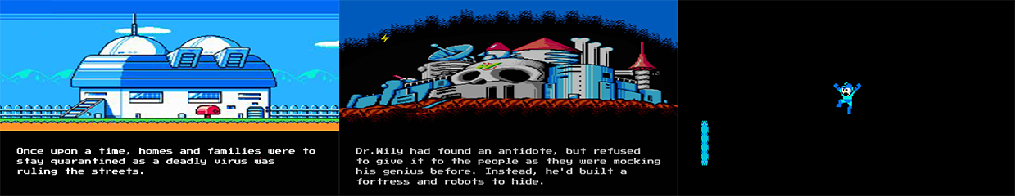Figure 1: The introduction of the story of the game during the cinematic (left), Dr.Wily's Castle (middle), the end of the cinematic (right)
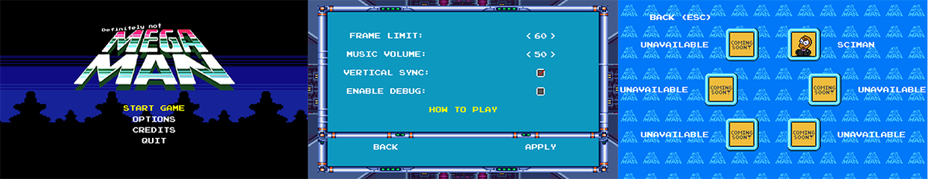Figure 2: main menu (left), option menu (middle), stage selection menu (right)
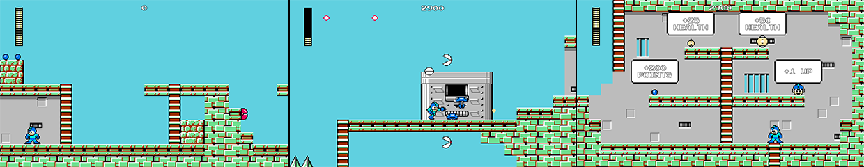Figure 3: spawn area of the available level (left), Mega Man fighting enemies in the level (middle), a section of the tutorial level showcasing the items of the game (right)

Input
The game handles inputs via an object made by the input framework provided by the module tutors. SFML tells us which keys have been pressed or released between each frame. The input object registers those inputs into an array of boolean (values that can be either true or false; here true if it was pressed, false otherwise). We can then identify anywhere in the program if a key has been pressed by referencing the input object where we need it and by calling the following function:
input→isKeyDown( desired key )
However, this could cause issues, like if the user holds a key or while navigating through menus. For instance, if the user would like to change the highlighted selection to the next one and press the corresponding key, the highlight will not be in the intended place. In fact, since the check happens every frame and the game runs at least thirty frames per second, the user would have to press the key for no more than a thirtieth of a second to move the highlight to the next one. To fix this, I have modified the framework to also contain a second array, which will register all the inputs of the previous frame. To do this we need to call my following function in the main program:
input.updatePreviousFrameKeys()
It is very important to do this before we start to check key events with SFML, at the very beginning of the next frame calculation, as the normal array of keys has not been modified yet. I also introduced the following function:
input→isKeyDownOnce( desired key)
When it is called, it will check if the desired key was also pressed the frame before via the new array, in which case it will return false, as we would like to have it pressed only once. If the key was not pressed before, it will return true, allowing us to change the selection highlight to the next one as intended. This is also used in game, to navigate through the pause menu, make Mega Man shoot or jump. With this Mega Man shoots only 1 bullet at a time instead of firing them all each frame and will not repeatedly jump if the user holds the jump key.

Sprite Work
Outline the important sprite work (animated, NPC and user controlled), including screenshots. Be sure to describe what kind of animation work is being used and how it works. Highlight interesting or novel work. This should be focused on technical implementation.

Collision Detection and Response
Describe the collision detection methods used and resolutions (what happens after a collision is detected), focus on the important ones. Describe the technical implementation, specifically what does it do and how does it work. Support your work with diagrams and pseudo code, using the image/caption format.

Audio
Describe the where you have used the audio in relation to input and Collision Response. Describe the technical implementation, specifically what does it do and how does it work. Support your work with diagrams and pseudo code, using the image/caption format.

Game Logic and Unique Mechanics
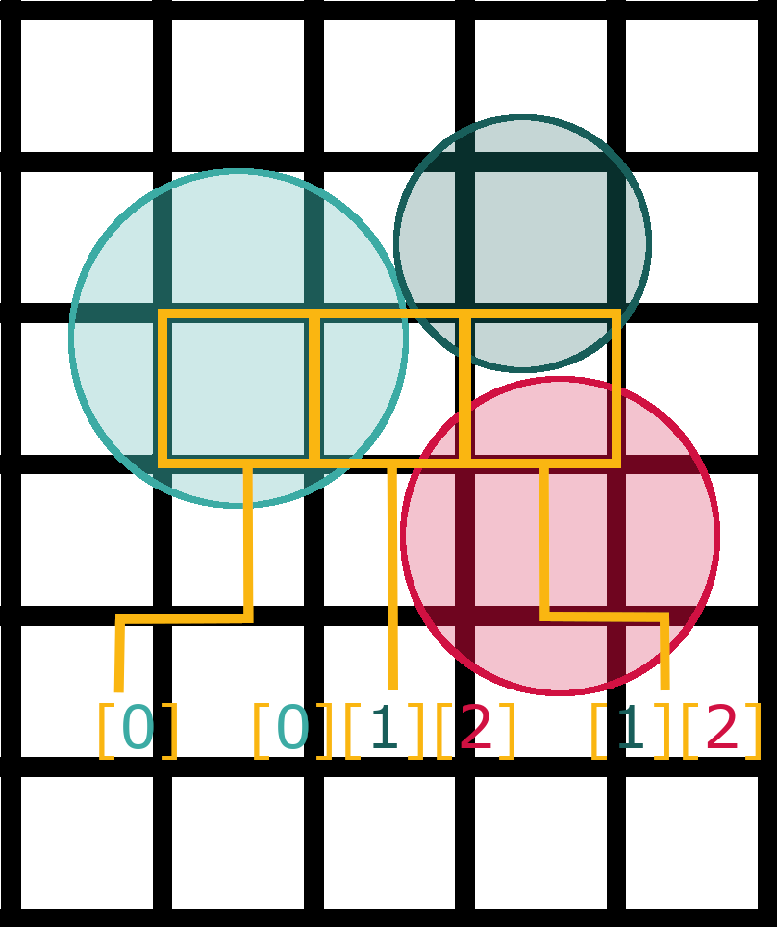
This is where you will discuss the unique algorithms and mechanics that you have implemented in your game. For example, if you have a player that uses a grappling hook, use this section to talk about the technical implementation specifically what does it do and how does it work. Describe WHAT the code does for launching a hook sprite and rendering a trail along the vector between the player and the target reticule. Then explain HOW the code works. Support your work with diagrams and pseudo code, using the image/caption format. Be sure to reference any relevant work that helped you. For example, separating out the angle and magnitude is the first step to creating the hook shot (Duffy 2017).

Conclusion
Use the start of the conclusion to tie together the technical implementations from the above section. Use the next few sentences to reflect on the process of creating the game. What went well, what did not, what can be carried forward in the future, what should be changed to improve your development process. Focus on the how and the why.

References
Textures & Images:
Note: Some textures and images may have been modified or adjusted through Adobe Photoshop.
StarSimsUniverse (2012) Dr.Light (Mega Mania Style Game Boy Advanced Sprite). Available at: http://forum.rockmanpm.com/index.php?topic=6849.0 (Accessed: 3 April 2020).
StarSimsUniverse (2012) Dr.Wily (Mega Mania Style Game Boy Advanced Sprite). Available at: http://forum.rockmanpm.com/index.php?topic=6849.0 (Accessed: 3 April 2020).
Xtremertro (2018) Infogrames Entertainment. Available at: https://xtremeretro.com/infogrames-entertainment-parte-4/ (Accessed: 3 April 2020).
TheAlmightyGuru (2010) Mega Man 2 - NES - Weapons. Available at: http://www.vgmpf.com/Wiki/index.php?title=File:Mega_Man_2_-_NES_-_Weapons.png (Accessed: 24 April 2020).
Mystick10 (2012) Mega Man - Shiver Man's Stage. Available at: https://www.deviantart.com/mystick10/art/Mega-Man-Shiver-Man-s-Stage-IN-PROGRESS-297333159 (Accessed: 31 March 2020).
Unknown Artist (Unknown date) Megaman Logo. Available at: https://logot.org/megaman-logo/megaman-logo-39570/ (Accessed: 31 March 2020).
Nokii (2019) Wily Castle in Mega Man 2. Available at: https://www.ssbwiki.com/File:Wily_Castle_MM2.png (Accessed: 3 April 2020).
Zmanwarrior (2012) Dr.Light's House (extended). Available at: https://www.smackjeeves.com/discover/detail?titleNo=91833&articleNo=381 (Accessed: 3 April 2020).
hfbn2 (2010) Dr.Light Lab Inside. Available at: https://www.deviantart.com/hfbn2/art/Dr-Light-Lab-Inside-182996044 (Accessed: 3 April 2020).
Evan G. (2016) Megaman X3 Pause Menu. Available at: http://snescentral.com/review.php?id=0054&num=1&fancy=yes&article=proto (Accessed: 31 March 2020).
DanFo07 (2015) Megaman 3 Stage Select. Available at: https://danfasulo.wordpress.com/category/mega-man-land/ (Accessed: 4 April 2020).
Random Talking Bush (2011) Mega Man and Friendly NPCs. Available at: https://www.spriters-resource.com/nes/mm/sheet/36582/ (Accessed: 2 April 2020).
Polar Koala, Shadowman44 (2010) Tiles. Available at: https://www.spriters-resource.com/nes/mm/sheet/260/ (Accessed: 2 April 2020).
Elnock200, Superjustinbros (2019) Life and Energy Bars. Available at: https://www.spriters-resource.com/nes/mm/sheet/113678/ (Accessed: 2 April 2020).
Polar Koala (2009) Intro & Stage Select. Available at: https://www.spriters-resource.com/nes/mm/sheet/258/ (Accessed: 2 April 2020).
-ShyGuy- (2013) Enemies. Available at: https://www.spriters-resource.com/nes/mm/sheet/32924/ (Accessed: 2 April 2020).
Magma MK-II (2012) Items. Available at: https://www.spriters-resource.com/nes/mm/sheet/45633/ (Accessed: 2 April 2020).
AlphaSystem (2010) Portal Wallpaper. Available at: https://wall.alphacoders.com/big.php?i=31312 (Accessed: 10 May 2020).
TechOnTheNet (Unknown date) Letter W key. Available at: https://www.techonthenet.com/clipart/keyboard/letter_w.php (Accessed: 25 April 2020).
TechOnTheNet (Unknown date) Letter A key. Available at: https://www.techonthenet.com/clipart/keyboard/letter_a.php (Accessed: 25 April 2020).
TechOnTheNet (Unknown date) Letter S key. Available at: https://www.techonthenet.com/clipart/keyboard/letter_s.php (Accessed: 25 April 2020).
TechOnTheNet (Unknown date) Letter D key. Available at: https://www.techonthenet.com/clipart/keyboard/letter_d.php (Accessed: 25 April 2020).
TechOnTheNet (Unknown date) Space bar key (small). Available at: https://www.techonthenet.com/clipart/keyboard/space_key_s.php (Accessed: 25 April 2020).
TechOnTheNet (Unknown date) Enter key. Available at: https://www.techonthenet.com/clipart/keyboard/enter_key.php (Accessed: 25 April 2020).

TechOnTheNet (Unknown date) Esc key. Available at: https://www.techonthenet.com/clipart/keyboard/esc_key.php (Accessed: 25 April 2020).

TechOnTheNet (Unknown date) Tab key (version 2). Available at: https://www.techonthenet.com/clipart/keyboard/tab_key2.php (Accessed: 25 April 2020).

FreePik (Unknown date) Mouse Left Button Free Icon. Available at: https://www.flaticon.com/free-icon/mouse-left-button_32041 (Accessed: 25 April 2020).

Audio:
Joueur Du Grenier (2013) Chanson Infogrames. In: Les jeux Disney [time code: 17:58]. Available at: https://www.youtube.com/watch?v=5I7pukuy8sQ (Accessed: 3 April 2020).
Gbelair (2009) Mega Man (NES) Music - Elec Man Stage. Available at: https://www.youtube.com/watch?v=CJdFxTOysjo&list=PL7EF_qp0zBDmKNoUhxqH7qwDOg_mcmLR4&index=2 (Accessed: 26 April 2020).
Gbelair (2009) Mega Man (NES) Music - Cut Man Stage. Available at: https://www.youtube.com/watch?v=GsXEqfDL40k&list=PL7EF_qp0zBDmKNoUhxqH7qwDOg_mcmLR4&index=3 (Accessed: 9 April 2020).
Wireboom (2010) Mega Man 2 Intro Opening Theme HQ. Available at: https://www.youtube.com/watch?v=ZT9DST_M_g8&list=PL7EF_qp0zBDmKNoUhxqH7qwDOg_mcmLR4&index=12 (Accessed: 3 April 2020).
SuperChaosControl (2015) Megaman 1 - Sound Effects. Available at: https://www.youtube.com/watch?v=nVpjIcw1spw (Accessed: 9 April 2020).
Cepblu2206 (2010) Mega Man 1 NES Music: Level/Boss Selection. Available at: https://www.youtube.com/watch?v=dbKCDrovBNQ (Accessed: 4 April 2020).
Crowman85 (2010) Megaman Stage Start Collection. Available at: https://www.youtube.com/watch?v=RKgDZrTAVrM (Accessed: 4 April 2020).
SuperChaosControl (2015) Megaman 1 - STAGE CLEAR. Available at: https://www.youtube.com/watch?v=YGjR8iT7-lo (Accessed: 26 April 2020).

Code:
John Dibling (2009) Random Float Number Generation [C++ code]. Available at: https://stackoverflow.com/questions/686353/random-float-number-generation (Accessed: 6 April 2020).

