CMP105 Coursework Report: Name of Game

Justin Syfrig
1904770
Git Username: nefastes

Introduction
I thought of this project after launching some games on my NES, particularly Megaman 1, my personal favourite. This was then my goal, to recreate similar mechanics and enemies to the original game, and as it turns out this has been quite successful. The game is a 2D platformer, in which you play Megaman, a humanoid that need to defeat the evil Dr.Wily.
Here is where you write a short introduction of the project you’ve created. This should be an overview of your game: describe the type of game is it, what is the aim and the major mechanics. Briefly state how the game displays a use of multiple screens, input, sprites, animation, collision detection and response, and audio. Finally, state what unique game mechanics are in your game this gets its own sentence to stress its importance.

Controls
You may include controls for your game here, but they MUST be built into the game as well in a splash screen or menu or tutorial.

Game Screens
State what game screens there are (splash, level1, end screen) include images where appropriate.
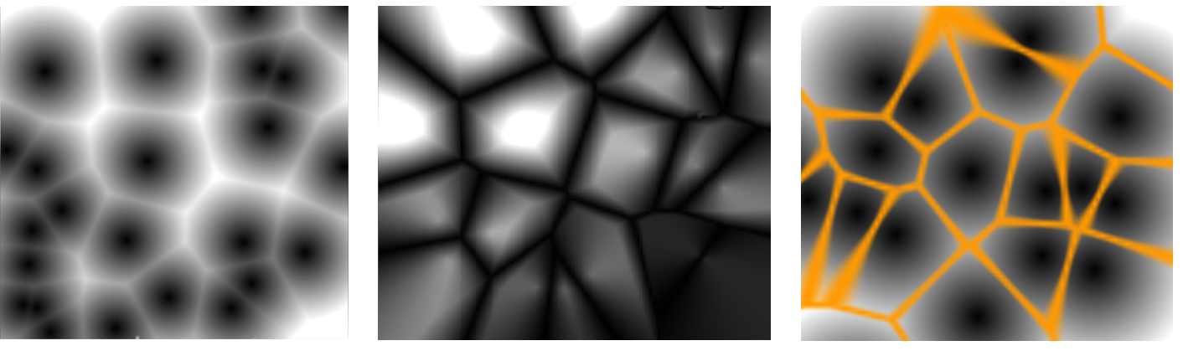
Figure 1: 2D image description (left) a descriptive caption of this image (middle), something from your game (right) You only need (left, middle, right) if there are multiple images. If there are no references then it is assumed to be something you created
You may choose inline or newline formats be sure to right click on the image and add caption Figures will auto number from 1 to n as needed.

Input
Use this section to discuss what implementation of input you are using and how it works. You may want to tie this back to the player or the user. This should always be focused on technical implementations and improvements beyond the sample code. Use diagrams and pseudo code as needed to help support your explanation of how it works.

Sprite Work
Outline the important sprite work (animated, NPC and user controlled), including screenshots. Be sure to describe what kind of animation work is being used and how it works. Highlight interesting or novel work. This should be focused on technical implementation.

Collision Detection and Response
Describe the collision detection methods used and resolutions (what happens after a collision is detected), focus on the important ones. Describe the technical implementation, specifically what does it do and how does it work. Support your work with diagrams and pseudo code, using the image/caption format.

Audio
Describe the where you have used the audio in relation to input and Collision Response. Describe the technical implementation, specifically what does it do and how does it work. Support your work with diagrams and pseudo code, using the image/caption format.

Game Logic and Unique Mechanics
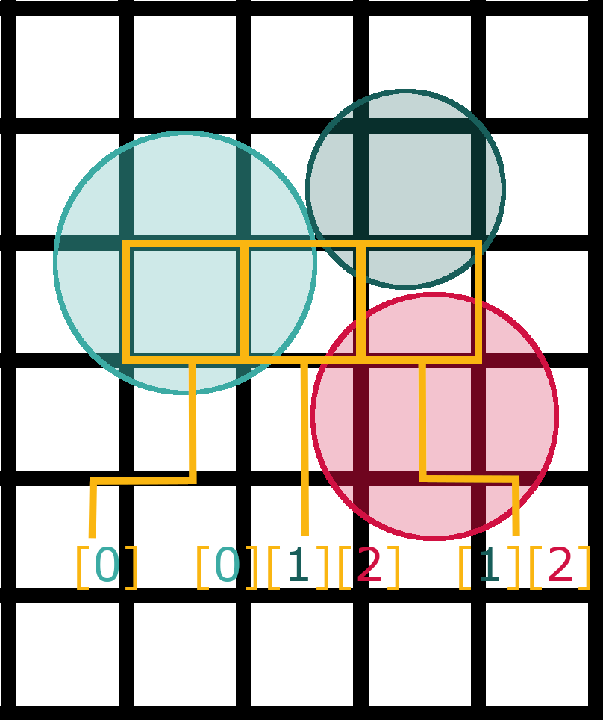
This is where you will discuss the unique algorithms and mechanics that you have implemented in your game. For example, if you have a player that uses a grappling hook, use this section to talk about the technical implementation specifically what does it do and how does it work. Describe WHAT the code does for launching a hook sprite and rendering a trail along the vector between the player and the target reticule. Then explain HOW the code works. Support your work with diagrams and pseudo code, using the image/caption format. Be sure to reference any relevant work that helped you. For example, separating out the angle and magnitude is the first step to creating the hook shot (Duffy 2017).

Conclusion
Use the start of the conclusion to tie together the technical implementations from the above section. Use the next few sentences to reflect on the process of creating the game. What went well, what did not, what can be carried forward in the future, what should be changed to improve your development process. Focus on the how and the why.

References

Textures & Images:
Notice: Some textures and images may have been modified or adjusted through Photoshop.
StarSimsUniverse (2012) Dr.Light (Mega Mania Style Game Boy Advanced Sprite). Available at: http://forum.rockmanpm.com/index.php?topic=6849.0 (Accessed: 3 April 2020).
StarSimsUniverse (2012) Dr.Wily (Mega Mania Style Game Boy Advanced Sprite). Available at: http://forum.rockmanpm.com/index.php?topic=6849.0 (Accessed: 3 April 2020).
Xtremertro (2018) Infogrames Entertainment. Available at: https://xtremeretro.com/infogrames-entertainment-parte-4/ (Accessed: 3 April 2020).
TheAlmightyGuru (2010) Mega Man 2 - NES - Weapons. Available at: http://www.vgmpf.com/Wiki/index.php?title=File:Mega_Man_2_-_NES_-_Weapons.png (Accessed: 24 April 2020).
Mystick10 (2012) Mega Man - Shiver Man's Stage. Available at: https://www.deviantart.com/mystick10/art/Mega-Man-Shiver-Man-s-Stage-IN-PROGRESS-297333159 (Accessed: 31 March 2020).
Unknown Artist (Unknown date) Megaman Logo. Available at: https://logot.org/megaman-logo/megaman-logo-39570/ (Accessed: 31 March 2020).

Nokii (2019) Wily Castle in Mega Man 2. Available at: https://www.ssbwiki.com/File:Wily_Castle_MM2.png (Accessed: 3 April 2020).

Zmanwarrior (2012) Dr.Light's House (extended). Available at: https://www.smackjeeves.com/discover/detail?titleNo=91833&articleNo=381 (Accessed: 3 April 2020).

hfbn2 (2010) Dr.Light Lab Inside. Available at: https://www.deviantart.com/hfbn2/art/Dr-Light-Lab-Inside-182996044 (Accessed: 3 April 2020).

Evan G. (2016) Megaman X3 Pause Menu. Available at: http://snescentral.com/review.php?id=0054&num=1&fancy=yes&article=proto (Accessed: 31 March 2020).

DanFo07 (2015) Megaman 3 Stage Select. Available at: https://danfasulo.wordpress.com/category/mega-man-land/ (Accessed: 4 April 2020).

Random Talking Bush (2011) Mega Man and Friendly NPCs. Available at: https://www.spriters-resource.com/nes/mm/sheet/36582/ (Accessed: 2 April 2020).

Polar Koala, Shadowman44 (2010) Tiles. Available at: https://www.spriters-resource.com/nes/mm/sheet/260/ (Accessed: 2 April 2020).

Elnock200, Superjustinbros (2019) Life and Energy Bars. Available at: https://www.spriters-resource.com/nes/mm/sheet/113678/ (Accessed: 2 April 2020).

Polar Koala (2009) Intro & Stage Select. Available at: https://www.spriters-resource.com/nes/mm/sheet/258/ (Accessed: 2 April 2020).

-ShyGuy- (2013) Enemies. Available at: https://www.spriters-resource.com/nes/mm/sheet/32924/ (Accessed: 2 April 2020).

Magma MK-II (2012) Items. Available at: https://www.spriters-resource.com/nes/mm/sheet/45633/ (Accessed: 2 April 2020).

Audio:

Code:

Be sure to reference anything that is not your own original work, including textures, audio, tutorials, code snippets.

