Supplementary Material
Prediction of 10-year Fatal Cardiovascular Risk in Mexico using the Recalibrated Globorisk Equation
Neftali Eduardo Antonio-Villa, Enrique Aguilar-Camacho, Jerónimo Perezalonso-Espinosa, Mario Cesar Torres-Chávez, América Citlali Bermejo-Isidro, Daniel Ramírez-García, Juan Pablo Díaz-Sánchez, Carlos Alberto Fermín Martínez, Jacqueline A. Seiglie, Omar Yaxmehen Bello-Chavolla

Index

Supplementary Methods 2
Supplementary Figure 1 3
Supplementary Figure 2 4
Supplementary Figure 3 5
Supplementary Figure 5 6
Supplementary Figure 6. 7

Supplementary Methods

ENSANUT 2022 sampling design
The Mexican National Health and Nutrition Survey (ENSANUT) 2022 is a probabilistic, stratified, multi-stage survey designed to be representative of the Mexican population at a municipal level, conducted by the Mexican Ministry of Health and the National Institute of Public Health. Complete methods have been published elsewhere [1]. Briefly, the ENSANUT sample size of 13,879 households aimed to estimate a 53% COVID-19 seroprevalence (margin of error of 6%), adjusted for a design effect of 3.52 (based on ENSANUT 2021 estimations) and a response rate of 59%. The final sample included 10,160 households, which were assumed to be sufficient to obtain accurate chronic disease estimates based on 2020 data [1]. The subsampling strategy used for blood pressure and biochemical measurements was applied only to a randomly selected subsample of participants. All analyses applied the corresponding survey sampling weight to preserve national representativeness despite these restrictions. For our analyses, we performed a complete-case analysis.
Prevalence estimations
CVD risk categories were derived by applying the Globorisk equation recalibrated for the Mexican population to each participant's estimated 10-year fatal CVD risk, using the original Globorisk thresholds: low (<5%), intermediate (5–9.9%), high (10–19.9%), and very high (≥20%) risk [2,3]. Weighted prevalence estimates and their 95% confidence intervals were obtained using the "survey" R package [4]. We incorporated the complex sampling design of ENSANUT 2022. Confidence intervals for proportions were estimated using the Korn–Graubard method [5]. Estimates with a sample size <30 were flagged and considered not clinically or epidemiologically interpretable.

Supplementary Figure 1

STROBE flow diagram describing participant selection from the National Health and Nutrition Survey from 2022 venous subsample.
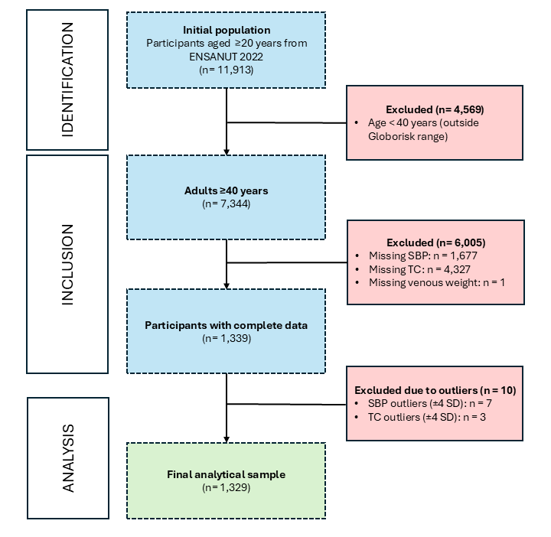

Abbreviations: ENSANUT, Encuesta Nacional de Salud y Nutrición; SBP, systolic blood pressure; TC, total cholesterol; SD, Standard Deviation.

Supplementary Figure 2
Weighted distribution of 10-year fatal cardiovascular risk categories among Mexican adults aged 40–79 years using the Globorisk-fatal equation recalibrated for Mexico.
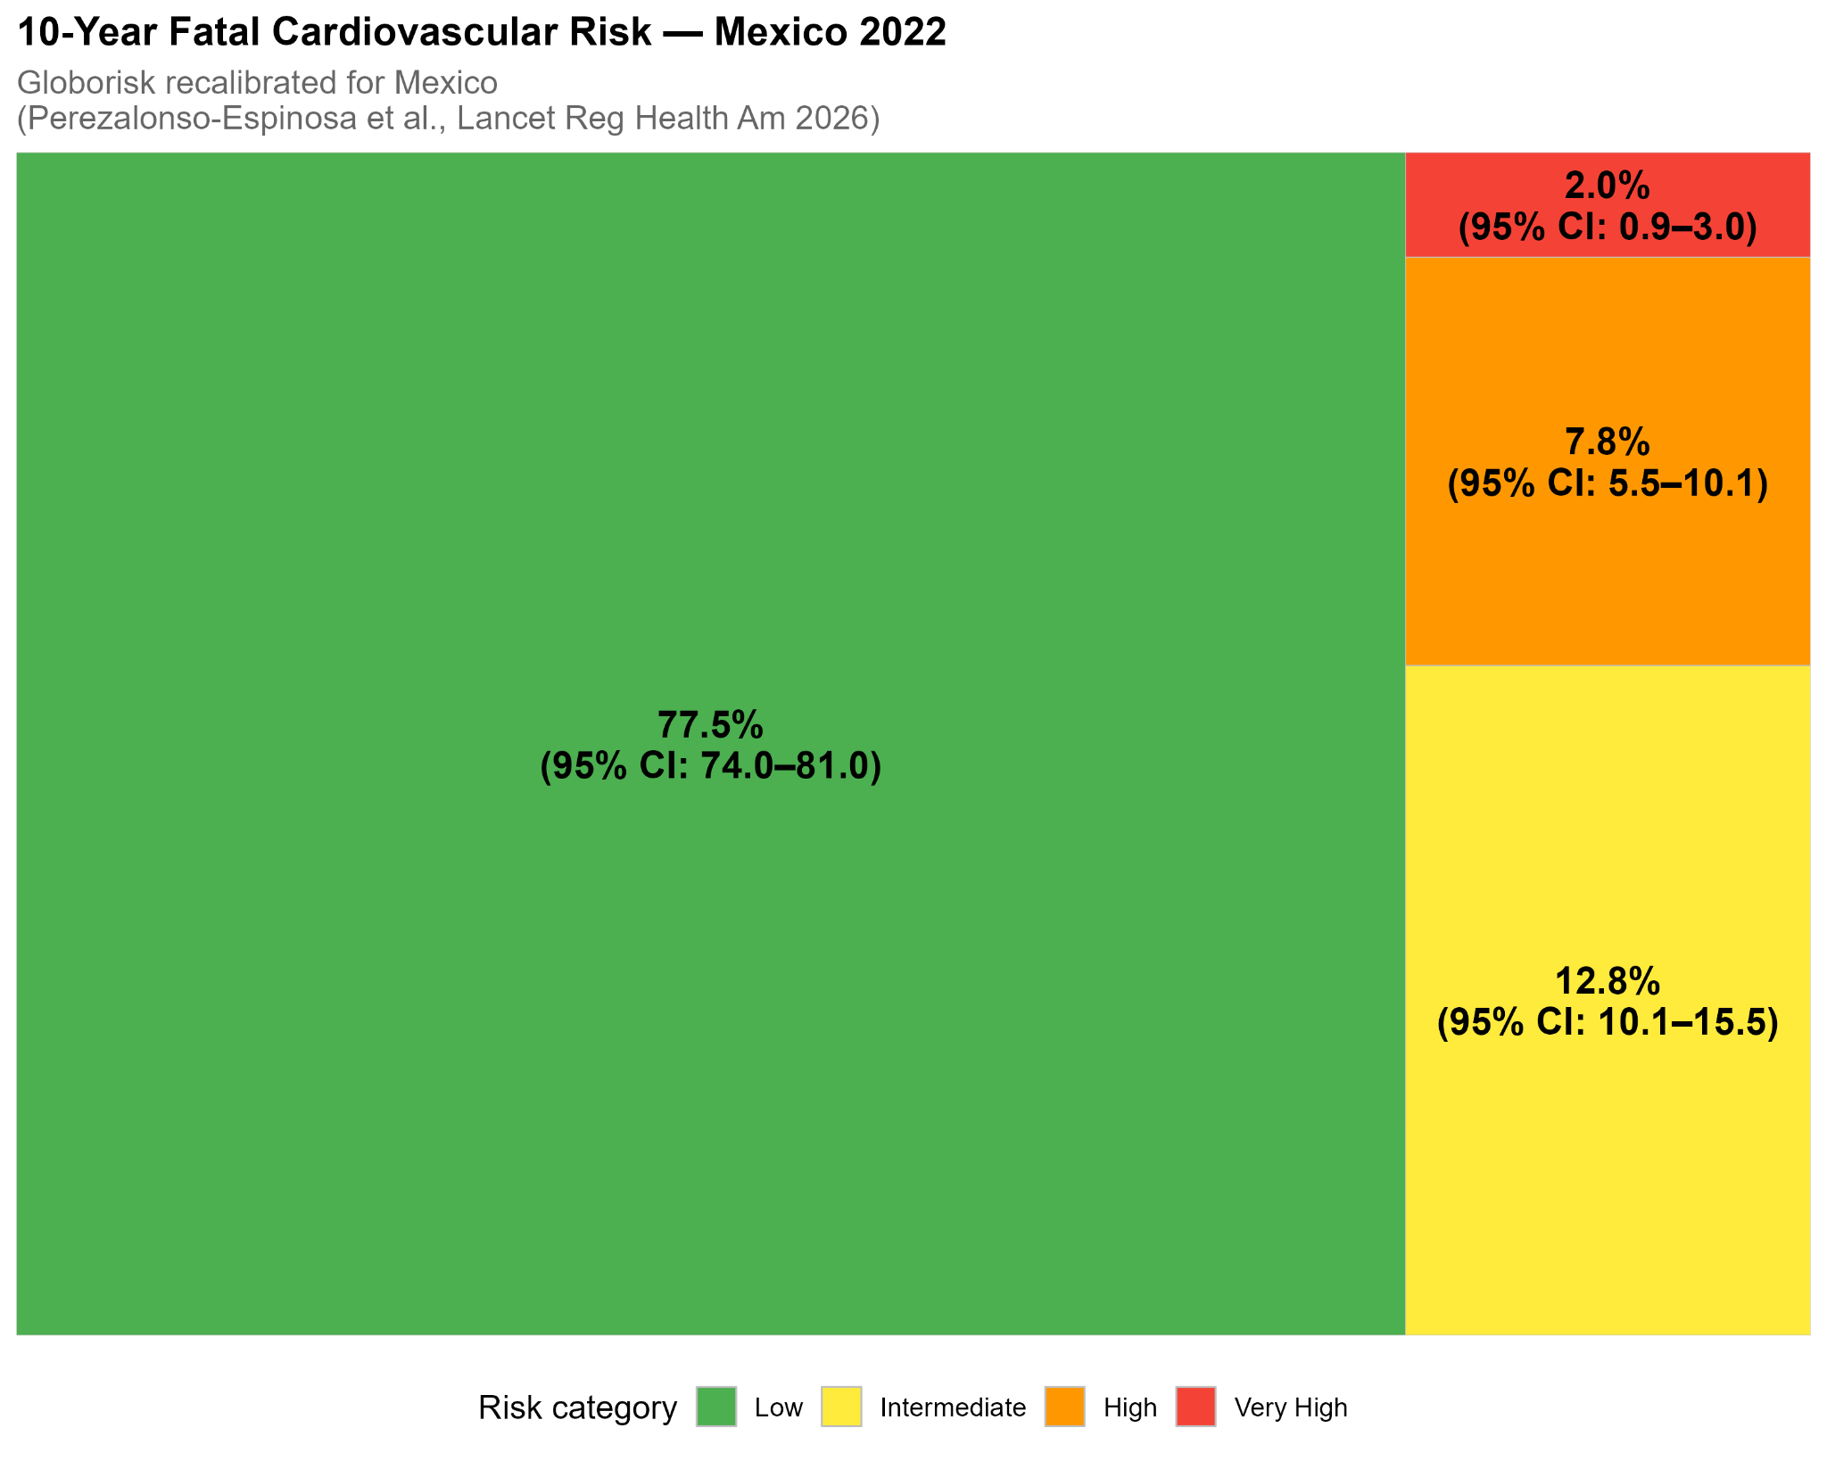
Annotations: Values are presented as weighted percentages with 95% confidence intervals (95% CI). Risk categories were defined according to the Globorisk-fatal equation recalibrated as follows: low risk (≤5%), intermediate risk (6–9%), high risk (10–19%), and very high risk (≥20%).
Abbreviations: CI, confidence interval.

Supplementary Figure 3
Comparison of weighted prevalence estimates across 10-year fatal cardiovascular risk categories using the original Globorisk equation and the recalibrated Globorisk-fatal model for Mexico.
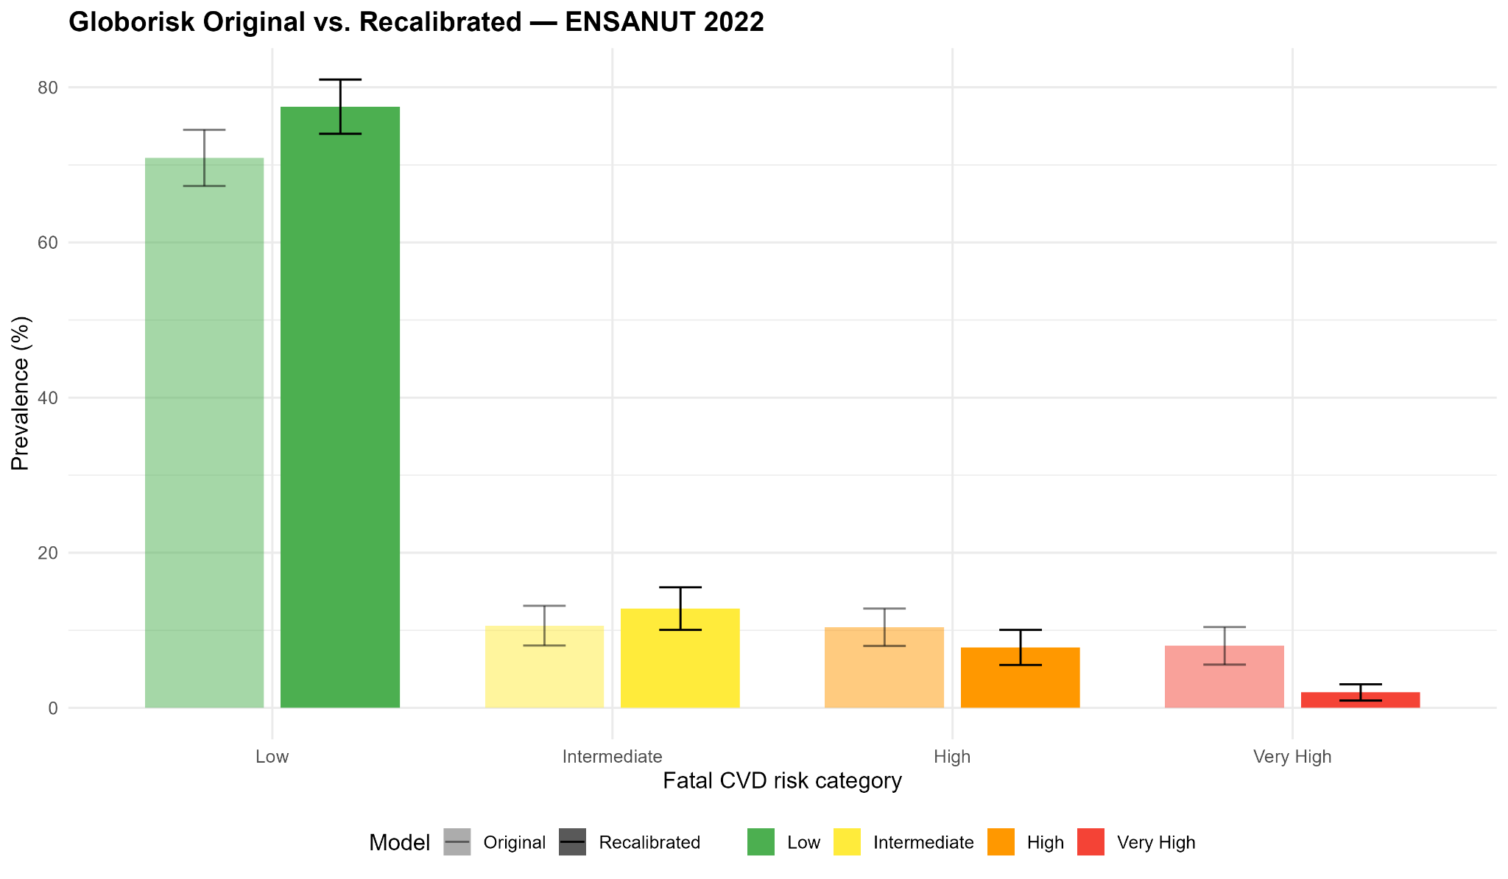
Footnote. Values are presented as weighted percentages with 95% confidence intervals (95% CI). Risk categories were defined according to the Globorisk-fatal equation recalibrated as follows: low risk (≤5%), intermediate risk (6–9%), high risk (10–19%), and very high risk (≥20%).
Abbreviations: CI, confidence interval; CVD, cardiovascular disease

Supplementary Figure 4.
Representative example of the individual risk CVD estimation presented in the Shinny-App. For this scenario, we used as a hypothetical example a 62-year-old male living with diabetes, with a systolic blood pressure of 160 mmHg, a total cholesterol of 250 mg/dL, and no active smoking. The application reports an estimated 10-year fatal cardiovascular risk of 11% and automatically displays guideline-based therapeutic recommendations, LDL-C targets, pharmacological treatment, lifestyle interventions, and risk-factor alerts. The Shiny App that can be accessed at: https://antonio-villa-lab.shinyapps.io/CKD_RISK_APP/.
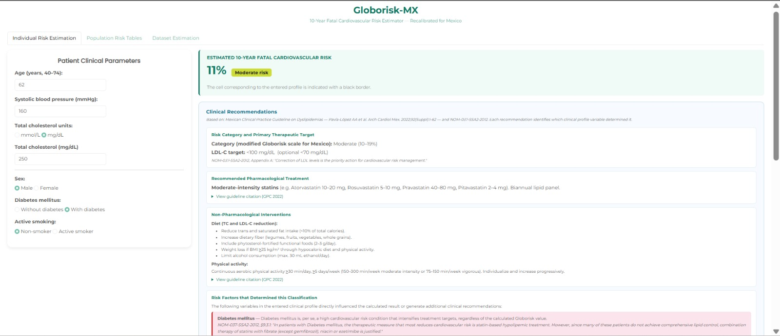

Supplementary Figure 5
Color-guided risk tables of 10-year fatal cardiovascular risk. A full-size resolution of this table can be found at:
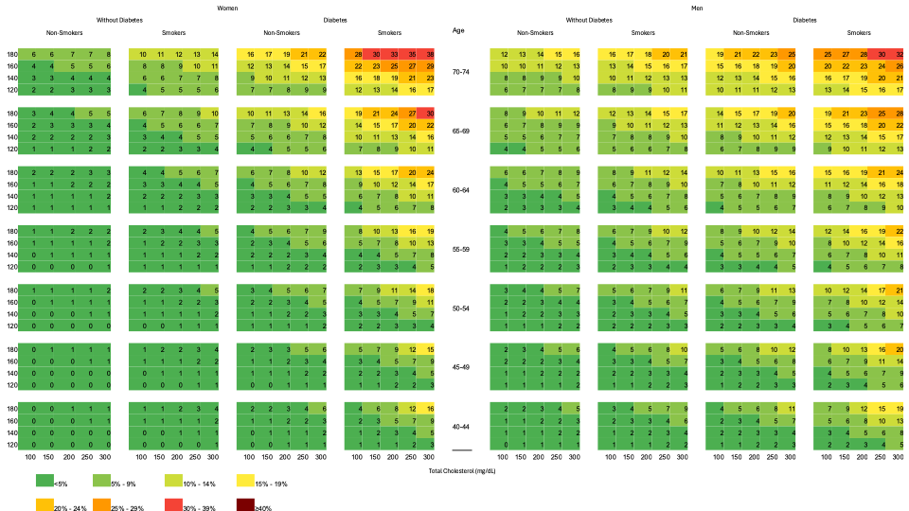

REFERENCES
1. Romero-Martínez M, Barrientos-Gutiérrez T, Cuevas-Nasu L, Bautista-Arrendondo S, Colchero MA, Gaona-Pineda EB, Martínez-Barnetche J, Alpuche-Aranda C, Gómez-Acosta LM, Mendoza-Alvarado LR, Rivera-Dommarco J, Lazcano-Ponce E, Shamah-Levy T. Metodología de la Encuesta Nacional de Salud y Nutrición 2022 y Planeación y diseño de la Ensanut Continua 2020-2024. Salud Pública de México. 2022 Aug 26;64(5, sept-oct):522–9. doi:10.21149/14186
2. Perezalonso-Espinosa J, Ramírez-García D, Díaz-Sánchez JP, Carrillo-Herrera KB, Cabrera-Quintana LA, Dávila-López G, Fermín-Martínez CA, Malagón-Liceaga A, Basile-Álvarez MR, Berumen-Campos J, Kuri-Morales P, Tapia-Conyer R, Alegre-Díaz J, Seiglie JA, Antonio-Villa NE, Bello-Chavolla OY. External validation and recalibration of cardiovascular risk scores for prediction of 10-year risk of fatal cardiovascular disease: a prospective, observational, population-based cohort analysis of adults in Mexico City. Lancet Reg Health Am. 2026 Apr;56:101403. doi:10.1016/j.lana.2026.101403 PubMed PMID: 41732703; PubMed Central PMCID: PMC12925590.
3. Hajifathalian K, Ueda P, Lu Y, Woodward M, Ahmadvand A, Aguilar-Salinas CA, Azizi F, Cifkova R, Di Cesare M, Eriksen L, Farzadfar F, Ikeda N, Khalili D, Khang YH, Lanska V, León-Muñoz L, Magliano D, Msyamboza KP, Oh K, Rodríguez-Artalejo F, Rojas-Martinez R, Shaw JE, Stevens GA, Tolstrup J, Zhou B, Salomon JA, Ezzati M, Danaei G. A novel risk score to predict cardiovascular disease risk in national populations (Globorisk): a pooled analysis of prospective cohorts and health examination surveys. Lancet Diabetes Endocrinol. 2015 May;3(5):339–55. doi:10.1016/S2213-8587(15)00081-9 PubMed PMID: 25819778.
4. Lumley T. survey: Analysis of Complex Survey Samples [Internet]. 2023 [cited 2023 Jun 10]. Available from: https://cran.r-project.org/web/packages/survey/index.html
5. Graubard BI, Korn EL. Modelling the sampling design in the analysis of health surveys. Stat Methods Med Res. 1996 Sep;5(3):263–81. doi:10.1177/096228029600500304 PubMed PMID: 8931196.

