**Supplementary Table 1:** Description of Geriatric Syndrome Component Assessment and Fragility Components in the Study Population

|  |  |
| --- | --- |
| **Parameter** | **All-Population (n=501)** |
| ***Recruitment places*** |  |
| Mexico City (%) | 290 (57.9) |
| Cuernavaca (%) | 5 (0.99) |
| Aguascalientes (%) | 30 (5.9) |
| Guanajuato (%) | 118 (23.5) |
| Mexico State (%) | 58 (11.6) |
| ***Scales*** |  |
| Disability for ADL (Barthel scale <90 pts) (%) | 48 (9.6) |
| Disability for IADL (Lawton & Brody scale) (%) | 50 (9.98) |
| Disability for mobility (Rosow-Breslau < 3) (%) | 323 (64.47) |
| History of Falls (%) | 149 (29.74) |
| Visual impairment (%) | 353 (70.46) |
| Hearing impairment (%) | 26 (5.19) |
| Geriatric depression scale [median, (IQR)] | 1 (0-3) |
| Mini-Mental State Examination [median, (IQR)] | 28 (26-29) |
| HIV Dementia Scale (pts) | 10 (9-11) |
| ***Frailty*** |  |
| Nonfrail (%) | 347 (69.9) |
| Pre-Frailty (%) | 140 (27.94) |
| Frailty (%) | 14 (2.79) |

*Abbreviations*: RB= Rosow-Breslow; PASE= Physical Activity Scale for the Elderly.

**Supplementary Table 2:** Descriptive Characteristics of Data-Driven Clustering in Older Adults Living with HIV

|  |  |  |  |  |
| --- | --- | --- | --- | --- |
| **Parameter** | **Cluster 1**  **(n=116; 23.2%)** | **Cluster 2**  **(n=189; 37.7%)** | **Cluster 3**  **(n=196; 39.1%)** | **p-value** |
| Age (Years) | 57.59 (±6.43) | 59.23 (±7.64) | 56.71 (±5.71) | 0.05 |
| Women (%) | 30 (25) | 32 (17.49) | 30 (15.15) | 0.08 |
| Education (Years) | 10.55 (±5.86) | 9.86 (±6.04) | 11.13 (±6.15) | 0.20 |
| ***Comorbidities*** | | | | |
| No-Comorbidities, n (%) | 30 (25) | 81 (44.26) | 83 (41.92) | <0.001 |
| ≥2 Comorbidities, n (%) | 63 (52.5) | 51 (27.87) | 51 (25.76) | <0.001 |
| Diabetes, n (%) | 21 (17.5) | 25 (13.66) | 24 (12.12) | 0.002 |
| Hypertension, n (%) | 21 (17.5) | 25 (13.66) | 24 (12.12) | <0.01 |
| Dyslipidemia, n (%) | 63 (52.5) | 69 (37.7) | 76 (38.38) | <0.01 |
| Cancer, n (%) | 10 (8.33) | 13 (7.1) | 12 (6.06) | 0.900 |
| Cardiovascular disease, n (%) | 4 (3.33) | 4 (2.19) | 6 (3.03) | 0.900 |
| COPD, n (%) | 9 (7.5) | 1 (0.55) | 2 (1.01) | <0.01 |
| Chronic hepatopathy, n (%) | 1 (0.83) | 0 (0) | 0 (0) | 0.600 |
| Chronic kidney disease, n (%) | 6 (5) | 9 (4.92) | 3 (1.52) | <0.001 |
| ***Clinical and anthropometric profiles*** | | | | |
| Body mass index, median (IQR) | 24.91 (22.25-28.1) | 24.9 (22.94-27.25) | 25.11 (22.79-27.55) | 0.60 |
| Nair CD4+ (cells/ml) | 116.0 (42-191) | 53.0 (23-113) | 270 (202-383) | <0.001 |
| Current CD4+ (cells/ml) | 481 (376-668) | 308 (207-404) | 711 (523-810) | <0.001 |
| Detectable viral load, n (%) | 13 (11.2) | 24 (13.5) | 11 (5.7) | <0.001 |

*Abbreviations:* COPD= Chronic obstructive pulmonary diseases.

**Supplementary Figure 1:** “Prevalence of geriatric syndrome components”

A) Disability

B) Sensory Deficit

C) Depression

F) Falls

E) Cognitive Decline

F) Polypharmacy

G) Self-Reported Comorbidities

H) Fraility

I) Incontinency

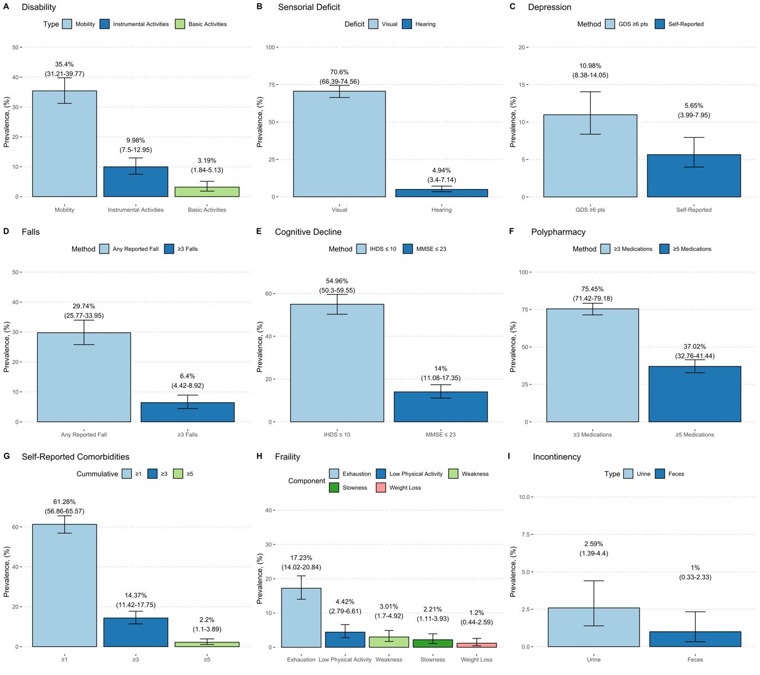

*Footnotes:* Confidence intervals were obtained using Copper-Pearson exact method.

**Supplementary Figure 2:** "CD4+ Nadir and Current CD4+ Stratified by Geriatric Syndrome Types"

A) Polypharmacy

B) Sensory Deficit

C) Cognitive Decline

D) Physical Disabilities

E) Frailty Prevalence

F) Falls

G) Depression

H) Multimorbidity

I) Incontinence.

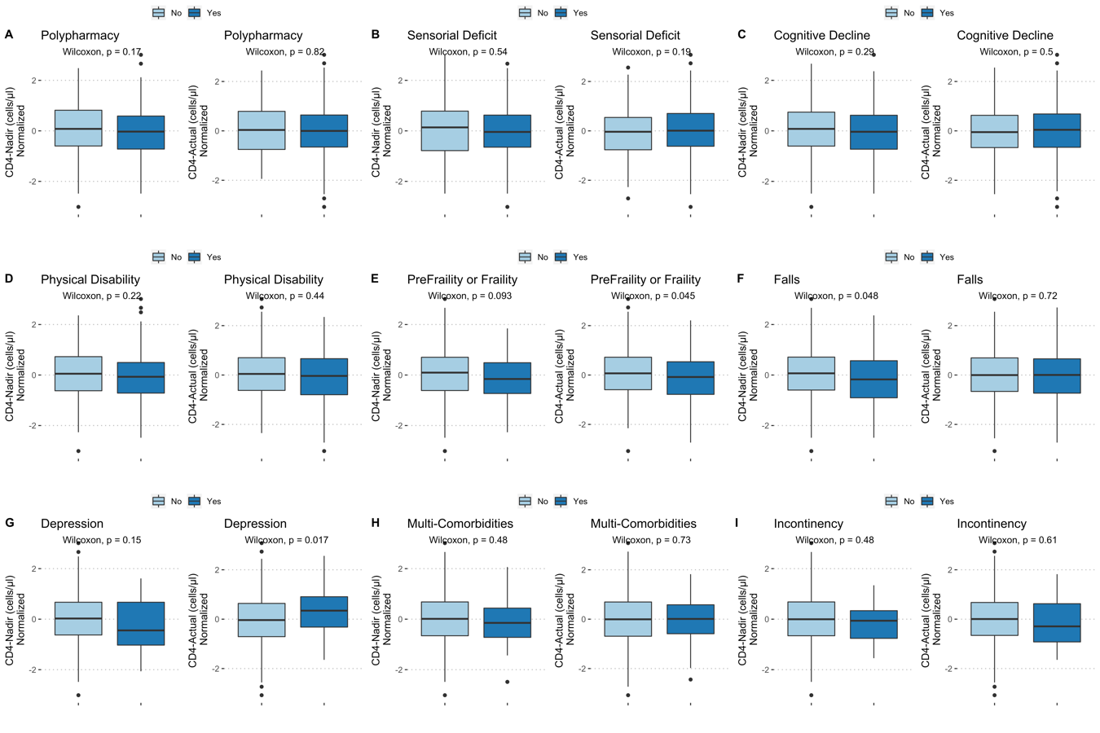

**Supplementary Figure 3:** "Assumptions of the Poisson Regression Model for Accumulative Geriatric Syndromes Based on Chronological Age"

A) Residual Histogram

B) Residuals vs. Fitted Values Plot

C) Residuals Q-Q Plot

D) Scale-Location Plot

E) Residuals vs. Leverage Plot

F) Cook's Distance

Footnote: The null deviance in our model was 417.42, while the residual deviance was 391.18. The residuals of our Poisson model were divided by the degrees of freedom, yielding a squared sum of 0.7575, indicating no overdispersion and equal variance to the model dispersion. This was confirmed with a likelihood ratio test, where the null hypothesis was Poisson being better than the Negative Binomial model. The critical value of the test statistic was -0.006 with a p-value of 0.5, leading to rejection of the alternative hypothesis of overdispersion, thereby demonstrating that the Poisson model fits the data variance adequately.

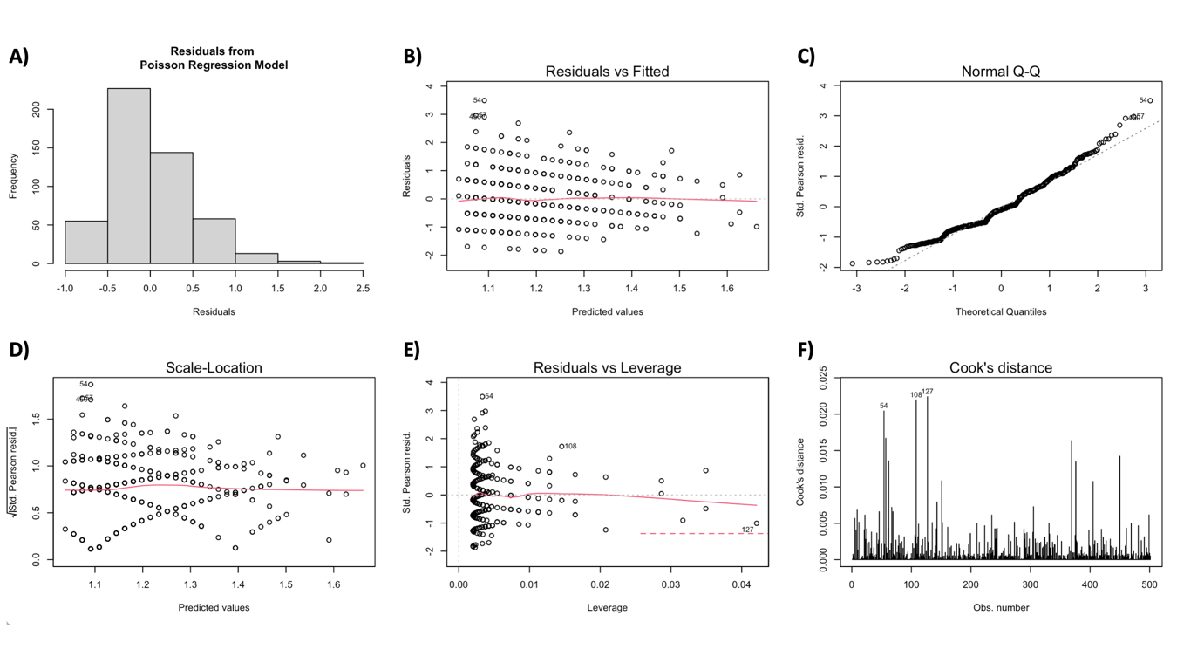

**Supplementary Figure 4:** "Estimation of Optimal Number of Clusters in Our Study Population"

A) Elbow Plot of Sum of Square Errors

B) Average Silhouette Weight

C) Calinski-Harabasz Criterion to Evaluate Clustering Stability

Footnote: The Jaccard bootstrap for clusters 1, 2, and 3 were 0.8810, 0.8465, and 0.7922, respectively.

