Correction_Atelier_Nefzi_Firas
Exposer 2 cruds des différentes entités en créant leurs controleurs
exposer les services réalisés en keyword et en jpql
Tester ces Web Services avec Postamn.

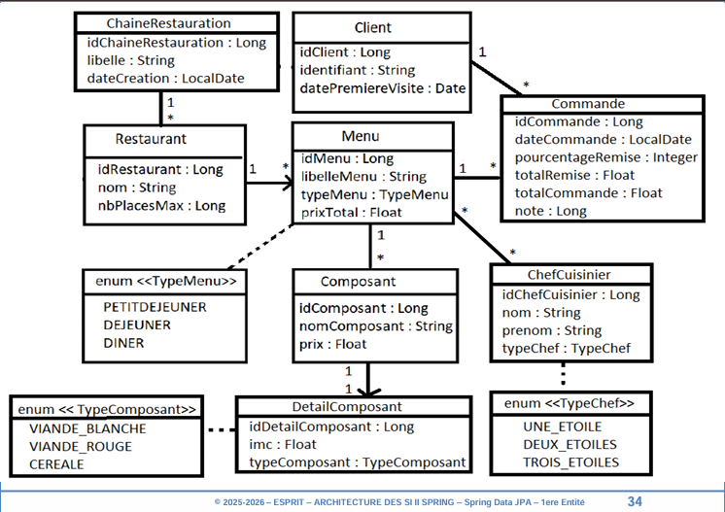

package Spring_Project_4twin.Controllres;
import lombok.AllArgsConstructor;
import org.springframework.web.bind.annotation.RestController;
import Spring_Project_4twin.Entities.Commande;
import Spring_Project_4twin.Services.CommandeInterface;
import org.springframework.web.bind.annotation.*;
import java.util.List;
@RestController
@AllArgsConstructor
@RequestMapping("/commande")
public class CommandeController {
private final CommandeInterface commandeService;
// http://localhost:8089/menu/commande/retrieve-all-commandes
@GetMapping("/retrieve-all-commandes")
public List<Commande> getCommandes() {
return commandeService.retrieveAllCommandes();
}
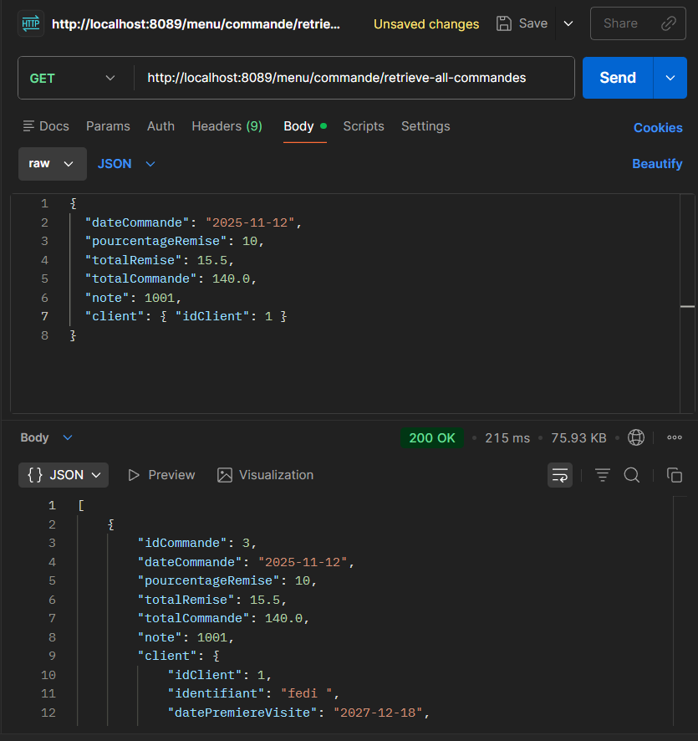
// http://localhost:8089/menu/commande/retrieve-commande/1
@GetMapping("/retrieve-commande/{commande-id}")
public Commande retrieveCommande(@PathVariable("commande-id") Long commandeId) {
return commandeService.retrieveCommande(commandeId);
}
// http://localhost:8089/menu/commande/add-commande
@PostMapping("/add-commande")
public Commande addCommande(@RequestBody Commande c) {
return commandeService.addCommande(c);
}
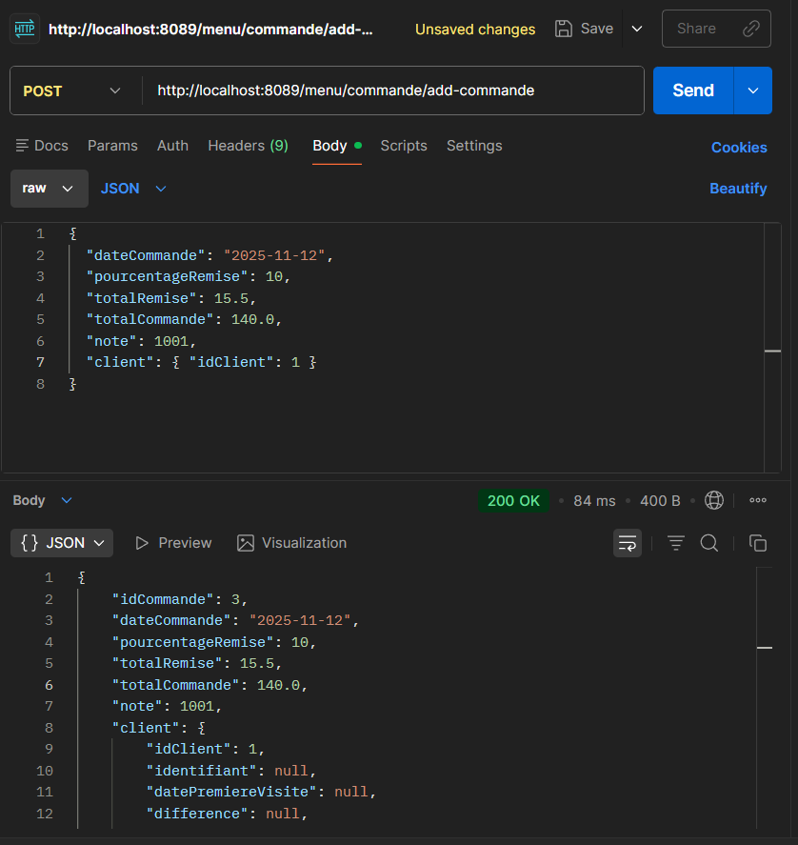

// http://localhost:8089/menu/commande/add-commandes
@PostMapping("/add-commandes")
public List<Commande> addCommandes(@RequestBody List<Commande> commandes) {
return commandeService.addCommandes(commandes);
}
// http://localhost:8089/menu/commande/remove-commande/1
@DeleteMapping("/remove-commande/{commande-id}")
public void removeCommande(@PathVariable("commande-id") Long commandeId) {
commandeService.removeCommande(commandeId);
}
// http://localhost:8089/menu/commande/update-commande
@PutMapping("/update-commande")
public Commande updateCommande(@RequestBody Commande c) {
return commandeService.updateCommande(c);
}
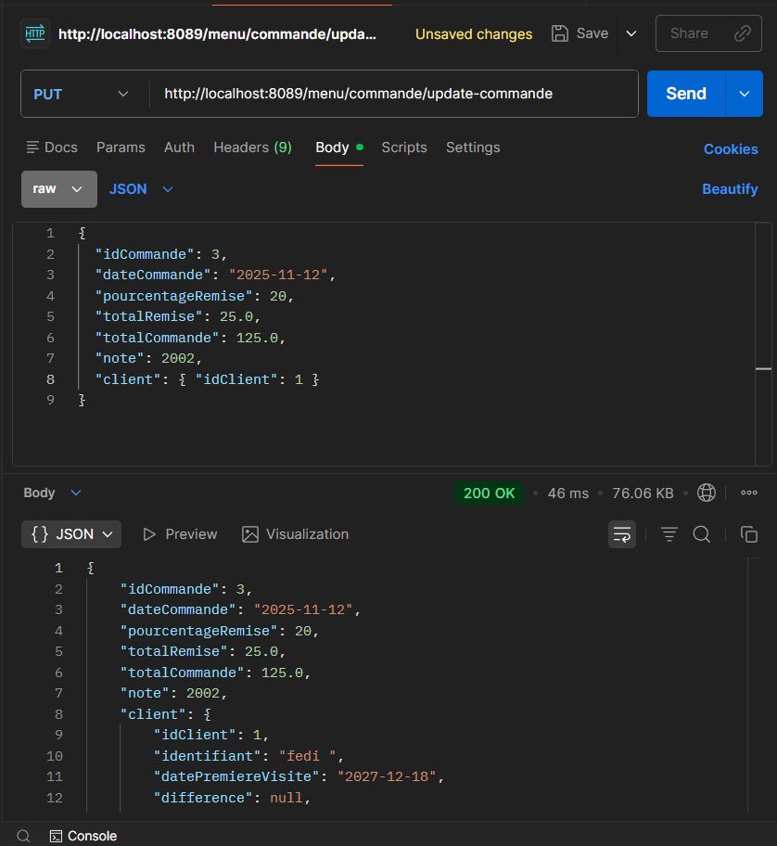
}

package Spring_Project_4twin.Controllres;
import lombok.AllArgsConstructor;
import org.springframework.web.bind.annotation.RestController;
import Spring_Project_4twin.Services.MenuService;
import Spring_Project_4twin.Entities.Menu;
import Spring_Project_4twin.Services.MenuInterface;
import org.springframework.beans.factory.annotation.Autowired;
import org.springframework.web.bind.annotation.*;
import java.util.List;
@RestController
@RequestMapping("/menu")
public class MenuController {
private final MenuInterface menuService;
@Autowired
public MenuController(MenuInterface menuService) {
this.menuService = menuService;
}
@GetMapping("/retrieve-all-menus")
public List<Menu> getAllMenus() {
return menuService.retrieveAlMenus();
}
@GetMapping("/retrieve-menu/{id}")
public Menu getMenuById(@PathVariable("id") Long id) {
return menuService.retrieveMenu(id);
}
@PostMapping("/add-menu")
public Menu addMenu(@RequestBody Menu m) {
return menuService.addMenu(m);
}
@PostMapping("/add-menus")
public List<Menu> addMenus(@RequestBody List<Menu> menus) {
return menuService.addMenus(menus);
}
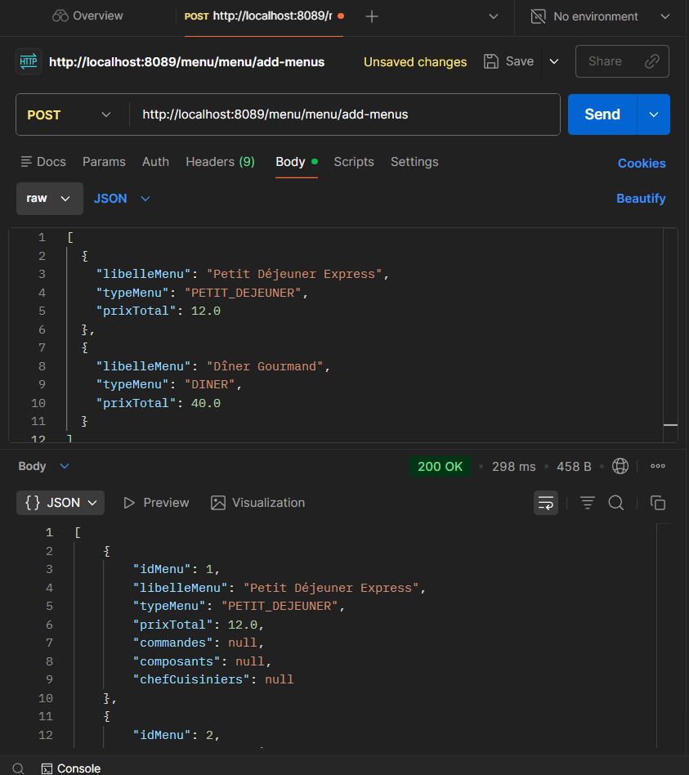
@PutMapping("/update-menu")
public Menu updateMenu(@RequestBody Menu m) {
return menuService.updateMenu(m);
}
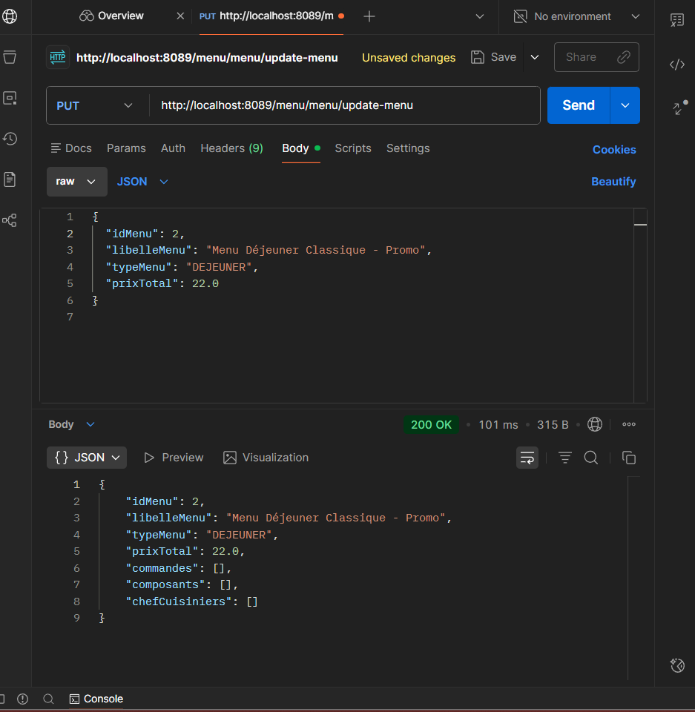
@DeleteMapping("/remove-menu/{id}")
public void removeMenu(@PathVariable("id") Long id) {
menuService.removeMenu(id);
}
}

