singlecell_Seurat_pipeline

2023-02-12

## Single-cell RNA-Seq analysis pipeline (GEO dataset)

This is a pipeline to analyze single-cell RNA Seq data from GEO. In this script the single cell RNA-Seq results from this paper is regenerated: <https://pubmed.ncbi.nlm.nih.gov/34956864/> Title: Bulk and Single-Cell Profiling of Breast Tumors Identifies TREM-1 as a Dominant Immune Suppressive Marker Associated With Poor Outcomes

## Initial library loading

library(Seurat)  
library(tidyverse)  
library(GEOquery)

## 0. Fetch data from GEO

#### Note: No need to fetch the data if it is already created

file <- getGEOSuppFiles("GSE188600")  
untar("GSE188600/GSE188600_RAW.tar", exdir = 'data/')

## 1. Create the counts matrix

#### Find the files in data folder (i.e., barcodes, features, matrix)

wd = getwd()  
files = list.files(path = paste0(wd, '/data'), full.names = FALSE, recursive = FALSE)  
  
mtx.cnts <- ReadMtx(mtx = paste0('data/', files[3]),  
 features = paste0('data/', files[2]),  
 cells = paste0('data/', files[1]))

## 2. Create a seurat object

Seurat.obj <- CreateSeuratObject(counts = mtx.cnts)  
  
Seurat.obj

## An object of class Seurat   
## 33694 features across 770 samples within 1 assay   
## Active assay: RNA (33694 features, 0 variable features)

## 3. QC and filtering

### View Seurat object meta data

## orig.ident nCount_RNA nFeature_RNA  
## AAACCTGTCGTGACAT-1 SeuratProject 3057 1301  
## AAAGATGTCGCCTGTT-1 SeuratProject 7981 1903  
## AAAGCAAAGAGCTATA-1 SeuratProject 1814 876  
## AAAGCAACAAGTAGTA-1 SeuratProject 2749 1325  
## AAAGTAGCATGCTAGT-1 SeuratProject 5421 1406  
## AAAGTAGGTCCAGTAT-1 SeuratProject 1957 1017  
## AAAGTAGGTTGTACAC-1 SeuratProject 13236 2703  
## AAAGTAGTCACAGTAC-1 SeuratProject 5116 1516  
## AAATGCCAGCCGATTT-1 SeuratProject 6864 1774  
## AACACGTCAAGCCCAC-1 SeuratProject 18283 3069

## 3.1 Calculate mitochondrial percentage

#### High percentage shows bad quality

Seurat.obj$mito.prct <- PercentageFeatureSet(Seurat.obj, pattern = '^MT-')

## 3.2 Explore QC

#### Plot feature and RNA counts and mitochondial percentage

VlnPlot(Seurat.obj, features = c("nFeature_RNA", "nCount_RNA", "mito.prct"), ncol = 3)

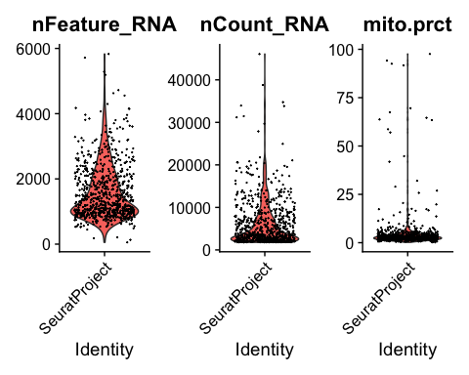

FeatureScatter(Seurat.obj, feature1 = "nCount_RNA", feature2 = "nFeature_RNA") +  
 geom_smooth(method = 'lm')

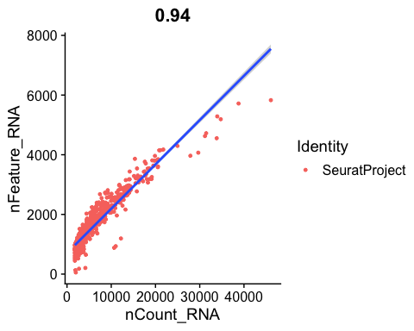

## 3.3 Filter cells

#### more than 800 RNA count and more than 500 genes and less than 10 mitochondrial%

Seurat.obj.filt <- subset(Seurat.obj, subset = nCount_RNA >800 &  
 nFeature_RNA > 500 &  
 mito.prct < 10)

## 4. Finding Variable genes

#### note: This data set contains one sample, if more than 1 sample was used correction for potential batch effects should be considered

### 4.1 Normalize data

Seurat.obj.filt <- NormalizeData(object = Seurat.obj.filt)

### 4.2 Find variable genes

#### with visualization of top 10 variable genes

Seurat.obj.filt <- FindVariableFeatures(object = Seurat.obj.filt, selection.method = 'vst', nfeatures = 2000)  
  
top10 <- head(VariableFeatures(Seurat.obj.filt), 10)  
  
plot1 <- VariableFeaturePlot(Seurat.obj.filt)  
LabelPoints(plot = plot1, points = top10, repel = TRUE)

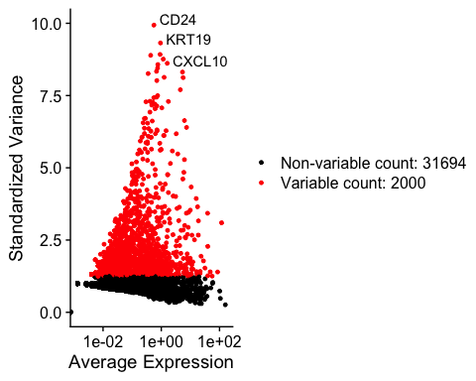

## 5. Clustering the cells

### 5.1 Scale the data

Seurat.obj.filt <- ScaleData(object = Seurat.obj.filt)

### 5.2 Perform linear dimensionality reduction

Seurat.obj.filt <- RunPCA(object = Seurat.obj.filt, features = VariableFeatures((Seurat.obj.filt)))

### 5.3 Select the PCA plots with elbow plot

ElbowPlot(Seurat.obj.filt, ndims = 35)

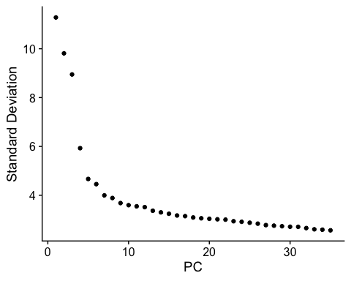

### 5.4 Find Neighbors

Seurat.obj.filt <- FindNeighbors(object = Seurat.obj.filt, dim = 1:20)

### 5.5 Understand the resolution

Seurat.obj.filt <- RunUMAP(object = Seurat.obj.filt, dim = 1:20)  
Seurat.obj.filt <- FindClusters(object = Seurat.obj.filt, resolution = c(0.01, 0.1, 0.3, 0.5, 0.8, 1, 1.2))

## Modularity Optimizer version 1.3.0 by Ludo Waltman and Nees Jan van Eck  
##   
## Number of nodes: 736  
## Number of edges: 21217  
##   
## Running Louvain algorithm...  
## Maximum modularity in 10 random starts: 0.9932  
## Number of communities: 3  
## Elapsed time: 0 seconds  
## Modularity Optimizer version 1.3.0 by Ludo Waltman and Nees Jan van Eck  
##   
## Number of nodes: 736  
## Number of edges: 21217  
##   
## Running Louvain algorithm...  
## Maximum modularity in 10 random starts: 0.9618  
## Number of communities: 4  
## Elapsed time: 0 seconds  
## Modularity Optimizer version 1.3.0 by Ludo Waltman and Nees Jan van Eck  
##   
## Number of nodes: 736  
## Number of edges: 21217  
##   
## Running Louvain algorithm...  
## Maximum modularity in 10 random starts: 0.9111  
## Number of communities: 7  
## Elapsed time: 0 seconds  
## Modularity Optimizer version 1.3.0 by Ludo Waltman and Nees Jan van Eck  
##   
## Number of nodes: 736  
## Number of edges: 21217  
##   
## Running Louvain algorithm...  
## Maximum modularity in 10 random starts: 0.8790  
## Number of communities: 8  
## Elapsed time: 0 seconds  
## Modularity Optimizer version 1.3.0 by Ludo Waltman and Nees Jan van Eck  
##   
## Number of nodes: 736  
## Number of edges: 21217  
##   
## Running Louvain algorithm...  
## Maximum modularity in 10 random starts: 0.8422  
## Number of communities: 11  
## Elapsed time: 0 seconds  
## Modularity Optimizer version 1.3.0 by Ludo Waltman and Nees Jan van Eck  
##   
## Number of nodes: 736  
## Number of edges: 21217  
##   
## Running Louvain algorithm...  
## Maximum modularity in 10 random starts: 0.8190  
## Number of communities: 11  
## Elapsed time: 0 seconds  
## Modularity Optimizer version 1.3.0 by Ludo Waltman and Nees Jan van Eck  
##   
## Number of nodes: 736  
## Number of edges: 21217  
##   
## Running Louvain algorithm...  
## Maximum modularity in 10 random starts: 0.7959  
## Number of communities: 11  
## Elapsed time: 0 seconds

### 5.6 Optimize the resolution

#### This resolution should be changed until the correct number of clusters are achieved

DimPlot(Seurat.obj.filt, group.by = 'RNA_snn_res.0.5', label = TRUE)

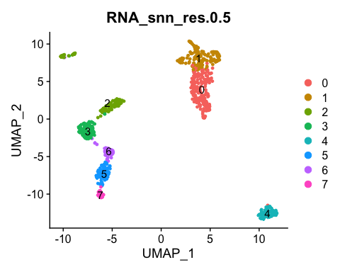

### 5.7 Set identity of clusters

Seurat.obj.filt <- RunUMAP(object = Seurat.obj.filt, dim = 1:20)  
Seurat.obj.filt <- RunTSNE(object = Seurat.obj.filt, dims = 1:20)  
Idents(Seurat.obj.filt) <- 'RNA_snn_res.0.5'

### 5.8 umap observation

DimPlot(Seurat.obj.filt, reduction = 'umap', label = TRUE)

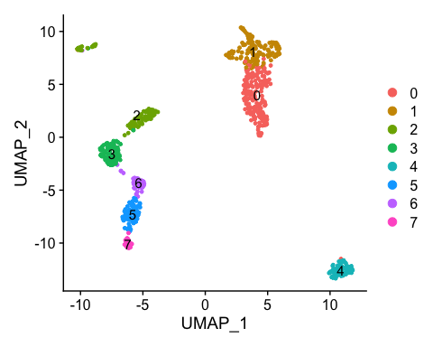

### 5.9 tsne observation

DimPlot(Seurat.obj.filt, reduction = 'tsne' , label = TRUE)

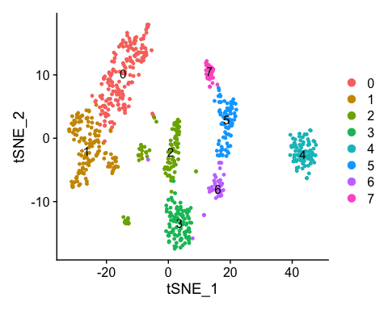

## 6. Annotate the clusters

### 6.1 Find the assay type

DefaultAssay(Seurat.obj.filt) # make sure it is RNA

## [1] "RNA"

### 6.2 Find the differentially expressed markers

#### Find markers for every cluster compared to all remaining cells, report only the positive ones

Seurat.obj.filt.markers <- FindAllMarkers(Seurat.obj.filt, only.pos = TRUE, min.pct = 0.25, logfc.threshold = 0.25)

### 6.2 Select top (4 -> can be changed) upregulated genes in each cluster

clust.markers <- Seurat.obj.filt.markers %>%  
 group_by(cluster) %>%  
 slice_max(n = 4, order_by = avg_log2FC)

### 6.3 Visualize top upregulated genes in each cluster

DoHeatmap(Seurat.obj.filt, features = clust.markers$gene, size = 4,  
 angle = 90)

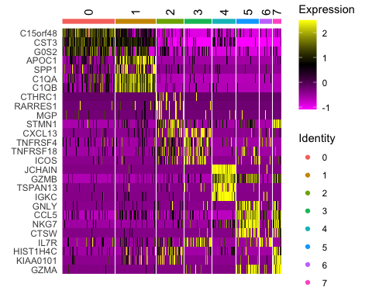

### 6.4 Ridge plots - from ggridges.

#### Visualize single cell expression distributions in each cluster

RidgePlot(Seurat.obj.filt, features = clust.markers$gene, ncol = 4)

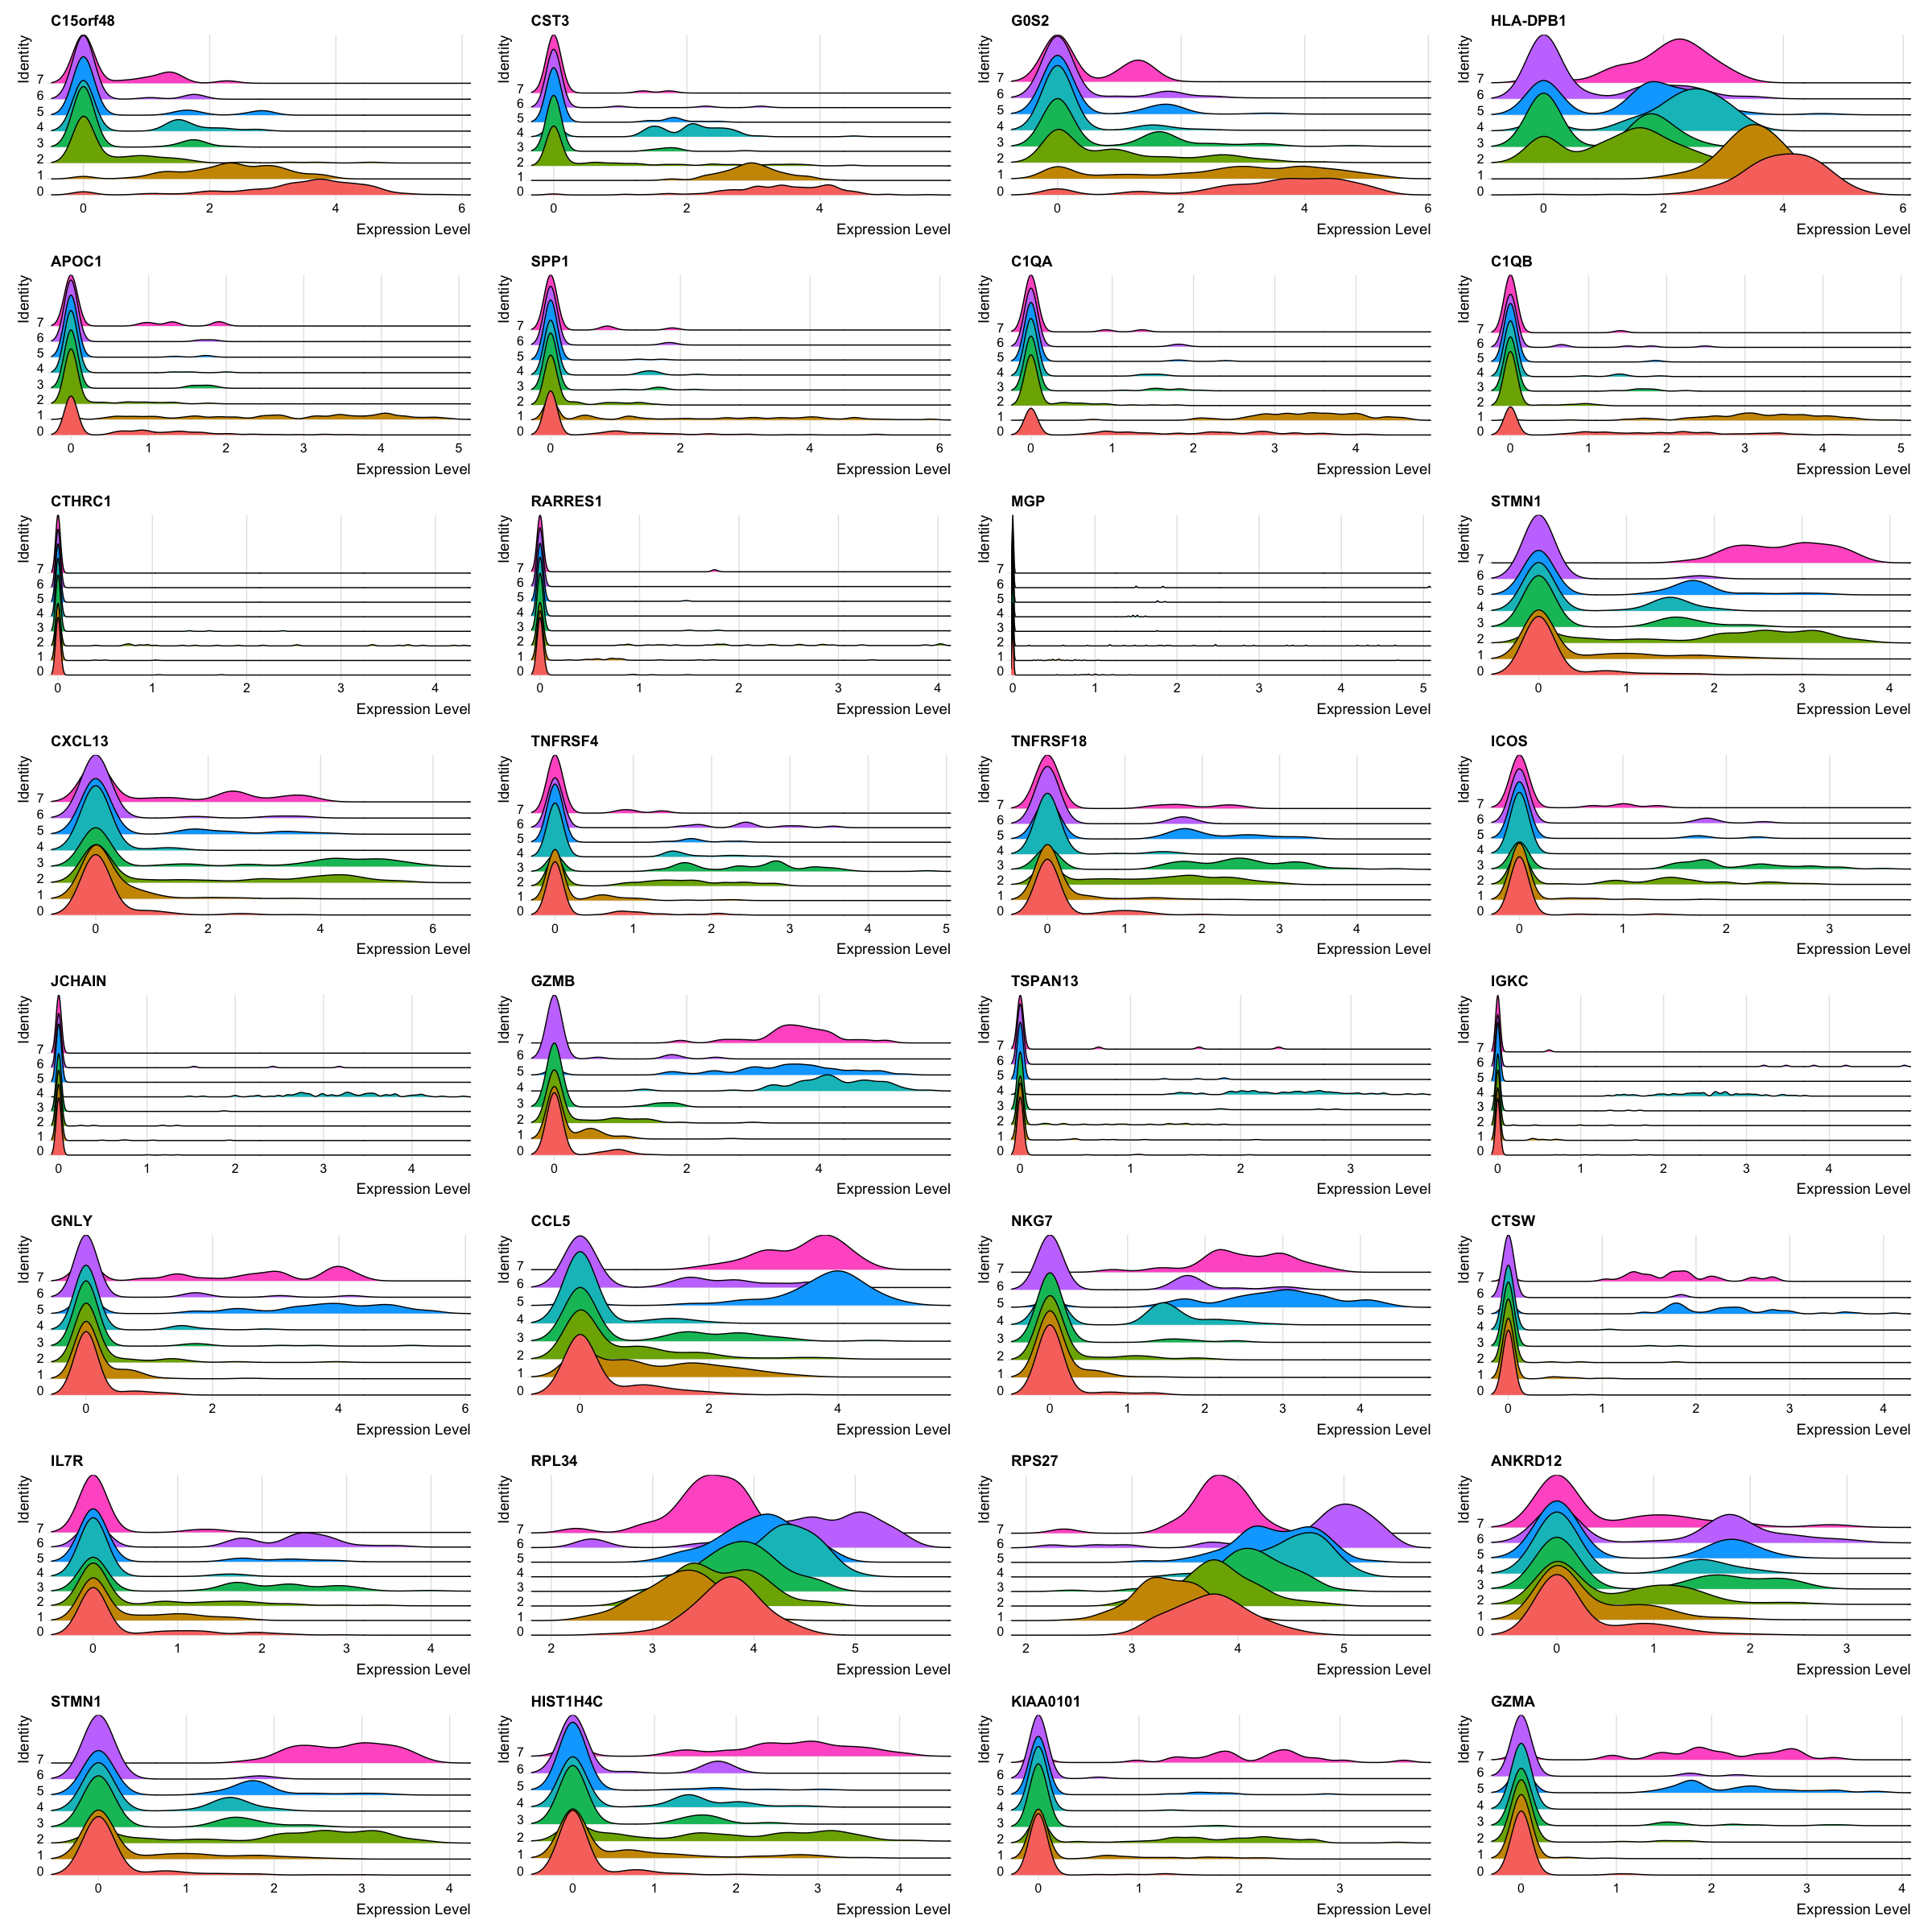

### 6.5 Violin plot

#### Visualize single cell expression distributions in each cluster

VlnPlot(Seurat.obj.filt, features = clust.markers$gene, ncol = 4)

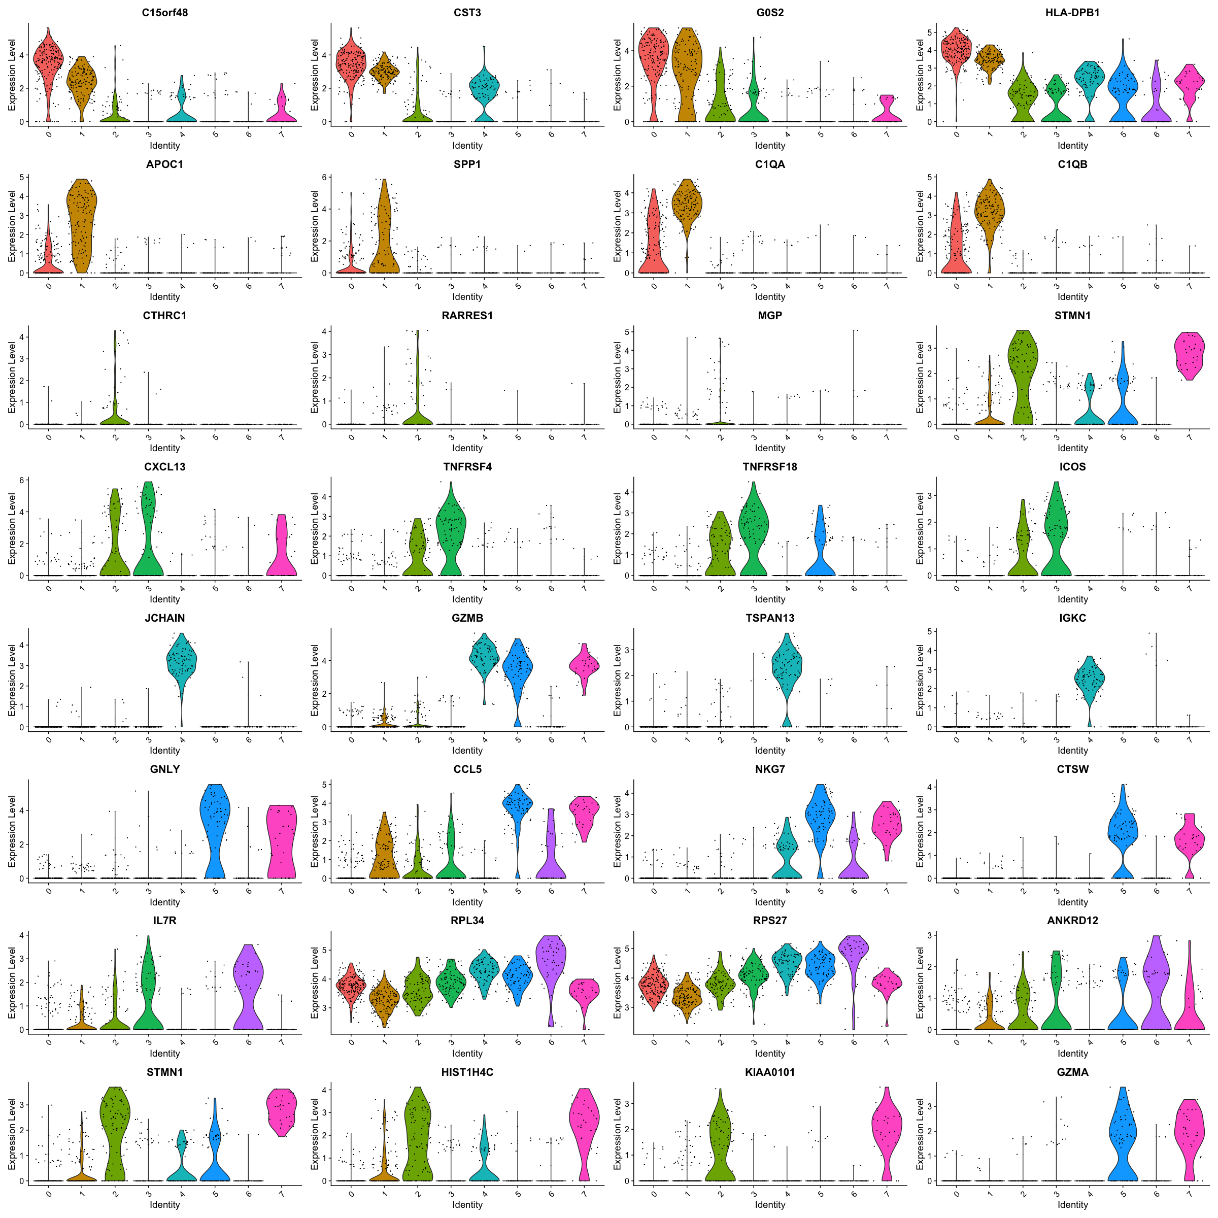

### 6.6 Feature plot

#### visualize feature expression in low-dimensional space

FeaturePlot(Seurat.obj.filt, features = clust.markers$gene, ncol = 4)

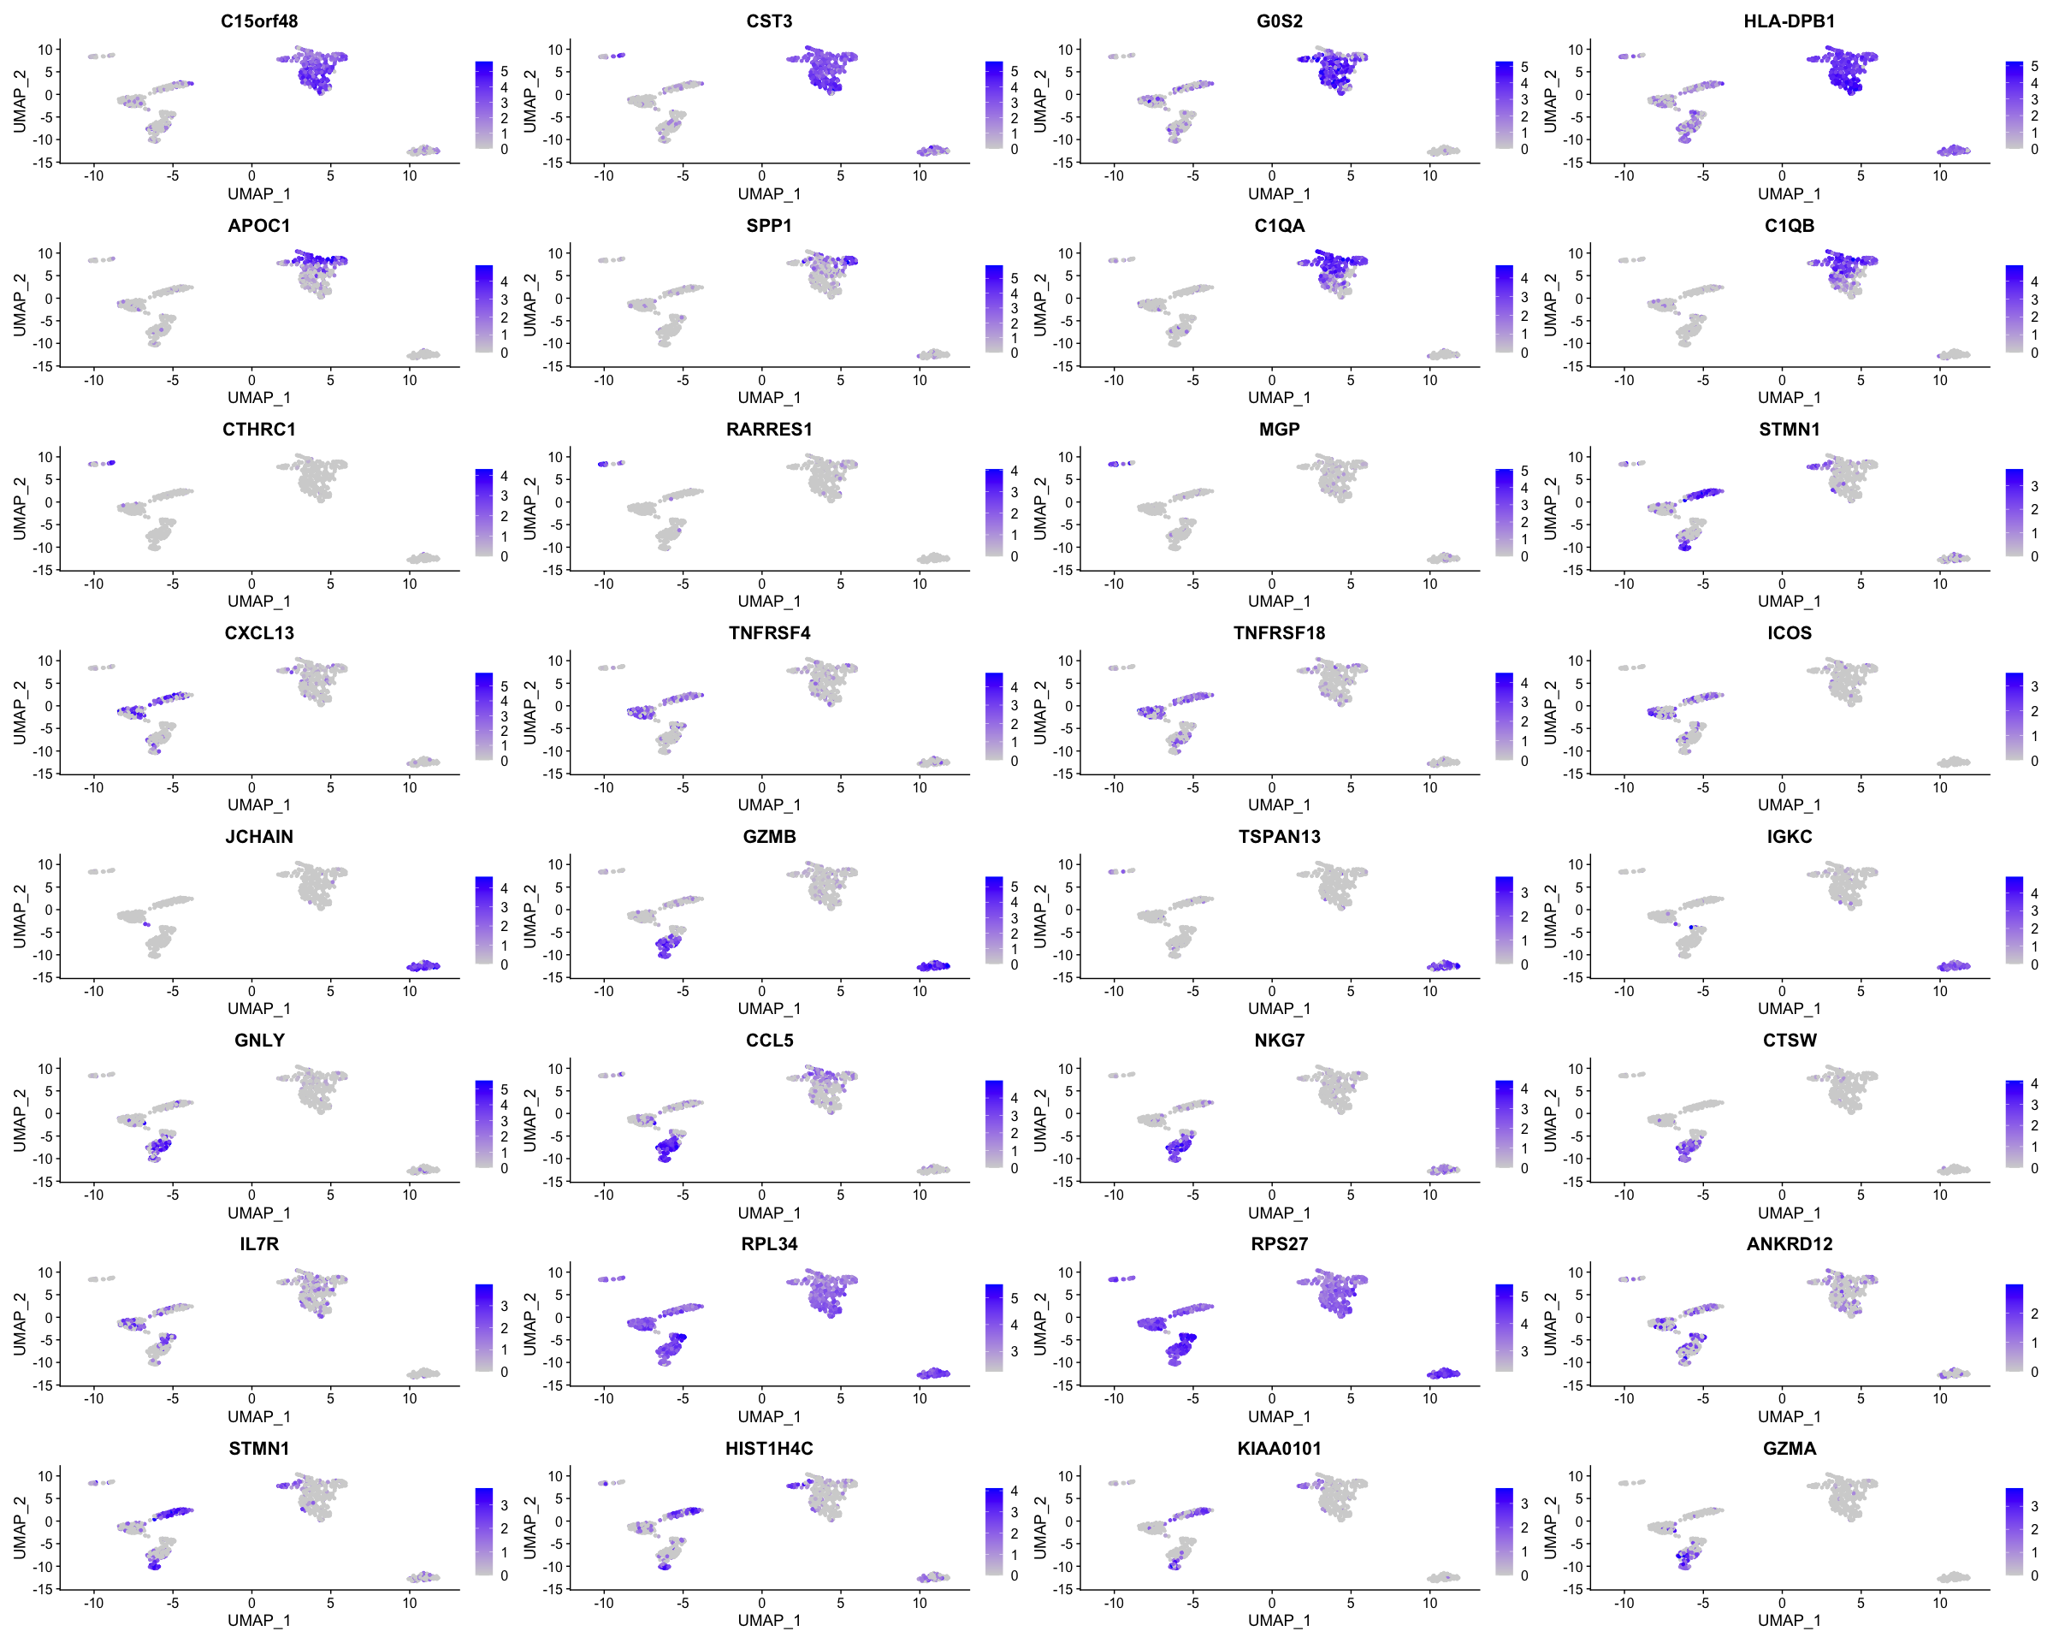

### 6.7 Check the individual feature

#### Use for optimization of annotating

FeaturePlot(Seurat.obj.filt, features = c('CD163'), min.cutoff = 'q10')

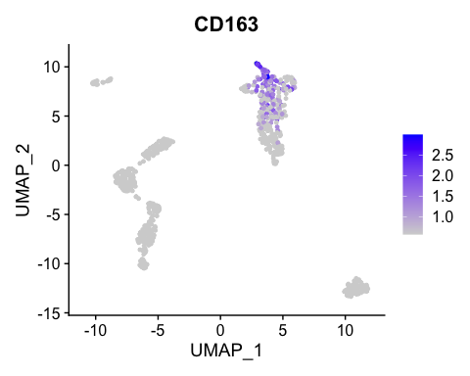

### 6.8 Select the top features

#### Feature identification based on up-reg genes and pangloadb

features <- c("CST3", "CD86", "SPP1", "C1QA", "CTHRC1", "MGP", "CXCL13", "TNFRSF18", "JCHAIN", "IGKC",  
 "NKG7", "GNLY", "IL7R", "RPL34", "STMN1", "KIAA0101")

### 6.9 Assign the new clusters to data

new.cluster.ids <- c("Mature DC", "DC", "Fibroblast", "T cell", "Immature DC",  
 "NK cells", "Naive T cell", "TNBC")

## 7. Visulization

### 7.1 View annotated clusters

names(new.cluster.ids) <- levels(Seurat.obj.filt)  
Seurat.obj.filt <- RenameIdents(Seurat.obj.filt, new.cluster.ids)  
DimPlot(Seurat.obj.filt, reduction = "umap", label = TRUE, pt.size = 0.5) + NoLegend()

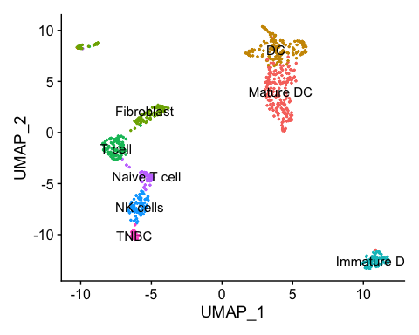

DimPlot(Seurat.obj.filt, reduction = "umap")

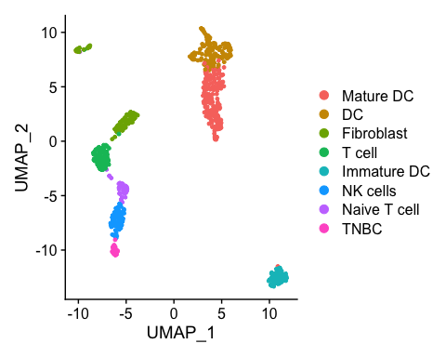

### 7.2 Single cell heatmap of features expression

DoHeatmap(subset(Seurat.obj.filt, downsample = 700), features = features, size = 3)

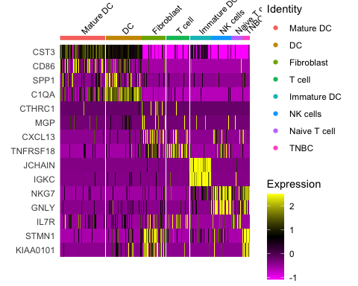

### 7.3 Feature plot

#### Visualize feature expression in low-dimensional space

FeaturePlot(Seurat.obj.filt, features = features, ncol = 4)

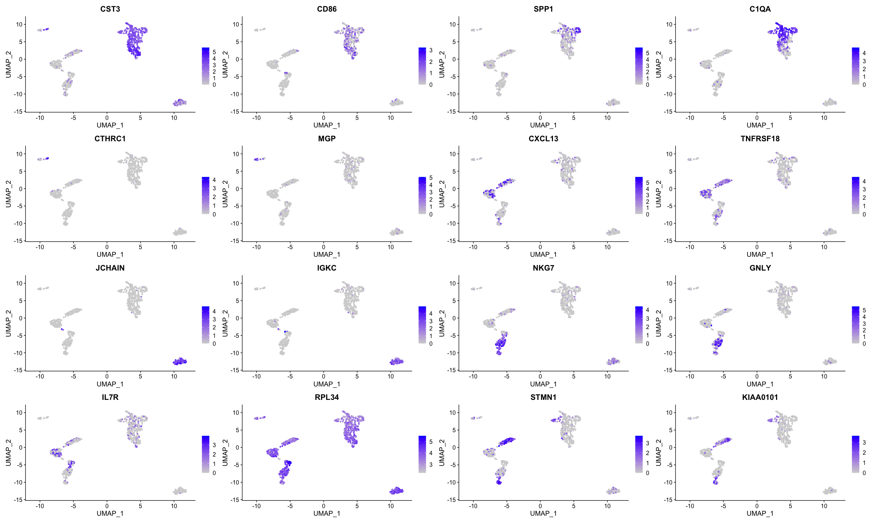

### 7.4 Heatmap plot

#### Select top (6 -> can be changed) upregulated genes in each cluster

top.features <- Seurat.obj.filt.markers %>%  
 group_by(cluster) %>%  
 slice_max(n = 6, order_by = avg_log2FC)  
DoHeatmap(subset(Seurat.obj.filt, downsample = 700), features = top.features$gene, size = 3)

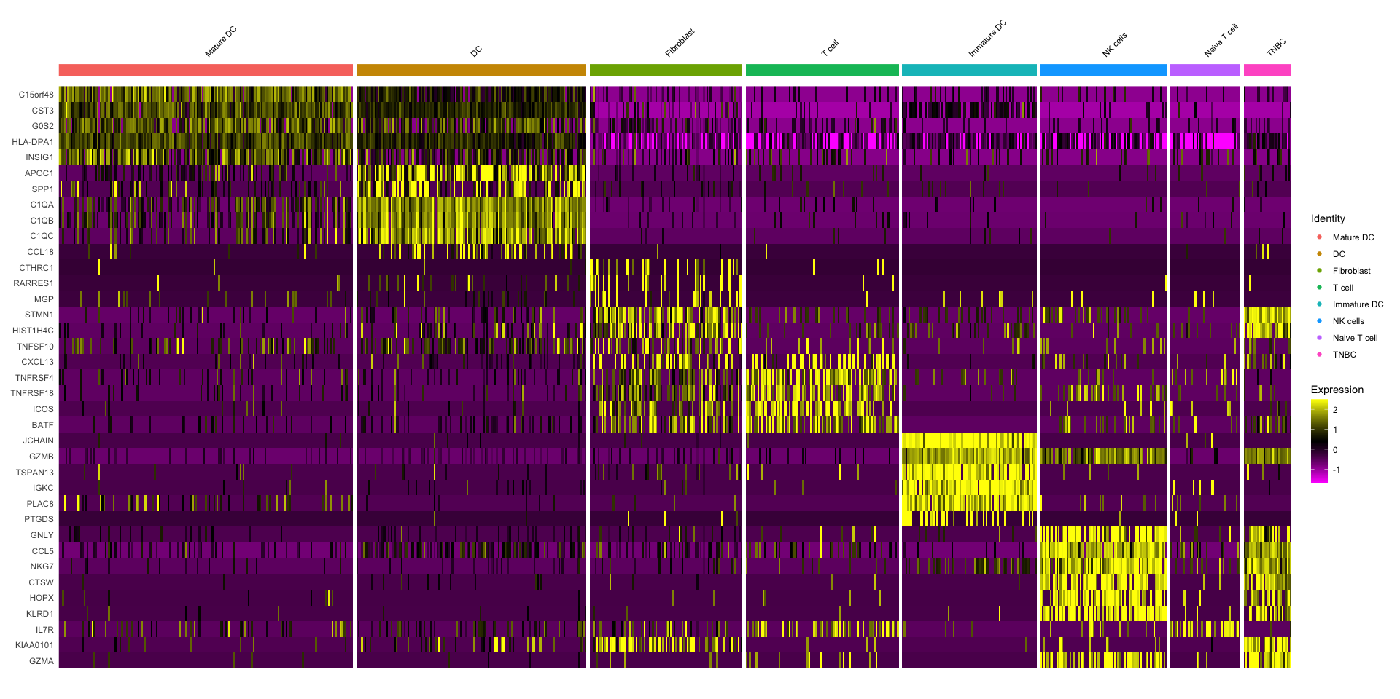

### 7.5 Dot plots

#### the size of the dot corresponds to the percentage of cells expressing the feature in each cluster. The color represents the average expression level

DotPlot(Seurat.obj.filt, features = features) + RotatedAxis()

