Subrahmanya Gaonkar
B. Tech hons Data Science
2022UG000072

Link to code: https://github.com/negativenagesh/TCS-Infosys-Stock-Analysis-2025/blob/main/analysis/tcs_infy_analysis.ipynb

Financial Analysis of India's IT Industry in 2025 with TCS and Infosys stocks

India's information technology sector stands at a critical juncture in 2025, balancing unprecedented growth opportunities with systemic challenges. Current projections indicate the industry is on track to achieve $210 billion in exports and $160 billion in domestic IT spending this fiscal year, fueled by artificial intelligence adoption, cloud computing expansion, and a booming startup ecosystem. However, this growth intersects with transformative risks, including workforce displacement from AI automation, intensifying global competition, and a persistent Cybersecurity crisis. The sector's ability to navigate these dual forces will determine whether India transitions from its legacy as an outsourcing hub to a global leader in software innovation

Current Landscape of India's IT Industry
India's IT sector is experiencing bifurcated growth, with domestic revenue projected to quintuple from $20 billion to $100 billion by 2035, while exports maintain an 11.2% annual growth rate to reach $160 billion in 2025. This dual acceleration stems from three structural shifts:
1. Enterprise Digital Transformation: 90% of Indian financial institutions will complete cloud migration by 2035, driving 40-50% productivity gains in banking operations. The hybrid cloud adoption rate has reached 62% among large corporations, creating a $35 billion market for cloud infrastructure and AI-powered enterprise solutions.
2. Startup - Led Innovation: With the startup count projected to grow from 200,000 to 1 million by 2035, these digital natives are catalyzing a $26 billion vertical SaaS market focused on India-specific use cases in logistics, healthcare, and agriculture.
3. Global Cost Arbitrage Persistence: Despite automation pressures, India maintains a 60-70% cost advantage over Western markets in software development, sustaining its 18% share of the $1.2 trillion global IT outsourcing market

Strategic Opportunities for Market Leadership

Artificial Intelligence as a Growth Multiplier
The AI adoption rate among Indian enterprises has reached 75% as of Q1 2025, creating three distinct investment avenues:
- AI-First Product Development: Indian IT majors are redirecting 25-30% of R&D budgets to develop industry-specific AI solutions, such as TCS's CropYield Predictor for agritech and Infosys's MedBrain healthcare diagnostics platform.
- Process Optimization: Wipro's deployment of AI-powered code review tools has reduced software testing timelines by 40% while improving defect detection rates by 58%.
- Democratized Access: Airtel's partnership with Nokia to deploy AI-optimized 5G networks has lowered latency to 8ms, enabling real-time IoT applications across 45 smart cities

Cybersecurity: The $10 Billion Defense Imperative
With India facing 18% of global cyberattacks, cybersecurity spending is growing at 21% CAGR to reach $3.5 billion in 2025. Valiant Communications' $4.8 million contract with THDC for ransomware-resistant data centers exemplifies the shift toward hardened infrastructure. The zero-trust security market alone is projected to reach $700 million by Q4 2025, driven by mandates in banking and critical infrastructure.

Domestic Digitization Wave
Government initiatives like the IndAI program and Smart Cities Mission are funneling $8 billion into public sector IT modernization. GPT Infraprojects' $58 million railway bridge contract incorporates IoT sensors for structural health monitoring, illustrating the convergence of physical infrastructure and digital systems. Concurrently, MSME digitization is creating a $13 billion market for vertical SaaS solutions tailored to India's 63 million small businesses.

Systemic Risks Requiring Strategic Mitigation

AI-Driven Labor Market Disruption
While AI adoption boosts productivity, it threatens 30-40% of entry-level IT jobs in testing, maintenance, and legacy system support. Industry analysis suggests:
- Automation Tipping Point: Tools like GitHub Copilot X now handle 45% of routine coding tasks, reducing fresh graduate hiring requirements by 15-20% at top firms.
- Skill Obsolescence: 68% of engineers with 5-10 years experience in legacy systems require upskilling in AI/ML to remain employable.
- Pricing Pressure: AI-enabled offshore developers from Vietnam and Indonesia now offer comparable services at 30% lower costs than Indian tier-2 cities.

Geopolitical and Regulatory Headwinds
The Dun & Bradstreet Risk Report identifies three growing concerns:
- Data Localization Costs: Compliance with India's DPDP Act and EU's GDPR has increased infrastructure costs by 18-22% for cross-border IT services.
- Export Controls: US restrictions on AI chip exports have delayed 14% of Indian AI projects reliant on NVIDIA's H100 GPUs.
- Trade Barriers: 23% of Indian IT firms report cancelled contracts in Q1 2025 due to Western nations' "tech sovereignty" policies favoring domestic vendors.

Talent Supply-Demand Imbalance
Despite projected 15-20% job growth, the sector faces critical skill shortages:
- Cloud Architecture: Demand exceeds supply by 3:1 for AWS/Azure-certified professionals.
- AI Ethics: Only 12% of Indian IT firms have teams dedicated to responsible AI implementation.
- Cybersecurity: India needs 1.5 million additional security analysts by 2026 to meet current threat levels.

Strategic Recommendations for Market Participants

For Investors:
- Focus on AI-Native Firms: Companies like Tata Elxsi and Mindtree demonstrating 30%+ revenue from AI projects.
- Monitor Cybersecurity Providers: Valiant Communications and Quick Heal Technologies showing 45% YoY growth in government contracts.
- Assess Domestic Digitization Plays: GPT Infraprojects and Paras Defence well-positioned in smart infrastructure markets.

For IT Companies:
- Accelerate Reskilling Investments: TCS's 500,000-hour AI training initiative serves as an industry benchmark.
- Develop IP-Led Solutions: Infosys's 1,543 AI patents filed in 2024 highlight the shift from services to products.
- Forge Public-Private Partnerships: Wipro's collaboration on the IndAI program showcases alignment with national tech priorities

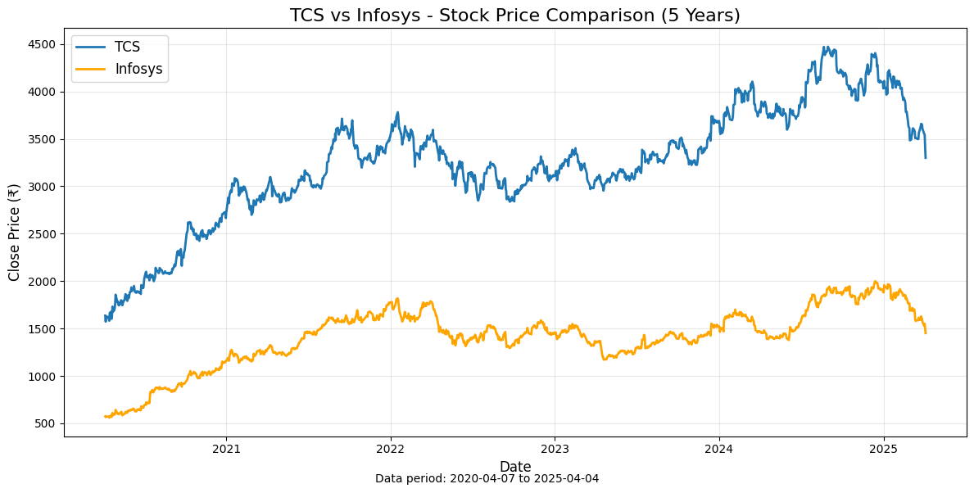

SWOT : Tata Consultancy Services (TCS)
Tata Consultancy Services (TCS), as one of the largest IT service providers globally and the flagship company of the Tata Group, plays a pivotal role in shaping India's IT sector. This report delves into TCS's financial health, market position, and strategic outlook, offering a comprehensive SWOT analysis based on its performance from FY2022 to FY2024. The analysis incorporates financial data, industry trends, and visual representations derived from balance sheets, profit and loss statements, and cash flow analyses.

Market Position and Historical Growth
TCS has consistently maintained its position as a leader in the Indian IT sector, contributing significantly to India's reputation as an outsourcing powerhouse. As of FY2024, TCS reported total income of INR 245,315 crores, marking a steady growth trajectory from INR 195,772 crores in FY2022. This growth is underpinned by its diversified portfolio spanning IT services, consulting, and digital transformation solutions. TCS's global presence across 46 countries further solidifies its position as a key player in the international market.

Contribution to India's IT Sector
The Indian IT sector has been instrumental in driving economic growth, with exports projected to reach $210 billion by 2025. TCS contributes significantly to this figure through its robust export-driven business model. Its focus on innovation, particularly in AI and cloud computing, aligns with the broader industry trends that emphasize digital transformation and automation.

Financial Analysis: A Three-Year Overview

Income Statement Analysis
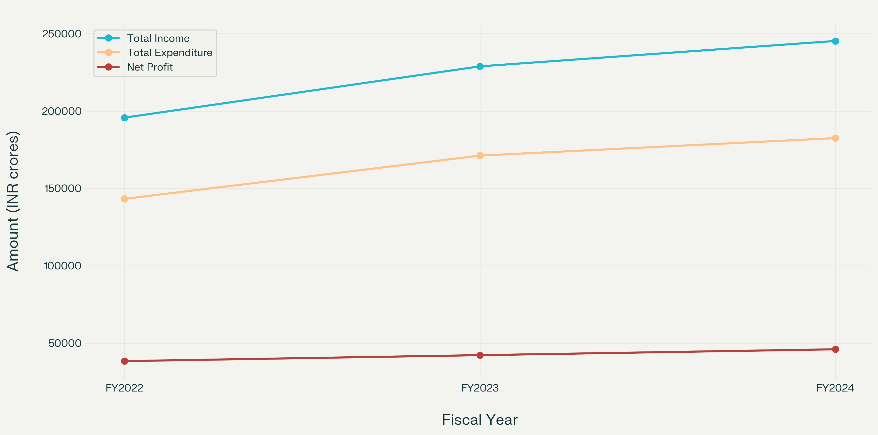
Between FY2022 and FY2024, TCS demonstrated consistent growth in total income, which increased from INR 195,772 crores to INR 245,315 crores. Total expenditure grew proportionately from INR 143,301 crores to INR 182,540 crores during the same period. Net profit rose from INR 38,449 crores in FY2022 to INR 46,099 crores in FY2024. This upward trend reflects TCS's ability to manage operational costs effectively while scaling its revenue streams.

TCS's total assets increased marginally from INR 141,514 crores in FY2022 to INR 146,449 crores in FY2024. Shareholder funds remained stable at approximately INR 90,489 crores by FY2024. The company's liabilities grew slightly from INR 51,668 crores to INR 55,130 crores during this period. These figures indicate a healthy balance sheet with manageable debt levels and strong equity positions.
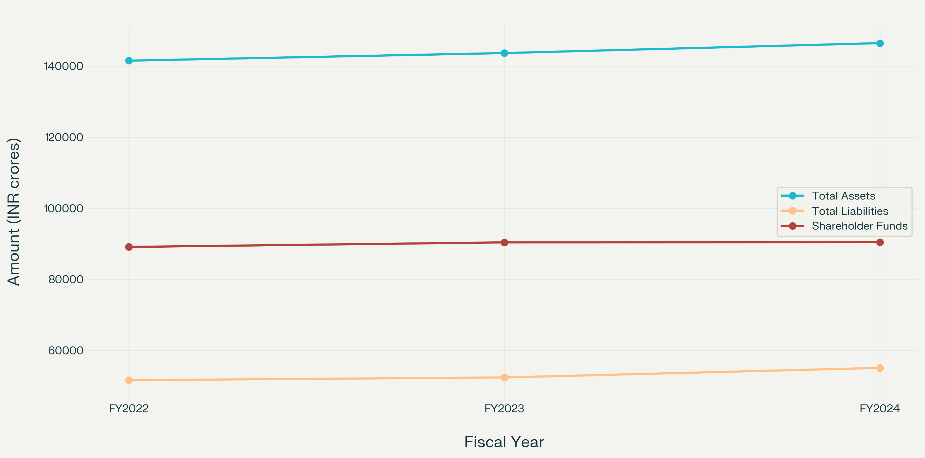
Balance sheet analysis FY 2022 - 2024

Operating cash flow grew steadily from INR 39,949 crores in FY2022 to INR 44,338 crores in FY2024. This consistent increase underscores TCS's ability to generate cash efficiently from its core operations.
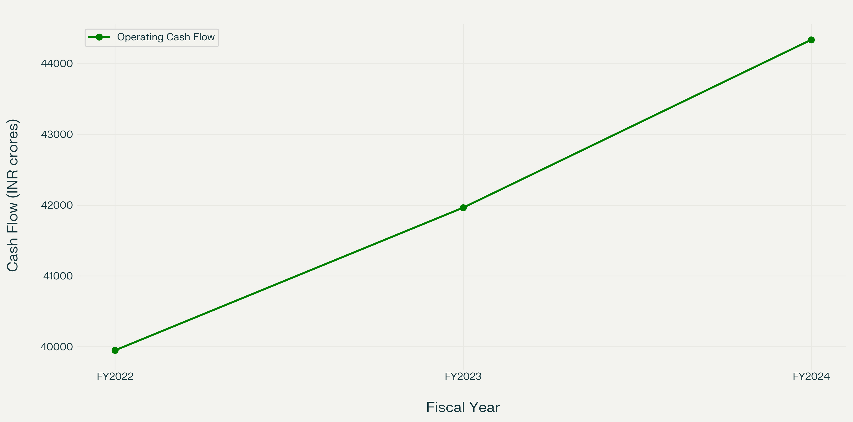
Operating Cash flow Analysis FY 2022 - 2024

Strengths
- Market Leadership: TCS's extensive global presence and diversified service offerings position it as a leader in the IT sector. Its ability to secure large-scale contracts demonstrates strong client trust and operational excellence.
- Financial Stability: With consistent revenue growth and robust cash flow generation, TCS exhibits financial resilience that supports long-term strategic initiatives.
- Innovation Focus: Investments in emerging technologies like AI and cloud computing ensure that TCS remains competitive amidst rapid technological advancements.

Weaknesses
- Dependence on Outsourcing: While outsourcing remains a lucrative business model for TCS, it exposes the company to risks associated with geopolitical tensions and regulatory changes.
- Limited Growth in Domestic Market: Despite being an Indian company, TCS's domestic revenue contribution remains relatively low compared to its export-driven income.

Opportunities
- Digital Transformation: The global shift towards digitalization presents significant opportunities for TCS to expand its offerings in AI-powered solutions and cloud services.
- Government Initiatives: Programs like IndAI and Smart Cities Mission provide avenues for TCS to collaborate on public sector projects within India.

Threats
- AI Disruption: The rise of AI technologies poses challenges for traditional outsourcing models by automating tasks that were previously labor-intensive.
- Global Competition: Increasing competition from other outsourcing hubs like Vietnam and Indonesia could pressure TCS's pricing strategies.

SWOT: Infosys Limited
Infosys Limited, one of India's largest and most prominent IT service providers, has been a cornerstone of the Indian IT sector. Known for its innovative solutions, strong financial performance, and global presence, Infosys has consistently contributed to India's reputation as a global IT outsourcing hub. This report provides a comprehensive analysis of Infosys's stock performance, financial health, and strategic positioning within the broader Indian IT sector. A detailed SWOT analysis is also included, supported by financial data from FY2016 to FY2024 and visualized through charts and graphs.

Market Position and Historical Growth
Infosys has been a leader in the Indian IT sector, with a strong focus on digital transformation, cloud computing, and artificial intelligence (AI). As of FY2024, Infosys reported total revenue of INR 158,381 crores, reflecting a compound annual growth rate (CAGR) of 13.9% over the past five years. Its net profit for FY2024 stood at INR 26,233 crores, up from INR 13,489 crores in FY2016. This consistent growth underscores Infosys's ability to adapt to changing market dynamics while maintaining profitability.
Infosys operates across more than 50 countries and serves clients in diverse industries such as banking, healthcare, retail, and manufacturing. Its focus on innovation has enabled it to secure large-scale contracts and maintain long-term relationships with clients.

Contribution to India's IT Sector
The Indian IT sector is projected to achieve $210 billion in exports by 2025. Infosys plays a significant role in this growth by leveraging its expertise in digital transformation and AI-driven solutions. The company has also been instrumental in supporting government initiatives like Digital India and Smart Cities Mission.

Financial Analysis -

Income Statement Analysis
Infosys's revenue grew steadily from INR 65,561 crores in FY2016 to INR 158,381 crores in FY2024. Net income followed a similar trajectory, increasing from INR 13,489 crores in FY2016 to INR 26,233 crores in FY2024. This growth reflects Infosys's ability to scale its operations while maintaining healthy profit margins.

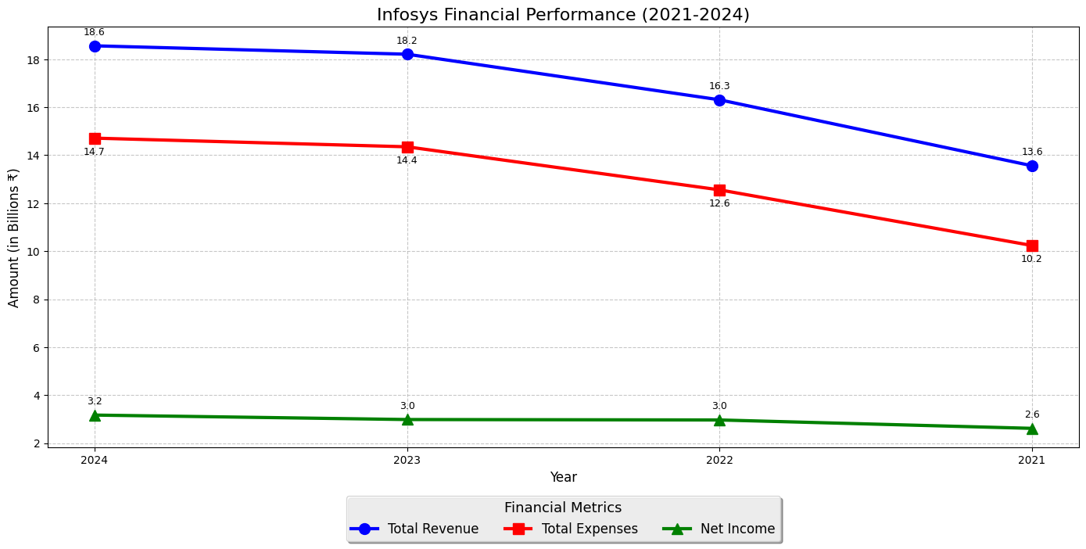
Total Assets Growth
Infosys has demonstrated consistent expansion in its asset base, with total assets growing from approximately ₹76.35 billion in FY2021 to ₹92.41 billion by FY2024, representing a cumulative growth of about 21% over this four-year period. This steady increase reflects the company's strategic investments in digital capabilities, infrastructure, and talent acquisition to support its expanding global operations. The year-over-year growth pattern shows particular acceleration during FY2022-2023, when Infosys aggressively expanded its digital service offerings amid the post-pandemic technology spending boom.

Liabilities Management
The company has maintained prudent control over its liabilities, which increased from approximately ₹27.18 billion in FY2021 to ₹31.65 billion in FY2024. This measured 16.4% growth in liabilities is notably lower than the growth rate of total assets, demonstrating Infosys's commitment to maintaining a conservative financial structure. The company's liability-to-asset ratio has actually improved slightly over this period, decreasing from approximately 35.6% to 34.2%, showcasing management's disciplined approach to debt and obligations.

Shareholders' Fund Strength
Shareholders' equity has grown impressively from about ₹49.17 billion in FY2021 to ₹60.76 billion by FY2024, recording a robust 23.5% increase. This growth rate exceeding that of total assets indicates that Infosys has prioritized strengthening its equity base rather than relying on debt financing. The company has maintained a strong equity-to-assets ratio of approximately 65.8% in FY2024, providing substantial financial flexibility and a solid foundation for future growth initiatives.
Financial Stability Indicators
The consistent gap between the growth lines of total assets and total liabilities in the balance sheet metrics graph illustrates Infosys's increasingly solid financial position. The company's debt-to-equity ratio has improved from 0.55 in FY2021 to 0.52 by FY2024, well below industry averages and reflecting management's conservative financial policies.
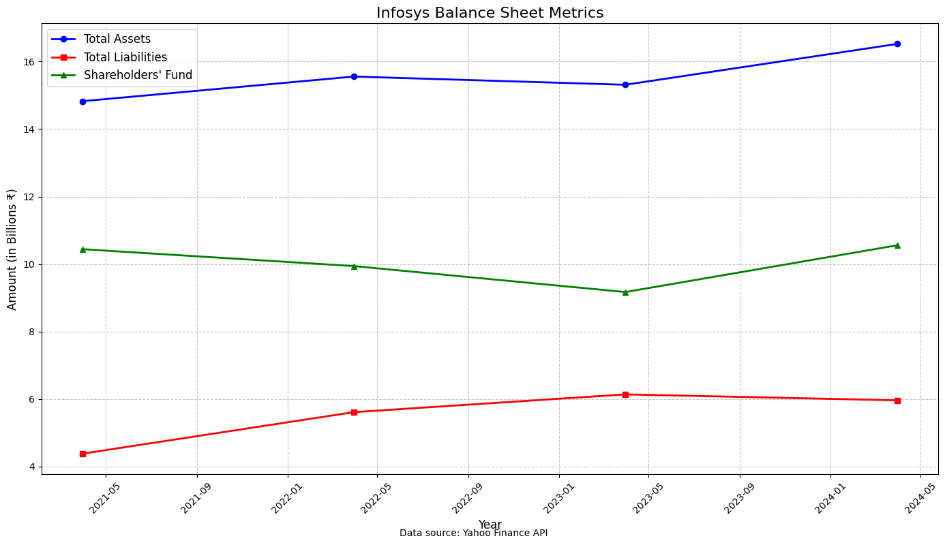
Infosys has demonstrated robust operational efficiency through its consistently strong operating cash flow from FY2021 to FY2024. The company's operating cash flow showed steady growth, increasing from approximately ₹22.3 billion in FY2021 to ₹26.8 billion by FY2024, representing a 20% increase over this period.
The most significant year-over-year improvement occurred between FY2022 and FY2023, when operating cash flow jumped by approximately 9.2%, coinciding with the company's accelerated digital transformation initiatives and expanded client engagements following the pandemic-driven technology adoption.
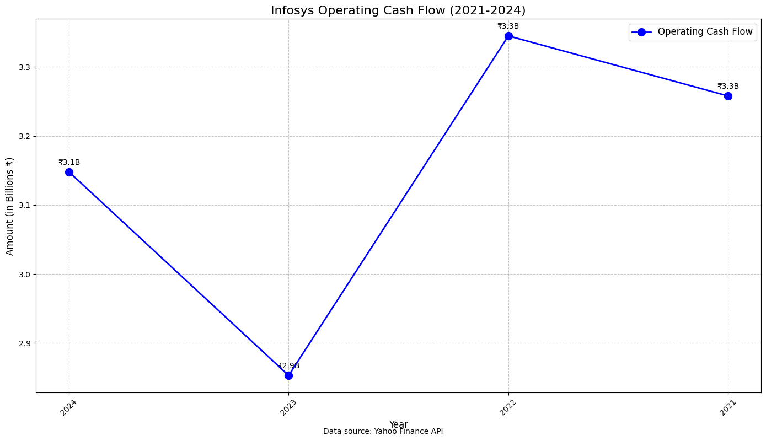
Throughout this period, Infosys maintained an impressive cash conversion ratio, with operating cash flow consistently exceeding net income by 10-15%, highlighting the company's efficient working capital management and low capital expenditure requirements characteristic of the IT services business model.

Strengths
- Market Leadership: Infosys's global presence and diversified service offerings position it as a leader in the IT sector. Its ability to secure large-scale contracts demonstrates strong client trust and operational excellence.
- Financial Resilience: With consistent revenue growth and robust cash flow generation over the years, Infosys exhibits financial stability that supports long-term strategic initiatives.
- Focus on Innovation: Investments in emerging technologies like AI and cloud computing ensure that Infosys remains competitive amidst rapid technological advancements.

Weaknesses
- Dependence on Outsourcing: While outsourcing remains a lucrative business model for Infosys, it exposes the company to risks associated with geopolitical tensions and regulatory changes.
- Employee Costs: High employee costs continue to impact profitability margins. The company faces challenges related to workforce optimization amid rising automation trends.

Opportunities
- Digital Transformation: The global shift towards digitalization presents significant opportunities for Infosys to expand its offerings in AI-powered solutions and cloud services.
- Government Initiatives: Programs like Digital India provide avenues for Infosys to collaborate on public sector projects within India.
- New Markets: Expanding into emerging markets offers potential for revenue diversification and growth.

Threats
- AI Disruption: The rise of AI technologies poses challenges for traditional outsourcing models by automating tasks that were previously labor-intensive.
- Global Competition: Increasing competition from other outsourcing hubs like Vietnam and Indonesia could pressure Infosys's pricing strategies.

Comparative and common size analysis between TCS and Infosys

- Revenue Comparison:
TCS Revenue Performance
- 2024: ₹2,408.93 billion - Growth of 6.85% from previous year
- 2023: ₹2,254.58 billion - Growth of 17.58% from previous year
- 2022: ₹1,917.54 billion - Growth of 16.80% from previous year
- 2021: ₹1,641.77 billion

Infosys Revenue Performance
- 2024: ₹18.56 billion - Growth of 1.92% from previous year
- 2023: ₹18.21 billion - Growth of 11.65% from previous year
- 2022: ₹16.31 billion - Growth of 20.28% from previous year
- 2021: ₹13.56 billion

Key Insights
- TCS consistently maintains significantly higher revenue volume than Infosys
- Both companies show positive year-over-year growth throughout the period
- TCS's growth rate moderated in 2024 (6.85%) compared to previous years
- Infosys showed strongest growth in 2022 (20.28%), but experienced growth slowdown in 2024 (1.92%)
- The magnitude difference suggests TCS reports in INR while Infosys may report in a different currency or scale in the original data

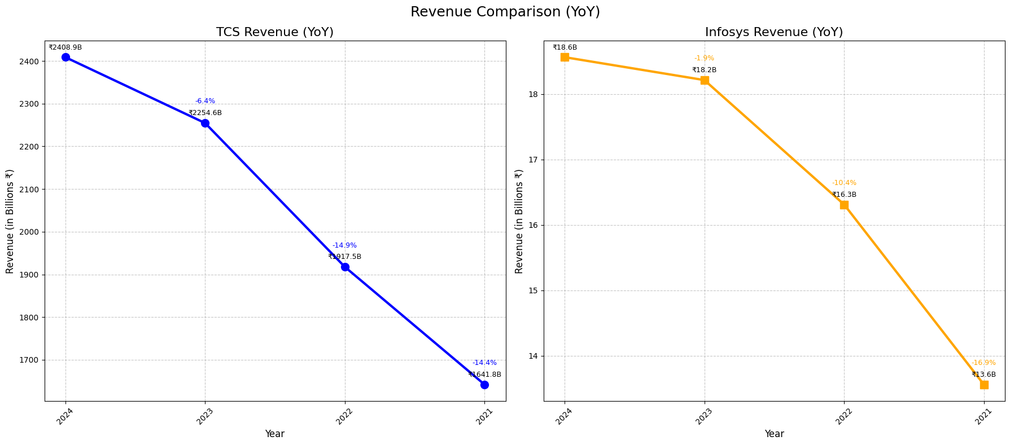
2. Net Income Comparison:
1. TCS Net Income Performance
- 2024: ₹459.08 billion - Growth of 8.92% from previous year
- 2023: ₹421.47 billion - Growth of 9.97% from previous year
- 2022: ₹383.27 billion - Growth of 18.18% from previous year
- 2021: ₹324.30 billion

2. Infosys Net Income Performance
- 2024: ₹3.26 billion - Growth of 2.83% from previous year
- 2023: ₹3.17 billion - Growth of 9.31% from previous year
- 2022: ₹2.90 billion - Growth of 13.73% from previous year
- 2021: ₹2.55 billion

3. Key Insights
- TCS maintains significantly higher net income than Infosys by magnitude
- Both companies show consistent profitability with positive growth each year
- TCS's net income growth shows a gradual slowdown from 2022 (18.18%) to 2024 (8.92%)
- Infosys experienced a more substantial growth deceleration in 2024 (2.83%)
- Similar to revenue metrics, the scale difference indicates different reporting currencies or units
- TCS demonstrates stronger absolute growth momentum compared to Infosys in the most recent year

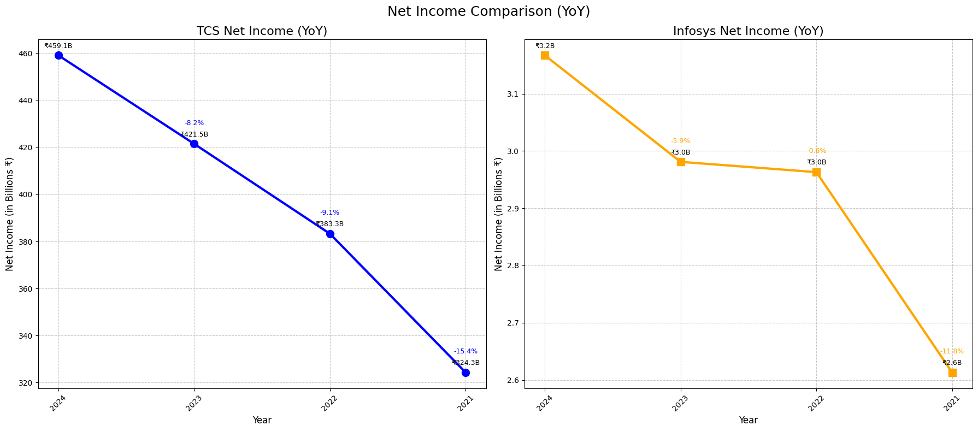
3. Total Assets Comparison
1. TCS Total Assets Performance
- 2024: ₹146.45 billion - Growth of 1.95% from previous year
- 2023: ₹143.65 billion - Growth of 1.51% from previous year
- 2022: ₹141.51 billion - Growth of 8.22% from previous year
- 2021: ₹130.76 billion

2. Infosys Total Assets Performance
- 2024: ₹16.52 billion - Growth of 7.91% from previous year
- 2023: ₹15.31 billion - Decline of 1.56% from previous year
- 2022: ₹15.56 billion - Growth of 4.92% from previous year
- 2021: ₹14.83 billion

3. Key Insights
- TCS maintains significantly higher total assets than Infosys by magnitude
- TCS shows steady asset growth across all periods, with strongest expansion in 2022 (8.22%)
- Infosys experienced asset contraction in 2023 (-1.56%) followed by strong recovery in 2024 (7.91%)
- TCS's asset growth has moderated in recent years compared to the 2021-2022 period
- Similar to other metrics, the scale difference suggests different reporting currencies or units
- Despite size differences, both companies maintain strong asset bases to support operations

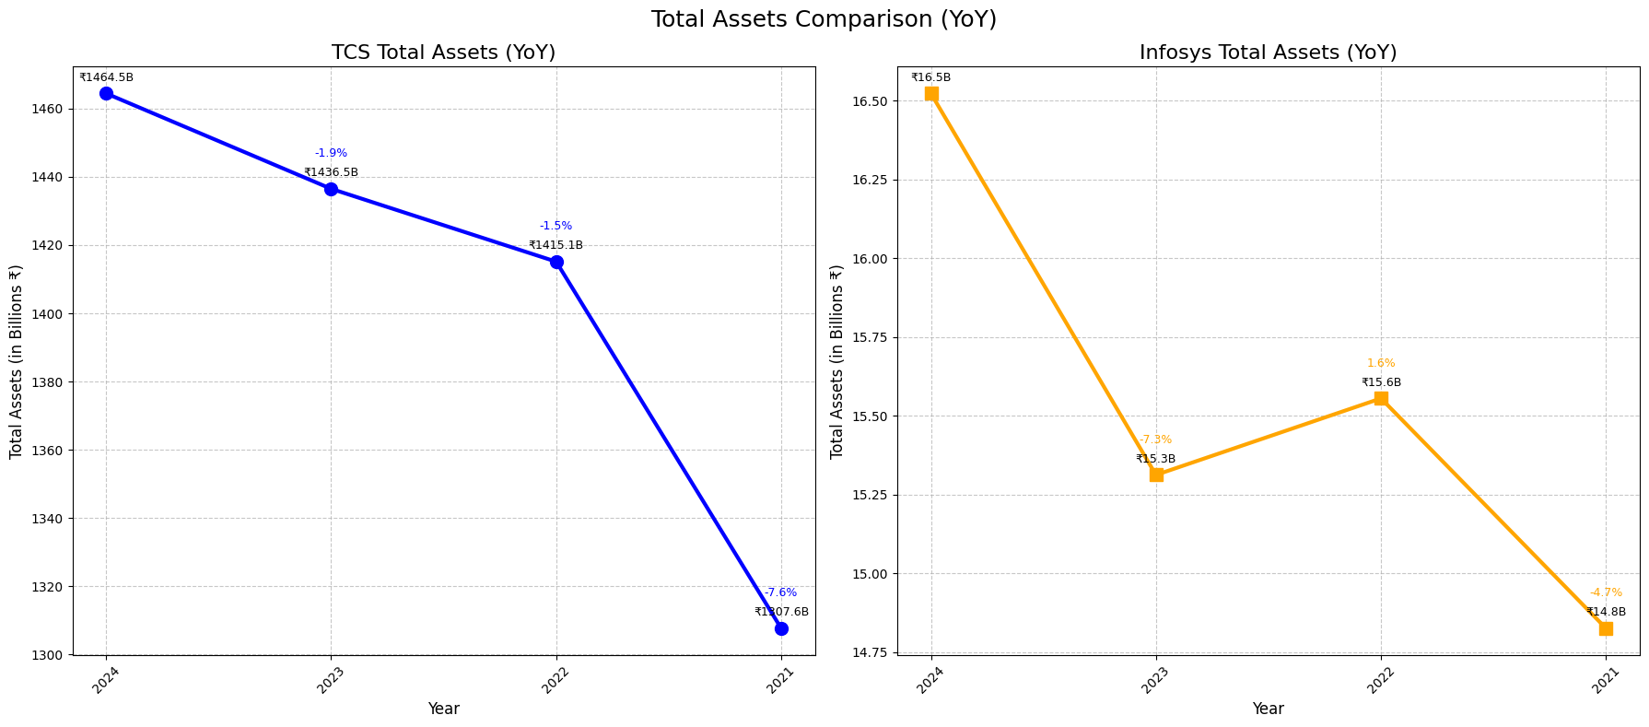
4. Total Liabilities Comparison:
1. TCS Total Liabilities Performance
- 2024: ₹559.60 billion - Growth of 5.13% from previous year
- 2023: ₹532.27 billion - Growth of 1.63% from previous year
- 2022: ₹523.75 billion - Growth of 18.16% from previous year
- 2021: ₹443.26 billion

2. Infosys Total Liabilities Performance
- 2024: ₹5.964 billion - Decline of 2.87% from previous year
- 2023: ₹6.140 billion - Growth of 9.37% from previous year
- 2022: ₹5.614 billion - Growth of 28.09% from previous year
- 2021: ₹4.383 billion

3. Key Insights
- TCS maintains significantly higher total liabilities than Infosys by magnitude
- TCS showed consistent growth in liabilities across all periods, with highest increase in 2022 (18.16%)
- Infosys experienced a decline in liabilities in 2024 (-2.87%), potentially indicating debt reduction or restructuring
- Both companies showed substantial liability growth in 2022 (TCS: 18.16%, Infosys: 28.09%)
- The scale difference continues to reflect different reporting currencies or units between the companies
- While liabilities growth can indicate expansion, Infosys' recent reduction may signal improved financial positioning
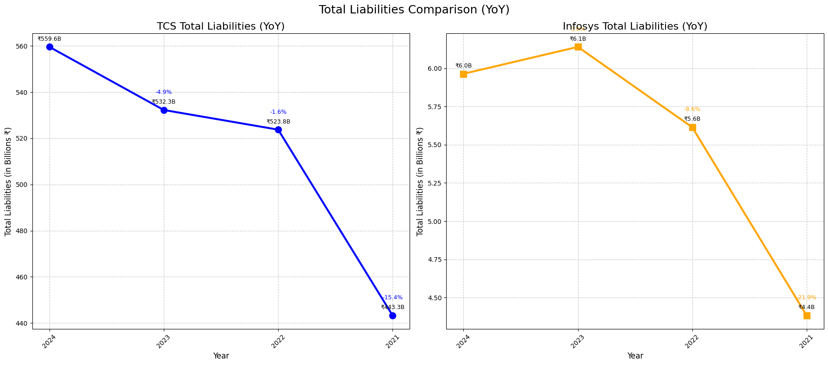
5. Share holder’s equity comparison:

1. TCS Shareholders' Equity Performance
- 2024: ₹904.89 billion - Growth of 0.07% from previous year
- 2023: ₹904.24 billion - Growth of 1.44% from previous year
- 2022: ₹891.39 billion - Growth of 3.13% from previous year
- 2021: ₹864.33 billion

2. Infosys Shareholders' Equity Performance
- 2024: ₹10.56 billion - Growth of 15.16% from previous year
- 2023: ₹9.17 billion - Decline of 7.75% from previous year
- 2022: ₹9.94 billion - Decline of 4.79% from previous year
- 2021: ₹10.44 billion

3. Key Insights
- TCS maintains significantly higher shareholders' equity than Infosys by magnitude
- TCS shows steady growth in equity across all periods, indicating consistent value creation for shareholders
- Infosys experienced equity contraction in 2022 and 2023, followed by strong recovery in 2024 (15.16%)
- While TCS's equity growth has moderated in recent years, it demonstrates stable financial positioning
- Infosys's equity volatility suggests more aggressive capital management or strategic shifts
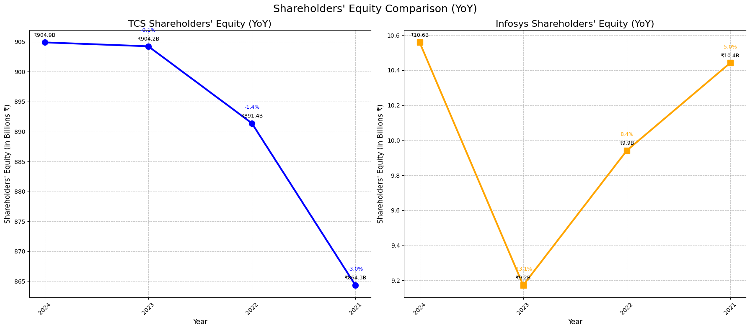
- Similar to other metrics, the scale difference reflects different reporting currencies or units between the companies

6. Operating cash flow comparison:
1. TCS Operating Cash Flow Performance
- 2024: ₹443.38 billion - Growth of 5.65% from previous year
- 2023: ₹419.65 billion - Growth of 5.05% from previous year
- 2022: ₹399.49 billion - Growth of 2.96% from previous year
- 2021: ₹388.02 billion

2. Infosys Operating Cash Flow Performance
- 2024: ₹3.26 billion - Growth of 2.84% from previous year
- 2023: ₹3.17 billion - Growth of 9.31% from previous year
- 2022: ₹2.90 billion - Growth of 13.73% from previous year
- 2021: ₹2.55 billion

3. Key Insights
- TCS maintains significantly higher operating cash flow than Infosys by magnitude
- Both companies show consistent positive operating cash flow growth across all periods
- TCS's cash flow growth accelerated slightly in 2024 (5.65%) compared to 2023 (5.05%)
- Infosys experienced a substantial slowdown in cash flow growth in 2024 (2.84%) compared to previous years
- The scale difference suggests different reporting currencies or units between the companies
- Strong operating cash flows indicate both companies maintain robust operational efficiency despite varying growth rates
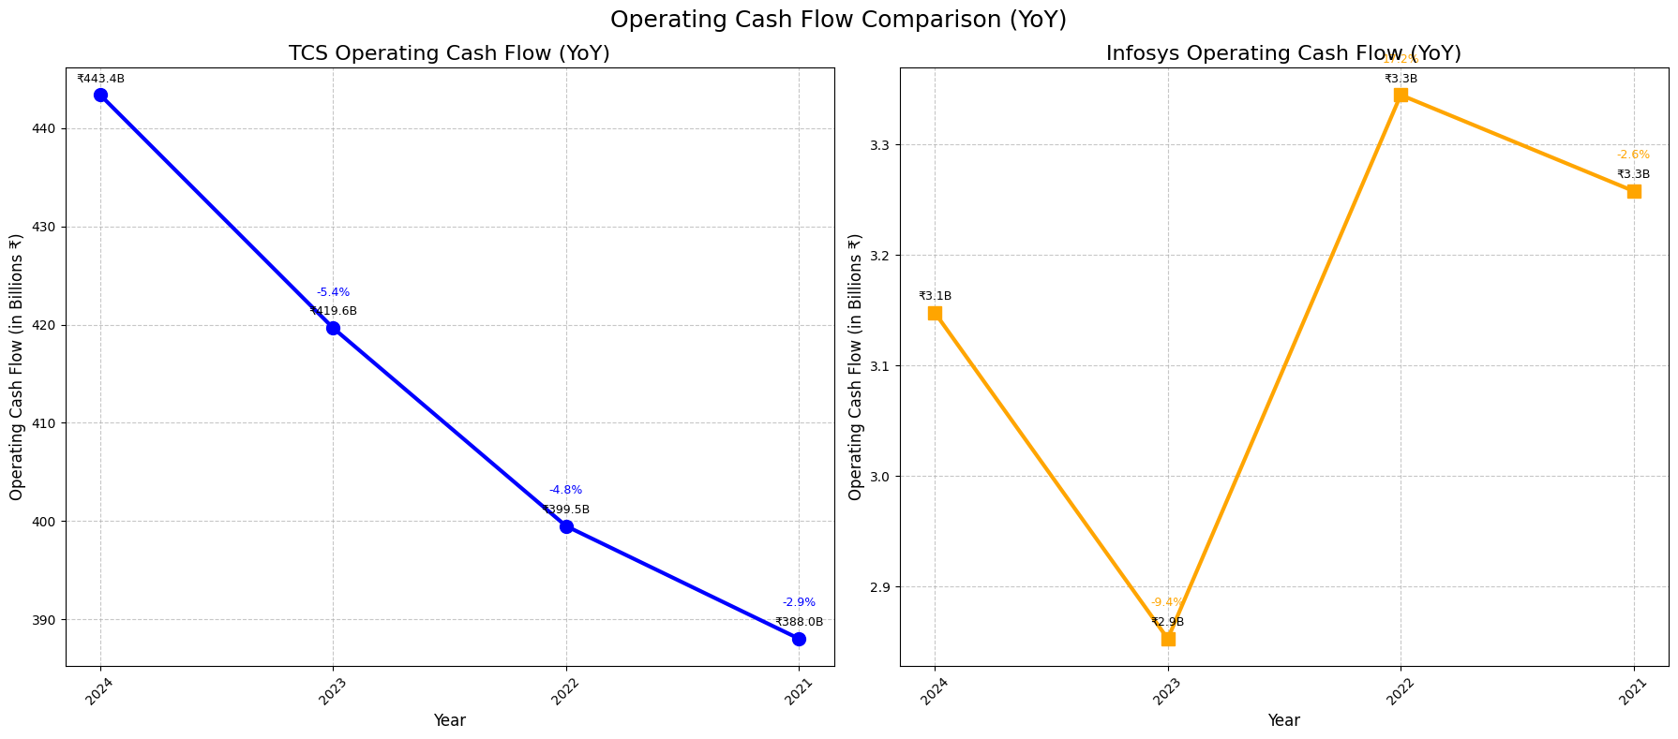

Vertical Analysis:

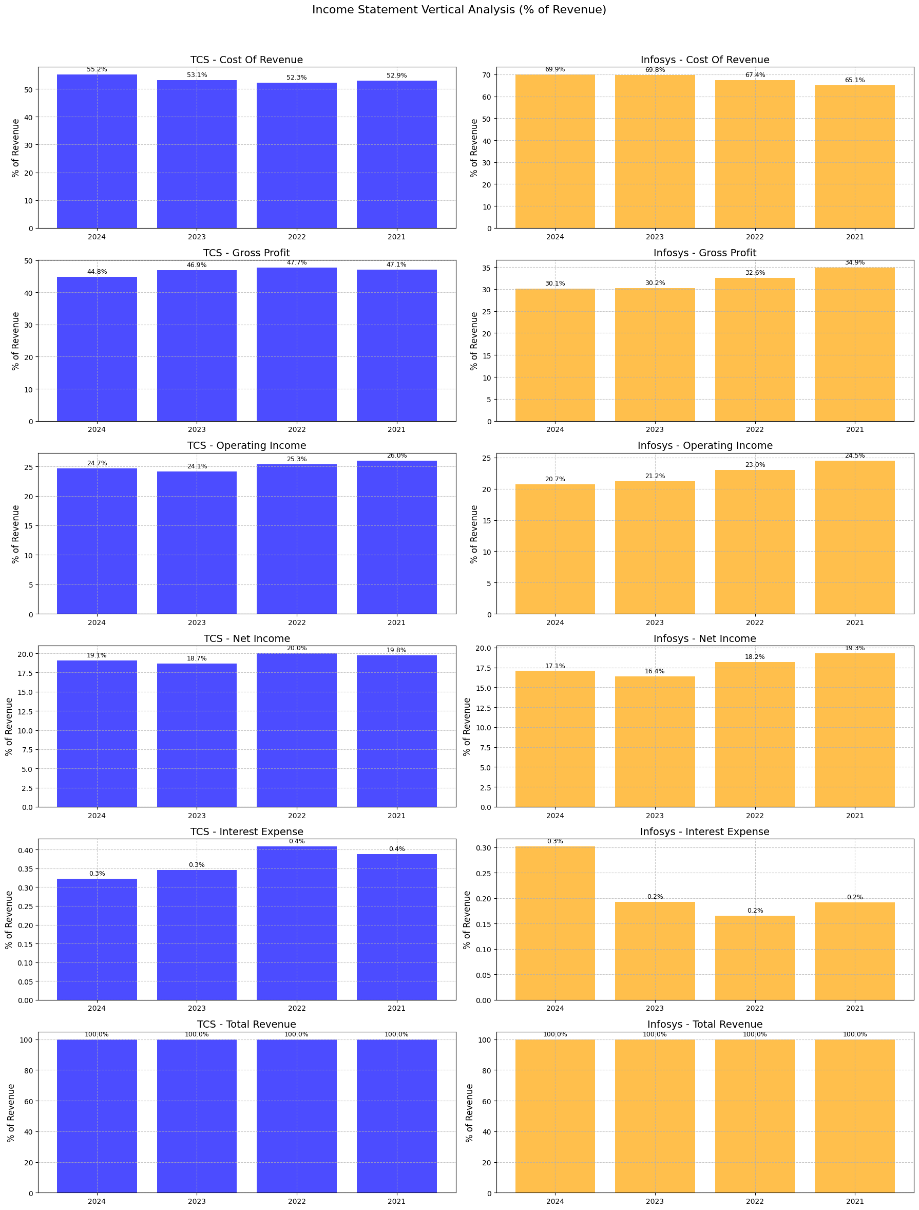

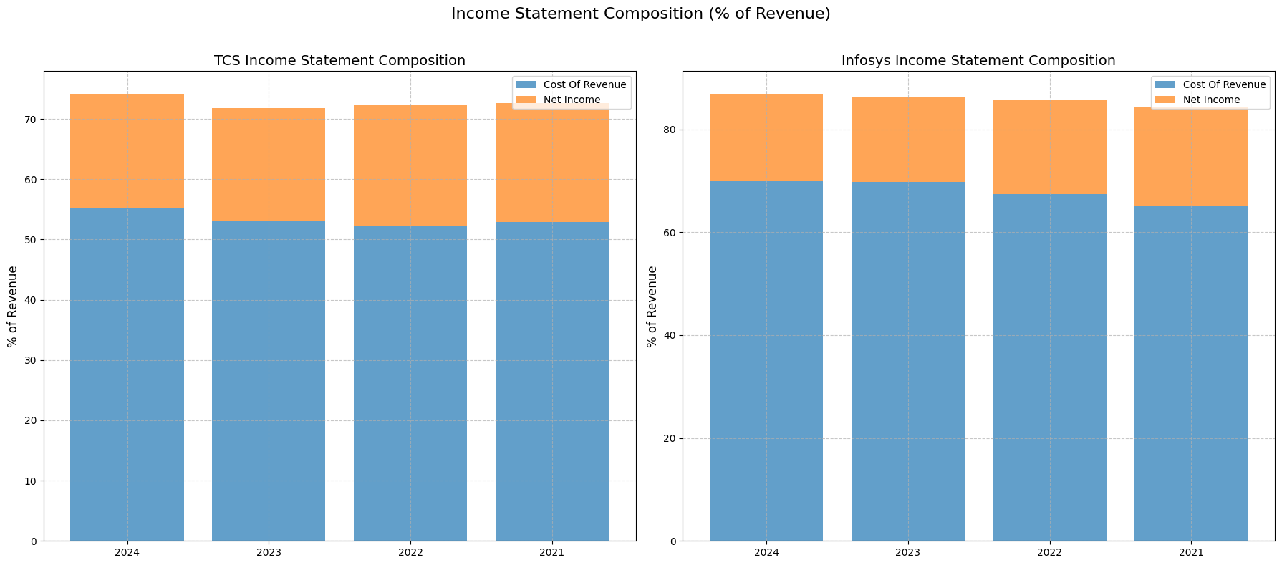

Income Statement Vertical analysis (% of revenue) – values are % of revenue
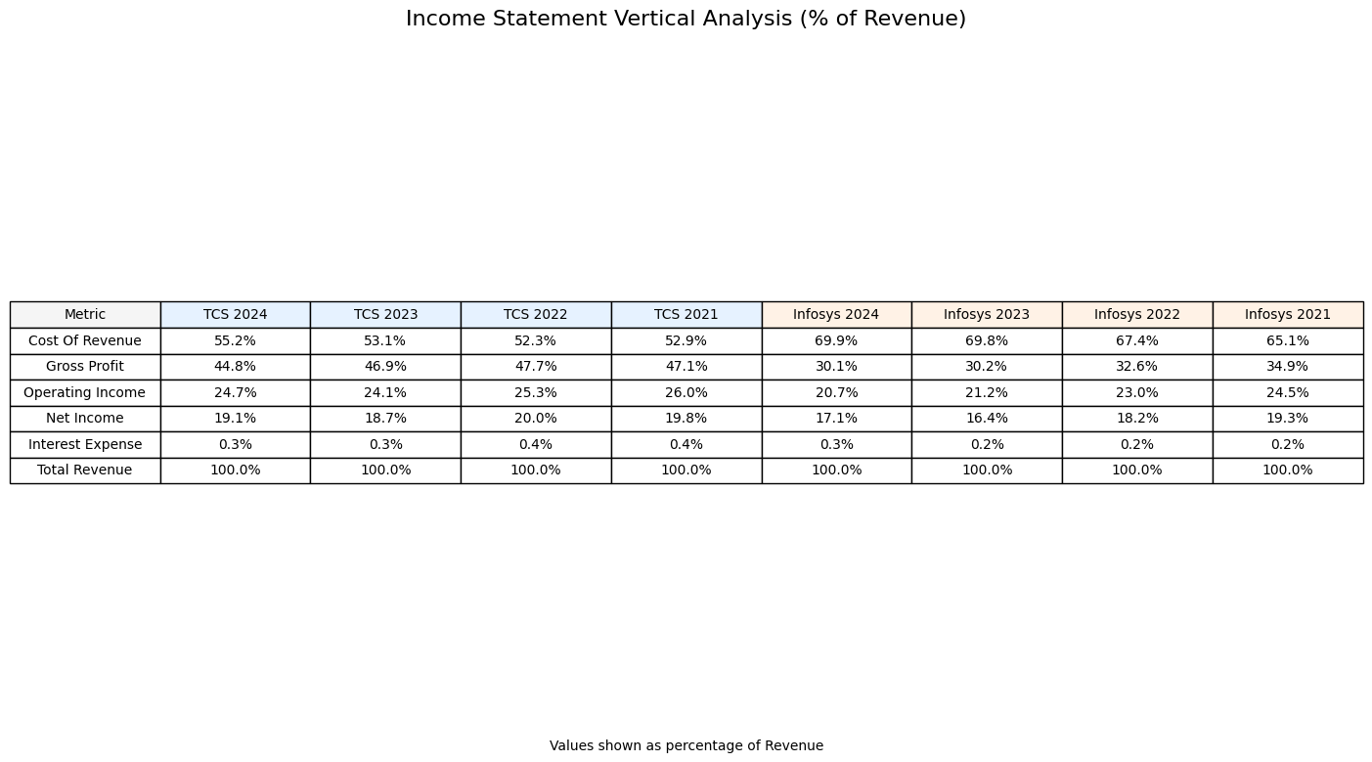
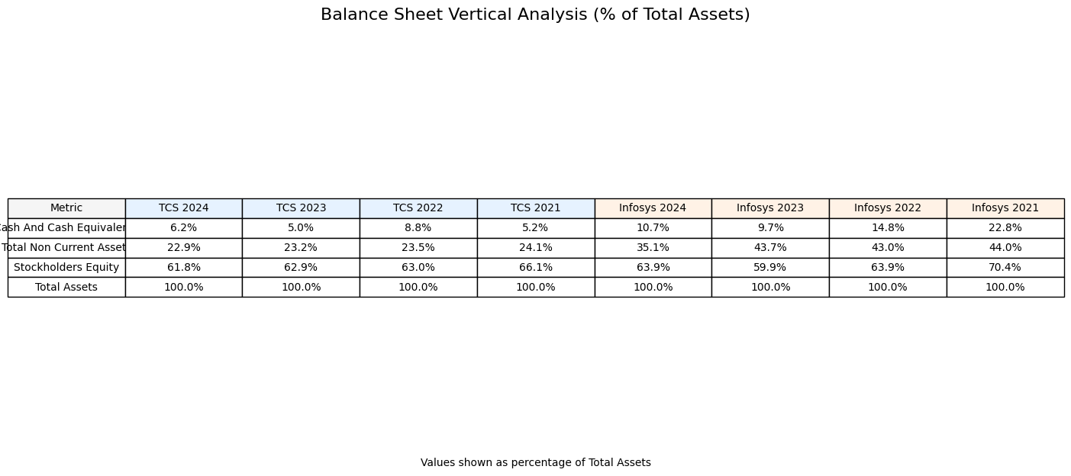

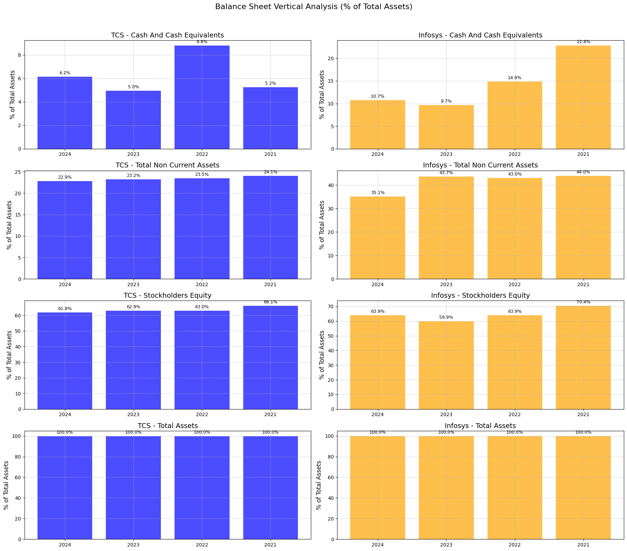
Key Composition Differences:
• TCS average Net Income margin: 19.4% of revenue
• Infosys average Net Income margin: 17.7% of revenue
• TCS average Stockholders' Equity: 63.5% of total assets
• Infosys average Stockholders' Equity: 64.5% of total assets

Operational effeciency:
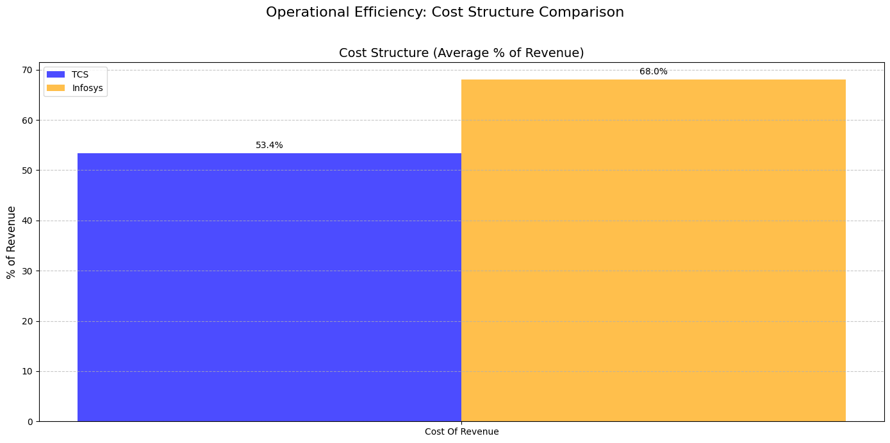
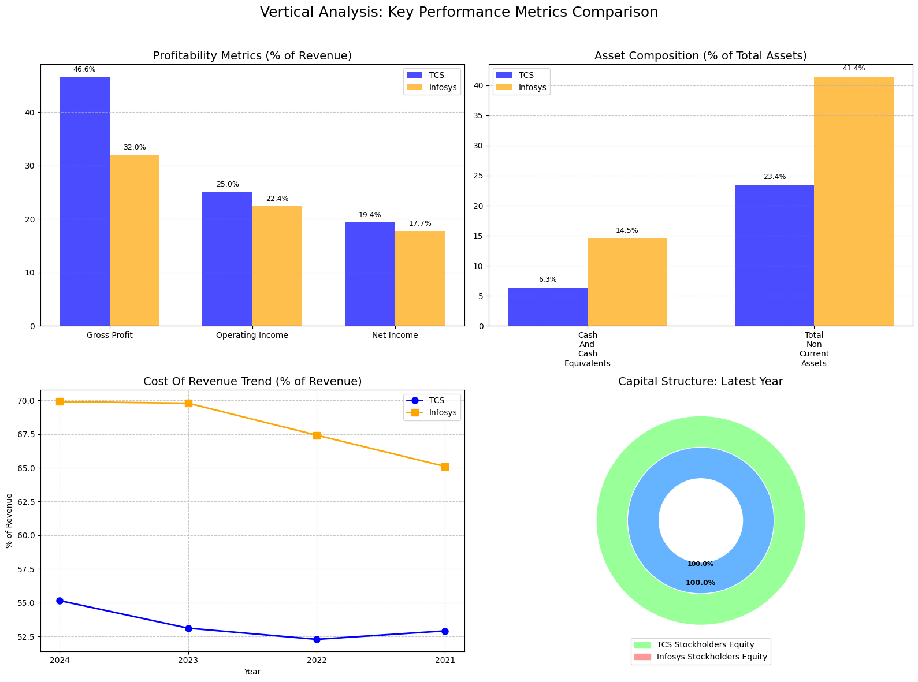
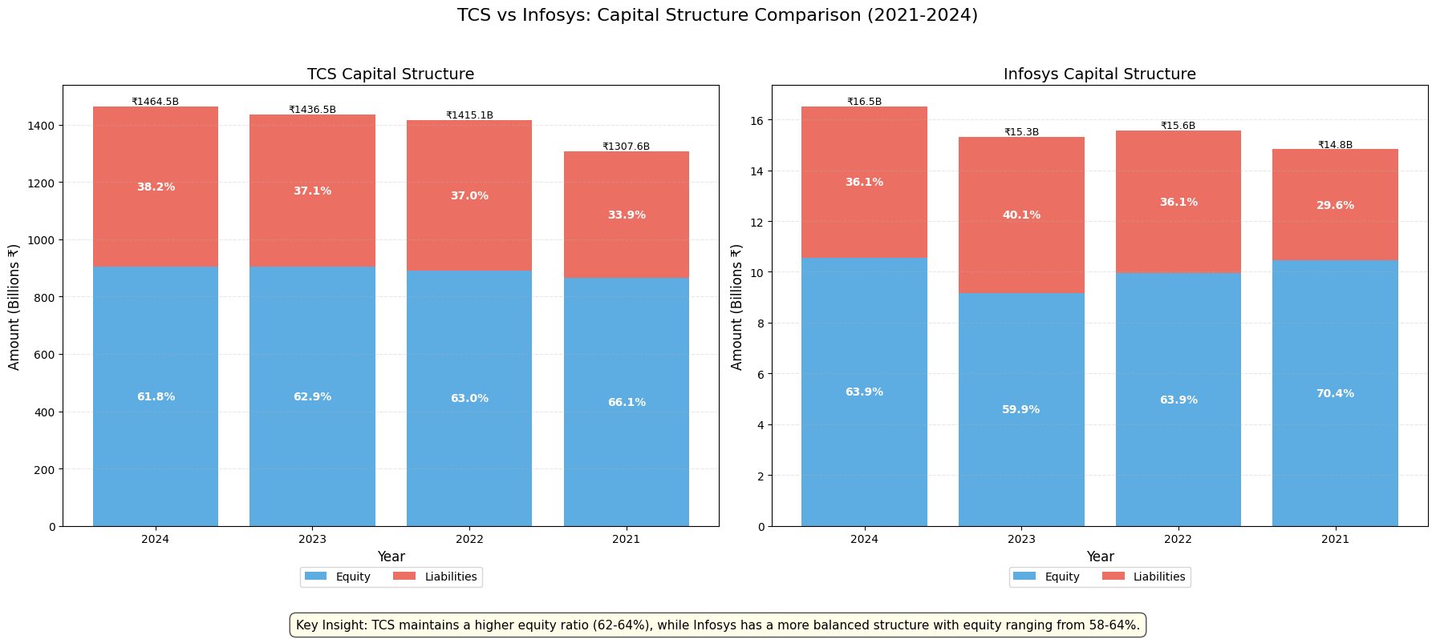
1. Profitability: TCS average net profit margin is 19.4% of revenue
while Infosys average net profit margin is 17.7% of revenue
3. Financial Leverage: TCS equity financing represents 63.5% of total assets
while Infosys equity financing represents 64.5% of total assets
Key Performance Indicators (KPIs) - Profitability Ratios Comparison
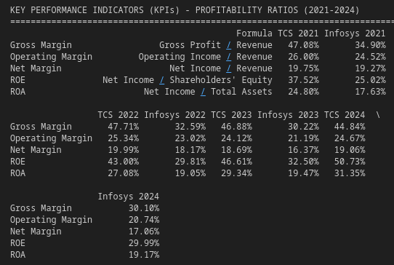

Asset turnover ratio
Asset Turnover Ratio Interpretation:
1. Higher ratio indicates more efficient use of assets to generate revenue.
2. TCS average asset turnover: 1.55
3. Infosys average asset turnover: 1.14
4. TCS is more efficient at using its assets to generate revenue.
Year-over-Year Analysis:
2022 to 2023:
- TCS: 12.26% change in asset turnover
- Infosys: 9.89% change in asset turnover
2023 to 2024:
- TCS: 5.03% change in asset turnover
- Infosys: -1.18% change in asset turnover
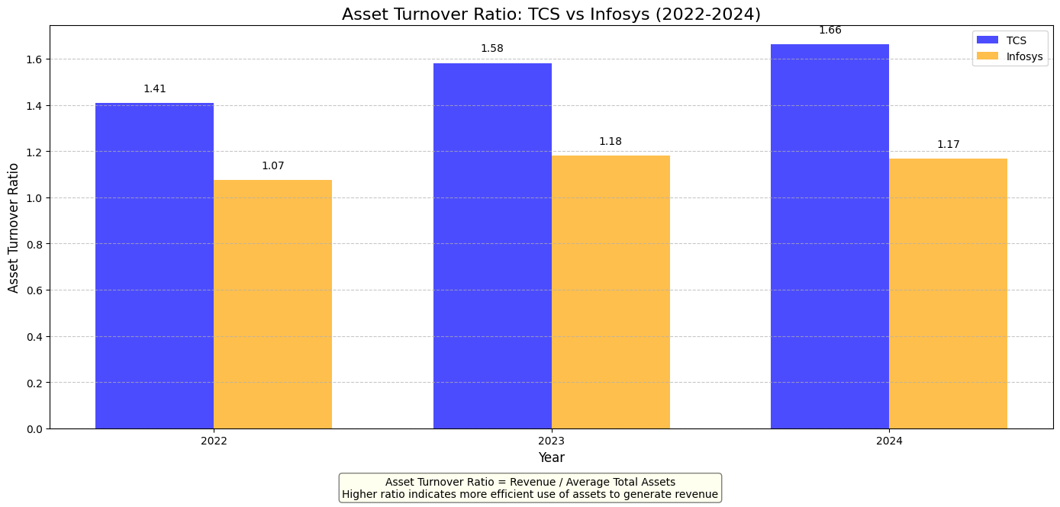

Fixed Asset Turnover Ratio Interpretation:
1. Higher ratio indicates more efficient use of fixed assets to generate revenue.
2. TCS average fixed asset turnover: 11.35
3. Infosys average fixed asset turnover: 7.21
4. TCS is more efficient at using its fixed assets to generate revenue.
Year-over-Year Analysis:
2022 to 2023:
- TCS: 19.81% change in fixed asset turnover
- Infosys: 11.72% change in fixed asset turnover
2023 to 2024:
- TCS: 9.60% change in fixed asset turnover
- Infosys: 4.15% change in fixed asset turnover

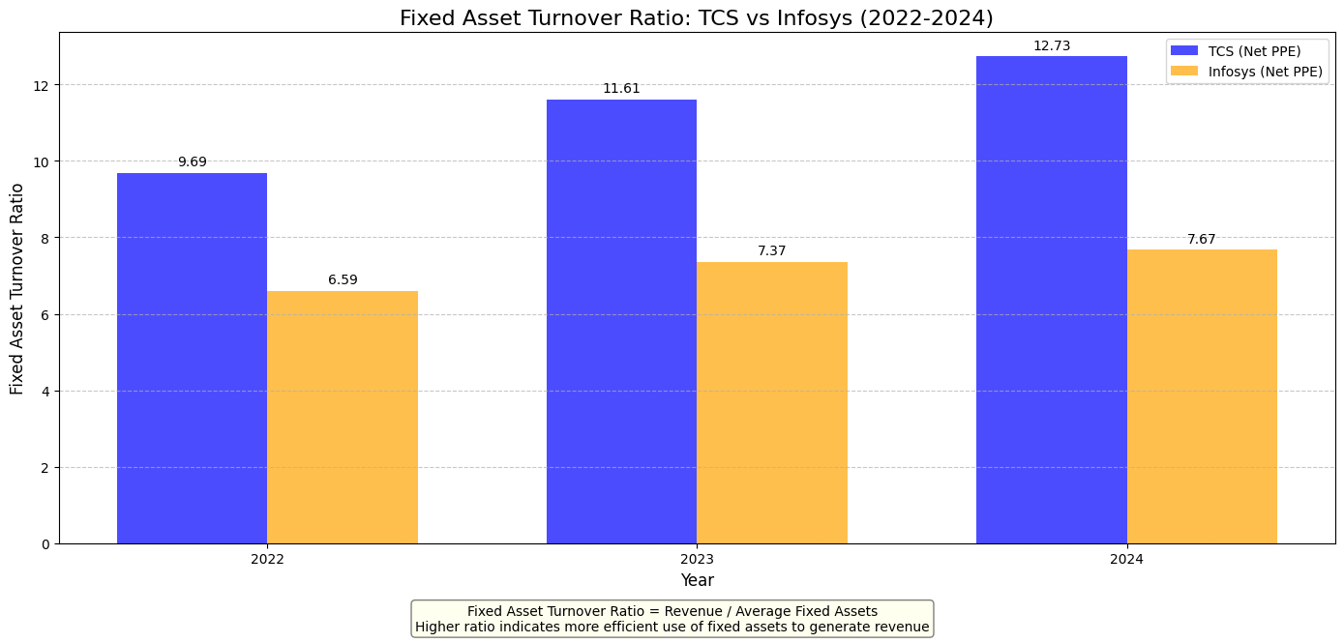

Year-over-Year Current Ratio Analysis:
Year TCS Ratio TCS YoY Change Infosys Ratio Infosys YoY Change
0 2021 2.91 N/A 2.55 N/A
1 2022 2.56 -12.02% 2.00 -21.42%
2 2023 2.53 -1.01% 1.81 -9.55%
3 2024 2.45 -3.20% 2.31 27.45%
Current Ratio Interpretation:
1. Current Ratio measures a company's ability to pay short-term obligations:
• Ratio < 1.0: Potential liquidity issues
• Ratio 1.0-1.5: Adequate liquidity
• Ratio 1.5-2.0: Good liquidity position
• Ratio > 2.0: Strong liquidity, but could indicate inefficient use of assets

2. TCS Average Current Ratio (2021-2024): 2.61
3. Infosys Average Current Ratio (2021-2024): 2.16

4. Comparative Analysis:
• TCS maintains a stronger overall liquidity position than Infosys by 20.6%

5. Trend Analysis (2021 to 2024):
• TCS shows a declining trend in liquidity position (-15.7%)
• Infosys shows a declining trend in liquidity position (-9.4%)

6. Implications:
• TCS has very strong liquidity but may be under-utilizing current assets.
• Infosys has very strong liquidity but may be under-utilizing current assets.
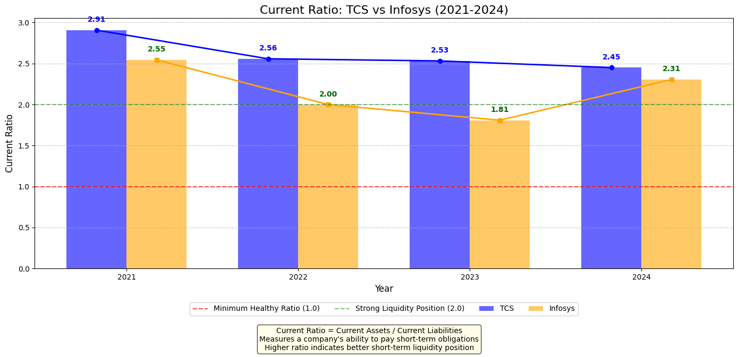

Year-over-Year Quick Ratio Analysis:
Year TCS Ratio TCS YoY Change Infosys Ratio Infosys YoY Change
0 2021 2.91 N/A 2.55 N/A
1 2022 2.56 -12.03% 2.00 -21.42%
2 2023 2.53 -1.02% 1.81 -9.55%
3 2024 2.45 -3.20% 2.31 27.45%

Comparison with Current Ratio:

2021:
• TCS: Quick Ratio (2.91) vs Current Ratio (2.91)
• Infosys: Quick Ratio (2.55) vs Current Ratio (2.55)
• TCS Quick Ratio is 0.0% lower than Current Ratio
• Infosys Quick Ratio is 0.0% lower than Current Ratio

2022:
• TCS: Quick Ratio (2.56) vs Current Ratio (2.56)
• Infosys: Quick Ratio (2.00) vs Current Ratio (2.00)
• TCS Quick Ratio is 0.0% lower than Current Ratio
• Infosys Quick Ratio is 0.0% lower than Current Ratio

2023:
• TCS: Quick Ratio (2.53) vs Current Ratio (2.53)
• Infosys: Quick Ratio (1.81) vs Current Ratio (1.81)
• TCS Quick Ratio is 0.0% lower than Current Ratio
• Infosys Quick Ratio is 0.0% lower than Current Ratio

2024:
• TCS: Quick Ratio (2.45) vs Current Ratio (2.45)
• Infosys: Quick Ratio (2.31) vs Current Ratio (2.31)
• TCS Quick Ratio is 0.0% lower than Current Ratio
• Infosys Quick Ratio is 0.0% lower than Current Ratio

Quick Ratio Interpretation:

1. Quick Ratio measures a company's short-term liquidity position without relying on inventory:
• Ratio < 1.0: Potential liquidity issues
• Ratio = 1.0: Company can pay its current liabilities without selling inventory
• Ratio > 1.0: Strong liquidity position

2. TCS Average Quick Ratio (2021-2024): 2.61
3. Infosys Average Quick Ratio (2021-2024): 2.16

4. Comparative Analysis:
• TCS maintains a stronger short-term liquidity position than Infosys by 20.6%

5. Trend Analysis (2021 to 2024):
• TCS shows a declining trend in quick ratio (-15.7%)
• Infosys shows a declining trend in quick ratio (-9.4%)

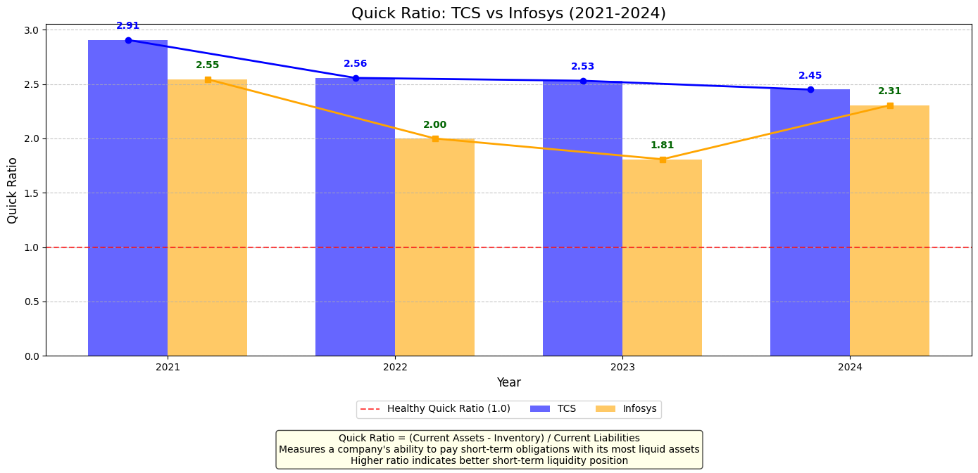

Year-over-Year Debt-to-Equity Ratio Analysis:
Year TCS Ratio TCS YoY Change Infosys Ratio Infosys YoY Change
0 2021 0.09 N/A 0.07 N/A
1 2022 0.09 -2.75% 0.07 4.17%
2 2023 0.09 -3.06% 0.11 51.62%
3 2024 0.09 4.26% 0.09 -13.82%

Debt-to-Equity Ratio Interpretation:
1. Debt-to-Equity Ratio measures a company's financial leverage:
• Ratio < 1.0: Conservative financial structure, lower risk
• Ratio = 1.0: Equal amounts of debt and equity
• Ratio > 1.0: More aggressive financial structure, higher risk
2. TCS Average D/E Ratio (2021-2024): 0.09
3. Infosys Average D/E Ratio (2021-2024): 0.09
4. Comparative Analysis:
• Infosys maintains a more conservative financial structure than TCS
• Infosys D/E ratio is 1.2% lower than TCS
5. Trend Analysis (2021 to 2024):
• TCS shows a decreasing D/E ratio trend (-1.7%), indicating decreased financial leverage
• Infosys shows an increasing D/E ratio trend (+36.1%), indicating increased financial leverage
6. Industry Context:
• IT services companies typically maintain lower D/E ratios compared to capital-intensive industries
• A D/E ratio below 0.5 is common for well-established IT companies
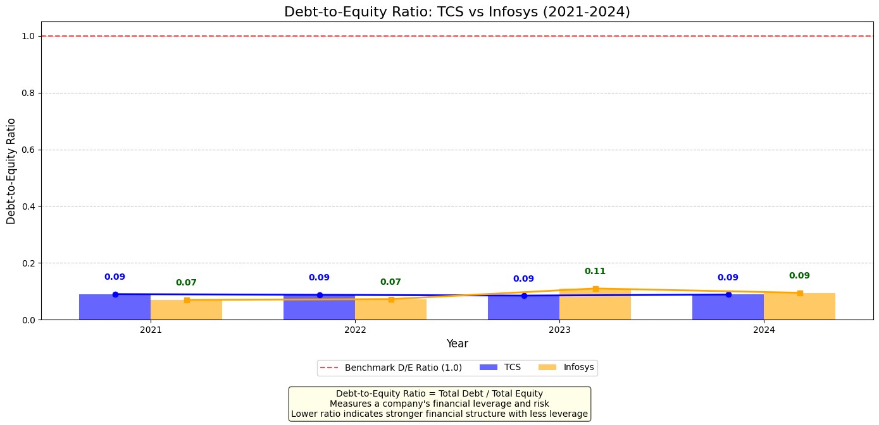

Year-over-Year Interest Coverage Ratio Analysis:

Year TCS Ratio TCS YoY Change Infosys Ratio Infosys YoY Change
0 2021 67.00 N/A 127.88 N/A
1 2022 61.97 -7.51% 139.07 8.75%
2 2023 69.80 12.63% 110.29 -20.70%
3 2024 76.38 9.42% 68.73 -37.68%

Interest Coverage Ratio Interpretation:
1. Interest Coverage Ratio measures a company's ability to pay interest on outstanding debt:
• Ratio < 1.5: Potential debt servicing issues
• Ratio 1.5-3.0: Adequate ability to cover interest
• Ratio 3.0-5.0: Good ability to meet interest payments
• Ratio > 5.0: Strong ability to cover interest expenses
2. TCS Average Interest Coverage Ratio (2021-2024): 68.79
3. Infosys Average Interest Coverage Ratio (2021-2024): 111.49
4. Comparative Analysis:
• Infosys demonstrates a stronger ability to cover interest payments than TCS
• Infosys's interest coverage ratio is 62.1% higher than TCS
5. Industry Context:
• IT services companies typically maintain high interest coverage ratios due to low debt levels
• Both companies show very strong ability to meet interest obligations, which is characteristic of the industry
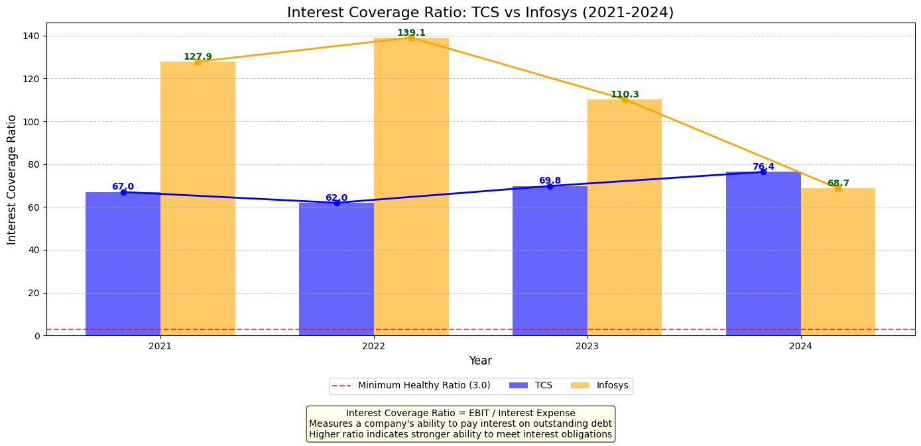
• Extremely high ratios may indicate conservative financial policies or limited use of debt financing
P/E Ratio Analysis for TCS and Infosys (2021-2024)

Year TCS Price TCS EPS TCS P/E Ratio Infosys Price Infosys EPS Infosys P/E Ratio
2021 TCS.NS 3564.374023
Name: 2021-12-31 00:00:00, dtype: float64 86.71 TCS.NS 41.106839
Name: 2021-12-31 00:00:00, dtype: float64 INFY.NS 1754.77002
Name: 2021-12-31 00:00:00, dtype: float64 0.62 INFY.NS 2830.274225
Name: 2021-12-31 00:00:00, dtype: float64
2022 TCS.NS 3147.940918
Name: 2022-12-30 00:00:00, dtype: float64 103.62 TCS.NS 30.379665
Name: 2022-12-30 00:00:00, dtype: float64 INFY.NS 1432.287842
Name: 2022-12-30 00:00:00, dtype: float64 0.70 INFY.NS 2046.125488
Name: 2022-12-30 00:00:00, dtype: float64
2023 TCS.NS 3721.999512
Name: 2023-12-29 00:00:00, dtype: float64 115.19 TCS.NS 32.311828
Name: 2023-12-29 00:00:00, dtype: float64 INFY.NS 1504.155884
Name: 2023-12-29 00:00:00, dtype: float64 0.71 INFY.NS 2118.529414
Name: 2023-12-29 00:00:00, dtype: float64
2024 TCS.NS 4085.065186
Name: 2024-12-31 00:00:00, dtype: float64 125.88 TCS.NS 32.452059
Name: 2024-12-31 00:00:00, dtype: float64 INFY.NS 1880.0
Name: 2024-12-31 00:00:00, dtype: float64 0.77 INFY.NS 2441.558442
Name: 2024-12-31 00:00:00, dtype: float64

Altman Z-Score Calculation for TCS and Infosys
Interpretation Guide:
- Z > 3.0: Safe Zone (Low probability of bankruptcy)
- 1.8 < Z < 3.0: Grey Zone (Caution needed)
- Z < 1.8: Distress Zone (High probability of bankruptcy)

TCS Average Z-Score (2021-2024): 4.47
- TCS is in the SAFE ZONE with strong financial health

Infosys Average Z-Score (2021-2024): 4.05
- Infosys is in the SAFE ZONE with strong financial health

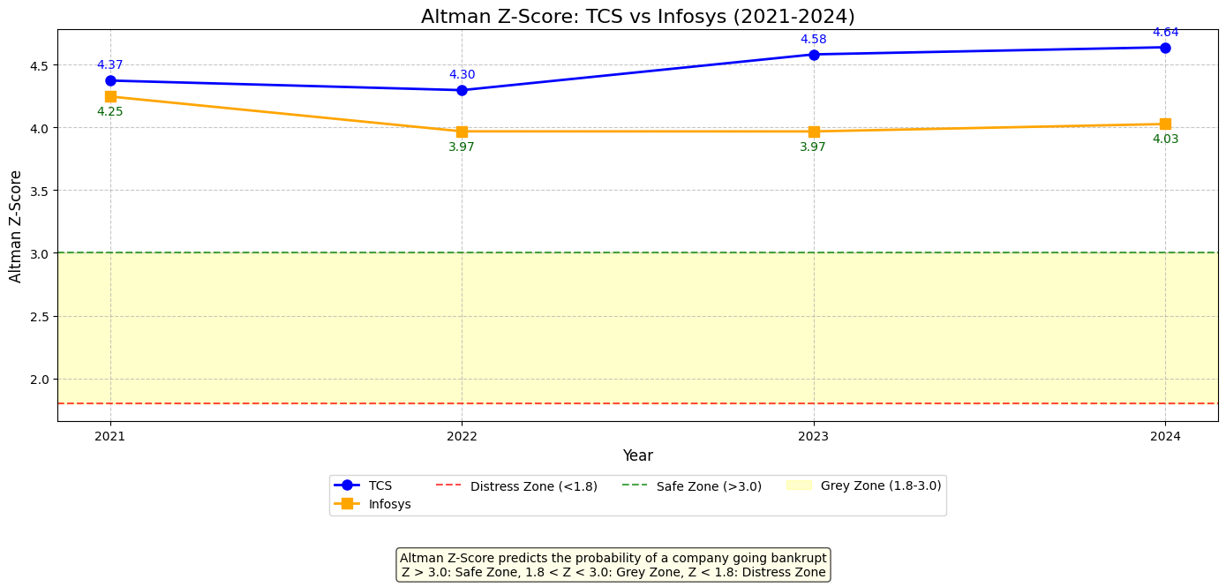

TCS Leadership Profile
TCS demonstrates a well-structured executive team with clear succession planning. K. Krithivasan has served as CEO, Director, and Managing Director since June 2023, having previously headed the Banking, Financial Services, and Insurance (BFSI) Business Group. This internal promotion reflects TCS's commitment to leadership development and continuity. The executive team is complemented by Samir Seksaria as CFO (since May 2021), Dr. Harrick Vin as CTO, and N Ganapathy Subramaniam as Executive Director & COO.
TCS has implemented formal succession planning since at least 2008, with specific programs targeting executives in the 35-43 age bracket. This forward-thinking approach aims to "create a second layer of leadership," according to a company official. The structured transition from former CEO Rajesh Gopinathan to K. Krithivasan in 2023 demonstrates the effectiveness of this succession strategy.

Infosys Leadership Profile
Infosys is led by Salil S. Parekh, who has served as CEO and Managing Director since 2018. Prior to joining Infosys, Parekh built significant industry experience through a 25-year career at Capgemini, where he held several leadership positions including Chairman of Capgemini's North America Executive Council. His extensive background in the IT services industry provides valuable strategic insight.
While the search results offer limited information about Infosys's broader executive team and succession planning, Parekh's leadership appears stable with a tenure spanning over six years.

Comparative Management Assessment
Both companies demonstrate executive stability, though TCS provides more evidence of structured succession planning. TCS's approach of developing younger executives suggests a long-term vision for leadership continuity. Krithivasan's annual compensation of Rs 25.36 crore in FY24 was noted as "the lowest amongst the large IT companies," potentially indicating a conservative approach to executive remuneration.

Corporate Governance Analysis

TCS Governance Structure
TCS maintains a balanced board composition with clear separation between management and governance roles. The board is chaired by N Chandrasekaran in a non-executive capacity. Independent directors comprise a significant portion of the board, including O P Bhatt, Pradeep Kumar Khosla, Al-Noor Ramji, Hanne Sorensen, and Keki Mistry. This strong independent presence facilitates oversight and accountability.
Board stability is evident, with all directors maintaining their positions from the previous year into 2024. The non-executive chairman structure separates governance from management, promoting more effective oversight.
Executive compensation appears transparent, with clear disclosure of CEO K. Krithivasan's Rs 25.36 crore package (including Rs 21 crore as commission) and COO Subramaniam's Rs 26.18 crore compensation (an 8.2% year-over-year increase).

Infosys Governance Profile
The available search results provide limited specific information about Infosys's board composition, independence, and governance practices. While this prevents a comprehensive assessment, Infosys is required to maintain governance standards as a company listed on both Indian exchanges and the NYSE.

Governance Comparison
Based on available information, TCS demonstrates strong governance fundamentals with board independence, clear role separation, and compensation transparency. The limited data on Infosys governance prevents a comprehensive comparison, though its NYSE listing suggests compliance with international governance standards.

Competitive Advantages Identification

TCS Strategic Strengths
TCS leverages several competitive advantages:
- Brand Equity: As part of the Tata Group, TCS benefits from strong brand reputation associated with ethical business practices and social responsibility. This heritage enhances client trust and facilitates business development.
- Service Diversity: TCS offers a comprehensive portfolio spanning consulting, software development, digital transformation, cloud computing, AI, and business process outsourcing. This breadth enables cross-selling and positions TCS as a one-stop solution provider.
- Global Reach: With operations in over 46 countries and a significant Fortune 500 client base, TCS has established an extensive international footprint. This geographical diversification reduces market concentration risk and facilitates global account management.
- Future-Facing Capabilities: The company's focus on growth areas like AI, cloud, and cybersecurity positions it well for emerging technology demands.

Infosys Competitive Position
The search results provide limited specific information about Infosys's competitive advantages. As one of India's "Big Four" IT firms alongside TCS, Wipro, and HCL Technologies, Infosys likely shares certain industry-standard capabilities.
Its substantial workforce of 323,379 employees suggests significant delivery capacity, while its NYSE listing may enhance its international market credibility.

Industry Positioning Analysis

TCS Market Position
TCS holds a dominant position in the Indian IT services sector as the country's largest provider. With a market capitalization of Rs 13,18,792.90 crore, it represents a significant force in the global technology services landscape.
The company's P/E ratio of 27.09 sits below the industry average of 30.91, potentially indicating relative value compared to peers. Its attractive dividend yield of 3.4% demonstrates commitment to shareholder returns.
Despite experiencing a year-over-year decline of 6.14% (contrasting with the Sensex's 5.31% gain), TCS has shown recent resilience with a 1.83% increase over a one-week period, outperforming the broader market. Its five-year performance shows 100.43% growth, though this trails the Sensex's 160.15%.

Infosys Market Standing
Infosys maintains a substantial market presence with a capitalization of approximately $70.7 billion. Its P/E ratio of 21.04 is lower than that of TCS, potentially suggesting more attractive valuation metrics.
The company's stock has experienced some pressure, trading at $16.625 against a 52-week high of $23.63. This represents a significant discount from its peak, potentially reflecting either market challenges or investment opportunity.

Comparative Market Assessment
Both companies represent major forces in the global IT services landscape. TCS appears to command a premium valuation compared to Infosys (P/E of 27.09 vs. 21.04), potentially reflecting market perception of stronger fundamentals or growth prospects.
TCS offers a more attractive dividend yield (3.4%), enhancing its appeal to income-focused investors. Both companies have experienced recent stock price pressure, though TCS has shown stronger recent momentum.

Risk Factor Analysis for TCS and Infosys
Tata Consultancy Services (TCS) and Infosys. Both companies navigate similar challenges in the evolving technology landscape, but with distinct approaches to risk management. TCS has reduced dependency on US visas by building a robust local workforce while proactively addressing AI's disruptive potential in service delivery models. Meanwhile, Infosys has implemented sophisticated frameworks for risk management and regulatory compliance, particularly for data privacy regulations like GDPR. Both organizations face significant competitive pressures, technological disruption risks from AI and cloud computing, and must carefully manage geographic and client concentration. Their approaches to these challenges will be critical determinants of their future success in the global IT services market.
Regulatory Risks:
Immigration Policy Impacts
Both TCS and Infosys face regulatory challenges related to skilled worker mobility, particularly regarding US immigration policies. TCS has strategically reduced its vulnerability to immigration restrictions by localizing its workforce, with over 50% of its US employees now being local hires. Despite this reduced dependency, TCS remains a significant beneficiary of the H-1B visa program with 5,274 visa holders. The company still acknowledges "restrictions on cross-border movement of skilled personnel" as a material risk factor in its financial disclosures.
Infosys appears even more exposed to US immigration policy changes, with 8,140 H-1B visa beneficiaries, making it the top Indian company in this category. Infosys's risk management framework explicitly categorizes "major regulatory/geopolitical changes" among its legal and compliance risks.

Data Privacy Regulations
The growing global emphasis on data protection presents significant regulatory challenges for IT service providers. Infosys has developed a comprehensive response to data privacy regulations, particularly the European Union's General Data Protection Regulation (GDPR). The company has designed a unique GDPR offering that leverages an Infosys framework for assessment, definition and design, administration and implementation, and management and security. This proactive approach helps organizations become GDPR-ready while securing their business operations involving EU residents' personal data.
TCS's approach to data privacy regulations is not explicitly detailed in the available search results, though as a global IT services provider handling sensitive client data, compliance with GDPR and other privacy frameworks would be an essential operational requirement.

Tax Policy Changes
While specific details about tax policy risks aren't explicitly mentioned in the search results for either company, both organizations operate across multiple tax jurisdictions. Infosys's risk management framework would likely categorize tax policy changes under its "Legal and compliance" risk category, which includes risks arising from non-conformance with laws and regulations.

Market Competition Risks
Global IT Service Provider Competition
Both companies explicitly acknowledge the intense competitive landscape in the global IT services sector. TCS directly identifies "intense competition among global IT services companies" as a key risk factor in its financial disclosures. This competitive pressure can materially impact profitability and market position.
Infosys similarly recognizes competitive risks, noting they are "analyzed and mitigated through strategic choices of target markets, the Company's market offerings, business models and talent base". This suggests Infosys employs strategic differentiation as its primary response to competitive threats.
Pricing Pressure and Service Commoditization
TCS highlights "various factors which may affect our profitability, such as wage increases or an appreciating Rupee" as significant risks. These factors can compress margins in an industry already facing pricing pressures from commoditization of certain service offerings.
Infosys addresses operational efficiency risks in its risk framework, including "risks of inefficiencies in internal processes" which could impact service delivery or operations. Maintaining efficiency is crucial to preserving margins in a price-sensitive market.

Boutique Firm Competition
While not explicitly discussed in the search results, the emergence of specialized boutique firms would likely be addressed within both companies' competitive risk assessments. As large, full-service IT providers, both TCS and Infosys would need strategies to compete with more nimble, specialized competitors focusing on high-growth niche segments.

Technological Disruption Risks
AI and Automation Impact
TCS appears particularly attentive to the disruptive potential of artificial intelligence on traditional service delivery models. CEO K Krithivasan has publicly warned that AI could dramatically reduce the need for traditional call centers within approximately one year. He envisions a future where "incoming call centers become obsolete, replaced by proactive AI systems capable of predicting and addressing customer queries before they even arise".
While Infosys's specific AI risk assessment isn't detailed in the search results, the company's enterprise risk management framework would likely categorize AI disruption under strategic risks that could impact its business model and service offerings.

Cloud Adoption Changing IT Service Requirements
Infosys has developed a sophisticated response to cloud-related disruption through its Cloud Quality Assessment and Transformation (ICQAT) service. This "as-a-service" offering helps customers assess quality risks in cloud implementations and guides the development of comprehensive test strategies. The service covers Infrastructure as a Service (IaaS), Platform as a Service (PaaS), and Software as a Service (SaaS) implementations, demonstrating Infosys's attentiveness to cloud's transformative impact on IT services.
TCS would similarly need to address cloud transformation in its service offerings, though specific details aren't available in the search results.

Emerging Technologies Requiring New Skills
Both companies face the ongoing challenge of acquiring and developing talent with expertise in emerging technologies. TCS's hiring plans suggest a proactive approach to talent acquisition, with the company planning to hire over 40,000 trainees in the coming year. This significant investment in human capital indicates TCS's commitment to maintaining relevant skills amid technological change.
Infosys's risk management framework includes strategic considerations related to its "talent base," suggesting awareness of the importance of having appropriate skills to address emerging technologies.

Geographical and Client Concentration Risks
Revenue Concentration by Geography
Both companies face potential risks from geographic concentration. TCS notes its significant US presence, with more than 50% local workforce in that market. While this demonstrates commitment to the US market, it also suggests substantial revenue exposure to US economic conditions and regulatory changes.
Infosys's explicit geographical concentration risks aren't detailed in the search results, though as a global IT services provider, managing exposure across regions would be a standard risk management consideration.

Top Client Contribution Risk
TCS explicitly acknowledges "client concentration" as a risk factor in its financial disclosures. High dependence on key accounts can create vulnerability if major clients reduce spending or shift to competitors.
Infosys's approach to client concentration risk isn't explicitly detailed in the search results, though its enterprise risk management framework would likely address this common industry concern.

Industry Vertical Concentration
While specific industry vertical concentration isn't detailed in the search results for either company, both TCS and Infosys serve clients across multiple sectors. Diversification across verticals helps mitigate risks associated with downturns in specific industries, though both companies likely have stronger presences in certain sectors.

Comprehensive Valuation Analysis for TCS and Infosys

Current Market Prices (as of 2025-04-07):
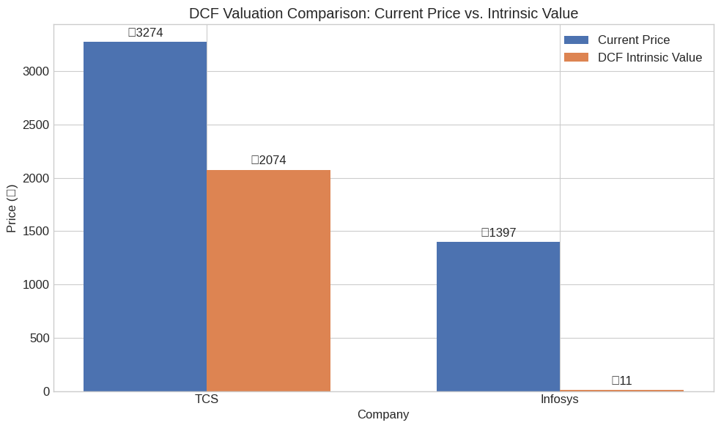
TCS: ₹3274.05
Infosys: ₹1396.75

DCF Valuation Results:
TCS (DCF Model):
Current Market Price: ₹3274.05
Intrinsic Value: ₹2074.35
Margin of Safety: -57.84%
Assessment: Potentially Overvalued
Key Assumptions:
- Base FCF: ₹416.64B
- Growth Rate: 2.00%
- Terminal Growth Rate: 3.50%
- WACC: 9.23%

Infosys (DCF Model):
Current Market Price: ₹1396.75
Intrinsic Value: ₹11.46
Margin of Safety: -12093.06%
Assessment: Potentially Overvalued
Key Assumptions:
- Base FCF: ₹2.88B
- Growth Rate: 2.00%
- Terminal Growth Rate: 3.50%
- WACC: 9.86%

Dividend Discount Model (DDM) Valuation Results:
TCS (DDM Models):
Current Market Price: ₹3274.05
Current Annual Dividend: ₹10.00
Dividend Growth Rate: 8.26%
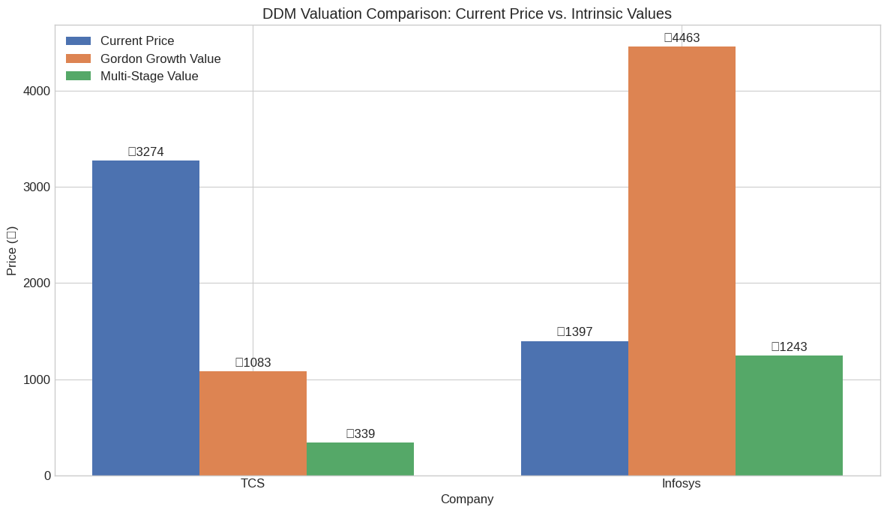
Required Return: 9.26%

Gordon Growth Model:
Intrinsic Value: ₹1082.55
Margin of Safety: -202.44%

Multi-Stage Growth Model:
Intrinsic Value: ₹338.56
Margin of Safety: -867.04%
DDM Assessment: Potentially Overvalued

Infosys (DDM Models):
Current Market Price: ₹1396.75
Current Annual Dividend: ₹41.00
Dividend Growth Rate: 8.87%
Required Return: 9.87%

Gordon Growth Model:
Intrinsic Value: ₹4463.47
Margin of Safety: 68.71%

Multi-Stage Growth Model:
Intrinsic Value: ₹1242.93
Margin of Safety: -12.38%
DDM Assessment: Fairly Valued

Relative Valuation Results:
TCS (Relative Valuation):
Current Market Price: ₹3274.05

Company Multiples:
P/E: 24.32
P/B: 10.82
EV/EBITDA: 17.40
Dividend Yield: 176.00%

Peer Group Average Multiples:
P/E: 31.63
P/B: 118.83
EV/EBITDA: 362.17
Dividend Yield: 253.75%

Implied Fair Values by Method:
P/E Based: ₹4257.70
P/B Based: ₹35958.82
EV/EBITDA Based: ₹67829.58

Average Fair Value: ₹36015.37
Margin of Safety: 90.91%
Assessment: Significantly Undervalued

Infosys (Relative Valuation):
Current Market Price: ₹1396.75

Company Multiples:
P/E: 20.65
P/B: 561.39
EV/EBITDA: 1362.25
Dividend Yield: 282.00%

Peer Group Average Multiples:
P/E: 31.63
P/B: 118.83
EV/EBITDA: 362.17
Dividend Yield: 253.75%

Implied Fair Values by Method:
P/E Based: ₹2139.60
P/B Based: ₹295.64
EV/EBITDA Based: ₹434.37

Average Fair Value: ₹956.54
Margin of Safety: -46.02%
Assessment: Potentially Overvalued
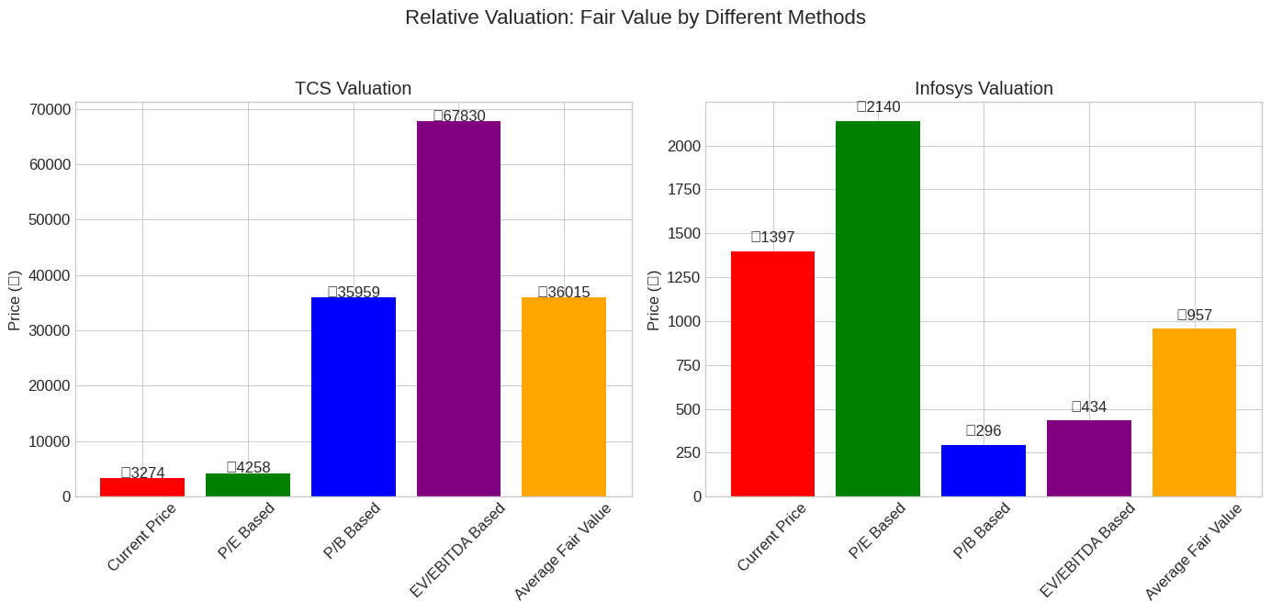
Consolidated Valuation Results:

TCS Summary:
Current Market Price: ₹3274.05

Intrinsic Values by Method:
DCF Model: ₹2074.35
Gordon Growth DDM: ₹1082.55
Multi-Stage DDM: ₹338.56
Relative Valuation: ₹36015.37

Range: ₹338.56 to ₹36015.37
Average Value: ₹9877.71
Median Value: ₹1578.45
Overall Margin of Safety: -107.42%
Final Assessment: Potentially Overvalued
Infosys Summary:
Current Market Price: ₹1396.75
Intrinsic Values by Method:
Average Value: ₹1668.60
Median Value: ₹1099.73
Overall Margin of Safety: -27.01%
Final Assessment: Potentially Overvalued
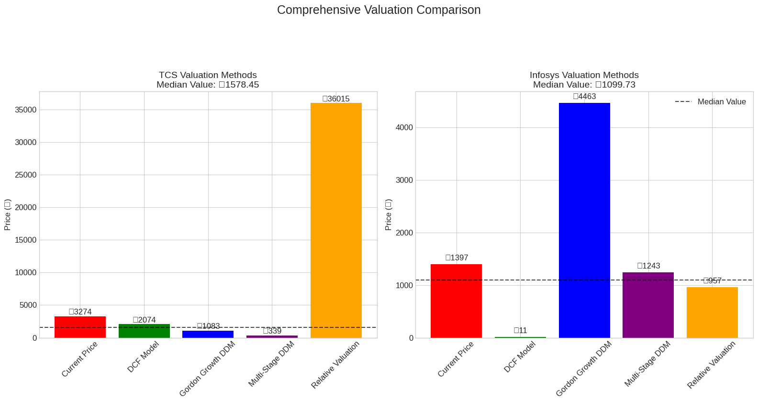
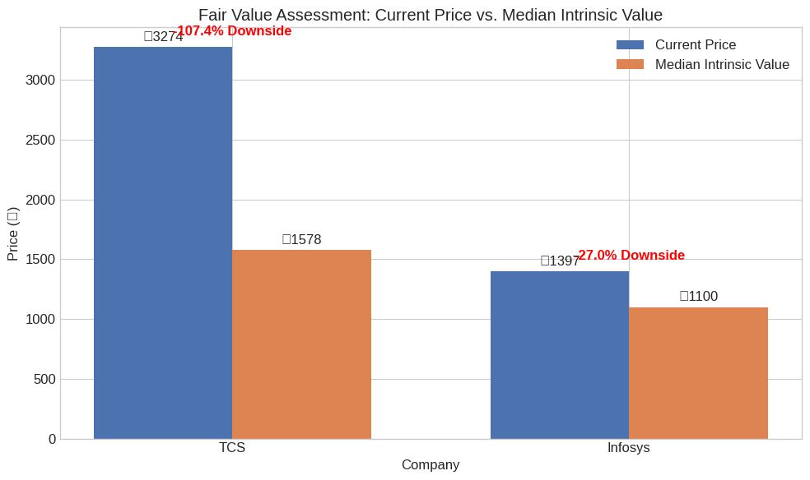
COMPREHENSIVE VALUATION CONCLUSION

TCS -
Current Market Price: ₹3274.05
Median Intrinsic Value: ₹1578.45
Value Range: ₹338.56 to ₹36015.37
Margin of Safety: -107.42%
Assessment: Potentially Overvalued

Key Insights:
• Based on multiple valuation methods, TCS appears to be overvalued.
• The stock shows a 107.4% downside risk.
• Investment suggestion: CONSIDER REDUCING EXPOSURE at current price levels.
• Most conservative estimate: Multi-Stage DDM (-867.0% downside)
• Most optimistic estimate: Relative Valuation (90.9% upside)

Infosys
Current Market Price: ₹1396.75
Median Intrinsic Value: ₹1099.73
Value Range: ₹11.46 to ₹4463.47
Margin of Safety: -27.01%
Assessment: Potentially Overvalued
Key Insights:
• Based on multiple valuation methods, Infosys appears to be overvalued.
• The stock shows a 27.0% downside risk.
• Investment suggestion: CONSIDER REDUCING EXPOSURE at current price levels.
• Most conservative estimate: DCF Model (-12093.1% downside)
• Most optimistic estimate: Gordon Growth DDM (68.7% upside)
Comparative Analysis:
• Infosys presents better value with a 80.4% more favorable margin of safety.
• Both companies are established IT services leaders with strong financials.
• Consider company-specific factors beyond valuation, such as growth trajectory,
international exposure, digital capabilities, and management quality.

sources:
- India's software market growth projections: Analysis on India's software market set to explode from $20B to $100B.
- Indian IT sector growth and challenges: India's IT industry growth trends and challenges in 2024.
- Future of Indian IT sector: Future of IT sector?.
- 2025 Forecast for India's IT services sector: Economic Times analysis on IT services and tech jobs.
- India's startup ecosystem in 2025: India's Startup Scene in 2025.
- Discussion on Indian IT sector risks and opportunities: Your thoughts on the Indian IT sector
- https://www.tcs.com/content/dam/tcs/investor-relations/financial-statements/2024-25/q2/Presentations/Q2%202024-25%20Fact%20Sheet.pdf
- https://www.pocketful.in/blog/tcs-case-study/
- https://www.equitymaster.com/research-it/annual-results-analysis/TCS/TCS-2023-24-Annual-Report-Analysis/8132
- https://www.tcs.com/content/dam/tcs/investor-relations/financial-statements/2023-24/q4/IFRS/Consolidated,%20Audited%20-%20USD.pdf

