CS425 - Software Engineering – Lab 6

By - Negede Teshome

ID – 611139

Professor – Obinna Kalu

* 1. Installed JDK Versions

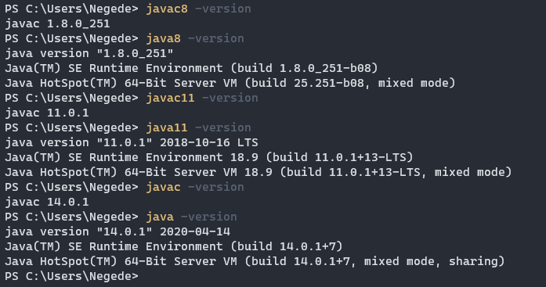

* 1. Chosen IDE – IntelliJ IDEA
  2. Command Line Java Application with Student Information

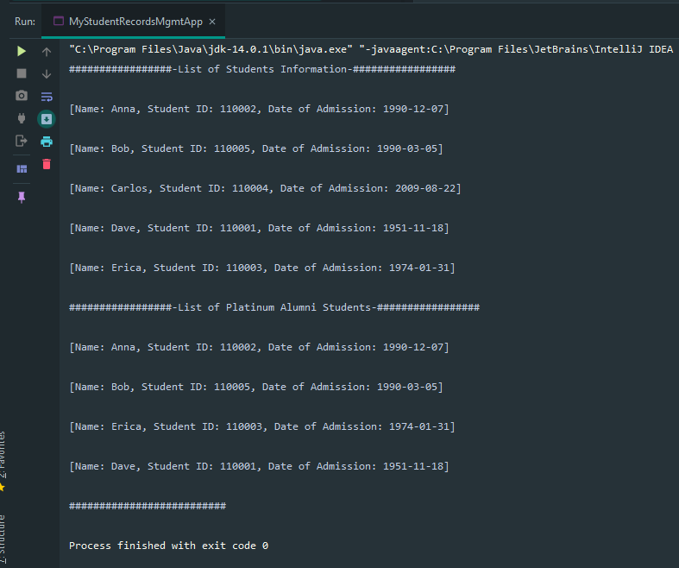

* 1. Further Coding problems

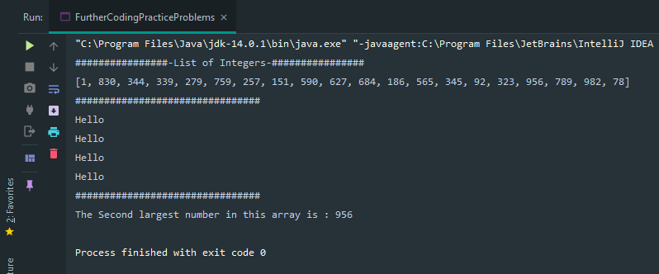

* 1. Apache Maven Version

