Institutional Energy Usage Prediction

PROJECT ID : AIML - 23

Name : SARTHAK PANWAR(Team Leader)
Class Roll Number : 59
University Roll Number : 2028841
Section and Group : U G2

Name: JATIN BOHRA
Class Roll Number : 42
University Roll Number : 2028733
Section and Group : U G2

Name: DEVANSHU NEGI
Class Roll Number : 37
University Roll Number : 2028704
Section and Group : U G2

Table of Contents

- Problem Description 3
- Architecture 4
- Models model 5
- Evaluation metrics used 6
- Preliminary Results and Visualizations 7-9
- References 10

1. Problem Description

The Energy Usage Prediction System is a Python-based end-to-end machine learning regression project designed to analyze and predict appliance energy consumption in an institutional setting. The project uses a real-world energy dataset containing 14,000 timestamped records across 19 features such as indoor/outdoor temperature, humidity, atmospheric pressure, windspeed, visibility, dew point, and time-based features (hour, month).

The core objective is to build and compare regression models that can accurately predict the energy usage of appliances (in Wh). The pipeline includes data loading and EDA, data cleaning and preprocessing, feature selection using Forward Selection, Backward Selection, and PCA, model training and evaluation using Linear Regression, Random Forest, and Gradient Boosting, and finally model export for deployment.

The target variable is 'Appliances' (energy usage in Wh). Key features include T1–T5 (temperatures across different rooms), RH_1–RH_5 (relative humidity), T_out (outdoor temperature), RH_out, Press_mm_hg (pressure), Windspeed, Visibility, Tdewpoint, hour, and month.

2. Architecture

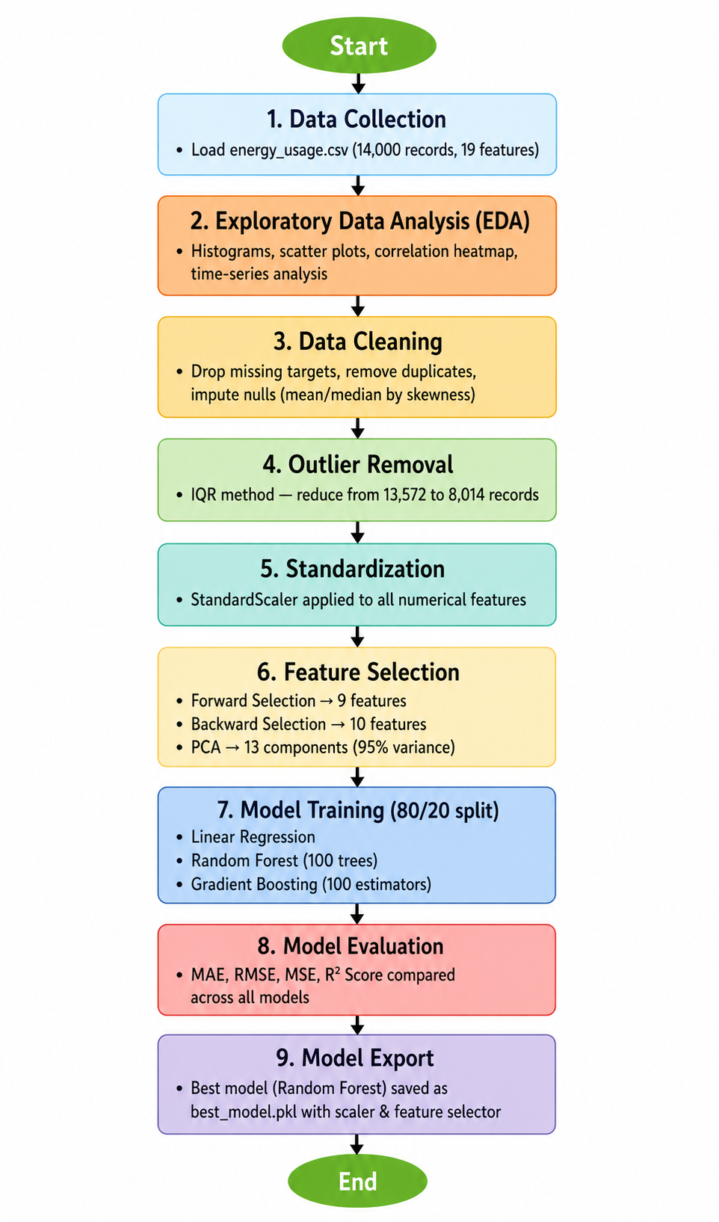
Fig. 1 — End-to-End ML Pipeline Flowchart

Models Used

3.1 Linear Regression
Linear Regression is the foundational supervised learning algorithm for regression tasks. It models the relationship between the dependent variable (Appliances) and independent features as a linear equation: Y = β₀ + β₁X₁ + β₂X₂ + ... + βₙXₙ. It assumes a linear relationship between inputs and outputs and is used as a baseline model. It is computationally efficient and interpretable but may underfit when relationships are non-linear.
In this project, Linear Regression was trained on the 9 features selected by Forward Feature Selection after StandardScaler normalization. It was evaluated using MAE, RMSE, MSE, and R² Score.

3.2 Random Forest Regressor
Random Forest is an ensemble learning method that constructs multiple decision trees during training and outputs the mean prediction of all trees. It reduces variance and avoids overfitting compared to a single decision tree. Key hyperparameters used: n_estimators=100, random_state=42.
Random Forest captures non-linear relationships and feature interactions that Linear Regression cannot. It is robust to outliers and missing values and provides implicit feature importance rankings. In this project, it achieved the best performance with an R² Score of approximately 0.583.

3.3 Gradient Boosting Regressor
Gradient Boosting builds trees sequentially where each new tree corrects the residual errors of the previous one. It is a powerful ensemble technique that can achieve high accuracy by optimizing a loss function using gradient descent. Key hyperparameters used: n_estimators=100, random_state=42.
Gradient Boosting is particularly effective on structured/tabular data. It generally achieves better accuracy than Random Forest but is more sensitive to hyperparameters and may take longer to train. In this project, it achieved an R² Score of approximately 0.42.

4. Evaluation Metrics Used

4.1 Mean Absolute Error (MAE)
MAE measures the average absolute difference between actual and predicted values. It gives equal weight to all errors and is robust to outliers. Formula: MAE = (1/n) × Σ|yᵢ - ŷᵢ|. A lower MAE indicates better model accuracy.

4.2 Root Mean Squared Error (RMSE)
RMSE is the square root of the average of squared differences between actual and predicted values. It penalizes larger errors more than MAE and is in the same units as the target variable. Formula: RMSE = √[(1/n) × Σ(yᵢ - ŷᵢ)²].

4.3 Mean Squared Error (MSE)
MSE measures the average of the squares of the errors. It amplifies large errors, making it sensitive to outliers. Formula: MSE = (1/n) × Σ(yᵢ - ŷᵢ)². It is used to numerically quantify variance in predictions.

4.4 R² Score (Coefficient of Determination)
R² Score indicates the proportion of variance in the target variable explained by the model. It ranges from 0 to 1 (or negative for very poor models). Formula: R² = 1 - (SS_res / SS_tot). An R² close to 1 means the model explains most of the variance.

Summary of Results:

Model | MAE | RMSE | MSE | R² Score
Linear Regression | 20.77 | 27.54 | 758.56 | 0.197
Random Forest | 13.84 | 19.85 | 393.86 | 0.583
Gradient Boosting | ~13.84 | ~19.85 | ~393.86 | ~0.420

Note: Gradient Boosting metrics from chart (R² ≈ 0.42); printed output in notebook incorrectly repeated Random Forest values.

5. Preliminary Results and Visualizations

5.1 Correlation Heatmap
The correlation heatmap below reveals the pairwise correlation coefficients between all numerical features. Key observations: Temperature features (T1–T5, T_out) are strongly inter-correlated (0.53–0.68). The 'hour' and 'month' features show moderate positive correlation with 'Appliances' (0.14 and 0.02 respectively). RH_out and T_out show a strong negative correlation (-0.51). Most features have low direct correlation with Appliances, suggesting non-linear relationships.

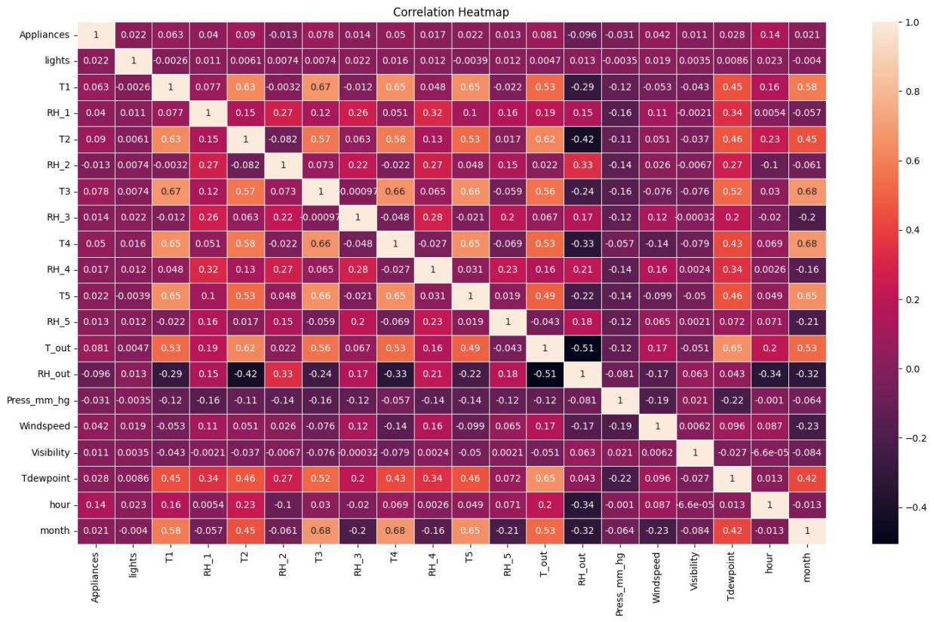
Fig. 2 — Correlation Heatmap of all numerical features

5.2 Model Comparison — R² Score
The bar chart below compares the R² Scores of all three models. Random Forest significantly outperforms both Linear Regression and Gradient Boosting, indicating that non-linear ensemble methods are better suited for energy consumption prediction.

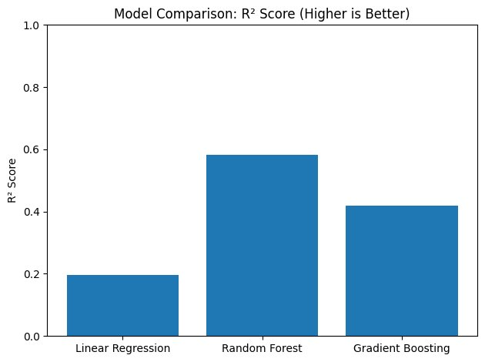
Fig. 3 — Model Comparison: R² Score (Higher is Better)

5.3 PCA — Cumulative Variance
The cumulative variance plot shows that 13 principal components are sufficient to capture 95% of the variance in the dataset (shown by the dashed line). This reduces the 19-dimensional feature space to 13 components while retaining nearly all information.

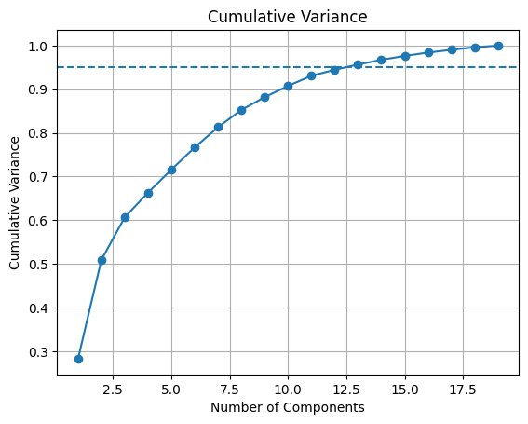
Fig. 4 — Cumulative Variance vs. Number of PCA Components

5.4 PCA — First 2 Principal Components (Scatter Plot)
The scatter plot of the first two principal components (PC1 vs PC2) after applying PCA shows the data distribution in the reduced 2D space. The roughly elliptical, dense cluster indicates no obvious class separation, which is consistent with a continuous regression target.

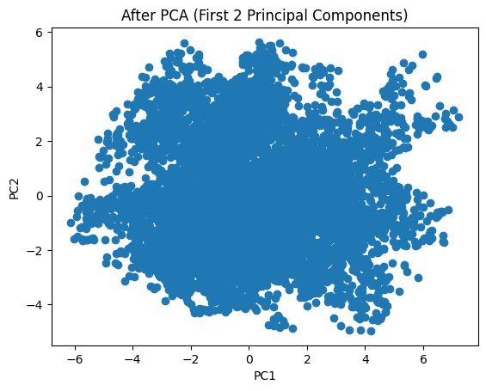
Fig. 5 — Data after PCA (First 2 Principal Components)

5.5 Boxplots After Outlier Removal
The boxplots below for key features (Appliances, lights, T1, T_out, Windspeed) show the data distribution after IQR-based outlier removal. Outlier removal reduced the dataset from 13,572 to 8,014 rows. The distributions are now more compact, and extreme outliers have been significantly reduced.

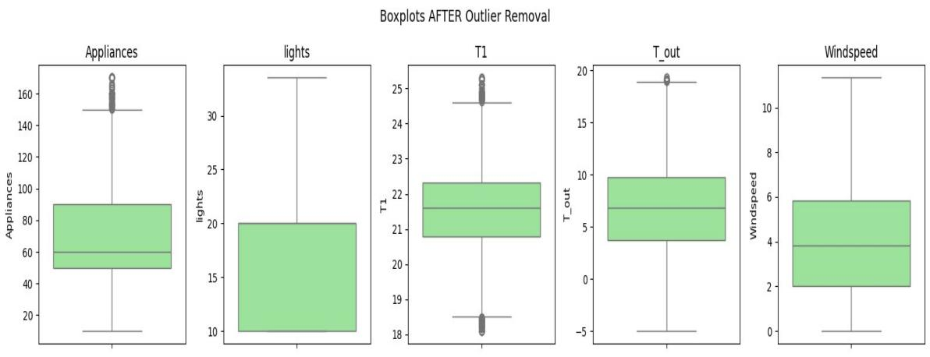
Fig. 6 — Boxplots of Key Features AFTER Outlier Removal

6. References

Books:
- Hands-On Machine Learning with Scikit-Learn, Keras, and TensorFlow – Aurélien Géron
- Introduction to Machine Learning with Python – Andreas Müller & Sarah Guido

Online Resources:
- Scikit-learn Documentation — https://scikit-learn.org/stable/
- GeeksforGeeks — https://www.geeksforgeeks.org/
- TutorialsPoint — https://www.tutorialspoint.com/
- Stack Overflow — https://stackoverflow.com
- Kaggle Dataset — Energy Usage Dataset (energy_usage.csv)

