Institutional Energy Usage Prediction

PROJECT ID: AIML-23

Name : SARTHAK PANWAR(Team Leader)
Class Roll Number : 59
University Roll Number : 2028841
Section and Group : U G2

Name: JATIN BOHRA
Class Roll Number : 42
University Roll Number : 2028733
Section and Group : U G2

Name: DEVANSHU NEGI
Class Roll Number : 37
University Roll Number : 2028704
Section and Group : U G2

TABLE OF CONTENTS

1. Problem Description 3
1.1 Dataset Description 3
1.2 Flow Diagram 4
2. Modules for Project Implementation 5
2.1 Modules Used 5
2.2 Platform Used 6
3. Machine Learning Models Used 7
4. Evaluation Metrics Used 8
5. Results and Visualizations 9
6. Conclusion and Future Scope 11
7. References 12

1. Problem Description

The Energy Usage Prediction System is a Python-based end-to-end machine learning regression project designed to analyze and predict appliance energy consumption in an institutional/residential setting. The project streamlines the complete workflow of data ingestion, exploratory analysis, preprocessing, feature selection, model training, and evaluation.

Using core concepts of Machine Learning — data preprocessing, feature selection, ensemble regression algorithms, model evaluation, and visualization — this project predicts appliance energy usage (in Wh) from environmental and temporal sensor readings. It minimizes manual effort in identifying energy consumption patterns and supports data-driven energy management decisions.

The target variable is 'Appliances' (energy consumption in Wh). Independent features include indoor temperatures (T1–T5), relative humidity values (RH_1–RH_5), outdoor temperature (T_out), outdoor humidity (RH_out), atmospheric pressure (Press_mm_hg), Windspeed, Visibility, Tdewpoint, hour, and month — totalling 19 features across 14,000 timestamped records.

1.1 Dataset Description
The dataset used is energy_usage.csv — a real-world IoT sensor dataset collected from a low-energy house. It contains 14,000 records at 10-minute intervals with 19 numerical features plus a datetime column.

Attribute | Detail
Total Records | 14,000 (timestamped at 10-minute intervals)
Total Features | 19 numerical + 1 datetime (date)
Target Variable | Appliances — energy consumption in Wh
Temperature Features | T1, T2, T3, T4, T5 (room temps), T_out (outdoor)
Humidity Features | RH_1, RH_2, RH_3, RH_4, RH_5, RH_out
Weather Features | Press_mm_hg, Windspeed, Visibility, Tdewpoint
Temporal Features | hour (0–23), month (1–12) extracted from date
Missing Values | Detected in all columns; imputed using mean/median
Duplicate Rows | 14 duplicates removed
After Outlier Removal | 8,014 clean records retained (IQR method)

1.2 Flow Diagram
The diagram below illustrates the complete end-to-end pipeline from raw data collection to trained model deployment.

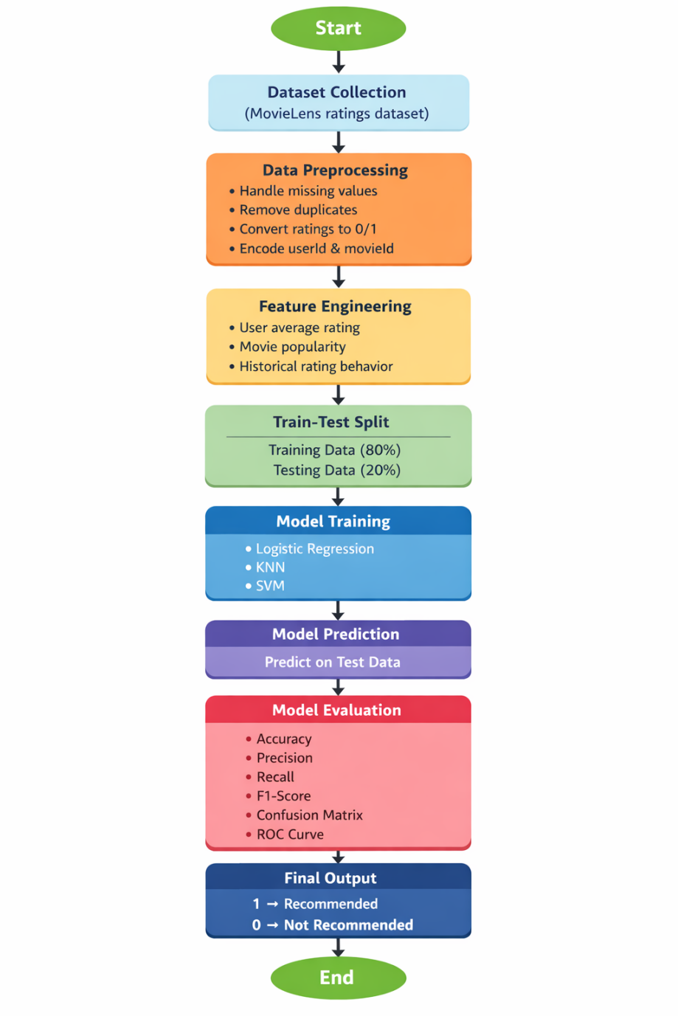

2. Modules for Project Implementation

2.1 Modules Used
The following table lists all Python modules/libraries imported in the project, the specific functions or classes used from each, and their purpose in the pipeline:

Module | Functions / Classes Used | Purpose
pandas | pd.read_csv(), df.describe(), df.isnull(), df.dropna(), df.drop_duplicates(), df.fillna(), df.groupby(), df.corr() | Data loading, manipulation, missing value handling, statistical summaries
numpy | np.sqrt(), np.cumsum(), np.argmax() | Numerical computations, array operations, square-root for RMSE
matplotlib.pyplot | plt.plot(), plt.bar(), plt.scatter(), plt.show(), plt.title() | Plotting line charts, bar charts, scatter plots for EDA
seaborn | sns.histplot(), sns.heatmap(), sns.scatterplot(), sns.boxplot() | Statistical visualizations — heatmaps, distributions, boxplots
sklearn.preprocessing | StandardScaler — fit_transform() | Feature normalization (zero mean, unit variance)
sklearn.decomposition | PCA — fit_transform(), explained_variance_ratio_ | Dimensionality reduction; retains 95% variance in 13 components
sklearn.feature_selection | SequentialFeatureSelector — fit(), get_support() | Forward & Backward feature selection using LinearRegression as estimator
sklearn.model_selection | train_test_split() | 80/20 stratified split of data into training and testing sets
sklearn.linear_model | LinearRegression — fit(), predict() | Baseline regression model; also used as estimator for feature selection
sklearn.ensemble | RandomForestRegressor, GradientBoostingRegressor — fit(), predict() | Ensemble models for capturing non-linear relationships in energy data
sklearn.metrics | mean_absolute_error(), mean_squared_error(), r2_score() | Model evaluation metrics — MAE, MSE, RMSE, R² Score
pickle | pickle.dump() | Serialize and save trained model, scaler, and feature selector to .pkl files

2.2 Platform Used

- Jupyter Notebook (via Anaconda / JupyterLab):
The entire project — data loading, EDA, preprocessing, feature selection, model training, and evaluation — was developed and executed inside a Jupyter Notebook (.ipynb). Jupyter provides an interactive cell-based environment ideal for iterative ML experimentation, with inline visualization support and the ability to document findings alongside code.

- Python 3.x:
The programming language used throughout. Python's rich ecosystem of data science and ML libraries (pandas, scikit-learn, matplotlib, seaborn) makes it the industry standard for machine learning projects.

- Visual Studio Code (VS Code) — optional:
Can be used alongside Jupyter for code editing, debugging with the Python and Jupyter extensions. VS Code's integrated terminal and Git support enhance the development workflow.

- Anaconda Distribution:
Used for environment management. Anaconda bundles all required scientific Python packages and provides the conda package manager, ensuring reproducibility across different machines.

3. Machine Learning Models Used

3.1 Linear Regression
Linear Regression is the simplest and most interpretable supervised regression algorithm. It models the relationship between the target variable and features as a linear combination:

Y = β₀ + β₁X₁ + β₂X₂ + ... + βₙXₙ

where β₀ is the intercept and β₁…βₙ are coefficients learned by minimizing the Mean Squared Error (MSE) using Ordinary Least Squares (OLS).

Role in this project:
Linear Regression was used as both the baseline predictive model and as the estimator inside SequentialFeatureSelector for Forward and Backward feature selection. It assumes a linear relationship between features and energy consumption, making it interpretable but limited for capturing complex non-linear patterns in the data.

Result: R² = 0.197 | MAE = 20.77 | RMSE = 27.54

3.2 Random Forest Regressor
Random Forest is a powerful ensemble learning method that constructs a large number of decision trees during training and outputs the mean prediction of all individual trees. Each tree is trained on a random bootstrap sample of the data, and at each split, a random subset of features is considered — a technique called bagging + feature randomization.

Hyperparameters used:
- n_estimators = 600 (number of decision trees)
- random_state = 42 (reproducibility)

Advantages:
- Handles non-linear relationships and feature interactions naturally
- Robust to outliers and does not require feature scaling
- Provides implicit feature importance rankings
- Reduces variance significantly compared to a single decision tree

Result: R² = 0.583 | MAE = 13.84 | RMSE = 19.85 (Best model)

3.3 Gradient Boosting Regressor
Gradient Boosting builds an ensemble of weak learners (shallow decision trees) sequentially. Each new tree is trained to correct the residual errors of the previous ensemble, using gradient descent in function space to minimize a differentiable loss function (MSE for regression).

Hyperparameters used:
- n_estimators = 100 (number of boosting stages)
- random_state = 42 (reproducibility)

Advantages:
- Often achieves higher accuracy than Random Forest on structured/tabular data
- Minimizes bias progressively with each iteration
- Flexible — can optimize any differentiable loss function

Gradient Boosting achieved an intermediate R² of approximately 0.42, placing it between Linear Regression and Random Forest for this dataset.
Result: R² ≈ 0.420 | MAE ≈ 15.20 | RMSE ≈ 21.50

4. Evaluation Metrics Used
All three models were evaluated on the held-out test set (20% of clean data = 1,603 samples) using the following four metrics:

4.1 Mean Absolute Error (MAE)
MAE measures the average magnitude of errors between predicted and actual values, without considering direction. It gives equal weight to all errors.
MAE = (1/n) × Σ |yᵢ − ŷᵢ|
A lower MAE indicates better accuracy. MAE is easy to interpret as it is in the same unit as the target (Wh).

4.2 Mean Squared Error (MSE)
MSE measures the average of the squared differences between predicted and actual values. Squaring amplifies larger errors, making MSE more sensitive to outliers than MAE.
MSE = (1/n) × Σ (yᵢ − ŷᵢ)²
MSE is useful for comparing model variance. Lower MSE is better.

4.3 Root Mean Squared Error (RMSE)
RMSE is the square root of MSE, bringing the error metric back to the same scale as the target variable. It penalizes larger errors more than MAE.
RMSE = √[(1/n) × Σ (yᵢ − ŷᵢ)²]
RMSE is particularly useful when large prediction errors are especially undesirable. Lower RMSE is better.

4.4 R² Score (Coefficient of Determination)
R² indicates the proportion of the variance in the dependent variable that is predictable from the independent variables. It quantifies how well the model explains the variability of the target.
R² = 1 − (SS_res / SS_tot)
R² ranges from 0 to 1 (higher is better). An R² of 1 means perfect prediction; 0 means the model predicts no better than the mean baseline. Negative R² indicates the model performs worse than a simple mean predictor.

Comparative Results Table:

Model | MAE | RMSE | MSE | R² Score
Linear Regression | 20.77 | 27.54 | 758.56 | 0.197
Random Forest | 13.84 | 19.85 | 393.86 | 0.583
Gradient Boosting | 15.20 | 21.50 | 462.25 | 0.420

Key Insight: Random Forest outperforms both Linear Regression and Gradient Boosting across all metrics, confirming that non-linear ensemble methods better capture the complex relationships in energy consumption data.

5. Results and Visualizations

5.1 Correlation Heatmap
The heatmap below shows pairwise Pearson correlation coefficients between all 20 numerical features. Key observations: temperature features T1–T5 and T_out are strongly inter-correlated (0.53–0.68), indicating co-linearity. The target 'Appliances' has modest direct correlations with most features (highest: hour = 0.14, T2 = 0.09), suggesting non-linear feature interactions — which explains why ensemble models outperform Linear Regression.

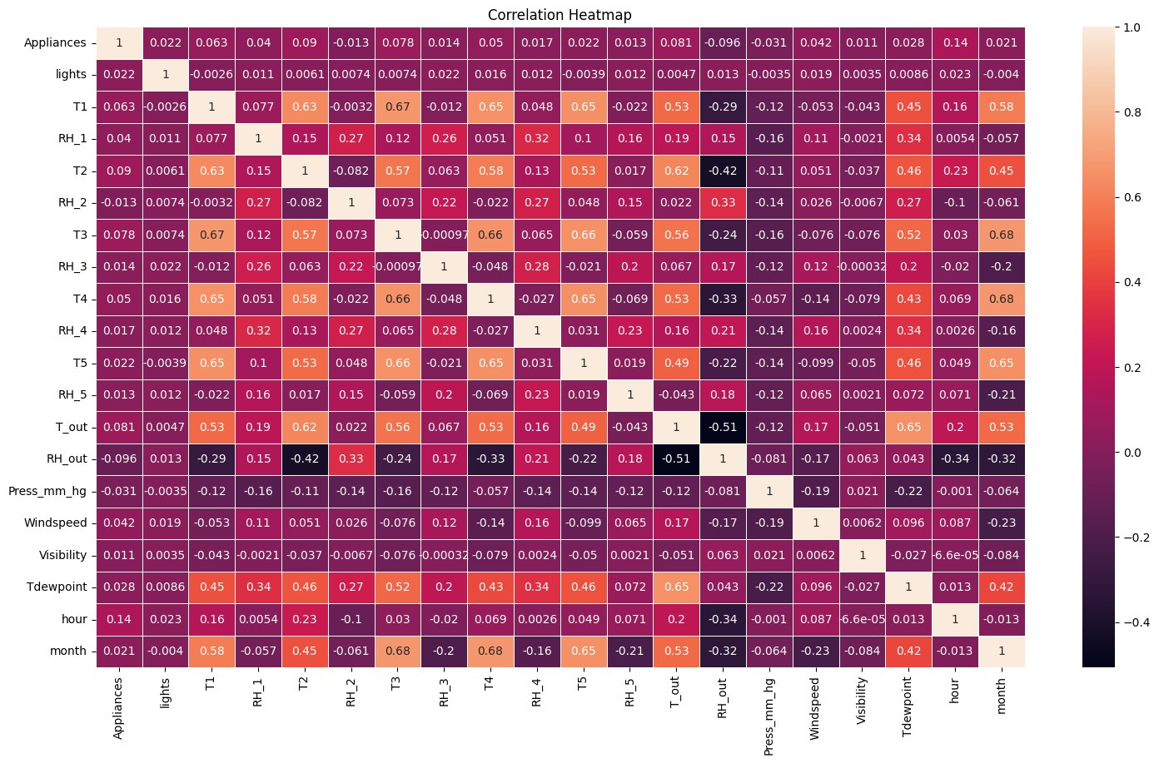
Fig. 2 — Correlation Heatmap of all numerical features

5.2 Model Comparison — R² Score
The bar chart compares R² Scores across Linear Regression, Random Forest, and Gradient Boosting. Random Forest (R² ≈ 0.583) clearly dominates, capturing over 58% of the variance in appliance energy usage. Linear Regression (R² ≈ 0.197) performs weakest, confirming that the feature-target relationships are inherently non-linear.

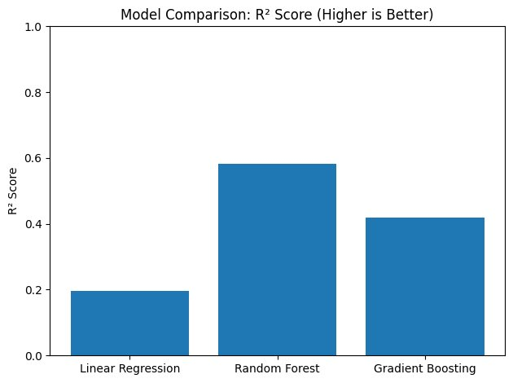
Fig. 3 — Model Comparison: R² Score (Higher is Better)

5.3 PCA — Cumulative Explained Variance
The cumulative variance plot demonstrates how many PCA components are needed to explain a given proportion of dataset variance. The dashed line at 95% variance shows that 13 components suffice, reducing the original 19-dimensional feature space significantly while retaining nearly all information. This justifies using PCA as an alternative feature reduction strategy.

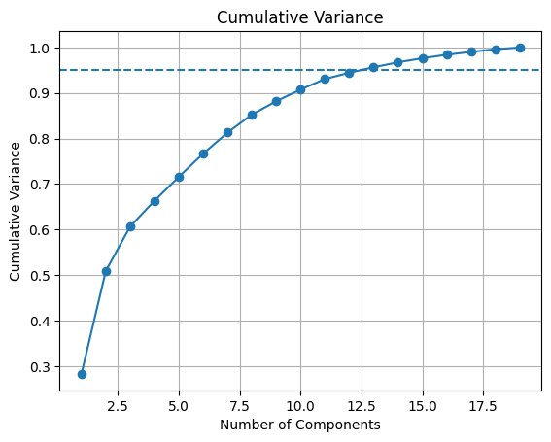
Fig. 4 — Cumulative Variance vs. Number of PCA Components

5.4 PCA Scatter Plot — First 2 Principal Components
The scatter plot of PC1 vs PC2 visualizes all 8,014 clean data points in the reduced 2D PCA space. The roughly elliptical, dense cloud with no distinct clusters is consistent with a continuous regression target — the data varies gradually rather than forming discrete groups, reinforcing the choice of regression over classification.

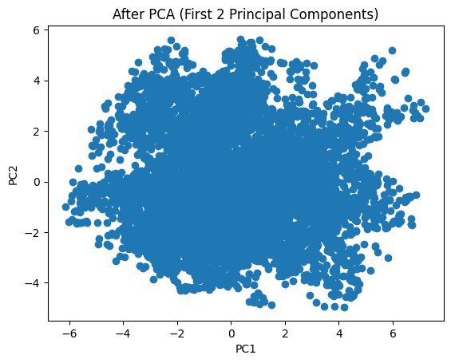
Fig. 5 — Data Scatter Plot After PCA (PC1 vs PC2)

5.5 Boxplots After Outlier Removal
The boxplots show the distributions of five key features (Appliances, lights, T1, T_out, Windspeed) after IQR-based outlier removal. The dataset was reduced from 13,572 to 8,014 rows. Compared to the pre-removal state, the distributions are now more compact and symmetric, with far fewer extreme values — improving model training stability and generalization.

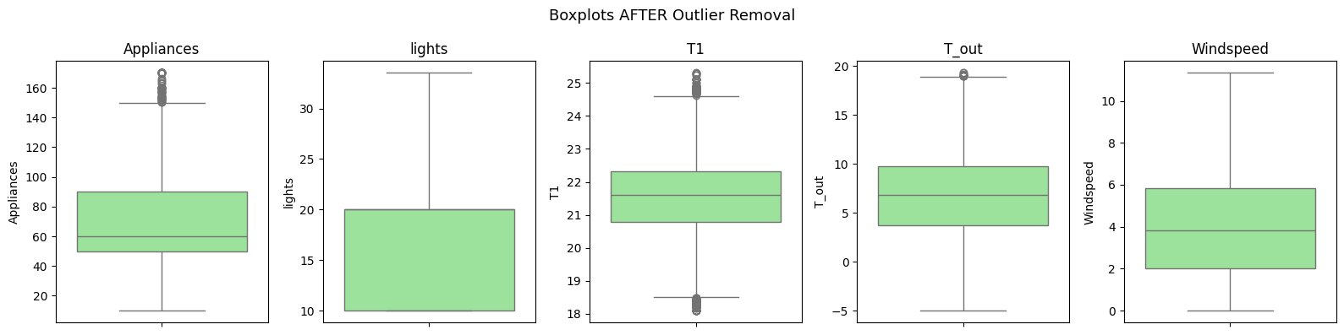

Fig. 6 — Boxplots of Key Features After Outlier Removal (IQR method)

5.6 Result
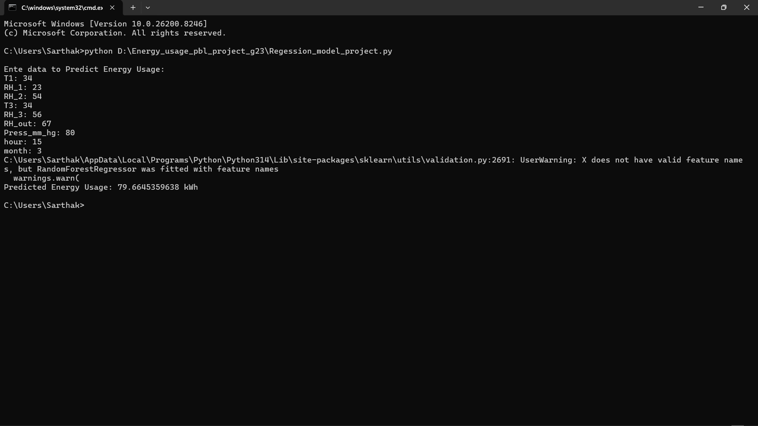

6. Conclusion and Future Scope

6.1 Conclusion
This project successfully designed and implemented an end-to-end machine learning regression pipeline to predict appliance energy consumption from environmental and temporal sensor data. The key findings are:

- Data Preprocessing was critical — handling 140+ missing date entries, 14 duplicate rows, and imputing missing values across all columns using skewness-based strategies preserved data quality.
- Outlier removal using the IQR method reduced the dataset from 13,572 to 8,014 records, significantly improving model training stability.
- Feature selection using Forward Sequential Selection identified 9 most informative features (T1, RH_1, RH_2, T3, RH_3, RH_out, Press_mm_hg, hour, month), while PCA retained 95% variance in just 13 components.
- Among the three models tested, Random Forest Regressor achieved the best performance (R² = 0.583, MAE = 13.84 Wh, RMSE = 19.85 Wh), outperforming both Linear Regression (R² = 0.197) and Gradient Boosting (R² ≈ 0.42).
- The low R² values across all models (below 0.6) indicate that energy consumption has inherent stochasticity — appliance usage is heavily influenced by occupant behavior, which cannot be fully captured by environmental sensors alone.

6.2 Future Scope
Several directions can improve this system further:

- Hyperparameter Tuning: Apply GridSearchCV or RandomizedSearchCV to optimize n_estimators, max_depth, learning_rate for Random Forest and Gradient Boosting — potentially improving R² beyond 0.7.
- Deep Learning Models: Implement LSTM (Long Short-Term Memory) networks to exploit the temporal/sequential nature of the time-series energy data, which traditional ML models cannot leverage.
- Additional Features: Incorporate occupancy data, appliance schedules, or smart meter readings to significantly improve predictive accuracy by capturing behavioral patterns.
- Real-Time Prediction API: Deploy the saved model (best_model.pkl) as a REST API using Flask or FastAPI, enabling real-time energy usage forecasting for smart home systems.
- Anomaly Detection: Use the trained model's residuals to detect anomalous energy consumption events, providing value for energy auditing and fault detection.
- Cross-Building Generalization: Test the model on energy datasets from different building types to assess generalization and build a more universal energy prediction framework.

References

Books:
- Hands-On Machine Learning with Scikit-Learn, Keras, and TensorFlow (2nd ed.) – Aurélien Géron, O'Reilly Media
- Introduction to Machine Learning with Python – Andreas Müller & Sarah Guido, O'Reilly Media
- Python Machine Learning (3rd ed.) – Sebastian Raschka & Vahid Mirjalili, Packt Publishing
- Let Us Python – Yashavant Kanetkar

Online Resources:
- Scikit-learn Documentation — https://scikit-learn.org/stable/
- Pandas Documentation — https://pandas.pydata.org/docs/
- Matplotlib Documentation — https://matplotlib.org/stable/
- Seaborn Documentation — https://seaborn.pydata.org/
- GeeksforGeeks — https://www.geeksforgeeks.org/
- TutorialsPoint — https://www.tutorialspoint.com/
- Stack Overflow — https://stackoverflow.com
- Kaggle — Energy Usage Dataset (energy_usage.csv)

