Institutional Energy Usage Prediction

PROJECT ID : AIML - 23

Name : SARTHAK PANWAR(Team Leader)
Class Roll Number : 59
University Roll Number : 2028841
Section and Group : U G2

Name: JATIN BOHRA
Class Roll Number : 42
University Roll Number : 2028733
Section and Group : U G2

Name: DEVANSHU NEGI
Class Roll Number : 37
University Roll Number : 2028704
Section and Group : U G2

1. Problem Description
Energy consumption in institutional buildings has become a critical area of concern due to rising operational costs and the growing need for sustainable infrastructure. Predicting appliance-based energy usage accurately is a challenging task, as consumption depends on multiple dynamic factors such as time of day, indoor temperature across different rooms, relative humidity, outdoor weather conditions, atmospheric pressure, wind speed, visibility, and dew point temperature. Traditional energy auditing methods fail to capture the complex, non-linear interactions between these variables, making data-driven approaches essential.
The aim of the Institutional Energy Usage Prediction system is to develop an end-to-end machine learning regression pipeline that analyses historical energy data from sensorequipped institutional buildings and predicts future appliance energy consumption (in wh). The dataset used contains 14,000 records with 19 features including timestamps, appliance usage, lighting levels, multi-zone temperature and humidity readings, and meteorological parameters.
Data preprocessing steps such as handling missing values, removing duplicate records, correcting data types, and applying normalization techniques are performed to ensure data quality. Exploratory Data Analysis (EDA) is conducted to uncover consumption patterns, detect outliers, and understand feature correlations through statistical summaries and visualizations including line plots, histograms, and heatmaps. Feature selection methods including Principal Component Analysis (PCA), Forward Selection, and Backward Elimination are applied to identify the most relevant features. A machine learning regression model is then trained and evaluated to predict energy usage, demonstrating a complete ML workflow from raw sensor data to an evaluated predictive system.

2. Steps of Implementation
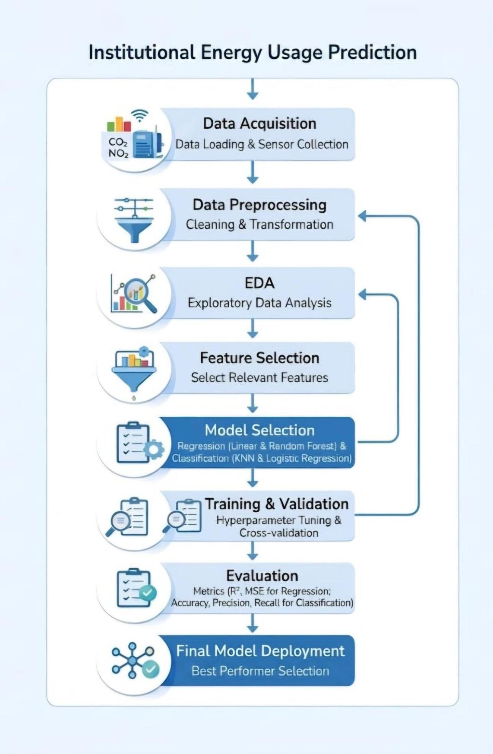

- Expected Modules / Libraries to be Used:

- NumPy
NumPy is used for efficient numerical computations and handling multi-dimensional arrays. It provides mathematical operations required for data processing, feature scaling, and matrixbased computations in the regression pipeline.

- Pandas
Pandas is used for data loading, manipulation, and analysis. It helps in reading the CSV dataset, parsing datetime columns, handling missing values, removing duplicates, and organizing sensor readings into structured DataFrames for further processing.

- Matplotlib
Matplotlib is a visualization library used to create line plots, histograms, scatter plots, and residual plots. It helps in visualizing energy consumption patterns over time and evaluating model prediction quality.

- Seaborn
Seaborn is a statistical data visualization library built on top of Matplotlib. It is used to generate correlation heatmaps, distribution plots, and pair plots to analyse relationships between temperature, humidity, and energy consumption features.

- Scikit-learn (sklearn)
Scikit-learn provides the core machine learning tools used in this project, including regression algorithms, preprocessing utilities, feature selection methods, and model evaluation metrics. It supports the complete ML pipeline from data splitting to model evaluation.

- train_test_split (from sklearn.model_selection)
This module is used to split the dataset into training and testing subsets to evaluate the generalization performance of the regression model on unseen data.

- MinMaxScaler and StandardScaler (from sklearn.preprocessing)
MinMaxScaler normalizes feature values to the [0, 1] range, while StandardScaler standardizes features to have zero mean and unit variance. Both are applied to ensure consistent feature scales before model training.

- PCA (from sklearn.decomposition)
Principal Component Analysis is used for dimensionality reduction. It transforms the highdimensional feature space into a smaller set of uncorrelated principal components that retain the maximum variance of the original data.

- LinearRegression (from sklearn.linear_model)
Linear Regression is used as the baseline model for predicting continuous energy usage values. Random Forest Regressor is used as an ensemble model to capture non-linear relationships between features and energy consumption.

- Expected Evaluation Metrics and Plots to be Used:

- Mean Absolute Error (MAE):
MAE measures the average magnitude of prediction errors without considering direction. It gives a straightforward measure of how far off the model's energy usage predictions are from the actual values in Wh.

- Mean Squared Error (MSE):
MSE calculates the average of squared differences between predicted and actual values. It penalizes larger errors more heavily, making it useful for identifying models that produce occasional large prediction deviations
.
- Root Mean Squared Error (RMSE):
RMSE is the square root of MSE and is expressed in the same units as the target variable (wh). It is the primary evaluation metric as it provides an interpretable measure of prediction accuracy in the context of energy usage.

- R² Score (Coefficient of Determination):
R² measures the proportion of variance in the energy consumption that is explained by the model. A value closer to 1 indicates that the model explains most of the variability in the data, indicating a strong predictive fit.

- Correlation Heatmap:
A heatmap visualization of the Pearson correlation matrix between all numeric features is used to identify strongly correlated predictors and support feature selection decisions.

6. Actual vs Predicted Scatter Plot:
A scatter plot comparing actual and predicted energy usage values is used to visually assess model accuracy. Points lying close to the diagonal line indicate accurate predictions.

7. Residual Plot:
A residual plot displaying the difference between actual and predicted values against predicted values is used to check for patterns in prediction errors, which may indicate model bias or heteroscedasticity.

8. Model Comparison Bar Chart:
A bar chart comparing RMSE and R² scores of different models (Linear Regression vs Random Forest) and different feature sets (PCA, Forward Selection, Backward Elimination) is used to identify the best-performing configuration.

5. Required Topics from the Subject:

- Strings:
Strings are used to handle textual data such as the date-time column. The date column is stored as a string and must be parsed and converted to a numeric format (e.g., hour of day, day of week) to serve as usable features in the regression model.

- Pointers:
Pointers are an important concept in programming used to store memory addresses of variables. They help in efficient memory management and faster data access, which is useful when handling large datasets or performing operations on data structures.

- Files:
File handling is used to store and retrieve data from external files such as CSV datasets. In this project, file operations are used to read the energy dataset (energy_final_dataset_v3.csv) and load it into the program for preprocessing, training, and prediction.

- Arrays / Data Structures:
Arrays and structured data containers are used to store and organize multiple values of dataset features such as multi-zone temperature and humidity readings. They help in performing batch operations and passing feature matrices to machine learning models.

- Functions:
Functions are used to divide the program into smaller reusable modules. They improve code readability and allow specific tasks such as preprocessing, EDA, normalization, feature selection, model training, and evaluation to be performed efficiently.

6. Platform Required:

Jupyter Notebook:

Jupyter Notebook will be used for implementing the machine learning regression model as it provides an interactive environment to write code, visualize plots inline, and document each stage of the ML workflow step by step.

Python:

Python will be the main programming language used for the project because it provides powerful libraries such as NumPy, Pandas, Matplotlib, Seaborn, and Scikit-learn for data analysis and machine learning.

Books and Link Sources:

- “Hands-On Machine Learning with Scikit-Learn, Keras, and TensorFlow” – Aurélien Géron
Provides practical knowledge about implementing regression models, feature engineering, and building end-to-end machine learning pipelines using Scikit-learn.

- “Python for Data Analysis” – Wes McKinney
Covers data manipulation with Pandas and NumPy, essential for loading, cleaning, and transforming the institutional energy sensor dataset.

- Scikit-learn Official Documentation
https://scikit-learn.org
Provides detailed information and examples for machine learning algorithms, preprocessing tools, and feature selection methods used in the project.

- Kaggle Dataset Repository https://www.kaggle.com
Source for publicly available energy consumption datasets and community notebooks demonstrating best practices for regression-based energy prediction problems.

