PROBABILITY AND STATISTICS FOR DATA ANALYSIS
ASSIGNMENT 1
NEGI HOXHA ((p3352524)

Exercise 1:
- Because f is a pdf, the total area under the curve must be 1:
$$P\left(x\right) = 1 ⟺\int_{1}^{2}{f\left(x\right)dx} = 1 ⟺\int_{1}^{2}{c\left(4 -2x\right)dx} = 1 ⟺ c \int_{1}^{2}{\left(4 - 2x\right)dx} = 1 ⟺ c{\left[4x - x^{2} \right]}_{1}^{2}= 1⟺ c \left(\left(4 ⋅ 2 - 2^{2}\right)- \left(4 ⋅ 1 - 1^{2}\right)\right) = 1 ⟺ c\left(\left(8 - 4\right)-\left(4-1\right)\right) = 1 ⟺ c\left(4-3\right) = 1⟺ c = 1$$

Thus the pdf is f(x) = 4 – 2x for 1 ≤ x ≤ 2, and 0 otherwise.

- For $x < 1$, we have $F_{X}\left(x\right) = P\left(X ≤x\right) = 0$.
- For $1 ≤ x ≤ 2$, we have
$$F_{X}\left(x\right) =\int_{1}^{x}{f\left(t\right)dt} = \int_{1}^{t}{\left(4 - 2t\right)dt} = {\left[4t - t^{2}\right]}_{1}^{x}=$$
$\left(4x - x^{2}\right) - \left(4 ⋅ 1 - 1^{2}\right) = -x^{2 }+ 4x - 3$.
- For $x > 2$, we have $F_{X}\left(X\right) = P\left(X ≤ x \right) = 1$.

$$P\left(X ≤ 1.5\right) = F_{X}\left(1.5\right) = -{1.5}^{2 }+ 4 ⋅ 1.5 - 3 =$$
$$-2.25 + 6 - 3 = 0.75.$$

$$E\left(X\right) = \int_{-∞}^{∞}{xf_{x}\left(x\right)dx} = \int_{1}^{2}{xf_{x}\left(x\right)dx} = \int_{1}^{2}{x\left(4 - 2x\right)dx} =$$
$$\int_{1}^{2}{\left(4x - 2x^{2}\right)dx} = {\left[2x^{2} - \frac{2x^{3}}{3}\right]}_{1}^{2}=\int_{1}^{2}{\left(4x - 2x^{2}\right)dx} == {\left[2x^{2} - \frac{2x^{3}}{3}\right]}_{1}^{2}= \left(2 ⋅ 2^{2} - \frac{2⋅2^{3}}{3}\right) - \left(2 ⋅ 1^{2}-\frac{2⋅1^{3}}{3}\right) =$$
$$= \left(2 ⋅ 4 - \frac{2⋅8}{3}\right)-\left(2⋅ 1 - \frac{2⋅1}{3}\right)=$$
$$\left(2 ⋅ 1^{2} - \frac{2⋅1^{3}}{3}\right) = \left(2 ⋅ 4 -\frac{2⋅8}{3}\right)-\left(2⋅1 -\frac{2⋅1}{3}\right)=$$
$$= 8 - \frac{16}{3}-2 + \frac{2}{3} = 6 -\frac{14}{3}= \frac{18}{3}- \frac{14}{3}=\frac{4}{3}.$$

Exercise 2:

$$L\left(θ\left|X\right|\right) = Π_{i = 1}^{n} f\left(x_{i} θ\right) = Π_{i=1}^{n} c\left(2, x_{i}\right)θ^{x} {\left(1 - θ\right)}^{2 - x} α Π_{i = 1}^{n}θ^{x} \left(1 - θ\right) ^{2- x} =$$
$$= θ^{Σx_{i}} {\left(1 - θ\right)}^{2n-Σx_{i}}.$$
$$\log{L}\left(θ\left|Χ\right|\right) = \log\left\{θ^{Σx_{i}} {\left(1 - θ\right)}^{2n - Σx_{i}}\right\} = logθ^{Σx_{i}}+ {\log\left(1 - θ\right)}^{2n-Σx_{i}}=$$
$$= \left(Σ_{i=1}^{n} x_{i} \right)\log{θ} + \left(2n - Σ_{i= 1}^{n} x_{i}\right)\log\left(1-θ\right)$$
$$\frac{∂}{∂θ}\log{L}\left(θ\left|X\right|\right) = \frac{∂}{∂θ}\left\{\left(Σ_{i= 1}^{n} x_{i}\right)\log{θ} + \left(2n - Σ_{i = 1}^{n} x_{i}\right)\log\left(1-θ\right)\right\} =\frac{Σ_{i=1}^{n}}{θ}- \frac{2n Σ_{i =1}^{n} xi}{1 - θ}\frac{∂}{∂θ} \log{L\left(θ\left|X\right|\right)} = 0 ⟺ \frac{Σ_{i = 1}^{n}x_{i}}{θ}- \frac{2n - Σ_{i=1}^{n}x_{i}}{1-θ}= 0 ⟺\frac{\left(Σx_{i}\right)\left(1-θ\right)-θ\left(2n-Σ_{i=1}^{n}x_{i}\right)}{θ\left(1-θ\right)}= 0⟺ \left(Σ_{i=1}^{n}x_{i}\right) \left(1-θ\right) - θ\left(2n - Σ_{i =1}^{n}x_{i}\right)=0$$
$$⟺ Σ_{i=1}^{n} x_{i} - θ Σ_{i = 1}^{n}- 2nθ + θ Σ_{i=1}^{n} x_{i} = 0$$
$$⟺ 2nθ = Σ_{i = 1}^{n}x_{i} ⟺ θ = \frac{Σ_{i= 1}^{n} x_{i}}{2n} = \frac{1}{2} ⋅ \frac{Σ_{i=1}^{n}x_{i}}{n}=\frac{\overline{x}}{2}.$$

$\frac{∂^{2}}{∂θ^{2}}\log{L\left(θ\left|Χ\right|\right)} = - \frac{\sum_{i=1}^{n}{x_{i}}}{θ} - \frac{2n -\sum_{i =1}^{n}{x_{i}}}{\left(1-θ\right)}< 0, ∀θ ∈ θ = \left(0,1\right) ⟹ \frac{∂}{∂θ}\log{L\left(θ\left|Χ\right|\right)}$ is strictly decreasing at $θ = \left(0,1\right)$and $θ = \frac{\overline{x}}{2}$ is unique. The MLE of the parameter θ is θ̂ =$\frac{x}{2}$.

$Ε\left(\hat{θ}\right)=Ε\left(\frac{\overline{x}}{2}\right)= \frac{1}{2}. E\left(\overline{x}\right)= \frac{1}{2} . E\left(\frac{\sum_{i=1}^{n}{x_{i}}}{n}\right)= \frac{1}{2}* \frac{1}{n}. E\left(\sum_{i=1}^{n}{x_{i}}\right)= \frac{1}{2n}. \sum_{i=1}^{n}{2θ}= \frac{1}{2n}. 2nθ=θ$ The MLE is unbiased since we have proven that $E\left(\hat{θ}\right)=θ$.

$$P\left(X=2\right)=f\left(2\right)=C\left(2,2\right)*θ^{2}*{\left(1-θ\right)}^{2-2}=1* θ^{2}*{\left(1- θ\right)}^{0}= θ^{2}$$
We want to estimate g(θ) = $θ^{2}$. We will do that by using the invariance property of MLEs, which states that if $\hat{θ}$ is the MLE of θ, then $g\left(\hat{θ}\right)$ is the estimator of $g(θ)$. In our case we have $g\left(\hat{θ}\right)=P\left(X=2\right)={\left(\hat{θ}\right)}^{2}= {(\frac{\overline{x}}{2})}^{2}= \frac{{(\overline{x})}^{2}}{4}$.

Exercise 3:
The pdf:
$f_{x}\left(x\right)={λe}^{-λχ }=1*e^{-1x}=e^{-x}, ∀x ∊(0,∞)$

The cdf:
For x < 0, we have $F(X) = P( X ≤ x) = 0$.
For $x ≥ 0$, we have
$F_{x}\left(x\right)= \int_{0}^{x}{f\left(t\right)dt= \int_{0}^{x}{e^{-t}dt={[-e^{-t}]}_{0}^{x}=1-e^{-x}}}$.
For random variable $Y = logX$, it holds
$X ∊\left(0, ∞\right) ⟺Y=logX ∊( - ∞,∞)$.
The cdf:
$F_{Y}\left(y\right)=P\left(Y ≤y\right)=P\left(logX ≤y\right)=P\left(X ≤e^{y}\right)=F_{X}\left(e^{y}\right)=1-e^{-e^{y}}$, ∀y ∊ $\left( - ∞,∞\right).$

The Pdf:
$f_{y}\left(y\right)= \frac{d}{dy}F_{y}\left(y\right)=\frac{d}{dy} \left(1-e^{-e^{y}}\right)=\left({-e}^{-e^{y}}\right)*\left(-e^{- e^{y}}\right)=e^{y-e^{y}}, ∀y ∊$ $\left( - ∞,∞\right).$

Exercise 4:

- IQ test scores. Let the IQ score be random variable $X ∼N\left(μ, σ^{2}\right)=Ν(100, {15}^{2})$.
- Probability that the score is above 125
Standarise: $Z= \frac{X-μ}{σ}, P\left(X>125\right)= P( z >\frac{125-100}{15}$) = P(Z > 1.67).
Using the standard normal cdf Φ,
$P\left(Z>1.67\right)=1-Φ\left(1.67\right)≈1-0.9525=0.0475$.
So $P\left(X>125\right)≈0.0475$.

- Probability that the score is between 90 and 110
$P\left(90 ≤X ≤110\right)=P\left(\frac{90-100}{15} ≤Z ≤\frac{110-100}{15} \right)=P(-0.67 ≤Z ≤0.67)$.
$P\left(-0.67 ≤Z ≤0.67\right)=Φ \left(0.67\right)-Φ(-0.67)$.
Using the symmetry $Φ\left(-Ζ\right)= 1-Φ(Ζ)$:
$Φ\left(0.67\right)-Φ\left(-0.67\right)=(Φ\left(0.67\right)-\left(1-Φ\left(0.67\right)\right)=2Φ \left(0.67\right)-1$
$With Φ(0.67 ≈0.7486,$
$P\left(90 ≤X ≤110\right)≈2\left(0.7486\right)-1=1.4972-1=0.4972$.
So $P\left(90 ≤X ≤110\right)≈0.4972$.

- The probabilities in (a) and (b) can be obtained in R as:
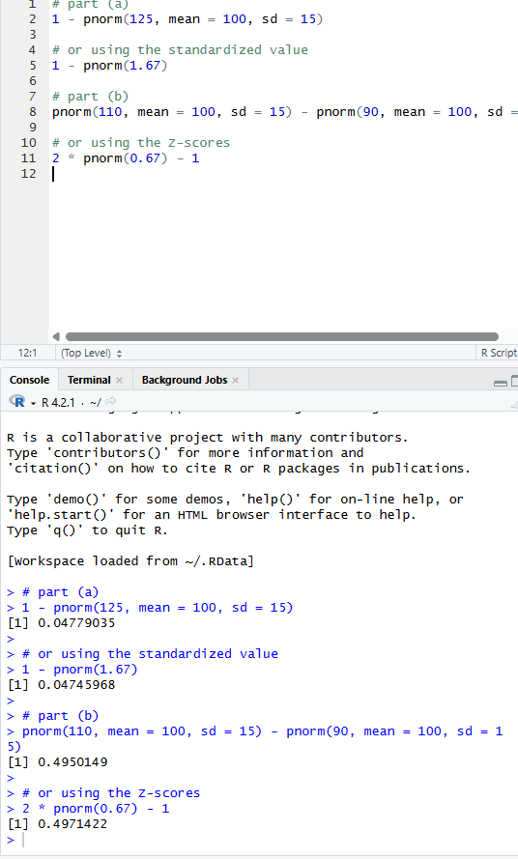
- Multiple-choice examitation
There are n =15 questions, each with 5 possible answers and exactly one correct answer. The student guesses randomly on every question, so the probability of a correct answer is:
$p=\frac{1}{5}=0.2$
Let X be the number of questions answered correctly.
Then X has a binomial distribution:
$X ∼Binomial( n=15, p=0.2)$
With the probability mass function:
$P\left(X=x\right)= \left({15 \atop x}\right){\left(0.2\right)}^{x}{(0.8)}^{15-x}, x=0,1,…, 15.$
Probability that the student gets at least 3 correct
$P\left(X ≥3\right)=1-P\left(X ≤2\right)=1-[P\left(X=0\right)+P\left(X=1\right)+P\left(X=2\right)]$.
$Compute each term$:
$$P\left(X=0\right)= \left({15 \atop 0}\right){\left(0.2\right)}^{0}{\left(0.8\right)}^{15}=1*{0.8}^{15} ≈0.0352,$$
$P\left(X=1\right)= \left({15 \atop 1}\right){\left(0.2\right)}^{1}{(0.8)}^{14}=15*0.2*{0.8}^{14} ≈0.1319,$
$P\left(X=2\right)= \left({15 \atop 2}\right)({0.2)}^{2}{\left(0.8\right)}^{13}=105*0,04*{0.8}^{13} ≈0.2309$

Add them:
$P\left(X ≤2\right)≈0.0352+0.1319+0.2309=0.3980.$

Hence
$P\left(X ≥3\right)=1-0.3980 ≈0.6020.$
So the probability of getting at least 3 answers correct by guessing is
$$P\left( X ≥3\right)≈0.602.$$

