US MSA Rent Rate Data 2015-2022 (Vickylynn)



Per_Capital Income by County 2019-2021 (Counterfactual)

Census_Pop Change

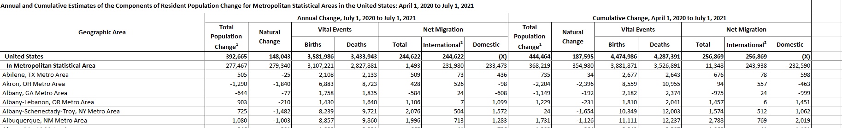

CPI_MSA_2022-2022

Note: Needs to be converted to a long table

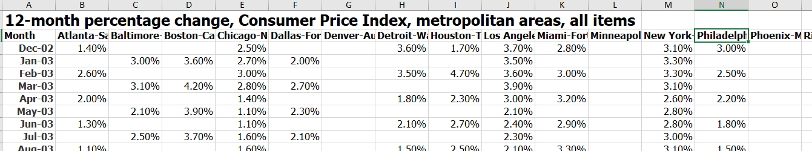

Population_Age (CounterFactual)

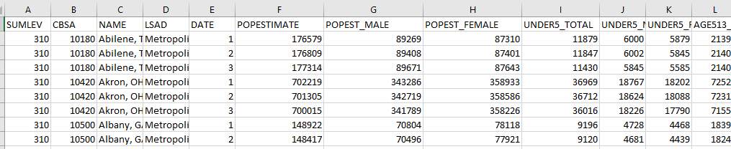

Stock_market

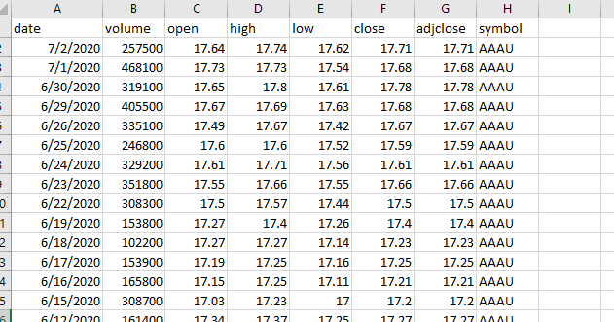

System-Performance-Measures-Data-Since-FY-2015_Homelessness

