The module can use 125 different channels which gives a possibility to have a network of 125 independently working modems in one place. Each channel can have up to 6 addresses, or each unit can [communicate with up to 6 other units at the same time](https://howtomechatronics.com/tutorials/arduino/how-to-build-an-arduino-wireless-network-with-multiple-nrf24l01-modules/).

The power consumption of this module is just around 12mA during transmission, which is even lower than a single LED. The operating voltage of the module is from 1.9 to 3.6V, but the good thing is that the other pins tolerate 5V logic, so we can easily connect it to an Arduino without using any logic level converters.

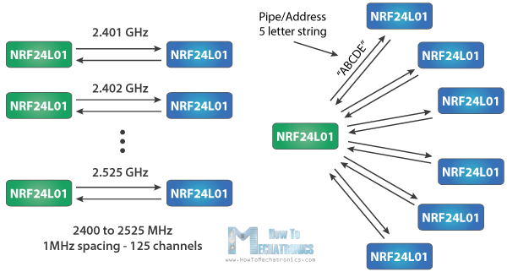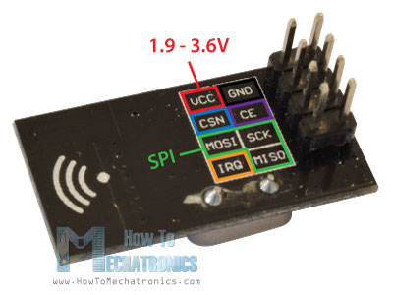

Three of these pins are for the SPI communication and they need to be connected to the SPI pins of the Arduino, but note that each Arduino board have different SPI pins. The pins CSN and CE can be connected to any digital pin of the Arduino board and they are used for setting the module in standby or active mode, as well as for switching between transmit or command mode. The last pin is an interrupt pin which doesn’t have to be used.

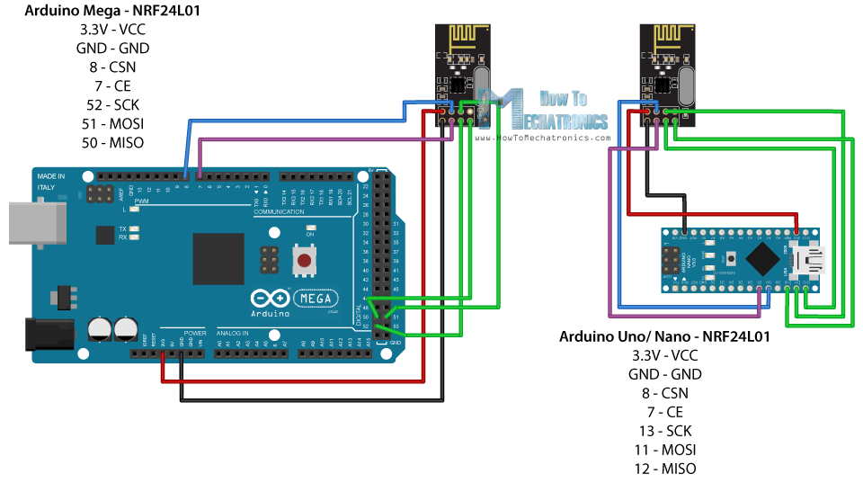

So vcc goes to 3.3 volts, have in mind not to plug it to 5 volts, ground goes to ground

The CE you can plug it into any digital pin

The next pin is the CS and you can also connect it to any digital pin you want

Next pin is SCK which goes to digital pin13 of the Arduino

MOSI goes to digital pin 11

MISO goes to digital pin 12

___________

Both modules have to use the same channel number and the same pipe address

This module sends data on a pipe(which basically is like a tunnel for the wireless communication)

There is this post which I don’t really understand :

<https://forum.arduino.cc/index.php?topic=374557.0>

<https://arduino.stackexchange.com/questions/2946/nrf24l01-pipe-question>

<https://tmrh20.blogspot.com/2016/08/rf24-addressing-review-of-nrf24l01.html>

some explanation I have found on the net:

“Note that the *openReadingPipe()* method must be passed an additional integer parameter that describes which0020reading pipe is being initialized.  This is because the RF module can have up to 6 reading pipes open at a given time!”

Sooooo, from what I understood, each of this devices can be a transmitter and receiver at the same time, but can only write one and read 6 times, so when you say write this thing so it will be transmittedand the receivers will get the data you don’t say: “use this one” cause there is only one tunnel for writing but when you say to the module go and read this thing askes you: which of my 6 tunnels for reading do you want me to use?

“ Just ensure that the reading and writing addresses are swapped on the two devices, or no data will be transmitted or read!”