**Lab7**

Negin Kheirmand

9831023

This week’s lab is about working with EEPROM and making a washing machine’s brain along the way.

**IC & Modules I used:**

* Arduino Nano
* EEPROM (ATMEL721P 24C02B PU27 D)
* LED
* Keypad
* LCD (character display)
* a 100k potentiometer (& some jumper wires & resistors)

Codes for the Lab:

1. Last Part: sketch_Translay directory

**What I learnt in this experiments:**

* **What relays are and how they work**
* **(this one should probably be in the list of “things I couldn’t figure out) I couldn’t make the last circuit work, I thought it might be because the base current of transistor (provided by the Arduino D5) might not be enough specially after adding a 10k resistor in the way to further control the current, so I changed the resistor by replacing it with a 1.5k and even a 220 and proceeded to also change the relay to make sure it’s not because the relay is not working or something like that, still didn’t work! ☹** 
  + **Will investigate further in the future**

Experiment Report:

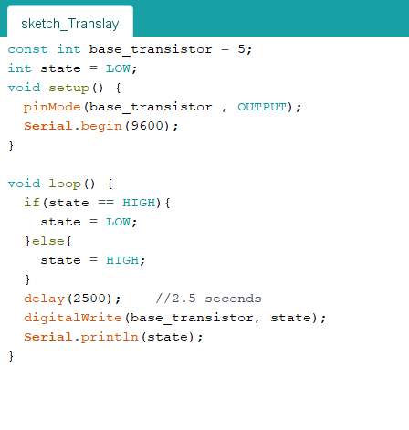

## Questions:



1. EEPROM uses: