**Lab4**

Negin Kheirmand

9831023

This week’s lab is about working with Relays.

**IC & Modules I used:**

* Arduino Nano
* LED (and diode –I used LED instead -)
* Push Button
* Battery (9v)
* Motor
* Relay
* NPN transistor (2n2222a h331)
* 10k, 20k(2*10k), 1k (used 1.5k instead), 220 Resistors
* a 100k potentiometer (& some jumper wires)

Codes for the Lab:

1. Last Part: sketch_Translay directory

**What I learnt in this experiments:**

* **What relays are and how they work**
* **(this one should probably be in the list of “things I couldn’t figure out) I couldn’t make the last circuit work, I thought it might be because the base current of transistor (provided by the Arduino D5) might not be enough specially after adding a 10k resistor in the way to further control the current, so I changed the resistor by replacing it with a 1.5k and even a 220 and proceeded to also change the relay to make sure it’s not because the relay is not working or something like that, still didn’t work! ☹** 
  + **Will investigate further in the future**

Experiment Report:

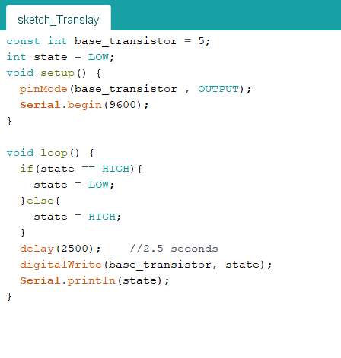

## Questions:

1. What is relay:

* A relay is an electromagnetic switch that opens and closes circuits electromechanically or electronically. A relatively small electric current that can turn on or off a much larger electric current operates a relay. Relays work like some electrical products since they receive an electrical signal and send the signal to other equipment by turning the switch on and off. Even if the relay contact is normally closed or normally open, they are not energized. Its state will change only if you apply an electrical current to the contacts.

1. How it works:

* 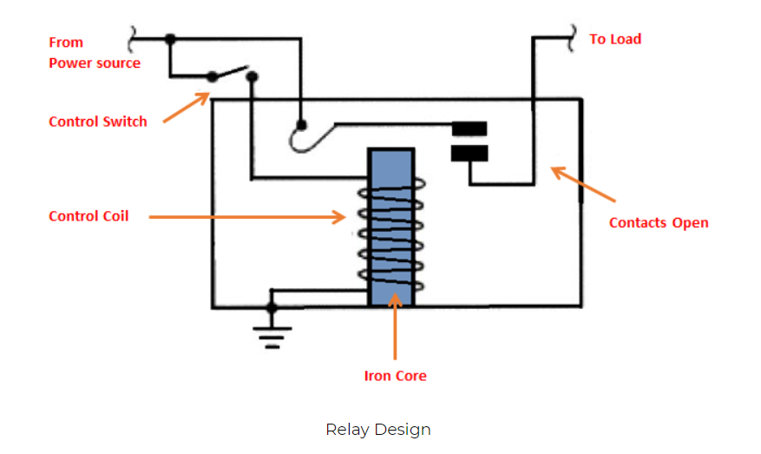

The figure above shows the inner sections diagram of a relay. A control coil surrounds the iron core. The electromagnet starts energizing when the current flows through the control coil then intensifies the magnetic field. The electromagnet becomes connected to the power source through the contacts to the load and a control switch. The upper contact arm becomes attracted to the lower fixed arm and then closes the contacts that result in a short circuit. The contact then moves in the opposite direction and creates an open circuit once the relay has been de-energized.

The movable armature will return to its initial position when the coil current is off. The force that causes its movement will be almost the same as the half strength of the magnetic force. Spring and gravity provide this force

1. Relay Pins:

* Normally Open (NO) terminal – connect your device (e.g., LED or any load) to this terminal if you want the device to be off when the relay is not powered, and on when the relay is powered.
* Normally Closed (NC) terminal – connect to this terminal if you want your device to be off when the relay is powered and normally on when the relay is not powered.
* Common Terminal – it is the terminal of the relay where you connect the first part of your circuit. When the relay is powered, and the switch is closed, the common terminal and the normally open terminal have continuity. On the other hand, when the relay is not powered, and the switch is open, the common terminal and the normally closed terminal have continuity.
* COIL – the terminals where you apply voltage to supply power to the coils that will eventually close the switch. Here, polarity is not important. Either of the sides can be negative or positive. However, polarity does matter when using a diode

1. Different Type of Relays:

* **Electromechanical Relays vs Solid State Relays**
  + Relays are either electromechanical relays or solid-state relays. In **electromechanical relays** (EMR), contacts are opened or closed by a magnetic force. With **solid-state relays** (SSR), there are no contacts and switching is totally electronic. The decision to use electromechanical or solid state relays depends on an application's electrical requirements, cost constraints and life expectancy. Although solid-state relays have become very popular, electromechanical relays remain common. Many of the functions performed by heavy-duty equipment need the switching capabilities of electromechanical relays. Solid State Relays switches the current using non-moving electronic devices such as silicon controlled rectifiers.  
    These differences in the two types of relays result in advantages and disadvantages with each system. Because solid state relays do not have to either energize a coil or open contacts, less voltage is required to "turn" Solid State Relays on or off. Similarly, Solid State Relays turn on and turn off faster because there are no physical parts to move. Although the absence of contacts and moving parts means that Solid State Relays are not subject to arcing and do not wear out, contacts on Electromechanical Relays can be replaced, whereas entire Solid State Relays must be replaced when any part becomes defective. Because of the construction of Solid State Relays, there is residual electrical resistance and/or current leakage whether switches are open and closed. The small voltage drops that are created are not usually a problem; however, Electromechanical Relays provide a cleaner ON or OFF condition because of the relatively large distance between contacts, which acts as a form of insulation.
  + Uses of these relays:
    - The point of a relay is to use a small amount of power to switch to a large amount of power. Relays typically are used in modern household appliances such as hair dryers, kitchen appliances, and lights that need to be switched on and off. They are also used in cars where things need to be turned off and on. In fact, modern car manufacturers are using relay panels in fuse boxes because they make maintenance simpler. There are a few things to think about when selecting relays for modern devices. First, you need to consider whether the contact will be normally closed (NC) or normally open (NO). Each of these situations will dictate which types of relays are needed and whether the device needs to be on all the time or needs to be toggled between the on and off positions. Another thing that must be considered is the maximum amount of voltage that the armature and its contact devices can handle. Finally, and perhaps the most important consideration, is the voltage and current that will be needed in the electronics project being undertaken because this will determine the armature activation.
  + Comparison:

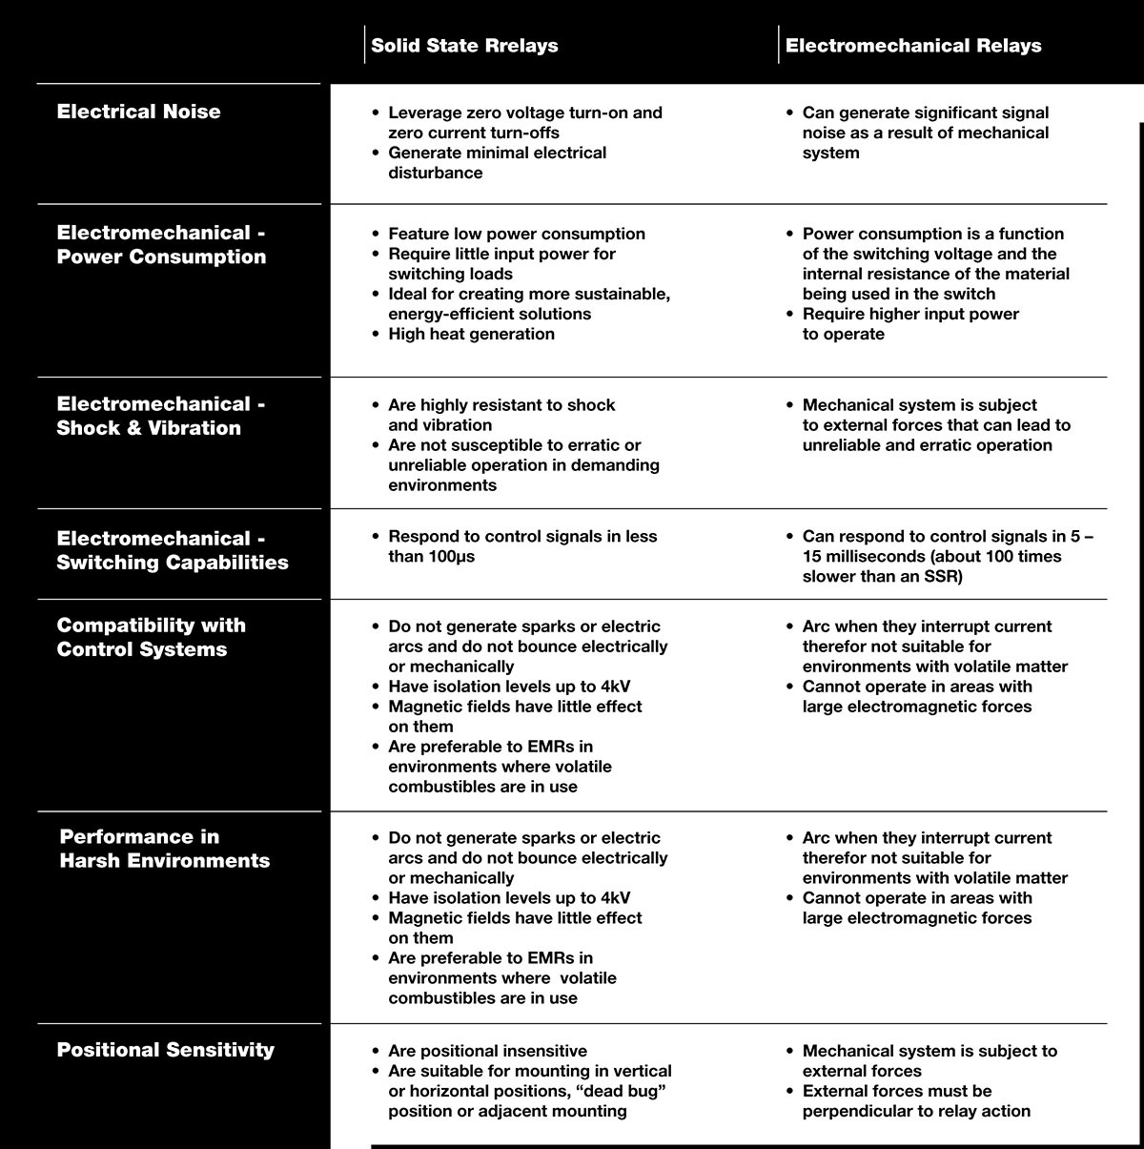

* Also can be divided to different type of relays depending on the connection:
  + SPST-NO (Single-Pole Single-Throw, Normally-Open) relays have a single Form A contact or make contact. These have two terminals which can be connected or disconnected. Including two for the coil, such a relay has four terminals in total.
  + SPST-NC (Single-Pole Single-Throw, Normally-Closed) relays have a single Form B or break contact. As with an SPST-NO relay, such a relay has four terminals in total.
  + SPDT (Single-Pole Double-Throw) relays have a single set of Form C, break before make or transfer contacts. That is, a common terminal connects to either of two others, never connecting to both at the same time. Including two for the coil, such a relay has a total of five terminals.
  + DPST – Double-Pole Single-Throw relays are equivalent to a pair of SPST switches or relays actuated by a single coil. Including two for the coil, such a relay has a total of six terminals. The poles may be Form A or Form B (or one of each; the designations NO and NC should be used to resolve the ambiguity).
  + DPDT – Double-Pole Double-Throw relays have two sets of Form C contacts. These are equivalent to two SPDT switches or relays actuated by a single coil. Such a relay has eight terminals, including the coil

1. How to identify relay pins:

* Start by finding the two pins connected to the relay coil. You can do this with your multi-meter. The coil pins will be the only pair that exhibit a resistance. It's likely to be somewhere between about 50Ω and 1000Ω.
* Low voltage DC relay coils obeys Ohm's Law. That is: - Current = Voltage ÷ Resistance. For example - the standard version of the 12v Omron G2E relay - has a coil resistance of 330Ω. So the current through the coil is 12v ÷ 330Ω = 36mA.
* Always check for any markings that indicate coil polarity. Relay coils give off high reverse-voltage spikes that will destroy sensitive electronic components. These spikes are generated by the coil - when the relay de-energizes - and the coil's magnetic field collapses. They are generally removed by fitting an external suppressor diode - across the relay coil. See diode D1 on this Repeat Timer Schematic.
* However - Very Rarely - you'll find a relay that's fitted with an internal suppressor diode. If there is an internal suppressor diode - it's important that the coil is connected the right way round. Otherwise the diode will cause a short circuit. So - always check for polarity markings - just in case.
* You'll probably find that most relays will work satisfactorily with a range of supply voltages. For example - the standard 12v G2E will work from about 8 Volts - up to about 14 Volts. If you have no idea what voltage your coil is - start with say 3 volts - and increase it until the relay energizes.
* Next - switch the power off - and turn your attention to the remaining pins. With your meter - you should be able to divide them into two groups. Some pins will be joined together in pairs. And some pins will stand alone - with no connection to any other pin. Take a careful note of each.
* Although there will be exceptions - the stand alone pins are likely to be normally-open contacts. And the pairs of pins are most likely to be the pole and normally-closed contacts.
* Start with a normally-closed pair. One will be the pole - and the other will be the normally-closed contact. When power is applied to the coil - the pole will part from the normally-closed contact - and establish a new connection with the normally-open contact. When you switch off the power, the pole should part from the normally-open contact - and return to the normally-closed contact.

1. Internal schematic(structure) of relays:

* 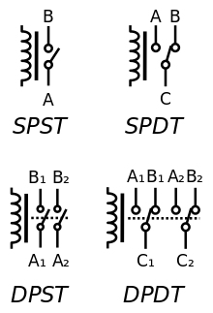

1. How does the circuit (not) work?

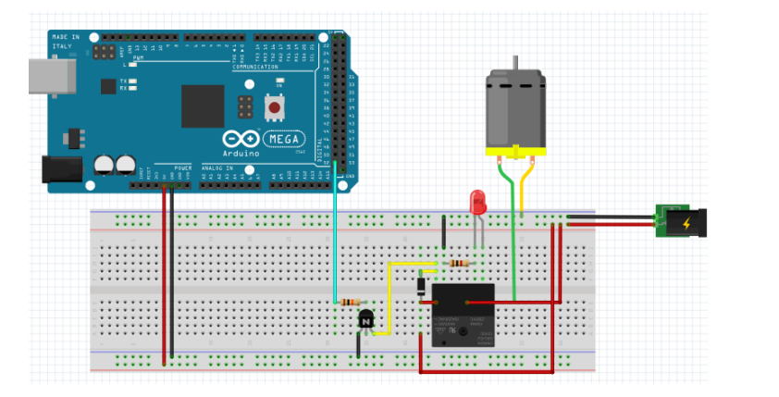

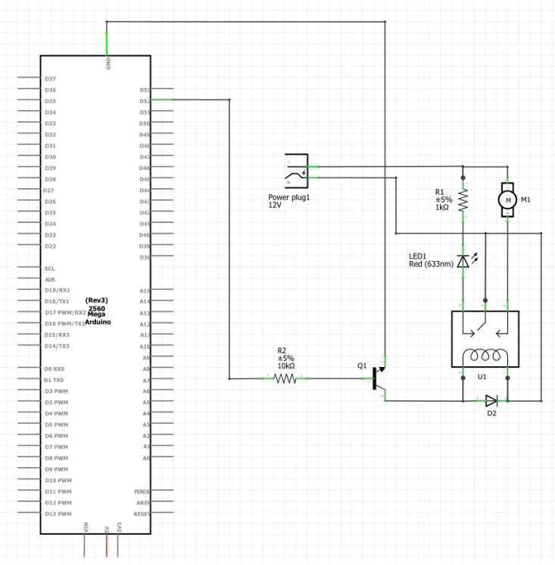

* Well, I’m no professional in this, if I was I could get my circuit to work correctly but this is how (I think) it works:
  + If the base has current (Arduino digital pin is high) then the emitter and collector of the transistor are connected, then the current can pass through the coil pins of the relay and the relay has the common pin and the NO pins connected meaning the motor would be spinning in this state
  + If the base doesn’t have any current (Arduino digital pin is low) then the emitter and collector of the transistor are not connected, meaning current cannot pass through the coil pins of the relay and the relay has the common pin and the NC pins connected, so the motor is not spinning and instead the LED is turned on.

Sources:

<https://circuitdigest.com/article/relay-working-types-operation-applications>

<https://www.galco.com/comp/prod/relay.htm>

<https://www.arrow.com/en/research-and-events/articles/crydom-solid-state-relays-vs-electromechanical-relays>

<https://320volt.com/en/spdt-relay-and-dpdt-relay/>

<http://www.zen22142.zen.co.uk/ronj/cpr.html>

<https://tutorial.cytron.io/2012/08/01/identify-terminal-pins-of-a-relay-without-reference-to-datasheet-2/>