# **Daily Transaction Summary – User Manual**

Table of Contents

1. Pre-requisites 3

2. Setup, Install and Run 3

3. Troubleshooting 4

# Pre-requisites

The software requires at-least Java 1.8 and Maven to build and run.

# Setup, Install and Run

Download the zip or clone the repository from GitHub –

<https://github.com/negirajeev04/transaction-summary-report>

Unzip the folder and move to root directory transaction-summary-report where the pom.xml is located.

To build the software run –

***mvn clean package***

This will build and deploy the jars in /target folder.

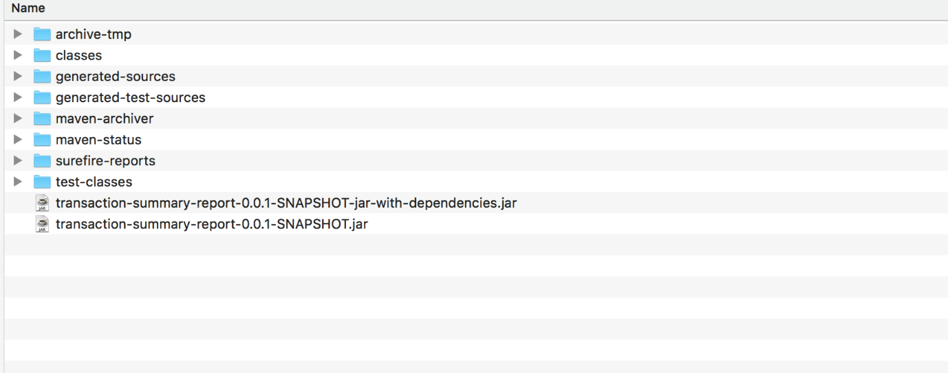

To run the software, we can use either maven execute plugin or using JRE.

Using Maven –

mvn exec:java –Dexec.args={Absolute path to the input flat file}.

Ex –

***mvn exec:java –Dexec.args=”/Users/RajeevNegi/Documents/workspace/transaction-sumary-report/Input.txt”***

Using Jre –

java –cp target/transaction-summary-report-0.0.1-SNAPSHOT-jar-with-dependencies.jar org.rajnegi.transactionsummary.transaction_summary_report.TransactionSummary {INPUT_FILE_PATH}

Ex –

***java –cp target/transaction-summary-report-0.0.1-SNAPSHOT-jar-with-dependencies.jar org.rajnegi.transactionsummary.transaction_summary_report.TransactionSummary /Users/RajeevNegi/Documents/workspace/transaction-sumary-report/Input.txt***

The daily summary report in CSV format will be generated in the same folder where the input file is located.

Sample output.csv and logs attached –

 

# Troubleshooting

|  |  |
| --- | --- |
| **Issue** | **Root Cause** |
| The program exists with the error - *Missing the input flat file path. Please mention absolute path for the file as part of the program arguments.* | The program arguments is missing the input file path. The program argument should be an absolute path to the input flat file. |
| Errors in the log file - *Unable to parse the record - "+record+"; Missing fields!!"*  *Moving to next record.* | The flat record length excluding the trailing fillers must be 176 in length. If not, the record will be logged as invalid and program will continue with the next record. |
| Errors in the log file – *Unable to parse <dateString> to date.* | The dateString is not a valid format yyyyMMdd. The current record will be skipped. |
| Errors in the log file – *Unable to parse <amount> to double.* | The amount is unable to parse to double. Current record will be skipped. |