# ECE60146 Homework 9

Utsav A. Negi

April 12, 2024

## Aim

The aim of this report is to demonstrate the approach used to train neural networks built using Gated Recurrent Unit (GRU) for sentiment analysis and to evaluate its performance in predicting the sentiments of a given sentence.

### Source Code Detail

For this assignment, the details about the source code are as follows:

* *hw9.py*: Source code consisting of all the essential classes, functions & main ML pipeline for training and evaluating a GRU-based neural network which is trained and tested using the given data.csv file.
* hw9_extra_200.py: Source code consisting of all the essential classes, functions and main ML pipeline for training and evaluating a GRU-based neural network which is trained and tested using SentimentDataset200.
* hw9_extra_400.py: Source code consisting of all the essential classes, functions and main ML pipeline for training and evaluating a GRU-based neural network which is trained and tested using SentimentDataset400.

### Data Organization

For this project, the data from each dataset is organized into training data and testing data by using a list of sentences alongside a list of their associated sentiments. The TextDataset class which is a child class of torch.utils.data.Dataset is responsible to generate embeddings and subsequent sentiments in one-hot encoding form. To generate the embeddings, every subwords in the sentences are tokenized and later embedded using pretrained Bert tokenizer and pretrained Bert model respectively. The __getitem__ class function is overridden to return a pair consisting of embedding and its associated sentiments in one-hot encoding form.

### Model

The model uses nn.GRU from PyTorch to keep track of hidden layers and one of the constructor parameters of the model class is responsible for setting bidirectional to either True or False. Furthermore, at the start of the model, the hidden layer is initialized as a zero vector which is then fed into the GRU layer along with the input. Non-linearity function is applied to the resultant tensor and using the linear layer and LogSoftmax function, the output of desired size is achieved. Note that, in this case, the input data will be arranged in batches, which gives more freedom to the GRU to handle the values in the hidden states.

### Training

The dataloader yields a pair consisting of processed embedding and its associated sentiments in one-hot encoding form. The embedding is reshaped to the dimensions (batch size, max length of embedding, input size) which is later serves as an input for the GRU-based model. The output of the model is then compared with the ground truth sentiment by determining loss using Negative Log Likelihood loss function. The parameters are optimized using Adam optimizer with a learning rate of 1e-3. For the training, the batch size is set to 25, input size is set to 768, the epochs are set to 25, embedding size is set to 512, hidden layer size is set to 800 along with number of layers set to 2. Furthermore, the output layer is set to 3 in the case of using data.csv as the data source while the output layer is set to 2 in the case of using SentimentDataset200 and SentimentDataset400.

### Evaluation

The trained model is evaluated by determining its accuracy in determining correct sentiments for test sentences and the observations are then presented using a confusion matrix. The dataloader yields a pair consisting of processed embedding and its associated sentiments in one-hot encoding form. The embedding is again reshaped to match the dimension format used in training which is used as an input to the trained model. The batched generated results and the batched ground truth sentiments are iterated to determine the classification accuracy and the values for the confusion matrix are recorded.

### Observations

### Using data.csv as Data Source

When data.csv is used as the data source, the classification accuracy of the trained model with bidirectional set to False is 76.82% while the classification accuracy of the trained model with bidirectional set to True is 96.07%. The training loss trend in Figure 1 shows that the model trained with bidirectional set to True converges faster than the model trained with bidirectional set to False.

*Figure 1: Training Loss when the given data.csv file is used as the data source for training.*

Furthermore, the confusion matrix for the unidirectional model (Figure 2) shows some misclassifications while the confusion matrix for the bidirectional model (Figure 3) shows that the model is quite strong in classifying the sentiments for a given input sentence.

*Figure 2: Confusion matrix of model when bidirectional is set to False which is trained using data sourced from the given data.csv file.*

*Figure 3: Confusion matrix of model when bidirectional is set to True which is trained using data sourced from the given data.csv file.*

### Using SentimentDataset200 as Data Source

When SentimentDataset200 is used as the data source, the classification accuracy of the trained model with bidirectional set to False is 86.68% while the classification accuracy of the trained model with bidirectional set to True is 86.52%. The training loss trend in Figure 4 shows that the model trained with bidirectional set to True converges faster than the model trained with bidirectional set to False.

*Figure 4: Training Loss when the SentimentDataset200 is used as the data source for training.*

*Figure 5: Confusion matrix of model when bidirectional is set to False which is trained using data sourced from SentimentDataset200.*

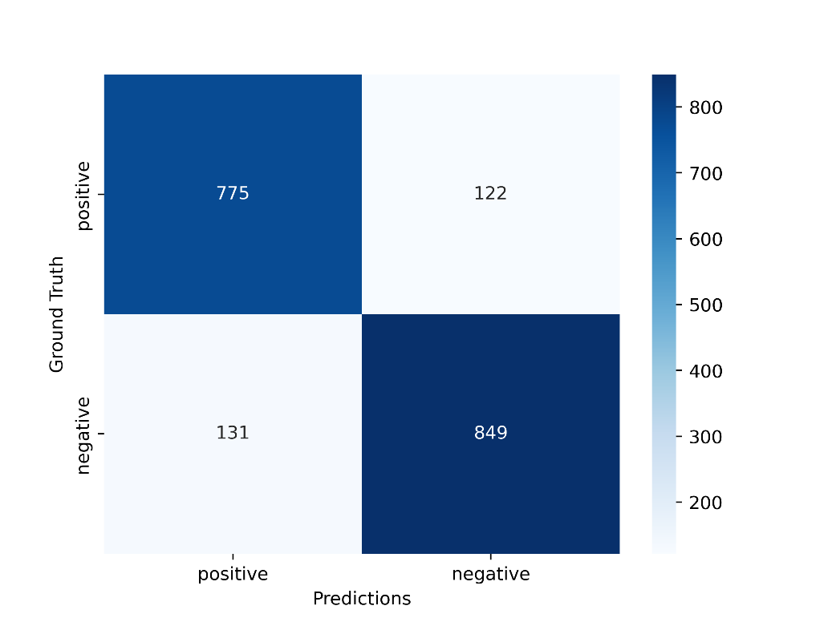

*Figure 6: Confusion matrix of model when bidirectional is set to True which is trained using data sourced from SentimentDataset200.*

*Note: Here, the first column and row represent predicted negative sentiments and ground truth negative sentiments respectively while the second column and row represent predicted positive sentiments and ground truth positive sentiments respectively.*

Furthermore, the confusion matrix for the bidirectional model (Figure 5) shows some misclassifications compared to the confusion matrix for the unidirectional model (Figure 6). This shows that the unidirectional model is stronger in classifying sentiments from a given sentence.

### Using SentimentDataset400 as Data Source

When SentimentDataset400 is used as the data source, the classification accuracy of the trained model with bidirectional set to False is 88.13% while the classification accuracy of the trained model with bidirectional set to True is 87.68%. The training loss trend in Figure 7 shows that the model trained with bidirectional set to True equally converges with the model trained with bidirectional set to False.

*Figure 7: Training Loss when the SentimentDataset400 is used as the data source for training.*

*Figure 8: Confusion matrix of model when bidirectional is set to False which is trained using data sourced from SentimentDataset400.*

*Figure 9: Confusion matrix of model when bidirectional is set to True which is trained using data sourced from SentimentDataset400.*

*Note: Here, the first column and row represent predicted negative sentiments and ground truth negative sentiments respectively while the second column and row represent predicted positive sentiments and ground truth positive sentiments respectively.*

Furthermore, the confusion matrix for the bidirectional model (Figure 5) shows the same number of misclassifications as the confusion matrix for the unidirectional model (Figure 6).

### Summary

This project uses the Gated Recurrent Unit (GRU) in the model to determine sentiments associated with a given sentence. Using three different data sources, the model is trained, and its performance is evaluated. While using the given data.csv as the data source, it is observed that the classification accuracy of bidirectional model is higher than the classification accuracy of the unidirectional model. However, upon using the SentimentDataset200 and SentimentDataset400, it is noticed that the unidirectional model has slightly better accuracy compared to the bidirectional model. Further, the confusion matrix of models trained using data.csv as data source classifies sentences as neutral prominently over other two sentiments, while the confusion matrix of models trained using SentimentDataset200 as well as the confusion matrix of models trained using SentimentDataset400 classifies sentences as positive prominently over negative sentiments. Based on the results, there are no signs of extreme bias or variance which can impact the outcome and with better hyperparameters along with more training epoch, higher classification accuracy can be attained.