THE SOLAR SYSTEM
~GUI in Matlab~

Student :
Negrea Sara Diana
Group 2022
Year II
Series English
Coordinator :
Ph.D Eng. Mihaela Cîrlugea
Ph.D Eng .Paul FARAGO
Table of Content
1.INTRODUCTION
2.My Project: The Solar System
3.Theoretical presentation
- CONCEPT
4.Files in Matlab
- Main file
- Mercury window
- Venus window
- Earth window
- Mars window
- Jupiter window
- Saturn window
- Uranus window
- Neptune window
- Function for radius and surface for each planet
- Solar system window

- INTRODUCTION

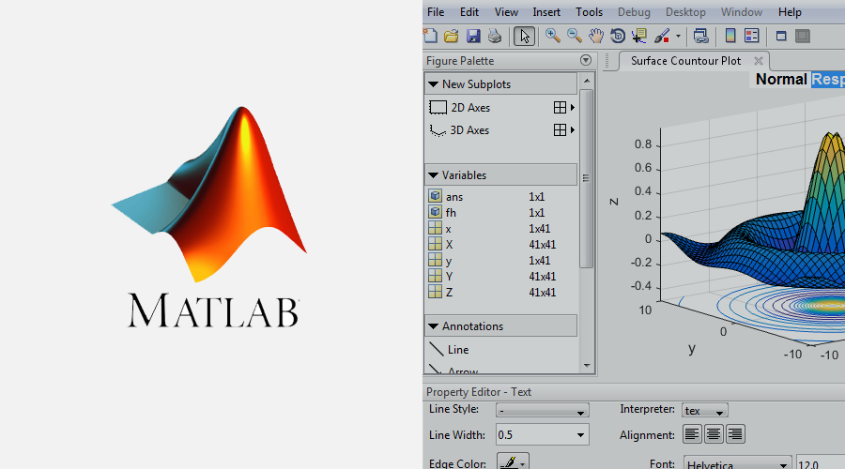
- The toolboxes Matlab has containing packages of built-in functions and classes, provide great help for topics like data acquisition, modelling and simulation, data and signal analysis, image processing, deep learning, statistics etc.

- Today, Matlab is a valuable tool, being widely used in many industries, finances and for engineering research. Nowadays it is very easy to use, very error tolerant, pictural and offers many suggestions when typing or creating functions or programs.
- The toolboxes Matlab has containing packages of built-in functions and classes, provide great help for topics like data acquisition, modelling and simulation, data and signal analysis, image processing, deep learning, statistics etc.
- Standing for MATrix LABoratory, Matlab was invented in the late 1970s by the chairman of the Computer Science department of the University of New Mexico, Cleve Moler. In those times, C and Fortan were widely used, but scientists and engineers were in need of a more powerful and versatile environment provided for calculus with matrices.

DID YOU KNOW THAT???

II. My Project: The Solar System
- The Solar System is the gravitationally bound system of the Sun and the objects that orbit it. It formed about 4.6 billion years ago when a dense region of a molecular cloud collapsed, forming the Sun and a protoplanetary disc.

- The largest objects that orbit the Sun are the eight planets. In order from the Sun, they are four terrestrial planets (Mercury, Venus, Earth and Mars); two gas giants (Jupiter and Saturn); and two ice giants (Uranus and Neptune). All terrestrial planets have solid surfaces.

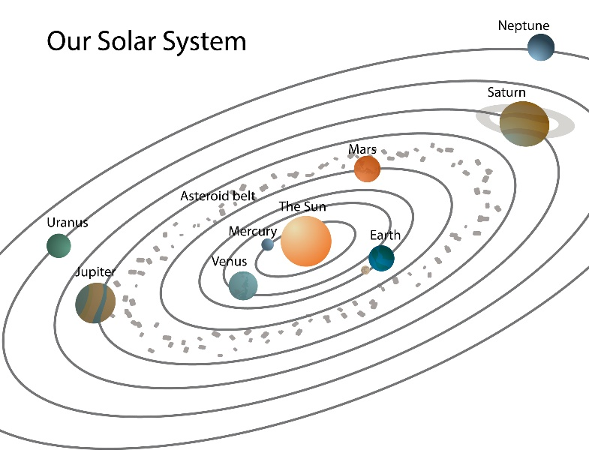
Definition:
How was it discovered?
- Initially, ancient and medieval astronomers observed visible objects like the Sun, Moon, planets, comets, and atmospheric phenomena. Early tools and geometric observations paved the way for the telescope's invention, enabling the discovery of planetary moons, rings, asteroids, and new planets. This era revealed Earth as a planet and stars as other suns, distinguishing the Solar System as a separate entity.

- For centuries, the Solar System was perceived as the entire universe until the mid-17th century, when the distinction between it and outer space became clear. Advances in spectroscopy and various branches of astronomy (e.g., radio, infrared, X-ray) enriched knowledge about celestial compositions. Robotic probes, the Apollo Moon landings, and space telescopes furthered planetary science, offering insights into planetary atmospheres, geology, and electromagnetic properties.

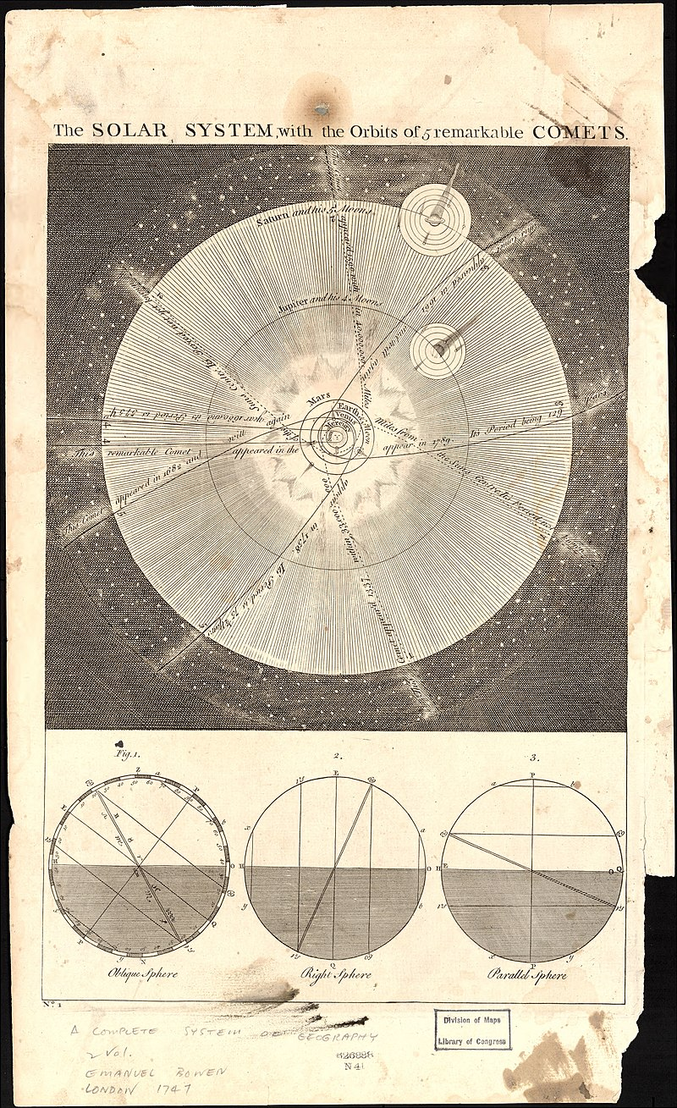

III. Theoretical presentation
- CONCEPT:
-the project includes a graphic interface that will show in 3D the real size of each planet of the Solar System separately, displaying its radius and its surface, followed by a real scaled graphic will all 8 planets.
- This pushbutton will open a word document (this one) that will contain all the details about the GUI

The main Menu

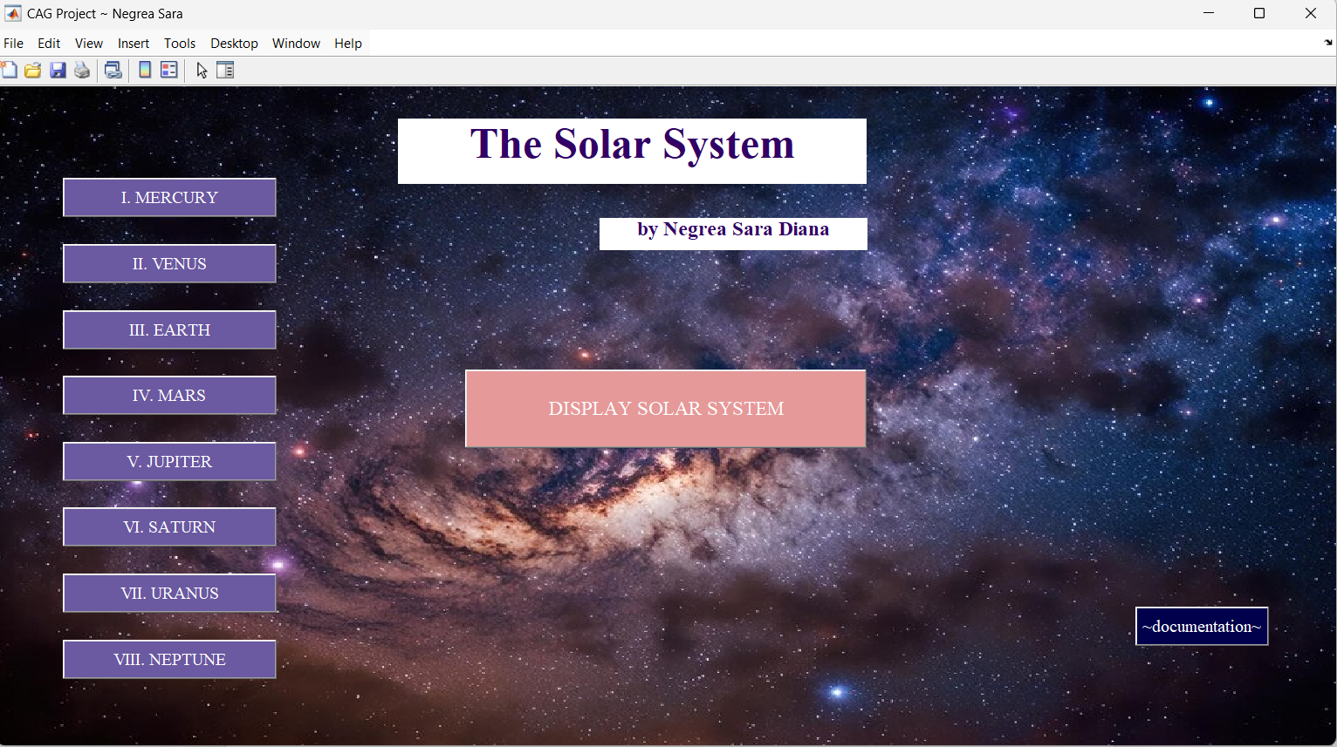
- This pushbutton will open a real-life scaled graphic with all planets
- Each of these pushbuttons will open a separate window for each planet

- The Planets Characteristics
-The popup menu is holding the radius for each planet (+the name of it)
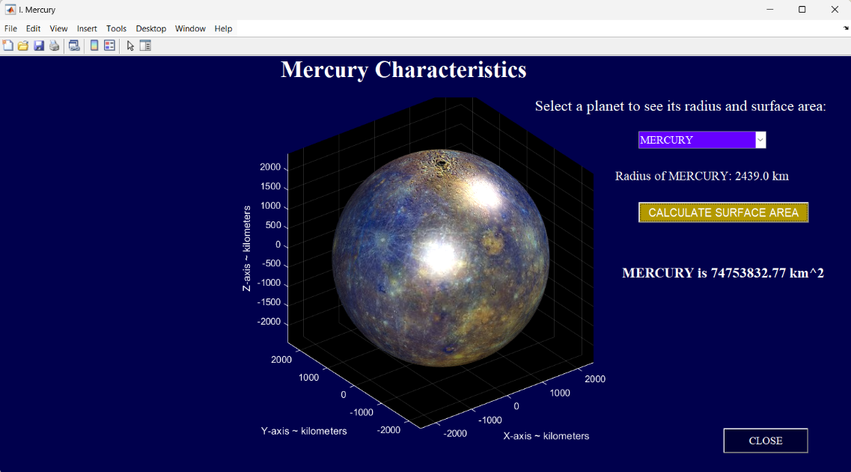
-The ‘CALCULATE SURFACE AREA’ button will calculate, using the previous selected radius, the surface of the entire planet with the FORMULA :
$A=4πr^{2}$ and it will display it
-The close button returns to the main interface

The rest of the windows:
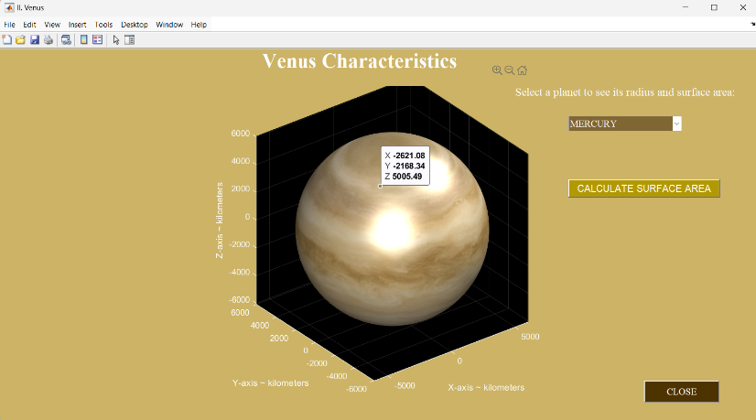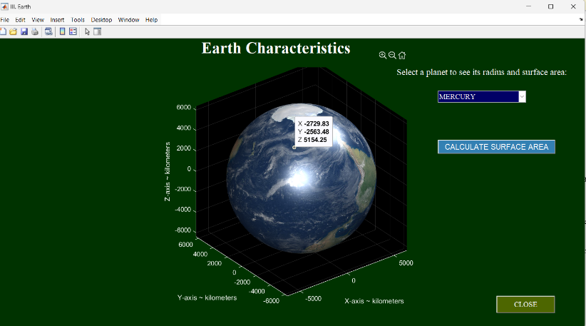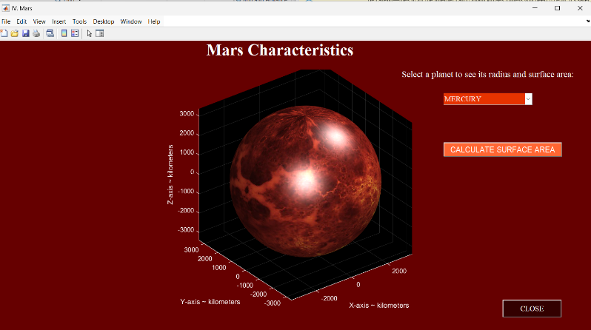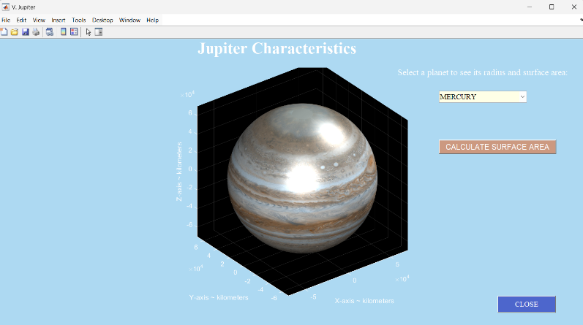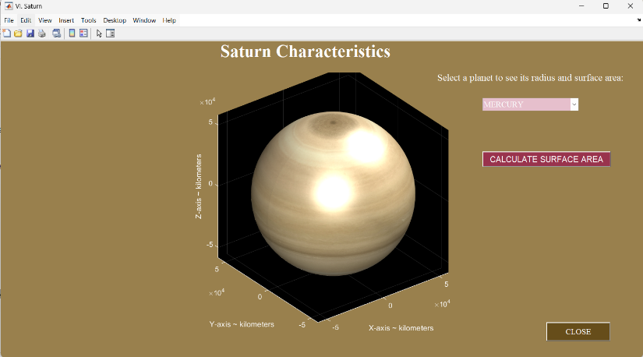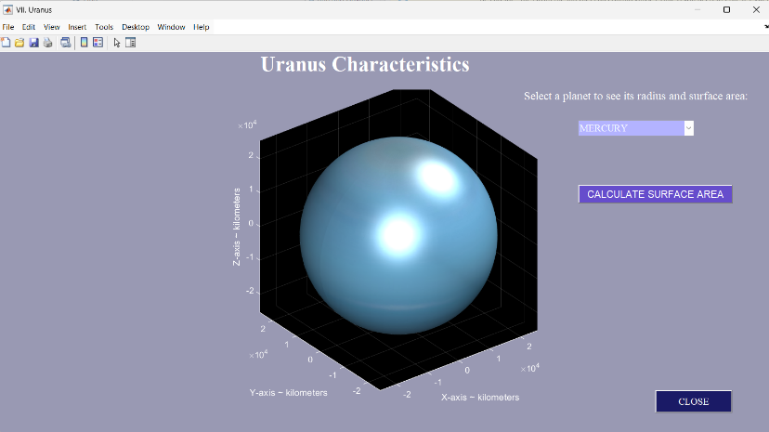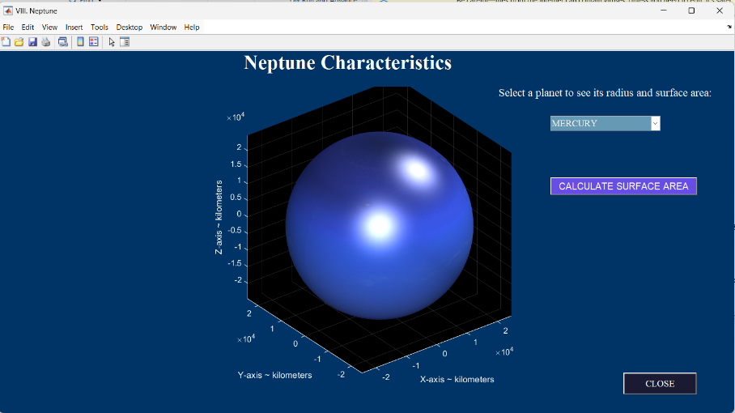
-The 3D view of the solar system (real- life scaled) allows us to rotate, minimize and maximize the graphic as we please

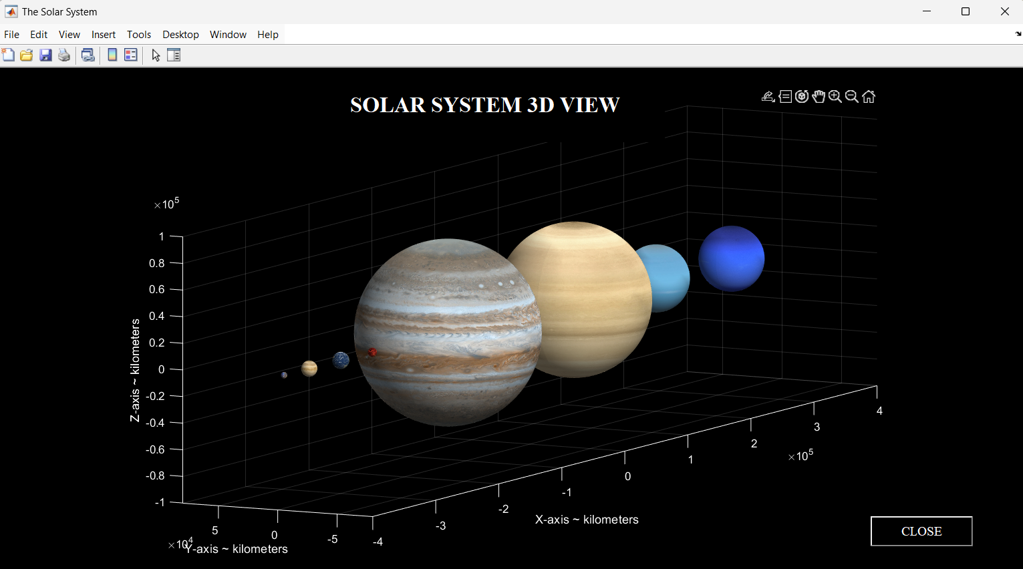

- Files in Matlab
- Main file
%%
% |%%%% MAIN MENU|
close all;

%creating the main menu
Fig=figure('Name','CAG Project ~ Negrea Sara',...
'Units','normalized',...
'Position',[0.1 0.1 0.8 0.7],...
'color','none',...
'NumberTitle','off');
backgroundimg =imread('milkyway.jpg'); %imread() allows us to 'read' the image

backgroundAxes = axes('Parent', Fig, 'Position', [0, 0, 1, 1]);
%%
imagesc(backgroundimg); %this one sets the previous image as a backround
set(backgroundAxes, 'handlevisibility', 'off', 'visible', 'off');

uicontrol('Style','text',...
'Units','normalized',...
'Position',[0.3 0.85 0.35 0.1],...
'backgroundcolor','#FFFFFF',...',...
'foregroundcolor',"#330066",...
'Fontname','Times New Roman',...
'FontWeight','Bold',...
'FontSize',30,...
'String','The Solar System');

uicontrol('Style', 'text', ...
'Units', 'normalized', ...
'Position', [0.45 0.75 0.2 0.05], ...
'BackgroundColor', '#FFFFFF', ...
'ForegroundColor', "#330066", ...
'FontName', 'Times New Roman', ...
'FontWeight', 'Bold', ...
'FontSize', 14, ...
'HorizontalAlignment', 'center', ...
'String', 'by Negrea Sara Diana');

%%
% _%%mercury_
uicontrol('style','pushbutton',...
'Units','normalized',...
'Position',[0.05 0.8 0.16 0.06],...
'string','I. MERCURY',...
'FontName','Times New Roman',...
'FontSize',12,...
'backgroundcolor',[0.42, 0.35, 0.63],...',...
'foregroundcolor',"#FFFFFF",...
'Callback','mercury_interface');

%%
% _%venus_
uicontrol('style','pushbutton',...
'Units','normalized',...
'Position',[0.05 0.7 0.16 0.06],...
'string','II. VENUS',...
'FontName','Times New Roman',...
'FontSize',12,...
'backgroundcolor',[0.42, 0.35, 0.63],...',...
'foregroundcolor',"#FFFFFF",...
'Callback','venus_interface');

%%
% _%%earth_
uicontrol('style','pushbutton',...
'Units','normalized',...
'Position',[0.05 0.6 0.16 0.06],...
'string','III. EARTH',...
'FontName','Times New Roman',...
'FontSize',12,...
'backgroundcolor',[0.42, 0.35, 0.63],...',...
'foregroundcolor',"#FFFFFF",...
'Callback','earth_interface');

%%
% _%%mars_
uicontrol('style','pushbutton',...
'Units','normalized',...
'Position',[0.05 0.5 0.16 0.06],...
'string','IV. MARS',...
'FontName','Times New Roman',...
'FontSize',12,...
'backgroundcolor',[0.42, 0.35, 0.63],...',...
'foregroundcolor',"#FFFFFF",...
'Callback','mars_interface');

%%
% _%%jupiter_
uicontrol('style','pushbutton',...
'Units','normalized',...
'Position',[0.05 0.4 0.16 0.06],...
'string','V. JUPITER',...
'FontName','Times New Roman',...
'FontSize',12,...
'backgroundcolor',[0.42, 0.35, 0.63],...',...
'foregroundcolor',"#FFFFFF",...
'Callback','jupiter_interface');

%%
% _%saturn_
uicontrol('style','pushbutton',...
'Units','normalized',...
'Position',[0.05 0.3 0.16 0.06],...
'string','VI. SATURN',...
'FontName','Times New Roman',...
'FontSize',12,...
'backgroundcolor',[0.42, 0.35, 0.63],...',...
'foregroundcolor',"#FFFFFF",...
'Callback','saturn_interface');
%%
% _
%uranus_
uicontrol('style','pushbutton',...
'Units','normalized',...
'Position',[0.05 0.2 0.16 0.06],...
'string','VII. URANUS',...
'FontName','Times New Roman',...
'FontSize',12,...
'backgroundcolor',[0.42, 0.35, 0.63],...',...
'foregroundcolor',"#FFFFFF",...
'Callback','uranus_interface');

%%
% _%%neptune_
uicontrol('style','pushbutton',...
'Units','normalized',...
'Position',[0.05 0.1 0.16 0.06],...
'string','VIII. NEPTUNE',...
'FontName','Times New Roman',...
'FontSize',12,...
'backgroundcolor',[0.42, 0.35, 0.63],...',...
'foregroundcolor',"#FFFFFF",...
'Callback','neptune_interface');

%%
% _%display_solar_system_button_
uicontrol('style','pushbutton',...
'Units','normalized',...
'Position',[0.35 0.45 0.3 0.12],...
'string','DISPLAY SOLAR SYSTEM',...
'FontName','Times New Roman',...
'FontSize',14,...
'backgroundcolor',[0.9, 0.6, 0.6],...',...
'foregroundcolor',"#FFFFFF",...
'Callback','solarsyst');

%%documentation
uicontrol('style','pushbutton',...
'Units','normalized',...
'Position',[0.85 0.15 0.10 0.06],...
'string','~documentation~',...
'FontName','Times New Roman',...
'FontSize',12,...
'backgroundcolor',[0, 0.0, 0.3],...',...
'foregroundcolor',"#FFFFFF",...
'Callback','open (''the_solar_system.docx'')');

- Mercury window
close all;

Fig=figure('Name','I. Mercury',...
'Units','normalized',...
'Position',[0.1 0.1 0.8 0.7],...
'color',[0 0.0 0.3],...
'NumberTitle','off');
radius_mercury();
%title
uicontrol('Style','text',...
'Units','normalized',...
'Position',[0.3 0.9 0.35 0.1],...
'backgroundcolor',[0 0.0 0.3],...',...
'foregroundcolor','white',...
'Fontname','Times New Roman',...
'FontWeight','Bold',...
'FontSize',25,...
'String','Mercury Characteristics');

img = imread('mercury_colormap.jpg'); %texture for Mercury

%creating the sphere
[x, y, z] = sphere(100);

scale_x = 2440;
scale_y = 2440;
scale_z = 2440;

x = scale_x * x;
y = scale_y * y;
z = scale_z * z;

surface(x, y, z, ...
'FaceColor', 'texturemap', ...
'EdgeColor', 'none', ...
'CData', img);

axis equal;
ax = gca;

ax.Color = 'black';
ax.XColor = 'white';
ax.YColor = 'white';
ax.ZColor = 'white';

view(3);
xlabel('X-axis ~ kilometers', 'Color', 'white');
ylabel('Y-axis ~ kilometers', 'Color', 'white');
zlabel('Z-axis ~ kilometers', 'Color', 'white');

grid on;
ax.GridColor = 'white';

light;
lighting phong;
camlight headlight;

xlim([-scale_x, scale_x]);
ylim([-scale_y, scale_y]);
zlim([-scale_z, scale_z]);
ax.TickLabelInterpreter = 'none';
ax.XColor = 'white';
ax.YColor = 'white';
ax.ZColor = 'white';

- Venus window
close all;

Fig=figure('Name','II. Venus',...
'Units','normalized',...
'Position',[0.1 0.1 0.8 0.7],...
'color',[0.8 0.7 0.4],...
'NumberTitle','off');

radius_venus();
uicontrol('Style','text',...
'Units','normalized',...
'Position',[0.3 0.9 0.35 0.1],...
'backgroundcolor',[0.8 0.7 0.4],...',...
'foregroundcolor','white',...
'Fontname','Times New Roman',...
'FontWeight','Bold',...
'FontSize',25,...
'String','Venus Characteristics');

img = imread('venus_colormap.jpg'); %texture for Venus

[x, y, z] = sphere(100);

scale_x = 6052;
scale_y = 6052;
scale_z = 6052;

x = scale_x * x;
y = scale_y * y;
z = scale_z * z;

surface(x, y, z, ...
'FaceColor', 'texturemap', ...
'EdgeColor', 'none', ...
'CData', img);

axis equal;
ax = gca;

ax.Color = 'black';
ax.XColor = 'white';
ax.YColor = 'white';
ax.ZColor = 'white';

view(3);
xlabel('X-axis ~ kilometers', 'Color', 'white');
ylabel('Y-axis ~ kilometers', 'Color', 'white');
zlabel('Z-axis ~ kilometers', 'Color', 'white');

grid on;
ax.GridColor = 'white';

light;
lighting phong;
camlight headlight;

xlim([-scale_x, scale_x]);
ylim([-scale_y, scale_y]);
zlim([-scale_z, scale_z]);
ax.TickLabelInterpreter = 'none';
ax.XColor = 'white';
ax.YColor = 'white';
ax.ZColor = 'white';

- Earth window

close all;

Fig=figure('Name','III. Earth',...
'Units','normalized',...
'Position',[0.1 0.1 0.8 0.7],...
'color',[0 0.2 0],...
'NumberTitle','off');

radius_earth();
uicontrol('Style','text',...
'Units','normalized',...
'Position',[0.3 0.9 0.35 0.1],...
'backgroundcolor',[0 0.2 0],...',...
'foregroundcolor','white',...
'Fontname','Times New Roman',...
'FontWeight','Bold',...
'FontSize',25,...
'String','Earth Characteristics');

img = imread('earth_colormap.jpg'); %texture for Earth

[x, y, z] = sphere(100);

scale_x = 6371;
scale_y = 6371;
scale_z = 6371;

x = scale_x * x;
y = scale_y * y;
z = scale_z * z;

surface(x, y, z, ...
'FaceColor', 'texturemap', ...
'EdgeColor', 'none', ...
'CData', img);

axis equal;
ax = gca;

ax.Color = 'black';
ax.XColor = 'white';
ax.YColor = 'white';
ax.ZColor = 'white';

view(3);
xlabel('X-axis ~ kilometers', 'Color', 'white');
ylabel('Y-axis ~ kilometers', 'Color', 'white');
zlabel('Z-axis ~ kilometers', 'Color', 'white');

grid on;
ax.GridColor = 'white';

light;
lighting phong;
camlight headlight;

xlim([-scale_x, scale_x]);
ylim([-scale_y, scale_y]);
zlim([-scale_z, scale_z]);
ax.TickLabelInterpreter = 'none';
ax.XColor = 'white';
ax.YColor = 'white';
ax.ZColor = 'white';

- Mars window

close all;

Fig=figure('Name','IV. Mars',...
'Units','normalized',...
'Position',[0.1 0.1 0.8 0.7],...
'color',[0.4 0 0],...
'NumberTitle','off');

radius_mars();
uicontrol('Style','text',...
'Units','normalized',...
'Position',[0.3 0.9 0.35 0.1],...
'backgroundcolor',[0.4 0 0],...',...
'foregroundcolor','white',...
'Fontname','Times New Roman',...
'FontWeight','Bold',...
'FontSize',25,...
'String','Mars Characteristics');

img = imread('mars_colormap.jpg'); %texture for Earth

[x, y, z] = sphere(100);

scale_x = 3390;
scale_y = 3390;
scale_z = 3390;

x = scale_x * x;
y = scale_y * y;
z = scale_z * z;

surface(x, y, z, ...
'FaceColor', 'texturemap', ...
'EdgeColor', 'none', ...
'CData', img);

axis equal;
ax = gca;

ax.Color = 'black';
ax.XColor = 'white';
ax.YColor = 'white';
ax.ZColor = 'white';

view(3);
xlabel('X-axis ~ kilometers', 'Color', 'white');
ylabel('Y-axis ~ kilometers', 'Color', 'white');
zlabel('Z-axis ~ kilometers', 'Color', 'white');

grid on;
ax.GridColor = 'white';

light;
lighting phong;
camlight headlight;

xlim([-scale_x, scale_x]);
ylim([-scale_y, scale_y]);
zlim([-scale_z, scale_z]);
ax.TickLabelInterpreter = 'none';
ax.XColor = 'white';
ax.YColor = 'white';
ax.ZColor = 'white';

- Jupiter window

close all;

Fig=figure('Name','V. Jupiter',...
'Units','normalized',...
'Position',[0.1 0.1 0.8 0.7],...
'color',[0.68, 0.85, 0.95],...
'NumberTitle','off');

radius_jupiter();
uicontrol('Style','text',...
'Units','normalized',...
'Position',[0.3 0.9 0.35 0.1],...
'backgroundcolor',[0.68, 0.85, 0.95],...',...
'foregroundcolor','white',...
'Fontname','Times New Roman',...
'FontWeight','Bold',...
'FontSize',25,...
'String','Jupiter Characteristics');

img = imread('jupiter_colormap.jpg'); %texture for Earth

[x, y, z] = sphere(100);

scale_x = 69911;
scale_y = 69911;
scale_z = 69911;

x = scale_x * x;
y = scale_y * y;
z = scale_z * z;

surface(x, y, z, ...
'FaceColor', 'texturemap', ...
'EdgeColor', 'none', ...
'CData', img);

axis equal;
ax = gca;

ax.Color = 'black';
ax.XColor = 'white';
ax.YColor = 'white';
ax.ZColor = 'white';

view(3);
xlabel('X-axis ~ kilometers', 'Color', 'white');
ylabel('Y-axis ~ kilometers', 'Color', 'white');
zlabel('Z-axis ~ kilometers', 'Color', 'white');

grid on;
ax.GridColor = 'white';

light;
lighting phong;
camlight headlight;

xlim([-scale_x, scale_x]);
ylim([-scale_y, scale_y]);
zlim([-scale_z, scale_z]);
ax.TickLabelInterpreter = 'none';
ax.XColor = 'white';
ax.YColor = 'white';
ax.ZColor = 'white';

- Saturn window

close all;

Fig=figure('Name','VI. Saturn',...
'Units','normalized',...
'Position',[0.1 0.1 0.8 0.7],...
'color',[0.6 0.5 0.3],...
'NumberTitle','off');

radius_saturn();
uicontrol('Style','text',...
'Units','normalized',...
'Position',[0.3 0.9 0.35 0.1],...
'backgroundcolor',[0.6 0.5 0.3],...',...
'foregroundcolor','white',...
'Fontname','Times New Roman',...
'FontWeight','Bold',...
'FontSize',25,...
'String','Saturn Characteristics');

img = imread('saturn_colormap.jpg'); %texture for Earth

[x, y, z] = sphere(100);

scale_x = 58232;
scale_y = 58232;
scale_z = 58232;

x = scale_x * x;
y = scale_y * y;
z = scale_z * z;

surface(x, y, z, ...
'FaceColor', 'texturemap', ...
'EdgeColor', 'none', ...
'CData', img);

axis equal;
ax = gca;

ax.Color = 'black';
ax.XColor = 'white';
ax.YColor = 'white';
ax.ZColor = 'white';

view(3);
xlabel('X-axis ~ kilometers', 'Color', 'white');
ylabel('Y-axis ~ kilometers', 'Color', 'white');
zlabel('Z-axis ~ kilometers', 'Color', 'white');

grid on;
ax.GridColor = 'white';

light;
lighting phong;
camlight headlight;

xlim([-scale_x, scale_x]);
ylim([-scale_y, scale_y]);
zlim([-scale_z, scale_z]);
ax.TickLabelInterpreter = 'none';
ax.XColor = 'white';
ax.YColor = 'white';
ax.ZColor = 'white';

- Uranus window

close all;

Fig=figure('Name','VII. Uranus',...
'Units','normalized',...
'Position',[0.1 0.1 0.8 0.7],...
'color',[0.6, 0.6, 0.7],...
'NumberTitle','off');

radius_uranus();
uicontrol('Style','text',...
'Units','normalized',...
'Position',[0.3 0.9 0.35 0.1],...
'backgroundcolor',[0.6, 0.6, 0.7],...',...
'foregroundcolor','white',...
'Fontname','Times New Roman',...
'FontWeight','Bold',...
'FontSize',25,...
'String','Uranus Characteristics');

img = imread('uranus_colormap.jpg'); %texture for Earth

[x, y, z] = sphere(100);

scale_x = 25362;
scale_y = 25362;
scale_z = 25362;

x = scale_x * x;
y = scale_y * y;
z = scale_z * z;

surface(x, y, z, ...
'FaceColor', 'texturemap', ...
'EdgeColor', 'none', ...
'CData', img);

axis equal;
ax = gca;

ax.Color = 'black';
ax.XColor = 'white';
ax.YColor = 'white';
ax.ZColor = 'white';

view(3);
xlabel('X-axis ~ kilometers', 'Color', 'white');
ylabel('Y-axis ~ kilometers', 'Color', 'white');
zlabel('Z-axis ~ kilometers', 'Color', 'white');

grid on;
ax.GridColor = 'white';

light;
lighting phong;
camlight headlight;

xlim([-scale_x, scale_x]);
ylim([-scale_y, scale_y]);
zlim([-scale_z, scale_z]);
ax.TickLabelInterpreter = 'none';
ax.XColor = 'white';
ax.YColor = 'white';
ax.ZColor = 'white';

- Neptune window

close all;

Fig=figure('Name','VIII. Neptune',...
'Units','normalized',...
'Position',[0.1 0.1 0.8 0.7],...
'color',[0 0.2 0.4],...
'NumberTitle','off');
radius_neptune();
uicontrol('Style','text',...
'Units','normalized',...
'Position',[0.3 0.9 0.35 0.1],...
'backgroundcolor',[0 0.2 0.4],...',...
'foregroundcolor','white',...
'Fontname','Times New Roman',...
'FontWeight','Bold',...
'FontSize',25,...
'String','Neptune Characteristics');

img = imread('neptune_colormap.jpg'); %texture for Earth

[x, y, z] = sphere(100);

scale_x = 24622;
scale_y = 24622;
scale_z = 24622;

x = scale_x * x;
y = scale_y * y;
z = scale_z * z;

surface(x, y, z, ...
'FaceColor', 'texturemap', ...
'EdgeColor', 'none', ...
'CData', img);

axis equal;
ax = gca;

ax.Color = 'black';
ax.XColor = 'white';
ax.YColor = 'white';
ax.ZColor = 'white';

view(3);
xlabel('X-axis ~ kilometers', 'Color', 'white');
ylabel('Y-axis ~ kilometers', 'Color', 'white');
zlabel('Z-axis ~ kilometers', 'Color', 'white');

grid on;
ax.GridColor = 'white';

light;
lighting phong;
camlight headlight;

xlim([-scale_x, scale_x]);
ylim([-scale_y, scale_y]);
zlim([-scale_z, scale_z]);
ax.TickLabelInterpreter = 'none';
ax.XColor = 'white';
ax.YColor = 'white';
ax.ZColor = 'white';

- Functions for determining the radius and the surface:

- Mercury

function radius_mercury()

planets = {'MERCURY', 'VENUS', 'EARTH', 'MARS', 'JUPITER', 'SATURN', 'URANUS', 'NEPTUNE'};
radii = [2439, 6051.8, 6371, 3389, 69911, 58232, 25362, 24622]; % Radii in km

uicontrol('Style', 'text', ...
'Units', 'normalized', ...
'Position', [0.6, 0.85, 0.4, 0.05], ...
'String', 'Select a planet to see its radius and surface area:', ...
'ForegroundColor', 'white', ...
'BackgroundColor', [0 0 0.3], ...
'FontSize', 16, ...
'FontName', 'Times New Roman', ...
'HorizontalAlignment', 'center');

popup = uicontrol('Style', 'popupmenu', ...
'Units', 'normalized', ...
'Position', [0.75, 0.74, 0.15, 0.08], ...
'String', planets, ...
'FontName', 'Times New Roman', ...
'FontSize', 12, ...
'HorizontalAlignment', 'center',...
'BackgroundColor', [0.4 0 1], ...
'ForegroundColor', 'white', ...
'Callback', @update_radius);

% Text to display the selected planet's radius
radiusText = uicontrol('Style', 'text', ...
'Units', 'normalized', ...
'Position', [0.7, 0.68, 0.25, 0.05], ...
'ForegroundColor', 'white', ...
'BackgroundColor', [0 0 0.3], ...
'FontName', 'Times New Roman', ...
'FontSize', 14, ...
'HorizontalAlignment', 'center');

%button for area
calcButton = uicontrol('Style', 'pushbutton', ...
'Units', 'normalized', ...
'Position', [0.75, 0.6, 0.2, 0.05], ...
'FontSize', 12, ...
'ForegroundColor', 'white', ...
'BackgroundColor', [0.7 0.6 0], ...
'String', 'CALCULATE SURFACE AREA', ...
'Callback', @calculate_surface_area);

%calculated area
resultText = uicontrol('Style', 'text', ...
'Units', 'normalized', ...
'Position', [0.7, 0.45, 0.3, 0.05], ...
'BackgroundColor', [0 0 0.3], ...
'ForegroundColor', 'white', ...
'FontName', 'Times New Roman', ...
'FontWeight', 'Bold', ...
'FontSize', 15, ...
'String', '');

%closebutton
uicontrol('style','pushbutton',...
'Units','normalized',...
'Position',[0.85 0.05 0.10 0.06],...
'string','CLOSE',...
'FontName','Times New Roman',...
'FontSize',12,...
'backgroundcolor',[0 0.0 0.2],...',...
'foregroundcolor','white',...
'Callback','interface');

function update_radius(~, ~)
selectedIndex = popup.Value;
selectedRadius = radii(selectedIndex);
radiusText.String = sprintf('Radius of %s: %.1f km', ...
planets{selectedIndex}, selectedRadius);
end

function calculate_surface_area(~, ~)
selectedIndex = popup.Value;
radius = radii(selectedIndex);

% Calculate surface area
surfaceArea = 4 * pi * radius^2;
resultText.String = sprintf('%s is %.2f km^2', ...
planets{selectedIndex}, surfaceArea);
end
end

- Venus

function radius_venus()

planets = {'MERCURY', 'VENUS', 'EARTH', 'MARS', 'JUPITER', 'SATURN', 'URANUS', 'NEPTUNE'};
radii = [2439, 6051.8, 6371, 3389, 69911, 58232, 25362, 24622]; % Radii in km

uicontrol('Style', 'text', ...
'Units', 'normalized', ...
'Position', [0.65, 0.85, 0.35, 0.05], ...
'String', 'Select a planet to see its radius and surface area:', ...
'ForegroundColor', 'white', ...
'BackgroundColor', [0.8 0.7 0.4], ...
'FontSize', 14, ...
'FontName', 'Times New Roman', ...
'HorizontalAlignment', 'center');

popup = uicontrol('Style', 'popupmenu', ...
'Units', 'normalized', ...
'Position', [0.75, 0.74, 0.15, 0.08], ...
'String', planets, ...
'FontName', 'Times New Roman', ...
'FontSize', 12, ...
'HorizontalAlignment', 'center',...
'BackgroundColor', [0.5 0.4 0.2], ...
'ForegroundColor', 'white', ...
'Callback', @update_radius);

% Text to display the selected planet's radius
radiusText = uicontrol('Style', 'text', ...
'Units', 'normalized', ...
'Position', [0.7, 0.68, 0.25, 0.05], ...
'ForegroundColor', 'white', ...
'BackgroundColor', [0.8 0.7 0.4], ...
'FontName', 'Times New Roman', ...
'FontSize', 14, ...
'HorizontalAlignment', 'center');

%button for area
calcButton = uicontrol('Style', 'pushbutton', ...
'Units', 'normalized', ...
'Position', [0.75, 0.6, 0.2, 0.05], ...
'FontSize', 12, ...
'ForegroundColor', 'white', ...
'BackgroundColor', [0.7 0.6 0], ...
'String', 'CALCULATE SURFACE AREA', ...
'Callback', @calculate_surface_area);

%calculated area
resultText = uicontrol('Style', 'text', ...
'Units', 'normalized', ...
'Position', [0.7, 0.45, 0.3, 0.05], ...
'BackgroundColor', [0.8 0.7 0.4], ...
'ForegroundColor', 'white', ...
'FontName', 'Times New Roman', ...
'FontWeight', 'Bold', ...
'FontSize', 15, ...
'String', '');

%closebutton
uicontrol('style','pushbutton',...
'Units','normalized',...
'Position',[0.85 0.05 0.10 0.06],...
'string','CLOSE',...
'FontName','Times New Roman',...
'FontSize',12,...
'backgroundcolor',[0.3 0.2 0],...',...
'foregroundcolor','white',...
'Callback','interface');

function update_radius(~, ~)
selectedIndex = popup.Value;
selectedRadius = radii(selectedIndex);
radiusText.String = sprintf('Radius of %s: %.1f km', ...
planets{selectedIndex}, selectedRadius);
end

function calculate_surface_area(~, ~)
selectedIndex = popup.Value;
radius = radii(selectedIndex);

% Calculate surface area
surfaceArea = 4 * pi * radius^2;
resultText.String = sprintf('%s is %.2f km^2', ...
planets{selectedIndex}, surfaceArea);
end
end

- Earth

function radius_earth()

planets = {'MERCURY', 'VENUS', 'EARTH', 'MARS', 'JUPITER', 'SATURN', 'URANUS', 'NEPTUNE'};
radii = [2439, 6051.8, 6371, 3389, 69911, 58232, 25362, 24622]; % Radii in km

uicontrol('Style', 'text', ...
'Units', 'normalized', ...
'Position', [0.65, 0.85, 0.35, 0.05], ...
'String', 'Select a planet to see its radius and surface area:', ...
'ForegroundColor', 'white', ...
'BackgroundColor', [0 0.2 0], ...
'FontSize', 14, ...
'FontName', 'Times New Roman', ...
'HorizontalAlignment', 'center');

popup = uicontrol('Style', 'popupmenu', ...
'Units', 'normalized', ...
'Position', [0.75, 0.74, 0.15, 0.08], ...
'String', planets, ...
'FontName', 'Times New Roman', ...
'FontSize', 12, ...
'HorizontalAlignment', 'center',...
'BackgroundColor', [0 0 0.4], ...
'ForegroundColor', 'white', ...
'Callback', @update_radius);

% Text to display the selected planet's radius
radiusText = uicontrol('Style', 'text', ...
'Units', 'normalized', ...
'Position', [0.7, 0.68, 0.25, 0.05], ...
'ForegroundColor', 'white', ...
'BackgroundColor', [0 0.2 0], ...
'FontName', 'Times New Roman', ...
'FontSize', 14, ...
'HorizontalAlignment', 'center');

%button for area
calcButton = uicontrol('Style', 'pushbutton', ...
'Units', 'normalized', ...
'Position', [0.75, 0.6, 0.2, 0.05], ...
'FontSize', 12, ...
'ForegroundColor', 'white', ...
'BackgroundColor', [0.2 0.5 0.7], ...
'String', 'CALCULATE SURFACE AREA', ...
'Callback', @calculate_surface_area);

%calculated area
resultText = uicontrol('Style', 'text', ...
'Units', 'normalized', ...
'Position', [0.7, 0.45, 0.3, 0.05], ...
'BackgroundColor', [0 0.2 0], ...
'ForegroundColor', 'white', ...
'FontName', 'Times New Roman', ...
'FontWeight', 'Bold', ...
'FontSize', 15, ...
'String', '');

%closebutton
uicontrol('style','pushbutton',...
'Units','normalized',...
'Position',[0.85 0.05 0.10 0.06],...
'string','CLOSE',...
'FontName','Times New Roman',...
'FontSize',12,...
'backgroundcolor',[0.3 0.4 0],...',...
'foregroundcolor','white',...
'Callback','interface');

function update_radius(~, ~)
selectedIndex = popup.Value;
selectedRadius = radii(selectedIndex);
radiusText.String = sprintf('Radius of %s: %.1f km', ...
planets{selectedIndex}, selectedRadius);
end

function calculate_surface_area(~, ~)
selectedIndex = popup.Value;
radius = radii(selectedIndex);

% Calculate surface area
surfaceArea = 4 * pi * radius^2;
resultText.String = sprintf('%s is %.2f km^2', ...
planets{selectedIndex}, surfaceArea);
end
end

- Mars

function radius_mars()

planets = {'MERCURY', 'VENUS', 'EARTH', 'MARS', 'JUPITER', 'SATURN', 'URANUS', 'NEPTUNE'};
radii = [2439, 6051.8, 6371, 3389, 69911, 58232, 25362, 24622]; % Radii in km

uicontrol('Style', 'text', ...
'Units', 'normalized', ...
'Position', [0.65, 0.85, 0.35, 0.05], ...
'String', 'Select a planet to see its radius and surface area:', ...
'ForegroundColor', 'white', ...
'BackgroundColor', [0.4 0 0], ...
'FontSize', 14, ...
'FontName', 'Times New Roman', ...
'HorizontalAlignment', 'center');

popup = uicontrol('Style', 'popupmenu', ...
'Units', 'normalized', ...
'Position', [0.75, 0.74, 0.15, 0.08], ...
'String', planets, ...
'FontName', 'Times New Roman', ...
'FontSize', 12, ...
'HorizontalAlignment', 'center',...
'BackgroundColor', [0.9 0.2 0], ...
'ForegroundColor', 'white', ...
'Callback', @update_radius);

% Text to display the selected planet's radius
radiusText = uicontrol('Style', 'text', ...
'Units', 'normalized', ...
'Position', [0.7, 0.68, 0.25, 0.05], ...
'ForegroundColor', 'white', ...
'BackgroundColor', [0.4 0 0], ...
'FontName', 'Times New Roman', ...
'FontSize', 14, ...
'HorizontalAlignment', 'center');

%button for area
calcButton = uicontrol('Style', 'pushbutton', ...
'Units', 'normalized', ...
'Position', [0.75, 0.6, 0.2, 0.05], ...
'FontSize', 12, ...
'ForegroundColor', 'white', ...
'BackgroundColor', [1 0.4 0.2], ...
'String', 'CALCULATE SURFACE AREA', ...
'Callback', @calculate_surface_area);

%calculated area
resultText = uicontrol('Style', 'text', ...
'Units', 'normalized', ...
'Position', [0.7, 0.45, 0.3, 0.05], ...
'BackgroundColor', [0.4 0 0], ...
'ForegroundColor', 'white', ...
'FontName', 'Times New Roman', ...
'FontWeight', 'Bold', ...
'FontSize', 15, ...
'String', '');

%closebutton
uicontrol('style','pushbutton',...
'Units','normalized',...
'Position',[0.85 0.05 0.10 0.06],...
'string','CLOSE',...
'FontName','Times New Roman',...
'FontSize',12,...
'backgroundcolor',[0.2 0 0],...',...
'foregroundcolor','white',...
'Callback','interface');

function update_radius(~, ~)
selectedIndex = popup.Value;
selectedRadius = radii(selectedIndex);
radiusText.String = sprintf('Radius of %s: %.1f km', ...
planets{selectedIndex}, selectedRadius);
end

function calculate_surface_area(~, ~)
selectedIndex = popup.Value;
radius = radii(selectedIndex);

% Calculate surface area
surfaceArea = 4 * pi * radius^2;
resultText.String = sprintf('%s is %.2f km^2', ...
planets{selectedIndex}, surfaceArea);
end
end

- Jupiter

function radius_jupiter()

planets = {'MERCURY', 'VENUS', 'EARTH', 'MARS', 'JUPITER', 'SATURN', 'URANUS', 'NEPTUNE'};
radii = [2439, 6051.8, 6371, 3389, 69911, 58232, 25362, 24622]; % Radii in km

uicontrol('Style', 'text', ...
'Units', 'normalized', ...
'Position', [0.65, 0.85, 0.35, 0.05], ...
'String', 'Select a planet to see its radius and surface area:', ...
'ForegroundColor', 'white', ...
'BackgroundColor', [0.68, 0.85, 0.95], ...
'FontSize', 14, ...
'FontName', 'Times New Roman', ...
'HorizontalAlignment', 'center');

popup = uicontrol('Style', 'popupmenu', ...
'Units', 'normalized', ...
'Position', [0.75, 0.74, 0.15, 0.08], ...
'String', planets, ...
'FontName', 'Times New Roman', ...
'FontSize', 12, ...
'HorizontalAlignment', 'center',...
'BackgroundColor', [1, 1, 0.9], ...
'ForegroundColor', 'black', ...
'Callback', @update_radius);

% Text to display the selected planet's radius
radiusText = uicontrol('Style', 'text', ...
'Units', 'normalized', ...
'Position', [0.7, 0.68, 0.25, 0.05], ...
'ForegroundColor', 'white', ...
'BackgroundColor', [0.68, 0.85, 0.95], ...
'FontName', 'Times New Roman', ...
'FontSize', 14, ...
'HorizontalAlignment', 'center');

%button for area
calcButton = uicontrol('Style', 'pushbutton', ...
'Units', 'normalized', ...
'Position', [0.75, 0.6, 0.2, 0.05], ...
'FontSize', 12, ...
'ForegroundColor', 'white', ...
'BackgroundColor', [0.8, 0.6, 0.5], ...
'String', 'CALCULATE SURFACE AREA', ...
'Callback', @calculate_surface_area);

%calculated area
resultText = uicontrol('Style', 'text', ...
'Units', 'normalized', ...
'Position', [0.7, 0.45, 0.3, 0.05], ...
'BackgroundColor', [0.68, 0.85, 0.95], ...
'ForegroundColor', 'white', ...
'FontName', 'Times New Roman', ...
'FontWeight', 'Bold', ...
'FontSize', 15, ...
'String', '');

%closebutton
uicontrol('style','pushbutton',...
'Units','normalized',...
'Position',[0.85 0.05 0.10 0.06],...
'string','CLOSE',...
'FontName','Times New Roman',...
'FontSize',12,...
'backgroundcolor',[0.3, 0.4, 0.8],...',...
'foregroundcolor','white',...
'Callback','interface');

function update_radius(~, ~)
selectedIndex = popup.Value;
selectedRadius = radii(selectedIndex);
radiusText.String = sprintf('Radius of %s: %.1f km', ...
planets{selectedIndex}, selectedRadius);
end

function calculate_surface_area(~, ~)
selectedIndex = popup.Value;
radius = radii(selectedIndex);

% Calculate surface area
surfaceArea = 4 * pi * radius^2;
resultText.String = sprintf('%s is %.2f km^2', ...
planets{selectedIndex}, surfaceArea);
end
end

- Saturn

function radius_saturn()

planets = {'MERCURY', 'VENUS', 'EARTH', 'MARS', 'JUPITER', 'SATURN', 'URANUS', 'NEPTUNE'};
radii = [2439, 6051.8, 6371, 3389, 69911, 58232, 25362, 24622]; % Radii in km

uicontrol('Style', 'text', ...
'Units', 'normalized', ...
'Position', [0.65, 0.85, 0.35, 0.05], ...
'String', 'Select a planet to see its radius and surface area:', ...
'ForegroundColor', 'white', ...
'BackgroundColor', [0.6 0.5 0.3], ...
'FontSize', 14, ...
'FontName', 'Times New Roman', ...
'HorizontalAlignment', 'center');

popup = uicontrol('Style', 'popupmenu', ...
'Units', 'normalized', ...
'Position', [0.75, 0.74, 0.15, 0.08], ...
'String', planets, ...
'FontName', 'Times New Roman', ...
'FontSize', 12, ...
'HorizontalAlignment', 'center',...
'BackgroundColor', [0.9, 0.75, 0.8], ...
'ForegroundColor', 'white', ...
'Callback', @update_radius);

% Text to display the selected planet's radius
radiusText = uicontrol('Style', 'text', ...
'Units', 'normalized', ...
'Position', [0.7, 0.68, 0.25, 0.05], ...
'ForegroundColor', 'white', ...
'BackgroundColor', [0.6 0.5 0.3], ...
'FontName', 'Times New Roman', ...
'FontSize', 14, ...
'HorizontalAlignment', 'center');

%button for area
calcButton = uicontrol('Style', 'pushbutton', ...
'Units', 'normalized', ...
'Position', [0.75, 0.6, 0.2, 0.05], ...
'FontSize', 12, ...
'ForegroundColor', 'white', ...
'BackgroundColor', [0.6, 0.2, 0.3], ...
'String', 'CALCULATE SURFACE AREA', ...
'Callback', @calculate_surface_area);

%calculated area
resultText = uicontrol('Style', 'text', ...
'Units', 'normalized', ...
'Position', [0.7, 0.45, 0.3, 0.05], ...
'BackgroundColor', [0.6 0.5 0.3], ...
'ForegroundColor', 'white', ...
'FontName', 'Times New Roman', ...
'FontWeight', 'Bold', ...
'FontSize', 15, ...
'String', '');

%closebutton
uicontrol('style','pushbutton',...
'Units','normalized',...
'Position',[0.85 0.05 0.10 0.06],...
'string','CLOSE',...
'FontName','Times New Roman',...
'FontSize',12,...
'backgroundcolor',[0.4 0.3 0.1],...',...
'foregroundcolor','white',...
'Callback','interface');

function update_radius(~, ~)
selectedIndex = popup.Value;
selectedRadius = radii(selectedIndex);
radiusText.String = sprintf('Radius of %s: %.1f km', ...
planets{selectedIndex}, selectedRadius);
end

function calculate_surface_area(~, ~)
selectedIndex = popup.Value;
radius = radii(selectedIndex);

% Calculate surface area
surfaceArea = 4 * pi * radius^2;
resultText.String = sprintf('%s is %.2f km^2', ...
planets{selectedIndex}, surfaceArea);
end
end

- Uranus

function radius_uranus()

planets = {'MERCURY', 'VENUS', 'EARTH', 'MARS', 'JUPITER', 'SATURN', 'URANUS', 'NEPTUNE'};
radii = [2439, 6051.8, 6371, 3389, 69911, 58232, 25362, 24622]; % Radii in km

uicontrol('Style', 'text', ...
'Units', 'normalized', ...
'Position', [0.65, 0.85, 0.35, 0.05], ...
'String', 'Select a planet to see its radius and surface area:', ...
'ForegroundColor', 'white', ...
'BackgroundColor', [0.6, 0.6, 0.7], ...
'FontSize', 14, ...
'FontName', 'Times New Roman', ...
'HorizontalAlignment', 'center');

popup = uicontrol('Style', 'popupmenu', ...
'Units', 'normalized', ...
'Position', [0.75, 0.74, 0.15, 0.08], ...
'String', planets, ...
'FontName', 'Times New Roman', ...
'FontSize', 12, ...
'HorizontalAlignment', 'center',...
'BackgroundColor', [0.7, 0.7, 1], ...
'ForegroundColor', 'white', ...
'Callback', @update_radius);

% Text to display the selected planet's radius
radiusText = uicontrol('Style', 'text', ...
'Units', 'normalized', ...
'Position', [0.7, 0.68, 0.25, 0.05], ...
'ForegroundColor', 'white', ...
'BackgroundColor', [0.6, 0.6, 0.7], ...
'FontName', 'Times New Roman', ...
'FontSize', 14, ...
'HorizontalAlignment', 'center');

%button for area
calcButton = uicontrol('Style', 'pushbutton', ...
'Units', 'normalized', ...
'Position', [0.75, 0.6, 0.2, 0.05], ...
'FontSize', 12, ...
'ForegroundColor', 'white', ...
'BackgroundColor', [0.4 0.3 0.8], ...
'String', 'CALCULATE SURFACE AREA', ...
'Callback', @calculate_surface_area);

%calculated area
resultText = uicontrol('Style', 'text', ...
'Units', 'normalized', ...
'Position', [0.7, 0.45, 0.3, 0.05], ...
'BackgroundColor', [0.6, 0.6, 0.7], ...
'ForegroundColor', 'white', ...
'FontName', 'Times New Roman', ...
'FontWeight', 'Bold', ...
'FontSize', 15, ...
'String', '');

%closebutton
uicontrol('style','pushbutton',...
'Units','normalized',...
'Position',[0.85 0.05 0.10 0.06],...
'string','CLOSE',...
'FontName','Times New Roman',...
'FontSize',12,...
'backgroundcolor',[0.1 0.1 0.4],...',...
'foregroundcolor','white',...
'Callback','interface');

function update_radius(~, ~)
selectedIndex = popup.Value;
selectedRadius = radii(selectedIndex);
radiusText.String = sprintf('Radius of %s: %.1f km', ...
planets{selectedIndex}, selectedRadius);
end

function calculate_surface_area(~, ~)
selectedIndex = popup.Value;
radius = radii(selectedIndex);

% Calculate surface area
surfaceArea = 4 * pi * radius^2;
resultText.String = sprintf('%s is %.2f km^2', ...
planets{selectedIndex}, surfaceArea);
end
end

- Neptune

function radius_neptune()

planets = {'MERCURY', 'VENUS', 'EARTH', 'MARS', 'JUPITER', 'SATURN', 'URANUS', 'NEPTUNE'};
radii = [2439, 6051.8, 6371, 3389, 69911, 58232, 25362, 24622]; % Radii in km

uicontrol('Style', 'text', ...
'Units', 'normalized', ...
'Position', [0.65, 0.85, 0.35, 0.05], ...
'String', 'Select a planet to see its radius and surface area:', ...
'ForegroundColor', 'white', ...
'BackgroundColor', [0 0.2 0.4], ...
'FontSize', 14, ...
'FontName', 'Times New Roman', ...
'HorizontalAlignment', 'center');

popup = uicontrol('Style', 'popupmenu', ...
'Units', 'normalized', ...
'Position', [0.75, 0.74, 0.15, 0.08], ...
'String', planets, ...
'FontName', 'Times New Roman', ...
'FontSize', 12, ...
'HorizontalAlignment', 'center',...
'BackgroundColor', [0.4 0.6 0.7], ...
'ForegroundColor', 'white', ...
'Callback', @update_radius);

% Text to display the selected planet's radius
radiusText = uicontrol('Style', 'text', ...
'Units', 'normalized', ...
'Position', [0.7, 0.68, 0.25, 0.05], ...
'ForegroundColor', 'white', ...
'BackgroundColor', [0 0.2 0.4], ...
'FontName', 'Times New Roman', ...
'FontSize', 14, ...
'HorizontalAlignment', 'center');

%button for area
calcButton = uicontrol('Style', 'pushbutton', ...
'Units', 'normalized', ...
'Position', [0.75, 0.6, 0.2, 0.05], ...
'FontSize', 12, ...
'ForegroundColor', 'white', ...
'BackgroundColor', [0.4 0.3 0.9], ...
'String', 'CALCULATE SURFACE AREA', ...
'Callback', @calculate_surface_area);

%calculated area
resultText = uicontrol('Style', 'text', ...
'Units', 'normalized', ...
'Position', [0.7, 0.45, 0.3, 0.05], ...
'BackgroundColor', [0 0.2 0.4], ...
'ForegroundColor', 'white', ...
'FontName', 'Times New Roman', ...
'FontWeight', 'Bold', ...
'FontSize', 15, ...
'String', '');

%closebutton
uicontrol('style','pushbutton',...
'Units','normalized',...
'Position',[0.85 0.05 0.10 0.06],...
'string','CLOSE',...
'FontName','Times New Roman',...
'FontSize',12,...
'backgroundcolor',[0.1 0.1 0.2],...',...
'foregroundcolor','white',...
'Callback','interface');

function update_radius(~, ~)
selectedIndex = popup.Value;
selectedRadius = radii(selectedIndex);
radiusText.String = sprintf('Radius of %s: %.1f km', ...
planets{selectedIndex}, selectedRadius);
end

function calculate_surface_area(~, ~)
% Get the selected planet index
selectedIndex = popup.Value;

% Get the radius of the selected planet
radius = radii(selectedIndex);

% Calculate surface area
surfaceArea = 4 * pi * radius^2;

% Update the result text
resultText.String = sprintf('%s is %.2f km^2', ...
planets{selectedIndex}, surfaceArea);
end
end

- Solar System window

close all;

Fig=figure('Name','The Solar System',...
'Units','normalized',...
'Position',[0.1 0.1 0.8 0.7],...
'color','black',...
'NumberTitle','off');

uicontrol('Style','text',...
'Units','normalized',...
'Position',[0.3 0.85 0.35 0.1],...
'backgroundcolor','black',...',...
'foregroundcolor','white',...
'Fontname','Times New Roman',...
'FontWeight','Bold',...
'FontSize',20,...
'String','SOLAR SYSTEM 3D VIEW');

[x, y, z] = sphere(100);

% Planet Data (Name, Radius in kilometers, Texture File, Offset along x-axis)
planets = {
'Mercury', 2440, 'mercury_colormap.jpg', -390000;
'Venus', 6052, 'venus_colormap.jpg', -350000;
'Earth', 6371, 'earth_colormap.jpg', -300000;
'Mars', 3390, 'mars_colormap.jpg', -250000;
'Jupiter', 69911, 'jupiter_colormap.jpg', -130000;
'Saturn', 58232, 'saturn_colormap.jpg', 70000;
'Uranus', 25362, 'uranus_colormap.jpg', 200000;
'Neptune', 24622, 'neptune_colormap.jpg', 320000;
};

for i = 1:size(planets, 1)
% Extract planet data
planet_name = planets{i, 1};
radius = planets{i, 2};
texture_file = planets{i, 3};
x_offset = planets{i, 4};

img = imread(texture_file);

x_scaled = radius * x + x_offset; % Apply x-axis offset
y_scaled = radius * y;
z_scaled = radius * z;

surface(x_scaled, y_scaled, z_scaled, ...
'FaceColor', 'texturemap', ...
'EdgeColor', 'none', ...
'CData', img);
end

%axis properties
axis equal;
ax = gca; % Get current axes handle
ax.Color = 'black'; % Set axes background to black
ax.XColor = 'white'; % Set x-axis color to white
ax.YColor = 'white'; % Set y-axis color to white
ax.ZColor = 'white'; % Set z-axis color to white

view(3);

xlabel('X-axis ~ kilometers', 'Color', 'white');
ylabel('Y-axis ~ kilometers', 'Color', 'white');
zlabel('Z-axis ~ kilometers', 'Color', 'white');

grid on;
ax.GridColor = 'white';

light;
lighting phong;
material dull;
camlight headlight;

xlim([-400000, 400000]);
ylim([-80000, 80000]);
zlim([-100000, 100000]);

ax.TickLabelInterpreter = 'none';
ax.XColor = 'white';
ax.YColor = 'white';
ax.ZColor = 'white';

%closebutton
uicontrol('style','pushbutton',...
'Units','normalized',...
'Position',[0.85 0.05 0.10 0.06],...
'string','CLOSE',...
'FontName','Times New Roman',...
'FontSize',12,...
'backgroundcolor','black',...',...
'foregroundcolor','white',...
'Callback','interface');

Bibliography:
- https://en.wikipedia.org/wiki/Discovery_and_exploration_of_the_Solar_System#:~:text=Ancient%20astronomers%20were%20able%20to,structure%20of%20the%20Solar%20System.
- M Cîrlugea, P Farago: MatLab for students, Vol I, UTPRESS 2019
- https://science.nasa.gov/resource/solar-system-sizes/
- https://www.mathworks.com/?s_tid=gn_logo

