# Azure Discovery Days 2019

## Data Analytics & Near Real Time Intelligence with Azure - Hands-On Lab Guide

## Lab 0: Preparation and Pre-Requisites

### 1. Azure Subscription

You will need access to an Azure subscription where you can deploy and configure various types of Azure resources.

Ideally, this will be a non-production subscription where you are in the Azure Contributor or Owner role. Alternately, if you are working in your organization’s subscription and cannot be added to the subscription’s Contributor or Owner role, you can work in a Resource Group to whose Owner or Contributor role you have been added.

If you do not have access to your organization’s Azure subscription, you can create a new subscription at <https://azure.com/free>.

**Task:** Please log onto <https://portal.azure.com> and verify that you have an Azure subscription before continuing.

### 2. Azure Region

During these labs, you will deploy several Azure resources. In general, it’s a good practice to co-locate Azure resources that are part of a larger platform in the same Azure region to optimize network latency and inter-region costs.

For the resources to be deployed in these labs, we recommend that you select one of the following Azure regions for all your resource deployments:

* United States
  + Central US
  + East US
  + East US 2
  + North Central US
  + South Central US
  + West Central US
  + West US
  + West US 2
* Australia East
* Brazil South
* Canada Central
* Central India
* East Asia
* France Central
* Japan East
* Japan West
* Korea Central
* North Europe
* Southeast Asia
* UK South
* West Europe

**Task:** please select an Azure region from the above list and plan to use that for all deployments.

### 3. Resource Group

Plan to deploy all Azure resources in these labs into the same Azure Resource Group. This is for simplicity; naturally, Azure deployments can be distributed across Resource Groups and Azure regions.

**Task (option 1)**: Create a new Resource Group in the Azure portal. (Option 2 uses the Azure CLI. Choose either option.)

Log onto the Azure portal at <https://portal.azure.com>. On the left main nav bar, click “+ Create a resource”.

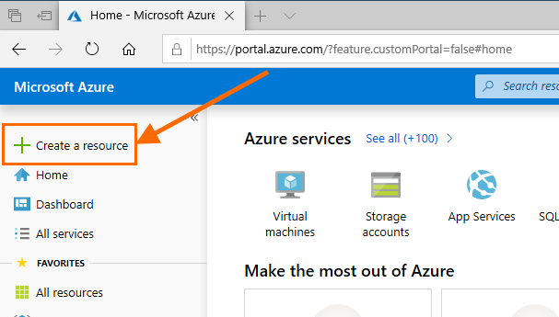

Type “Resource Group” in the search box and click Enter.

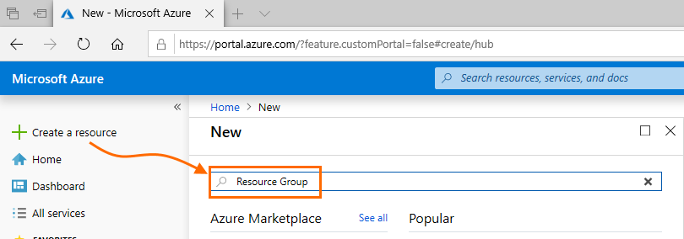

In the list of results, click “Resource Group”, then click “Create” on the next screen.

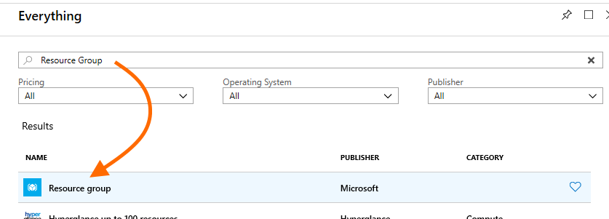

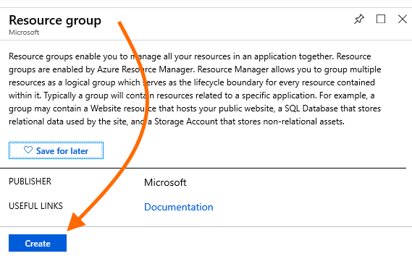

Provide the Resource Group name and Azure region (in the following screenshot, “DiscoveryDay” and East US, respectively), then click “Review + Create”. On the following confirmation screen, click “Create”.

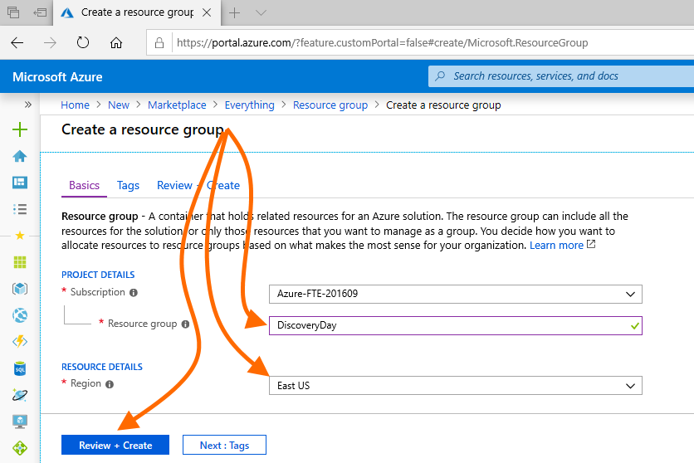

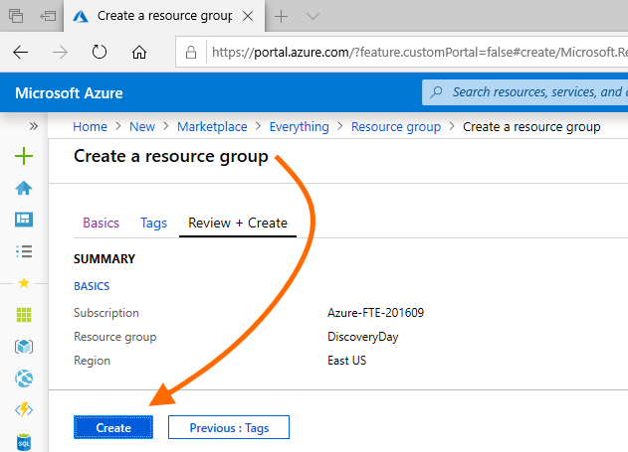

When the Resource Group is created, navigate to it so you are on its Overview blade. You can do this via the “Resource group created” notification that will appear when the Resource Group is created (and which can also be found under the portal’s bell-shaped Notifications icon in the top nav bar), or by navigating to the new Resource Group from the portal home page.

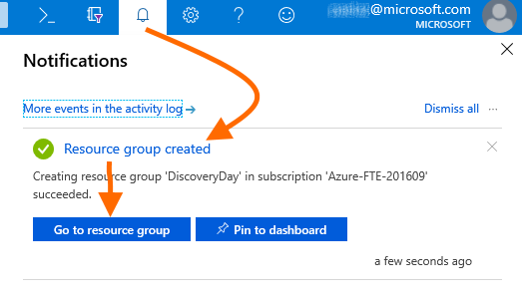

When you are at the Overview for the new Resource Group, this task is complete.

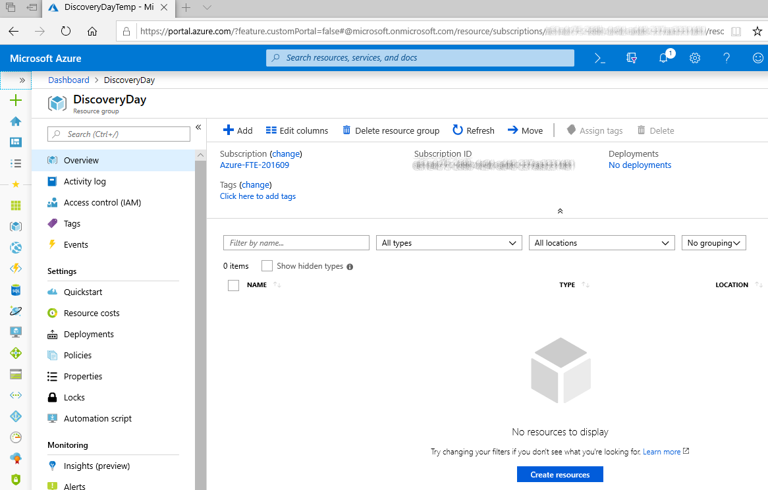

**Task (option 2)**: Create a new Resource Group using the Azure CLI. (Option 1 uses the Azure portal. Choose either option.)

As noted in the lab overview document, the labs will use the cloud shell available in the Azure portal site. To start, click the cloud shell icon in the top nav bar. The first time, you may be asked to designate or create a storage resource for the shell; please do so. Then choose a shell; these lab documents use the Bash shell.

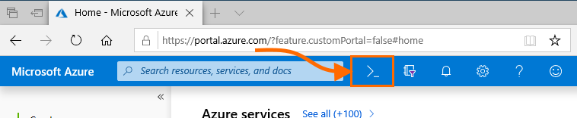

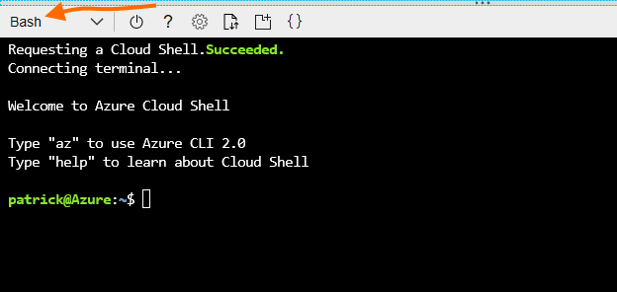

Optional: type az interactive to access the Azure CLI’s interactive, assistive mode.

Type az group create --location “East US” --name “DiscoveryDay”. Substitute the appropriate Azure region that you chose, and a different resource group name if desired.

After typing Enter, verify that the operation completed successfully. You can also do this by listing resource groups using az group list -o table.

Feel free to experiment with az CLI commands. Using az interactive is especially useful.

After resource group creation, navigate to the new resource group’s Overview blade in the Azure portal (see option 1, above). When you are there, this task is complete.