Name: ______

Safety glasses

White noise

**1. Pattern recognition**

Learning 8 patterns (5 min).

Experiment 8 patterns, 8 times each in a random manner.

**2. Flight test**

**2.1 Rules**

**2.1.1 Flight control**

While flying, the swarm is keeping the triangle shape with equal sides. The swarm position follows the glove position (drones flies in front of the glove), therefore human operator could manipulate the position of the formation in space (in 2D) by movement of the glove. The orientation of the swarm in XY plane also replicates the glove orientation. While flying, each drone performs obstacle avoidance individually (it couldn’t approach an obstacle closer than safety radius). Due to obstacle avoidance, the default triangle shape of the swarm (fig.1b) could be changed, becoming

- Contracted, as in fig.1a (smaller, when one or more drones are pushed to the center of the formation by the obstacle))

- Extended, as in fig.1c (bigger, when the drones flying around the obstacle)

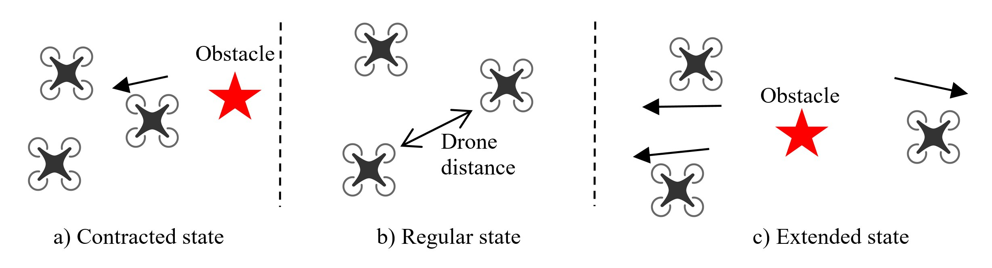Fig. 1. Contracted, regular(default), and extended state of the formation.

**2.1.2 Mission**

The swarm takeoff near the table.

Operator has to manipulate the swarm trough the labyrinth from start to the finish point.

After operator has to manipulate the swarm around the labyrinth, keeping as close to the labyrinth border as possible.

The swarm lands near the table.

**2.1.3 Goal, very important!**

* Avoid crashes, that is due to small drone-to-drone distance in contracted state (fig.1a)
* Keep the default triangle shape of the formation (fig.1b) with as small changes as possible. The operator has to try to prevent contracted of extended shape of the formation, therefore contact with obstacle will be minimized, which is our goal.

**2.1.4 Tactile patterns**

Tactile patterns are provided to better feel non-default states of the swarm (fig.1a and fig.1c).

While flying, the operator will experience two tactile patterns. When the swarm is in the default state, no tactile stimulus will be provided. When the swarm is in contracted state, as in fig.1a, the operator will feel the vibration on the middle finger (third). When the swarm is in extended state, as in fig.1c, the operator will feel the vibration on the side fingers (first and fifth).

**2.1.5 Possible strategies**

If the operator feel (using visual or tactile or both types of feedback) that the swarm is in contracted or extended state while flying, the operator could do the following:

* Make a move back and move the swarm further from the obstacle
* Select the other way to go through the narrow set of obstacles
* Change the orientation of the swarm by changing the glove orientation, while flying through or around the obstacles (for example place only one drone in front)
* If nothing possible to do, just try to minimize time of being in non-default state, but avoid crashes.

**2.2 Simulation:**

2 minutes: with glove off

2 minutes: with glove on

**2.3 Real flight:**

**Trials:**

one without tactile

one with tactile

**Experiment:**

2 times without

two time with the glove (mixed)

**Recording:**

number of crashes.

2.4 Questionary after the experiment:

|  |  |  |
| --- | --- | --- |
|  | Questions | 1=completely disagree, 7=completely agree |
|  | It has been easy to wear and use the SwarmGlove |  |
|  | It was easy to easy to move my hand and fingers while wearing the SwarmGlove |  |
|  | Visual feedback is enough to estimate the swarm geometry |  |
|  | It was easy to feel the swarm state with only tactile feedback |  |
|  | I had the feeling of better performance while receiving only visual feedback |  |
|  | I had the feeling of better performance while receiving the combination of visual and tactile feedback |  |
|  |  |  |
|  |  |  |
|  |  |  |
|  |  |  |