1

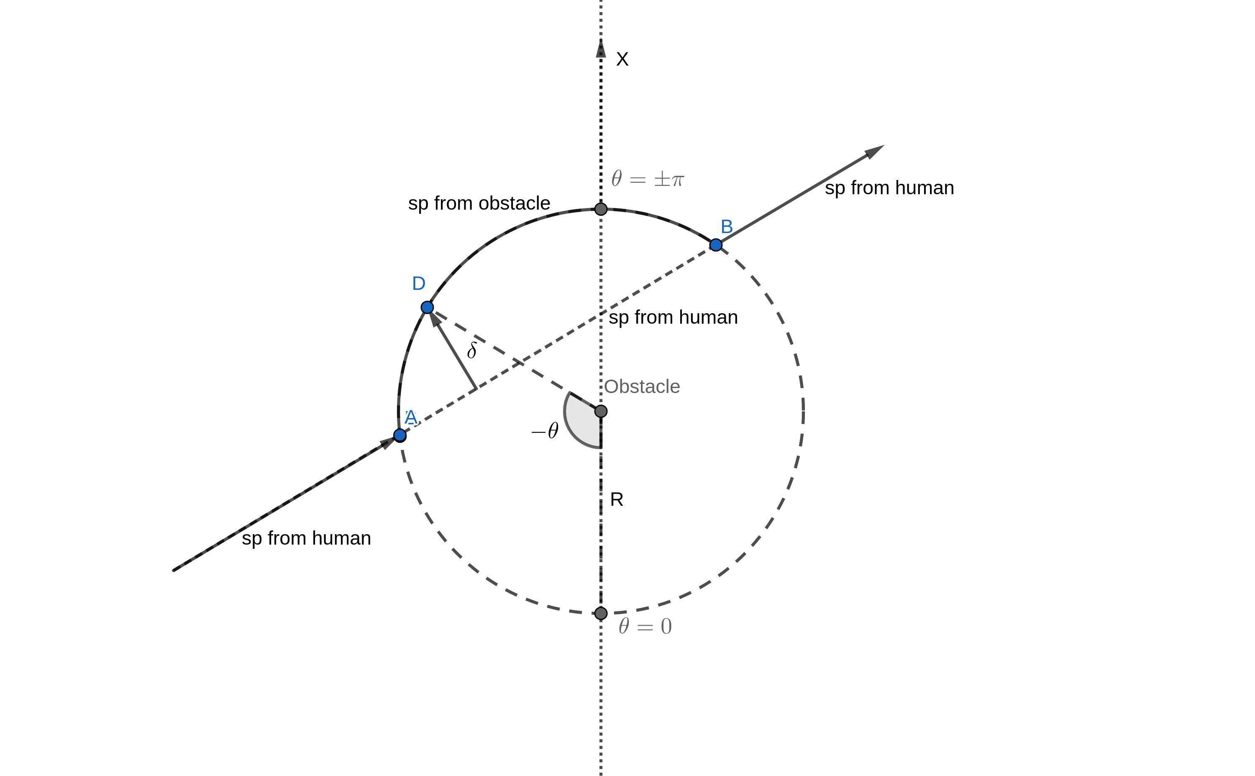

Fig. 1. Obstacle avoidance algorithm

* **INTRODUCTION**
* **DRONES CONTROL**

**2.1** **Obstacle avoidance algorithm**

The location of drones and obstacles is given by Vicon Vantage

5 motion capture system. Every object pose is broadcasted at

60 Hz frequency and is known at each period of time. So each

quadrotor is aware of the obstacles positions relative to it. Drones

goal positions are commanded relatively to the human location.

However if a quadrotor from the swarm is approaching the

obstacle its position is corrected relatively to the obstacle pose

as depicted on the fig. 1. If the drone is commanded by the human

to fly inside the circular vicinity of the obstacle, the aerial vehi-

cle will avoid the object, following the circumference, defining

the obstacle boundary. However this obstacle avoidance method

requires drones to move through the arc faster in comparison

with following straight line trajectory. In addition the quadrotors

should perform sharp maneuvers being in points A and B of the

circumference.

**2.2** **Delta-impedance control**

Impedance control is used in order to make trajectories near

obstacles feasible for the drones as follows. In the circle-like

obstacle vicinity the impedance correction term is added to the

drone goal position, based on the distance between the set-point

on the circumference and the goal position commanded by human

if there were not obstacles. This distance is denoted by the letter d

on the fig. 1. In order to calculate impedance pose correction term

the following equation should be solved for the drone, situated

near the obstacle:

|  |  |
| --- | --- |
| mx¨ + bx˙ + kx = Fd (t) | (1) |

where Fd = Kd , m is the desired mass of virtual body, b is

desired damping, and k is the desired stiffness. In such a way

the external force Fd (t) acting on the drone near the obstacle

affects drone’s desired position proportionally to d -value. Drones

trajectories in the vicinity of the obstacles become more smooth.

* **CONCLUSION**

The conclusion goes here.