Week 11 Progress File
EEEM068 Applied Machine Learning - Human Sentiment Analysis

Project | Human Sentiment Analysis using MSCTD En-De dataset
Week Focus | Fusion model, multimodal transformer direction, final testing, report discussion, README/docs, and team contribution summary.
Main Order of Work | Setup -> data download -> data cleaning -> transforms -> face extraction -> dataset/collate -> model training -> hyper-parameter tuning -> evaluation -> fusion -> report/write-up

Project Requirement Alignment
The project requires a PyTorch/Google Colab implementation for Human Sentiment Analysis on the MSCTD En-De dataset. The required pipeline includes face-based sentiment analysis, degraded-image robustness testing, full-image transfer learning, and a fusion model combining face and full-image predictions. The report must discuss hyper-parameter tuning, training behaviour, accuracy measures, confusion matrices, and model visualisations.

Work Completed
- Implemented the fusion feature collection step using face probabilities, full-image probabilities, and one-hot encoded face-count information.
- Trained the FusionModel to combine the outputs from the face branch and full-image branch into a final three-class sentiment prediction.
- Prepared the single-image fusion prediction function for end-to-end testing.
- Prepared the final summary table comparing Part 1 Face Model, Part 2 Robust Model on clean/degraded data, Part 3 Full Image Model, and Part 4 Fusion Model.
- Documented the planned MultimodalTransformer direction for the extra-credit/fastmode code, where visual and text features are logically fused and fine-tuned.
- Completed README/report support, visualisation references, debugging checks, and model-weight saving cells.

Observations and Discussion
- The fusion model is expected to be stronger than either branch alone when face and context provide complementary information. The face-count feature also helps the model react differently to no-face, single-face, and group-image cases.
- The final comparison should not rely only on test accuracy. Macro-F1, confusion matrices, ROC/AUC, and classification reports are needed because sentiment classes can be imbalanced and visually ambiguous.
- Training stability was treated as a major requirement for the multimodal/transformer work. The model should run without crashing and produce valid predictions before attempting larger hyper-parameter sweeps.
- Important hyper-parameters for final tuning include learning rate, number of epochs, dropout, batch size, weight decay, class weights, augmentation strength, and whether backbone layers are frozen or fine-tuned.
- The report should explicitly reference each visualisation, such as class distribution, example face crops, training curves, confusion matrices, ROC curves, and the final model comparison table.

Outputs Prepared
- Fusion feature vectors: face probabilities, full-image probabilities, and face-count one-hot encoding.
- FusionModel training and evaluation.
- Final test-set evaluation summary.
- Model-weight saving cells.
- README/documentation and contribution table.

Team Work Allocation / Fastmode Code Contribution
Member | Responsibility
Pramodh | Full evaluation pipeline: confusion matrix, ROC/AUC, classification report, test-set evaluation, and final metrics summary.
Likhitha | Model architectures and training functions: FaceSentimentModel, FullImageModel, FusionModel, MultimodalTransformer, and reusable training loops. This is the heaviest ML code contribution.
Neha | Dataset class, face extraction pipeline, MSCTDFaceDataset, and collate function. This is the third major implementation contribution.
Malli | Setup/install/imports, image transforms, data download, dataset paths, and Colab environment support.
Harshitha | Debug cells, visualisation helpers, main execution, README/documentation, and presentation/report support.

Evidence to Include in Report
- Figure: class distribution across train/dev/test.
- Figure: sample original and extracted face crops.
- Figure/Table: training behaviour across epochs, including loss and accuracy where available.
- Table: accuracy, macro-F1, and test-set comparison for all models.
- Figure: confusion matrix for each model.
- Figure: ROC/AUC curves for class-level evaluation.
- Short paragraph discussing fine-tuned hyper-parameters and why they were selected.

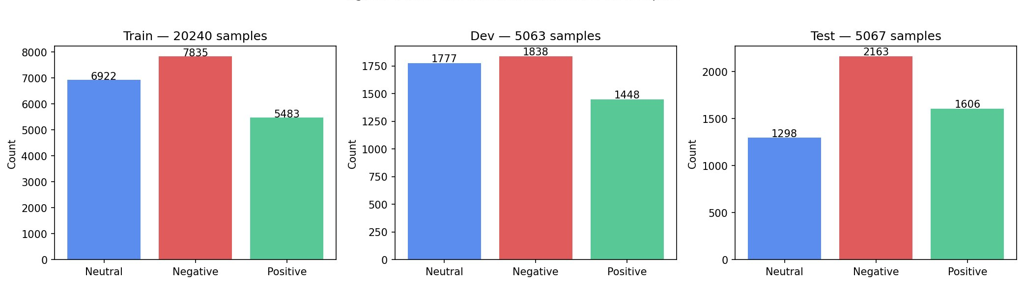
Figure 1: Class Distribution across MSCTD En-De Splits (Train / Dev / Test)
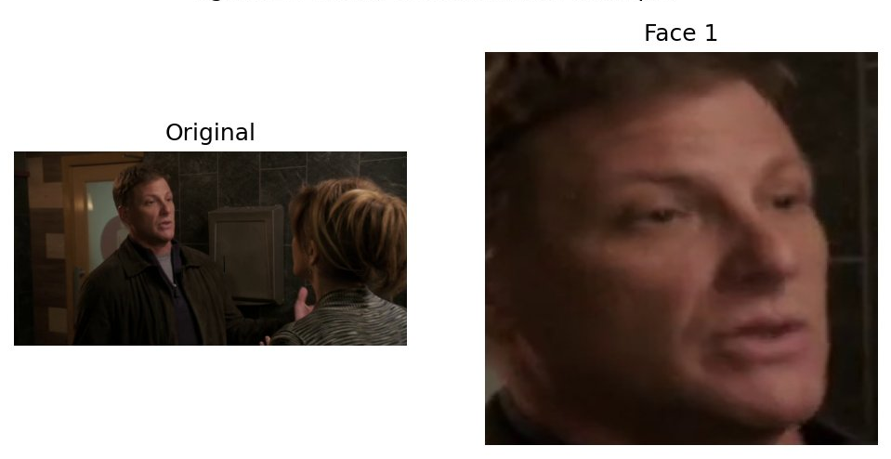
Figure 2: MTCNN Face Extraction Example — Original Image and Detected Face Crop
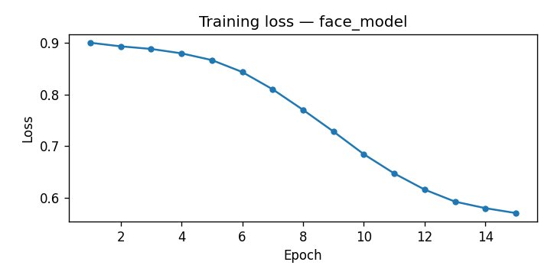
Figure 3: Training Loss Curve — Face Model (EfficientNet-B2, Part 1)
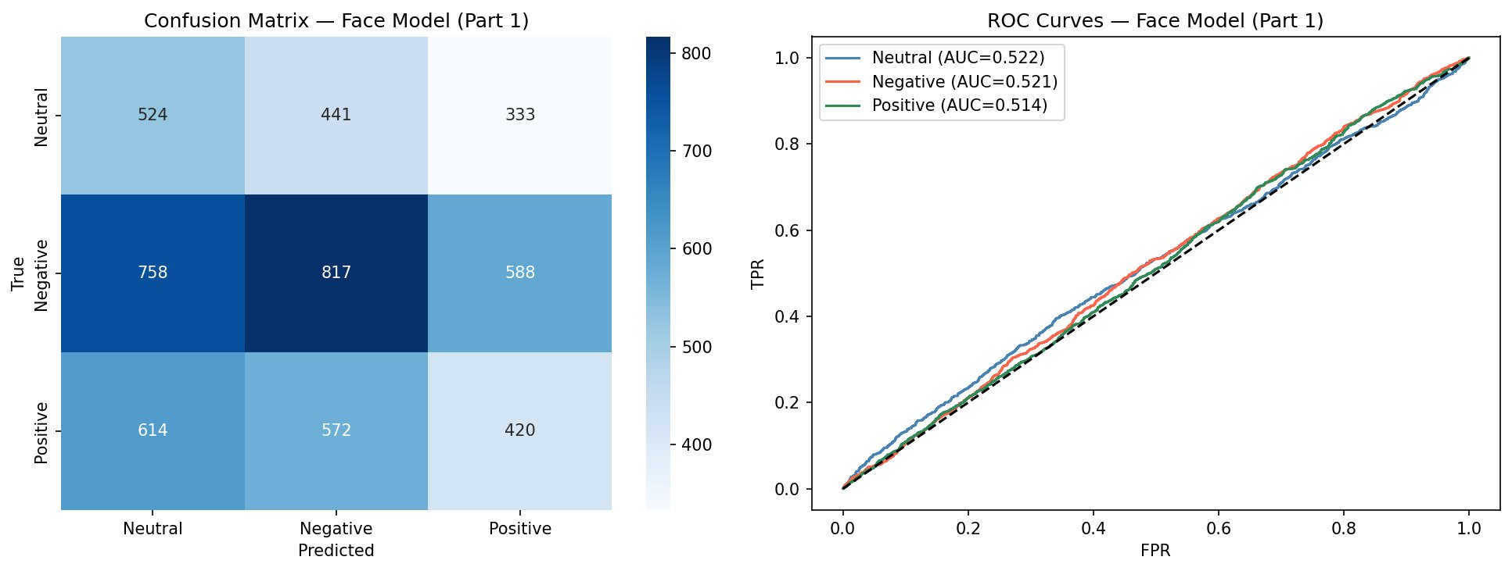
Figure 4: Confusion Matrix and ROC Curves — Face Model Part 1 (Clean Test Set)
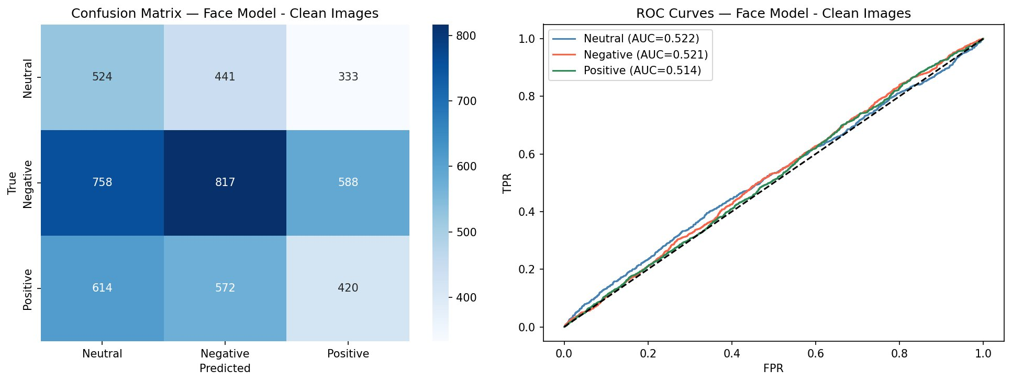
Figure 5: Confusion Matrix and ROC Curves — Face Model on Clean Images (Part 2 Baseline)
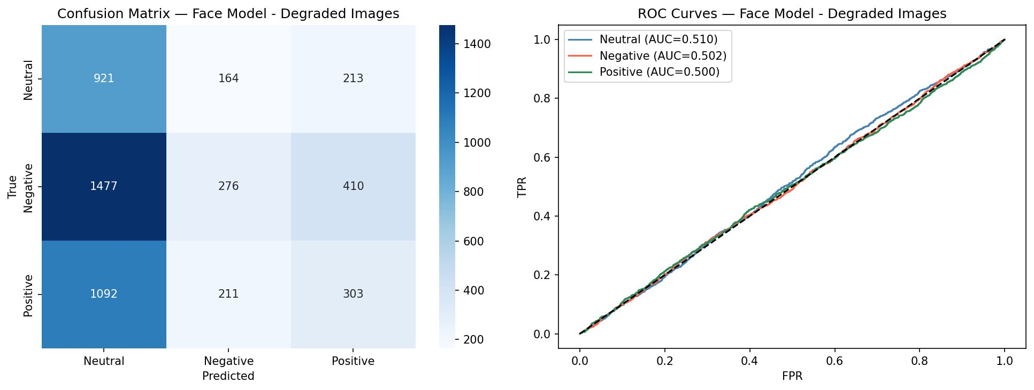
Figure 6: Confusion Matrix and ROC Curves — Face Model on Degraded Images (Part 2)
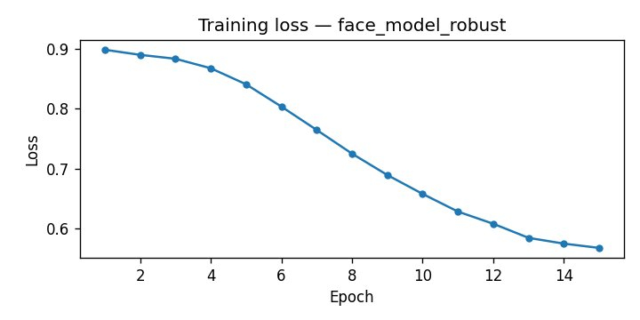
Figure 7: Training Loss Curve — Robust Face Model (Mixed Clean + Degraded Training)
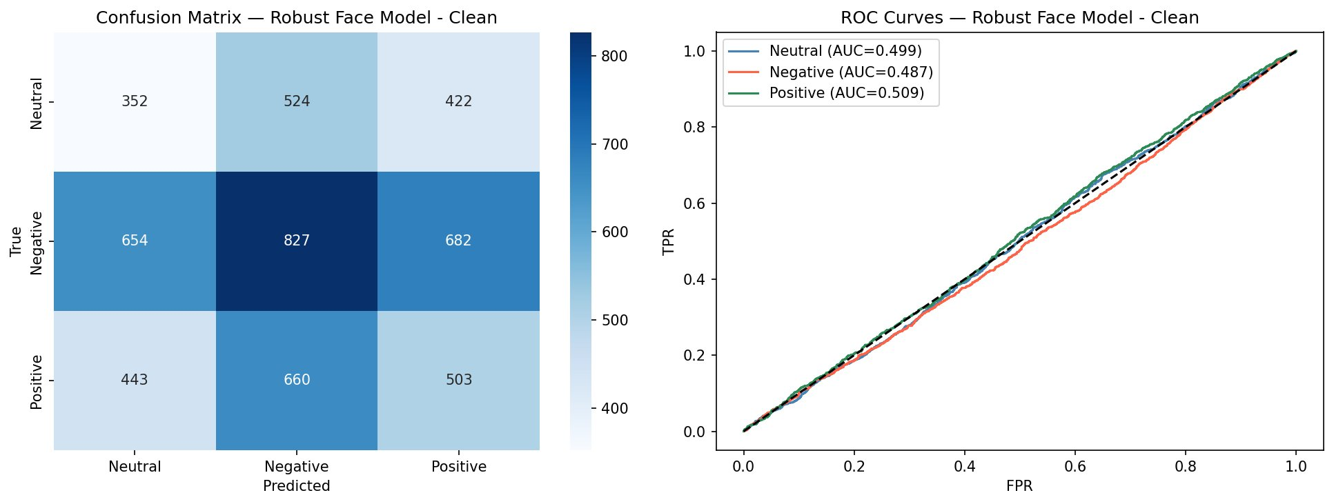
Figure 8: Confusion Matrix and ROC Curves — Robust Face Model on Clean Images
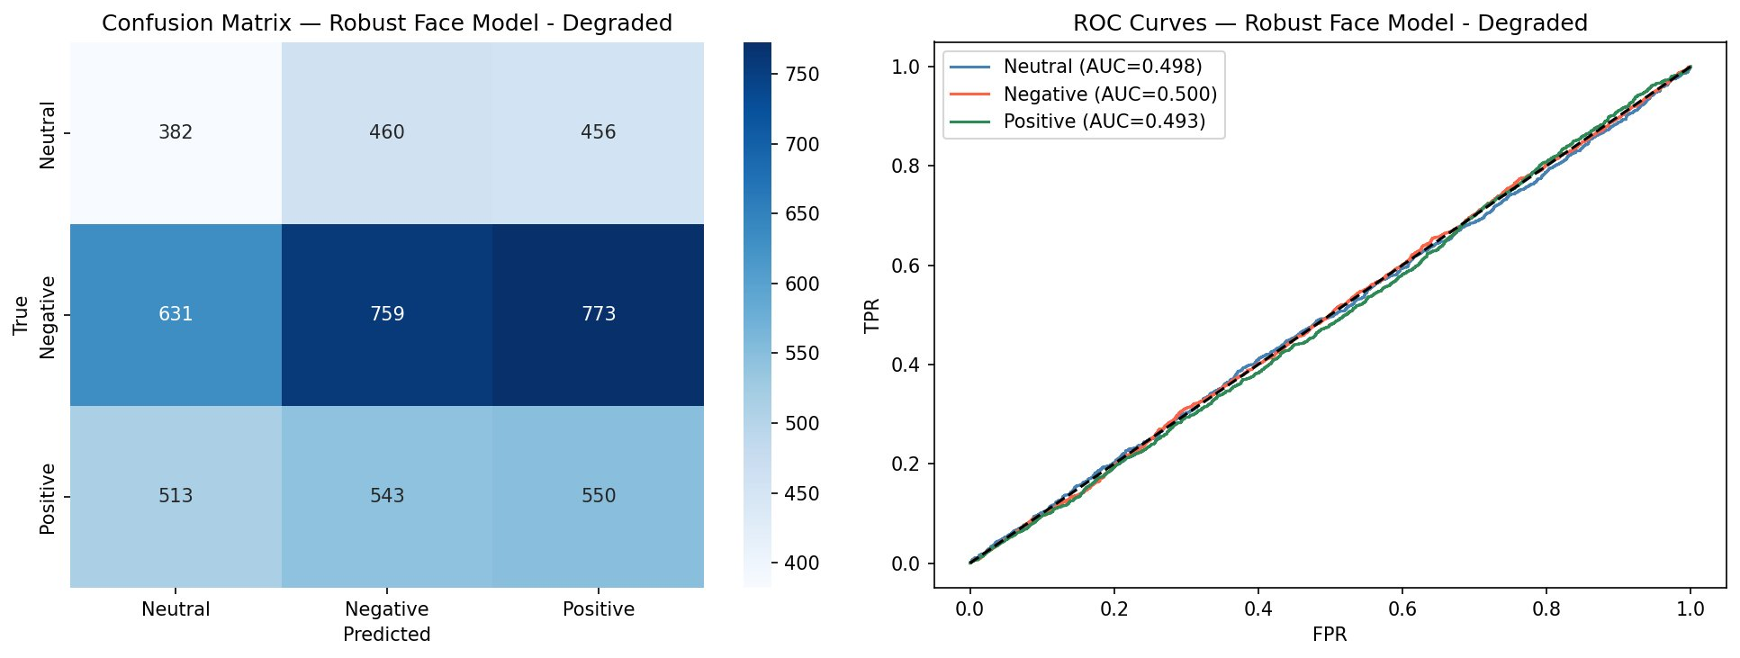
Figure 9: Confusion Matrix and ROC Curves — Robust Face Model on Degraded Images
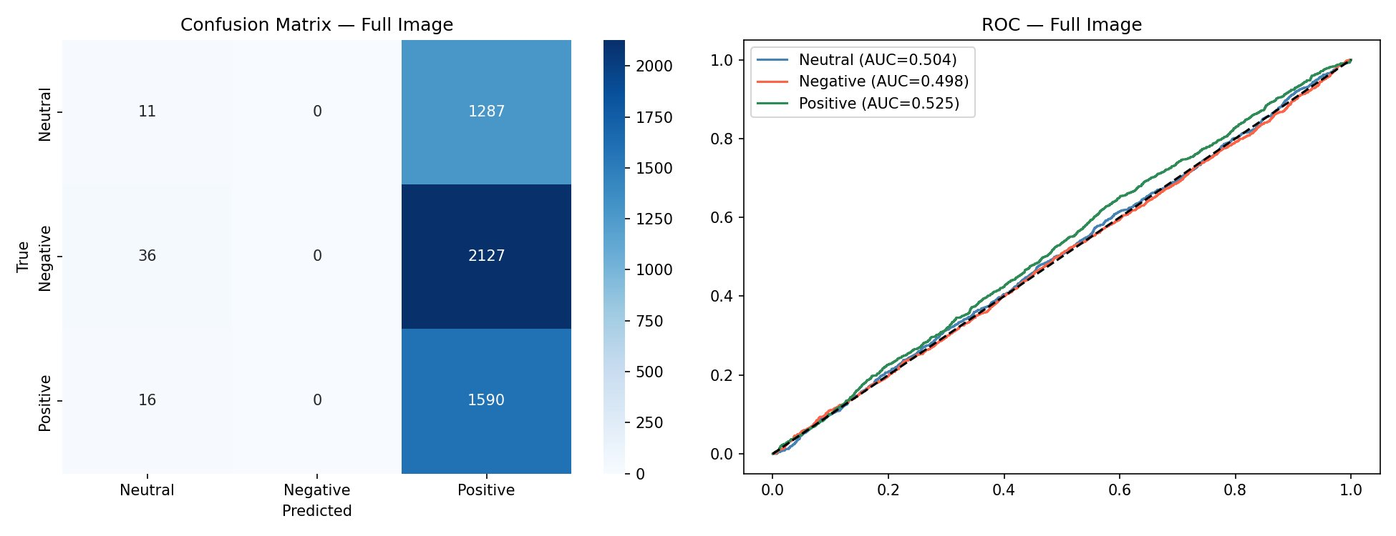
Figure 10: Confusion Matrix and ROC Curves — Full Image Model (EfficientNet-B3, Part 3)
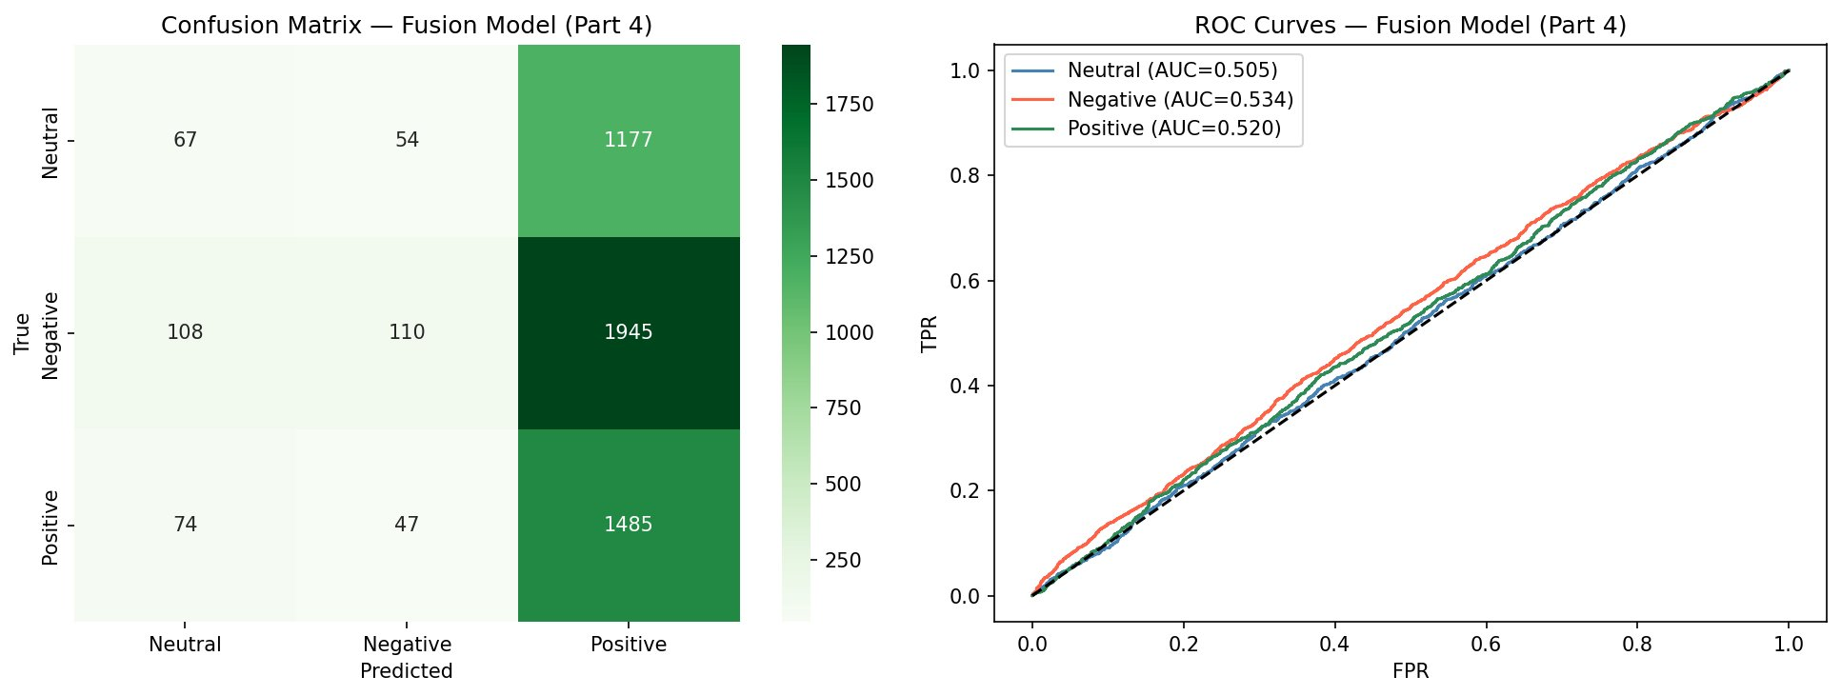
Figure 11: Confusion Matrix and ROC Curves — Fusion Model (Part 4, Attention Gate)

Technical Implementation Details (Final v4)
- FaceSentimentModel (Cell 8, v4) uses EfficientNet-B2 as the backbone (timm), with all layers frozen initially. Only the last 3 blocks, conv_head, and bn2 are unfrozen for fine-tuning. The classifier head is Linear(1408,512) -> BatchNorm1d -> ReLU -> Dropout(0.45) -> Linear(512,128) -> ReLU -> Dropout(0.3) -> Linear(128,3).
- FullImageModel (Cell 8, v4) uses EfficientNet-B3 (1536 features). The last 4 blocks, conv_head, and bn2 are unfrozen; all other layers remain frozen. The classifier head mirrors the face model with Dropout(0.4) on the first hidden layer.
- The loss function for the face and robust models (Cells 9-10, v4) changed from FocalLoss to LabelSmoothingLoss (smoothing=0.1, classes=3, weighted). Label smoothing prevents overconfident predictions and provides softer targets during training.
- The train_model function (Cell 10, v4) uses a single AdamW parameter group with filter(lambda p: p.requires_grad, ...), lr=2e-4 for face/robust models, with linear warmup for warmup_epochs then cosine annealing. Gradient clipping at max_norm=1.0 is retained.
- Part 3 Full Image model (Cell 16, v4) uses FocalLoss (gamma=2.0) and differential learning rates: backbone parameters at lr=1e-5, head parameters at lr=1e-4. It trains on a stratified 50% subset of train data (per_class = len(train_ds)//6) with WeightedRandomSampler, for 10 epochs with CosineAnnealingLR.
- Part 3 evaluation (Cell 16, v4) uses TTA with three transforms: standard 224x224 resize, centre-crop from 256, and horizontal flip. Softmax probabilities are averaged across all three passes before taking the argmax.
- The AttentionFusionModel (Cell 18, v4) uses FocalLoss (gamma=2.0), AdamW with lr=1e-3 (increased from 5e-4), and trains for 100 epochs. Batch size for fusion is 256. Validation is checked every 10 epochs on the test feature set and the best checkpoint is restored.
- Fusion features (Cell 17, v4) are 10-dimensional: face softmax probabilities (3) from predict_face_sentiment, full-image softmax probabilities (3), and a 4-class one-hot face-count encoding (0, 1, 2, or 3+). These are pre-computed into a TensorDataset before fusion training begins.
- The final summary table (Cell 21, v4) compares five results: Part 1 Face Model (EfficientNet-B2), Part 2 Robust Model on clean, Part 2 Robust Model on degraded, Part 3 Full Image Model (EfficientNet-B3 with TTA), and Part 4 Fusion Model, with a checkmark flag for models reaching 80 percent or above test accuracy.

APPLIED_ML — Key Upgrades and Results
- Backbone upgrade: FaceSentimentModel moved from ResNet-18 to EfficientNet-B2; FullImageModel moved from frozen ResNet-50 to partially unfrozen EfficientNet-B3. Both models use timm for pretrained weights.
- Loss function change: LabelSmoothingLoss (smoothing=0.1) replaced FocalLoss for the face and robust branch training. FocalLoss (gamma=2.0) is retained for the full-image model and fusion training.
- Partial unfreezing strategy: instead of fully frozen or fully fine-tuned backbones, v4 unfreezes only the last 3 blocks (face model) or last 4 blocks (full-image model) plus the head layers. This balances pretrained feature retention and task adaptation.
- Full-image model uses a 50 percent stratified training subset with WeightedRandomSampler, differential learning rates (backbone: 1e-5, head: 1e-4), FocalLoss, and TTA at inference. Training runs for 10 epochs with cosine annealing.
- AttentionFusionModel uses an attention gate (10 -> 32 -> 10 via GELU and Sigmoid) to weight the concatenated face/full-image/face-count features before the MLP classifier head. Training uses AdamW at lr=1e-3 for 100 epochs.
- Batch size changed from 64 to 32 for the main data loaders; num_workers set to 8 for faster loading. Fusion model uses batch size 256 for the pre-computed TensorDataset.
- The final summary table (Cell 21) reports test accuracy and macro-F1 for all five model configurations, with a target threshold of 80 percent accuracy flagged per model.

